Supreetha Poojary
D/o Sanjeeva Poojary,
Moodlakatte-po (576217), Kundapura, Udupi, Karnataka
7338105683 | s.supreetha09@gmail.com
LinkedIn: https://www.linkedin.com/in/supreetha-poojary-b38ba81b80
Career Objective
To have a growth-oriented and challenging career, where I can contribute my knowledge and skills to the organization and enhance my experience through continuous learning and teamwork.

Education

Moodlakatte Institute of Technology (VTU) 2019 – 2021 Master of Business Administration (HR & Finance) 8.1 CGPA

Bhandarkars’ Arts & Science College Kundapura (Mangalore University) 2015 - 2018 Bachelor in Commerce 80%

Govt PU College Kundapura 2013 – 2015 PUC 77%

Govt High school Kundapura 2013 SSLC 82%
Work Experience

HR Recruiter (Non-IT) : TQA Business Solution Sept 2022 – Apr 2024 Roles and Responsibilities:
- Review job descriptions to understand the requirements received from clients.
- Job posting through Naukri.
- Responsible for sourcing and screening resumes using job portals like Naukri.
- Generating a pool of suitable & interested candidates.
- Cold calling the candidates & lining up the interviews.
- Interviewing & preparing candidates for further rounds with clients.
- Submitting the screened profiles to the companies.
- Scheduling the selected candidates for the final round of discussion with the company.
- Following up actively with candidates until they join the company.
- End-to-end recruitment.
Clerk cum Cashier :Vande Matharam Co-operative Society Mar 2022 –Sept 2022 Roles and Responsibilities:
- Process and accept deposit & payments from customers.
- Opening various kinds of deposits like savings, recurring deposit, fixed deposit, etc.
- Prepare loan documents & processing loan papers.
- Record keeping & filling of documents related to deposits, loans, etc.
- Handle customers & their financial transactions.
- Prepare and record all the daily transactions in the society's computer system.
- Processing financial instruments such as cheques.
- Reconciling the cash received & disbursed on a daily basis.
- Cash and general ledger account reconciliation.

SKILLS
- Cold calling
- Screening
- Interviewing
- Scheduling
- Shortlisting
- Salary Negotiations
- End to End Recruitment
- OMC (Office Management Course- Excel, Word, PPT)
- Nudi

Internships Projects
- Company: Britannia Industries Ltd
Industry: Food Processing Industry
Duration: One month
- Company: Beereshwara Co-operative Credit Society Ltd, Koteshwara
Industry: Banking Industry
Duration: 22nd Feb - 4th Apr 2021

Personal Strengths
- Capability to work with a team
- Interpersonal Skills
- Honest and positive attitude
- Hardworking and sincere

Languages Known
- English
- Kannada
- Hindi

Personal Information
- Date of Birth: 09 Feb 1998
- Marital Status: Unmarried
- Nationality: Indian
- Gender: Female

Hobbies and Interests
- Listening to music
- Playing brain training games like crosswords, word puzzles
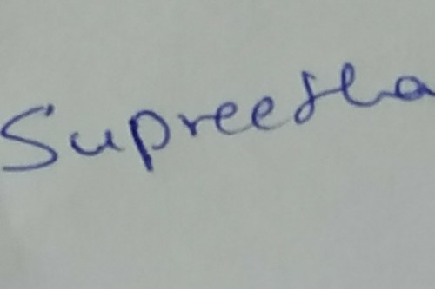
I hereby declare that the above-mentioned information is true to the best of my knowledge and belief.
Supreetha
Date :

Place :

