SUPREETHA POOJARY
D/o Sanjeeva Poojary, Moodlakatte-po (576217) . Kundapura, Udupi Karnataka
7338105683 | s.supreetha09@gmail.com
https://www.linkedin.com/in/supreetha-poojary-b38ba81b8

Objective

To have a growth oriented and challenging career, where I can contribute my knowledge and skills to the organization and enhance my experience through continuous learning and team work.

Experience

Vande Matharam VSSN (Co-operative Society)
Clerck cum cashier
Roles and Responsibility:
*Process and accept deposit & payments from customers.
- opening various kinds of deposits like savings, recurring deposit, ﬁxed deposit etc.
- prepare loan documents & processing loan papers.
- record keeping & ﬁlling of documents related to deposit, loans, etc.
- handle customers & their ﬁnancial transactions.
- prepare and record all the daily transaction in society's computer system.
- processing ﬁnancial instruments such as cheques.
- reconciling the cash received & disbursed on daily basis.
- cash and general ledger account reconciliation.

TQA Business solutions
HR Recruiter (Non IT)
- Review job description to understand the requirements received from the clients.
- Job posting through Naukri.
- Responsible for sourcing and screening the resumes using job portal like naukri.
- Generating a pool of suitable & interested candidates.
- Cold calling the candidates & line up the interviews.
- Interviewing & preparing candidates for further rounds with clients.
- Submits the screened proﬁles to the companies.
- Scheduling the selected candidates for ﬁnal round of discussion with the company.
- Following up actively with candidates until they join the company.
- End to end recruitment.

Education

Govt Junior College Kundapura
S. S. L. C 81.76%

Govt. P. U. College Kundapura
PUC
77.33%

Bhandarkars' Arts and Science College Kundapura (Mangalore university)
B. Com 80.00%

Moodlakatte Institute of Technology Kundapura ( VTU)
MBA (HR & Finance)
1-3-2022 - 3- 9-2022

04-09-2022 - 30-04-2024

2013

2013 - 2015

2015 - 2018

2019 - 2021

Skills
- cold calling * screening * interviewing * schedule * shortlisting * salary negotiations * recruitment OMC (ofﬁce management cource) Nudi
Projects

A summer internship project on Organization Study

Company : Britannia Industries Ltd Industry : Food Processing Industry Duration : one month
Final project on Financial Planning of Customer
Company : Beereshwara Co-operative Credit society Ltd Koteshwara Industry : Banking Industry
Duration : 22nd Feb - 4th Apr 2021

Strength
Capability to work with team, Willingness to learn, Honest and positive attitude, Hardworking and sincere

Languages
English Kannada Hindi

Personal Details
Date of birth : 09 Feb 1998 Marital status : unmarried Nationality : Indian
Gender : Female

Hobbies
Listening to music
Playing brain training games like cross words, word puzzle

Declaration
I hereby declare that the above mentioned information is true to the best of my knowledge and belief.
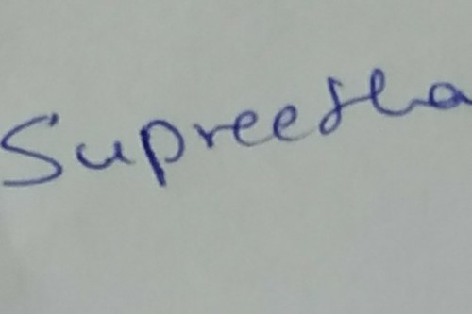
SUPREETHA POOJARY

