Mass-Storage Systems

nDescribe the physical structure of secondary and tertiary storage devices and the resulting effects on the uses of the devices
nExplain the performance characteristics of mass-storage devices
nDiscuss operating-system services provided for mass storage, including RAID and HSM
nOverview of Mass Storage Structure

nMagnetic disks provide bulk of secondary storage of modern computers
lDrives rotate at 60 to 200 times per second
lTransfer rate is rate at which data flow between drive and computer
lPositioning time (random-access time) is time to move disk arm to desired cylinder (seek time) and time for desired sector to rotate under the disk head (rotational latency)
lHead crash results from disk head making contact with the disk surface
That’s bad
nDisks can be removable
nDrive attached to computer via I/O bus
lBusses vary, including EIDE, ATA, SATA, USB, Fibre Channel, SCSI
lHost controller in computer uses bus to talk to disk controller built into drive or storage array
nMoving-head Disk Mechanism

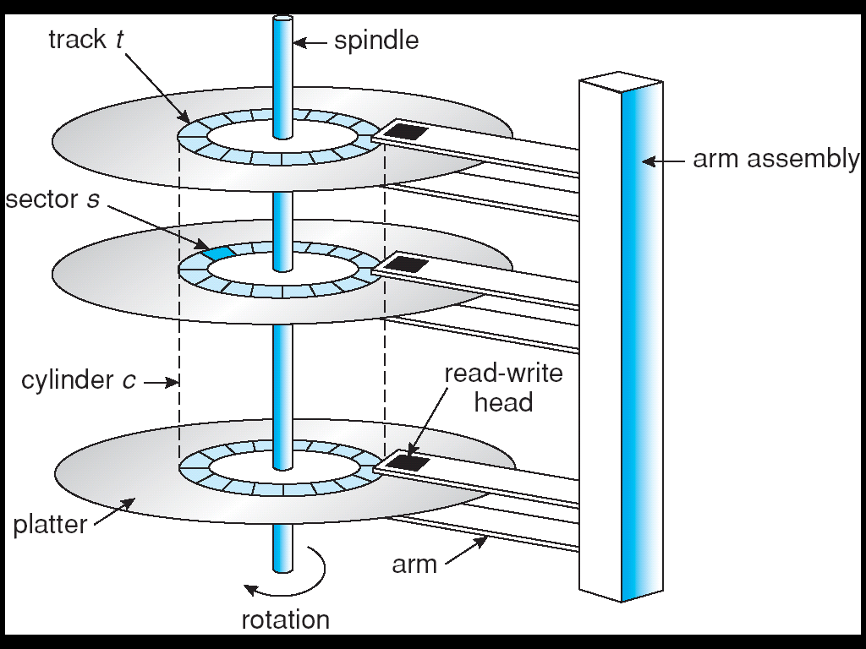

nMagnetic tape
lWas early secondary-storage medium
lRelatively permanent and holds large quantities of data
lAccess time slow
lRandom access ~1000 times slower than disk
lMainly used for backup, storage of infrequently-used data, transfer medium between systems
lKept in spool and wound or rewound past read-write head
lOnce data under head, transfer rates comparable to disk
l20-200GB typical storage
lCommon technologies are 4mm, 8mm, 19mm, LTO-2 and SDLT
Disk Structure

nDisk drives are addressed as large 1-dimensional arrays of logical blocks, where the logical block is the smallest unit of transfer
nThe 1-dimensional array of logical blocks is mapped into the sectors of the disk sequentially
lSector 0 is the first sector of the first track on the outermost cylinder
lMapping proceeds in order through that track, then the rest of the tracks in that cylinder, and then through the rest of the cylinders from outermost to innermost
nDisk Attachment

nHost-attached storage accessed through I/O ports talking to I/O busses
nSCSI itself is a bus, up to 16 devices on one cable, SCSI initiator requests operation and SCSI targets perform tasks
lEach target can have up to 8 logical units (disks attached to device controller
nFC is high-speed serial architecture
lCan be switched fabric with 24-bit address space – the basis of storage area networks (SANs) in which many hosts attach to many storage units
lCan be arbitrated loop (FC-AL) of 126 devices
Network-Attached Storage

nNetwork-attached storage (NAS) is storage made available over a network rather than over a local connection (such as a bus)
nNFS and CIFS are common protocols
nImplemented via remote procedure calls (RPCs) between host and storage
nNew iSCSI protocol uses IP network to carry the SCSI protocol

Storage Area Network
nCommon in large storage environments (and becoming more common)
nMultiple hosts attached to multiple storage arrays - flexible

Disk Scheduling

nThe operating system is responsible for using hardware efficiently — for the disk drives, this means having a fast access time and disk bandwidth
nAccess time has two major components
lSeek time is the time for the disk are to move the heads to the cylinder containing the desired sector
lRotational latency is the additional time waiting for the disk to rotate the desired sector to the disk head
nMinimize seek time
nSeek time » seek distance
nDisk bandwidth is the total number of bytes transferred, divided by the total time between the first request for service and the completion of the last transfer

nSeveral algorithms exist to schedule the servicing of disk I/O requests
nWe illustrate them with a request queue (0-199)
98, 183, 37, 122, 14, 124, 65, 67

Head pointer 53
FCFS

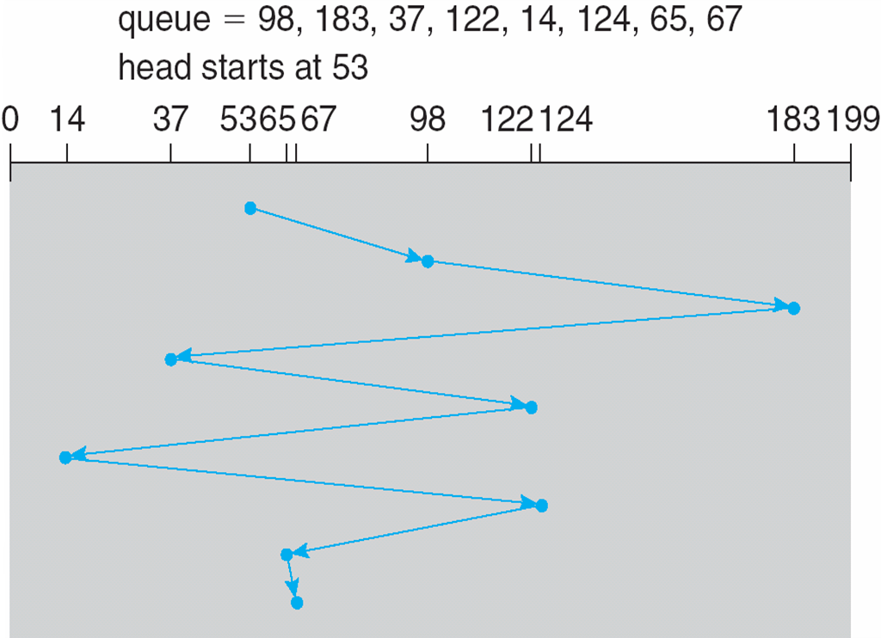
Illustration shows total head movement of 640 cylinders

SSTF
nSelects the request with the minimum seek time from the current head position
nSSTF scheduling is a form of SJF scheduling; may cause starvation of some requests
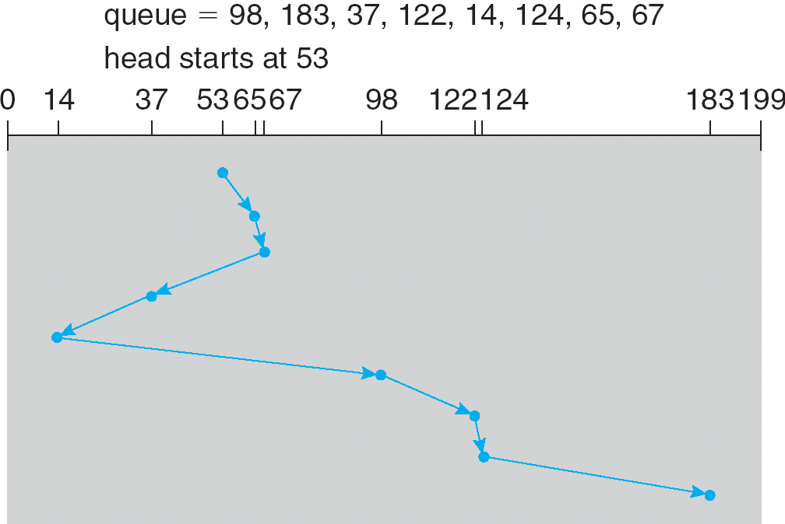
nIllustration shows total head movement of 236 cylinders

SCAN

nThe disk arm starts at one end of the disk, and moves toward the other end, servicing requests until it gets to the other end of the disk, where the head movement is reversed and servicing continues.
nSCAN algorithm Sometimes called the elevator algorithm
nIllustration shows total head movement of 208 cylinders

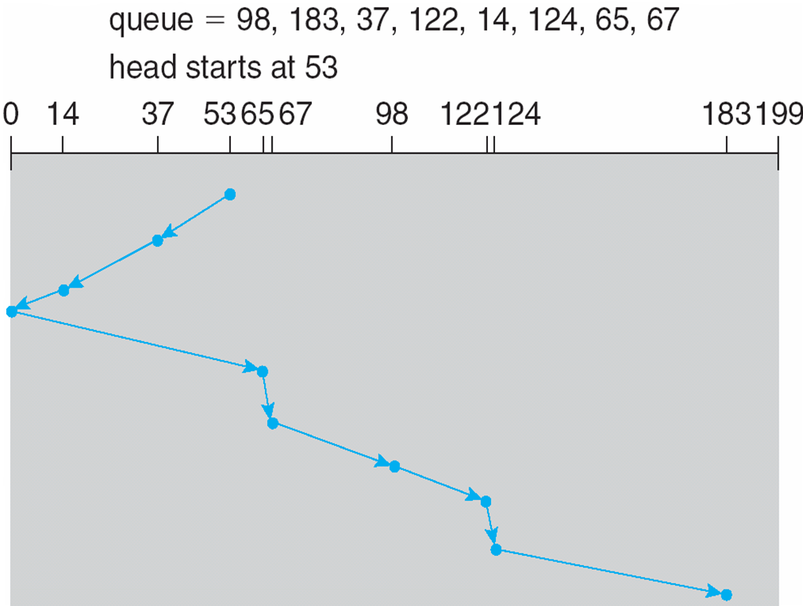

C-SCAN

nProvides a more uniform wait time than SCAN
nThe head moves from one end of the disk to the other, servicing requests as it goes
lWhen it reaches the other end, however, it immediately returns to the beginning of the disk, without servicing any requests on the return trip
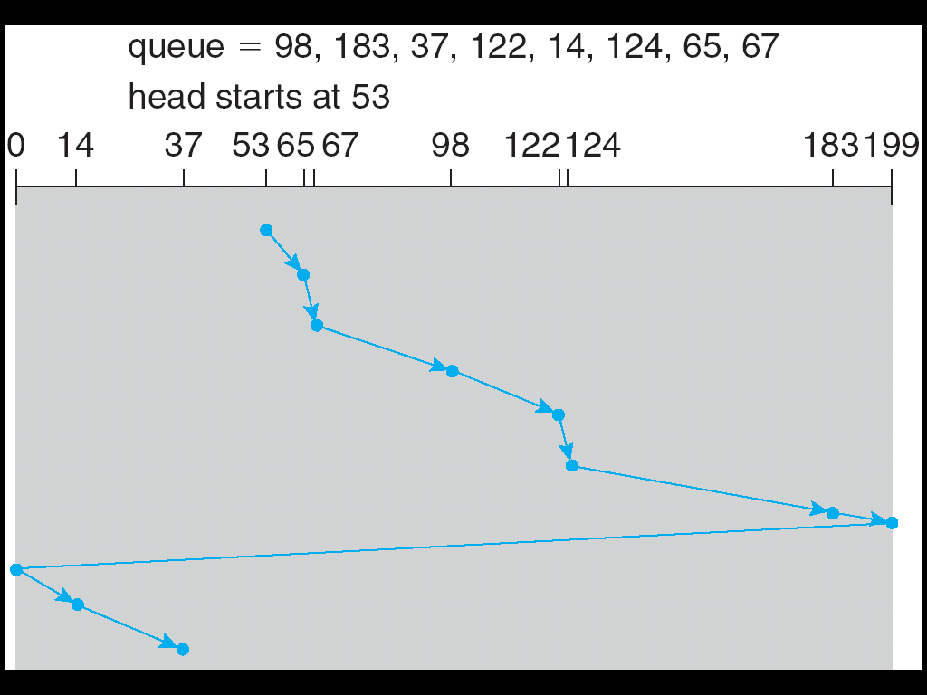
nTreats the cylinders as a circular list that wraps around from the last cylinder to the first one

C-LOOK

nVersion of C-SCAN
nArm only goes as far as the last request in each direction, then reverses direction immediately, without first going all the way to the end of the disk
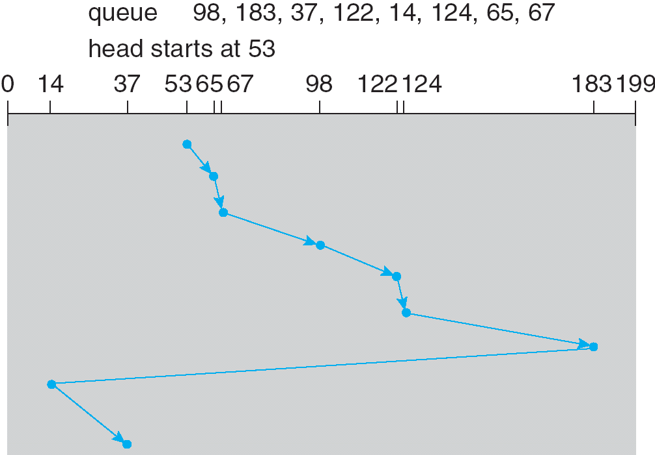

Selecting a Disk-Scheduling Algorithm

nSSTF is common and has a natural appeal
nSCAN and C-SCAN perform better for systems that place a heavy load on the disk
nPerformance depends on the number and types of requests
nRequests for disk service can be influenced by the file-allocation method
nThe disk-scheduling algorithm should be written as a separate module of the operating system, allowing it to be replaced with a different algorithm if necessary
nEither SSTF or LOOK is a reasonable choice for the default algorithm

Disk Management

nLow-level formatting, or physical formatting — Dividing a disk into sectors that the disk controller can read and write
nTo use a disk to hold files, the operating system still needs to record its own data structures on the disk
lPartition the disk into one or more groups of cylinders
lLogical formatting or “making a file system”
lTo increase efficiency most file systems group blocks into clusters
Disk I/O done in blocks
File I/O done in clusters
nBoot block initializes system
lThe bootstrap is stored in ROM
lBootstrap loader program
nMethods such as sector sparing used to handle bad blocks
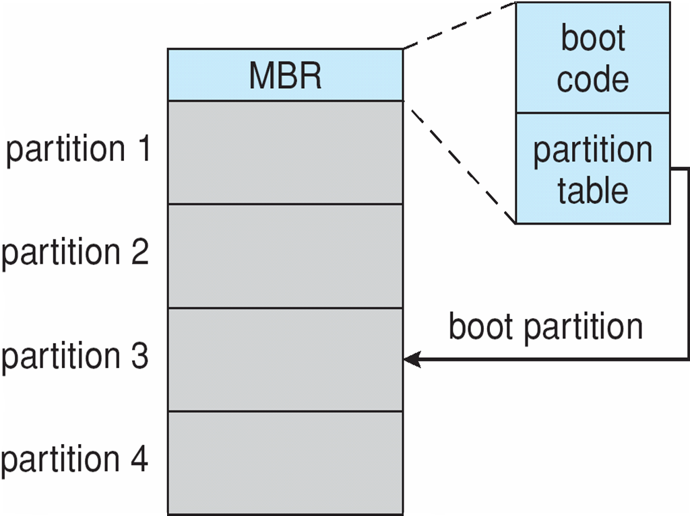
Booting from a Disk in Windows 2000

Swap-Space Management

nSwap-space — Virtual memory uses disk space as an extension of main memory
nSwap-space can be carved out of the normal file system, or, more commonly, it can be in a separate disk partition
nSwap-space management
l4.3BSD allocates swap space when process starts; holds text segment (the program) and data segment
lKernel uses swap maps to track swap-space use
lSolaris 2 allocates swap space only when a page is forced out of physical memory, not when the virtual memory page is first created

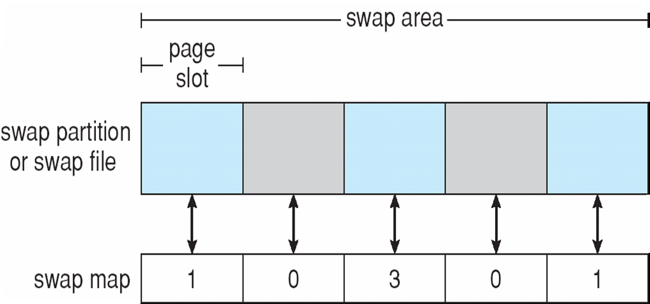
Data Structures for Swapping on Linux Systems

RAID Structure

nRAID – multiple disk drives provides reliability via redundancy
nIncreases the mean time to failure
nFrequently combined with NVRAM to improve write performance
n
nRAID is arranged into six different levels

nSeveral improvements in disk-use techniques involve the use of multiple disks working cooperatively
nDisk striping uses a group of disks as one storage unit
nRAID schemes improve performance and improve the reliability of the storage system by storing redundant data
lMirroring or shadowing (RAID 1) keeps duplicate of each disk
lStriped mirrors (RAID 1+0) or mirrored stripes (RAID 0+1) provides high performance and high reliability
lBlock interleaved parity (RAID 4, 5, 6) uses much less redundancy
nRAID within a storage array can still fail if the array fails, so automatic replication of the data between arrays is common
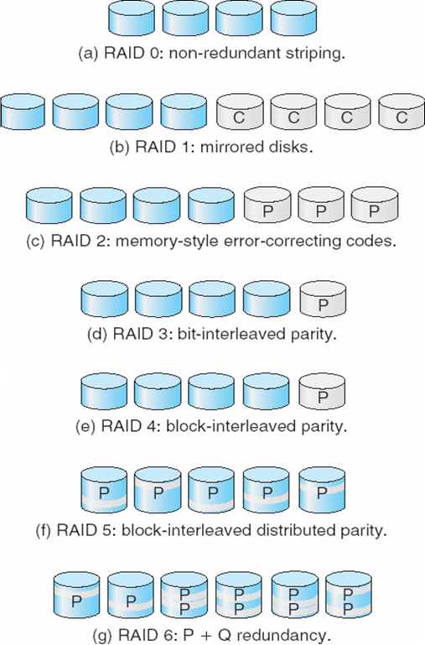
nFrequently, a small number of hot-spare disks are left unallocated, automatically replacing a failed disk and having data rebuilt onto them

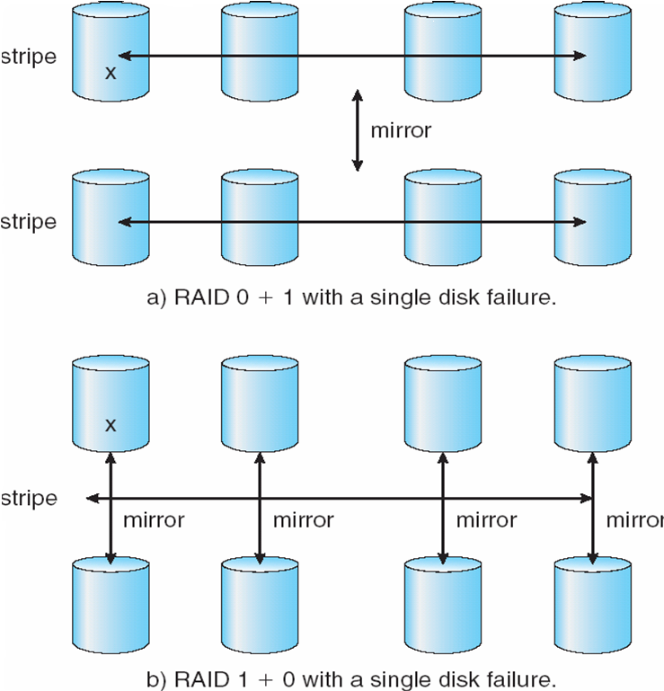
RAID (0 + 1) and (1 + 0)

Extensions

nRAID alone does not prevent or detect data corruption or other errors, just disk failures
nSolaris ZFS adds checksums of all data and metadata
nChecksums kept with pointer to object, to detect if object is the right one and whether it changed
nCan detect and correct data and metadata corruption
nZFS also removes volumes, partititions
lDisks allocated in pools
lFilesystems with a pool share that pool, use and release space like “malloc” and “free” memory allocate / release calls
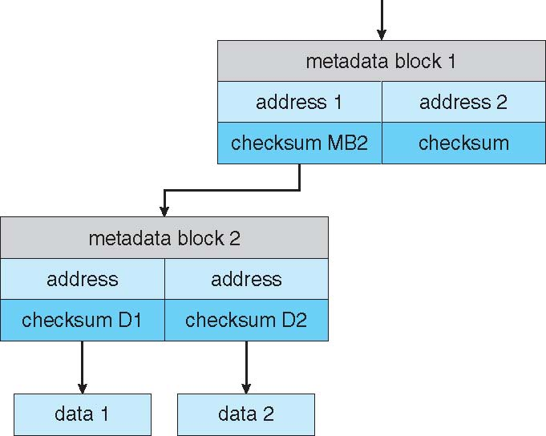
ZFS Checksums All Metadata and Data

Traditional and Pooled Storage

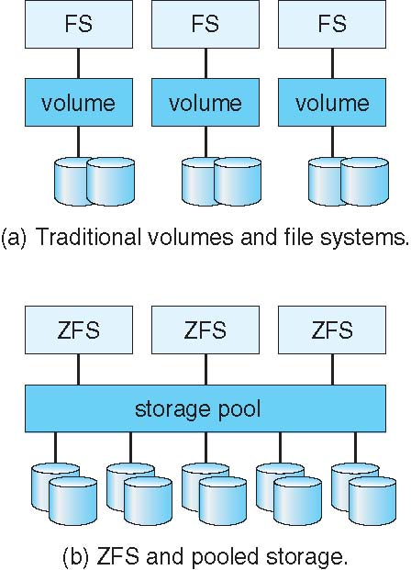

Stable-Storage Implementation

nWrite-ahead log scheme requires stable storage
nTo implement stable storage:
lReplicate information on more than one nonvolatile storage media with independent failure modes
lUpdate information in a controlled manner to ensure that we can recover the stable data after any failure during data transfer or recovery
Tertiary Storage Devices

nLow cost is the defining characteristic of tertiary storage
nGenerally, tertiary storage is built using removable media
nCommon examples of removable media are floppy disks and CD-ROMs; other types are available

Removable Disks

nFloppy disk — thin flexible disk coated with magnetic material, enclosed in a protective plastic case
lMost floppies hold about 1 MB; similar technology is used for removable disks that hold more than 1 GB
lRemovable magnetic disks can be nearly as fast as hard disks, but they are at a greater risk of damage from exposure
nA magneto-optic disk records data on a rigid platter coated with magnetic material
lLaser heat is used to amplify a large, weak magnetic field to record a bit
lLaser light is also used to read data (Kerr effect)
lThe magneto-optic head flies much farther from the disk surface than a magnetic disk head, and the magnetic material is covered with a protective layer of plastic or glass; resistant to head crashes
nOptical disks do not use magnetism; they employ special materials that are altered by laser light

WORM Disks

nThe data on read-write disks can be modified over and over
nWORM (“Write Once, Read Many Times”) disks can be written only once
nThin aluminum film sandwiched between two glass or plastic platters
nTo write a bit, the drive uses a laser light to burn a small hole through the aluminum; information can be destroyed by not altered
nVery durable and reliable
nRead-only disks, such ad CD-ROM and DVD, com from the factory with the data pre-recorded

Tapes

nCompared to a disk, a tape is less expensive and holds more data, but random access is much slower
nTape is an economical medium for purposes that do not require fast random access, e.g., backup copies of disk data, holding huge volumes of data
nLarge tape installations typically use robotic tape changers that move tapes between tape drives and storage slots in a tape library
lstacker – library that holds a few tapes
lsilo – library that holds thousands of tapes
nA disk-resident file can be archived to tape for low cost storage; the computer can stage it back into disk storage for active use

Operating System Support

nMajor OS jobs are to manage physical devices and to present a virtual machine abstraction to applications
nFor hard disks, the OS provides two abstraction:
lRaw device – an array of data blocks
lFile system – the OS queues and schedules the interleaved requests from several applications
Application Interface

nMost OSs handle removable disks almost exactly like fixed disks — a new cartridge is formatted and an empty file system is generated on the disk
nTapes are presented as a raw storage medium, i.e., and application does not not open a file on the tape, it opens the whole tape drive as a raw device
nUsually the tape drive is reserved for the exclusive use of that application
nSince the OS does not provide file system services, the application must decide how to use the array of blocks
nSince every application makes up its own rules for how to organize a tape, a tape full of data can generally only be used by the program that created it

Tape Drives

nThe basic operations for a tape drive differ from those of a disk drive
nlocate() positions the tape to a specific logical block, not an entire track (corresponds to seek())
nThe read position() operation returns the logical block number where the tape head is
nThe space() operation enables relative motion
nTape drives are “append-only” devices; updating a block in the middle of the tape also effectively erases everything beyond that block
nAn EOT mark is placed after a block that is written
File Naming

nThe issue of naming files on removable media is especially difficult when we want to write data on a removable cartridge on one computer, and then use the cartridge in another computer
nContemporary OSs generally leave the name space problem unsolved for removable media, and depend on applications and users to figure out how to access and interpret the data
nSome kinds of removable media (e.g., CDs) are so well standardized that all computers use them the same way

Hierarchical Storage Management (HSM)

nA hierarchical storage system extends the storage hierarchy beyond primary memory and secondary storage to incorporate tertiary storage — usually implemented as a jukebox of tapes or removable disks
nUsually incorporate tertiary storage by extending the file system
lSmall and frequently used files remain on disk
lLarge, old, inactive files are archived to the jukebox
nHSM is usually found in supercomputing centers and other large installations that have enormous volumes of data

Speed

nTwo aspects of speed in tertiary storage are bandwidth and latency
nBandwidth is measured in bytes per second
lSustained bandwidth – average data rate during a large transfer; # of bytes/transfer time
Data rate when the data stream is actually flowing
lEffective bandwidth – average over the entire I/O time, including seek() or locate(), and cartridge switching
Drive’s overall data rate
nAccess latency – amount of time needed to locate data
lAccess time for a disk – move the arm to the selected cylinder and wait for the rotational latency; < 35 milliseconds
lAccess on tape requires winding the tape reels until the selected block reaches the tape head; tens or hundreds of seconds
lGenerally say that random access within a tape cartridge is about a thousand times slower than random access on disk
nThe low cost of tertiary storage is a result of having many cheap cartridges share a few expensive drives
nA removable library is best devoted to the storage of infrequently used data, because the library can only satisfy a relatively small number of I/O requests per hour

Reliability
nA fixed disk drive is likely to be more reliable than a removable disk or tape drive
nAn optical cartridge is likely to be more reliable than a magnetic disk or tape
nA head crash in a fixed hard disk generally destroys the data, whereas the failure of a tape drive or optical disk drive often leaves the data cartridge unharmed

Cost

nMain memory is much more expensive than disk storage
nThe cost per megabyte of hard disk storage is competitive with magnetic tape if only one tape is used per drive
nThe cheapest tape drives and the cheapest disk drives have had about the same storage capacity over the years
nTertiary storage gives a cost savings only when the number of cartridges is considerably larger than the number of drives

