Protection

nDiscuss the goals and principles of protection in a modern computer system
nExplain how protection domains combined with an access matrix are used to specify the resources a process may access
nExamine capability and language-based protection systems
nGoals of Protection

nOperating system consists of a collection of objects, hardware or software
nEach object has a unique name and can be accessed through a well-defined set of operations
nProtection problem - ensure that each object is accessed correctly and only by those processes that are allowed to do so
n

Principles of Protection

nGuiding principle – principle of least privilege
lPrograms, users and systems should be given just enough privileges to perform their tasks
Domain Structure

nAccess-right = <object-name, rights-set>
where rights-set is a subset of all valid operations that can be performed on the object.
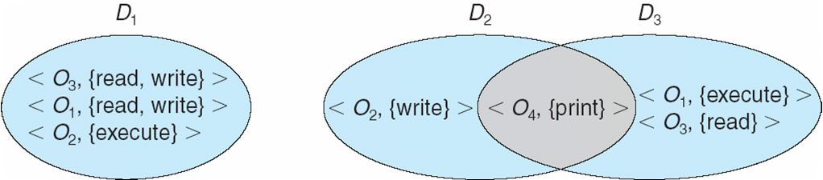
nDomain = set of access-rights

nSystem consists of 2 domains:
lUser
lSupervisor
nUNIX
lDomain = user-id
lDomain switch accomplished via file system
Each file has associated with it a domain bit (setuid bit)
When file is executed and setuid = on, then user-id is set to owner of the file being executed. When execution completes user-id is reset
Domain Implementation (MULTICS)
nLet Di and Dj be any two domain rings
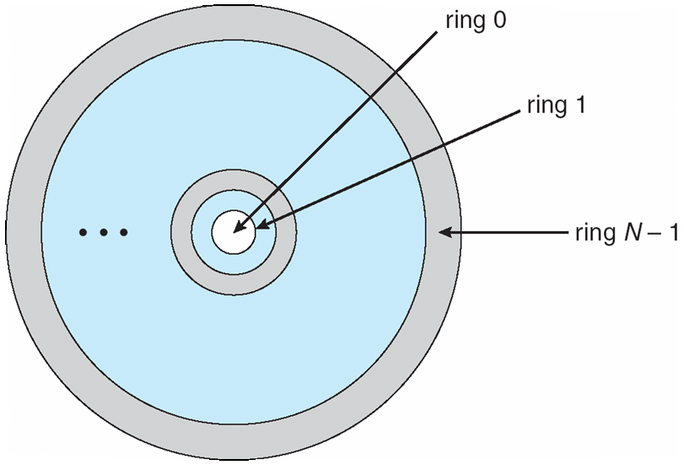
nIf j < I Þ Di Í Dj

Access Matrix
nView protection as a matrix (access matrix)
n
nRows represent domains
n
nColumns represent objects
n
nAccess(i, j) is the set of operations that a process executing in Domaini can invoke on Objectj

Use of Access Matrix

nIf a process in Domain Di tries to do “op” on object Oj, then “op” must be in the access matrix
nCan be expanded to dynamic protection
lOperations to add, delete access rights
lSpecial access rights:
owner of Oi
copy op from Oi to Oj
control – Di can modify Dj access rights
transfer – switch from domain Di to Dj

nAccess matrix design separates mechanism from policy
lMechanism
Operating system provides access-matrix + rules
If ensures that the matrix is only manipulated by authorized agents and that rules are strictly enforced
lPolicy
User dictates policy
Who can access what object and in what mode

Implementation of Access Matrix

nEach column = Access-control list for one object
Defines who can perform what operation.
Domain 1 = Read, Write
Domain 2 = Read
Domain 3 = Read
M
nEach Row = Capability List (like a key)
Fore each domain, what operations allowed on what objects.
Object 1 – Read
Object 4 – Read, Write, Execute
Object 5 – Read, Write, Delete, Copy

Access Matrix of Figure A With Domains as Objects

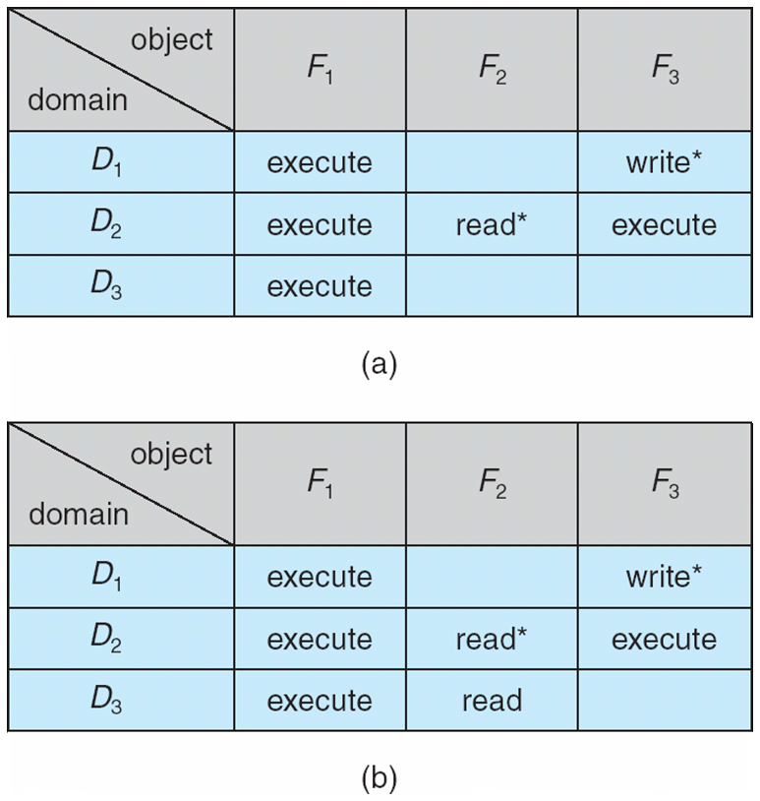
Access Matrix with Copy Rights

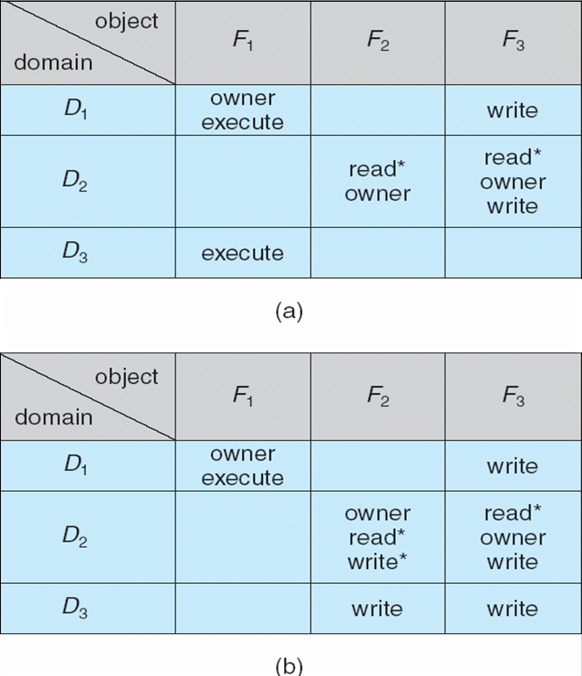
Access Matrix With Owner Rights

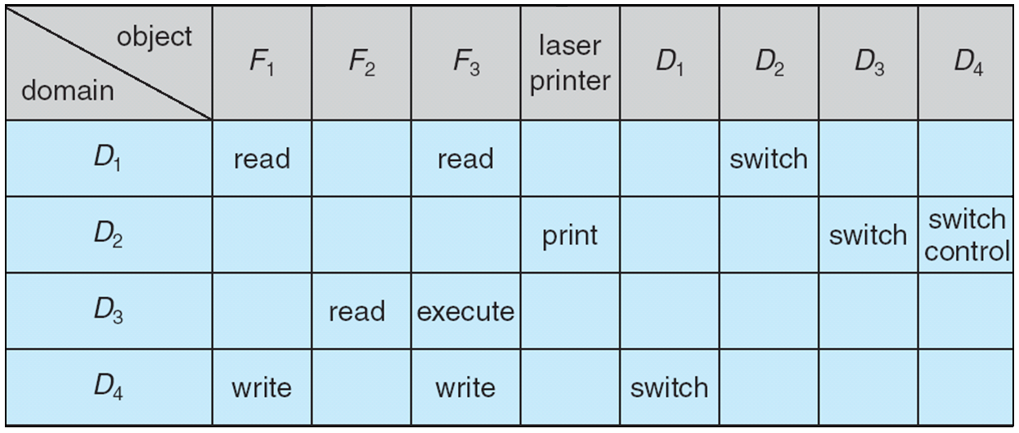
Modified Access Matrix of Figure B

Access Control

nProtection can be applied to non-file resources
nSolaris 10 provides role-based access control (RBAC) to implement least privilege
lPrivilege is right to execute system call or use an option within a system call
lCan be assigned to processes
lUsers assigned roles granting access to privileges and programs
Role-based Access Control in Solaris 10

Revocation of Access Rights

nAccess List – Delete access rights from access list
lSimple
lImmediate
nCapability List – Scheme required to locate capability in the system before capability can be revoked
lReacquisition
lBack-pointers
lIndirection
lKeys
Capability-Based Systems

nHydra
lFixed set of access rights known to and interpreted by the system
lInterpretation of user-defined rights performed solely by user's program; system provides access protection for use of these rights
nCambridge CAP System
lData capability - provides standard read, write, execute of individual storage segments associated with object
lSoftware capability -interpretation left to the subsystem, through its protected procedures

Language-Based Protection

nSpecification of protection in a programming language allows the high-level description of policies for the allocation and use of resources
nLanguage implementation can provide software for protection enforcement when automatic hardware-supported checking is unavailable
nInterpret protection specifications to generate calls on whatever protection system is provided by the hardware and the operating system

Protection in Java 2

nProtection is handled by the Java Virtual Machine (JVM)
nA class is assigned a protection domain when it is loaded by the JVM
nThe protection domain indicates what operations the class can (and cannot) perform
nIf a library method is invoked that performs a privileged operation, the stack is inspected to ensure the operation can be performed by the library

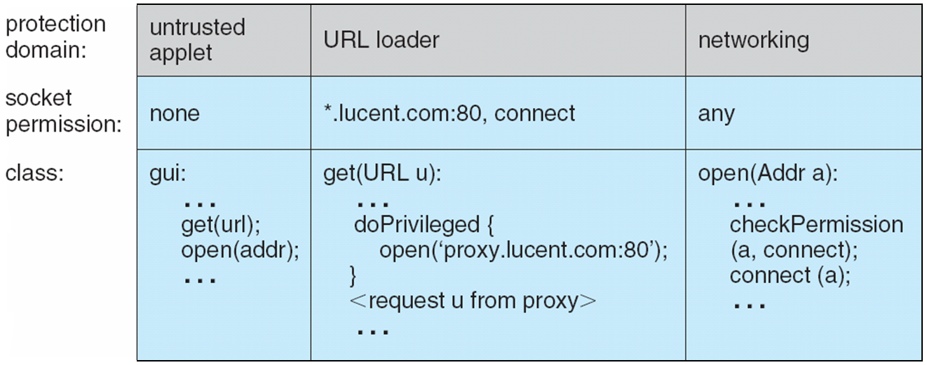
Stack Inspection

