KATHYAYANI

BN010

HR ATTRITION ANALYSIS
Project Documentation
Excel • MySQL • Power BI • Python
Updated to include the proposed Power BI star-schema model, dimension tables, fact table, relationships, DAX measures, and dashboard plan.
Documentation status: Model design described below is planned/discussed; actual creation of tables and relationships has not been independently verified.

1. Project Overview
This project analyzes employee turnover and explores potential associations with employee demographics, departments, job roles, compensation, satisfaction, and tenure. The workflow uses Excel for cleaning, MySQL for SQL analysis, Power BI for data modeling and dashboards, and Python for exploratory analysis.

2. Objectives
- Measure total employees, attrition count, and attrition rate.
- Compare attrition across departments and job roles.
- Explore patterns in age, salary, tenure, overtime, job satisfaction, and work-life balance.
- Build clear, interactive Power BI dashboards for HR decision support.

3. Source Data and Excel Cleaning
The source HR Attrition dataset was initially one table. Candidate fields include EmployeeNumber (or EmployeeID), Age, Gender, MaritalStatus, Department, JobRole, Education, Attrition,MonthlyIncome,YearsAtCompany,TotalWorkingYears, JobSatisfaction,WorkLifeBalance,OverTime,andDistanceFromHome. Field names must be checked against the actual dataset.
Excel cleaning was reported as completed. Age Group and Experience Group were not added; analysis can use the original Age and experience columns. Verify missing values, data types, duplicate employee IDs, and category consistency before modeling.

4. MySQL Import and Validation
An earlier import was reported to contain 1,150 records. This count should be reconciled with the cleaned Excel dataset; do not treat it as a confirmed final employee total. Check import errors, row counts, duplicate IDs, and null values before interpreting results.

5. Power BI Data Modeling

5.1 Proposed model structure
The original single-table design is being reorganized into a fact table with four dimensions. This is a practice-oriented star schema. It is not necessary for a small HR dataset, but it helps demonstrate modeling and filtering concepts.
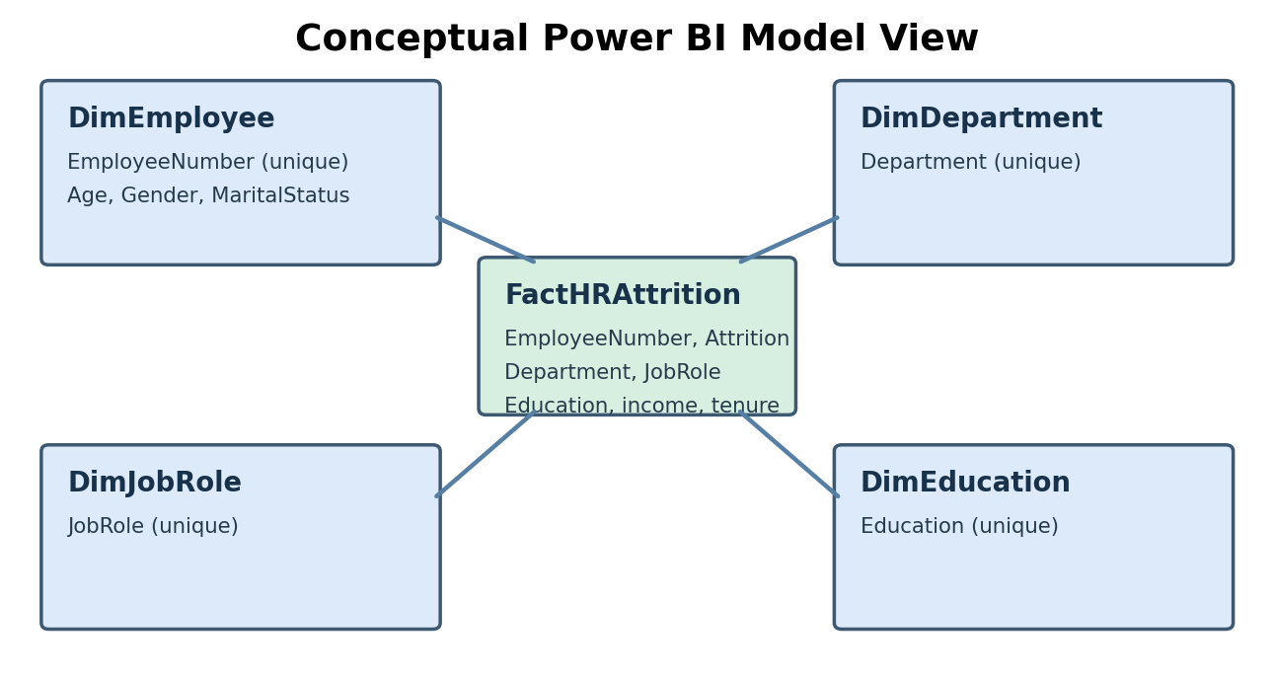
Figure 1. Conceptual star-schema layout; relationship cardinality must be determined from the actual data.

5.2 Tables and columns
Table | Suggested columns
DimEmployee | EmployeeNumber, Age, Gender, MaritalStatus
DimDepartment | Department
DimJobRole | JobRole
DimEducation | Education
FactHRAttrition | EmployeeNumber, Department, JobRole, Education, Attrition, MonthlyIncome, YearsAtCompany, TotalWorkingYears, JobSatisfaction, WorkLifeBalance, OverTime, DistanceFromHome

5.3 Power Query creation steps
- Home → Transform Data to open Power Query Editor.
- Right-click the original HR Attrition query → Reference; rename the new query DimEmployee.
- Keep EmployeeNumber, Age, Gender, and MaritalStatus using Remove Other Columns; remove duplicates on EmployeeNumber only after checking it uniquely identifies employees.
- Reference the original query again to create DimDepartment; retain Department, remove duplicate department values.
- Reference the original query to create DimJobRole; retain JobRole, remove duplicate job-role values.
- Reference the original query to create DimEducation; retain Education, remove duplicate education values.
- Reference the original query to create FactHRAttrition; retain relationship keys, Attrition, and numeric/analytical columns. Do not remove legitimate fact rows.
- Set matching key data types, check blanks and unmatched keys, then Close & Apply.
- After confirming all reports use the new model, disable load for the original staging query if appropriate.

5.4 Relationships in Model View
Dimension key | Fact key | Expected setup
DimEmployee[RowID] | FactHRAttrition[RowID] | Often 1:1 for one record per employee; verify
DimDepartment[Department] | FactHRAttrition[Department] | 1:*; Single filter
DimJobRole[JobRole] | FactHRAttrition[JobRole] | 1:*; Single filter
DimEducation[Education] | FactHRAttrition[Education] | 1:*; Single filter
Create each relationship by dragging the dimension key to its matching fact key. Ensure the dimension side is unique, relationships are active, and filters flow from dimension to fact. For EmployeeNumber, a one-to-one relationship may be correct when both tables contain exactly one row per employee; do not force 1:* when the data does not support it.

6. DAX Measures
These examples assume a FactHRAttrition table with EmployeeNumber and Attrition values of Yes/No. Rename fields as needed. Format Attrition Rate as Percentage.

Total Employees
Total Employees = DISTINCTCOUNT(FactHRAttrition[RowID])

Attrition Count
Attrition Count = CALCULATE(DISTINCTCOUNT(FactHRAttrition[RowID]), FactHRAttrition[Attrition] = "Yes")

Attrition Rate
Attrition Rate = DIVIDE([Attrition Count], [Total Employees], 0)

Active Employees
Active Employees = [Total Employees] - [Attrition Count]

Average Monthly Income
Average Monthly Income = AVERAGE(FactHRAttrition[MonthlyIncome])

7. Dashboard Design

Page 1 — HR Attrition Overview
- KPI cards: Total Employees, Attrition Count, Attrition Rate, Active Employees.
- Attrition by Department, Gender, and Job Role.
- Use dimensions for category axes and measures for values.

Page 2 — Satisfaction and Retention
- Work-Life Balance, Job Satisfaction, OverTime, YearsAtCompany, and MonthlyIncome analysis.
- Avoid repeating Attrition by Gender because it already appears on Page 1.
- For a Work-Life Balance donut, use WorkLifeBalance as legend and an appropriate employee count as values; use a filtered attrition count if showing only leavers.

8. Python Analysis
Suggested EDA uses pandas, numpy, matplotlib, and optionally seaborn: attrition frequency, department comparisons, salary distributions, tenure distributions, and relationships with satisfaction and overtime. Validate findings against SQL and Power BI measures.

9. Validation Checklist
- Source row count matches cleaned and imported data, or differences are explained.
- EmployeeNumber has no unexpected duplicates or missing values.
- Dimension relationship keys are unique and compatible in type with fact keys.
- No unmatched dimension keys cause missing categories.
- Measures agree with manual SQL/Excel checks.
- Slicers filter relevant visuals correctly; model changes do not break existing report pages.

10. Change Log
Area | Earlier state | Updated plan
Power BI model | One HR table | FactHRAttrition plus four dimensions
Model View | No dimension relationships | Department, JobRole, Education, Employee relationships
Age and experience | No grouped columns | Use original numeric fields
Dashboard page 2 | Gender analysis duplicated | Focus on satisfaction and retention
Data validation | 1,150 MySQL rows reported | Reconcile count with source

11. Expected Insights and Conclusion
Once validated, the project can identify where employee attrition is concentrated and whether overtime, tenure, compensation, and workplace satisfaction are associated with attrition. These are descriptive associations rather than proof of causation. The project showcases data cleaning, SQL analysis, Power Query transformation, dimensional modeling, DAX, and business-oriented reporting.

12. Implementation Status
Reported: Excel cleaning performed, MySQL import attempted with 1,150 rows, Power BI dashboard work in progress. Proposed/not yet confirmed: creation of four dimension tables, fact table, and final Model View relationships. Update this section after completing and verifying the model.

