*Background*

Radial neck fractures are rare lesions. They account for 5-10% of all elbow fractures in children[1] and 1% of all the fractures in the pediatric age[2].

In 1950, Jeffery[3, 4] showed two different types of displacement of the capital epiphysis of the radius. In the more common type displacement, are fractures of the neck of the radius produced by a valgus overload that caused a lateral inclination of the head of the radius from 0º to 90º.

In the more uncommon type II fracture, the capital epiphysis of the radius is found rotated backwards 90º. Jeffery[3, 4] described the Type II fracture as an injury produced during the reduction phase of a dislocation or subluxation of the elbow as a result of the impact of the capitellum against the anterior lip of the radial head that causes the backward tilt of the latter. This mechanism can be compared with that of a bottle-opener[5]

The elbow strikes the ground and the resulting upward force on the flexed elbow separates the capital epiphysis of the radius by impacting against the inferior aspect of the capitellum which causes spontaneous reduction of the dislocation, leaving the separated radial head beneath the capitellum [1, 5]

The treatment of radial neck fractures in children varies according to fracture´s displacement, angulation, and skeletal maturity[6]. Nondisplaced fractures can be treated with closed reduction and casting [5, 7] Displaced radial neck fractures with > 30 º angulation should be treated surgically; there are several options, percutaneous pin reduction, elastic stable intramedullary nailing, and open reduction with or without internal fixation[6,8,9]. Open reduction is a method of treatment often used in comminuted fractures or in fractures with a completely, anteriorly or posteriorly, displaced head on the radial metaphysis and when closed reduction has failed [6].

The aim of this article is to analyze the outcomes of completely displaced and angulated fractures. Also, since there is no consensus on which technique should be used, we believe that surgeons must be aware of the importance of a correct reduction, and if an open approach is performed, internal fixation should be the technique of choice.

*Material and Methods*

We present a case of a 12 year- old boy who was admitted to our emergency department in September 2016. He was injured after falling on his right hand with his elbow flexed. He referred a spontaneous reduction of his elbow. Physical examination showed moderate swelling of the elbow and any passive or active motion of the joint was impossible due to pain. Radiographs showed a displaced radial head lying at 90º to the shaft (Fig.1A, 1B)

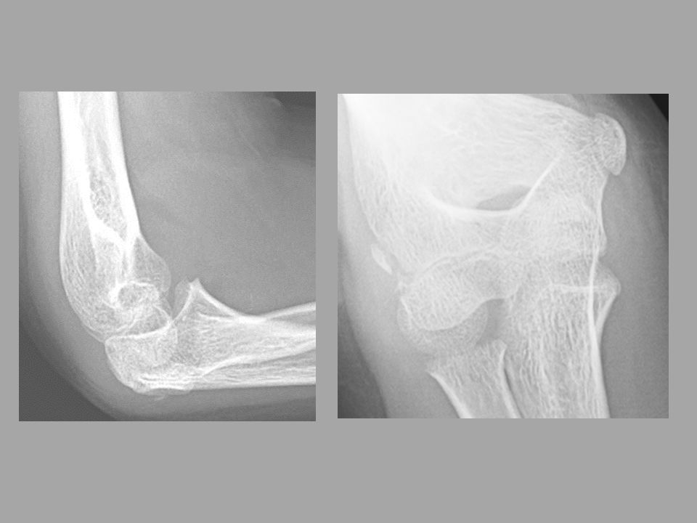

Fig 1A, 1B: Radiographs showed a displaced radial head lying at 90º to the shaft

Reduction by closed external manipulation by the Patterson and Israeli technique was unsuccessful. Open reduction was performed via a lateral radial head approach; it showed that the head was completely turned over without vascular supply.

The head was stabilized by using the Métaizeau technique pinning. Under general anesthesia, stability of the elbow was checked, and immobilized by cast in 90º elbow flexion and about 45 º of pronation for 4 to 5 weeks.

At 4 months follow-up, the patient presented loss of motion and on radiographic examination; the fracture was a bit slow to heal which was considered as a delayed union. At that moment, the oxford elbow score[10] was 28. A new open reduction was performed, intramedullary pinning removed, and the area was cleaned of fibrous adhesions and fixed with 1.5mm screws (Fig.2). The stability of the fracture and the mobility of the elbow were checked in the operating room. Range of montion (ROM) in flexion was 140º with a loss of 10 º of extension and complete pronation and supination.

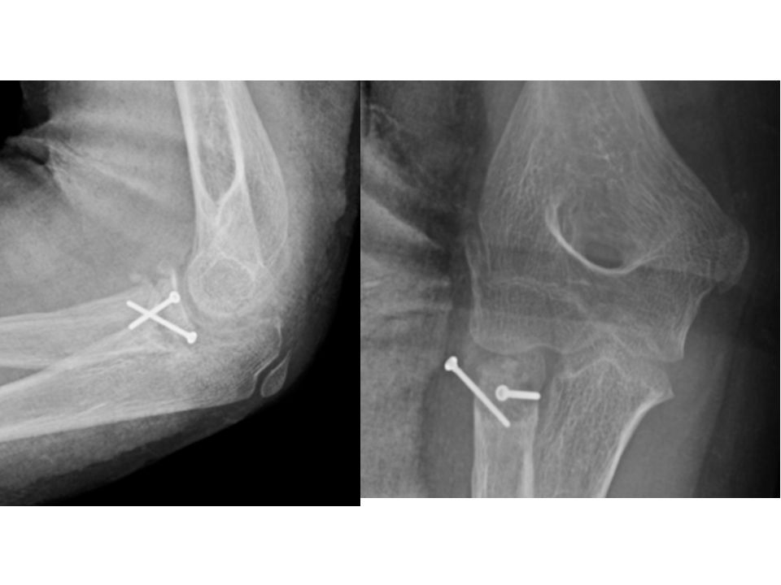

Fig 2A. 2B. After the area was cleaned of fibrous adhesions and the head was fixed with 1.5mm screws

At 1 year follow up, the mini screws were removed. On TC scan, a correct consolidation of the fracture was noted. (Fig.3)

The patient is currently 14 years old, and performs his usual sports activity without pain, with a complete ROM. He is a canoeist and competes without problems. Currently, the oxford elbow score is 44.

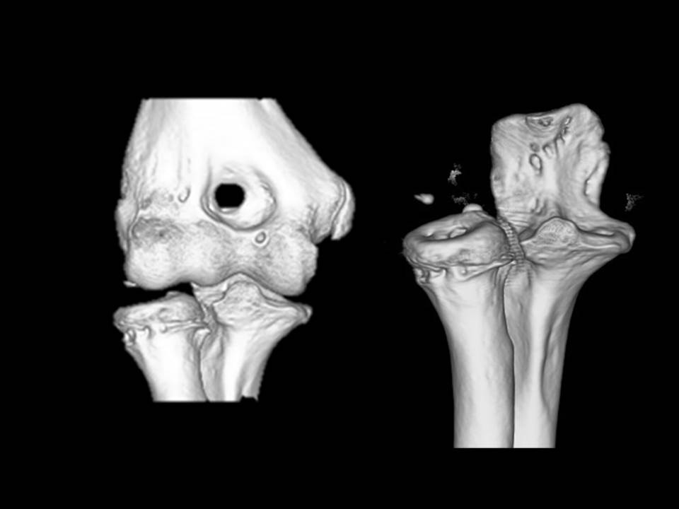

Fig3A, 3B: AP and Lateral views of TC scan a correct consolidation of the fracture was noted.

*Discussion*

Initially, Jeffery described the mechanism of injury[2] in 1950 which he further detailed3 in 1972. He put forward that this injury occurs during the reduction phase of a posterior dislocation or subluxation of the elbow. Twenty-eight more cases [5,11,12,13,14,15] of Jeffery type 2 have been reported in children, if we add our case. The sex ratio is 1.4 males to one female.[5] The youngest patient in the review was 6 year old [16]. But the diagnosis of Jeffery type 2 lesions before 5 years when the radial head is not yet ossified is still a challenge, and it would require further tests if there is a fat pad sign without obvious fracture on plain radiographs[17].

It is important to differentiate a typical Jeffery type 2 fracture from a radial neck fracture with posterior displacement. In our opinion, to be able to refer to a Jeffery type 2 there should be a capitellum interposition between the head and the radial metaphysis. This lesion should be differentiated from those where there is a posterior displacement between 10º and 90º without bone interposition Capitellum interposition renders closed manipulation ineffective, although Chotel *et* al[18] have described a new maneuver to allow closed reduction of this Jeffery type 2 fracture. However, the series is too short and the potential risks of a repetition of this maneuver are high, and hardly reproducible, therefore if a posterior metaphysoepiphyseal periosteal is present between the two radial fragments, it would be necessary to take out this interposition to allow the reduction of the fracture.

The main obstacle to the reduction of this fracture is capitellum interposition between the radial epiphysis and the metaphysis[5]. This is due to a rotating movement of the head around a fixed point represented here by the posterior periosteal hinge [5, 18]. The interposition of the capitellum, characteristic of Jeffery type II lesions makes closed handling ineffective.

We still recommend open surgery, due to the potential risk of damage the articular radial head. Open reduction is a method of treatment often used in comminuted fractures or in fractures with a completely displaced head anteriorly or posteriorly on the radial metaphysis.

More severe fractures warrant a more aggressive approach. The literature suggest that when the head of the radius remains displaced >30% and angulated >45º after attempts of closed or percutaneous reduction, an open reduction is indicated [9,19,20]. Open reduction was performed to provide an anatomic alignment with minimal trauma of soft tissue around the fracture[19].

It is important to always keep this fracture in mind, in posterior elbow dislocations in children. Before reduction of the dislocation, correct radiographs are required, looking for a radial neck fracture. However in 80% of Jeffery type 2 injuries no evident dislocation was reported.

We emphasize that even if the head is free of all vascular supply, a displaced proximal radial epiphysis with capitellum interposition should always be repositioned by open surgery and fixed with screws.

*Conclusion*

In our opinion, the Jeffery type II fracture should be treated with open surgery.

Open reduction should be performed with minimal injury to osteochondral, ligamentous and muscular structures to reduce complications associated with this injury.

We believe that the best technique, once you decide to perform an open approach is to fix the fracture with mini-screws. Due to some important phenomenon, the main objective is, once we have exposed the area, is to achieve a stable fixation. The second objective is that the Métaizeau technique, in spite of being widely extended, produces distraction of the fracture and therefore the lack of consolidation. It can even damage the articular cartilage when the fracture collapses. We believe that osteosynthesis with screws is the most precise technique especially when there is a 90º posterior tilt of the radial head. The ideal area fore screw placement is, with the forearm supinate, on the outer edge, so that they do not block pronosupination, and is away from the cartilage surface

The only cases in which we would considerer the Métaizeau technique after an open reduction, are those in which a broad periosteal pedicle was seen in young patients.

*Reference*

1. Chambers HG, Wilkins Ke. Fractures of the proximal radius and ulna. In: Rockwood CA, Wilkins Ke,King RE(editors) Fractures in children.volum 34th ed. Philadelphia: Lippincott- Raven;1996,pp.586-613
2. Salter RB, Harris WR.Injuries involving the epiphyseal plate. J Bone Joint Surg. 1963;45-A:587-622
3. Jeffery CC. Fractures of the head of the radius in children. J bone Joint Surg Br.1950;32B:314-324
4. Jeffery CC. Fractures of the neck of the radius in children. J Bone Joint Surg Br 1972;54B:717-710
5. Chotel F, Vallese P, Parot R et al. Complete dislocation of the radial head following fracture of the radial neck in children: the Jeffery type II lesion. J Pediatr Orthop B 2004; 13:268-274
6. Falciglia F, Giordano M, Aulisa AG et al. Radial neck fractures in children: Results when open reduction is indicated. J Pediatr Orthop; 34:756-762
7. Pring ME. Pediatric radial neck fractures: when and how to fix . J Pediatr Orthop. 2012;32:S14-S21
8. Ursei M, Sales de Gauzy J, Knorr J, et al. Surgical treatment of radial neck fractures in children by intramedullary pinning. Acta Orthop Belg. 2006;72:131-137
9. Newman JH. Displaced radial neck fractures in children. Injury, 1977;9:114-121
10. Dawson, J., Doll, H., Boller, I., Fitzpatrick, R. The development and validation of a patient-reported questionnaire to assess outcomes of elbow surgery. J Bone Joint Surg Br. 2008 Apr; 90-B: 466 - 4
11. Kerbeck T, Gillani S, Ali AM. Reversed reduction of neck fractures: a predictable complication of closed manipulation. Injury extra 2006,37,116-119.
12. Navali AM, Sadigi A. Displaced fracture of the neck of the radius with complete 180º rotation of the radial head during closed reduction. Journal of Hand Surgery. 2006; 31B:6:689-691
13. Sao Simao R, Monteiro M, Dopico C et al. Upside-Down Radial Head: a rare complication after an unrecognized Jeffery type 2 lesion. J Orthop trauma 2010;24:e17-e20
14. Ward WT. Radial neck fracture complicating closed reduction of a posterior elbow dislocation in a child: case report. J Trauma, 1991; 31:1686-1688
15. Tay D, Mahadev A. Un unexpected outcome following radial head excision for Jeffery type IIfracture-dislocation of the proximal radius in child. Annals academy of Medicine 2010. Vol 39. Nº 9. 742-744
16. Wilkins KE. Operative management of upper extremity fractures in children. American academy of orthopedic Surgeons monographs Series. Rosemont: American Academy of Orthopedic Surgeons,1994
17. Shtarker H, Stahl S, Ross A. the upside-down radial head a diagnosis challenge-. J Pediatr Orthop 2001;10:331-333
18. Chotel FM Sailhan F, Martin JN et al. A specific closed percutaneous technique for reduction of Jeffery type II lesion. J Pediatr Orthop B. 2006;15:376-378
19. Tibone JE , Stoltz m. Fractures of the radial head and neck in children. J Bone Joint Surg, 1981;63-a.100-106
20. Métaizeau JP, Lascombes P, Lemelle JL et al. Reduction and fixation of displaced radial neck fractures by closed intramedullary pinning. J Pediatr 1993; 13:355-360

*Figure:*

Figure 1A, 1B (Fig.1A, 1B): Radiographs showed a displaced radial head lying at 90º to the shaft

Figure 2A, 2B. (Fig.2A, 2B): After the area was cleaned of fibrous adhesions and the head was fixed with 1.5mm screws

Figure 3 (Fig.3A, 3B) On TC scan, a correct consolidation of the fracture was noted.