**INTRODUCTION**

Appendiceal epithelial neoplasms are divided broadly into three histologic types, mucinous, non-mucinous, and carcinoids. Mucinous appendiceal neoplasms demonstrate a metastatic site predilection for the peritoneum, systemic distant targets such as liver or lung being extremely rare. The majority of metastatic mucinous appendiceal adenocarcinomas display slow-growing biology and given the predilection for peritoneum, the primary treatment for those patients is complete cytoreductive surgery followed by hyperthermic intraperitoneal chemotherapy (CRS HIPEC) [1]. Slow-growing appendicular neoplasms may be considered chemoresistant because of their low proliferation index and their abundant component of acellular mucinous deposits in most of the cases.

The role of systemic chemotherapy (SC) in the management of metastatic appendiceal adenocarcinomas is not clearly defined. Adjuvant SC is often given to patients with poor prognostic factors such as incomplete cytoreduction, high-grade subtype, and lymph node involvement. Nevertheless, the efficacy of adjuvant postoperative chemotherapy in patients with appendiceal neoplasms is unknown[2].

The role of adjuvant SC in low-grade appendiceal adenocarcinomas is less studied in medical literature, and the indication for chemotherapy drugs in patients harboring this histologic type is ill-defined[3].

Systemic chemotherapy has been utilized in patients with appendiceal epithelial neoplasms who are not candidates for surgical cytoreduction, no matter the histological grade was [4]. Given the indolent course of the disease in the majority of appendiceal mucinous peritoneal carcinomatosis it is of the utmost importance to identify patients who will benefit from adjuvant treatment and those who can be spared the not negligible SC toxicity.

The aim of this study was to analyze the use of systemic chemotherapy in patients with peritoneal metastatic disease from appendiceal epithelial neoplasm treated in our institution with CRS and HIPEC.

**MATERIAL AND METHODS**

We performed a retrospective review of patients with peritoneal dissemination from appendiceal origin evaluated at the Hospital Clínico Universitario de Valencia between June 2004 and December 2017. This retrospective study was approved by the local review board. Informed consent was obtained from every patient before surgical treatment.

Patients included in the study had histological confirmation of adenocarcinoma of appendiceal origin, and peritoneal involvement from appendiceal neoplasm treated with CRS HIPEC. Most of the patients were referred to our hospital from outside centers.

Patients were explored via midline incision, and resection of involved peritoneal surfaces and organs was performed with peritonectomy procedures. Only sites with apparent disease were resected. The omentum and round ligament of the liver were routinely removed, but not so to the gallbladder. Metastatic dissemination was scored following the Peritoneal Carinomatosis Index described by Sugarbaker[5], and completeness of surgical resection was graded by Completeness of Cytoreduction Score (CC)[5]. HIPEC was performed employing the coliseum technique, and a heating and redistributing machine was employed for circulation of the drug during 60 minutes in the majority of cases (in the first cases, 90 minutes were the time of administration). The employed agent in all of those cases was Mitomycin C, 15mg/m2. Afterward, the perfusate was drained and anastomoses performed in the second time of the procedure.

The histological specimens were classified attending to the WHO classification for appendiceal tumors[6]. Anatomopathologic reports from specimens before 2010 were translated to the current WHO classification. Mucinous adenocarcinomas were defined by the presence of >50% of extracellular mucin; signet ring cell adenocarcinomas were defined by the presence of >50% signet ring cells.

The decision to administer SC, just as the choice of chemotherapy regimen, was determined by the referring oncologist.

Progression-free survival (PFS) and overall survival (OS) were analyzed using the Kaplan-Meier method. For the study population, OS was calculated from the date of cytoreduction surgery to death. The log-rank test was used to calculate the survival difference for categorical variables. The chi-square test and Fisher’s exact test were used to assess the relationship between categorical variables*.* P values were considered statistically significant when P <0.05.T-test was used to assess differences between means of continuous variables.

**RESULTS**

We identified 60 patients who were available for evaluation. There were 26 male patients, 34 were female. The median age was 63 years (range, 26-81). The median follow-up was 38 months (range, 2-155).

All the neoplasms were of mucinous type but 2, one was colonic type adenocarcinoma, and one was high-grade adenocarcinoid with signet ring cells. The most common histologic grade was low grade or well differentiated histology (72% of the cases).

The clinical and pathologic characteristics and treatment variables of the study population are summarized in Table 1. PCI values were not statistically different between the high- and low-grade groups, nor was it the attained CC score.

***Table 1. Characteristics of study patients (n=60)***

Median age (years) 63 [26-81]

Sex

Male 26 (43%)

Female 34 (57%)

Histologic subtype

Low-grade mucinous histology 45 (75%)

High-grade

Mucinous 5 (8%)

Signed Ring Cell 8 (13%)

Colonic typed 1 (2%)

Adenocarcinoid with signet ring cells 1 (2%)

PCI

High-grade 17,3 ± 6,3

Low-grade 16,0 ± 9,1 p=0,628

Completeness of Cytoreduction (CC)

High-grade

CC 0,1 12 /15 (80%)

Low-grade

CC 0,1 41 /45 (91%) p=0,672

Nonperitoneal distant metastases occurred in four patients, one patient had liver metastases from high-grade mucinous appendiceal adenocarcinoma, another had also liver metastases from colonic type appendiceal adenocarcinoma, and two patients had lung metastases from low-grade mucinous adenocarcinoma.

Neoadjuvant SC (oxaliplatin-based regimens) defined as SC cycles administered previously to the programmed CRS and HIPEC procedure was employed in 7/60 (11,7%) patients, 2 of them corresponding to the group of low-grade histology. Two patients of the mucinous high-grade type, and 2 of the signet ring cells group, also received preoperative SC, as well as the patient with colonic type.

Three patients died on the postoperative period (5% postoperative mortality). Two of them had intra-abdominal hemorrhage and underwent reoperation. One of them was previously treated by intravascular embolization but it resulted in ischemic colitis and sepsis. No active bleeding was detected in the laparotomy in those two cases. One patient died from sepsis and gastrointestinal bleeding leading to reoperation and finally multiorgan failure and death.

Systemic Chemotherapy was administered at any time after CRS/HIPEC in 26 patients/57 (43%), and adjuvant SC was decided by the referral oncologist in 19 patients/57 (32%) following the cytoreduction. Low-grade patients were submitted to adjuvant SC in 11 over the 42 cases (26%).

Patients with histologic subtype high-grade mucinous adenocarcinoma, signet ring cells adenocarcinoma, colonic adenocarcinoma (n=1), and adenocarcinoid (n=1) were grouped together for Kaplan Meier analysis of survival. No differences in OS and PFS were observed regardless the use of adjuvant SC (Figures 1 and 2).

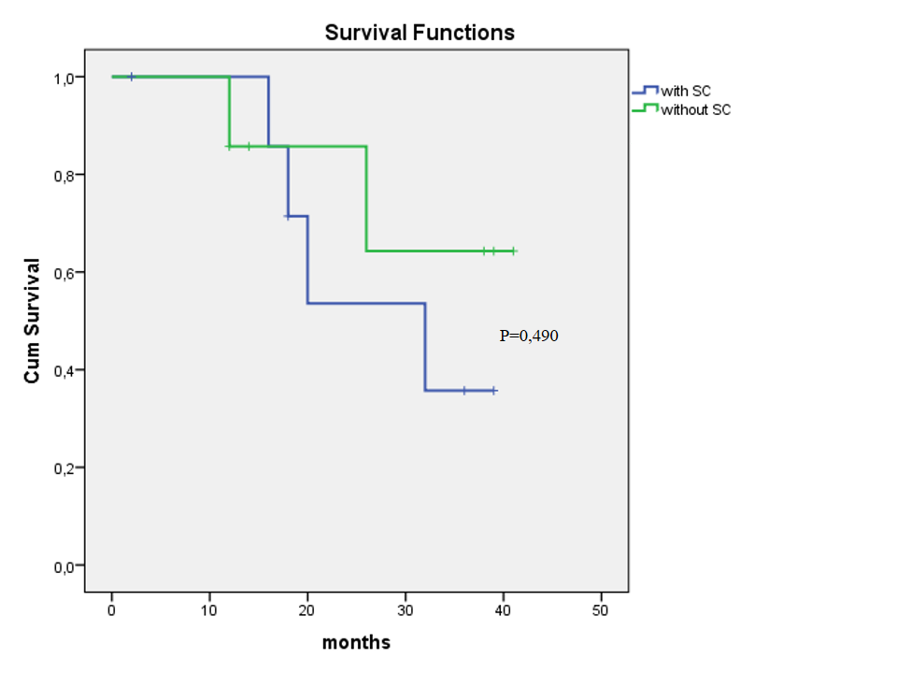

Figure 1.

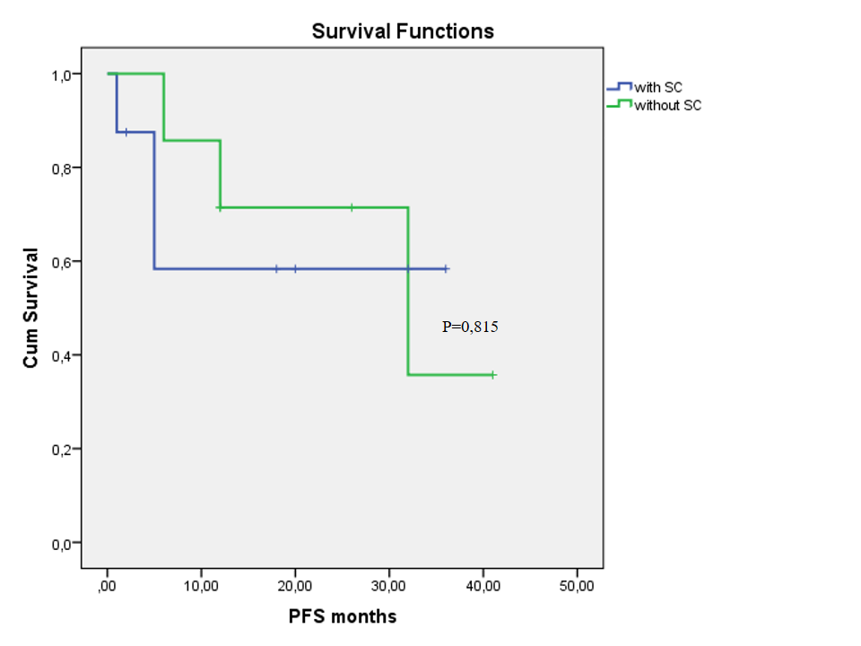

Figure 2.

All patients in the low-grade group are alive, regardless of the use of SC in their follow-up. Not significant differences in the progression free survival were found in the low-grade subtype regardless of SC administration (Figure 3).

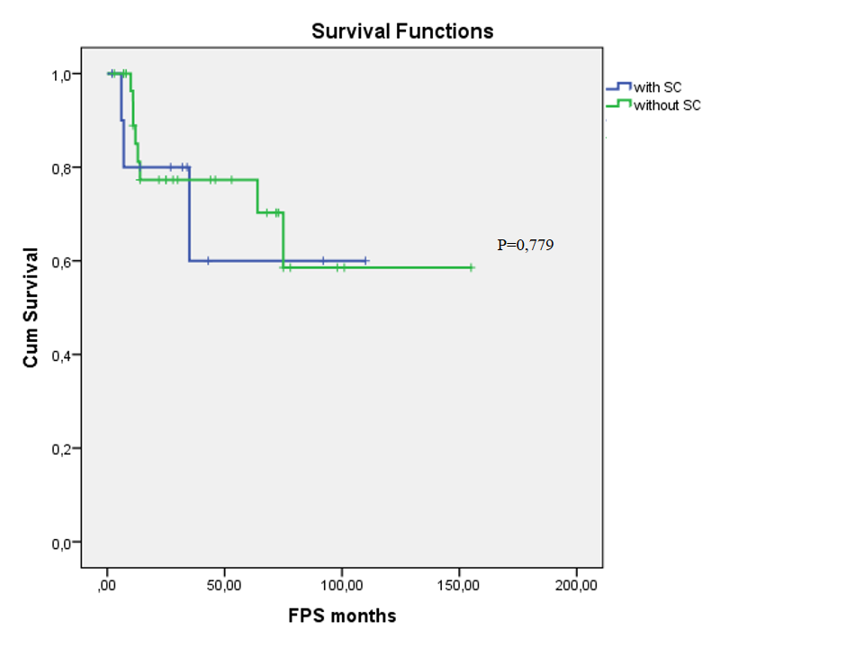

Figure 3.

**DISCUSSION**

It is important to differentiate the histologic type of appendiceal epithelial neoplasm when dealing with a patient diagnosed of metastatic disease. Pseudomyxoma Peritonei (PMP) will be the established diagnosis in some of the patients with appendiceal neoplasm. Nevertheless, PMP is a misnomer which maintains wrong concepts in the field of appendiceal neoplasms research. For example, when it is said that PMP is considered resistant to systemic chemotherapy[7], it is not specified what tumor is it, as the origin of the PMP is appendiceal neoplasm in a large proportion of cases but it can be originated from others tumors such as colonic adenocarcinomas. Even inside the group of appendiceal neoplasms, PMP can be derived from low grade neoplasms but also can be produced by high grade adenocarcinomas of the appendix. Therefore, this terminology do not have to be applied as histologic diagnosis for clinical or research purposes[8].

Adenocarcinomas of the appendix are classified into mucinous, nonmucinous, and signet ring cell types[9]. Outcomes are strongly determined by histologic subtype. Generally, mucinous type had the better prognosis, nonmucinous type also known as intestinal or colonic type mimics colon adenocarcinomas, and signet ring cell adenocarcinoma had the poor prognosis[10].

Historically, patients with low grade appendiceal mucinous neoplasm (LAMN) and pseudomyxoma peritonei had a protracted clinical course with multiple recurrences or persistence of the disease, progressive fibrous adhesions and complications such as fatal obstructive disease when debulking was the treatment of choice. Currently, the standard approach for those neosplasms is performance of CRS and HIPEC[1]. Systemic Chemotherapy has been considered when recurrence occurs. Our data do not support any benefit from SC in those patients, and we agree with Blackham *et al*[11] considering repeat CRS and HIPEC the treatment for recurrent or progressive disease, rather than SC, when possible. When cytoreduction is not possible, some oncology providers would consider SC as maintenance treatment. Nevertheless, in a recent analysis of Surveillance, Epidemiology, and Results (SEER) data, patients with stage IV well-differenciated mucinous appendiceal adenocarcinomas demonstrated no benefit from systemic chemotherapy[12]. Taken into account the toxicity of such treatments, we consider that SC has not benefit as maintenance treatment in those patients, and at least dosage of drugs or patterns of administration must be fitted in each individualized patient to reduce the adverse events inherent of this kind of modern regimens.

Even though it is true that low-grade mucinous appendiceal neoplasms demonstrate a relative slow-growing biology and they show poor response to SC, it is not the same for their high-grade or signet ring cell counterpart, which histology appear to have a more aggressive biology, and therefore the potential effects of SC in this subtype of appendiceal neoplasms may be more rewarding. In their retrospective analysis of a large series of poorly differentiated and signed ring cell adenocarcinomas of the appendix, Lieu *et al* [13]. found that the use of SC for these patients was a valid approach, and that CRS offered a survival benefit in this subgroup of patients mainly in patients in whom CC 0 was achieved. In our present series we have not been able to find significant differences with the use of SC in patients with high-grade histology, but the small size of the sample may bias this result.

Neoadjuvant SC has demonstrated positive results in liver metastases from colorectal origin. Some groups advocate for this modality of treatment in peritoneal metastases from colorectal origin mimicking the strategy employed in liver metastases, and we support this practice. Nevertheless, conflicting results are reported when neoadjuvant SC is proposed in appendiceal neoplasms[11,14,15]. In the present series, 7 patients received neoadjuvancy. Statistical analysis had not been performed in this subgroup of patients because of the limited number of patients. Nevertheless, the descriptive analysis is not useless. The fact that 2 of the 7 patients had low-grade histology revealed the lack of standardization on this topic.

The finding of lung metastases in two patients with low-grade histology in the present series deserves some comments. Malignancy of low-grade appendiceal neoplasms has been questioned. Lymph nodes metastases and distant extraperitoneal mestastases are virtually nonexistent, which are arguments to sustain the non-malignant condition of those neoplasm. Nevertheless, in a review article by Kitai[16] in 2012 it was reported 11 cases of true lung metastases from low-grade appendiceal neoplasms. This study included the whole of the cases published until then. We found another case published in 2013 [17] with sincronous lung metastasis from low-grade appendiceal tumor. The existence of two more cases in our series herein presented, and the knowledge of another case communicated in the GECOP (Grupo Español de Cirugía Oncológica Peritoneal) 7th international meeting which was held in Mallorca, (Spain) in 2018, makes a strong argument for the malignancy of low-grade appendiceal neoplasm with extra-appendicular spread, and not to consider this entity as a benign disseminated adenomucinosis with origin in a benign neoplasm of the appendix ruptured to the peritoneum.

The retrospective nature of the current study and the small number of patients included raise the possibility of bias due to lack of power. The unavailability of the oncologic criteria for the prescription of SC in adjuvant regimen diminish the legitimacy of the conclusions of the study. Nevertheless, due to the rarity of appendiceal adenocarcinomas with peritoneal spread the analysis of the series remains of interest in this field, especially when SC studies are lacking.

In conclusion, the indications for SC in advanced appendiceal adenocarcinomas are not delineated. The use of SC in low-grade mucinous adenocarcinoma subtype is not supported by our results, and there is no literature date supporting it neither. The palliative aspect of SC in high-grade patients deserves of clinical trials for been accepted as standard of care, and its application supported by the standards of care in colorectal cancer seems no justified when appendiceal neoplasms are distinct entities with their own biologic behavior (in contrast to colorectal adenocarcinomas, appendiceal neoplasms are commonly mucinous, spread intraperitoneally, and have limited incidence of nodal and systemic metastases).

**DISCLOSURES**

The authors do not have any conflict of interests about this study.