**Urinothorax: an Unusual Cause of Massive Pleural Effusion**

A 74 year-old male with a history of high blood pressure and hyperuricemia was admitted to the hospital with asthenia, unquantified weight loss, dyspnea on moderate exertion for 2 weeks, and diffuse abdominal pain. Blood leukocyte count was 12400/uL, creatinine 0.98 mg/dL, CRP 19 mg/dL, and LDH 318 U/L. The chest X-ray (*Fig.*1) showed a right pleural effusion and the pleural fluid was suggestive of an exudate.

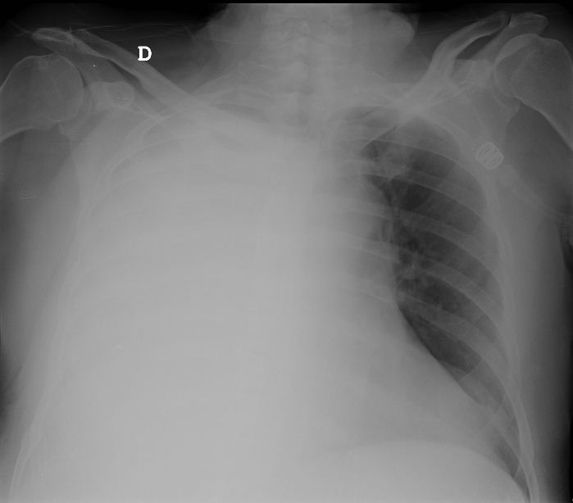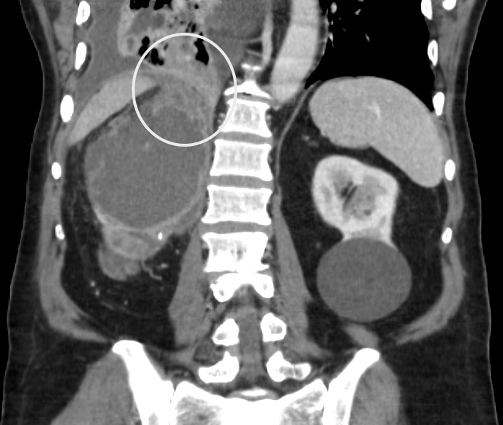

Figures 1 and 2.

Thorax and abdominal CT scan revealed a polycystic right kidney with grade IV hydronephrosis and suggested the presence of a nephropleural fistula (*Fig. 2*). The thoracocentesis was repeated and the pleural fluid / serum ratio of creatinine obtained was higher than 1 (1.35 mg/dL), which is a diagnostic criterion for urinothorax1. Finally, a retrograde pyelography was carried out, and confirmed the passage of urinary tract fluid into the pleural cavity (*Fig.*3).

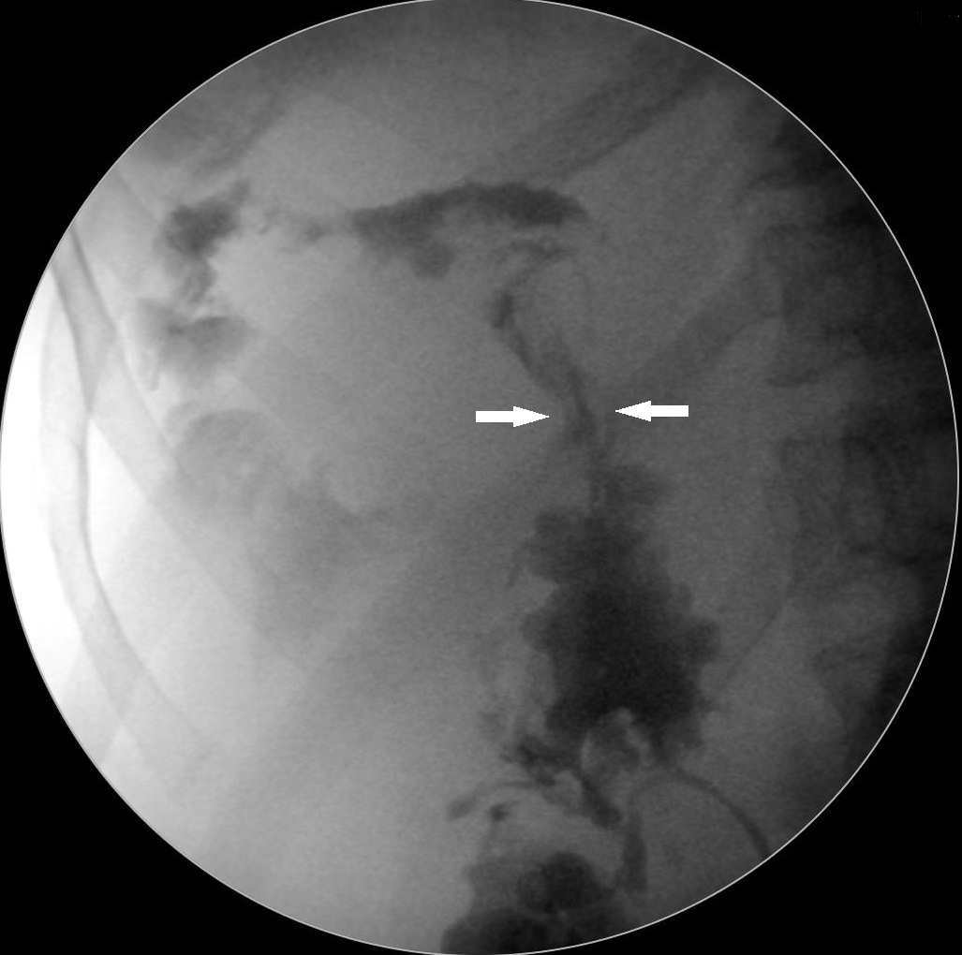

Figure 3.

A thoracic drainage tube and a nephrostomy through the superior calyx were placed, both draining purulent material. One month later, the control CT shows a right atrophic kidney and a reduction of the size of the fistulous path.

Urinothorax is an infrequent and underdiagnosed pathology, with few cases reported. It is usually presented as a transudative pleural effusion. Currently, no test is available to confirm the diagnosis2, although the ratio of serum creatinine/pleural creatinine could suggest the presence of urinothorax. Radiographic imaging is useful to support the diagnosis. Management of a urinothorax requires a multidisciplinary approach with an emphasis on the correction of the underlying urinary tract pathology, and once corrected, this often leads to a rapid resolution of the pleural effusion.

**Bibliography:**

1. Austin A, Jogani SN, Brasher PB, Argula RG, Huggins JT, Chopra A. The Urinothorax: A Comprehensive Review With Case Series. *Am J Med Sci*. 2017;354(1):44-53. doi:10.1016/j.amjms.2017.03.034

2. Vergne F, Le Mao R, Simonin L, et al. Une pleurésie très inhabituelle. *Rev Mal Respir*. 2018;35:567-570. doi:10.1016/j.rmr.2017.10.665