U.S. Territory Preterm Births during 2020-2023 [COMPLETE EXAMPLE]
  - Prepared by Dr. Katie Labgold
Last updated: 09/02/2026

Key Findings
- The number of live births in US Territories decreased from 23200 births in 2020 to 22627 births in 2024.
- The preterm birth rate was 11.7 preterm births per 100 live births in 2024, similar to the rate in 2020 (11.7 preterm births per 100 live births).
- Mothers ages Under 15 Years had the highest preterm birth rate during 2020-2024 (25 per 100 live births), while mothers ages 25-34 Years had the lowest preterm birth rate during 2020-2024 (11.4 per 100 live births).
- Mothers reported to be of Non-Hispanic Native Hawaiian and Other Pacific Islander race and ethnicity had the highest preterm birth rate during 2020-2024 (13 per 100 live births), while mothers reported to be of Non-Hispanic American Indian and Alaska Native race and ethnicity had the lowest preterm birth rate during 2020-2024 (7.3 per 100 live births).
- The preterm birth rate was higher for mothers with any diabetes and any hypertension, with a rate 1.6 and 2.7 times the rate for no diabetes and no hypertension, respectively.

The number of births decreased from 2020 to 2024
The number of live births in US Territories decreased from 23200 births in 2020 to 22627 births in 2024.
Table 1: Preterm Birth Rates by Year
Birth Year | Preterm Births | Live Births | Preterm Births per 100 Live Births
Overall 2020-2024 | 13,575 | 114,618 | 11.8
2020 | 2,675 | 23,200 | 11.5
2021 | 2,790 | 23,408 | 11.9
2022 | 2,700 | 22,969 | 11.8
2023 | 2,766 | 22,414 | 12.3
2024 | 2,644 | 22,627 | 11.7

The preterm birth rate was relatively constant during 2020 to 2024
The preterm birth rate was 11.7 preterm births per 100 live births in 2024, similar to the rate in 2020 (11.7 preterm births per 100 live births).
The 5-year preterm birth rate for 2020-2024 was 2024 preterm births per 100 live births.
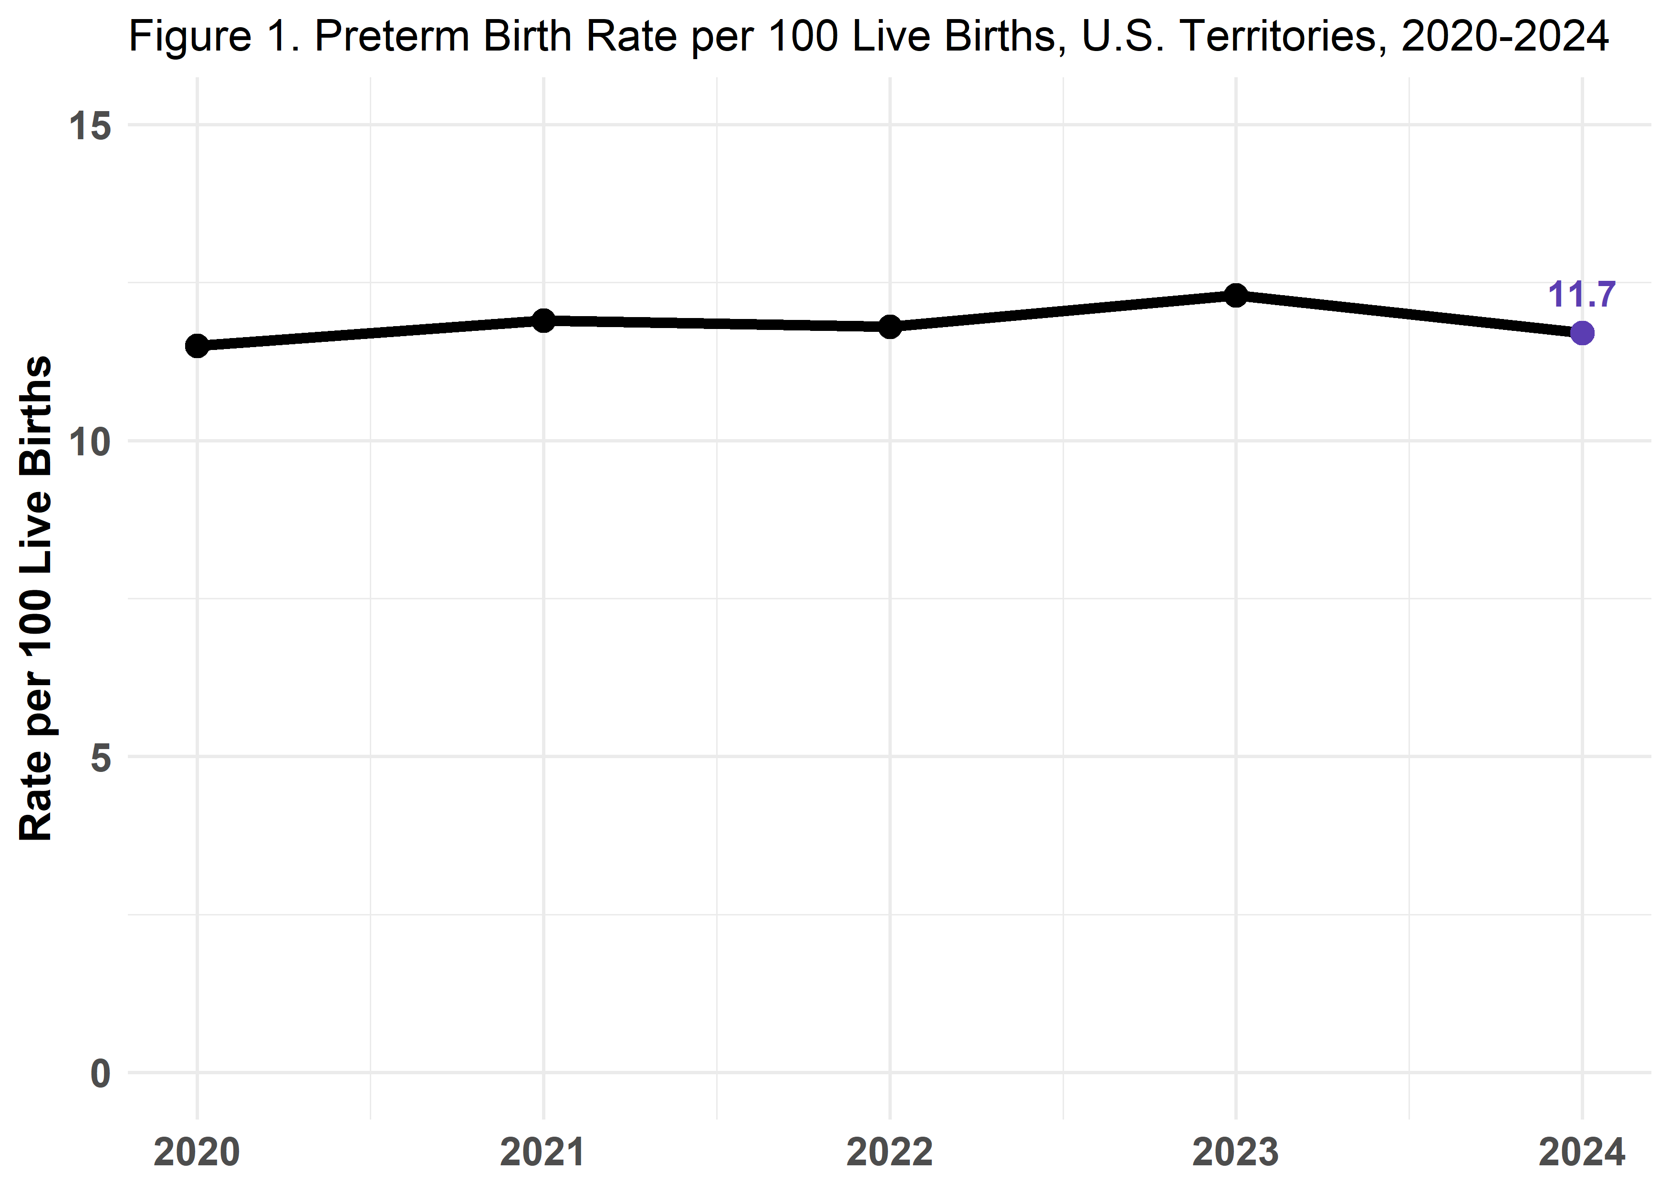

Preterm birth rates varied by maternal age and maternal race and ethnicity
Mothers ages Under 15 Years had the highest preterm birth rate during 2020-2024 (25 per 100 live births), while mothers ages 25-34 Years had the lowest preterm birth rate during 2020-2024 (11.4 per 100 live births).
Mothers reported to be of Non-Hispanic Native Hawaiian and Other Pacific Islander race and ethnicity had the highest preterm birth rate during 2020-2024 (13 per 100 live births), while mothers reported to be of Non-Hispanic American Indian and Alaska Native race and ethnicity had the lowest preterm birth rate during 2020-2024 (7.3 per 100 live births).
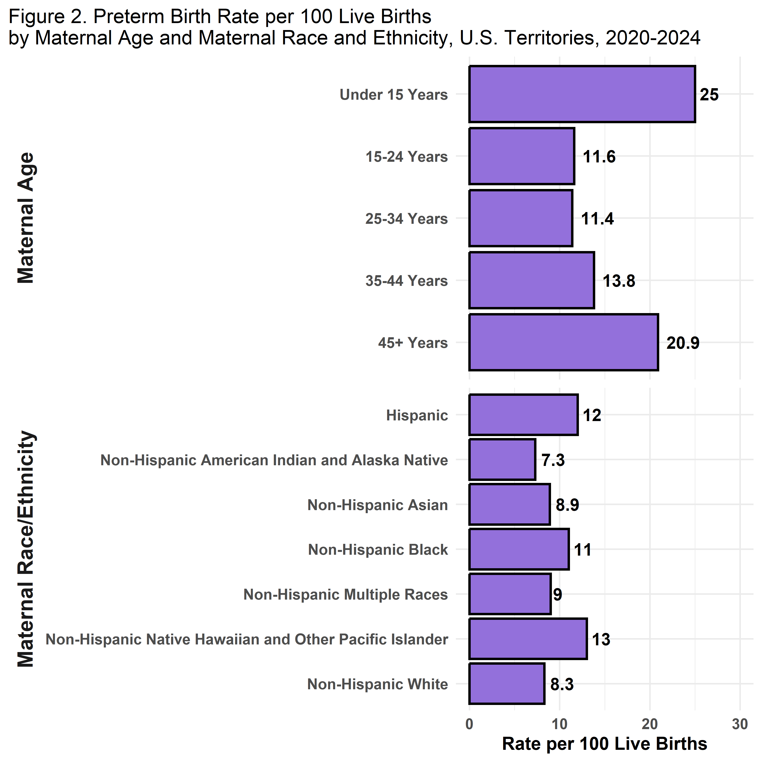

Preterm birth rates were highest for mothers with any diabetes and any hypertension history
The preterm birth rate was higher for mothers with any diabetes and any hypertension, with a rate 1.6 and 2.7 times the rate for no diabetes and no hypertension, respectively.
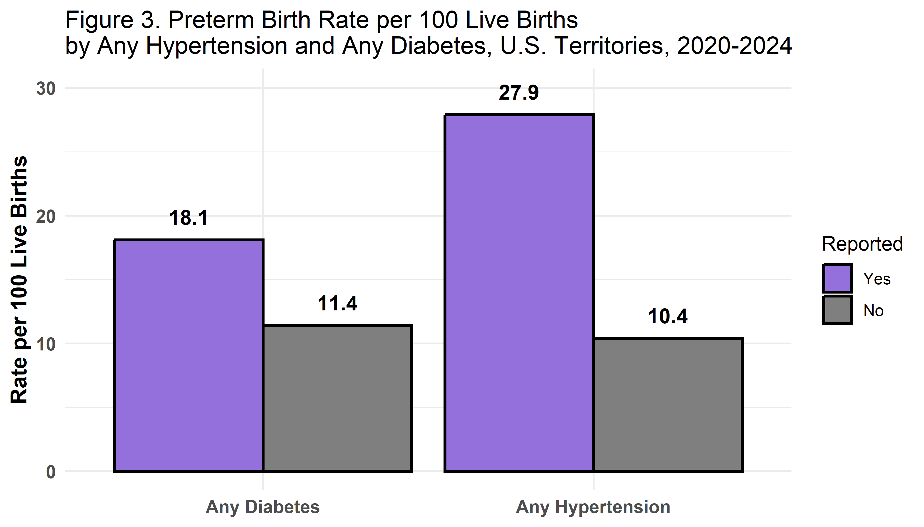

Recommendations
The following recommendations have been identified from these findings:
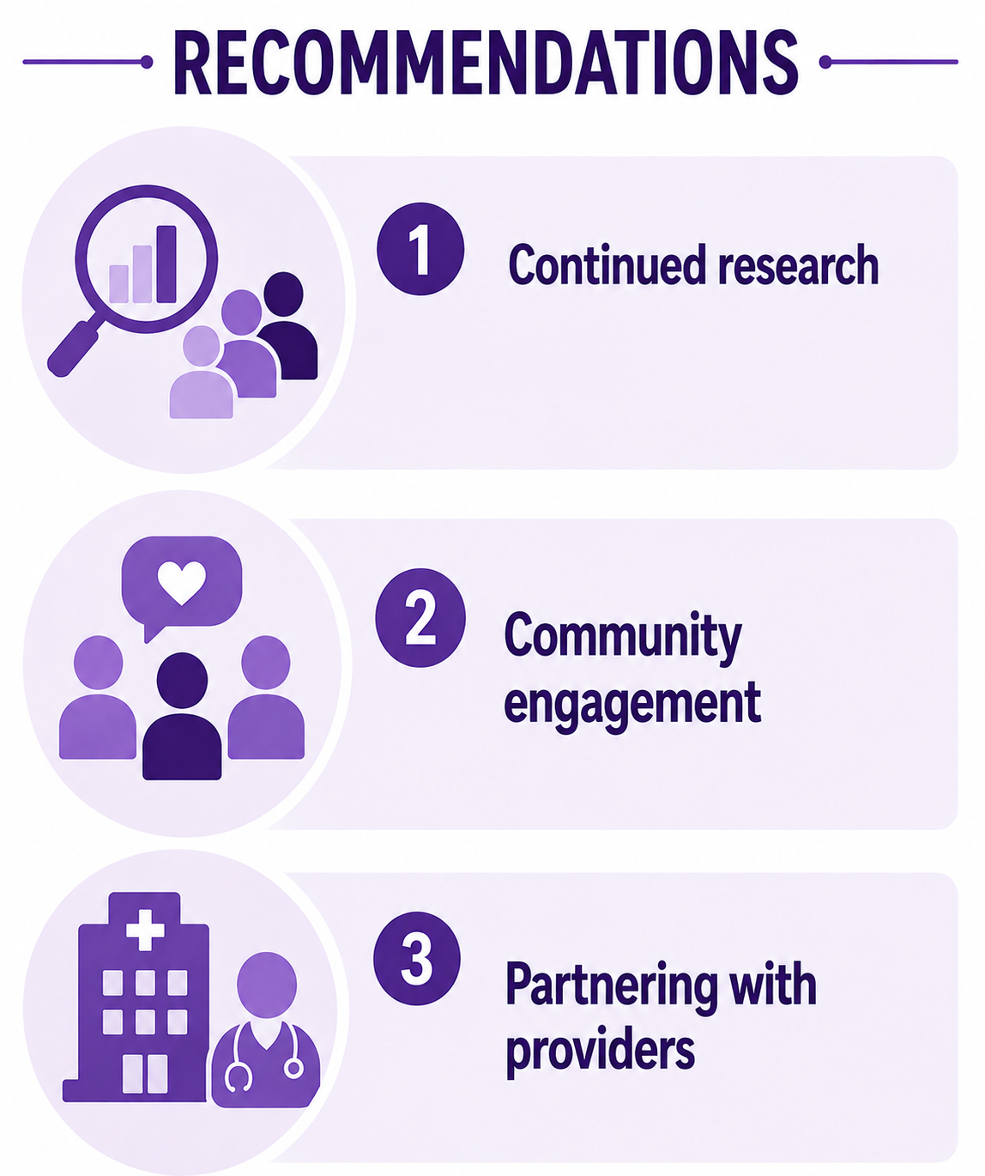

(1) Continued research
Continued analysis is needed to understand the unique drivers of higher preterm birth rates among certain maternal age and race and ethnicity categories in US Territories, which have distinct social and medical environments.

(2) Community engagement
Working with community members to identify culturally relevant opportunities to address hypertension and diabetes.

(3) Partnering with providers
Working with providers through territorial Perinatal Quality Collaboratives and other local collaborative organizations to identify culturally relevant opportunities to address hypertension and diabetes.

Data Source and Methods
Data for the analysis was downloaded from the CDC NCHS publicly available vital statistics birth data files for US Territories during 2020-2024. Consult the User’s Guide files for more details on the data source.
Preterm birth rates per calculated as the number of preterm births per 100 live births. Births were excluded if there was no information available on gestational age, based on the variable OEGest_R3.
Age was categorized in 10-year age groups based on the MAGER variable. Any diabetes and any hypertension were categorized based on having reported either pre-pregnancy or gestational diabetes and hypertension, respectively.
Additional details on the preparation of data for this report can be viewed in documentation available on our GitHub page.

