Modelling the effects of land-use change and land-use intensity on fire frequency

Setting up data:
diversity <- readRDS("~/Imperial/PROJECT/PREDICTS data/database.rds")
fire_hist <- read.csv("~/Imperial/PROJECT/Combined data/Fire_history.csv")
diversity <- mutate(diversity,
Measurement = Effort_corrected_measurement,
Sampling_effort = Rescaled_sampling_effort)
## Calculate diversity metrics
sites <- diversity %>%
mutate(Diversity_metric_is_valid = TRUE) %>%
predictsFunctions::SiteMetrics(extra.cols = c("SSB", "SSBS", "Predominant_land_use", "Biome", "Country")) %>%
group_by(SS) %>%
mutate(MaxAbundance = ifelse(Diversity_metric_type == "Abundance",
max(Total_abundance),
NA)) %>%
ungroup() %>%
mutate(RescaledAbundance = ifelse(Diversity_metric_type == "Abundance",
Total_abundance/MaxAbundance,
NA))
## Computing site metrics for 3250404 measurements
## The data contain 480 sources, 666 studies and 26112 sites
## Computing site-level values
## Computing total abundance
## Computing species richness
## Assembling site-level values
## Tidying up land use
sites <- sites %>%
mutate(
Predominant_land_use = recode_factor(Predominant_land_use,
"Primary forest" = "Primary vegetation",
"Primary non-forest" = "Primary vegetation"),
Predominant_land_use = na_if(Predominant_land_use, "Secondary vegetation (indeterminate age)"),
Predominant_land_use = na_if(Predominant_land_use, "Cannot decide"),
Use_intensity = na_if(Use_intensity, "Cannot decide"),
Predominant_land_use = factor(Predominant_land_use),
Predominant_land_use = relevel(Predominant_land_use, ref = "Primary vegetation"),
Use_intensity = factor(Use_intensity),
Use_intensity = relevel(Use_intensity, ref = "Minimal use")
)
## subset to after 2006
sites_post_2006 <- subset(sites, sites$Sample_start_earliest > "2006-01-01")
sites_post_2006_NA <- subset(sites_post_2006, (! is.na(Longitude) | ! is.na(Latitude)))
## Merge with fire data
PREDICTS_fire_hist <- merge(sites_post_2006_NA, fire_hist
[,c("SSBS", "Freq", "fire_ID", "size", "start_date", "duration", "days_since_fire",
"year", "years_since_fire")], by="SSBS", all.x=TRUE)
## Change freq from NA to 0
PREDICTS_fire_hist$Freq[is.na(PREDICTS_fire_hist$Freq)] <- 0
## Adding a column of fire presence
PREDICTS_fire_hist$fire_presence <- ifelse(PREDICTS_fire_hist$Freq==0, "No",
ifelse(PREDICTS_fire_hist$Freq!=0, "Yes",
NA))
PREDICTS_fire_hist$fire_presence <- as.factor(PREDICTS_fire_hist$fire_presence)

Data exploration:
model_data <- drop_na(PREDICTS_fire_hist, Predominant_land_use, Use_intensity, Freq)
## 10121 sites in total
## remove the levels with no data/Can't have fires
model_data<-model_data[!(model_data$Biome == "Rock & Ice"),]
model_data<-model_data[!(model_data$Biome == "Flooded Grasslands & Savannas"),]
model_data<-model_data[!(model_data$Biome == "Mangroves"),]
model_data<-model_data[!(model_data$Biome == "Inland Water"),]
model_data<-model_data[!(model_data$Biome == "Tundra"),]
model_data$Biome <- as.factor(as.character(model_data$Biome))
## Land use classes:
## Remove plantation and urban and merge intermediate and mature secondary to avoid low data levels
model_data<- drop_na(model_data, Predominant_land_use)
model_data<-model_data[!(model_data$Predominant_land_use == "Plantation forest"),]
model_data<-model_data[!(model_data$Predominant_land_use == "Urban"),]
model_data$Predominant_land_use <- as.factor(as.character(model_data$Predominant_land_use))
## merge intermediate and mature secondary together to avoid serious data imbalances.
model_data <- model_data %>%
mutate( Predominant_land_use = recode_factor(Predominant_land_use,
"Intermediate secondary vegetation" = "Older secondary vegetation",
"Mature secondary vegetation" = "Older secondary vegetation"),
Predominant_land_use = factor(Predominant_land_use),
Predominant_land_use = relevel(Predominant_land_use, ref = "Primary vegetation")
)
model_data$Predominant_land_use <- factor(model_data$Predominant_land_use, levels = c("Primary vegetation", "Young secondary vegetation", "Older secondary vegetation",
"Cropland", "Pasture"))
table(model_data$Predominant_land_use, model_data$Freq)
##
## 0 1 2 3
## Primary vegetation 3934 172 113 41
## Young secondary vegetation 588 56 43 9
## Older secondary vegetation 948 36 0 0
## Cropland 749 23 3 1
## Pasture 1373 27 9 2
## Use intensity - merging light and intense use together
model_data <- model_data %>%
mutate(Use_intensity_2 = recode_factor(Use_intensity, "Light use" = "Greater use",
"Intense use" = "Greater use"),
Use_intensity_2 = factor(Use_intensity_2),
Use_intensity_2 = relevel(Use_intensity_2, ref = "Minimal use"))
## Also trying a different merger of land use classes.
model_data <- model_data %>%
mutate(Landuse = recode_factor(Predominant_land_use, "Young secondary vegetation" = "Secondary vegetation",
"Older secondary vegetation" = "Secondary vegetation"),
Landuse = factor(Landuse),
Landuse = relevel(Landuse, ref = "Primary vegetation"))
model_data$Landuse <- factor(model_data$Landuse, levels = c("Primary vegetation",
"Secondary vegetation",
"Cropland",
"Pasture"))

Modelling

Assumptions:
Collinearity:
corvif(model_data[ , c("Landuse", "Use_intensity", "Freq")])
##
##
## Variance inflation factors
##
## GVIF Df GVIF^(1/2Df)
## Landuse 1.157291 3 1.024646
## Use_intensity 1.213961 2 1.049666
## Freq 1.077237 1 1.037900
Frequency is count data so needs to be modelled using Poisson error structure.
m1 <- glmer(Freq ~ Landuse + Use_intensity +
(1|SS) + (1|SSB) ,
data = model_data, family = poisson)
Anova(m1)
## Analysis of Deviance Table (Type II Wald chisquare tests)
##
## Response: Freq
## Chisq Df Pr(>Chisq)
## Landuse 15.739 3 0.001283 **
## Use_intensity 31.886 2 1.191e-07 ***
## ---
## Signif. codes: 0 '***' 0.001 '**' 0.01 '*' 0.05 '.' 0.1 ' ' 1
summary(m1)
## Generalized linear mixed model fit by maximum likelihood (Laplace Approximation) ['glmerMod']
## Family: poisson ( log )
## Formula: Freq ~ Landuse + Use_intensity + (1 | SS) + (1 | SSB)
## Data: model_data
##
## AIC BIC logLik deviance df.resid
## 2207.7 2263.7 -1095.8 2191.7 8119
##
## Scaled residuals:
## Min 1Q Median 3Q Max
## -1.4905 -0.0060 -0.0043 -0.0027 6.1784
##
## Random effects:
## Groups Name Variance Std.Dev.
## SSB (Intercept) 0.03744 0.1935
## SS (Intercept) 73.35089 8.5645
## Number of obs: 8127, groups: SSB, 743; SS, 247
##
## Fixed effects:
## Estimate Std. Error z value Pr(>|z|)
## (Intercept) -10.07332 0.89314 -11.279 < 2e-16 ***
## LanduseSecondary vegetation 0.01535 0.11307 0.136 0.892034
## LanduseCropland -1.15111 0.31132 -3.698 0.000218 ***
## LandusePasture -0.77001 0.28757 -2.678 0.007414 **
## Use_intensityLight use -0.94616 0.28706 -3.296 0.000981 ***
## Use_intensityIntense use -1.72320 0.30600 -5.631 1.79e-08 ***
## ---
## Signif. codes: 0 '***' 0.001 '**' 0.01 '*' 0.05 '.' 0.1 ' ' 1
##
## Correlation of Fixed Effects:
## (Intr) LndsSv LndsCr LndsPs Us_nLu
## LndsScndryv -0.045
## LandsCrplnd 0.026 -0.001
## LandusePstr 0.002 0.081 0.369
## Us_ntnstyLu -0.040 0.011 -0.788 -0.404
## Us_ntnstyIu -0.017 -0.049 -0.361 0.390 0.522
m1_output <- simulateResiduals(m1)
plot(m1_output)
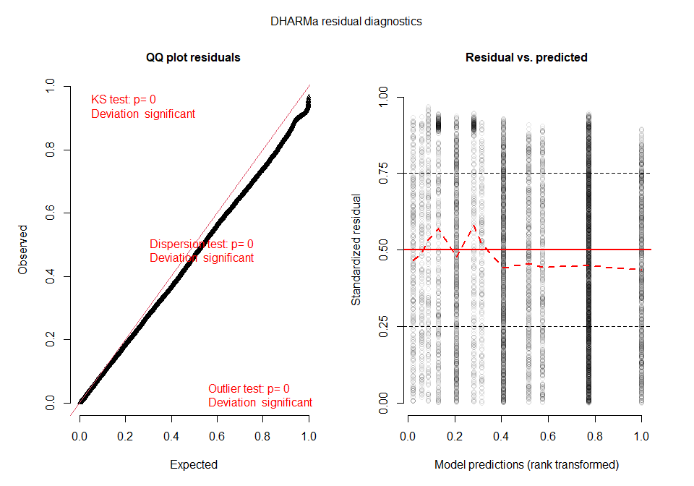
Checking for over/underdispersion:
check_overdispersion(m1)
## # Overdispersion test
##
## dispersion ratio = 0.101
## Pearson's Chi-Squared = 819.916
## p-value = 1
## No overdispersion detected.
Dispersion ratio very small so model is underdispersed.
check_zeroinflation(m1)
## # Check for zero-inflation
##
## Observed zeros: 7592
## Predicted zeros: 7651
## Ratio: 1.01
## Model seems ok, ratio of observed and predicted zeros is within the tolerance range.
The underdispersion is not being caused by zero inflation. It is likely that the underdispersion is due to spatial autocorrelation, as sites located close together are likely to be experiencing the same fires. To combat this, I can fit a spatial model. Attempts were made using glmmTMB and spaMM packages, but models would not run due to errors in memory allocation. Instead a gamm fitted with a smooth spatial term could be used.

Spatial models using gamm:
Mixed effects poisson gamm
gamm_model <- gamm4(Freq ~ s(Longitude, Latitude) + Landuse + Use_intensity,
random = ~(1|SS) + (1|SSB), data = model_data, family = poisson)
summary(gamm_model$mer)
## Generalized linear mixed model fit by maximum likelihood (Laplace Approximation) ['glmerMod']
## Family: poisson ( log )
##
## AIC BIC logLik deviance df.resid
## 2232.5 2309.5 -1105.2 2210.5 8116
##
## Scaled residuals:
## Min 1Q Median 3Q Max
## -1.5109 -0.0246 -0.0033 -0.0004 5.3718
##
## Random effects:
## Groups Name Variance Std.Dev.
## SSB (Intercept) 1.463e-03 0.03826
## SS (Intercept) 2.596e+01 5.09542
## Xr s(Longitude,Latitude) 2.537e+02 15.92837
## Number of obs: 8127, groups: SSB, 743; SS, 247; Xr, 27
##
## Fixed effects:
## Estimate Std. Error z value Pr(>|z|)
## X(Intercept) -10.21039 1.22240 -8.353 < 2e-16 ***
## XLanduseSecondary vegetation -0.01267 0.11127 -0.114 0.90931
## XLanduseCropland -1.20479 0.31639 -3.808 0.00014 ***
## XLandusePasture -0.76798 0.27850 -2.758 0.00582 **
## XUse_intensityLight use -0.91121 0.29079 -3.134 0.00173 **
## XUse_intensityIntense use -1.66108 0.30440 -5.457 4.85e-08 ***
## Xs(Longitude,Latitude)Fx1 0.48664 1.62927 0.299 0.76518
## Xs(Longitude,Latitude)Fx2 1.32372 2.76961 0.478 0.63269
## ---
## Signif. codes: 0 '***' 0.001 '**' 0.01 '*' 0.05 '.' 0.1 ' ' 1
##
## Correlation of Fixed Effects:
## X(Int) XLndSv XLndsC XLndsP XUs_Lu XUs_Iu X(L,L)F1
## XLndsScndrv 0.031
## XLndsCrplnd -0.004 0.012
## XLandusPstr -0.010 0.086 0.371
## XUs_ntnstLu -0.012 -0.001 -0.791 -0.406
## XUs_ntnstIu -0.022 -0.062 -0.389 0.354 0.552
## Xs(Lng,L)F1 0.126 0.046 0.000 -0.016 -0.006 -0.037
## Xs(Lng,L)F2 0.217 0.023 -0.022 -0.017 0.027 0.006 0.135
The model shows that longitude and latitude arent having signficant effects on fire frequency.
checking for over/under dispersion:
check_overdispersion(gamm_model$mer)
## # Overdispersion test
##
## dispersion ratio = 0.099
## Pearson's Chi-Squared = 807.194
## p-value = 1
## No overdispersion detected.
Model shows no overdispersion, but the dispersion ratio is very small suggesting there is still underdispersion in this model. Mild underdispersion is probably OK to use.

Model selection
Model selection as well as including a fixed effect interaction of whether a site is savanna or not to see if there are significant differences. Setting up savanna or not:
model_data$savanna <- ifelse(model_data$Biome== "Tropical & Subtropical Grasslands, Savannas & Shrublands","Savanna",
ifelse(model_data$Biome != "Tropical & Subtropical Grasslands, Savannas & Shrublands",
"Not_savanna", NA))
model_data$savanna <- as.factor(model_data$savanna)
Setting up functions for model comparison in MuMIn:
gamm4 <- function(...) structure(c(gamm4::gamm4(...), list(call = match.call())),
class = c("gamm", "list"))
logLik.gamm <- function(object, ...) logLik(object[[if (is.null(object$lme)) "mer" else "lme"]], ...)
formula.gamm <- function(x, ...) formula(x$gam, ...)
nobs.gamm <- function(object, ...) nobs(object$gam, ...)
nobs.gam <- function(object, ...) stats:::nobs.glm(object, ...)
coeffs.gamm <- function(model) coef(model$gam)
getAllTerms.gamm <- function(x, ...) getAllTerms(x$gam)
tTable.gamm <- function(model, ...) tTable(model$gam)
m1 <- gamm4(Freq ~ s(Longitude, Latitude) + Landuse + Use_intensity_2 + Landuse:Use_intensity_2,
random = ~(1|SS) + (1|SSB), data = model_data, family = poisson)
m2 <- gamm4(Freq ~ s(Longitude, Latitude) + Landuse + Use_intensity_2 + Landuse:Use_intensity_2:savanna,
random = ~(1|SS) + (1|SSB), data = model_data, family = poisson)
## fixed-effect model matrix is rank deficient so dropping 5 columns / coefficients
summary(m1$mer)
## Generalized linear mixed model fit by maximum likelihood (Laplace Approximation) ['glmerMod']
## Family: poisson ( log )
##
## AIC BIC logLik deviance df.resid
## 2232.5 2323.5 -1103.2 2206.5 8114
##
## Scaled residuals:
## Min 1Q Median 3Q Max
## -1.5033 -0.0196 -0.0105 -0.0067 7.1612
##
## Random effects:
## Groups Name Variance Std.Dev.
## SSB (Intercept) 0.03388 0.1841
## SS (Intercept) 19.76416 4.4457
## Xr s(Longitude,Latitude) 0.15826 0.3978
## Number of obs: 8127, groups: SSB, 743; SS, 247; Xr, 27
##
## Fixed effects:
## Estimate Std. Error z value Pr(>|z|)
## X(Intercept) -7.7118 0.6921 -11.143 < 2e-16 ***
## XLanduseSecondary vegetation -0.9317 0.5274 -1.766 0.0773 .
## XLanduseCropland -0.4946 0.4324 -1.144 0.2526
## XLandusePasture -0.8806 0.5704 -1.544 0.1226
## XUse_intensity_2Greater use -1.3996 0.2993 -4.676 2.93e-06 ***
## XLanduseSecondary vegetation:Use_intensity_2Greater use 0.9371 0.5357 1.750 0.0802 .
## XLanduseCropland:Use_intensity_2Greater use -0.4199 0.5848 -0.718 0.4727
## XLandusePasture:Use_intensity_2Greater use 0.6031 0.6086 0.991 0.3217
## Xs(Longitude,Latitude)Fx1 -1.0858 0.4221 -2.573 0.0101 *
## Xs(Longitude,Latitude)Fx2 -0.2434 0.4011 -0.607 0.5439
## ---
## Signif. codes: 0 '***' 0.001 '**' 0.01 '*' 0.05 '.' 0.1 ' ' 1
##
## Correlation of Fixed Effects:
## X(Int) XLndSv XLndsC XLndsP XU__2u XLSv:u XLC:Uu XLP:Uu X(L,L)F1
## XLndsScndrv -0.144
## XLndsCrplnd -0.078 0.134
## XLandusPstr -0.092 0.215 0.140
## XUs_ntn_2Gu -0.092 0.269 0.121 0.158
## XLSv:U__2Gu 0.144 -0.977 -0.133 -0.213 -0.286
## XLnC:U__2Gu 0.098 -0.224 -0.796 -0.178 -0.566 0.233
## XLnP:U__2Gu 0.086 -0.221 -0.142 -0.950 -0.240 0.232 0.222
## Xs(Lng,L)F1 0.196 -0.053 -0.015 -0.037 -0.042 0.059 0.027 0.040
## Xs(Lng,L)F2 0.096 0.037 -0.012 0.008 -0.005 -0.032 0.013 -0.010 0.490
summary(m2$mer)
## Warning in vcov.merMod(object, use.hessian = use.hessian): variance-covariance matrix computed from finite-difference Hessian is
## not positive definite or contains NA values: falling back to var-cov estimated from RX
## Warning in vcov.merMod(object, correlation = correlation, sigm = sig): variance-covariance matrix computed from finite-difference Hessian is
## not positive definite or contains NA values: falling back to var-cov estimated from RX
## Generalized linear mixed model fit by maximum likelihood (Laplace Approximation) ['glmerMod']
## Family: poisson ( log )
##
## AIC BIC logLik deviance df.resid
## 2228.1 2375.1 -1093.0 2186.1 8106
##
## Scaled residuals:
## Min 1Q Median 3Q Max
## -1.5014 -0.0316 -0.0118 -0.0045 6.3378
##
## Random effects:
## Groups Name Variance Std.Dev.
## SSB (Intercept) 0.03857 0.1964
## SS (Intercept) 8.13514 2.8522
## Xr s(Longitude,Latitude) 37.01411 6.0839
## Number of obs: 8127, groups: SSB, 743; SS, 247; Xr, 27
##
## Fixed effects:
## Estimate Std. Error z value
## X(Intercept) -2.281e+01 5.826e+04 0.000
## XLanduseSecondary vegetation 2.411e-02 1.177e-01 0.205
## XLanduseCropland -3.702e-01 4.028e-01 -0.919
## XLandusePasture -9.049e-02 1.835e-01 -0.493
## XUse_intensity_2Greater use 1.821e+01 5.826e+04 0.000
## XLandusePrimary vegetation:Use_intensity_2Minimal use:savannaNot_savanna 1.506e+01 5.826e+04 0.000
## XLanduseSecondary vegetation:Use_intensity_2Minimal use:savannaNot_savanna 1.522e+01 5.826e+04 0.000
## XLanduseCropland:Use_intensity_2Minimal use:savannaNot_savanna 1.458e+01 5.826e+04 0.000
## XLandusePasture:Use_intensity_2Minimal use:savannaNot_savanna 1.483e+01 5.826e+04 0.000
## XLandusePrimary vegetation:Use_intensity_2Greater use:savannaNot_savanna -3.567e+00 1.115e+00 -3.200
## XLanduseSecondary vegetation:Use_intensity_2Greater use:savannaNot_savanna -4.115e+00 1.375e+00 -2.993
## XLanduseCropland:Use_intensity_2Greater use:savannaNot_savanna -7.542e+00 1.007e+01 -0.749
## XLandusePasture:Use_intensity_2Greater use:savannaNot_savanna -4.300e+00 1.961e+00 -2.193
## XLandusePrimary vegetation:Use_intensity_2Minimal use:savannaSavanna 2.002e+01 5.826e+04 0.000
## XLanduseSecondary vegetation:Use_intensity_2Minimal use:savannaSavanna 1.798e+01 5.826e+04 0.000
## XLanduseCropland:Use_intensity_2Minimal use:savannaSavanna 2.018e+01 5.826e+04 0.000
## Xs(Longitude,Latitude)Fx1 -1.191e-01 1.324e+00 -0.090
## Xs(Longitude,Latitude)Fx2 -2.469e-01 2.575e+00 -0.096
## Pr(>|z|)
## X(Intercept) 0.99969
## XLanduseSecondary vegetation 0.83762
## XLanduseCropland 0.35807
## XLandusePasture 0.62200
## XUse_intensity_2Greater use 0.99975
## XLandusePrimary vegetation:Use_intensity_2Minimal use:savannaNot_savanna 0.99979
## XLanduseSecondary vegetation:Use_intensity_2Minimal use:savannaNot_savanna 0.99979
## XLanduseCropland:Use_intensity_2Minimal use:savannaNot_savanna 0.99980
## XLandusePasture:Use_intensity_2Minimal use:savannaNot_savanna 0.99980
## XLandusePrimary vegetation:Use_intensity_2Greater use:savannaNot_savanna 0.00137 **
## XLanduseSecondary vegetation:Use_intensity_2Greater use:savannaNot_savanna 0.00276 **
## XLanduseCropland:Use_intensity_2Greater use:savannaNot_savanna 0.45381
## XLandusePasture:Use_intensity_2Greater use:savannaNot_savanna 0.02828 *
## XLandusePrimary vegetation:Use_intensity_2Minimal use:savannaSavanna 0.99973
## XLanduseSecondary vegetation:Use_intensity_2Minimal use:savannaSavanna 0.99975
## XLanduseCropland:Use_intensity_2Minimal use:savannaSavanna 0.99972
## Xs(Longitude,Latitude)Fx1 0.92835
## Xs(Longitude,Latitude)Fx2 0.92362
## ---
## Signif. codes: 0 '***' 0.001 '**' 0.01 '*' 0.05 '.' 0.1 ' ' 1
##
## Correlation matrix not shown by default, as p = 18 > 12.
## Use print(x, correlation=TRUE) or
## vcov(x) if you need it
## fit warnings:
## fixed-effect model matrix is rank deficient so dropping 5 columns / coefficients
In model 1 (which contains the land use, use intensity interaction), there appears to be no significant affect of the interaction.
Log liklihood:
logLik(m2$mer)
## 'log Lik.' -1093.042 (df=21)
logLik(m1$mer)
## 'log Lik.' -1103.226 (df=13)
AIC(m1, m2)
## df AIC
## m1 13 2232.453
## m2 21 2228.083
Model comparison: Code sets up a maximal model and then looks at every possible comparison.
m3 <- uGamm(Freq ~ s(Longitude, Latitude) + Landuse + Use_intensity_2 + Landuse:Use_intensity_2:savanna,
random = ~(1|SS) + (1|SSB), data = model_data, family = poisson)
## fixed-effect model matrix is rank deficient so dropping 5 columns / coefficients
(dd <- dredge(m3))
## Fixed term is "(Intercept)"
## fixed-effect model matrix is rank deficient so dropping 5 columns / coefficients
## fixed-effect model matrix is rank deficient so dropping 5 columns / coefficients
## Global model call: uGamm(formula = Freq ~ s(Longitude, Latitude) + Landuse + Use_intensity_2 +
## Landuse:Use_intensity_2:savanna, random = ~(1 | SS) + (1 |
## SSB), data = model_data, family = poisson)
## ---
## Model selection table
## (Int) Lnd s(Lng,Ltt) Use_int_2 Lnd:svn:Use_int_2 df logLik AICc delta weight
## 6 -10.050 + + 7 -1099.914 2213.8 0.00 0.649
## 5 -10.120 + 4 -1104.046 2216.1 2.26 0.210
## 14 -22.310 + + + 18 -1090.674 2217.4 3.59 0.108
## 7 -9.982 + + 7 -1102.963 2219.9 6.10 0.031
## 8 -13.330 + + + 10 -1103.124 2226.3 12.43 0.001
## 16 -22.810 + + + + 21 -1093.042 2228.2 14.36 0.000
## 2 -10.330 + 6 -1117.323 2246.7 32.81 0.000
## 4 -10.140 + + 9 -1124.860 2267.7 53.90 0.000
## 1 -10.550 3 -1186.462 2378.9 165.09 0.000
## 3 -10.670 + 6 -1185.277 2382.6 168.72 0.000
## Models ranked by AICc(x)
summary(model.avg(dd, subset = delta <= 8))
##
## Call:
## model.avg(object = dd, subset = delta <= 8)
##
## Component model call:
## uGamm(formula = Freq ~ <4 unique rhs>, random = ~(1 | SS) + (1 | SSB), data = model_data, family =
## poisson)
##
## Component models:
## df logLik AICc delta weight
## 13 7 -1099.91 2213.84 0.00 0.65
## 3 4 -1104.05 2216.10 2.26 0.21
## 134 18 -1090.67 2217.43 3.59 0.11
## 23 7 -1102.96 2219.94 6.10 0.03
##
## Term codes:
## Landuse s(Longitude, Latitude) Use_intensity_2
## 1 2 3
## Landuse:savanna:Use_intensity_2
## 4
##
## Model-averaged coefficients:
## (full average)
## Estimate Std. Error Adjusted SE
## (Intercept) -1.139e+01 3.670e+13 3.670e+13
## LanduseSecondary vegetation 7.830e-03 4.991e+13 4.991e+13
## LanduseCropland -5.594e-01 1.719e+13 1.719e+13
## LandusePasture -1.416e-01 3.845e+13 3.845e+13
## Use_intensity_2Greater use 6.523e-01 3.524e+13 3.524e+13
## LandusePrimary vegetation:savannaNot_savanna:Use_intensity_2Minimal use 1.553e+00 3.670e+13 3.670e+13
## LanduseSecondary vegetation:savannaNot_savanna:Use_intensity_2Minimal use 1.543e+00 3.217e+13 3.217e+13
## LanduseCropland:savannaNot_savanna:Use_intensity_2Minimal use 1.529e+00 3.692e+13 3.692e+13
## LandusePasture:savannaNot_savanna:Use_intensity_2Minimal use 1.518e+00 3.133e+13 3.133e+13
## LandusePrimary vegetation:savannaNot_savanna:Use_intensity_2Greater use -5.276e-01 2.612e+13 2.612e+13
## LanduseSecondary vegetation:savannaNot_savanna:Use_intensity_2Greater use -5.817e-01 3.815e+13 3.815e+13
## LanduseCropland:savannaNot_savanna:Use_intensity_2Greater use -3.031e+00 2.325e+13 2.325e+13
## LandusePasture:savannaNot_savanna:Use_intensity_2Greater use -6.259e-01 3.298e+13 3.298e+13
## LandusePrimary vegetation:savannaSavanna:Use_intensity_2Minimal use 2.174e+00 3.670e+13 3.670e+13
## LanduseSecondary vegetation:savannaSavanna:Use_intensity_2Minimal use 1.986e+00 3.217e+13 3.217e+13
## LanduseCropland:savannaSavanna:Use_intensity_2Minimal use 2.213e+00 3.692e+13 3.692e+13
## LandusePasture:savannaSavanna:Use_intensity_2Minimal use 0.000e+00 0.000e+00 0.000e+00
## LandusePrimary vegetation:savannaSavanna:Use_intensity_2Greater use 0.000e+00 0.000e+00 0.000e+00
## LanduseSecondary vegetation:savannaSavanna:Use_intensity_2Greater use 0.000e+00 0.000e+00 0.000e+00
## LanduseCropland:savannaSavanna:Use_intensity_2Greater use 0.000e+00 0.000e+00 0.000e+00
## LandusePasture:savannaSavanna:Use_intensity_2Greater use 0.000e+00 0.000e+00 0.000e+00
## s(Longitude,Latitude).1 0.000e+00 2.620e-06 2.621e-06
## s(Longitude,Latitude).2 -8.867e-32 1.589e-06 1.589e-06
## s(Longitude,Latitude).3 3.761e-32 2.752e-06 2.753e-06
## s(Longitude,Latitude).4 -1.107e-32 2.946e-06 2.946e-06
## s(Longitude,Latitude).5 1.105e-33 6.714e-07 6.715e-07
## s(Longitude,Latitude).6 -6.980e-32 1.254e-06 1.254e-06
## s(Longitude,Latitude).7 -5.166e-34 2.219e-06 2.219e-06
## s(Longitude,Latitude).8 5.687e-34 1.188e-06 1.188e-06
## s(Longitude,Latitude).9 8.169e-34 3.531e-07 3.531e-07
## s(Longitude,Latitude).10 -2.633e-34 8.709e-07 8.710e-07
## s(Longitude,Latitude).11 -2.101e-34 9.935e-07 9.936e-07
## s(Longitude,Latitude).12 5.181e-35 2.357e-06 2.358e-06
## s(Longitude,Latitude).13 1.252e-34 2.322e-06 2.323e-06
## s(Longitude,Latitude).14 -2.736e-35 1.778e-07 1.778e-07
## s(Longitude,Latitude).15 -3.405e-36 2.443e-06 2.444e-06
## s(Longitude,Latitude).16 9.984e-35 1.737e-06 1.737e-06
## s(Longitude,Latitude).17 -2.398e-35 2.082e-06 2.083e-06
## s(Longitude,Latitude).18 1.259e-34 1.278e-06 1.278e-06
## s(Longitude,Latitude).19 3.491e-35 7.230e-07 7.231e-07
## s(Longitude,Latitude).20 2.995e-35 9.200e-07 9.201e-07
## s(Longitude,Latitude).21 -3.284e-34 1.731e-06 1.731e-06
## s(Longitude,Latitude).22 4.854e-36 1.689e-06 1.689e-06
## s(Longitude,Latitude).23 -1.666e-32 1.985e-06 1.986e-06
## s(Longitude,Latitude).24 -1.731e-35 1.239e-06 1.240e-06
## s(Longitude,Latitude).25 -1.983e-32 1.771e-06 1.771e-06
## s(Longitude,Latitude).26 1.573e-35 1.758e-06 1.758e-06
## s(Longitude,Latitude).27 -6.235e-19 1.610e-05 1.611e-05
## s(Longitude,Latitude).28 -6.173e-04 2.241e-01 2.242e-01
## s(Longitude,Latitude).29 -2.690e-02 2.911e-01 2.912e-01
## z value Pr(>|z|)
## (Intercept) 0.000 1.000
## LanduseSecondary vegetation 0.000 1.000
## LanduseCropland 0.000 1.000
## LandusePasture 0.000 1.000
## Use_intensity_2Greater use 0.000 1.000
## LandusePrimary vegetation:savannaNot_savanna:Use_intensity_2Minimal use 0.000 1.000
## LanduseSecondary vegetation:savannaNot_savanna:Use_intensity_2Minimal use 0.000 1.000
## LanduseCropland:savannaNot_savanna:Use_intensity_2Minimal use 0.000 1.000
## LandusePasture:savannaNot_savanna:Use_intensity_2Minimal use 0.000 1.000
## LandusePrimary vegetation:savannaNot_savanna:Use_intensity_2Greater use 0.000 1.000
## LanduseSecondary vegetation:savannaNot_savanna:Use_intensity_2Greater use 0.000 1.000
## LanduseCropland:savannaNot_savanna:Use_intensity_2Greater use 0.000 1.000
## LandusePasture:savannaNot_savanna:Use_intensity_2Greater use 0.000 1.000
## LandusePrimary vegetation:savannaSavanna:Use_intensity_2Minimal use 0.000 1.000
## LanduseSecondary vegetation:savannaSavanna:Use_intensity_2Minimal use 0.000 1.000
## LanduseCropland:savannaSavanna:Use_intensity_2Minimal use 0.000 1.000
## LandusePasture:savannaSavanna:Use_intensity_2Minimal use NA NA
## LandusePrimary vegetation:savannaSavanna:Use_intensity_2Greater use NA NA
## LanduseSecondary vegetation:savannaSavanna:Use_intensity_2Greater use NA NA
## LanduseCropland:savannaSavanna:Use_intensity_2Greater use NA NA
## LandusePasture:savannaSavanna:Use_intensity_2Greater use NA NA
## s(Longitude,Latitude).1 0.000 1.000
## s(Longitude,Latitude).2 0.000 1.000
## s(Longitude,Latitude).3 0.000 1.000
## s(Longitude,Latitude).4 0.000 1.000
## s(Longitude,Latitude).5 0.000 1.000
## s(Longitude,Latitude).6 0.000 1.000
## s(Longitude,Latitude).7 0.000 1.000
## s(Longitude,Latitude).8 0.000 1.000
## s(Longitude,Latitude).9 0.000 1.000
## s(Longitude,Latitude).10 0.000 1.000
## s(Longitude,Latitude).11 0.000 1.000
## s(Longitude,Latitude).12 0.000 1.000
## s(Longitude,Latitude).13 0.000 1.000
## s(Longitude,Latitude).14 0.000 1.000
## s(Longitude,Latitude).15 0.000 1.000
## s(Longitude,Latitude).16 0.000 1.000
## s(Longitude,Latitude).17 0.000 1.000
## s(Longitude,Latitude).18 0.000 1.000
## s(Longitude,Latitude).19 0.000 1.000
## s(Longitude,Latitude).20 0.000 1.000
## s(Longitude,Latitude).21 0.000 1.000
## s(Longitude,Latitude).22 0.000 1.000
## s(Longitude,Latitude).23 0.000 1.000
## s(Longitude,Latitude).24 0.000 1.000
## s(Longitude,Latitude).25 0.000 1.000
## s(Longitude,Latitude).26 0.000 1.000
## s(Longitude,Latitude).27 0.000 1.000
## s(Longitude,Latitude).28 0.003 0.998
## s(Longitude,Latitude).29 0.092 0.926
##
## (conditional average)
## Estimate Std. Error Adjusted SE
## (Intercept) -1.139e+01 3.670e+13 3.670e+13
## LanduseSecondary vegetation 1.032e-02 5.730e+13 5.730e+13
## LanduseCropland -7.375e-01 1.974e+13 1.974e+13
## LandusePasture -1.866e-01 4.414e+13 4.414e+13
## Use_intensity_2Greater use 6.523e-01 3.524e+13 3.524e+13
## LandusePrimary vegetation:savannaNot_savanna:Use_intensity_2Minimal use 1.438e+01 1.117e+14 1.117e+14
## LanduseSecondary vegetation:savannaNot_savanna:Use_intensity_2Minimal use 1.428e+01 9.786e+13 9.786e+13
## LanduseCropland:savannaNot_savanna:Use_intensity_2Minimal use 1.415e+01 1.123e+14 1.123e+14
## LandusePasture:savannaNot_savanna:Use_intensity_2Minimal use 1.405e+01 9.532e+13 9.532e+13
## LandusePrimary vegetation:savannaNot_savanna:Use_intensity_2Greater use -4.884e+00 7.946e+13 7.946e+13
## LanduseSecondary vegetation:savannaNot_savanna:Use_intensity_2Greater use -5.384e+00 1.161e+14 1.161e+14
## LanduseCropland:savannaNot_savanna:Use_intensity_2Greater use -2.806e+01 7.073e+13 7.073e+13
## LandusePasture:savannaNot_savanna:Use_intensity_2Greater use -5.793e+00 1.003e+14 1.003e+14
## LandusePrimary vegetation:savannaSavanna:Use_intensity_2Minimal use 2.012e+01 1.117e+14 1.117e+14
## LanduseSecondary vegetation:savannaSavanna:Use_intensity_2Minimal use 1.839e+01 9.786e+13 9.786e+13
## LanduseCropland:savannaSavanna:Use_intensity_2Minimal use 2.048e+01 1.123e+14 1.123e+14
## LandusePasture:savannaSavanna:Use_intensity_2Minimal use NA NA NA
## LandusePrimary vegetation:savannaSavanna:Use_intensity_2Greater use NA NA NA
## LanduseSecondary vegetation:savannaSavanna:Use_intensity_2Greater use NA NA NA
## LanduseCropland:savannaSavanna:Use_intensity_2Greater use NA NA NA
## LandusePasture:savannaSavanna:Use_intensity_2Greater use NA NA NA
## s(Longitude,Latitude).1 0.000e+00 1.492e-05 1.492e-05
## s(Longitude,Latitude).2 -2.874e-30 9.045e-06 9.047e-06
## s(Longitude,Latitude).3 1.219e-30 1.567e-05 1.567e-05
## s(Longitude,Latitude).4 -3.588e-31 1.677e-05 1.678e-05
## s(Longitude,Latitude).5 3.582e-32 3.823e-06 3.823e-06
## s(Longitude,Latitude).6 -2.263e-30 7.139e-06 7.140e-06
## s(Longitude,Latitude).7 -1.675e-32 1.263e-05 1.264e-05
## s(Longitude,Latitude).8 1.843e-32 6.765e-06 6.766e-06
## s(Longitude,Latitude).9 2.648e-32 2.010e-06 2.011e-06
## s(Longitude,Latitude).10 -8.536e-33 4.958e-06 4.959e-06
## s(Longitude,Latitude).11 -6.812e-33 5.656e-06 5.657e-06
## s(Longitude,Latitude).12 1.679e-33 1.342e-05 1.342e-05
## s(Longitude,Latitude).13 4.058e-33 1.322e-05 1.322e-05
## s(Longitude,Latitude).14 -8.870e-34 1.012e-06 1.012e-06
## s(Longitude,Latitude).15 -1.104e-34 1.391e-05 1.391e-05
## s(Longitude,Latitude).16 3.236e-33 9.888e-06 9.890e-06
## s(Longitude,Latitude).17 -7.774e-34 1.186e-05 1.186e-05
## s(Longitude,Latitude).18 4.080e-33 7.274e-06 7.275e-06
## s(Longitude,Latitude).19 1.132e-33 4.116e-06 4.117e-06
## s(Longitude,Latitude).20 9.708e-34 5.238e-06 5.239e-06
## s(Longitude,Latitude).21 -1.065e-32 9.857e-06 9.858e-06
## s(Longitude,Latitude).22 1.574e-34 9.618e-06 9.619e-06
## s(Longitude,Latitude).23 -5.402e-31 1.130e-05 1.130e-05
## s(Longitude,Latitude).24 -5.612e-34 7.057e-06 7.058e-06
## s(Longitude,Latitude).25 -6.427e-31 1.008e-05 1.008e-05
## s(Longitude,Latitude).26 5.098e-34 1.001e-05 1.001e-05
## s(Longitude,Latitude).27 -2.021e-17 9.168e-05 9.169e-05
## s(Longitude,Latitude).28 -2.001e-02 1.276e+00 1.276e+00
## s(Longitude,Latitude).29 -8.720e-01 1.418e+00 1.418e+00
## z value Pr(>|z|)
## (Intercept) 0.000 1.000
## LanduseSecondary vegetation 0.000 1.000
## LanduseCropland 0.000 1.000
## LandusePasture 0.000 1.000
## Use_intensity_2Greater use 0.000 1.000
## LandusePrimary vegetation:savannaNot_savanna:Use_intensity_2Minimal use 0.000 1.000
## LanduseSecondary vegetation:savannaNot_savanna:Use_intensity_2Minimal use 0.000 1.000
## LanduseCropland:savannaNot_savanna:Use_intensity_2Minimal use 0.000 1.000
## LandusePasture:savannaNot_savanna:Use_intensity_2Minimal use 0.000 1.000
## LandusePrimary vegetation:savannaNot_savanna:Use_intensity_2Greater use 0.000 1.000
## LanduseSecondary vegetation:savannaNot_savanna:Use_intensity_2Greater use 0.000 1.000
## LanduseCropland:savannaNot_savanna:Use_intensity_2Greater use 0.000 1.000
## LandusePasture:savannaNot_savanna:Use_intensity_2Greater use 0.000 1.000
## LandusePrimary vegetation:savannaSavanna:Use_intensity_2Minimal use 0.000 1.000
## LanduseSecondary vegetation:savannaSavanna:Use_intensity_2Minimal use 0.000 1.000
## LanduseCropland:savannaSavanna:Use_intensity_2Minimal use 0.000 1.000
## LandusePasture:savannaSavanna:Use_intensity_2Minimal use NA NA
## LandusePrimary vegetation:savannaSavanna:Use_intensity_2Greater use NA NA
## LanduseSecondary vegetation:savannaSavanna:Use_intensity_2Greater use NA NA
## LanduseCropland:savannaSavanna:Use_intensity_2Greater use NA NA
## LandusePasture:savannaSavanna:Use_intensity_2Greater use NA NA
## s(Longitude,Latitude).1 0.000 1.000
## s(Longitude,Latitude).2 0.000 1.000
## s(Longitude,Latitude).3 0.000 1.000
## s(Longitude,Latitude).4 0.000 1.000
## s(Longitude,Latitude).5 0.000 1.000
## s(Longitude,Latitude).6 0.000 1.000
## s(Longitude,Latitude).7 0.000 1.000
## s(Longitude,Latitude).8 0.000 1.000
## s(Longitude,Latitude).9 0.000 1.000
## s(Longitude,Latitude).10 0.000 1.000
## s(Longitude,Latitude).11 0.000 1.000
## s(Longitude,Latitude).12 0.000 1.000
## s(Longitude,Latitude).13 0.000 1.000
## s(Longitude,Latitude).14 0.000 1.000
## s(Longitude,Latitude).15 0.000 1.000
## s(Longitude,Latitude).16 0.000 1.000
## s(Longitude,Latitude).17 0.000 1.000
## s(Longitude,Latitude).18 0.000 1.000
## s(Longitude,Latitude).19 0.000 1.000
## s(Longitude,Latitude).20 0.000 1.000
## s(Longitude,Latitude).21 0.000 1.000
## s(Longitude,Latitude).22 0.000 1.000
## s(Longitude,Latitude).23 0.000 1.000
## s(Longitude,Latitude).24 0.000 1.000
## s(Longitude,Latitude).25 0.000 1.000
## s(Longitude,Latitude).26 0.000 1.000
## s(Longitude,Latitude).27 0.000 1.000
## s(Longitude,Latitude).28 0.016 0.987
## s(Longitude,Latitude).29 0.615 0.539
The best model according to this selection process is a model which just includes land use and use intensity. No measure of lon/lat or the interaction including whether it is savanna or not. Implies that there are not significant differences between global and savanna?
Looking at the best selected model that included longitude and latitude.
m5 <- gamm4(Freq ~ s(Longitude, Latitude) + Use_intensity,
random = ~(1|SS) + (1|SSB), data = model_data, family = poisson)
summary(m5$mer)
## Generalized linear mixed model fit by maximum likelihood (Laplace Approximation) ['glmerMod']
## Family: poisson ( log )
##
## AIC BIC logLik deviance df.resid
## 2221.4 2277.5 -1102.7 2205.4 8119
##
## Scaled residuals:
## Min 1Q Median 3Q Max
## -1.4625 -0.0074 -0.0034 -0.0018 7.7839
##
## Random effects:
## Groups Name Variance Std.Dev.
## SSB (Intercept) 0.04749 0.2179
## SS (Intercept) 70.19875 8.3785
## Xr s(Longitude,Latitude) 3.97856 1.9946
## Number of obs: 8127, groups: SSB, 743; SS, 247; Xr, 27
##
## Fixed effects:
## Estimate Std. Error z value Pr(>|z|)
## X(Intercept) -10.1742 1.0069 -10.105 <2e-16 ***
## XUse_intensityLight use -1.9138 0.1753 -10.915 <2e-16 ***
## XUse_intensityIntense use -1.9607 0.2203 -8.898 <2e-16 ***
## Xs(Longitude,Latitude)Fx1 -0.6141 0.7979 -0.770 0.442
## Xs(Longitude,Latitude)Fx2 0.4131 1.2639 0.327 0.744
## ---
## Signif. codes: 0 '***' 0.001 '**' 0.01 '*' 0.05 '.' 0.1 ' ' 1
##
## Correlation of Fixed Effects:
## X(Int) XUs_Lu XUs_Iu X(L,L)F1
## XUs_ntnstLu 0.016
## XUs_ntnstIu 0.022 0.705
## Xs(Lng,L)F1 -0.064 -0.025 -0.019
## Xs(Lng,L)F2 -0.363 -0.042 -0.031 0.514
summary(m5$gam)
##
## Family: poisson
## Link function: log
##
## Formula:
## Freq ~ s(Longitude, Latitude) + Use_intensity
##
## Parametric coefficients:
## Estimate Std. Error z value Pr(>|z|)
## (Intercept) -10.1742 1.5612 -6.517 7.17e-11 ***
## Use_intensityLight use -1.9138 0.1763 -10.856 < 2e-16 ***
## Use_intensityIntense use -1.9607 0.2211 -8.868 < 2e-16 ***
## ---
## Signif. codes: 0 '***' 0.001 '**' 0.01 '*' 0.05 '.' 0.1 ' ' 1
##
## Approximate significance of smooth terms:
## edf Ref.df Chi.sq p-value
## s(Longitude,Latitude) 2.818 2.818 0.807 0.835
##
## R-sq.(adj) = -0.000586
## glmer.ML = 696.81 Scale est. = 1 n = 8127
anova(m5$gam)
##
## Family: poisson
## Link function: log
##
## Formula:
## Freq ~ s(Longitude, Latitude) + Use_intensity
##
## Parametric Terms:
## df Chi.sq p-value
## Use_intensity 2 120.7 <2e-16
##
## Approximate significance of smooth terms:
## edf Ref.df Chi.sq p-value
## s(Longitude,Latitude) 2.818 2.818 0.807 0.835
check_overdispersion(m5$mer)
## # Overdispersion test
##
## dispersion ratio = 0.112
## Pearson's Chi-Squared = 907.473
## p-value = 1
## No overdispersion detected.
Model is still underdispersed.
Diagnostic plots:
par(mfrow=c(1,2))
qqnorm(resid(m5$mer), main="normal qq-plot, residuals")
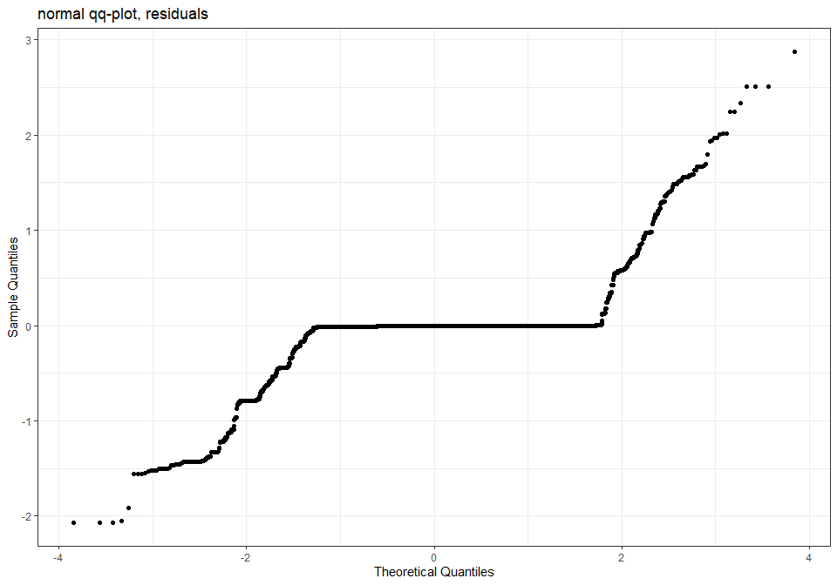
qqline(resid(m5$mer)) ## not bad
## mapping: intercept = ~intercept, slope = ~slope
## geom_abline: na.rm = FALSE
## stat_identity: na.rm = FALSE
## position_identity
plot(fitted(m5$mer), resid(m5$mer), main = "Residuals vs fitted") #residuals vs fitted
abline(h=0)
ran <- ranef(m5$mer, condVar=TRUE)
a <- dotplot(ran)[["SSB"]]
b <- dotplot(ran)[["SS"]]
grid.arrange(a,b, nrow=2, ncol=1)
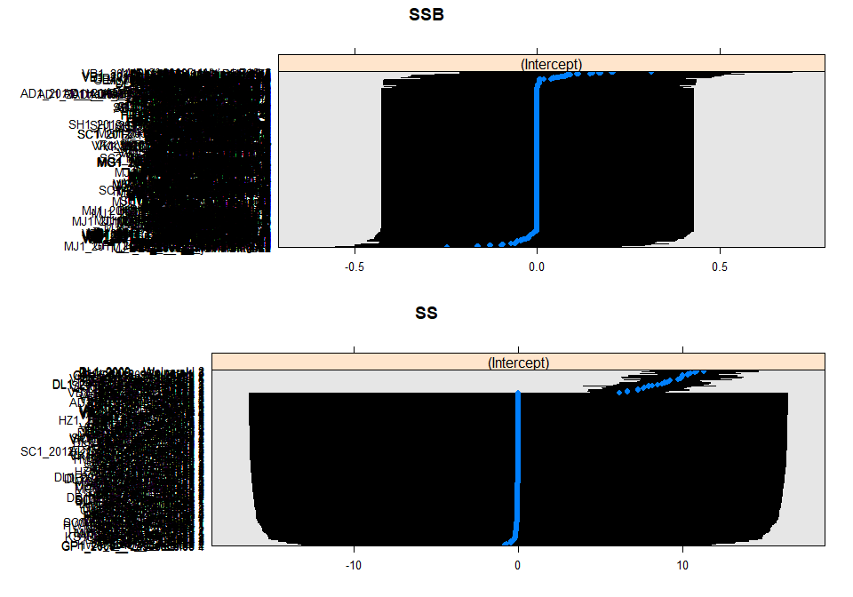
Plotting the model:
m5.2 <- gamm4V(Freq ~ s(Longitude, Latitude) + Use_intensity,
random = ~(1|SS) + (1|SSB), data = model_data, family = poisson)
plot.gamViz(m5.2, select = 2, xlab="Land use intensity") +
labs(title = NULL) +
xlab("Land use intensity") +
ylab("Change in fire frequency") +
theme_classic()
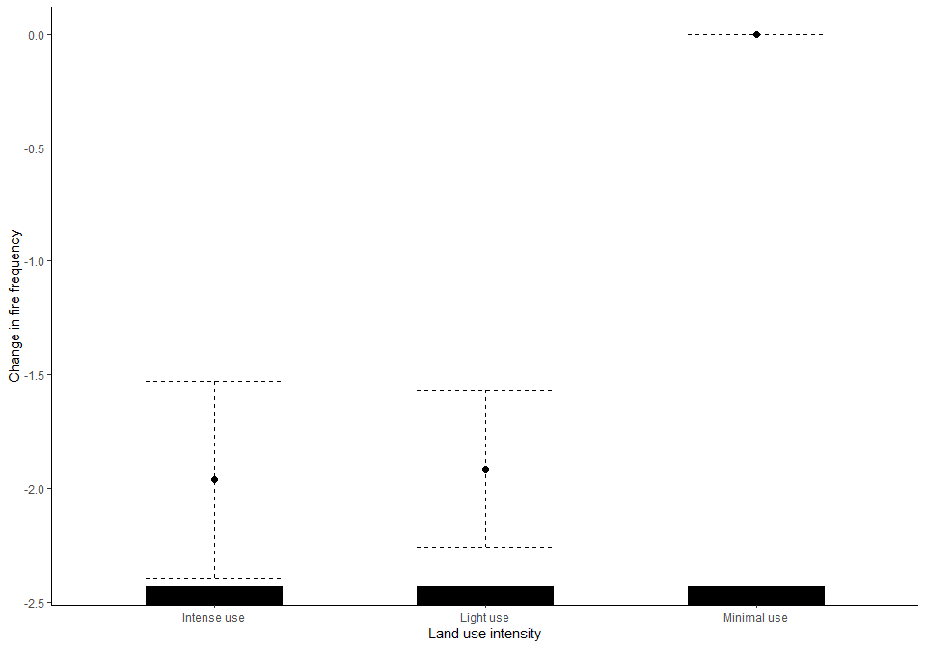

Savanna frequency models
Data set up:
Savanna_data <- subset(model_data, model_data$Biome == "Tropical & Subtropical Grasslands, Savannas & Shrublands")
Savanna_data$Landuse <- Savanna_data$Predominant_land_use
Savanna_data <- Savanna_data %>%
mutate(Landuse = recode_factor(Landuse, "Young secondary vegetation" = "Secondary vegetation",
"Older secondary vegetation" = "Secondary vegetation"),
Landuse = factor(Landuse),
Landuse = relevel(Landuse, ref = "Primary vegetation"))
Savanna_data$Landuse <- factor(Savanna_data$Landuse, levels = c("Primary vegetation",
"Secondary vegetation",
"Cropland",
"Pasture"))
Savanna_data <- Savanna_data %>%
mutate(
Use_intensity_2 = recode_factor(Use_intensity,
"Light use" = "Greater use",
"Intense use" = "Greater use"),
Use_intensity_2 = factor(Use_intensity_2),
Use_intensity_2 = relevel(Use_intensity_2, ref = "Minimal use")
)

Model selection
Maximal model:
max <- glmer(Freq ~ Landuse + Use_intensity_2 + Landuse:Use_intensity_2 +
(1|SS) + (1|SSB), data = Savanna_data, family = poisson)
## Warning in checkConv(attr(opt, "derivs"), opt$par, ctrl = control$checkConv, : unable to evaluate scaled
## gradient
## Warning in checkConv(attr(opt, "derivs"), opt$par, ctrl = control$checkConv, : Model failed to converge:
## degenerate Hessian with 1 negative eigenvalues
Model fails to converge. So, trying more aggregated classes to fit the interaction as there likely isn’t enough data in each category.
Savanna_data <- Savanna_data %>%
mutate(Landuse2 = recode_factor(Landuse, "Cropland" = "Agriculture",
"Pasture" = "Agriculture"),
Landuse2 = factor(Landuse2),
Landuse2 = relevel(Landuse2, ref = "Primary vegetation"))
Savanna_data$Landuse2 <- factor(Savanna_data$Landuse2, levels = c("Primary vegetation",
"Secondary vegetation",
"Agriculture"))
max.1 <- glmer(Freq ~ Landuse2 + Use_intensity_2 + Landuse2:Use_intensity_2 +
(1|SS) + (1|SSB), data = Savanna_data, family = poisson)
Anova(max.1)
## Analysis of Deviance Table (Type II Wald chisquare tests)
##
## Response: Freq
## Chisq Df Pr(>Chisq)
## Landuse2 2.0742 2 0.3545
## Use_intensity_2 53.7546 1 2.272e-13 ***
## Landuse2:Use_intensity_2 3.2951 2 0.1925
## ---
## Signif. codes: 0 '***' 0.001 '**' 0.01 '*' 0.05 '.' 0.1 ' ' 1
summary(max.1)
## Generalized linear mixed model fit by maximum likelihood (Laplace Approximation) ['glmerMod']
## Family: poisson ( log )
## Formula: Freq ~ Landuse2 + Use_intensity_2 + Landuse2:Use_intensity_2 + (1 | SS) + (1 | SSB)
## Data: Savanna_data
##
## AIC BIC logLik deviance df.resid
## 1674.2 1714.0 -829.1 1658.2 1054
##
## Scaled residuals:
## Min 1Q Median 3Q Max
## -1.4742 -0.2135 -0.0649 0.0124 5.1987
##
## Random effects:
## Groups Name Variance Std.Dev.
## SSB (Intercept) 0.03082 0.1756
## SS (Intercept) 7.16244 2.6763
## Number of obs: 1062, groups: SSB, 87; SS, 24
##
## Fixed effects:
## Estimate Std. Error z value Pr(>|z|)
## (Intercept) -1.3580 0.6640 -2.045 0.0409 *
## Landuse2Secondary vegetation -1.9675 1.1120 -1.769 0.0768 .
## Landuse2Agriculture -0.3536 0.4927 -0.718 0.4729
## Use_intensity_2Greater use -1.8923 0.2565 -7.376 1.63e-13 ***
## Landuse2Secondary vegetation:Use_intensity_2Greater use 1.9984 1.1115 1.798 0.0722 .
## Landuse2Agriculture:Use_intensity_2Greater use 0.1792 0.5286 0.339 0.7346
## ---
## Signif. codes: 0 '***' 0.001 '**' 0.01 '*' 0.05 '.' 0.1 ' ' 1
##
## Correlation of Fixed Effects:
## (Intr) Lnd2Sv Lnds2A U__2Gu L2Sv:u
## Lnds2Scndrv -0.030
## Lnds2Agrclt -0.059 0.003
## Us_ntns_2Gu -0.069 0.181 0.020
## L2Sv:U__2Gu 0.030 -0.995 -0.004 -0.196
## Ln2A:U__2Gu 0.069 -0.041 -0.937 -0.254 0.050
The interaction between land use and use intensity is not significant therefore I can remove this element from the model.
max.2 <- glmer(Freq ~ Landuse + Use_intensity +
(1|SS) + (1|SSB), data = Savanna_data, family = poisson)
Checking if significant explanatory power has been lost.
anova(max.2, max.1)
## Data: Savanna_data
## Models:
## max.2: Freq ~ Landuse + Use_intensity + (1 | SS) + (1 | SSB)
## max.1: Freq ~ Landuse2 + Use_intensity_2 + Landuse2:Use_intensity_2 +
## max.1: (1 | SS) + (1 | SSB)
## npar AIC BIC logLik deviance Chisq Df Pr(>Chisq)
## max.2 8 1669.6 1709.3 -826.78 1653.6
## max.1 8 1674.2 1714.0 -829.11 1658.2 0 0 1
No significant explanatory power lost

Looking at the selected model:
savanna_mod <- glmer(Freq ~ Landuse + Use_intensity +
(1|SS) + (1|SSB), data = Savanna_data, family = poisson)
Anova(savanna_mod)
## Analysis of Deviance Table (Type II Wald chisquare tests)
##
## Response: Freq
## Chisq Df Pr(>Chisq)
## Landuse 11.362 3 0.009919 **
## Use_intensity 23.151 2 9.394e-06 ***
## ---
## Signif. codes: 0 '***' 0.001 '**' 0.01 '*' 0.05 '.' 0.1 ' ' 1
summary(savanna_mod)
## Generalized linear mixed model fit by maximum likelihood (Laplace Approximation) ['glmerMod']
## Family: poisson ( log )
## Formula: Freq ~ Landuse + Use_intensity + (1 | SS) + (1 | SSB)
## Data: Savanna_data
##
## AIC BIC logLik deviance df.resid
## 1669.6 1709.3 -826.8 1653.6 1054
##
## Scaled residuals:
## Min 1Q Median 3Q Max
## -1.4880 -0.1835 -0.0663 -0.0234 5.2511
##
## Random effects:
## Groups Name Variance Std.Dev.
## SSB (Intercept) 0.01938 0.1392
## SS (Intercept) 6.53760 2.5569
## Number of obs: 1062, groups: SSB, 87; SS, 24
##
## Fixed effects:
## Estimate Std. Error z value Pr(>|z|)
## (Intercept) -1.51415 0.63557 -2.382 0.0172 *
## LanduseSecondary vegetation 0.04512 0.11283 0.400 0.6892
## LanduseCropland -1.31534 0.39975 -3.290 0.0010 **
## LandusePasture -0.87893 0.38443 -2.286 0.0222 *
## Use_intensityLight use -0.77050 0.38324 -2.010 0.0444 *
## Use_intensityIntense use -1.64980 0.34321 -4.807 1.53e-06 ***
## ---
## Signif. codes: 0 '***' 0.001 '**' 0.01 '*' 0.05 '.' 0.1 ' ' 1
##
## Correlation of Fixed Effects:
## (Intr) LndsSv LndsCr LndsPs Us_nLu
## LndsScndryv -0.015
## LandsCrplnd 0.056 -0.004
## LandusePstr 0.024 0.051 0.543
## Us_ntnstyLu -0.078 0.008 -0.872 -0.574
## Us_ntnstyIu -0.058 -0.057 -0.348 0.341 0.457
Increased land use intensity reduces fire frequency, and agricultural land uses result in lower fire frequency.
Diagnostics:
savanna_output <- simulateResiduals(savanna_mod)
plot(savanna_output)
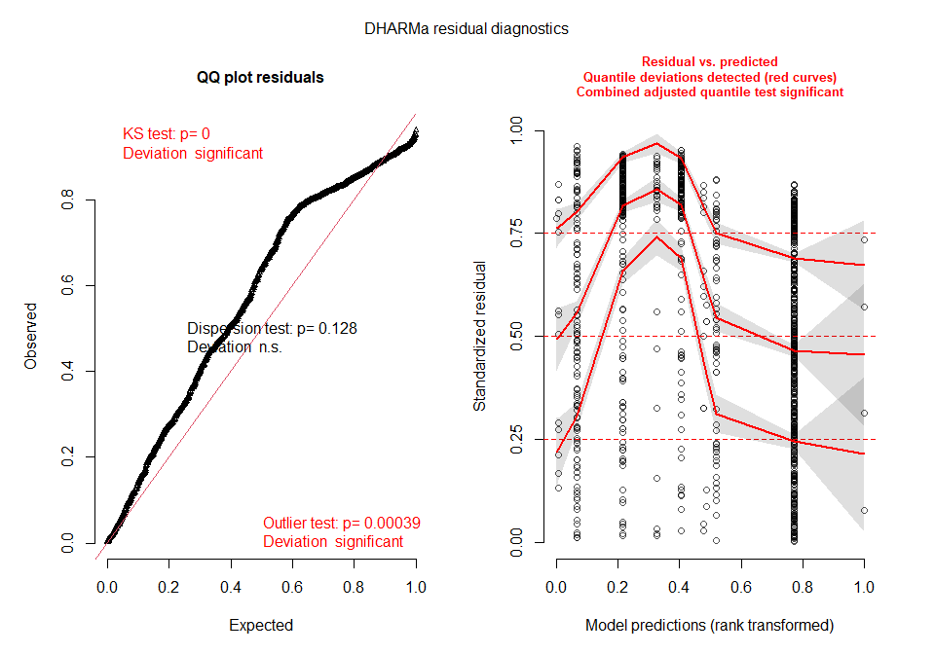 No over dispersion but do have issues with normality and outliers
check_overdispersion(savanna_mod) #No overdispersion.
## # Overdispersion test
##
## dispersion ratio = 0.421
## Pearson's Chi-Squared = 443.968
## p-value = 1
## No overdispersion detected.
Residuals
residuals <- resid(savanna_mod)
summary(residuals)
## Min. 1st Qu. Median Mean 3rd Qu. Max.
## -2.10438 -0.25471 -0.09375 -0.14387 -0.02345 2.99715
hist(residuals)
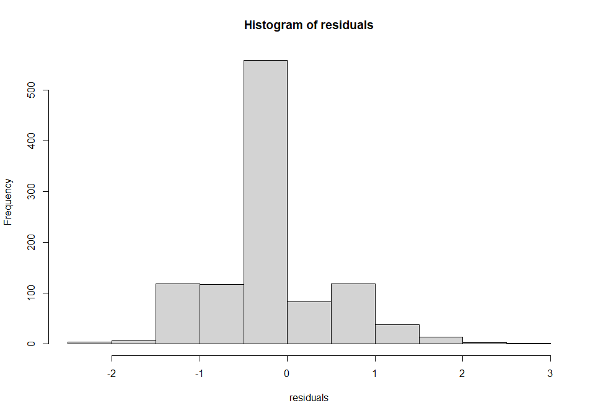
par(mfrow=c(1,2))
qqnorm(resid(savanna_mod), main="normal qq-plot, residuals")
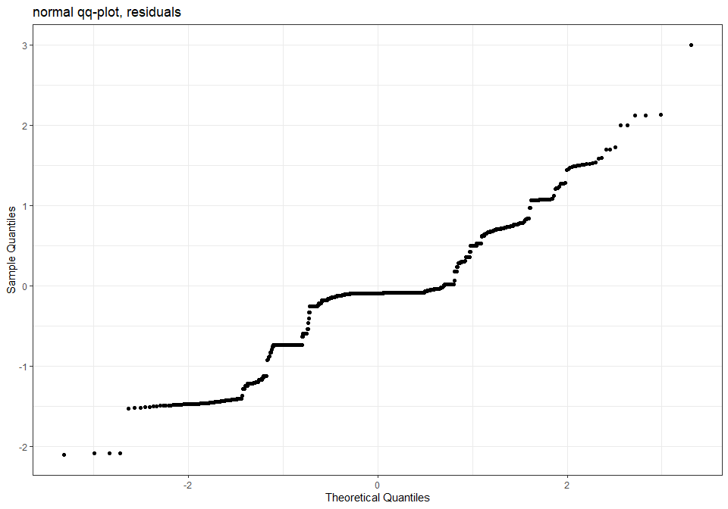
qqline(resid(savanna_mod)) ## not bad
## mapping: intercept = ~intercept, slope = ~slope
## geom_abline: na.rm = FALSE
## stat_identity: na.rm = FALSE
## position_identity
plot(fitted(savanna_mod), resid(savanna_mod), main = "Residuals vs fitted") #residuals vs fitted
abline(h=0)
ran <- ranef(savanna_mod, condVar=TRUE)
a <- dotplot(ran)[["SSB"]]
b <- dotplot(ran)[["SS"]]
grid.arrange(a,b, nrow=2, ncol=1)
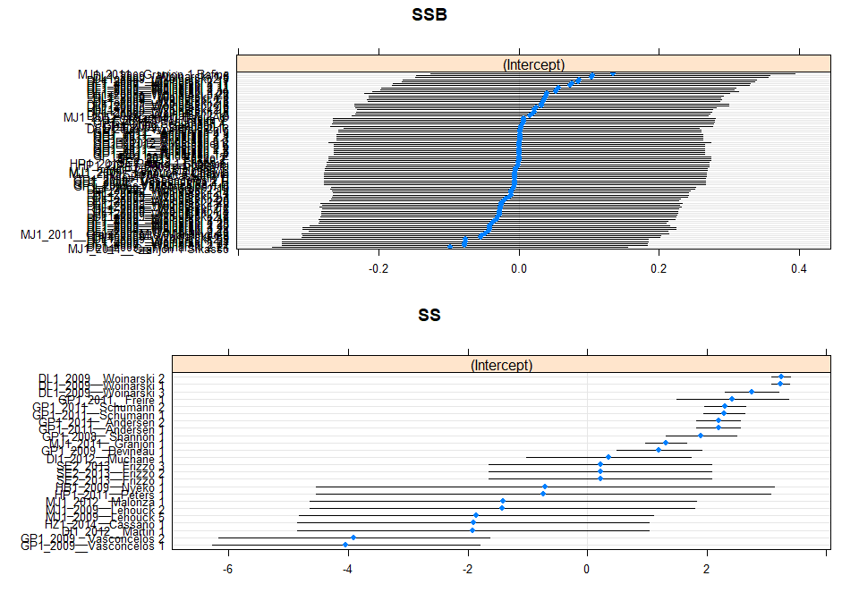
Plot:
set_theme(base = theme_classic(), axis.angle.x = 5, axis.textsize.x = 0.9)
LU <- plot_model(savanna_mod, type = "pred", terms = c("Landuse"), show.intercept = TRUE,
axis.title = c("Predominant land use", "Frequency of fires"),
title = "", axis.lim = c(0,0.9))
## Scale for 'y' is already present. Adding another scale for 'y', which will replace the existing scale.
UI <- plot_model(savanna_mod, type = "pred", terms = c("Use_intensity"), show.intercept = TRUE,
axis.title = c("Land use intensity", "Frequency of fires"),
title = "", axis.lim = c(0,0.9))
## Scale for 'y' is already present. Adding another scale for 'y', which will replace the existing scale.
ggarrange(LU, UI +
theme(axis.text.y = element_blank(),
axis.ticks.y = element_blank(),
axis.title.y = element_blank()),
labels = c("A", "B"))
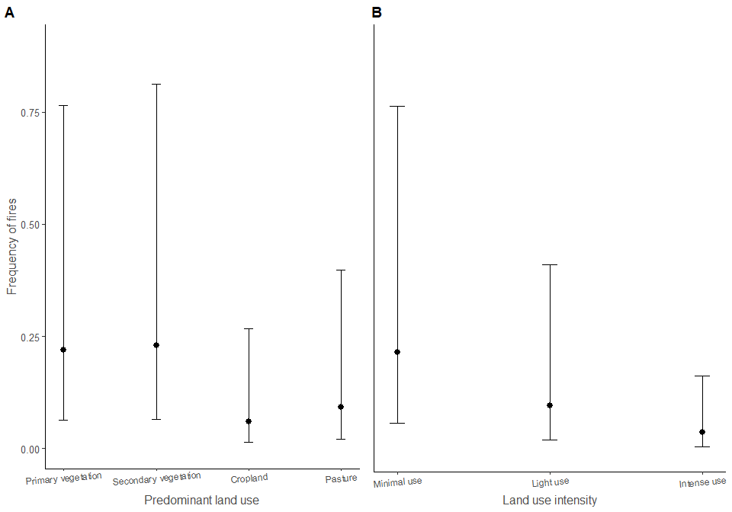
R2:
r.squaredGLMM(savanna_mod)
## Warning: 'r.squaredGLMM' now calculates a revised statistic. See the help page.
## Warning: The null model is correct only if all variables used by the original model remain unchanged.
## R2m R2c
## delta 0.09387374 0.9173575
## lognormal 0.09570556 0.9352585
## trigamma 0.09089729 0.8882709

