Global models of species richness

Data:
diversity <- readRDS("~/Imperial/PROJECT/PREDICTS data/database.rds")
fire_hist <- read.csv("~/Imperial/PROJECT/Combined data/Fire_history.csv")

Data preparation:
diversity <- mutate(diversity,
Measurement = Effort_corrected_measurement,
Sampling_effort = Rescaled_sampling_effort)
## Calculate diversity level metrics - calculated rescaled abundance
sites <- diversity %>%
# add Diversity_metric_is_valid column
mutate(Diversity_metric_is_valid = TRUE) %>%
# calculate SiteMetrics
predictsFunctions::SiteMetrics(extra.cols = c("SSB", "SSBS", "Predominant_land_use", "Biome", "Country")) %>%
# calculate the total abundance within each study
group_by(SS) %>%
mutate(MaxAbundance = ifelse(Diversity_metric_type == "Abundance",
max(Total_abundance),
NA)) %>%
ungroup() %>%
# now calculate the rescaled abundance (abundance divided by the maximum within each study)
mutate(RescaledAbundance = ifelse(Diversity_metric_type == "Abundance",
Total_abundance/MaxAbundance,
NA))
## Computing site metrics for 3250404 measurements
## The data contain 480 sources, 666 studies and 26112 sites
## Computing site-level values
## Computing total abundance
## Computing species richness
## Assembling site-level values
## Predominant land use
sites <- sites %>%
mutate(
# collapse primary forest and non-forest together into primary vegetation as these aren't well
#distinguished
Predominant_land_use = recode_factor(Predominant_land_use,
"Primary forest" = "Primary vegetation",
"Primary non-forest" = "Primary vegetation"),
# indeterminate secondary veg and cannot decide get NA
Predominant_land_use = na_if(Predominant_land_use, "Secondary vegetation (indeterminate age)"),
Predominant_land_use = na_if(Predominant_land_use, "Cannot decide"),
Use_intensity = na_if(Use_intensity, "Cannot decide"),
# set reference levels
Predominant_land_use = factor(Predominant_land_use),
Predominant_land_use = relevel(Predominant_land_use, ref = "Primary vegetation"),
Use_intensity = factor(Use_intensity),
Use_intensity = relevel(Use_intensity, ref = "Minimal use")
)
## For my analysis I need to subset so that all sites are after 2006 (so that we can have 3yrs of
#fire data)
sites_post_2006 <- subset(sites, sites$Sample_start_earliest > "2006-01-01")
## Removing rows that have NAs in latitude and longitude as these won't have fire data
sites_post_2006_NA <- subset(sites_post_2006, (! is.na(Longitude) | ! is.na(Latitude)))
## Merge with fire data
PREDICTS_fire_hist <- merge(sites_post_2006_NA, fire_hist
[,c("SSBS", "Freq", "fire_ID", "size", "start_date", "duration", "days_since_fire", "year", "years_since_fire")], by="SSBS", all.x=TRUE)
## Change freq from NA to 0
PREDICTS_fire_hist$Freq[is.na(PREDICTS_fire_hist$Freq)] <- 0
## Adding a column of fire presence
PREDICTS_fire_hist$fire_presence <- ifelse(PREDICTS_fire_hist$Freq==0, "No",
ifelse(PREDICTS_fire_hist$Freq!=0, "Yes",
NA))
PREDICTS_fire_hist$fire_presence <- as.factor(PREDICTS_fire_hist$fire_presence)
Remove NAs in the model variables:
model_data <- drop_na(PREDICTS_fire_hist, Species_richness, Predominant_land_use, Use_intensity, fire_presence)
Biomes
table(model_data$Biome, model_data$fire_presence)
##
## No Yes
## Tundra 21 0
## Boreal Forests/Taiga 485 8
## Temperate Conifer Forests 259 0
## Temperate Broadleaf & Mixed Forests 3511 7
## Montane Grasslands & Shrublands 318 38
## Temperate Grasslands, Savannas & Shrublands 614 0
## Mediterranean Forests, Woodlands & Scrub 486 4
## Deserts & Xeric Shrublands 139 5
## Tropical & Subtropical Grasslands, Savannas & Shrublands 666 456
## Tropical & Subtropical Coniferous Forests 336 0
## Flooded Grasslands & Savannas 0 0
## Tropical & Subtropical Dry Broadleaf Forests 164 0
## Tropical & Subtropical Moist Broadleaf Forests 2566 24
## Mangroves 14 0
## Inland Water 0 0
## Rock & Ice 0 0
Need to aggregate biomes together to be more representative. First remove the empty levels or where there are two little data, and then aggregate into two new classifications forest/non forest and coarser global biomes.
## remove the levels with no data/Can't have fires
model_data<-model_data[!(model_data$Biome == "Rock & Ice"),]
model_data<-model_data[!(model_data$Biome == "Flooded Grasslands & Savannas"),]
model_data<-model_data[!(model_data$Biome == "Mangroves"),]
model_data<-model_data[!(model_data$Biome == "Inland Water"),]
model_data<-model_data[!(model_data$Biome == "Tundra"),]
model_data$Biome <- as.factor(as.character(model_data$Biome))
## Forest vs non forest:
model_data$adj.biome <- ifelse(model_data$Biome=="Boreal Forests/Taiga", "Forest",
ifelse(model_data$Biome=="Temperate Conifer Forests", "Forest",
ifelse(model_data$Biome=="Temperate Broadleaf & Mixed Forests", "Forest",
ifelse(model_data$Biome=="Montane Grasslands & Shrublands", "Non Forest",
ifelse(model_data$Biome=="Temperate Grasslands, Savannas & Shrublands", "Non Forest",
ifelse(model_data$Biome=="Mediterranean Forests, Woodlands & Scrub", "Forest",
ifelse(model_data$Biome=="Deserts & Xeric Shrublands", "Non Forest",
ifelse(model_data$Biome=="Tropical & Subtropical Grasslands, Savannas & Shrublands", "Non Forest",
ifelse(model_data$Biome=="Tropical & Subtropical Coniferous Forests", "Forest",
ifelse(model_data$Biome=="Tropical & Subtropical Dry Broadleaf Forests", "Forest",
ifelse(model_data$Biome=="Tropical & Subtropical Moist Broadleaf Forests", "Forest",
NA)))))))))))
model_data$adj.biome <- as.factor(model_data$adj.biome)
## More representative biome spilts
model_data$new.biome <- model_data$Biome
model_data <- model_data %>%
mutate(
new.biome = recode_factor(new.biome,
"Deserts & Xeric Shrublands" = "Deserts, Shrublands and Grasslands",
"Montane Grasslands & Shrublands" = "Deserts, Shrublands and Grasslands",
"Temperate Grasslands, Savannas & Shrublands" = "Deserts, Shrublands and Grasslands",
"Temperate Broadleaf & Mixed Forests" = "Temperate Forest",
"Temperate Conifer Forests" = "Temperate Forest",
"Tropical & Subtropical Coniferous Forests" = "Tropical & Subtropical Forest",
"Tropical & Subtropical Dry Broadleaf Forests" = "Tropical & Subtropical Forest",
"Tropical & Subtropical Moist Broadleaf Forests" = "Tropical & Subtropical Forest")
)
model_data$new.biome <- as.factor(as.character(model_data$new.biome))
Land use
table(model_data$Predominant_land_use, model_data$fire_presence)
##
## No Yes
## Primary vegetation 3934 326
## Young secondary vegetation 588 108
## Intermediate secondary vegetation 643 33
## Mature secondary vegetation 305 3
## Plantation forest 1346 5
## Pasture 1373 38
## Cropland 749 27
## Urban 606 2
There is a lack of data in the urban and plantation land uses so these will be removed. Mature and intermediate secondary vegetation will be merged together.
model_data<- drop_na(model_data, Predominant_land_use)
model_data<-model_data[!(model_data$Predominant_land_use == "Plantation forest"),]
model_data<-model_data[!(model_data$Predominant_land_use == "Urban"),]
model_data$Predominant_land_use <- as.factor(as.character(model_data$Predominant_land_use))
model_data <- model_data %>%
mutate( Predominant_land_use = recode_factor(Predominant_land_use,
"Intermediate secondary vegetation" = "Older secondary vegetation",
"Mature secondary vegetation" = "Older secondary vegetation"),
Predominant_land_use = factor(Predominant_land_use),
Predominant_land_use = relevel(Predominant_land_use, ref = "Primary vegetation")
)
model_data$Predominant_land_use <- factor(model_data$Predominant_land_use, levels = c("Primary vegetation", "Young secondary vegetation", "Older secondary vegetation",
"Cropland", "Pasture"))

Assumption checking before modelling
Collinearity
corvif(model_data[ , c("Predominant_land_use", "Use_intensity", "fire_presence")])
##
##
## Variance inflation factors
##
## GVIF Df GVIF^(1/2Df)
## Predominant_land_use 1.234515 4 1.026685
## Use_intensity 1.308230 2 1.069476
## fire_presence 1.106210 1 1.051765
All GVIF values are low suggesting low collinearity between variables.
Complete cases
model_data <- drop_na(model_data, Species_richness, Predominant_land_use, Use_intensity, fire_presence)
Normality in the response variable
par(mfrow=c(1,2))
hist(model_data$Species_richness, xlab="Species richness", main="Histogram of species richness")
qqnorm(model_data$Species_richness)
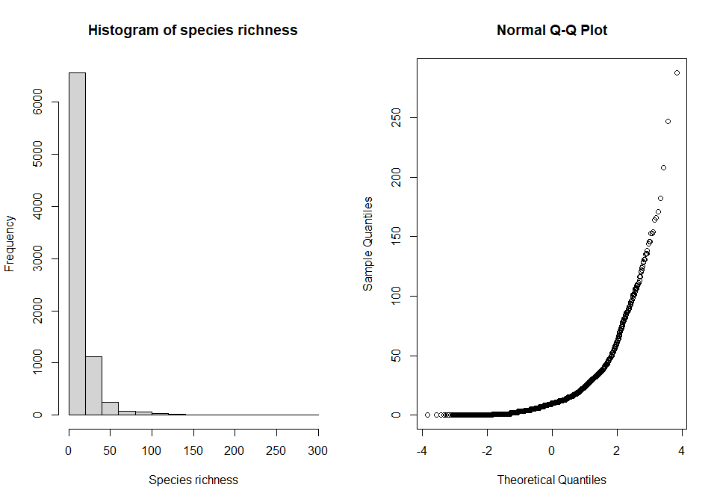
At present there is a very skewed distribution, and non-normality therefore it will be modelled using Poisson errors.

Starting model
m1 <- glmer(Species_richness ~ Predominant_land_use + Use_intensity + fire_presence +
Predominant_land_use:Use_intensity + Predominant_land_use:fire_presence +
(1|SS) + (1|SSB) + (1|Biome), data = model_data, family = poisson)
Breif look at the model:
Anova(m1)
## Analysis of Deviance Table (Type II Wald chisquare tests)
##
## Response: Species_richness
## Chisq Df Pr(>Chisq)
## Predominant_land_use 588.1292 4 < 2.2e-16 ***
## Use_intensity 37.9280 2 5.808e-09 ***
## fire_presence 0.3277 1 0.567
## Predominant_land_use:Use_intensity 253.6284 8 < 2.2e-16 ***
## Predominant_land_use:fire_presence 48.4822 4 7.487e-10 ***
## ---
## Signif. codes: 0 '***' 0.001 '**' 0.01 '*' 0.05 '.' 0.1 ' ' 1
summary(m1)
## Generalized linear mixed model fit by maximum likelihood (Laplace Approximation) ['glmerMod']
## Family: poisson ( log )
## Formula: Species_richness ~ Predominant_land_use + Use_intensity + fire_presence +
## Predominant_land_use:Use_intensity + Predominant_land_use:fire_presence +
## (1 | SS) + (1 | SSB) + (1 | Biome)
## Data: model_data
##
## AIC BIC logLik deviance df.resid
## 47659.3 47820.4 -23806.7 47613.3 8104
##
## Scaled residuals:
## Min 1Q Median 3Q Max
## -6.2127 -0.7611 -0.0515 0.6234 11.8050
##
## Random effects:
## Groups Name Variance Std.Dev.
## SSB (Intercept) 0.05207 0.2282
## SS (Intercept) 1.21667 1.1030
## Biome (Intercept) 0.02969 0.1723
## Number of obs: 8127, groups: SSB, 743; SS, 247; Biome, 11
##
## Fixed effects:
## Estimate Std. Error z value Pr(>|z|)
## (Intercept) 2.45176 0.09186 26.690 < 2e-16
## Predominant_land_useYoung secondary vegetation -0.10832 0.01908 -5.677 1.37e-08
## Predominant_land_useOlder secondary vegetation 0.11311 0.01944 5.819 5.93e-09
## Predominant_land_useCropland -0.19192 0.02861 -6.708 1.97e-11
## Predominant_land_usePasture 0.03382 0.02091 1.617 0.10580
## Use_intensityLight use 0.04835 0.01633 2.961 0.00307
## Use_intensityIntense use 0.12738 0.02340 5.443 5.24e-08
## fire_presenceYes 0.00215 0.02826 0.076 0.93935
## Predominant_land_useYoung secondary vegetation:Use_intensityLight use -0.05055 0.04137 -1.222 0.22180
## Predominant_land_useOlder secondary vegetation:Use_intensityLight use -0.11549 0.02692 -4.290 1.79e-05
## Predominant_land_useCropland:Use_intensityLight use -0.15565 0.04251 -3.662 0.00025
## Predominant_land_usePasture:Use_intensityLight use -0.15690 0.02515 -6.240 4.38e-10
## Predominant_land_useYoung secondary vegetation:Use_intensityIntense use -0.20475 0.03887 -5.268 1.38e-07
## Predominant_land_useOlder secondary vegetation:Use_intensityIntense use -0.51619 0.09515 -5.425 5.79e-08
## Predominant_land_useCropland:Use_intensityIntense use -0.67815 0.04901 -13.837 < 2e-16
## Predominant_land_usePasture:Use_intensityIntense use -0.36024 0.04123 -8.738 < 2e-16
## Predominant_land_useYoung secondary vegetation:fire_presenceYes 0.09195 0.05099 1.803 0.07137
## Predominant_land_useOlder secondary vegetation:fire_presenceYes -0.04018 0.08924 -0.450 0.65253
## Predominant_land_useCropland:fire_presenceYes 0.17566 0.19820 0.886 0.37547
## Predominant_land_usePasture:fire_presenceYes -0.44197 0.07137 -6.193 5.90e-10
##
## (Intercept) ***
## Predominant_land_useYoung secondary vegetation ***
## Predominant_land_useOlder secondary vegetation ***
## Predominant_land_useCropland ***
## Predominant_land_usePasture
## Use_intensityLight use **
## Use_intensityIntense use ***
## fire_presenceYes
## Predominant_land_useYoung secondary vegetation:Use_intensityLight use
## Predominant_land_useOlder secondary vegetation:Use_intensityLight use ***
## Predominant_land_useCropland:Use_intensityLight use ***
## Predominant_land_usePasture:Use_intensityLight use ***
## Predominant_land_useYoung secondary vegetation:Use_intensityIntense use ***
## Predominant_land_useOlder secondary vegetation:Use_intensityIntense use ***
## Predominant_land_useCropland:Use_intensityIntense use ***
## Predominant_land_usePasture:Use_intensityIntense use ***
## Predominant_land_useYoung secondary vegetation:fire_presenceYes .
## Predominant_land_useOlder secondary vegetation:fire_presenceYes
## Predominant_land_useCropland:fire_presenceYes
## Predominant_land_usePasture:fire_presenceYes ***
## ---
## Signif. codes: 0 '***' 0.001 '**' 0.01 '*' 0.05 '.' 0.1 ' ' 1
##
## Correlation matrix not shown by default, as p = 20 > 12.
## Use print(x, correlation=TRUE) or
## vcov(x) if you need it

Model criticism
m1_output <- simulateResiduals(fittedModel = m1, n = 250)
plot(m1_output)
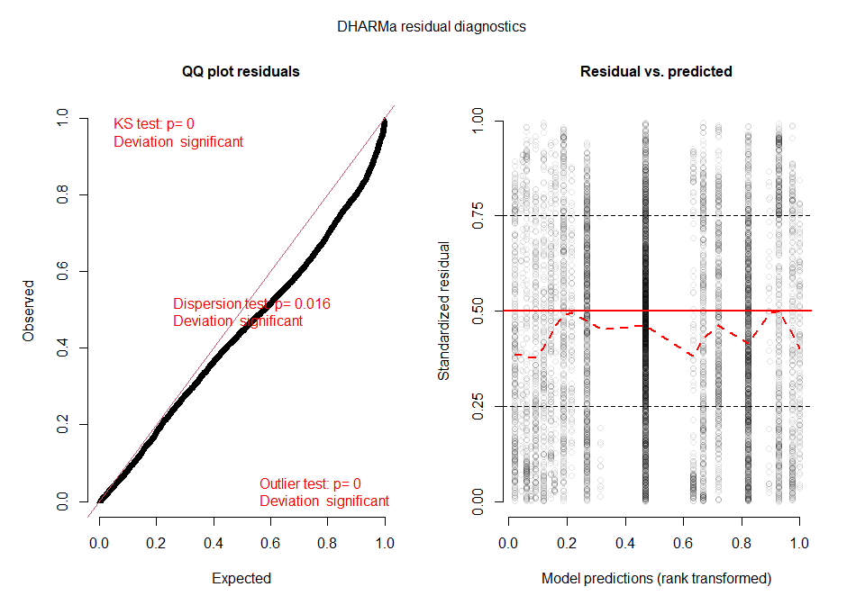
Based off these plots there is likely some overdispersion in the data. Test for over dispersion:
testDispersion(m1_output)
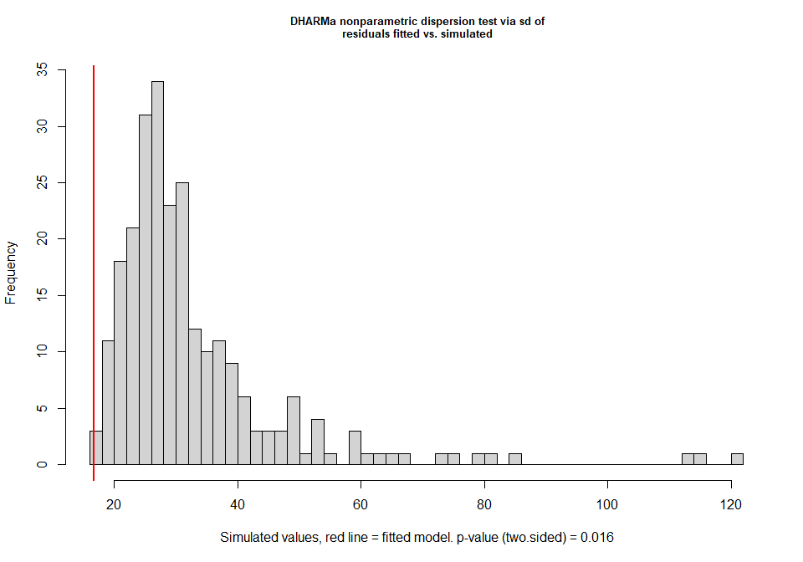
##
## DHARMa nonparametric dispersion test via sd of residuals fitted vs. simulated
##
## data: simulationOutput
## ratioObsSim = 0.51017, p-value = 0.016
## alternative hypothesis: two.sided
check_overdispersion(m1)
## # Overdispersion test
##
## dispersion ratio = 1.567
## Pearson's Chi-Squared = 12696.062
## p-value = < 0.001
## Overdispersion detected.
The test implies there is overdispersion in the data. We can try and correct for this by fitting a site level random effect to create a quasipoisson model:
m2 <- glmer(Species_richness ~ Predominant_land_use + Use_intensity + fire_presence +
Predominant_land_use:Use_intensity + Predominant_land_use:fire_presence +
(1|SS) + (1|SSB) + (1|Biome)+ (1|SSBS), data = model_data, family = poisson)
## Warning in checkConv(attr(opt, "derivs"), opt$par, ctrl = control$checkConv, : Model failed to converge with
## max|grad| = 0.00586603 (tol = 0.002, component 1)
However, this model fails to converge. Going to check if this is a false positive result or not:
m2_check <- with(m2@optinfo$derivs,solve(Hessian,gradient))
max(abs(m2_check))
## [1] 0.0003968403
Implies that there is a false positive result. Try refitting the model with different optimizers:
m2_allfit <- allFit(m2, data = model_data)
## bobyqa : [OK]
## Nelder_Mead :
## Warning in checkConv(attr(opt, "derivs"), opt$par, ctrl = control$checkConv, : Model failed to converge with
## max|grad| = 0.00776951 (tol = 0.002, component 1)
## [OK]
## nlminbwrap : [OK]
## nmkbw :
## Warning in checkConv(attr(opt, "derivs"), opt$par, ctrl = control$checkConv, : Model failed to converge with
## max|grad| = 0.00344004 (tol = 0.002, component 1)
## [OK]
## optimx.L-BFGS-B :
## Warning in checkConv(attr(opt, "derivs"), opt$par, ctrl = control$checkConv, : Model failed to converge with
## max|grad| = 0.0125096 (tol = 0.002, component 1)
## [OK]
## nloptwrap.NLOPT_LN_NELDERMEAD : [OK]
## nloptwrap.NLOPT_LN_BOBYQA :
## Warning in checkConv(attr(opt, "derivs"), opt$par, ctrl = control$checkConv, : Model failed to converge with
## max|grad| = 0.0071307 (tol = 0.002, component 1)
## [OK]
m2_sum <- summary(m2_allfit)
m2_sum$which.OK
## bobyqa Nelder_Mead nlminbwrap
## TRUE TRUE TRUE
## nmkbw optimx.L-BFGS-B nloptwrap.NLOPT_LN_NELDERMEAD
## TRUE TRUE TRUE
## nloptwrap.NLOPT_LN_BOBYQA
## TRUE
This output implies that all of these models are Ok and do converge. Refit the model using a different optimizer
m2_refit <- glmer(Species_richness ~ Predominant_land_use + Use_intensity + fire_presence +
Predominant_land_use:Use_intensity + Predominant_land_use:fire_presence +
(1|SS) + (1|SSB) + (1|Biome)+ (1|SSBS), data = model_data, family = poisson,
control = glmerControl(optimizer = "bobyqa"))
Anova(m2_refit)
## Analysis of Deviance Table (Type II Wald chisquare tests)
##
## Response: Species_richness
## Chisq Df Pr(>Chisq)
## Predominant_land_use 317.456 4 < 2.2e-16 ***
## Use_intensity 31.986 2 1.133e-07 ***
## fire_presence 0.862 1 0.3532
## Predominant_land_use:Use_intensity 119.879 8 < 2.2e-16 ***
## Predominant_land_use:fire_presence 34.114 4 7.060e-07 ***
## ---
## Signif. codes: 0 '***' 0.001 '**' 0.01 '*' 0.05 '.' 0.1 ' ' 1
summary(m2_refit)
## Generalized linear mixed model fit by maximum likelihood (Laplace Approximation) ['glmerMod']
## Family: poisson ( log )
## Formula: Species_richness ~ Predominant_land_use + Use_intensity + fire_presence +
## Predominant_land_use:Use_intensity + Predominant_land_use:fire_presence +
## (1 | SS) + (1 | SSB) + (1 | Biome) + (1 | SSBS)
## Data: model_data
## Control: glmerControl(optimizer = "bobyqa")
##
## AIC BIC logLik deviance df.resid
## 45899.0 46067.1 -22925.5 45851.0 8103
##
## Scaled residuals:
## Min 1Q Median 3Q Max
## -3.9311 -0.4952 -0.0177 0.3861 5.3684
##
## Random effects:
## Groups Name Variance Std.Dev.
## SSBS (Intercept) 0.05184 0.2277
## SSB (Intercept) 0.04112 0.2028
## SS (Intercept) 1.21315 1.1014
## Biome (Intercept) 0.02383 0.1544
## Number of obs: 8127, groups: SSBS, 8127; SSB, 743; SS, 247; Biome, 11
##
## Fixed effects:
## Estimate Std. Error z value Pr(>|z|)
## (Intercept) 2.44919 0.08935 27.410 < 2e-16
## Predominant_land_useYoung secondary vegetation -0.06353 0.03139 -2.024 0.043001
## Predominant_land_useOlder secondary vegetation 0.11275 0.03100 3.637 0.000276
## Predominant_land_useCropland -0.18740 0.04366 -4.292 1.77e-05
## Predominant_land_usePasture 0.02617 0.03071 0.852 0.394160
## Use_intensityLight use 0.04404 0.02307 1.909 0.056270
## Use_intensityIntense use 0.10581 0.03429 3.086 0.002029
## fire_presenceYes -0.02132 0.03889 -0.548 0.583549
## Predominant_land_useYoung secondary vegetation:Use_intensityLight use -0.05790 0.06491 -0.892 0.372361
## Predominant_land_useOlder secondary vegetation:Use_intensityLight use -0.08530 0.04056 -2.103 0.035461
## Predominant_land_useCropland:Use_intensityLight use -0.20715 0.06145 -3.371 0.000749
## Predominant_land_usePasture:Use_intensityLight use -0.16246 0.03539 -4.590 4.42e-06
## Predominant_land_useYoung secondary vegetation:Use_intensityIntense use -0.23072 0.05510 -4.187 2.83e-05
## Predominant_land_useOlder secondary vegetation:Use_intensityIntense use -0.61811 0.12394 -4.987 6.13e-07
## Predominant_land_useCropland:Use_intensityIntense use -0.62172 0.06765 -9.191 < 2e-16
## Predominant_land_usePasture:Use_intensityIntense use -0.34572 0.05701 -6.064 1.33e-09
## Predominant_land_useYoung secondary vegetation:fire_presenceYes 0.10573 0.06788 1.558 0.119313
## Predominant_land_useOlder secondary vegetation:fire_presenceYes 0.10839 0.12599 0.860 0.389646
## Predominant_land_useCropland:fire_presenceYes 0.20067 0.20348 0.986 0.324036
## Predominant_land_usePasture:fire_presenceYes -0.44106 0.08849 -4.984 6.23e-07
##
## (Intercept) ***
## Predominant_land_useYoung secondary vegetation *
## Predominant_land_useOlder secondary vegetation ***
## Predominant_land_useCropland ***
## Predominant_land_usePasture
## Use_intensityLight use .
## Use_intensityIntense use **
## fire_presenceYes
## Predominant_land_useYoung secondary vegetation:Use_intensityLight use
## Predominant_land_useOlder secondary vegetation:Use_intensityLight use *
## Predominant_land_useCropland:Use_intensityLight use ***
## Predominant_land_usePasture:Use_intensityLight use ***
## Predominant_land_useYoung secondary vegetation:Use_intensityIntense use ***
## Predominant_land_useOlder secondary vegetation:Use_intensityIntense use ***
## Predominant_land_useCropland:Use_intensityIntense use ***
## Predominant_land_usePasture:Use_intensityIntense use ***
## Predominant_land_useYoung secondary vegetation:fire_presenceYes
## Predominant_land_useOlder secondary vegetation:fire_presenceYes
## Predominant_land_useCropland:fire_presenceYes
## Predominant_land_usePasture:fire_presenceYes ***
## ---
## Signif. codes: 0 '***' 0.001 '**' 0.01 '*' 0.05 '.' 0.1 ' ' 1
##
## Correlation matrix not shown by default, as p = 20 > 12.
## Use print(x, correlation=TRUE) or
## vcov(x) if you need it
Checking the model for overdispersion and other issues:
check_overdispersion(m2_refit)
## # Overdispersion test
##
## dispersion ratio = 0.572
## Pearson's Chi-Squared = 4632.809
## p-value = 1
## No overdispersion detected.
No longer overdispersed.
Checking other diagnostics: Residuals vs fitted:
plot(m2_refit)
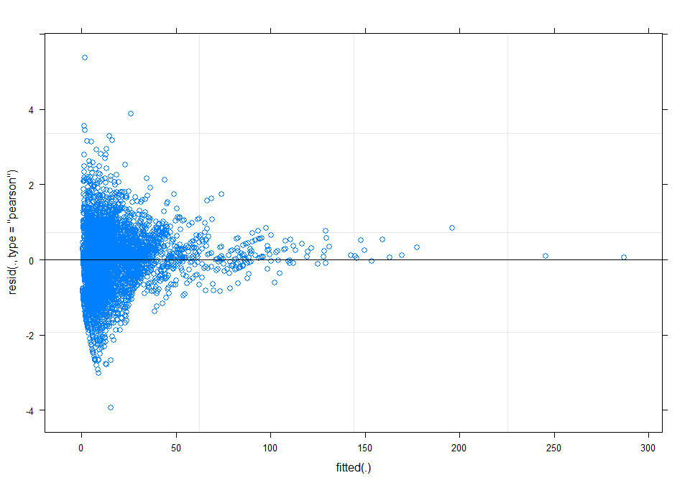
Normality of residuals:
qqnorm(resid(m2_refit), main="normal qq-plot, residuals")
qqline(resid(m2_refit))
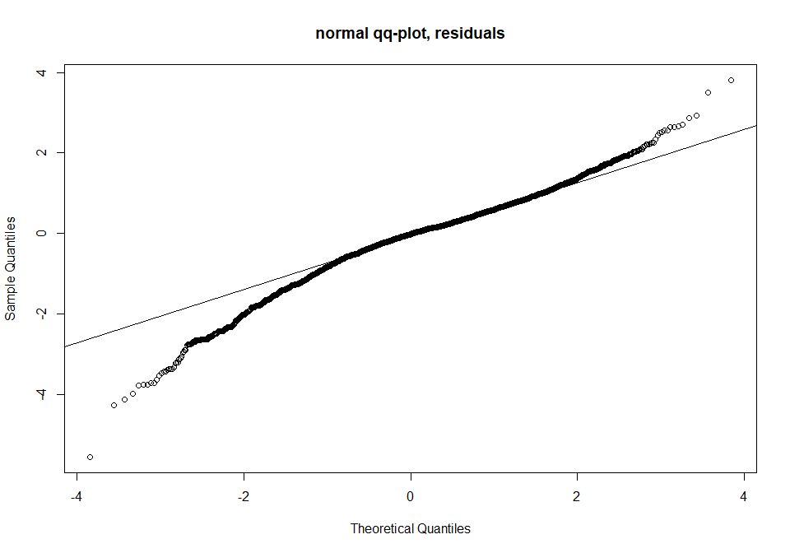
Random effects:
dotplot(ranef(m2_refit))
## $SSBS
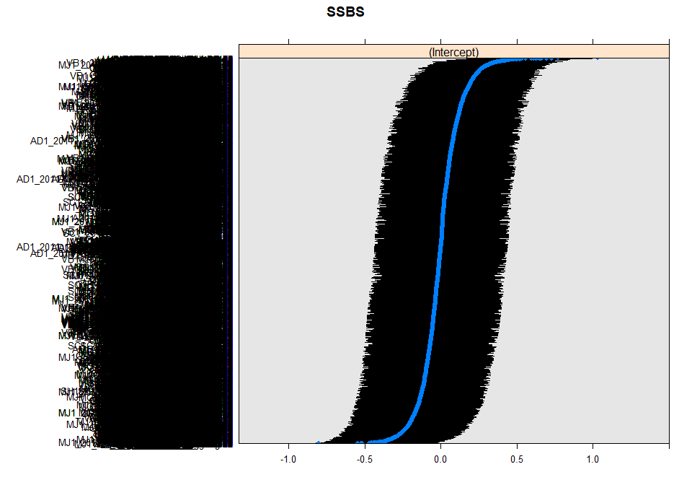
##
## $SSB
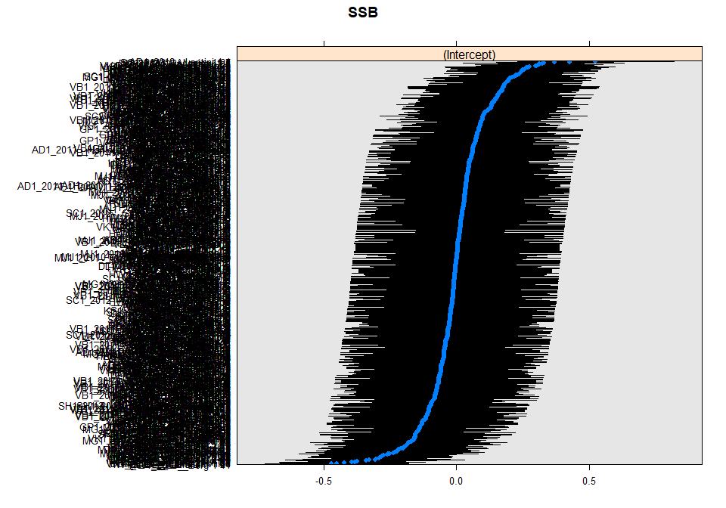
##
## $SS
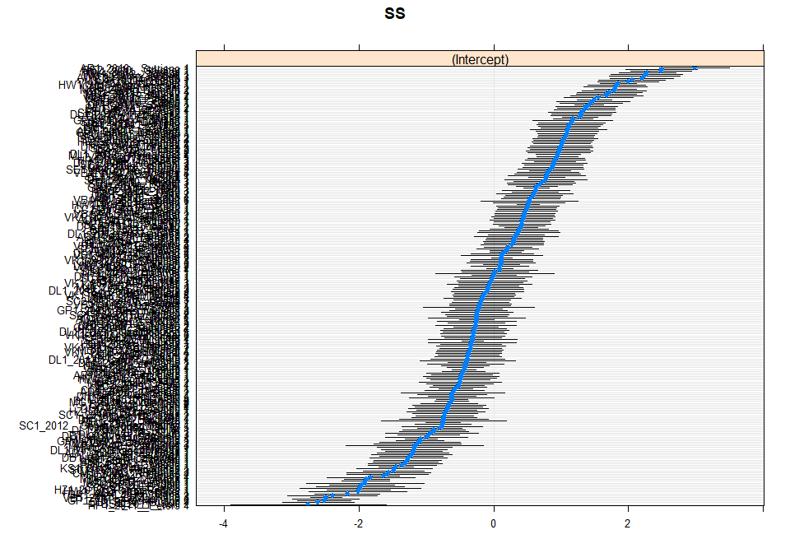
##
## $Biome
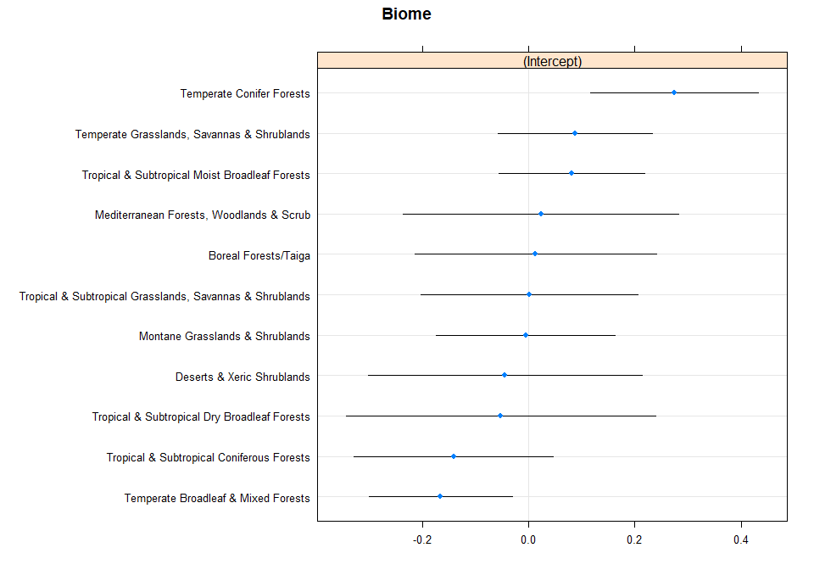
Also including the fixed effect of use_intensity:fire_presence
m3 <- glmer(Species_richness ~ Predominant_land_use + Use_intensity + fire_presence +
Predominant_land_use:Use_intensity + Predominant_land_use:fire_presence +
Use_intensity:fire_presence +
(1|SS) + (1|SSB) + (1|Biome)+ (1|SSBS), data = model_data, family = poisson,
control = glmerControl(optimizer = "bobyqa"))
Anova(m3)
## Analysis of Deviance Table (Type II Wald chisquare tests)
##
## Response: Species_richness
## Chisq Df Pr(>Chisq)
## Predominant_land_use 299.7311 4 < 2.2e-16 ***
## Use_intensity 32.0150 2 1.117e-07 ***
## fire_presence 0.8567 1 0.3546710
## Predominant_land_use:Use_intensity 114.1698 8 < 2.2e-16 ***
## Predominant_land_use:fire_presence 20.1588 4 0.0004646 ***
## Use_intensity:fire_presence 3.7039 2 0.1569318
## ---
## Signif. codes: 0 '***' 0.001 '**' 0.01 '*' 0.05 '.' 0.1 ' ' 1
Use intensity:fire presence interaction is not significant so we can remove this interaction from the model and just use the previous refitted version
Plot of the model:
set_theme(base = theme_classic(), legend.item.backcol = "white")
plot_model(m2_refit, type = "pred", terms = c("Predominant_land_use", "fire_presence"),
legend.title = "Fire presence", show.intercept = TRUE,
axis.title = c("Predominant land use", "Species richness")) +
theme(axis.text.x = element_text(angle = 10, hjust = 0.5, vjust = 0.75))
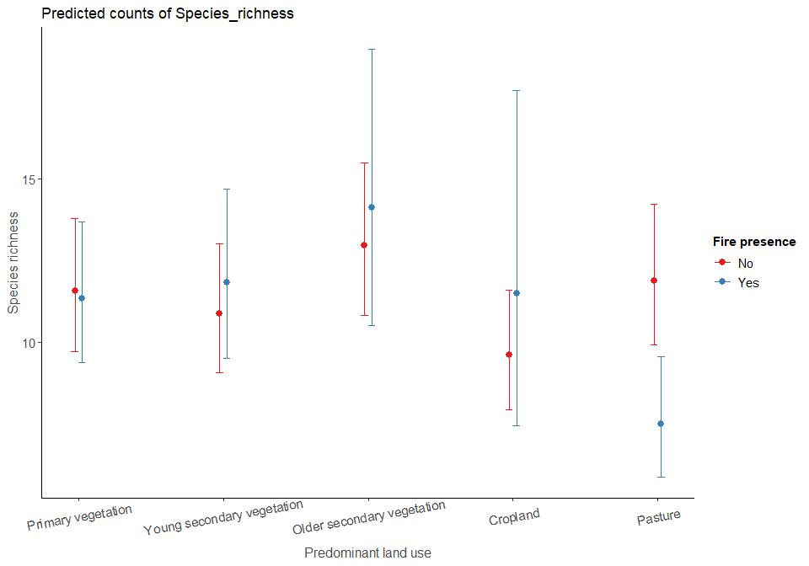

Model selection:
In this model I am going to use the same random effects structure as the abundance model as this will make for easier comparison of results. Also, the fixed effects structure has already been optimized above.
Selected model:
richness_model <- glmer(Species_richness ~ Predominant_land_use + Use_intensity + fire_presence +
Predominant_land_use:Use_intensity + Predominant_land_use:fire_presence +
(1|SS) + (1|SSB) + (1|Biome)+ (1|SSBS), data = model_data, family = poisson,
control = glmerControl(optimizer = "bobyqa"))
Anova(richness_model)
## Analysis of Deviance Table (Type II Wald chisquare tests)
##
## Response: Species_richness
## Chisq Df Pr(>Chisq)
## Predominant_land_use 317.456 4 < 2.2e-16 ***
## Use_intensity 31.986 2 1.133e-07 ***
## fire_presence 0.862 1 0.3532
## Predominant_land_use:Use_intensity 119.879 8 < 2.2e-16 ***
## Predominant_land_use:fire_presence 34.114 4 7.060e-07 ***
## ---
## Signif. codes: 0 '***' 0.001 '**' 0.01 '*' 0.05 '.' 0.1 ' ' 1
summary(richness_model)
## Generalized linear mixed model fit by maximum likelihood (Laplace Approximation) ['glmerMod']
## Family: poisson ( log )
## Formula: Species_richness ~ Predominant_land_use + Use_intensity + fire_presence +
## Predominant_land_use:Use_intensity + Predominant_land_use:fire_presence +
## (1 | SS) + (1 | SSB) + (1 | Biome) + (1 | SSBS)
## Data: model_data
## Control: glmerControl(optimizer = "bobyqa")
##
## AIC BIC logLik deviance df.resid
## 45899.0 46067.1 -22925.5 45851.0 8103
##
## Scaled residuals:
## Min 1Q Median 3Q Max
## -3.9311 -0.4952 -0.0177 0.3861 5.3684
##
## Random effects:
## Groups Name Variance Std.Dev.
## SSBS (Intercept) 0.05184 0.2277
## SSB (Intercept) 0.04112 0.2028
## SS (Intercept) 1.21315 1.1014
## Biome (Intercept) 0.02383 0.1544
## Number of obs: 8127, groups: SSBS, 8127; SSB, 743; SS, 247; Biome, 11
##
## Fixed effects:
## Estimate Std. Error z value Pr(>|z|)
## (Intercept) 2.44919 0.08935 27.410 < 2e-16
## Predominant_land_useYoung secondary vegetation -0.06353 0.03139 -2.024 0.043001
## Predominant_land_useOlder secondary vegetation 0.11275 0.03100 3.637 0.000276
## Predominant_land_useCropland -0.18740 0.04366 -4.292 1.77e-05
## Predominant_land_usePasture 0.02617 0.03071 0.852 0.394160
## Use_intensityLight use 0.04404 0.02307 1.909 0.056270
## Use_intensityIntense use 0.10581 0.03429 3.086 0.002029
## fire_presenceYes -0.02132 0.03889 -0.548 0.583549
## Predominant_land_useYoung secondary vegetation:Use_intensityLight use -0.05790 0.06491 -0.892 0.372361
## Predominant_land_useOlder secondary vegetation:Use_intensityLight use -0.08530 0.04056 -2.103 0.035461
## Predominant_land_useCropland:Use_intensityLight use -0.20715 0.06145 -3.371 0.000749
## Predominant_land_usePasture:Use_intensityLight use -0.16246 0.03539 -4.590 4.42e-06
## Predominant_land_useYoung secondary vegetation:Use_intensityIntense use -0.23072 0.05510 -4.187 2.83e-05
## Predominant_land_useOlder secondary vegetation:Use_intensityIntense use -0.61811 0.12394 -4.987 6.13e-07
## Predominant_land_useCropland:Use_intensityIntense use -0.62172 0.06765 -9.191 < 2e-16
## Predominant_land_usePasture:Use_intensityIntense use -0.34572 0.05701 -6.064 1.33e-09
## Predominant_land_useYoung secondary vegetation:fire_presenceYes 0.10573 0.06788 1.558 0.119313
## Predominant_land_useOlder secondary vegetation:fire_presenceYes 0.10839 0.12599 0.860 0.389646
## Predominant_land_useCropland:fire_presenceYes 0.20067 0.20348 0.986 0.324036
## Predominant_land_usePasture:fire_presenceYes -0.44106 0.08849 -4.984 6.23e-07
##
## (Intercept) ***
## Predominant_land_useYoung secondary vegetation *
## Predominant_land_useOlder secondary vegetation ***
## Predominant_land_useCropland ***
## Predominant_land_usePasture
## Use_intensityLight use .
## Use_intensityIntense use **
## fire_presenceYes
## Predominant_land_useYoung secondary vegetation:Use_intensityLight use
## Predominant_land_useOlder secondary vegetation:Use_intensityLight use *
## Predominant_land_useCropland:Use_intensityLight use ***
## Predominant_land_usePasture:Use_intensityLight use ***
## Predominant_land_useYoung secondary vegetation:Use_intensityIntense use ***
## Predominant_land_useOlder secondary vegetation:Use_intensityIntense use ***
## Predominant_land_useCropland:Use_intensityIntense use ***
## Predominant_land_usePasture:Use_intensityIntense use ***
## Predominant_land_useYoung secondary vegetation:fire_presenceYes
## Predominant_land_useOlder secondary vegetation:fire_presenceYes
## Predominant_land_useCropland:fire_presenceYes
## Predominant_land_usePasture:fire_presenceYes ***
## ---
## Signif. codes: 0 '***' 0.001 '**' 0.01 '*' 0.05 '.' 0.1 ' ' 1
##
## Correlation matrix not shown by default, as p = 20 > 12.
## Use print(x, correlation=TRUE) or
## vcov(x) if you need it
R2:
R2GLMER(richness_model)
## $conditional
## [1] 0.5761216
##
## $marginal
## [1] 0.01238938
Diagnostics:
par(mfrow=c(1,2))
qqnorm(resid(richness_model), main="normal qq-plot, residuals")
qqline(resid(richness_model)) ## not bad
plot(fitted(richness_model), resid(richness_model), main = "Residuals vs fitted") #residuals vs fitted
abline(h=0)
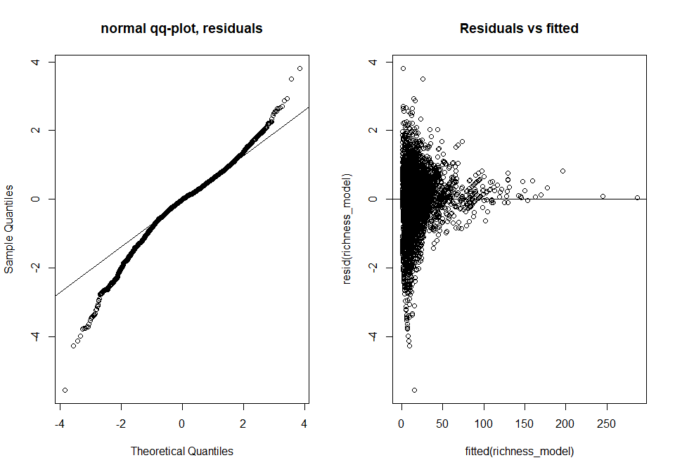
ran <- ranef(richness_model, condVar=TRUE)
a <- dotplot(ran)[["SSBS"]]
b <- dotplot(ran)[["SSB"]]
c <- dotplot(ran)[["SS"]]
d <- dotplot(ran)[["Biome"]]
grid.arrange(a,b,c,d, nrow=2, ncol=2)
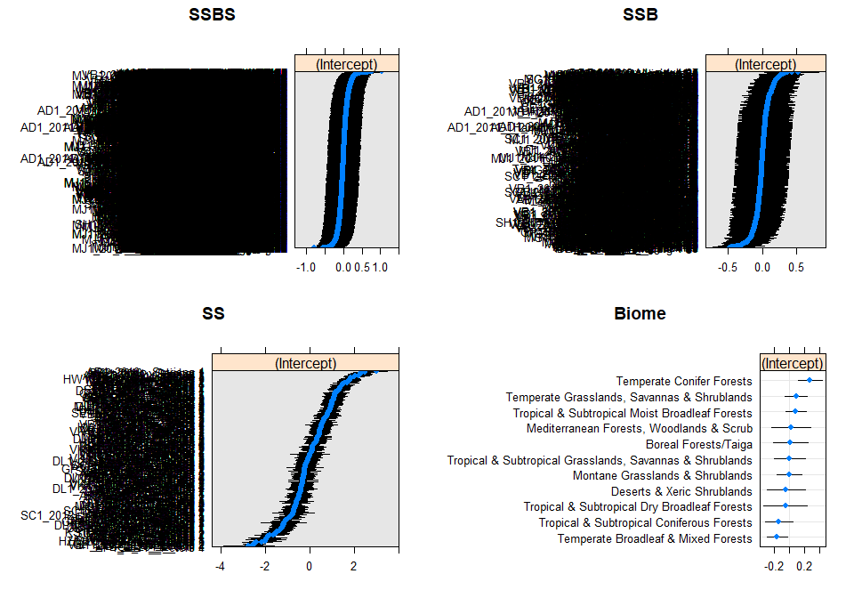
Plot:
set_theme(base = theme_classic(), legend.item.backcol = "white")
plot_model(richness_model, type = "pred", terms = c("Predominant_land_use", "fire_presence"),
legend.title = "Fire presence", show.intercept = TRUE,
axis.title = c("Predominant land use", "Species richness")) +
theme(axis.text.x = element_text(angle = 10, hjust = 0.5, vjust = 0.75))

Hypothesis testing - whether fire presence has a significant effect on species richness:
Setting up two models, one with fire and one without
richness_fire <- glmer(Species_richness ~ Predominant_land_use + Use_intensity + fire_presence +
Predominant_land_use:Use_intensity + Predominant_land_use:fire_presence +
(1|SS) + (1|SSB) + (1|Biome)+ (1|SSBS), data = model_data, family = poisson,
control = glmerControl(optimizer = "bobyqa"))
richness_nofire <- glmer(Species_richness ~ Predominant_land_use + Use_intensity +
Predominant_land_use:Use_intensity +
(1|SS) + (1|SSB) + (1|Biome)+ (1|SSBS),
data = model_data, family = poisson,
control = glmerControl(optimizer = "bobyqa"))
Now we want to see if significant explanatory power has been lost:
anova(richness_fire, richness_nofire)
## Data: model_data
## Models:
## richness_nofire: Species_richness ~ Predominant_land_use + Use_intensity + Predominant_land_use:Use_intensity +
## richness_nofire: (1 | SS) + (1 | SSB) + (1 | Biome) + (1 | SSBS)
## richness_fire: Species_richness ~ Predominant_land_use + Use_intensity + fire_presence +
## richness_fire: Predominant_land_use:Use_intensity + Predominant_land_use:fire_presence +
## richness_fire: (1 | SS) + (1 | SSB) + (1 | Biome) + (1 | SSBS)
## npar AIC BIC logLik deviance Chisq Df Pr(>Chisq)
## richness_nofire 19 45925 46058 -22943 45887
## richness_fire 24 45899 46067 -22926 45851 35.813 5 1.035e-06 ***
## ---
## Signif. codes: 0 '***' 0.001 '**' 0.01 '*' 0.05 '.' 0.1 ' ' 1
Fire presence and its interaction with land use has a significant effect on abundance (chisq = 35.813, df=5, p<0.001)

Comparing the savanna versus the rest of the world:
Creating a savanna/not savanna level:
model_data$savanna <- ifelse(model_data$Biome== "Tropical & Subtropical Grasslands, Savannas & Shrublands","Savanna",
ifelse(model_data$Biome != "Tropical & Subtropical Grasslands, Savannas & Shrublands",
"Not_savanna", NA))
model_data$savanna <- as.factor(model_data$savanna)
levels(model_data$savanna)
## [1] "Not_savanna" "Savanna"
Making sure we dont have rank deficiency
model_data <- model_data %>%
mutate(
Use_intensity_2 = recode_factor(Use_intensity,
"Light use" = "Greater use",
"Intense use" = "Greater use"),
Use_intensity_2 = factor(Use_intensity_2),
Use_intensity_2 = relevel(Use_intensity_2, ref = "Minimal use")
)
table(model_data$Predominant_land_use, model_data$Use_intensity_2)
##
## Minimal use Greater use
## Primary vegetation 2641 1619
## Young secondary vegetation 362 334
## Older secondary vegetation 479 505
## Cropland 216 560
## Pasture 403 1008
## Creating a second land use classs.
model_data$Landuse <- model_data$Predominant_land_use
model_data <- model_data %>%
mutate(Landuse = recode_factor(Landuse, "Young secondary vegetation" = "Secondary vegetation",
"Older secondary vegetation" = "Secondary vegetation"),
Landuse = factor(Landuse),
Landuse = relevel(Landuse, ref = "Primary vegetation"))
model_data$Landuse <- factor(model_data$Landuse, levels = c("Primary vegetation",
"Secondary vegetation",
"Cropland",
"Pasture"))
table(model_data$Landuse, model_data$Use_intensity_2, model_data$savanna)
## , , = Not_savanna
##
##
## Minimal use Greater use
## Primary vegetation 2163 1357
## Secondary vegetation 837 700
## Cropland 203 445
## Pasture 398 962
##
## , , = Savanna
##
##
## Minimal use Greater use
## Primary vegetation 478 262
## Secondary vegetation 4 139
## Cropland 13 115
## Pasture 5 46
Fitting a model with a fire, savanna interaction:
savanna_comp <- glmer(Species_richness ~ Predominant_land_use + Use_intensity + fire_presence +
Predominant_land_use:Use_intensity + Predominant_land_use:fire_presence +
fire_presence:savanna +
(1|SS) + (1|SSB) + (1|Biome)+ (1|SSBS), data = model_data, family = poisson,
control = glmerControl(optimizer = "bobyqa"))
Anova(savanna_comp)
## Analysis of Deviance Table (Type II Wald chisquare tests)
##
## Response: Species_richness
## Chisq Df Pr(>Chisq)
## Predominant_land_use 317.5725 4 < 2.2e-16 ***
## Use_intensity 32.1473 2 1.045e-07 ***
## fire_presence 0.8582 1 0.3543
## Predominant_land_use:Use_intensity 118.4885 8 < 2.2e-16 ***
## Predominant_land_use:fire_presence 35.9812 4 2.920e-07 ***
## fire_presence:savanna 2.4880 2 0.2882
## ---
## Signif. codes: 0 '***' 0.001 '**' 0.01 '*' 0.05 '.' 0.1 ' ' 1
Not significant therefore the effects of fire do not vary significantly between savanna and not.
Likelihood ratio test:
no_savanna <- glmer(Species_richness ~ Predominant_land_use + Use_intensity + fire_presence +
Predominant_land_use:Use_intensity + Predominant_land_use:fire_presence +
(1|SS) + (1|SSB) + (1|Biome)+ (1|SSBS), data = model_data, family = poisson,
control = glmerControl(optimizer = "bobyqa"))
anova(savanna_comp, no_savanna)
## Data: model_data
## Models:
## no_savanna: Species_richness ~ Predominant_land_use + Use_intensity + fire_presence +
## no_savanna: Predominant_land_use:Use_intensity + Predominant_land_use:fire_presence +
## no_savanna: (1 | SS) + (1 | SSB) + (1 | Biome) + (1 | SSBS)
## savanna_comp: Species_richness ~ Predominant_land_use + Use_intensity + fire_presence +
## savanna_comp: Predominant_land_use:Use_intensity + Predominant_land_use:fire_presence +
## savanna_comp: fire_presence:savanna + (1 | SS) + (1 | SSB) + (1 | Biome) +
## savanna_comp: (1 | SSBS)
## npar AIC BIC logLik deviance Chisq Df Pr(>Chisq)
## no_savanna 24 45899 46067 -22926 45851
## savanna_comp 26 45901 46083 -22924 45849 2.4574 2 0.2927
There is no significant difference in the effects of fire between the savanna and the rest of the world.

