Global models of abundance with different fire metrics, and time since fire models

Data
diversity <- readRDS("~/Imperial/PROJECT/PREDICTS data/database.rds")
fire_hist <- read.csv("~/Imperial/PROJECT/Combined data/Fire_history.csv")

Data preparation
Calculating site level diversity metrics, tidying up land use categories, subsetting data and merging with the fire atlas. The redundant biomes are removed, and biomes are aggregated. Land use categories are also aggregated.
diversity <- mutate(diversity,
Measurement = Effort_corrected_measurement,
Sampling_effort = Rescaled_sampling_effort)
sites <- diversity %>%
mutate(Diversity_metric_is_valid = TRUE) %>%
predictsFunctions::SiteMetrics(extra.cols = c("SSB", "SSBS", "Predominant_land_use", "Biome", "Country")) %>%
group_by(SS) %>%
mutate(MaxAbundance = ifelse(Diversity_metric_type == "Abundance",
max(Total_abundance),
NA)) %>%
ungroup() %>%
mutate(RescaledAbundance = ifelse(Diversity_metric_type == "Abundance",
Total_abundance/MaxAbundance,
NA))
## Computing site metrics for 3250404 measurements
## The data contain 480 sources, 666 studies and 26112 sites
## Computing site-level values
## Computing total abundance
## Computing species richness
## Assembling site-level values
sites <- sites %>%
mutate(
Predominant_land_use = recode_factor(Predominant_land_use,
"Primary forest" = "Primary vegetation",
"Primary non-forest" = "Primary vegetation"),
Predominant_land_use = na_if(Predominant_land_use, "Secondary vegetation (indeterminate age)"),
Predominant_land_use = na_if(Predominant_land_use, "Cannot decide"),
Use_intensity = na_if(Use_intensity, "Cannot decide"),
Predominant_land_use = factor(Predominant_land_use),
Predominant_land_use = relevel(Predominant_land_use, ref = "Primary vegetation"),
Use_intensity = factor(Use_intensity),
Use_intensity = relevel(Use_intensity, ref = "Minimal use")
)
## Subset to 2006
sites_post_2006 <- subset(sites, sites$Sample_start_earliest > "2006-01-01")
## Removing rows that have NAs in latitude and longitude as these won't have fire data
sites_post_2006_NA <- subset(sites_post_2006, (! is.na(Longitude) | ! is.na(Latitude)))
## Merge with fire data
PREDICTS_fire_hist <- merge(sites_post_2006_NA, fire_hist
[,c("SSBS", "Freq", "fire_ID", "size", "start_date", "duration", "days_since_fire",
"year", "years_since_fire")], by="SSBS", all.x=TRUE)
PREDICTS_fire_hist$Freq[is.na(PREDICTS_fire_hist$Freq)] <- 0
PREDICTS_fire_hist$fire_presence <- ifelse(PREDICTS_fire_hist$Freq==0, "No",
ifelse(PREDICTS_fire_hist$Freq!=0, "Yes",
NA))
PREDICTS_fire_hist$fire_presence <- as.factor(PREDICTS_fire_hist$fire_presence)
## Need to remove data which has NAs in categories required for our analysis
model_data <- drop_na(PREDICTS_fire_hist, Total_abundance, Predominant_land_use, Use_intensity, fire_presence)
## Biome alteration/aggregation
## remove the levels with no data/Can't have fires
model_data<-model_data[!(model_data$Biome == "Rock & Ice"),]
model_data<-model_data[!(model_data$Biome == "Flooded Grasslands & Savannas"),]
model_data<-model_data[!(model_data$Biome == "Mangroves"),]
model_data<-model_data[!(model_data$Biome == "Inland Water"),]
model_data<-model_data[!(model_data$Biome == "Tundra"),]
model_data$Biome <- as.factor(as.character(model_data$Biome))
table(model_data$Biome)
##
## Boreal Forests/Taiga
## 493
## Deserts & Xeric Shrublands
## 144
## Mediterranean Forests, Woodlands & Scrub
## 470
## Montane Grasslands & Shrublands
## 189
## Temperate Broadleaf & Mixed Forests
## 3014
## Temperate Conifer Forests
## 169
## Temperate Grasslands, Savannas & Shrublands
## 318
## Tropical & Subtropical Coniferous Forests
## 246
## Tropical & Subtropical Dry Broadleaf Forests
## 164
## Tropical & Subtropical Grasslands, Savannas & Shrublands
## 1071
## Tropical & Subtropical Moist Broadleaf Forests
## 2453
## Forest/non forest
model_data$adj.biome <- ifelse(model_data$Biome=="Boreal Forests/Taiga", "Forest",
ifelse(model_data$Biome=="Temperate Conifer Forests", "Forest",
ifelse(model_data$Biome=="Temperate Broadleaf & Mixed Forests", "Forest",
ifelse(model_data$Biome=="Montane Grasslands & Shrublands", "Non Forest",
ifelse(model_data$Biome=="Temperate Grasslands, Savannas & Shrublands", "Non Forest",
ifelse(model_data$Biome=="Mediterranean Forests, Woodlands & Scrub", "Forest",
ifelse(model_data$Biome=="Deserts & Xeric Shrublands", "Non Forest",
ifelse(model_data$Biome=="Tropical & Subtropical Grasslands, Savannas & Shrublands", "Non Forest",
ifelse(model_data$Biome=="Tropical & Subtropical Coniferous Forests", "Forest",
ifelse(model_data$Biome=="Tropical & Subtropical Dry Broadleaf Forests", "Forest",
ifelse(model_data$Biome=="Tropical & Subtropical Moist Broadleaf Forests", "Forest",
NA)))))))))))
model_data$adj.biome <- as.factor(model_data$adj.biome)
## Aggregated biomes
model_data$new.biome <- model_data$Biome
model_data <- model_data %>%
mutate(
new.biome = recode_factor(new.biome,
"Deserts & Xeric Shrublands" = "Deserts, Shrublands and Grasslands",
"Montane Grasslands & Shrublands" = "Deserts, Shrublands and Grasslands",
"Temperate Grasslands, Savannas & Shrublands" = "Deserts, Shrublands and Grasslands",
"Temperate Broadleaf & Mixed Forests" = "Temperate Forest",
"Temperate Conifer Forests" = "Temperate Forest",
"Tropical & Subtropical Coniferous Forests" = "Tropical & Subtropical Forest",
"Tropical & Subtropical Dry Broadleaf Forests" = "Tropical & Subtropical Forest",
"Tropical & Subtropical Moist Broadleaf Forests" = "Tropical & Subtropical Forest")
)
model_data$new.biome <- as.factor(as.character(model_data$new.biome))
## Predominant land use and use intensity. Need to remove plantation and urban due to lack of data and merge intermediate and mature together. Use intensity can stay as it is.
model_data<- drop_na(model_data, Predominant_land_use)
model_data<-model_data[!(model_data$Predominant_land_use == "Plantation forest"),]
model_data<-model_data[!(model_data$Predominant_land_use == "Urban"),]
model_data$Predominant_land_use <- as.factor(as.character(model_data$Predominant_land_use))
model_data <- model_data %>%
mutate( Predominant_land_use = recode_factor(Predominant_land_use,
"Intermediate secondary vegetation" = "Older secondary vegetation",
"Mature secondary vegetation" = "Older secondary vegetation"),
Predominant_land_use = factor(Predominant_land_use),
Predominant_land_use = relevel(Predominant_land_use, ref = "Primary vegetation")
)
model_data$Predominant_land_use <- factor(model_data$Predominant_land_use, levels = c("Primary vegetation", "Young secondary vegetation", "Older secondary vegetation",
"Cropland", "Pasture"))

Assumption checking
Collinearity
corvif(model_data[ , c("Predominant_land_use", "Use_intensity", "fire_presence")])
##
##
## Variance inflation factors
##
## GVIF Df GVIF^(1/2Df)
## Predominant_land_use 1.270604 4 1.030389
## Use_intensity 1.340113 2 1.075933
## fire_presence 1.113793 1 1.055364
complete cases
model_data <- drop_na(model_data, Total_abundance, Predominant_land_use, Use_intensity, fire_presence)
Need to transform abundance
model_data <- mutate(model_data,
logAbundance = log(RescaledAbundance + 1),
sqrtAbundance = sqrt(RescaledAbundance))

Fire metrics

Fire presence
Basic fire presence model, created and selected previously (see the global model selection script for method and justification)
m1 <- lmer(sqrtAbundance ~ Predominant_land_use + Use_intensity + fire_presence +
Predominant_land_use:fire_presence + Predominant_land_use:Use_intensity +
Use_intensity:fire_presence +
(1|SS) + (1|SSB) + (1|Biome), data = model_data)
Anova(m1)
## Analysis of Deviance Table (Type II Wald chisquare tests)
##
## Response: sqrtAbundance
## Chisq Df Pr(>Chisq)
## Predominant_land_use 67.2341 4 8.701e-14 ***
## Use_intensity 83.1178 2 < 2.2e-16 ***
## fire_presence 1.7099 1 0.190999
## Predominant_land_use:fire_presence 27.1934 4 1.817e-05 ***
## Predominant_land_use:Use_intensity 75.4353 8 4.036e-13 ***
## Use_intensity:fire_presence 9.3286 2 0.009426 **
## ---
## Signif. codes: 0 '***' 0.001 '**' 0.01 '*' 0.05 '.' 0.1 ' ' 1
summary(m1)
## Linear mixed model fit by REML ['lmerMod']
## Formula: sqrtAbundance ~ Predominant_land_use + Use_intensity + fire_presence +
## Predominant_land_use:fire_presence + Predominant_land_use:Use_intensity +
## Use_intensity:fire_presence + (1 | SS) + (1 | SSB) + (1 | Biome)
## Data: model_data
##
## REML criterion at convergence: -3569
##
## Scaled residuals:
## Min 1Q Median 3Q Max
## -4.0157 -0.5693 -0.0296 0.5710 4.6519
##
## Random effects:
## Groups Name Variance Std.Dev.
## SSB (Intercept) 0.007029 0.08384
## SS (Intercept) 0.035707 0.18896
## Biome (Intercept) 0.001241 0.03523
## Residual 0.030290 0.17404
## Number of obs: 7122, groups: SSB, 655; SS, 219; Biome, 11
##
## Fixed effects:
## Estimate Std. Error t value
## (Intercept) 0.629850 0.020269 31.075
## Predominant_land_useYoung secondary vegetation -0.012709 0.015738 -0.808
## Predominant_land_useOlder secondary vegetation 0.015980 0.015139 1.056
## Predominant_land_useCropland -0.038043 0.018951 -2.007
## Predominant_land_usePasture 0.007152 0.013844 0.517
## Use_intensityLight use -0.045443 0.011398 -3.987
## Use_intensityIntense use -0.022331 0.016797 -1.329
## fire_presenceYes -0.060531 0.021435 -2.824
## Predominant_land_useYoung secondary vegetation:fire_presenceYes -0.024673 0.031754 -0.777
## Predominant_land_useOlder secondary vegetation:fire_presenceYes 0.152424 0.057753 2.639
## Predominant_land_useCropland:fire_presenceYes 0.073275 0.045533 1.609
## Predominant_land_usePasture:fire_presenceYes -0.134606 0.042746 -3.149
## Predominant_land_useYoung secondary vegetation:Use_intensityLight use 0.024281 0.033262 0.730
## Predominant_land_useOlder secondary vegetation:Use_intensityLight use 0.036885 0.020490 1.800
## Predominant_land_useCropland:Use_intensityLight use -0.029224 0.026805 -1.090
## Predominant_land_usePasture:Use_intensityLight use 0.022370 0.016897 1.324
## Predominant_land_useYoung secondary vegetation:Use_intensityIntense use -0.048415 0.026304 -1.841
## Predominant_land_useOlder secondary vegetation:Use_intensityIntense use -0.303935 0.044242 -6.870
## Predominant_land_useCropland:Use_intensityIntense use -0.125250 0.029451 -4.253
## Predominant_land_usePasture:Use_intensityIntense use -0.101210 0.024946 -4.057
## Use_intensityLight use:fire_presenceYes 0.035530 0.038114 0.932
## Use_intensityIntense use:fire_presenceYes 0.093252 0.030597 3.048
##
## Correlation matrix not shown by default, as p = 22 > 12.
## Use print(x, correlation=TRUE) or
## vcov(x) if you need it

Frequency of fires in a three-year period
graph_data <- subset(model_data, model_data$fire_presence == "Yes")
ggplot(data=graph_data, aes(Freq)) +
geom_histogram(binwidth = 1, fill = 'light blue', colour = 'Black')+
xlab("Number of fires")+
ylab("Number of sites")+
theme_bw() + theme(panel.border = element_rect(colour = "black", fill=NA, size=0.5), panel.grid.major = element_blank(),
panel.grid.minor = element_blank(), axis.line = element_line(colour = "black"),
axis.text.x = element_text(size = 10, color = "black"), axis.title.x = element_text(size = 11), axis.text.y = element_text(size = 10, color = "black"))
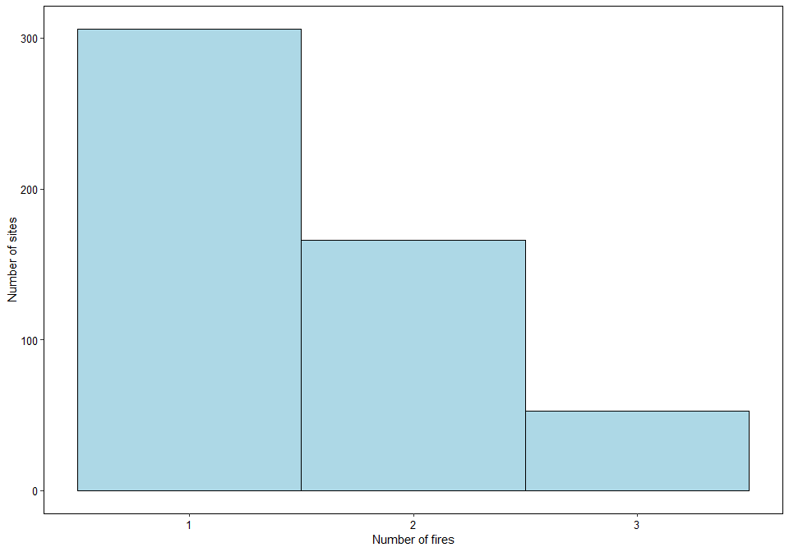
Most sites have no fires, but of those that do the majority have 1, which uniform decreasing amounts for 2 and 3.
Check collinearity before modelling:
corvif(model_data[ , c("Predominant_land_use", "Use_intensity", "Freq")])
##
##
## Variance inflation factors
##
## GVIF Df GVIF^(1/2Df)
## Predominant_land_use 1.268440 4 1.030170
## Use_intensity 1.305646 2 1.068947
## Freq 1.086818 1 1.042506
m_freq <- lmer(sqrtAbundance ~ Predominant_land_use + Use_intensity + Freq +
Predominant_land_use:Freq + Predominant_land_use:Use_intensity +Use_intensity:Freq +
(1|SS) + (1|SSB) + (1|Biome), data = model_data)
Anova(m_freq) #freq is significant
## Analysis of Deviance Table (Type II Wald chisquare tests)
##
## Response: sqrtAbundance
## Chisq Df Pr(>Chisq)
## Predominant_land_use 69.3133 4 3.169e-14 ***
## Use_intensity 82.7639 2 < 2.2e-16 ***
## Freq 5.6395 1 0.0175602 *
## Predominant_land_use:Freq 21.8812 4 0.0002116 ***
## Predominant_land_use:Use_intensity 77.1326 8 1.843e-13 ***
## Use_intensity:Freq 4.8436 2 0.0887627 .
## ---
## Signif. codes: 0 '***' 0.001 '**' 0.01 '*' 0.05 '.' 0.1 ' ' 1
summary(m_freq)
## Linear mixed model fit by REML ['lmerMod']
## Formula: sqrtAbundance ~ Predominant_land_use + Use_intensity + Freq +
## Predominant_land_use:Freq + Predominant_land_use:Use_intensity +
## Use_intensity:Freq + (1 | SS) + (1 | SSB) + (1 | Biome)
## Data: model_data
##
## REML criterion at convergence: -3559.7
##
## Scaled residuals:
## Min 1Q Median 3Q Max
## -4.0129 -0.5706 -0.0304 0.5723 4.6521
##
## Random effects:
## Groups Name Variance Std.Dev.
## SSB (Intercept) 0.006934 0.08327
## SS (Intercept) 0.035761 0.18911
## Biome (Intercept) 0.001236 0.03516
## Residual 0.030323 0.17414
## Number of obs: 7122, groups: SSB, 655; SS, 219; Biome, 11
##
## Fixed effects:
## Estimate Std. Error t value
## (Intercept) 0.630196 0.020250 31.121
## Predominant_land_useYoung secondary vegetation -0.013374 0.015718 -0.851
## Predominant_land_useOlder secondary vegetation 0.015514 0.015136 1.025
## Predominant_land_useCropland -0.037443 0.018929 -1.978
## Predominant_land_usePasture 0.006009 0.013846 0.434
## Use_intensityLight use -0.044723 0.011386 -3.928
## Use_intensityIntense use -0.018233 0.016575 -1.100
## Freq -0.032097 0.011325 -2.834
## Predominant_land_useYoung secondary vegetation:Freq -0.011274 0.019144 -0.589
## Predominant_land_useOlder secondary vegetation:Freq 0.151395 0.056441 2.682
## Predominant_land_useCropland:Freq 0.041204 0.038547 1.069
## Predominant_land_usePasture:Freq -0.084893 0.034534 -2.458
## Predominant_land_useYoung secondary vegetation:Use_intensityLight use 0.024016 0.033264 0.722
## Predominant_land_useOlder secondary vegetation:Use_intensityLight use 0.036336 0.020481 1.774
## Predominant_land_useCropland:Use_intensityLight use -0.033837 0.027074 -1.250
## Predominant_land_usePasture:Use_intensityLight use 0.020796 0.016884 1.232
## Predominant_land_useYoung secondary vegetation:Use_intensityIntense use -0.051727 0.025606 -2.020
## Predominant_land_useOlder secondary vegetation:Use_intensityIntense use -0.300938 0.044176 -6.812
## Predominant_land_useCropland:Use_intensityIntense use -0.130082 0.029305 -4.439
## Predominant_land_usePasture:Use_intensityIntense use -0.106272 0.024788 -4.287
## Use_intensityLight use:Freq 0.011765 0.031452 0.374
## Use_intensityIntense use:Freq 0.039101 0.017787 2.198
##
## Correlation matrix not shown by default, as p = 22 > 12.
## Use print(x, correlation=TRUE) or
## vcov(x) if you need it
Plotting the effects of fire frequency:
theme_set(theme_classic())
frequency_plot <- plot_model(m_freq, type = "pred", terms = c("Freq", "Predominant_land_use"),
axis.title = c("Fire frequency in a three year period", "Squareroot rescaled abundance"),legend.title = c("Predominant land use")) +
guides(col=guide_legend(nrow=5,byrow=TRUE))
frequency_UI_plot <- plot_model(m_freq, type = "pred", terms = c("Freq", "Use_intensity"),
axis.title = c("Fire frequency in a three year period", "Squareroot rescaled abundance"), legend.title = c("Land use intensity"))+
guides(col=guide_legend(nrow=3,byrow=TRUE))
ggarrange(frequency_plot, frequency_UI_plot, nrow = 1, ncol = 2, legend = "bottom",
labels = c("A", "B"))
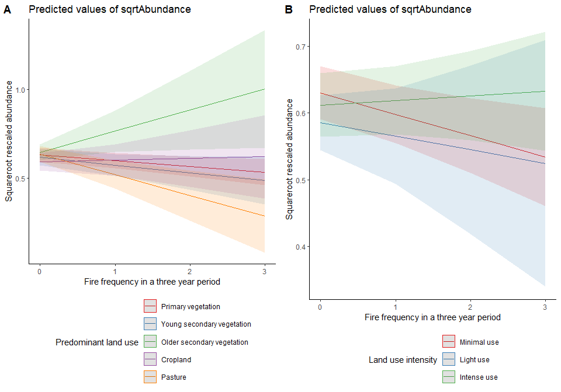

Fire size
Looking at the data:
hist <- ggplot(data=model_data, aes(size)) +
geom_histogram(binwidth = 100, fill = 'light blue', colour = 'Black')+
xlab("Fire size (km2)")+
ylab("Number of sites")+
scale_x_continuous(breaks = scales::pretty_breaks(n = 8)) +
theme_bw() + theme(panel.border = element_rect(colour = "black", fill=NA, size=0.5), panel.grid.major = element_blank(),
panel.grid.minor = element_blank(), axis.line = element_line(colour = "black"),
axis.text.x = element_text(size = 10, color = "black"), axis.title.x = element_text(size = 11), axis.text.y = element_text(size = 10, color = "black"))
box <- ggplot(model_data, aes(x = Predominant_land_use, y = size)) +
geom_boxplot()+
xlab("Predominant land use")+
ylab("Size of fires")+
theme_bw()+ theme(panel.border = element_rect(colour = "black", fill=NA, size=0.5), panel.grid.major = element_blank(),
panel.grid.minor = element_blank(), axis.line = element_line(colour = "black"),
axis.text.x = element_text(size = 10, color = "black", angle = 45, hjust = 1), axis.title.x = element_text(size = 11), axis.text.y = element_text(size = 10, color = "black"))
ggarrange(hist, box, ncol = 2, nrow = 1)
## Warning: Removed 6597 rows containing non-finite values (stat_bin).
## Warning: Removed 6597 rows containing non-finite values (stat_boxplot).
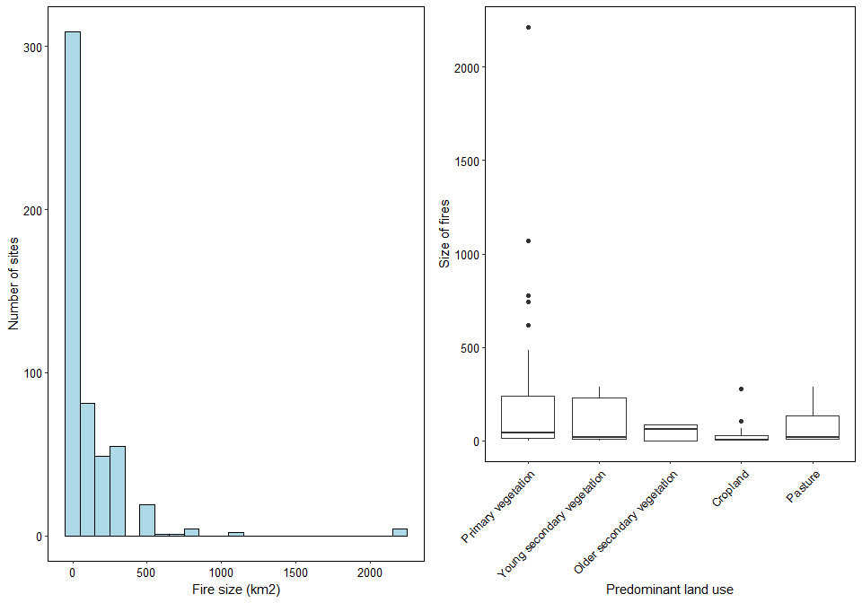
Need to give all the sites that do not have a fire a value of 0.
model_data$size[is.na(model_data$size)] <- 0
Checking collinearity:
corvif(model_data[ , c("Predominant_land_use", "Use_intensity", "size")])
##
##
## Variance inflation factors
##
## GVIF Df GVIF^(1/2Df)
## Predominant_land_use 1.244257 4 1.027694
## Use_intensity 1.244491 2 1.056204
## size 1.016429 1 1.008181
m_size <- lmer(sqrtAbundance ~ Predominant_land_use + Use_intensity + size +
Predominant_land_use:size + Predominant_land_use:Use_intensity + Use_intensity:size +
(1|SS) + (1|SSB) + (1|Biome), data = model_data)
Anova(m_size)
## Analysis of Deviance Table (Type II Wald chisquare tests)
##
## Response: sqrtAbundance
## Chisq Df Pr(>Chisq)
## Predominant_land_use 68.4300 4 4.868e-14 ***
## Use_intensity 75.6456 2 < 2.2e-16 ***
## size 4.2113 1 0.04016 *
## Predominant_land_use:size 9.7630 4 0.04462 *
## Predominant_land_use:Use_intensity 71.7774 8 2.174e-12 ***
## Use_intensity:size 8.6899 2 0.01297 *
## ---
## Signif. codes: 0 '***' 0.001 '**' 0.01 '*' 0.05 '.' 0.1 ' ' 1
summary(m_size)
## Linear mixed model fit by REML ['lmerMod']
## Formula: sqrtAbundance ~ Predominant_land_use + Use_intensity + size +
## Predominant_land_use:size + Predominant_land_use:Use_intensity +
## Use_intensity:size + (1 | SS) + (1 | SSB) + (1 | Biome)
## Data: model_data
##
## REML criterion at convergence: -3476.9
##
## Scaled residuals:
## Min 1Q Median 3Q Max
## -4.0073 -0.5752 -0.0265 0.5708 4.6600
##
## Random effects:
## Groups Name Variance Std.Dev.
## SSB (Intercept) 0.007079 0.08414
## SS (Intercept) 0.035302 0.18789
## Biome (Intercept) 0.001222 0.03496
## Residual 0.030381 0.17430
## Number of obs: 7122, groups: SSB, 655; SS, 219; Biome, 11
##
## Fixed effects:
## Estimate Std. Error t value
## (Intercept) 6.247e-01 2.004e-02 31.170
## Predominant_land_useYoung secondary vegetation -1.054e-02 1.564e-02 -0.673
## Predominant_land_useOlder secondary vegetation 2.195e-02 1.497e-02 1.467
## Predominant_land_useCropland -3.083e-02 1.866e-02 -1.652
## Predominant_land_usePasture 7.834e-03 1.370e-02 0.572
## Use_intensityLight use -4.124e-02 1.128e-02 -3.655
## Use_intensityIntense use -1.534e-02 1.606e-02 -0.955
## size -8.450e-05 3.613e-05 -2.339
## Predominant_land_useYoung secondary vegetation:size -3.322e-04 1.767e-04 -1.880
## Predominant_land_useOlder secondary vegetation:size 5.503e-04 6.980e-04 0.788
## Predominant_land_useCropland:size 3.131e-04 5.577e-04 0.561
## Predominant_land_usePasture:size -5.700e-04 2.607e-04 -2.187
## Predominant_land_useYoung secondary vegetation:Use_intensityLight use 2.131e-02 3.324e-02 0.641
## Predominant_land_useOlder secondary vegetation:Use_intensityLight use 3.030e-02 2.041e-02 1.484
## Predominant_land_useCropland:Use_intensityLight use -2.245e-02 2.651e-02 -0.847
## Predominant_land_usePasture:Use_intensityLight use 1.582e-02 1.684e-02 0.939
## Predominant_land_useYoung secondary vegetation:Use_intensityIntense use -4.470e-02 2.478e-02 -1.804
## Predominant_land_useOlder secondary vegetation:Use_intensityIntense use -2.586e-01 4.126e-02 -6.269
## Predominant_land_useCropland:Use_intensityIntense use -1.366e-01 2.888e-02 -4.730
## Predominant_land_usePasture:Use_intensityIntense use -1.058e-01 2.449e-02 -4.322
## Use_intensityLight use:size -2.221e-05 1.281e-04 -0.173
## Use_intensityIntense use:size 3.884e-04 1.334e-04 2.912
##
## Correlation matrix not shown by default, as p = 22 > 12.
## Use print(x, correlation=TRUE) or
## vcov(x) if you need it
Interestingly size in its own (and its interactions with land use and use intesity) is significant.
Plot:
theme_set(theme_classic())
size_plot <- plot_model(m_size, type = "pred", terms = c("size", "Predominant_land_use"),
axis.title = c("Fire size (km2)", "Squareroot rescaled abundance"),
legend.title = c("Predominant land use"))+
guides(col=guide_legend(nrow=5,byrow=TRUE))
size_UI_plot <- plot_model(m_size, type = "pred", terms = c("size", "Use_intensity"),
axis.title = c("Fire size (km2)", "Squareroot rescaled abundance"),
legend.title = c("Land use intensity"))+
guides(col=guide_legend(nrow=3,byrow=TRUE))
ggarrange(size_plot, size_UI_plot, nrow = 1, ncol = 2, legend = "bottom",
labels = c("A", "B"))
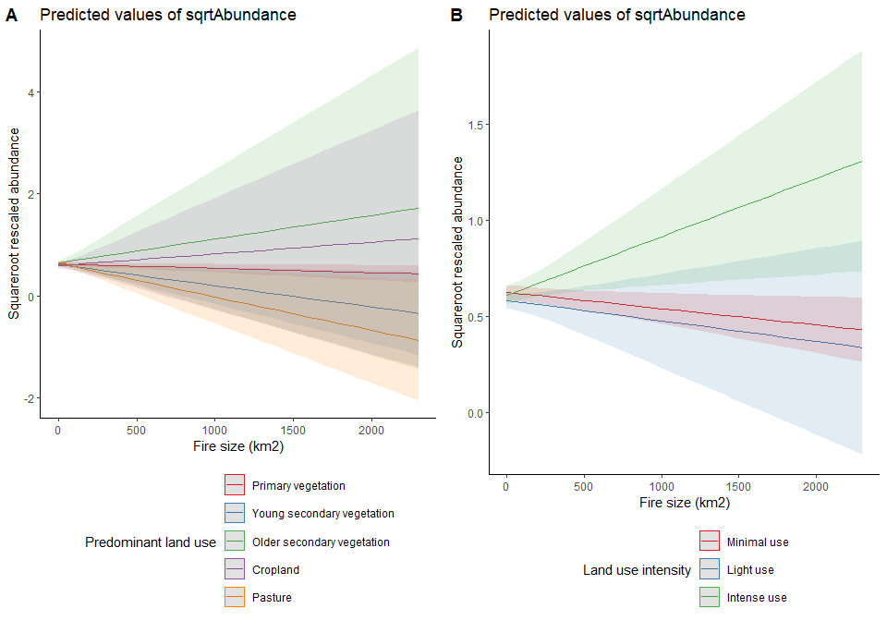

Fire duration
hist <- ggplot(data=model_data, aes(duration)) +
geom_histogram(binwidth = 5, fill = 'light blue', colour = 'Black')+
xlab("Duration of fire (days)")+
ylab("Number of sites")+
scale_x_continuous(breaks = scales::pretty_breaks(n = 8)) +
theme_bw() + theme(panel.border = element_rect(colour = "black", fill=NA, size=0.5), panel.grid.major = element_blank(),
panel.grid.minor = element_blank(), axis.line = element_line(colour = "black"),
axis.text.x = element_text(size = 10, color = "black"), axis.title.x = element_text(size = 11), axis.text.y = element_text(size = 10, color = "black"))
box <- ggplot(model_data, aes(x = Predominant_land_use, y = duration)) +
geom_boxplot()+
xlab("Predominant land use")+
ylab("Duration of fire (days)")+
theme_bw()+ theme(panel.border = element_rect(colour = "black", fill=NA, size=0.5), panel.grid.major = element_blank(),
panel.grid.minor = element_blank(), axis.line = element_line(colour = "black"),
axis.text.x = element_text(size = 10, color = "black", angle = 45, hjust = 1), axis.title.x = element_text(size = 11), axis.text.y = element_text(size = 10, color = "black"))
ggarrange(hist, box, ncol = 2, nrow = 1)
## Warning: Removed 6597 rows containing non-finite values (stat_bin).
## Warning: Removed 6597 rows containing non-finite values (stat_boxplot).
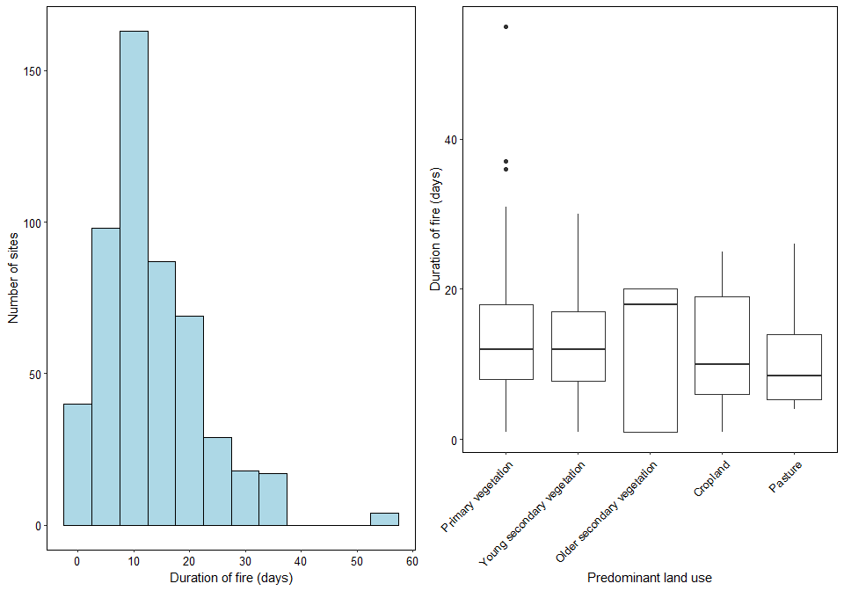
Giving all the sites that have not had a fire a value of 0.
model_data$duration[is.na(model_data$duration)] <- 0
Checking collinearity
corvif(model_data[ , c("Predominant_land_use", "Use_intensity", "duration")])
##
##
## Variance inflation factors
##
## GVIF Df GVIF^(1/2Df)
## Predominant_land_use 1.259348 4 1.029244
## Use_intensity 1.292875 2 1.066324
## duration 1.067622 1 1.033258
Model:
m_duration <- lmer(sqrtAbundance ~ Predominant_land_use + Use_intensity + duration +
Predominant_land_use:duration + Predominant_land_use:Use_intensity +
Use_intensity:duration +
(1|SS) + (1|SSB) + (1|Biome), data = model_data)
Anova(m_duration)
## Analysis of Deviance Table (Type II Wald chisquare tests)
##
## Response: sqrtAbundance
## Chisq Df Pr(>Chisq)
## Predominant_land_use 68.1972 4 5.451e-14 ***
## Use_intensity 84.5835 2 < 2.2e-16 ***
## duration 2.5607 1 0.109548
## Predominant_land_use:duration 16.2963 4 0.002646 **
## Predominant_land_use:Use_intensity 67.8468 8 1.317e-11 ***
## Use_intensity:duration 9.9606 2 0.006872 **
## ---
## Signif. codes: 0 '***' 0.001 '**' 0.01 '*' 0.05 '.' 0.1 ' ' 1
summary(m_duration)
## Linear mixed model fit by REML ['lmerMod']
## Formula: sqrtAbundance ~ Predominant_land_use + Use_intensity + duration +
## Predominant_land_use:duration + Predominant_land_use:Use_intensity +
## Use_intensity:duration + (1 | SS) + (1 | SSB) + (1 | Biome)
## Data: model_data
##
## REML criterion at convergence: -3525
##
## Scaled residuals:
## Min 1Q Median 3Q Max
## -4.0155 -0.5768 -0.0287 0.5676 4.6748
##
## Random effects:
## Groups Name Variance Std.Dev.
## SSB (Intercept) 0.007109 0.08431
## SS (Intercept) 0.035439 0.18825
## Biome (Intercept) 0.001255 0.03542
## Residual 0.030306 0.17409
## Number of obs: 7122, groups: SSB, 655; SS, 219; Biome, 11
##
## Fixed effects:
## Estimate Std. Error t value
## (Intercept) 0.6267050 0.0202149 31.002
## Predominant_land_useYoung secondary vegetation -0.0112424 0.0156836 -0.717
## Predominant_land_useOlder secondary vegetation 0.0217848 0.0150135 1.451
## Predominant_land_useCropland -0.0305653 0.0188919 -1.618
## Predominant_land_usePasture 0.0094083 0.0137798 0.683
## Use_intensityLight use -0.0447831 0.0113384 -3.950
## Use_intensityIntense use -0.0254497 0.0164178 -1.550
## duration -0.0024728 0.0009292 -2.661
## Predominant_land_useYoung secondary vegetation:duration -0.0027835 0.0018828 -1.478
## Predominant_land_useOlder secondary vegetation:duration 0.0008606 0.0030299 0.284
## Predominant_land_useCropland:duration -0.0016215 0.0033542 -0.483
## Predominant_land_usePasture:duration -0.0135593 0.0038560 -3.516
## Predominant_land_useYoung secondary vegetation:Use_intensityLight use 0.0243409 0.0332333 0.732
## Predominant_land_useOlder secondary vegetation:Use_intensityLight use 0.0333018 0.0204288 1.630
## Predominant_land_useCropland:Use_intensityLight use -0.0288917 0.0268325 -1.077
## Predominant_land_usePasture:Use_intensityLight use 0.0213196 0.0168693 1.264
## Predominant_land_useYoung secondary vegetation:Use_intensityIntense use -0.0450642 0.0253076 -1.781
## Predominant_land_useOlder secondary vegetation:Use_intensityIntense use -0.2544754 0.0413553 -6.153
## Predominant_land_useCropland:Use_intensityIntense use -0.1277011 0.0291925 -4.374
## Predominant_land_usePasture:Use_intensityIntense use -0.0979367 0.0246891 -3.967
## Use_intensityLight use:duration 0.0040803 0.0030173 1.352
## Use_intensityIntense use:duration 0.0052495 0.0017500 3.000
##
## Correlation matrix not shown by default, as p = 22 > 12.
## Use print(x, correlation=TRUE) or
## vcov(x) if you need it
Plot:
theme_set(theme_classic())
duration_plot <- plot_model(m_duration, type = "pred", terms = c("duration", "Predominant_land_use"),
axis.title = c("Fire duration (days)", "Squareroot rescaled abundance"),
legend.title = c("Predominant land use"))+
guides(col=guide_legend(nrow=5,byrow=TRUE))
duration_UI_plot <- plot_model(m_duration, type = "pred", terms = c("duration", "Use_intensity"),
axis.title = c("Fire duration (days)", "Squareroot rescaled abundance"),
legend.title = c("Land use intensity"))+
guides(col=guide_legend(nrow=3,byrow=TRUE))
ggarrange(duration_plot, duration_UI_plot, nrow = 1, ncol = 2, legend = "bottom",
labels = c("A", "B"))
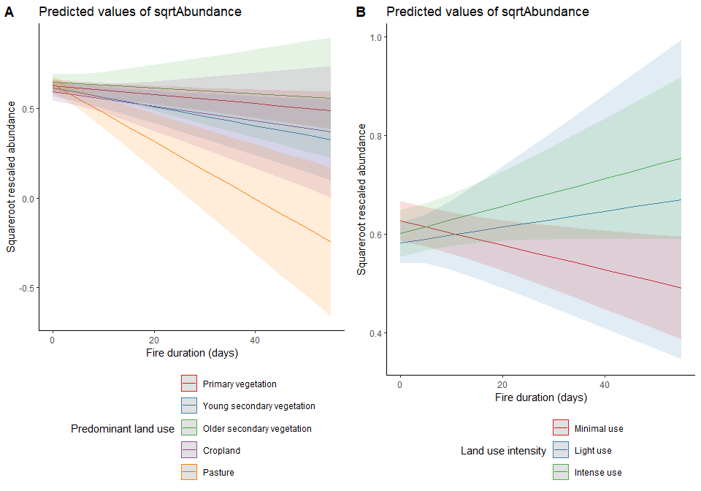

Comparing the different metrics:
Need to set up the models so that REML = FALSE to be able to compare fixed effects.
m1.ml <- lmer(sqrtAbundance ~ Predominant_land_use + Use_intensity + fire_presence +
Predominant_land_use:fire_presence + Predominant_land_use:Use_intensity +
Use_intensity:fire_presence +
(1|SS) + (1|SSB) + (1|Biome), data = model_data, REML=FALSE)
m_freq.ml <- lmer(sqrtAbundance ~ Predominant_land_use + Use_intensity + Freq +
Predominant_land_use:Freq + Predominant_land_use:Use_intensity +Use_intensity:Freq +
(1|SS) + (1|SSB) + (1|Biome), data = model_data, REML=FALSE)
m_size.ml <- lmer(sqrtAbundance ~ Predominant_land_use + Use_intensity + size +
Predominant_land_use:size + Predominant_land_use:Use_intensity + Use_intensity:size +
(1|SS) + (1|SSB) + (1|Biome), data = model_data, REML=FALSE)
m_duration.ml <- lmer(sqrtAbundance ~ Predominant_land_use + Use_intensity + duration +
Predominant_land_use:duration + Predominant_land_use:Use_intensity +
Use_intensity:duration +
(1|SS) + (1|SSB) + (1|Biome), data = model_data, REML=FALSE)
AIC(m1.ml, m_freq.ml, m_size.ml, m_duration.ml)
## df AIC
## m1.ml 26 -3649.204
## m_freq.ml 26 -3644.901
## m_size.ml 26 -3629.332
## m_duration.ml 26 -3644.105

Combinations of metrics
Before models with multiple metrics were tested, metrics were tested for collinearity and the only possible metric combinations are fire_presence and size and Freq and size.
Fire presence and size:
m.pressize <- lmer(sqrtAbundance ~ Predominant_land_use + Use_intensity + fire_presence + size +
Predominant_land_use:fire_presence + Predominant_land_use:Use_intensity +
Use_intensity:fire_presence + Predominant_land_use:size + Use_intensity:size +
(1|SS) + (1|SSB) + (1|Biome), data = model_data)
Anova(m.pressize) # Non of the size aspects come out as significant
## Analysis of Deviance Table (Type II Wald chisquare tests)
##
## Response: sqrtAbundance
## Chisq Df Pr(>Chisq)
## Predominant_land_use 68.0543 4 5.843e-14 ***
## Use_intensity 84.2641 2 < 2.2e-16 ***
## fire_presence 1.0387 1 0.3081144
## size 1.1404 1 0.2855574
## Predominant_land_use:fire_presence 20.5839 4 0.0003829 ***
## Predominant_land_use:Use_intensity 72.7217 8 1.408e-12 ***
## Use_intensity:fire_presence 3.2524 2 0.1966792
## Predominant_land_use:size 3.0038 4 0.5571837
## Use_intensity:size 5.3171 2 0.0700485 .
## ---
## Signif. codes: 0 '***' 0.001 '**' 0.01 '*' 0.05 '.' 0.1 ' ' 1
summary(m.pressize)
## Linear mixed model fit by REML ['lmerMod']
## Formula: sqrtAbundance ~ Predominant_land_use + Use_intensity + fire_presence +
## size + Predominant_land_use:fire_presence + Predominant_land_use:Use_intensity +
## Use_intensity:fire_presence + Predominant_land_use:size +
## Use_intensity:size + (1 | SS) + (1 | SSB) + (1 | Biome)
## Data: model_data
##
## REML criterion at convergence: -3469.9
##
## Scaled residuals:
## Min 1Q Median 3Q Max
## -4.0165 -0.5693 -0.0289 0.5701 4.6579
##
## Random effects:
## Groups Name Variance Std.Dev.
## SSB (Intercept) 0.007045 0.08393
## SS (Intercept) 0.035731 0.18903
## Biome (Intercept) 0.001240 0.03522
## Residual 0.030288 0.17403
## Number of obs: 7122, groups: SSB, 655; SS, 219; Biome, 11
##
## Fixed effects:
## Estimate Std. Error t value
## (Intercept) 6.296e-01 2.027e-02 31.057
## Predominant_land_useYoung secondary vegetation -1.309e-02 1.574e-02 -0.832
## Predominant_land_useOlder secondary vegetation 1.613e-02 1.514e-02 1.065
## Predominant_land_useCropland -3.779e-02 1.896e-02 -1.993
## Predominant_land_usePasture 7.243e-03 1.385e-02 0.523
## Use_intensityLight use -4.571e-02 1.140e-02 -4.009
## Use_intensityIntense use -2.455e-02 1.683e-02 -1.458
## fire_presenceYes -5.069e-02 2.351e-02 -2.156
## size -4.875e-05 3.944e-05 -1.236
## Predominant_land_useYoung secondary vegetation:fire_presenceYes 7.823e-03 3.854e-02 0.203
## Predominant_land_useOlder secondary vegetation:fire_presenceYes 1.685e-01 6.450e-02 2.612
## Predominant_land_useCropland:fire_presenceYes 6.728e-02 4.911e-02 1.370
## Predominant_land_usePasture:fire_presenceYes -1.335e-01 4.842e-02 -2.758
## Predominant_land_useYoung secondary vegetation:Use_intensityLight use 2.495e-02 3.326e-02 0.750
## Predominant_land_useOlder secondary vegetation:Use_intensityLight use 3.697e-02 2.049e-02 1.804
## Predominant_land_useCropland:Use_intensityLight use -3.001e-02 2.681e-02 -1.119
## Predominant_land_usePasture:Use_intensityLight use 2.246e-02 1.690e-02 1.329
## Predominant_land_useYoung secondary vegetation:Use_intensityIntense use -4.311e-02 2.642e-02 -1.632
## Predominant_land_useOlder secondary vegetation:Use_intensityIntense use -2.978e-01 4.448e-02 -6.694
## Predominant_land_useCropland:Use_intensityIntense use -1.236e-01 2.947e-02 -4.192
## Predominant_land_usePasture:Use_intensityIntense use -9.914e-02 2.497e-02 -3.971
## Use_intensityLight use:fire_presenceYes 3.771e-02 4.026e-02 0.937
## Use_intensityIntense use:fire_presenceYes 5.981e-02 3.378e-02 1.771
## Predominant_land_useYoung secondary vegetation:size -3.641e-04 2.135e-04 -1.705
## Predominant_land_useOlder secondary vegetation:size -3.347e-04 7.750e-04 -0.432
## Predominant_land_useCropland:size -8.342e-05 6.138e-04 -0.136
## Predominant_land_usePasture:size 1.795e-05 3.053e-04 0.059
## Use_intensityLight use:size -5.552e-05 1.339e-04 -0.415
## Use_intensityIntense use:size 3.331e-04 1.496e-04 2.226
##
## Correlation matrix not shown by default, as p = 29 > 12.
## Use print(x, correlation=TRUE) or
## vcov(x) if you need it
Fire frequency and size:
m.freqsize <- lmer(sqrtAbundance ~ Predominant_land_use + Use_intensity + Freq + size +
Predominant_land_use:Freq + Predominant_land_use:Use_intensity +
Use_intensity:Freq + Predominant_land_use:size + Use_intensity:size +
(1|SS) + (1|SSB) + (1|Biome), data = model_data)
Anova(m.freqsize)
## Analysis of Deviance Table (Type II Wald chisquare tests)
##
## Response: sqrtAbundance
## Chisq Df Pr(>Chisq)
## Predominant_land_use 69.5323 4 2.849e-14 ***
## Use_intensity 84.5933 2 < 2.2e-16 ***
## Freq 4.6395 1 0.031244 *
## size 1.4027 1 0.236269
## Predominant_land_use:Freq 16.0277 4 0.002982 **
## Predominant_land_use:Use_intensity 73.1441 8 1.160e-12 ***
## Use_intensity:Freq 1.1259 2 0.569516
## Predominant_land_use:size 3.7432 4 0.441879
## Use_intensity:size 7.0750 2 0.029086 *
## ---
## Signif. codes: 0 '***' 0.001 '**' 0.01 '*' 0.05 '.' 0.1 ' ' 1
summary(m.freqsize)
## Linear mixed model fit by REML ['lmerMod']
## Formula: sqrtAbundance ~ Predominant_land_use + Use_intensity + Freq +
## size + Predominant_land_use:Freq + Predominant_land_use:Use_intensity +
## Use_intensity:Freq + Predominant_land_use:size + Use_intensity:size +
## (1 | SS) + (1 | SSB) + (1 | Biome)
## Data: model_data
##
## REML criterion at convergence: -3463.1
##
## Scaled residuals:
## Min 1Q Median 3Q Max
## -4.0142 -0.5709 -0.0279 0.5709 4.6598
##
## Random effects:
## Groups Name Variance Std.Dev.
## SSB (Intercept) 0.006953 0.08338
## SS (Intercept) 0.035771 0.18913
## Biome (Intercept) 0.001238 0.03519
## Residual 0.030308 0.17409
## Number of obs: 7122, groups: SSB, 655; SS, 219; Biome, 11
##
## Fixed effects:
## Estimate Std. Error t value
## (Intercept) 6.299e-01 2.026e-02 31.091
## Predominant_land_useYoung secondary vegetation -1.312e-02 1.572e-02 -0.835
## Predominant_land_useOlder secondary vegetation 1.597e-02 1.513e-02 1.055
## Predominant_land_useCropland -3.704e-02 1.894e-02 -1.956
## Predominant_land_usePasture 6.523e-03 1.385e-02 0.471
## Use_intensityLight use -4.527e-02 1.139e-02 -3.974
## Use_intensityIntense use -2.316e-02 1.670e-02 -1.387
## Freq -2.622e-02 1.202e-02 -2.182
## size -5.582e-05 3.830e-05 -1.457
## Predominant_land_useYoung secondary vegetation:Freq 4.599e-03 2.067e-02 0.222
## Predominant_land_useOlder secondary vegetation:Freq 1.621e-01 6.273e-02 2.584
## Predominant_land_useCropland:Freq 3.687e-02 4.383e-02 0.841
## Predominant_land_usePasture:Freq -8.194e-02 3.693e-02 -2.219
## Predominant_land_useYoung secondary vegetation:Use_intensityLight use 2.448e-02 3.326e-02 0.736
## Predominant_land_useOlder secondary vegetation:Use_intensityLight use 3.658e-02 2.048e-02 1.786
## Predominant_land_useCropland:Use_intensityLight use -3.378e-02 2.707e-02 -1.248
## Predominant_land_usePasture:Use_intensityLight use 2.176e-02 1.689e-02 1.288
## Predominant_land_useYoung secondary vegetation:Use_intensityIntense use -4.346e-02 2.617e-02 -1.661
## Predominant_land_useOlder secondary vegetation:Use_intensityIntense use -2.942e-01 4.440e-02 -6.626
## Predominant_land_useCropland:Use_intensityIntense use -1.258e-01 2.938e-02 -4.280
## Predominant_land_usePasture:Use_intensityIntense use -1.012e-01 2.487e-02 -4.071
## Use_intensityLight use:Freq 1.740e-02 3.279e-02 0.531
## Use_intensityIntense use:Freq 1.920e-02 1.906e-02 1.007
## Predominant_land_useYoung secondary vegetation:size -3.546e-04 1.915e-04 -1.852
## Predominant_land_useOlder secondary vegetation:size -3.310e-04 7.743e-04 -0.428
## Predominant_land_useCropland:size -9.191e-05 6.928e-04 -0.133
## Predominant_land_usePasture:size -1.574e-04 2.854e-04 -0.552
## Use_intensityLight use:size -4.935e-05 1.330e-04 -0.371
## Use_intensityIntense use:size 3.708e-04 1.430e-04 2.593
##
## Correlation matrix not shown by default, as p = 29 > 12.
## Use print(x, correlation=TRUE) or
## vcov(x) if you need it

Comparing all models:
m.pressize.ml <- lmer(sqrtAbundance ~ Predominant_land_use + Use_intensity + fire_presence + size +
Predominant_land_use:fire_presence + Predominant_land_use:Use_intensity +
Use_intensity:fire_presence + Predominant_land_use:size + Use_intensity:size +
(1|SS) + (1|SSB) + (1|Biome), data = model_data, REML=FALSE)
m.freqsize.ml <- lmer(sqrtAbundance ~ Predominant_land_use + Use_intensity + Freq + size +
Predominant_land_use:Freq + Predominant_land_use:Use_intensity +
Use_intensity:Freq + Predominant_land_use:size + Use_intensity:size +
(1|SS) + (1|SSB) + (1|Biome), data = model_data, REML=FALSE)
AIC(m1.ml, m_freq.ml, m_size.ml, m_duration.ml, m.pressize.ml, m.freqsize.ml)
## df AIC
## m1.ml 26 -3649.204
## m_freq.ml 26 -3644.901
## m_size.ml 26 -3629.332
## m_duration.ml 26 -3644.105
## m.pressize.ml 33 -3642.044
## m.freqsize.ml 33 -3640.630
The best model is m1 so the model that only contains fire presence.

Time since fire
Need to make days since fire a numeric variable:
model_data$days_since_fire <- as.numeric(model_data$days_since_fire)
Need to change the NAs to a value to model them. Going to use 3.5 years or 1277 days asan arbitary value.
model_data$days_since_fire[is.na(model_data$days_since_fire)] <- 1277
For ease of understanding it may be best to convert days since fire into years.
model_data$time_since_fire <- model_data$days_since_fire
model_data$time_since_fire <- model_data$time_since_fire/365
str(model_data$time_since_fire)
## num [1:7122] 3.5 3.5 3.5 3.5 3.5 ...
Need to check collinearity before modelling:
corvif(model_data[ , c("Predominant_land_use", "Use_intensity", "fire_presence", "time_since_fire")])
##
##
## Variance inflation factors
##
## GVIF Df GVIF^(1/2Df)
## Predominant_land_use 1.275305 4 1.030865
## Use_intensity 1.343850 2 1.076683
## fire_presence 8.922317 1 2.987025
## time_since_fire 8.702385 1 2.949980
There are very high GVIF values for fire presence and time since fire so these likely cannot be modelled together.
Modelling with time since fire
m1_time <- lmer(sqrtAbundance ~ Predominant_land_use + Use_intensity + time_since_fire +
Predominant_land_use:Use_intensity + Predominant_land_use:time_since_fire +
Use_intensity:time_since_fire + (1|SS) + (1|SSB) + (1|Biome), data = model_data)
Anova(m1_time)
## Analysis of Deviance Table (Type II Wald chisquare tests)
##
## Response: sqrtAbundance
## Chisq Df Pr(>Chisq)
## Predominant_land_use 68.9177 4 3.841e-14 ***
## Use_intensity 78.5602 2 < 2.2e-16 ***
## time_since_fire 2.0784 1 0.1493945
## Predominant_land_use:Use_intensity 75.6854 8 3.596e-13 ***
## Predominant_land_use:time_since_fire 20.2169 4 0.0004525 ***
## Use_intensity:time_since_fire 8.6825 2 0.0130203 *
## ---
## Signif. codes: 0 '***' 0.001 '**' 0.01 '*' 0.05 '.' 0.1 ' ' 1
summary(m1_time)
## Linear mixed model fit by REML ['lmerMod']
## Formula: sqrtAbundance ~ Predominant_land_use + Use_intensity + time_since_fire +
## Predominant_land_use:Use_intensity + Predominant_land_use:time_since_fire +
## Use_intensity:time_since_fire + (1 | SS) + (1 | SSB) + (1 | Biome)
## Data: model_data
##
## REML criterion at convergence: -3549.4
##
## Scaled residuals:
## Min 1Q Median 3Q Max
## -4.0110 -0.5726 -0.0310 0.5746 4.6524
##
## Random effects:
## Groups Name Variance Std.Dev.
## SSB (Intercept) 0.006928 0.08324
## SS (Intercept) 0.035691 0.18892
## Biome (Intercept) 0.001230 0.03507
## Residual 0.030342 0.17419
## Number of obs: 7122, groups: SSB, 655; SS, 219; Biome, 11
##
## Fixed effects:
## Estimate Std. Error t value
## (Intercept) 0.548832 0.034329 15.987
## Predominant_land_useYoung secondary vegetation -0.055225 0.053237 -1.037
## Predominant_land_useOlder secondary vegetation 0.205943 0.083389 2.470
## Predominant_land_useCropland 0.047351 0.072305 0.655
## Predominant_land_usePasture -0.169276 0.063984 -2.646
## Use_intensityLight use -0.013972 0.059628 -0.234
## Use_intensityIntense use 0.113605 0.044698 2.542
## time_since_fire 0.023194 0.008634 2.686
## Predominant_land_useYoung secondary vegetation:Use_intensityLight use 0.023332 0.033272 0.701
## Predominant_land_useOlder secondary vegetation:Use_intensityLight use 0.035784 0.020486 1.747
## Predominant_land_useCropland:Use_intensityLight use -0.031030 0.026933 -1.152
## Predominant_land_usePasture:Use_intensityLight use 0.020095 0.016894 1.189
## Predominant_land_useYoung secondary vegetation:Use_intensityIntense use -0.049612 0.025732 -1.928
## Predominant_land_useOlder secondary vegetation:Use_intensityIntense use -0.316773 0.046795 -6.769
## Predominant_land_useCropland:Use_intensityIntense use -0.132032 0.029345 -4.499
## Predominant_land_usePasture:Use_intensityIntense use -0.106391 0.024838 -4.283
## Predominant_land_useYoung secondary vegetation:time_since_fire 0.012034 0.014931 0.806
## Predominant_land_useOlder secondary vegetation:time_since_fire -0.054441 0.024001 -2.268
## Predominant_land_useCropland:time_since_fire -0.023989 0.020681 -1.160
## Predominant_land_usePasture:time_since_fire 0.050041 0.018157 2.756
## Use_intensityLight use:time_since_fire -0.008581 0.017071 -0.503
## Use_intensityIntense use:time_since_fire -0.037318 0.012987 -2.874
##
## Correlation matrix not shown by default, as p = 22 > 12.
## Use print(x, correlation=TRUE) or
## vcov(x) if you need it
Plotting the effects of time since fire on abundance:
theme_set(theme_classic())
a <- plot_model(m1_time, type = "pred", terms = c("time_since_fire", "Predominant_land_use"),
legend.title = "Predominant land use", axis.title = c("Time since fire (years)",
"Square root rescaled abundance"),
title = "")+
font_size(axis_title.x = 10, axis_title.y = 10)
b <- plot_model(m1_time, type = "pred", terms = c("time_since_fire", "Use_intensity"),
legend.title = "Use intensity", axis.title = c("Time since fire (years)",
"Square root rescaled abundance"),
title = "")+
font_size(axis_title.x = 10, axis_title.y = 10)
ggarrange(a, b, nrow = 2, ncol=1, legend = "right", labels = c("A", "B"))
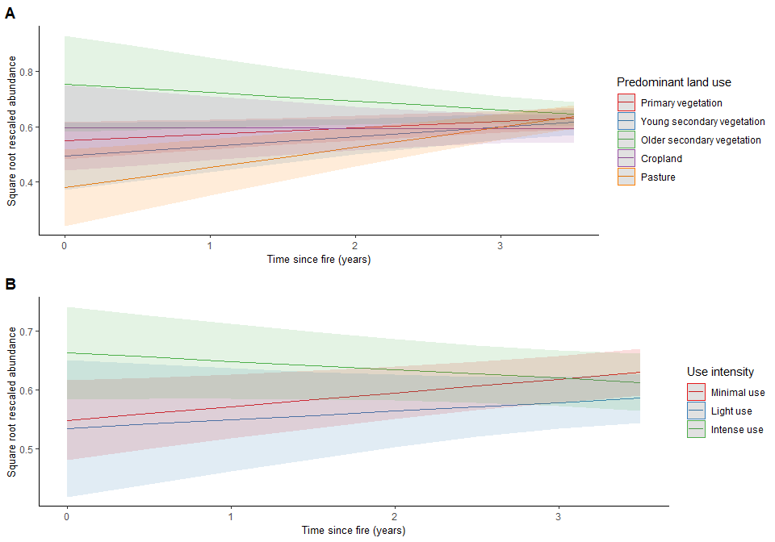
Diagnostics:
par(mfrow=c(1,2))
qqnorm(resid(m1_time), main="normal qq-plot, residuals")
qqline(resid(m1_time)) ## not bad
plot(fitted(m1_time), resid(m1_time), main = "Residuals vs fitted") #residuals vs fitted
abline(h=0)
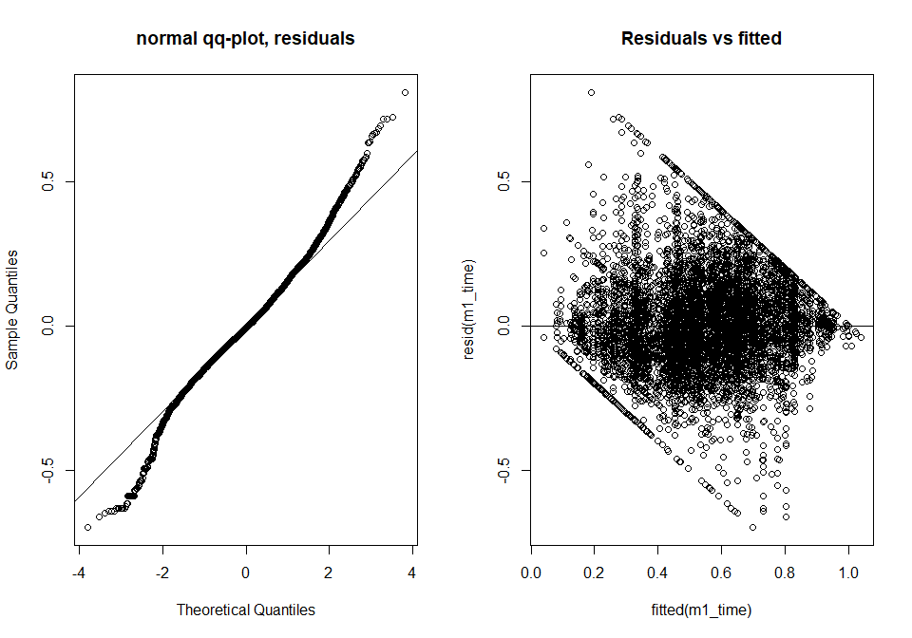
ran <- ranef(m1_time, condVar=TRUE)
#double square bracket access the lists in d1
a <- dotplot(ran)[["SSB"]]
b <- dotplot(ran)[["SS"]]
c <- dotplot(ran)[["Biome"]]
grid.arrange(a,b,c, nrow=2, ncol=2)
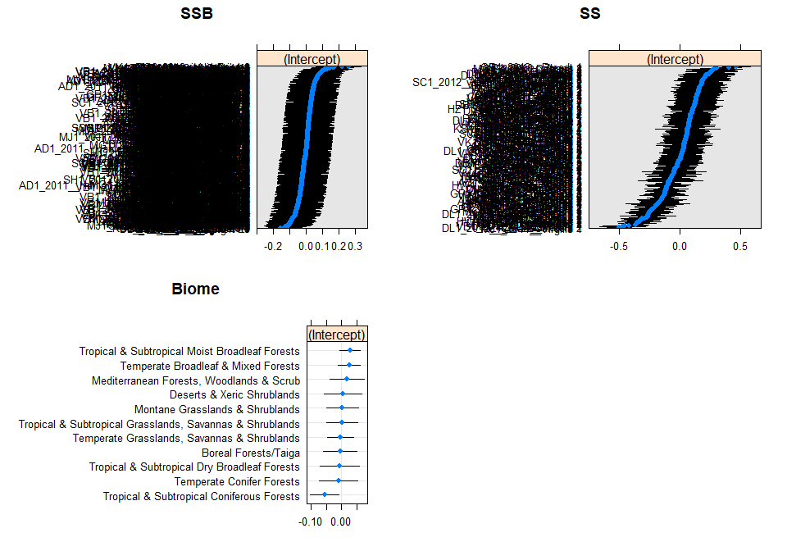
R2:
r.squaredGLMM(m1_time)
## Warning: 'r.squaredGLMM' now calculates a revised statistic. See the help page.
## R2m R2c
## [1,] 0.03570131 0.6056325

Hypothesis testing:
m1_notime <- lmer(sqrtAbundance ~ Predominant_land_use + Use_intensity +
Predominant_land_use:Use_intensity +
(1|SS) + (1|SSB) + (1|Biome), data = model_data)
anova(m1_time, m1_notime)
## refitting model(s) with ML (instead of REML)
## Data: model_data
## Models:
## m1_notime: sqrtAbundance ~ Predominant_land_use + Use_intensity + Predominant_land_use:Use_intensity +
## m1_notime: (1 | SS) + (1 | SSB) + (1 | Biome)
## m1_time: sqrtAbundance ~ Predominant_land_use + Use_intensity + time_since_fire +
## m1_time: Predominant_land_use:Use_intensity + Predominant_land_use:time_since_fire +
## m1_time: Use_intensity:time_since_fire + (1 | SS) + (1 | SSB) + (1 |
## m1_time: Biome)
## npar AIC BIC logLik deviance Chisq Df Pr(>Chisq)
## m1_notime 19 -3619.1 -3488.6 1828.6 -3657.1
## m1_time 26 -3641.4 -3462.7 1846.7 -3693.4 36.256 7 6.485e-06 ***
## ---
## Signif. codes: 0 '***' 0.001 '**' 0.01 '*' 0.05 '.' 0.1 ' ' 1
Time has a significant effect on abundance.

Is the relationship linear?
plot(m1_time)
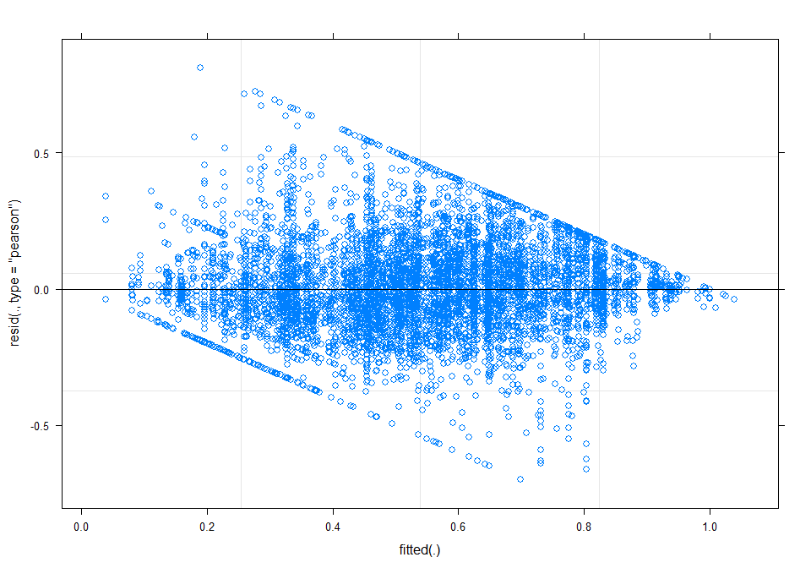
From this plot you can see the clear bounding of the response variable.
time_output <- simulateResiduals(fittedModel = m1_time)
plot(time_output, quantreg = T)
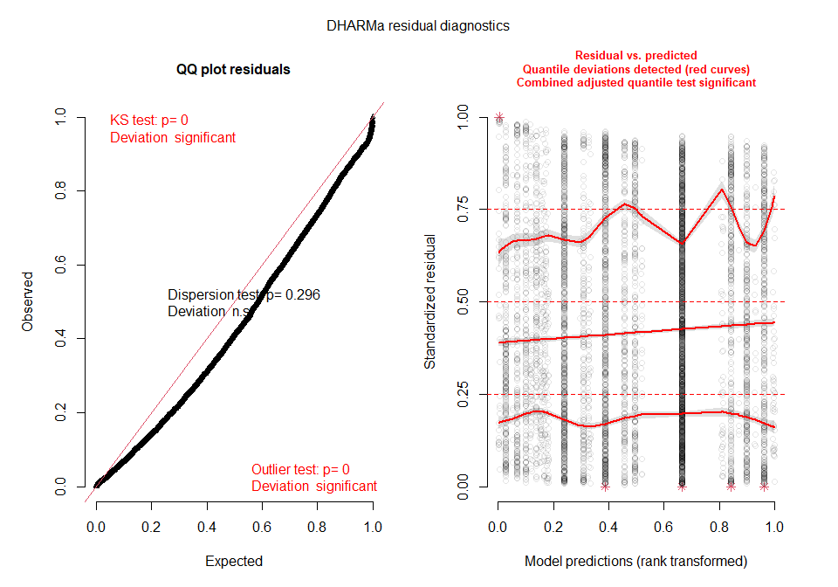
Plot suggests some non normality in the residuals and shows that there may be some misspecification within the model. Can plot time since fire to see if this has been properly specified.
plotResiduals(time_output, model_data$time_since_fire)
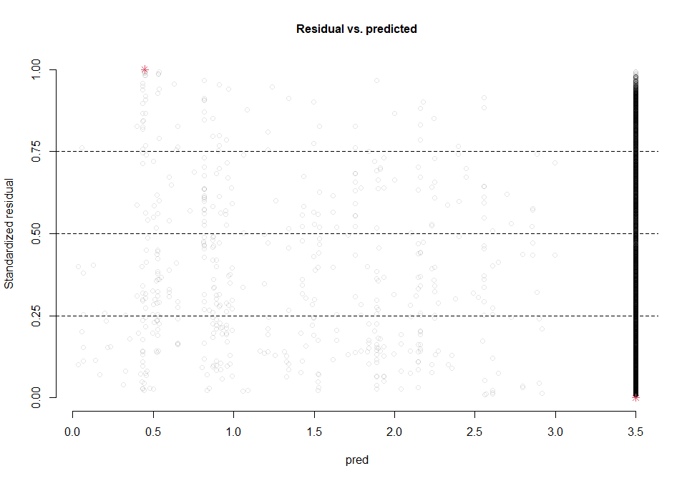
Plot suggests that this relationship is likely linear as no deviations are being picked up.
Testing different transformations
-1/Time:
model_data$minustime <- model_data$time_since_fire
model_data$minustime <- -1/model_data$time_since_fire
m1_minustime <- lmer(sqrtAbundance ~ Predominant_land_use + Use_intensity + minustime +
Predominant_land_use:Use_intensity + Predominant_land_use:minustime +
Use_intensity:minustime + (1|SS) + (1|SSB) + (1|Biome), data = model_data)
minustime_output <- simulateResiduals(fittedModel = m1_minustime)
plot(minustime_output, quantreg = T)
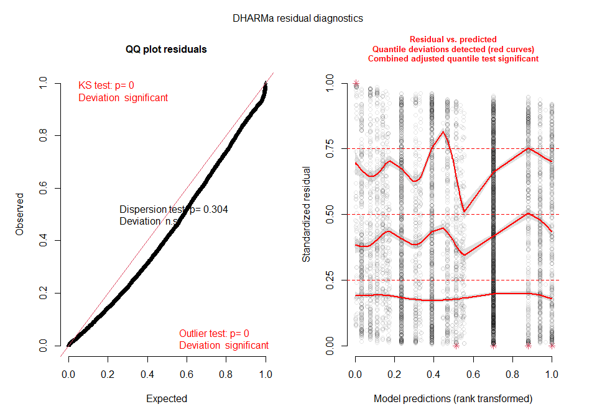
plotResiduals(minustime_output, model_data$minustime)
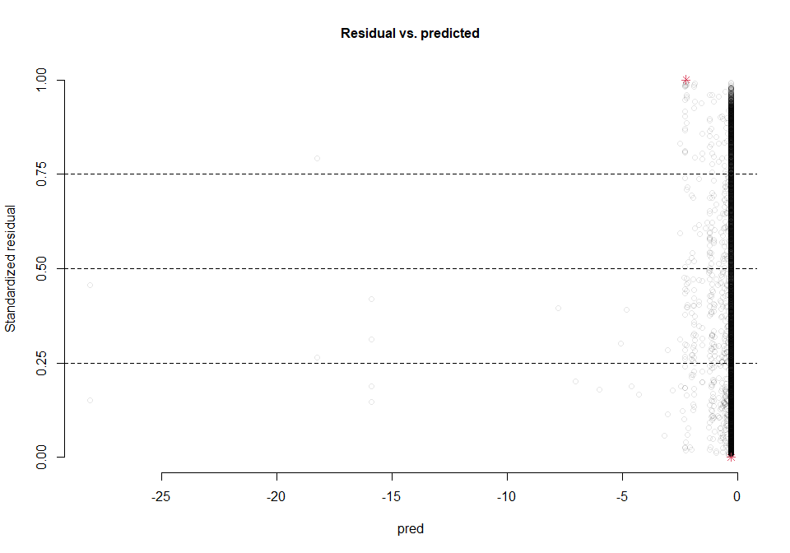
This transformation appears to result in more problems than time on its own.
Log time:
model_data$logtime <- model_data$time_since_fire
model_data$logtime <- log(model_data$time_since_fire)
m1_logtime <- lmer(sqrtAbundance ~ Predominant_land_use + Use_intensity + logtime +
Predominant_land_use:Use_intensity + Predominant_land_use:logtime +
Use_intensity:logtime + (1|SS) + (1|SSB) + (1|Biome), data = model_data)
logtime_output <- simulateResiduals(fittedModel = m1_logtime)
plot(logtime_output, quantreg = T)
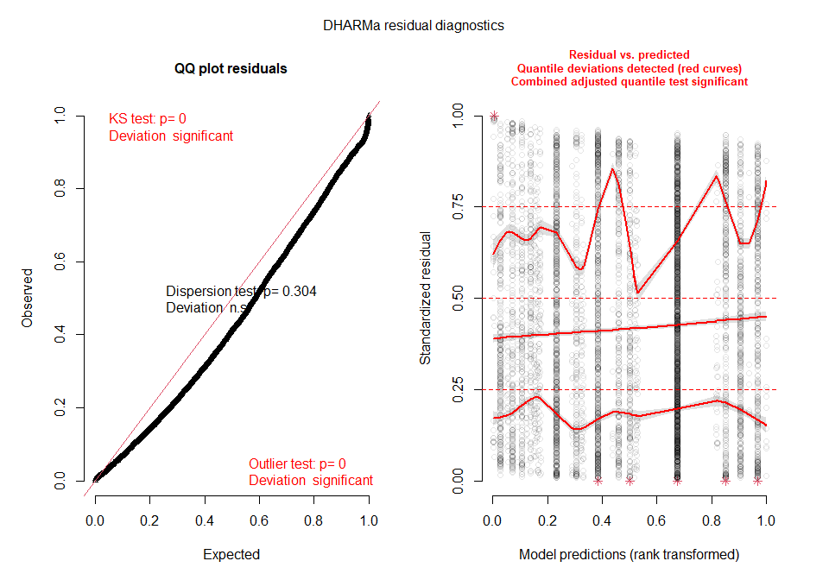
plotResiduals(logtime_output, model_data$logtime)
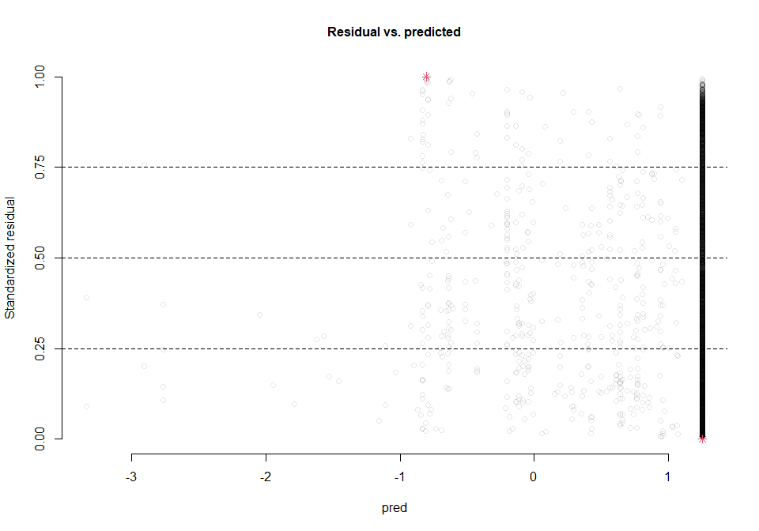
Log transformations also do not lead to an improved model.

Comparing time model to other models:
m1_time.ml <- lmer(sqrtAbundance ~ Predominant_land_use + Use_intensity + time_since_fire +
Predominant_land_use:Use_intensity + Predominant_land_use:time_since_fire +
Use_intensity:time_since_fire + (1|SS) + (1|SSB) + (1|Biome), data = model_data, REML = FALSE)
AIC(m1.ml, m_freq.ml, m_size.ml, m_duration.ml, m.pressize.ml, m.freqsize.ml, m1_time.ml)
## df AIC
## m1.ml 26 -3649.204
## m_freq.ml 26 -3644.901
## m_size.ml 26 -3629.332
## m_duration.ml 26 -3644.105
## m.pressize.ml 33 -3642.044
## m.freqsize.ml 33 -3640.630
## m1_time.ml 26 -3641.378
The model which contains fire presence on its own remains the optimum model.

