Selecting the Global abundance model
Load the required data (both PREDICTS and fire history data).
diversity <- readRDS("~/Imperial/PROJECT/PREDICTS data/database.rds")
fire_hist <- read.csv("~/Imperial/PROJECT/Combined data/Fire_history.csv")

PREDICTS data preparation
Calculating site level diversity metrics and tidying up the land use category.
diversity <- mutate(diversity,
Measurement = Effort_corrected_measurement,
Sampling_effort = Rescaled_sampling_effort)
sites <- diversity %>%
mutate(Diversity_metric_is_valid = TRUE) %>%
predictsFunctions::SiteMetrics(extra.cols = c("SSB", "SSBS", "Predominant_land_use", "Biome", "Country")) %>%
group_by(SS) %>%
mutate(MaxAbundance = ifelse(Diversity_metric_type == "Abundance",
max(Total_abundance),
NA)) %>%
ungroup() %>%
mutate(RescaledAbundance = ifelse(Diversity_metric_type == "Abundance",
Total_abundance/MaxAbundance,
NA))
sites <- sites %>%
mutate(
Predominant_land_use = recode_factor(Predominant_land_use,
"Primary forest" = "Primary vegetation",
"Primary non-forest" = "Primary vegetation"),
Predominant_land_use = na_if(Predominant_land_use, "Secondary vegetation (indeterminate age)"),
Predominant_land_use = na_if(Predominant_land_use, "Cannot decide"),
Use_intensity = na_if(Use_intensity, "Cannot decide"),
Predominant_land_use = factor(Predominant_land_use),
Predominant_land_use = relevel(Predominant_land_use, ref = "Primary vegetation"),
Use_intensity = factor(Use_intensity),
Use_intensity = relevel(Use_intensity, ref = "Minimal use")
)
## For my analysis I need to subset so that all sites are after 2006 (so that we can have 3yrs of
#fire data)
sites_post_2006 <- subset(sites, sites$Sample_start_earliest > "2006-01-01")
## Removing rows that have NAs in latitude and longitude as these won't have fire data
sites_post_2006_NA <- subset(sites_post_2006, (! is.na(Longitude) | ! is.na(Latitude)))

Combining with fire data
PREDICTS_fire_hist <- merge(sites_post_2006_NA, fire_hist
[,c("SSBS", "Freq", "fire_ID", "size", "start_date", "duration", "days_since_fire",
"year", "years_since_fire")], by="SSBS", all.x=TRUE)
## editing of data
## Change freq from NA to 0
PREDICTS_fire_hist$Freq[is.na(PREDICTS_fire_hist$Freq)] <- 0
## Adding a column of fire presence
PREDICTS_fire_hist$fire_presence <- ifelse(PREDICTS_fire_hist$Freq==0, "No",
ifelse(PREDICTS_fire_hist$Freq!=0, "Yes",
NA))
PREDICTS_fire_hist$fire_presence <- as.factor(PREDICTS_fire_hist$fire_presence)

Data exploration and biome splits
Before any analysis we need to ensure we have complete cases in the data.
model_data <- drop_na(PREDICTS_fire_hist, Total_abundance, Predominant_land_use, Use_intensity, fire_presence)
Numbers of sites with and without fires
table(model_data$fire_presence)
##
## No Yes
## 8235 531
8235 sites without fire and 531 sites with fire (6%). This is quite a large data imbalance.
Looking at how the fire presence data is split between land use classes
table(model_data$Predominant_land_use, model_data$fire_presence)
##
## No Yes
## Primary vegetation 3085 316
## Young secondary vegetation 548 108
## Intermediate secondary vegetation 617 33
## Mature secondary vegetation 265 3
## Plantation forest 1157 4
## Pasture 1373 38
## Cropland 744 27
## Urban 446 2
Intermediate and mature secondary vegetation have quite low numbers of sites where fires are present, so could be merged if this is too low. The same is true for pasture and cropland. Plantation forest and urban have very low number of sites with a fire so can be excluded, like in just the savanna models.
Looking at how fire presence data is split across biomes
table(model_data$Biome, model_data$fire_presence)
##
## No Yes
## Tundra 21 0
## Boreal Forests/Taiga 485 8
## Temperate Conifer Forests 169 0
## Temperate Broadleaf & Mixed Forests 3007 7
## Montane Grasslands & Shrublands 151 38
## Temperate Grasslands, Savannas & Shrublands 318 0
## Mediterranean Forests, Woodlands & Scrub 466 4
## Deserts & Xeric Shrublands 139 5
## Tropical & Subtropical Grasslands, Savannas & Shrublands 623 448
## Tropical & Subtropical Coniferous Forests 246 0
## Flooded Grasslands & Savannas 0 0
## Tropical & Subtropical Dry Broadleaf Forests 164 0
## Tropical & Subtropical Moist Broadleaf Forests 2432 21
## Mangroves 14 0
## Inland Water 0 0
## Rock & Ice 0 0
Tundra, temperate grasslands, tropical and subtropical coniferous forests, tropical and subtropical dry broadleaf forests, and mangroves all have sites without any fires have occurred in the 3 years prior to sampling. Of the 531 sites which have a fire 448 of them are within Tropical & Subtropical Grasslands, Savannas & Shrublands. We could overcome this split of data by merging biomes into smaller classes. e.g. forest vs non forest, or by aggregating similar biomes together.
First need to remove the biomes with no data, as well as mangroves and tundra as these two biomes do not have any fires in this data set and cannot be easily aggregated with other biomes.
model_data<-model_data[!(model_data$Biome == "Rock & Ice"),]
model_data<-model_data[!(model_data$Biome == "Flooded Grasslands & Savannas"),]
model_data<-model_data[!(model_data$Biome == "Mangroves"),]
model_data<-model_data[!(model_data$Biome == "Inland Water"),]
model_data<-model_data[!(model_data$Biome == "Tundra"),]
model_data$Biome <- as.factor(as.character(model_data$Biome))
Aggregating data into forest and non-forest
model_data$adj.biome <- ifelse(model_data$Biome=="Boreal Forests/Taiga", "Forest",
ifelse(model_data$Biome=="Temperate Conifer Forests", "Forest",
ifelse(model_data$Biome=="Temperate Broadleaf & Mixed Forests", "Forest",
ifelse(model_data$Biome=="Montane Grasslands & Shrublands", "Non Forest",
ifelse(model_data$Biome=="Temperate Grasslands, Savannas & Shrublands", "Non Forest",
ifelse(model_data$Biome=="Mediterranean Forests, Woodlands & Scrub", "Forest",
ifelse(model_data$Biome=="Deserts & Xeric Shrublands", "Non Forest",
ifelse(model_data$Biome=="Tropical & Subtropical Grasslands, Savannas & Shrublands", "Non Forest",
ifelse(model_data$Biome=="Tropical & Subtropical Coniferous Forests", "Forest",
ifelse(model_data$Biome=="Tropical & Subtropical Dry Broadleaf Forests", "Forest",
ifelse(model_data$Biome=="Tropical & Subtropical Moist Broadleaf Forests", "Forest",
NA)))))))))))
model_data$adj.biome <- as.factor(model_data$adj.biome)
table(model_data$adj.biome, model_data$fire_presence)
##
## No Yes
## Forest 6969 40
## Non Forest 1231 491
Even in this coarser biome categorisation we still have a large imbalance, with far more fires having occurred in the non-forested biomes. This is likely because we are using only 3-year long fire histories and in many forest biomes fire return intervals are greater than 3 years and therefore data may not be fully captured. In contrast grassland systems and tropical savannas often have return intervals of less than a year and therefore this is being picked up in more detail.
We can also aggregate the biomes together in a less coarse more representative way. We can split the biomes up into more general categories being boreal forests, temperate forests, Mediterranean, tropical forests, tropical grasslands, and deserts/shrublands/other grasslands.
model_data$new.biome <- model_data$Biome
model_data <- model_data %>%
mutate(
new.biome = recode_factor(new.biome,
"Deserts & Xeric Shrublands" = "Deserts, Shrublands and Grasslands",
"Montane Grasslands & Shrublands" = "Deserts, Shrublands and Grasslands",
"Temperate Grasslands, Savannas & Shrublands" = "Deserts, Shrublands and Grasslands",
"Temperate Broadleaf & Mixed Forests" = "Temperate Forest",
"Temperate Conifer Forests" = "Temperate Forest",
"Tropical & Subtropical Coniferous Forests" = "Tropical & Subtropical Forest",
"Tropical & Subtropical Dry Broadleaf Forests" = "Tropical & Subtropical Forest",
"Tropical & Subtropical Moist Broadleaf Forests" = "Tropical & Subtropical Forest")
)
model_data$new.biome <- as.factor(as.character(model_data$new.biome))
table(model_data$new.biome, model_data$fire_presence)
##
## No Yes
## Boreal Forests/Taiga 485 8
## Deserts, Shrublands and Grasslands 608 43
## Mediterranean Forests, Woodlands & Scrub 466 4
## Temperate Forest 3176 7
## Tropical & Subtropical Forest 2842 21
## Tropical & Subtropical Grasslands, Savannas & Shrublands 623 448
We now have a much better representation of the different biomes, although we still have some very small number of sites in categories including boreal forests/taiga, Mediterranean forest, and temperate forests. If this is a problem, then they could potentially be combined to form a “non-tropical forests” category, similar to the deserts, shrublands and grasslands category. At this stage I want to keep Mediterranean separate as these biomes often have very distinct fire regimes compared to temperate and boreal forests.

Adjusting the land use classes for analysis.
Need to remove NAs and remove the plantation and urban land use classes. Also going to merge intermediate and mature secondary vegetation together due to a lack of data.
model_data<- drop_na(model_data, Predominant_land_use)
model_data<-model_data[!(model_data$Predominant_land_use == "Plantation forest"),]
model_data<-model_data[!(model_data$Predominant_land_use == "Urban"),]
model_data$Predominant_land_use <- as.factor(as.character(model_data$Predominant_land_use))
model_data <- model_data %>%
mutate( Predominant_land_use = recode_factor(Predominant_land_use,
"Intermediate secondary vegetation" = "Older secondary vegetation",
"Mature secondary vegetation" = "Older secondary vegetation"),
Predominant_land_use = factor(Predominant_land_use),
Predominant_land_use = relevel(Predominant_land_use, ref = "Primary vegetation")
)
model_data$Predominant_land_use <- factor(model_data$Predominant_land_use, levels = c("Primary vegetation", "Young secondary vegetation", "Older secondary vegetation",
"Cropland", "Pasture"))
table(model_data$Predominant_land_use, model_data$fire_presence)
##
## No Yes
## Primary vegetation 3073 316
## Young secondary vegetation 546 108
## Older secondary vegetation 880 36
## Cropland 736 27
## Pasture 1362 38

Trying a basic global model
Biome will be fitted as a random effect within these models.

Assumption checking
collinearity:
source("https://highstat.com/Books/Book2/HighstatLibV10.R")
corvif(model_data[ , c("Predominant_land_use", "Use_intensity", "fire_presence")])
##
##
## Variance inflation factors
##
## GVIF Df GVIF^(1/2Df)
## Predominant_land_use 1.270604 4 1.030389
## Use_intensity 1.340113 2 1.075933
## fire_presence 1.113793 1 1.055364
The GVIF (Generalised variance inflation factor) values seen here are all quite low and are acceptable for not showing collinearity. Transform abundance as it has non-normal distribution
model_data <- mutate(model_data,
logAbundance = log(RescaledAbundance + 1),
sqrtAbundance = sqrt(RescaledAbundance)
)
par(mfrow=c(2,2))
hist(model_data$logAbundance, xlab="Log+1 abundance", main="Histogram of log+1 abundance")
qqnorm(model_data$logAbundance, main = "Normal Q-Q plot log+1 abundance")
hist(model_data$sqrtAbundance, xlab="Square root abundance", main="Histogram of square root abundance") #
qqnorm(model_data$sqrtAbundance, main = "Normal Q-Q plot sqaure root abundance") #
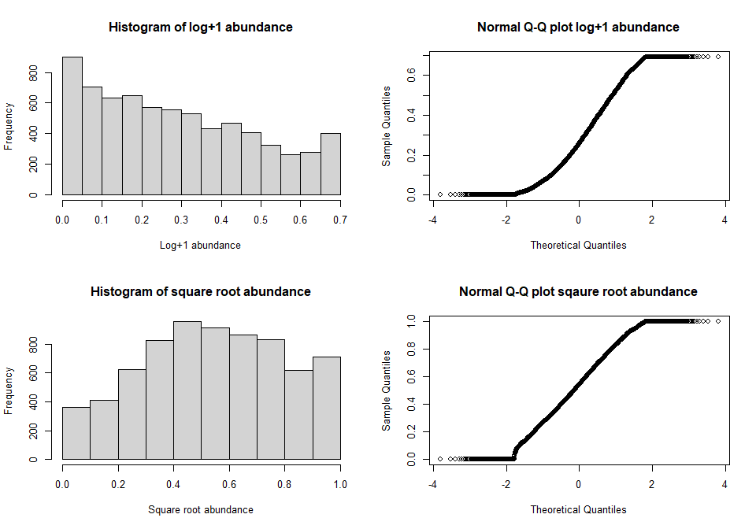
Going to use sqrtAbundance as it has the most normal distribution.

Model selection

Maximal starting model:
max <- lmer(sqrtAbundance ~ Predominant_land_use + Use_intensity + fire_presence +
Predominant_land_use:fire_presence + Predominant_land_use:Use_intensity +
Use_intensity:fire_presence +
(1|SS) + (1|SSB) + (1|Biome), data = model_data)
Anova(max)
## Analysis of Deviance Table (Type II Wald chisquare tests)
##
## Response: sqrtAbundance
## Chisq Df Pr(>Chisq)
## Predominant_land_use 67.2341 4 8.701e-14 ***
## Use_intensity 83.1178 2 < 2.2e-16 ***
## fire_presence 1.7099 1 0.190999
## Predominant_land_use:fire_presence 27.1934 4 1.817e-05 ***
## Predominant_land_use:Use_intensity 75.4353 8 4.036e-13 ***
## Use_intensity:fire_presence 9.3286 2 0.009426 **
## ---
## Signif. codes: 0 '***' 0.001 '**' 0.01 '*' 0.05 '.' 0.1 ' ' 1
summary(max)
## Linear mixed model fit by REML ['lmerMod']
## Formula: sqrtAbundance ~ Predominant_land_use + Use_intensity + fire_presence +
## Predominant_land_use:fire_presence + Predominant_land_use:Use_intensity +
## Use_intensity:fire_presence + (1 | SS) + (1 | SSB) + (1 | Biome)
## Data: model_data
##
## REML criterion at convergence: -3569
##
## Scaled residuals:
## Min 1Q Median 3Q Max
## -4.0157 -0.5693 -0.0296 0.5710 4.6519
##
## Random effects:
## Groups Name Variance Std.Dev.
## SSB (Intercept) 0.007029 0.08384
## SS (Intercept) 0.035707 0.18896
## Biome (Intercept) 0.001241 0.03523
## Residual 0.030290 0.17404
## Number of obs: 7122, groups: SSB, 655; SS, 219; Biome, 11
##
## Fixed effects:
## Estimate Std. Error t value
## (Intercept) 0.629850 0.020269 31.075
## Predominant_land_useYoung secondary vegetation -0.012709 0.015738 -0.808
## Predominant_land_useOlder secondary vegetation 0.015980 0.015139 1.056
## Predominant_land_useCropland -0.038043 0.018951 -2.007
## Predominant_land_usePasture 0.007152 0.013844 0.517
## Use_intensityLight use -0.045443 0.011398 -3.987
## Use_intensityIntense use -0.022331 0.016797 -1.329
## fire_presenceYes -0.060531 0.021435 -2.824
## Predominant_land_useYoung secondary vegetation:fire_presenceYes -0.024673 0.031754 -0.777
## Predominant_land_useOlder secondary vegetation:fire_presenceYes 0.152424 0.057753 2.639
## Predominant_land_useCropland:fire_presenceYes 0.073275 0.045533 1.609
## Predominant_land_usePasture:fire_presenceYes -0.134606 0.042746 -3.149
## Predominant_land_useYoung secondary vegetation:Use_intensityLight use 0.024281 0.033262 0.730
## Predominant_land_useOlder secondary vegetation:Use_intensityLight use 0.036885 0.020490 1.800
## Predominant_land_useCropland:Use_intensityLight use -0.029224 0.026805 -1.090
## Predominant_land_usePasture:Use_intensityLight use 0.022370 0.016897 1.324
## Predominant_land_useYoung secondary vegetation:Use_intensityIntense use -0.048415 0.026304 -1.841
## Predominant_land_useOlder secondary vegetation:Use_intensityIntense use -0.303935 0.044242 -6.870
## Predominant_land_useCropland:Use_intensityIntense use -0.125250 0.029451 -4.253
## Predominant_land_usePasture:Use_intensityIntense use -0.101210 0.024946 -4.057
## Use_intensityLight use:fire_presenceYes 0.035530 0.038114 0.932
## Use_intensityIntense use:fire_presenceYes 0.093252 0.030597 3.048
##
## Correlation matrix not shown by default, as p = 22 > 12.
## Use print(x, correlation=TRUE) or
## vcov(x) if you need it
All elements are significant expect for fire presence on its own.

Random effects:
Biome intercept:
max_ref1 <- lmer(sqrtAbundance ~ Predominant_land_use + Use_intensity + fire_presence +
Predominant_land_use:fire_presence + Predominant_land_use:Use_intensity +
Use_intensity:fire_presence +
(1|SS) + (1|SSB) + (1|Biome), data = model_data)
Aggregated biomes intercept:
max_ref2 <- lmer(sqrtAbundance ~ Predominant_land_use + Use_intensity + fire_presence +
Predominant_land_use:fire_presence + Predominant_land_use:Use_intensity +
Use_intensity:fire_presence +
(1|SS) + (1|SSB) + (1|new.biome), data = model_data)
Biome slope:
max_ref3 <- lmer(sqrtAbundance ~ Predominant_land_use + Use_intensity + fire_presence +
Predominant_land_use:fire_presence + Predominant_land_use:Use_intensity +
Use_intensity:fire_presence +
(1|SS) + (1|SSB) + (1+fire_presence|Biome), data = model_data)
## boundary (singular) fit: see ?isSingular
Singular fit warning
Aggregated biomes slope:
max_ref4 <- lmer(sqrtAbundance ~ Predominant_land_use + Use_intensity + fire_presence +
Predominant_land_use:fire_presence + Predominant_land_use:Use_intensity +
Use_intensity:fire_presence +
(1|SS) + (1|SSB) + (1+fire_presence|new.biome), data = model_data)
## boundary (singular) fit: see ?isSingular
Singular fit warning
Without biome:
max_ref5 <- lmer(sqrtAbundance ~ Predominant_land_use + Use_intensity + fire_presence +
Predominant_land_use:fire_presence + Predominant_land_use:Use_intensity +
Use_intensity:fire_presence +
(1|SS) + (1|SSB), data = model_data)
Comparing the random effects structures:
AIC(max_ref1, max_ref2, max_ref3, max_ref4, max_ref5)
## df AIC
## max_ref1 26 -3517.032
## max_ref2 26 -3507.657
## max_ref3 28 -3513.041
## max_ref4 28 -3503.672
## max_ref5 25 -3509.647
The first model, containing biome, SS and SSB as intercepts is the best model.

Fixed effects
Anova(max)
## Analysis of Deviance Table (Type II Wald chisquare tests)
##
## Response: sqrtAbundance
## Chisq Df Pr(>Chisq)
## Predominant_land_use 67.2341 4 8.701e-14 ***
## Use_intensity 83.1178 2 < 2.2e-16 ***
## fire_presence 1.7099 1 0.190999
## Predominant_land_use:fire_presence 27.1934 4 1.817e-05 ***
## Predominant_land_use:Use_intensity 75.4353 8 4.036e-13 ***
## Use_intensity:fire_presence 9.3286 2 0.009426 **
## ---
## Signif. codes: 0 '***' 0.001 '**' 0.01 '*' 0.05 '.' 0.1 ' ' 1
All fixed effects are significant therefore no simplification can be done.

Hypothesis testing whether fire has an effect on biodiversity
m_with_fire <- lmer(sqrtAbundance ~ Predominant_land_use + Use_intensity + fire_presence +
Predominant_land_use:fire_presence + Predominant_land_use:Use_intensity +
Use_intensity:fire_presence +
(1|SS) + (1|SSB) + (1|Biome), data = model_data)
m_no_fire <- lmer(sqrtAbundance ~ Predominant_land_use + Use_intensity +
Predominant_land_use:Use_intensity +
(1|SS) + (1|SSB) + (1|Biome), data = model_data)
anova(m_with_fire, m_no_fire)
## refitting model(s) with ML (instead of REML)
## Data: model_data
## Models:
## m_no_fire: sqrtAbundance ~ Predominant_land_use + Use_intensity + Predominant_land_use:Use_intensity +
## m_no_fire: (1 | SS) + (1 | SSB) + (1 | Biome)
## m_with_fire: sqrtAbundance ~ Predominant_land_use + Use_intensity + fire_presence +
## m_with_fire: Predominant_land_use:fire_presence + Predominant_land_use:Use_intensity +
## m_with_fire: Use_intensity:fire_presence + (1 | SS) + (1 | SSB) + (1 |
## m_with_fire: Biome)
## npar AIC BIC logLik deviance Chisq Df Pr(>Chisq)
## m_no_fire 19 -3619.1 -3488.6 1828.6 -3657.1
## m_with_fire 26 -3649.2 -3470.6 1850.6 -3701.2 44.082 7 2.06e-07 ***
## ---
## Signif. codes: 0 '***' 0.001 '**' 0.01 '*' 0.05 '.' 0.1 ' ' 1
Lost significant explanatory power therefore fire presence and its interaction with other factors is having an important influence on abundance.

Looking at selected model:
max <- lmer(sqrtAbundance ~ Predominant_land_use + Use_intensity + fire_presence +
Predominant_land_use:fire_presence + Predominant_land_use:Use_intensity +
Use_intensity:fire_presence +
(1|SS) + (1|SSB) + (1|Biome), data = model_data)
Anova(max)
## Analysis of Deviance Table (Type II Wald chisquare tests)
##
## Response: sqrtAbundance
## Chisq Df Pr(>Chisq)
## Predominant_land_use 67.2341 4 8.701e-14 ***
## Use_intensity 83.1178 2 < 2.2e-16 ***
## fire_presence 1.7099 1 0.190999
## Predominant_land_use:fire_presence 27.1934 4 1.817e-05 ***
## Predominant_land_use:Use_intensity 75.4353 8 4.036e-13 ***
## Use_intensity:fire_presence 9.3286 2 0.009426 **
## ---
## Signif. codes: 0 '***' 0.001 '**' 0.01 '*' 0.05 '.' 0.1 ' ' 1
summary(max)
## Linear mixed model fit by REML ['lmerMod']
## Formula: sqrtAbundance ~ Predominant_land_use + Use_intensity + fire_presence +
## Predominant_land_use:fire_presence + Predominant_land_use:Use_intensity +
## Use_intensity:fire_presence + (1 | SS) + (1 | SSB) + (1 | Biome)
## Data: model_data
##
## REML criterion at convergence: -3569
##
## Scaled residuals:
## Min 1Q Median 3Q Max
## -4.0157 -0.5693 -0.0296 0.5710 4.6519
##
## Random effects:
## Groups Name Variance Std.Dev.
## SSB (Intercept) 0.007029 0.08384
## SS (Intercept) 0.035707 0.18896
## Biome (Intercept) 0.001241 0.03523
## Residual 0.030290 0.17404
## Number of obs: 7122, groups: SSB, 655; SS, 219; Biome, 11
##
## Fixed effects:
## Estimate Std. Error t value
## (Intercept) 0.629850 0.020269 31.075
## Predominant_land_useYoung secondary vegetation -0.012709 0.015738 -0.808
## Predominant_land_useOlder secondary vegetation 0.015980 0.015139 1.056
## Predominant_land_useCropland -0.038043 0.018951 -2.007
## Predominant_land_usePasture 0.007152 0.013844 0.517
## Use_intensityLight use -0.045443 0.011398 -3.987
## Use_intensityIntense use -0.022331 0.016797 -1.329
## fire_presenceYes -0.060531 0.021435 -2.824
## Predominant_land_useYoung secondary vegetation:fire_presenceYes -0.024673 0.031754 -0.777
## Predominant_land_useOlder secondary vegetation:fire_presenceYes 0.152424 0.057753 2.639
## Predominant_land_useCropland:fire_presenceYes 0.073275 0.045533 1.609
## Predominant_land_usePasture:fire_presenceYes -0.134606 0.042746 -3.149
## Predominant_land_useYoung secondary vegetation:Use_intensityLight use 0.024281 0.033262 0.730
## Predominant_land_useOlder secondary vegetation:Use_intensityLight use 0.036885 0.020490 1.800
## Predominant_land_useCropland:Use_intensityLight use -0.029224 0.026805 -1.090
## Predominant_land_usePasture:Use_intensityLight use 0.022370 0.016897 1.324
## Predominant_land_useYoung secondary vegetation:Use_intensityIntense use -0.048415 0.026304 -1.841
## Predominant_land_useOlder secondary vegetation:Use_intensityIntense use -0.303935 0.044242 -6.870
## Predominant_land_useCropland:Use_intensityIntense use -0.125250 0.029451 -4.253
## Predominant_land_usePasture:Use_intensityIntense use -0.101210 0.024946 -4.057
## Use_intensityLight use:fire_presenceYes 0.035530 0.038114 0.932
## Use_intensityIntense use:fire_presenceYes 0.093252 0.030597 3.048
##
## Correlation matrix not shown by default, as p = 22 > 12.
## Use print(x, correlation=TRUE) or
## vcov(x) if you need it
Model suggests that the presence of fire has different effects in different land uses compared to primary vegetation. And the same is true for use intensity.
Diagnostics USing DHARMa:
max_output <- simulateResiduals(fittedModel = max, n = 250)
plot(max_output)
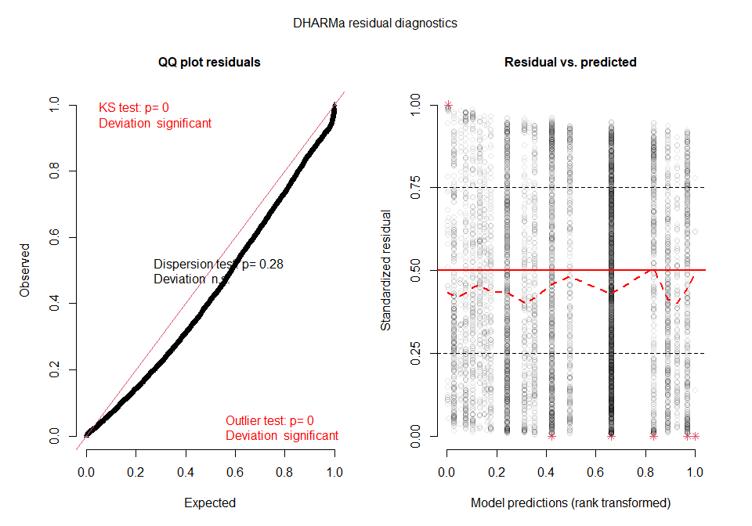
Significant deviation on QQ plot, and some outliers in residuals vs predictors
Plotting residuals against each predictor:
par(mfrow=c(1,3))
plotResiduals(max_output, model_data$Predominant_land_use, main="Predominant land use")
plotResiduals(max_output, model_data$Use_intensity, main="Use intensity")
plotResiduals(max_output, model_data$fire_presence, main="fire presence")
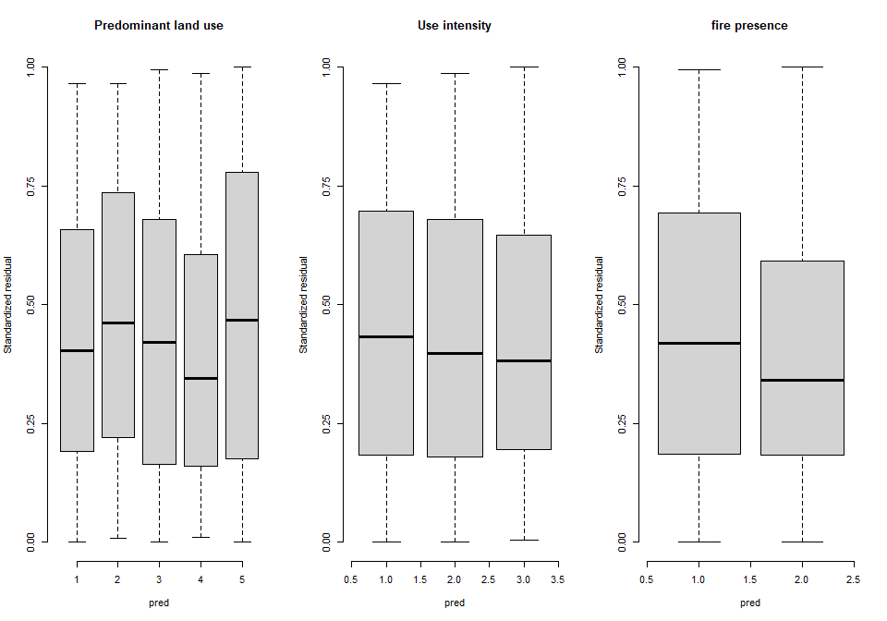 All appears ok
Residuals:
residuals <- resid(max)
summary(residuals)
## Min. 1st Qu. Median Mean 3rd Qu. Max.
## -0.698902 -0.099080 -0.005152 0.000000 0.099370 0.809609
hist(residuals)
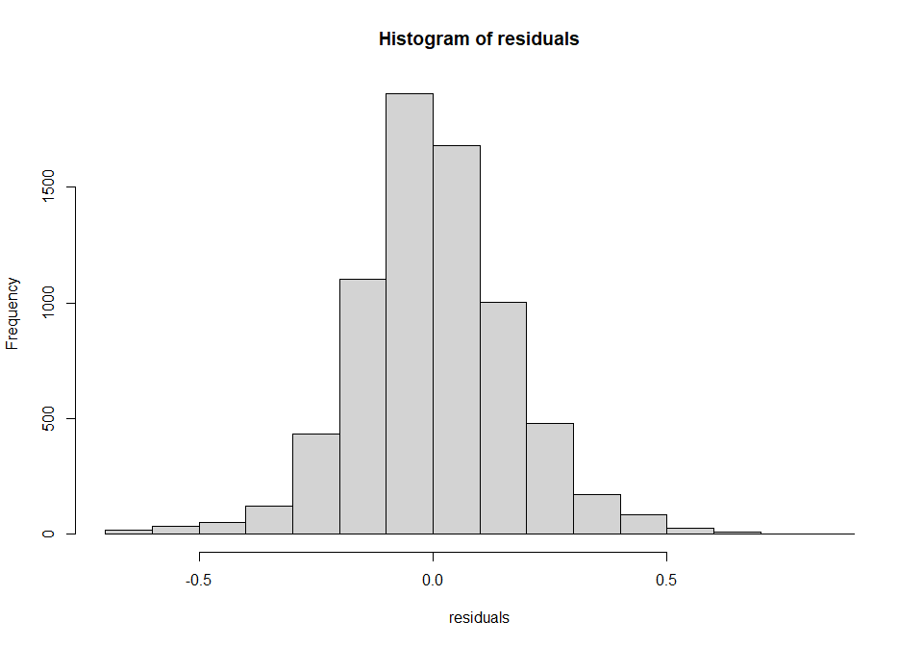
Residuals seem ok. mean is around 0 and they roughly show the expected curve.
Residuals qq plot and residuals vs fitted plot:
par(mfrow=c(1,2))
qqnorm(resid(max), main="normal qq-plot, residuals")
qqline(resid(max)) ## not bad
plot(fitted(max), resid(max), main = "Residuals vs fitted")
abline(h=0)
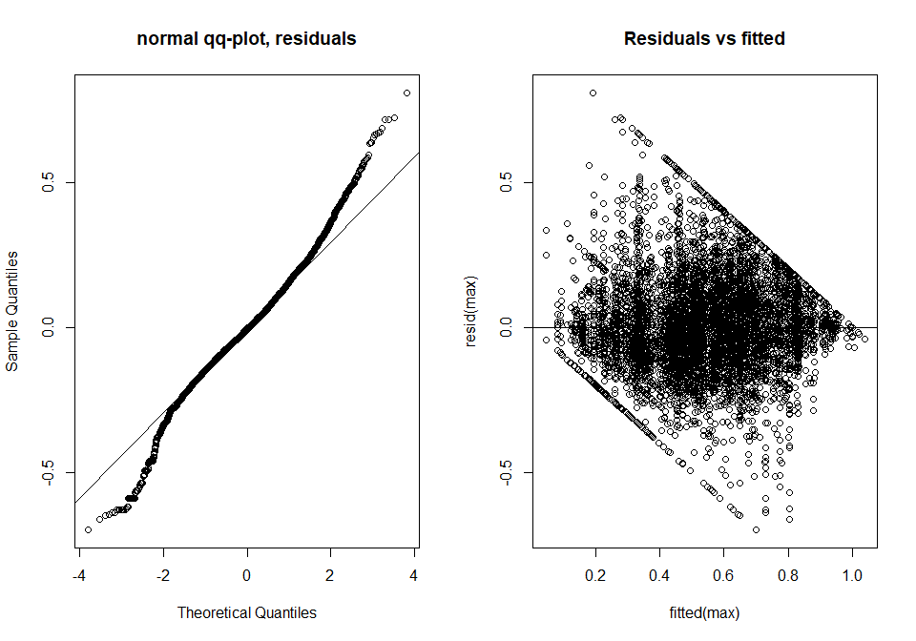
Normality of random effects:
ran <- ranef(max, condVar=TRUE)
a <- dotplot(ran)[["SSB"]]
b <- dotplot(ran)[["SS"]]
c <- dotplot(ran)[["Biome"]]
grid.arrange(a,b,c, nrow=2, ncol=2)
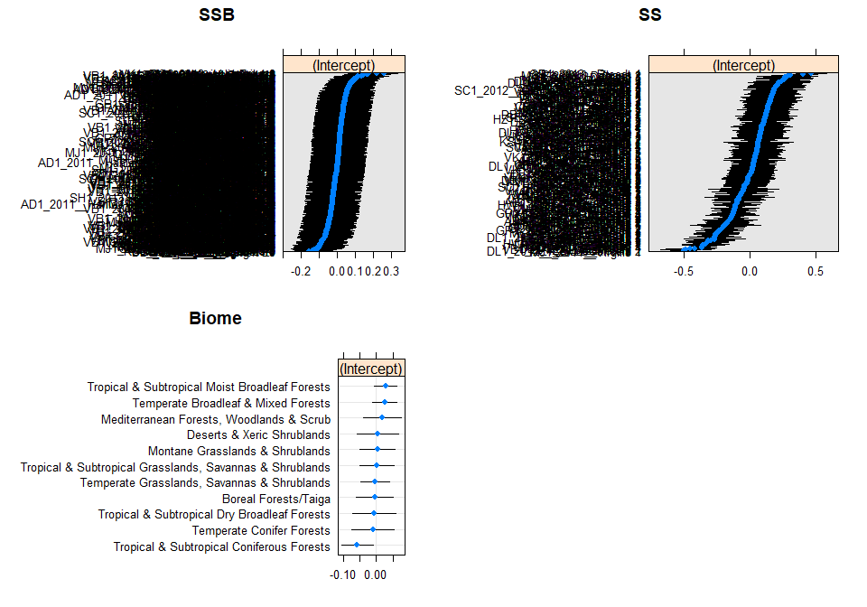
Plots:
set_theme(base = theme_classic(), legend.item.backcol = "white")
Land use fire presence interaction plot
LU_fp <- plot_model(max, type = "pred", terms = c("Predominant_land_use", "fire_presence"), legend.title = "Fire presence",
show.intercept = TRUE, axis.title = c("Predominant land use", "Square root of rescaled abundance")) +
theme(axis.text.x = element_text(angle = 10, hjust = 0.5, vjust = 0.75))
Use intensity fire presence plot
UI_fp <- plot_model(max, type = "pred", terms = c("Use_intensity", "fire_presence"), legend.title = "Fire presence",
show.intercept = TRUE, axis.title = c("Land use intensity", "Square root of rescaled abundance"))
ggarrange(LU_fp, UI_fp, nrow = 2, ncol = 1, labels = c("A", "B"),
common.legend = TRUE,legend = "right")
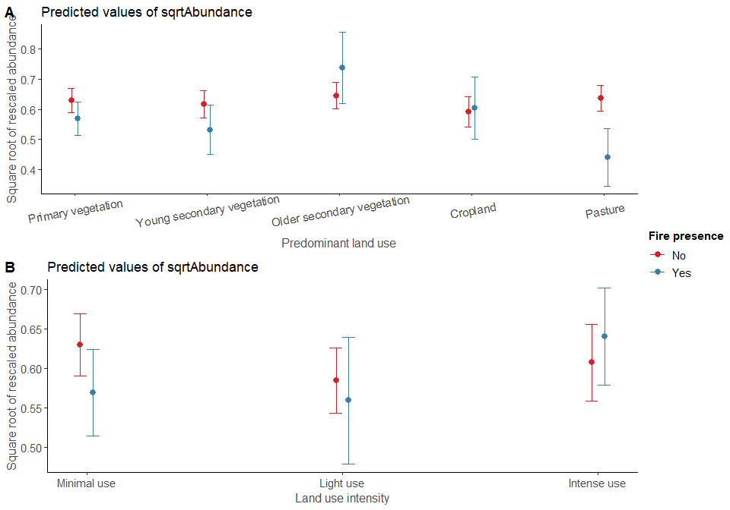
R2:
r.squaredGLMM(max)
## Warning: 'r.squaredGLMM' now calculates a revised statistic. See the help page.
## R2m R2c
## [1,] 0.03627764 0.6069431
fixed effects = 0.036, random and fixed effects = 0.607

Difference between the savanna and the rest of the world
Creating a savanna/not savanna level
model_data$savanna <- ifelse(model_data$Biome== "Tropical & Subtropical Grasslands, Savannas & Shrublands","Savanna",
ifelse(model_data$Biome != "Tropical & Subtropical Grasslands, Savannas & Shrublands",
"Not_savanna", NA))
model_data$savanna <- as.factor(model_data$savanna)
levels(model_data$savanna)
## [1] "Not_savanna" "Savanna"
Make sure we dont have rank deficiency by aggregating classes.
model_data <- model_data %>%
mutate(
Use_intensity_2 = recode_factor(Use_intensity,
"Light use" = "Greater use",
"Intense use" = "Greater use"),
Use_intensity_2 = factor(Use_intensity_2),
Use_intensity_2 = relevel(Use_intensity_2, ref = "Minimal use")
)
table(model_data$Predominant_land_use, model_data$Use_intensity_2)
##
## Minimal use Greater use
## Primary vegetation 2180 1209
## Young secondary vegetation 320 334
## Older secondary vegetation 452 464
## Cropland 205 558
## Pasture 401 999
## Creating a second land use classs.
model_data$Landuse <- model_data$Predominant_land_use
model_data <- model_data %>%
mutate(Landuse = recode_factor(Landuse, "Young secondary vegetation" = "Secondary vegetation",
"Older secondary vegetation" = "Secondary vegetation"),
Landuse = factor(Landuse),
Landuse = relevel(Landuse, ref = "Primary vegetation"))
model_data$Landuse <- factor(model_data$Landuse, levels = c("Primary vegetation",
"Secondary vegetation",
"Cropland",
"Pasture"))
table(model_data$Landuse, model_data$Use_intensity_2, model_data$savanna)
## , , = Not_savanna
##
##
## Minimal use Greater use
## Primary vegetation 1723 947
## Secondary vegetation 768 659
## Cropland 192 443
## Pasture 396 953
##
## , , = Savanna
##
##
## Minimal use Greater use
## Primary vegetation 457 262
## Secondary vegetation 4 139
## Cropland 13 115
## Pasture 5 46
Fitting an interaction effect between fire and savanna:
savanna_comp <- lmer(sqrtAbundance ~ Predominant_land_use + Use_intensity + fire_presence +
Predominant_land_use:fire_presence + Predominant_land_use:Use_intensity +
Use_intensity:fire_presence + fire_presence:savanna +
(1|SS) + (1|SSB) + (1|Biome), data = model_data)
Anova(savanna_comp)
## Analysis of Deviance Table (Type II Wald chisquare tests)
##
## Response: sqrtAbundance
## Chisq Df Pr(>Chisq)
## Predominant_land_use 66.6041 4 1.181e-13 ***
## Use_intensity 83.3678 2 < 2.2e-16 ***
## fire_presence 1.7087 1 0.191158
## Predominant_land_use:fire_presence 27.3419 4 1.695e-05 ***
## Predominant_land_use:Use_intensity 74.6386 8 5.827e-13 ***
## Use_intensity:fire_presence 9.4276 2 0.008971 **
## fire_presence:savanna 0.1587 2 0.923707
## ---
## Signif. codes: 0 '***' 0.001 '**' 0.01 '*' 0.05 '.' 0.1 ' ' 1
Not significant therefore the effects of fire do not vary significiant between savanna and not.
Liklihood ratio test:
no_savanna <- lmer(sqrtAbundance ~ Predominant_land_use + Use_intensity + fire_presence +
Predominant_land_use:fire_presence + Predominant_land_use:Use_intensity +
Use_intensity:fire_presence +
(1|SS) + (1|SSB) + (1|Biome), data = model_data)
anova(savanna_comp, no_savanna)
## refitting model(s) with ML (instead of REML)
## Data: model_data
## Models:
## no_savanna: sqrtAbundance ~ Predominant_land_use + Use_intensity + fire_presence +
## no_savanna: Predominant_land_use:fire_presence + Predominant_land_use:Use_intensity +
## no_savanna: Use_intensity:fire_presence + (1 | SS) + (1 | SSB) + (1 |
## no_savanna: Biome)
## savanna_comp: sqrtAbundance ~ Predominant_land_use + Use_intensity + fire_presence +
## savanna_comp: Predominant_land_use:fire_presence + Predominant_land_use:Use_intensity +
## savanna_comp: Use_intensity:fire_presence + fire_presence:savanna + (1 |
## savanna_comp: SS) + (1 | SSB) + (1 | Biome)
## npar AIC BIC logLik deviance Chisq Df Pr(>Chisq)
## no_savanna 26 -3649.2 -3470.6 1850.6 -3701.2
## savanna_comp 28 -3645.4 -3453.0 1850.7 -3701.4 0.1563 2 0.9248

