Savanna abundance models using different fire metrics and time since fire

Setting up the data for the model
Load the required data (both PREDICTS and fire history data).
diversity <- readRDS("~/Imperial/PROJECT/PREDICTS data/database.rds")
fire_hist <- read.csv("~/Imperial/PROJECT/Combined data/Fire_history.csv")
Getting the data and preparation for model (all code for model testing and selection in other markdowns).
diversity <- mutate(diversity,
Measurement = Effort_corrected_measurement,
Sampling_effort = Rescaled_sampling_effort)
## Calculating diversity metrics including rescaled abundance.
sites <- diversity %>%
mutate(Diversity_metric_is_valid = TRUE) %>%
predictsFunctions::SiteMetrics(extra.cols = c("SSB", "SSBS", "Predominant_land_use", "Biome", "Country")) %>%
group_by(SS) %>%
mutate(MaxAbundance = ifelse(Diversity_metric_type == "Abundance",
max(Total_abundance),
NA)) %>%
ungroup() %>%
mutate(RescaledAbundance = ifelse(Diversity_metric_type == "Abundance",
Total_abundance/MaxAbundance,
NA))
## Computing site metrics for 3250404 measurements
## The data contain 480 sources, 666 studies and 26112 sites
## Computing site-level values
## Computing total abundance
## Computing species richness
## Assembling site-level values
## Tidying up the predominant land use category
sites <- sites %>%
mutate(
Predominant_land_use = recode_factor(Predominant_land_use,
"Primary forest" = "Primary vegetation",
"Primary non-forest" = "Primary vegetation"),
Predominant_land_use = na_if(Predominant_land_use, "Secondary vegetation (indeterminate age)"),
Predominant_land_use = na_if(Predominant_land_use, "Cannot decide"),
Use_intensity = na_if(Use_intensity, "Cannot decide"),
Predominant_land_use = factor(Predominant_land_use),
Predominant_land_use = relevel(Predominant_land_use, ref = "Primary vegetation"),
Use_intensity = factor(Use_intensity),
Use_intensity = relevel(Use_intensity, ref = "Minimal use")
)
## For my analysis I need to subset so that all sites are after 2006 (so that we can have 3yrs of
#fire data)
sites_post_2006 <- subset(sites, sites$Sample_start_earliest > "2006-01-01")
## Removing rows that have NAs in latitude and longitude as these won't have fire data
sites_post_2006_NA <- subset(sites_post_2006, (! is.na(Longitude) | ! is.na(Latitude)))
## Merge with fire data
PREDICTS_fire_hist <- merge(sites_post_2006_NA, fire_hist
[,c("SSBS", "Freq", "fire_ID", "size", "start_date", "duration", "days_since_fire",
"year", "years_since_fire")], by="SSBS", all.x=TRUE)
## Creating fire presence column (need to change NAs in freq to 0 as these sites have no fires in the
#last 3 years)
PREDICTS_fire_hist$Freq[is.na(PREDICTS_fire_hist$Freq)] <- 0
PREDICTS_fire_hist$fire_presence <- ifelse(PREDICTS_fire_hist$Freq==0, "No",
ifelse(PREDICTS_fire_hist$Freq!=0, "Yes",
NA))
PREDICTS_fire_hist$fire_presence <- as.factor(PREDICTS_fire_hist$fire_presence)
## Need to remove data which has NAs in categories required for our analysis
PREDICTS_fire_hist2 <- drop_na(PREDICTS_fire_hist, Total_abundance, Predominant_land_use, Use_intensity, fire_presence)
## Subset to just the Tropical & Subtropical Grasslands, Savannas & Shrublands
sites_savanna <- subset(PREDICTS_fire_hist2, PREDICTS_fire_hist2$Biome == "Tropical & Subtropical Grasslands, Savannas & Shrublands")
## Looking at the data
## We need to make sure we have sufficient data for analysis
# Removing land use level which lack data
sites_savanna<-sites_savanna[!(sites_savanna$Predominant_land_use == "Plantation forest"),]
sites_savanna<-sites_savanna[!(sites_savanna$Predominant_land_use == "Urban"),]
sites_savanna$Predominant_land_use <- as.factor(as.character(sites_savanna$Predominant_land_use))
## Merge together the secondary land use ages
sites_savanna <- sites_savanna %>%
mutate( Predominant_land_use = recode_factor(Predominant_land_use,
"Young secondary vegetation" = "Secondary vegetation",
"Intermediate secondary vegetation" = "Secondary vegetation",
"Mature secondary vegetation" = "Secondary vegetation"),
Predominant_land_use = factor(Predominant_land_use),
Predominant_land_use = relevel(Predominant_land_use, ref = "Primary vegetation")
)
sites_savanna$Predominant_land_use <- factor(sites_savanna$Predominant_land_use, levels = c("Primary vegetation", "Secondary vegetation", "Cropland", "Pasture"))
## Also want to be able to use interaction between land use and use intensity. If we use the data as is, we will have rank deficiency and therefore it may be better to combine
#use intensities into coarser land uses.
sites_savanna <- sites_savanna %>%
mutate(
Use_intensity_2 = recode_factor(Use_intensity,
"Light use" = "Greater use",
"Intense use" = "Greater use"),
Use_intensity_2 = factor(Use_intensity_2),
Use_intensity_2 = relevel(Use_intensity_2, ref = "Minimal use")
)
model_data <- drop_na(sites_savanna, Total_abundance, Predominant_land_use, Use_intensity_2, fire_presence)
model_data <- mutate(model_data,
logAbundance = log(RescaledAbundance + 1),
sqrtAbundance = sqrt(RescaledAbundance))

Model
Model selection is in the savanna model selection R script and markdown.
m1 <- lmer(sqrtAbundance ~ Predominant_land_use + Use_intensity_2 + fire_presence +
Predominant_land_use:fire_presence + Predominant_land_use:Use_intensity_2+
(1|SS) + (1|SSB), data = model_data)
Anova(m1)
## Analysis of Deviance Table (Type II Wald chisquare tests)
##
## Response: sqrtAbundance
## Chisq Df Pr(>Chisq)
## Predominant_land_use 30.6533 3 1.006e-06 ***
## Use_intensity_2 0.4124 1 0.5207661
## fire_presence 0.1013 1 0.7502381
## Predominant_land_use:fire_presence 2.3548 3 0.5021091
## Predominant_land_use:Use_intensity_2 18.9871 3 0.0002751 ***
## ---
## Signif. codes: 0 '***' 0.001 '**' 0.01 '*' 0.05 '.' 0.1 ' ' 1
summary(m1)
## Linear mixed model fit by REML ['lmerMod']
## Formula: sqrtAbundance ~ Predominant_land_use + Use_intensity_2 + fire_presence +
## Predominant_land_use:fire_presence + Predominant_land_use:Use_intensity_2 + (1 | SS) + (1 | SSB)
## Data: model_data
##
## REML criterion at convergence: -311.1
##
## Scaled residuals:
## Min 1Q Median 3Q Max
## -2.7468 -0.6341 -0.0545 0.6116 3.3406
##
## Random effects:
## Groups Name Variance Std.Dev.
## SSB (Intercept) 0.004173 0.0646
## SS (Intercept) 0.034857 0.1867
## Residual 0.037781 0.1944
## Number of obs: 1041, groups: SSB, 85; SS, 22
##
## Fixed effects:
## Estimate Std. Error t value
## (Intercept) 0.504308 0.049255 10.239
## Predominant_land_useSecondary vegetation 0.331840 0.108519 3.058
## Predominant_land_useCropland -0.104291 0.073265 -1.423
## Predominant_land_usePasture 0.142793 0.111057 1.286
## Use_intensity_2Greater use 0.042276 0.043886 0.963
## fire_presenceYes 0.007604 0.025142 0.302
## Predominant_land_useSecondary vegetation:fire_presenceYes -0.040605 0.049589 -0.819
## Predominant_land_useCropland:fire_presenceYes 0.049205 0.050635 0.972
## Predominant_land_usePasture:fire_presenceYes -0.034452 0.070849 -0.486
## Predominant_land_useSecondary vegetation:Use_intensity_2Greater use -0.380624 0.111518 -3.413
## Predominant_land_useCropland:Use_intensity_2Greater use 0.042614 0.089561 0.476
## Predominant_land_usePasture:Use_intensity_2Greater use -0.322464 0.125003 -2.580
##
## Correlation of Fixed Effects:
## (Intr) Pr__Sv Prd__C Prd__P U__2Gu fr_prY P__Sv: P__C:_ P__P:_ P__Svu P__C:u
## Prdmnnt__Sv -0.159
## Prdmnnt_l_C -0.179 0.064
## Prdmnnt_l_P -0.054 0.009 0.010
## Us_ntns_2Gu -0.372 0.136 0.177 0.020
## fir_prsncYs -0.292 0.172 0.163 0.016 0.106
## Prdm__Sv:_Y 0.135 -0.154 -0.078 -0.007 -0.039 -0.490
## Prdmn__C:_Y 0.180 -0.117 -0.356 -0.010 -0.081 -0.480 0.236
## Prdmn__P:_Y -0.005 -0.033 -0.004 0.000 0.299 -0.349 0.177 0.158
## P__Sv:U__2u 0.106 -0.912 -0.039 -0.006 -0.140 -0.010 -0.201 0.037 -0.014
## P__C:U__2Gu 0.207 -0.030 -0.824 -0.011 -0.548 0.058 -0.038 0.134 -0.250 0.054
## P__P:U__2Gu 0.064 0.005 -0.016 -0.889 -0.207 0.134 -0.068 -0.057 -0.368 0.026 0.158

Data exploration of the fire metrics
We want to explore how different aspects of fire regimes may play a role in affecting biodiversity e.g. size, duration, frequency. We are also interested in how the effect of fire changes over time.

Distribution of data over time
Looking at the distribution of data in terms of days since fire and years since fire
days_hist <- ggplot(data=model_data, aes(days_since_fire)) +
geom_histogram(binwidth = 100, fill = 'light blue', colour = 'Black')+
xlab("Days since fire")+
ylab("Number of sites")+
scale_x_continuous(breaks = scales::pretty_breaks(n = 8)) +
theme_bw() + theme(panel.border = element_rect(colour = "black", fill=NA, size=0.5), panel.grid.major = element_blank(),
panel.grid.minor = element_blank(), axis.line = element_line(colour = "black"),
axis.text.x = element_text(size = 10, color = "black"), axis.title.x = element_text(size = 11), axis.text.y = element_text(size = 10, color = "black"))
years_hist <- ggplot(data=model_data, aes(years_since_fire)) +
geom_histogram(binwidth = 1, fill = 'light blue', colour = 'Black')+
xlab("Years since fire")+
ylab("Number of sites")+
theme_bw() + theme(panel.border = element_rect(colour = "black", fill=NA, size=0.5), panel.grid.major = element_blank(),
panel.grid.minor = element_blank(), axis.line = element_line(colour = "black"),
axis.text.x = element_text(size = 10, color = "black"), axis.title.x = element_text(size = 11), axis.text.y = element_text(size = 10, color = "black"))
grid.arrange(days_hist, years_hist, nrow=2)
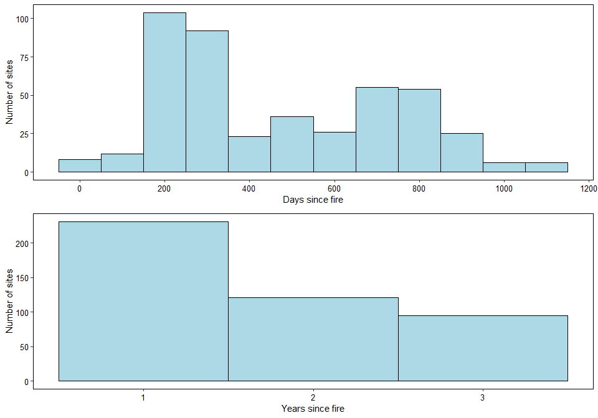
The histograms show that most of the data have been sampled within 1 year of the fire happening, but there is still quite a substantial amount of older data.

Fire frequency
years_hist <- ggplot(data=model_data, aes(Freq)) +
geom_histogram(binwidth = 1, fill = 'light blue', colour = 'Black')+
xlab("Number of fires")+
ylab("Number of sites")+
theme_bw() + theme(panel.border = element_rect(colour = "black", fill=NA, size=0.5), panel.grid.major = element_blank(),
panel.grid.minor = element_blank(), axis.line = element_line(colour = "black"),
axis.text.x = element_text(size = 10, color = "black"), axis.title.x = element_text(size = 11), axis.text.y = element_text(size = 10, color = "black"))
Most sites have not had a fire in the past 3 years, but in terms of those that have most have only had 1, with decreasing amounts have 2 or 3 fires. We could look at the effect of fire frequency on abundance in different land uses but we may need to transform the variable so that it is less skewed.

Fire size
ggplot(data=model_data, aes(size)) +
geom_histogram(binwidth = 100, fill = 'light blue', colour = 'Black')+
xlab("Fire size (km2)")+
ylab("Number of sites")+
scale_x_continuous(breaks = scales::pretty_breaks(n = 8)) +
theme_bw() + theme(panel.border = element_rect(colour = "black", fill=NA, size=0.5), panel.grid.major = element_blank(),
panel.grid.minor = element_blank(), axis.line = element_line(colour = "black"),
axis.text.x = element_text(size = 10, color = "black"), axis.title.x = element_text(size = 11), axis.text.y = element_text(size = 10, color = "black"))
## Warning: Removed 594 rows containing non-finite values (stat_bin).
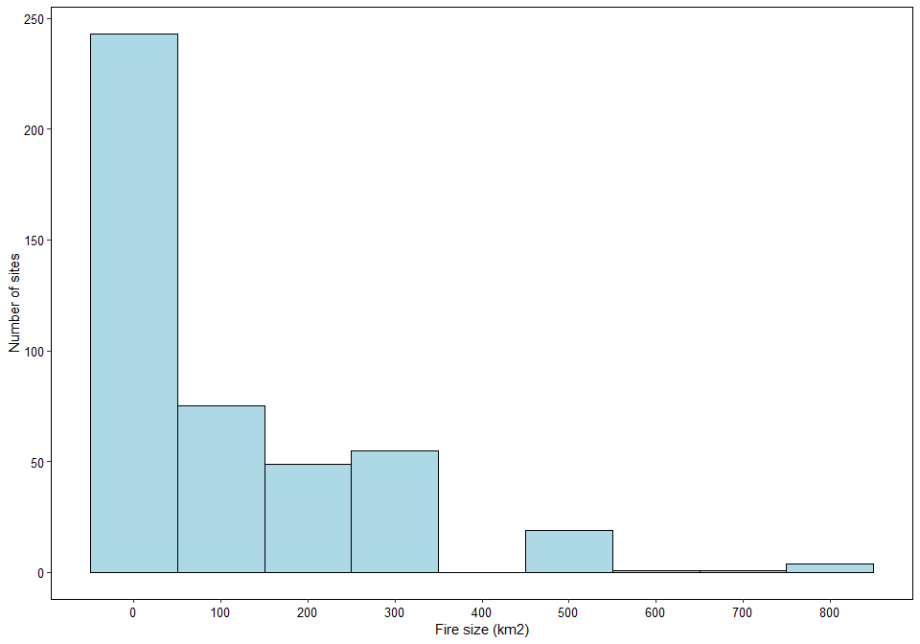
Most fires are small (less than 100km2), with very few large ones. This may make trying to model this difficult due to the lack of data at the higher end of the spectrum. It would be interesting to see how fire size varies with land use. Would expect there to be smaller fires in croplands and the largest fires to be in primary and older secondary vegetation.

Fire duration
ggplot(data=model_data, aes(duration)) +
geom_histogram(binwidth = 5, fill = 'light blue', colour = 'Black')+
xlab("Duration of fire (days)")+
ylab("Number of sites")+
scale_x_continuous(breaks = scales::pretty_breaks(n = 8)) +
theme_bw() + theme(panel.border = element_rect(colour = "black", fill=NA, size=0.5), panel.grid.major = element_blank(),
panel.grid.minor = element_blank(), axis.line = element_line(colour = "black"),
axis.text.x = element_text(size = 10, color = "black"), axis.title.x = element_text(size = 11), axis.text.y = element_text(size = 10, color = "black"))
## Warning: Removed 594 rows containing non-finite values (stat_bin).
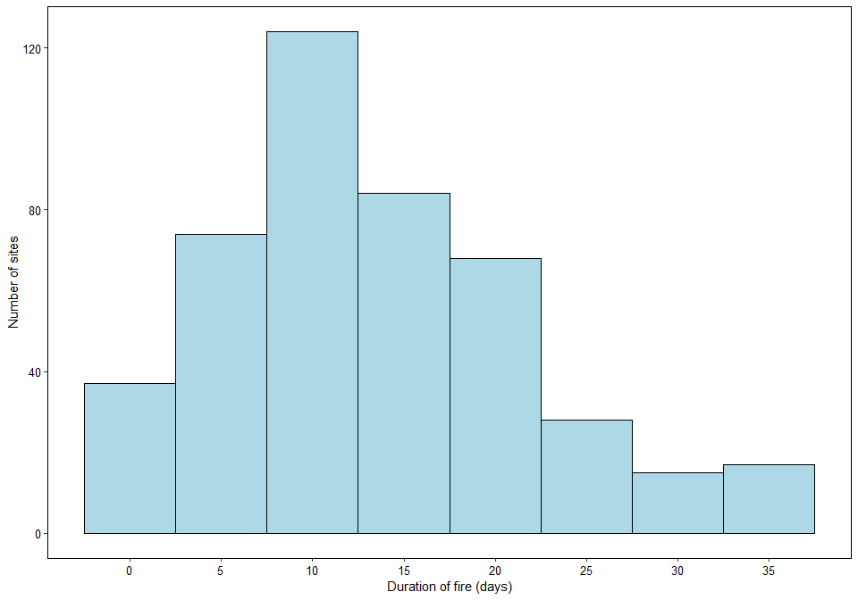
There is an almost normal distribution of fire duration, with most fire lasting for 10-15 days. This does not appear to vary much by land use.

Modelling with different years of data
Looking at using different years of data - 3yr window vs 2yr vs 1yr, ie any fires within 3 yr of sampling, any fires within 2 years and any within 1 (so I think we can just subset this from the years since fire column). Keeping the data used the same (PREDICTS sites sampled after 2006), to keep the time period consistent.
model_data_2yr <- subset(model_data, years_since_fire < 3 | is.na(years_since_fire))
model_data_1yr <- subset(model_data, years_since_fire < 2 | is.na(years_since_fire))
Can now create models, that are identical to the chosen model above, with each of these subsets of the data
m_2yr <- lmer(sqrtAbundance ~ Predominant_land_use + Use_intensity_2 + fire_presence +
Predominant_land_use:fire_presence + Predominant_land_use:Use_intensity_2+
(1|SS) + (1|SSB), data = model_data_2yr)
m_1yr <- lmer(sqrtAbundance ~ Predominant_land_use + Use_intensity_2 + fire_presence +
Predominant_land_use:fire_presence + Predominant_land_use:Use_intensity_2+
(1|SS) + (1|SSB), data = model_data_1yr)
Comparing the significance of the aspects contain in the models:
Anova(m1)
## Analysis of Deviance Table (Type II Wald chisquare tests)
##
## Response: sqrtAbundance
## Chisq Df Pr(>Chisq)
## Predominant_land_use 30.6533 3 1.006e-06 ***
## Use_intensity_2 0.4124 1 0.5207661
## fire_presence 0.1013 1 0.7502381
## Predominant_land_use:fire_presence 2.3548 3 0.5021091
## Predominant_land_use:Use_intensity_2 18.9871 3 0.0002751 ***
## ---
## Signif. codes: 0 '***' 0.001 '**' 0.01 '*' 0.05 '.' 0.1 ' ' 1
Anova(m_2yr)
## Analysis of Deviance Table (Type II Wald chisquare tests)
##
## Response: sqrtAbundance
## Chisq Df Pr(>Chisq)
## Predominant_land_use 20.2920 3 0.0001477 ***
## Use_intensity_2 0.2447 1 0.6208321
## fire_presence 0.0240 1 0.8770099
## Predominant_land_use:fire_presence 1.4556 3 0.6925512
## Predominant_land_use:Use_intensity_2 18.2593 3 0.0003889 ***
## ---
## Signif. codes: 0 '***' 0.001 '**' 0.01 '*' 0.05 '.' 0.1 ' ' 1
Anova(m_1yr)
## Analysis of Deviance Table (Type II Wald chisquare tests)
##
## Response: sqrtAbundance
## Chisq Df Pr(>Chisq)
## Predominant_land_use 15.7469 3 0.001278 **
## Use_intensity_2 0.4703 1 0.492832
## fire_presence 0.2217 1 0.637782
## Predominant_land_use:fire_presence 1.5554 3 0.669536
## Predominant_land_use:Use_intensity_2 13.9222 3 0.003013 **
## ---
## Signif. codes: 0 '***' 0.001 '**' 0.01 '*' 0.05 '.' 0.1 ' ' 1
The 1yr data has a higher significant of fire in the model (interesting maybe?- possibly because the sampling would have been done closer to the disturbance and so the vegetation has had a chance to recover yet and so will be in that initially damaged state still) The 2yr data doesn’t suggest that this is a linear trend. The effect of land use also appears to become less important as the sampling window is shortened.
summary(m_1yr)
## Linear mixed model fit by REML ['lmerMod']
## Formula: sqrtAbundance ~ Predominant_land_use + Use_intensity_2 + fire_presence +
## Predominant_land_use:fire_presence + Predominant_land_use:Use_intensity_2 + (1 | SS) + (1 | SSB)
## Data: model_data_1yr
##
## REML criterion at convergence: -189.8
##
## Scaled residuals:
## Min 1Q Median 3Q Max
## -2.6395 -0.6114 -0.0615 0.6236 3.2455
##
## Random effects:
## Groups Name Variance Std.Dev.
## SSB (Intercept) 0.002544 0.05044
## SS (Intercept) 0.035920 0.18953
## Residual 0.040517 0.20129
## Number of obs: 825, groups: SSB, 80; SS, 21
##
## Fixed effects:
## Estimate Std. Error t value
## (Intercept) 0.50083 0.05127 9.768
## Predominant_land_useSecondary vegetation 0.31799 0.12929 2.459
## Predominant_land_useCropland -0.14206 0.08709 -1.631
## Predominant_land_usePasture 0.14520 0.11480 1.265
## Use_intensity_2Greater use 0.03417 0.04995 0.684
## fire_presenceYes 0.01370 0.03121 0.439
## Predominant_land_useSecondary vegetation:fire_presenceYes -0.05721 0.05763 -0.993
## Predominant_land_useCropland:fire_presenceYes -0.06889 0.07499 -0.919
## Predominant_land_usePasture:fire_presenceYes -0.04363 0.09021 -0.484
## Predominant_land_useSecondary vegetation:Use_intensity_2Greater use -0.34749 0.13575 -2.560
## Predominant_land_useCropland:Use_intensity_2Greater use 0.09032 0.10658 0.847
## Predominant_land_usePasture:Use_intensity_2Greater use -0.31433 0.13009 -2.416
##
## Correlation of Fixed Effects:
## (Intr) Pr__Sv Prd__C Prd__P U__2Gu fr_prY P__Sv: P__C:_ P__P:_ P__Svu P__C:u
## Prdmnnt__Sv -0.139
## Prdmnnt_l_C -0.189 0.043
## Prdmnnt_l_P -0.058 0.008 0.011
## Us_ntns_2Gu -0.398 0.081 0.193 0.023
## fir_prsncYs -0.295 0.148 0.114 0.017 0.134
## Prdm__Sv:_Y 0.158 -0.079 -0.061 -0.009 -0.072 -0.536
## Prdmn__C:_Y 0.154 -0.088 -0.261 -0.009 -0.080 -0.401 0.215
## Prdmn__P:_Y 0.016 -0.058 0.005 -0.001 0.232 -0.365 0.194 0.146
## P__Sv:U__2u 0.097 -0.936 -0.032 -0.006 -0.088 -0.035 -0.180 0.041 0.030
## P__C:U__2Gu 0.213 0.016 -0.851 -0.012 -0.527 0.079 -0.042 0.108 -0.218 0.008
## P__P:U__2Gu 0.073 0.017 -0.029 -0.884 -0.221 0.125 -0.067 -0.049 -0.316 0.011 0.169
summary(m_2yr)
## Linear mixed model fit by REML ['lmerMod']
## Formula: sqrtAbundance ~ Predominant_land_use + Use_intensity_2 + fire_presence +
## Predominant_land_use:fire_presence + Predominant_land_use:Use_intensity_2 + (1 | SS) + (1 | SSB)
## Data: model_data_2yr
##
## REML criterion at convergence: -258
##
## Scaled residuals:
## Min 1Q Median 3Q Max
## -2.7016 -0.6212 -0.0615 0.6064 3.3937
##
## Random effects:
## Groups Name Variance Std.Dev.
## SSB (Intercept) 0.003126 0.05591
## SS (Intercept) 0.035053 0.18722
## Residual 0.038871 0.19716
## Number of obs: 946, groups: SSB, 83; SS, 22
##
## Fixed effects:
## Estimate Std. Error t value
## (Intercept) 0.50967 0.04934 10.331
## Predominant_land_useSecondary vegetation 0.33240 0.11004 3.021
## Predominant_land_useCropland -0.13163 0.08068 -1.631
## Predominant_land_usePasture 0.14326 0.11252 1.273
## Use_intensity_2Greater use 0.03085 0.04503 0.685
## fire_presenceYes 0.00709 0.02673 0.265
## Predominant_land_useSecondary vegetation:fire_presenceYes -0.04921 0.05127 -0.960
## Predominant_land_useCropland:fire_presenceYes 0.02140 0.05780 0.370
## Predominant_land_usePasture:fire_presenceYes -0.03960 0.07756 -0.510
## Predominant_land_useSecondary vegetation:Use_intensity_2Greater use -0.37157 0.11318 -3.283
## Predominant_land_useCropland:Use_intensity_2Greater use 0.08264 0.09777 0.845
## Predominant_land_usePasture:Use_intensity_2Greater use -0.30871 0.12687 -2.433
##
## Correlation of Fixed Effects:
## (Intr) Pr__Sv Prd__C Prd__P U__2Gu fr_prY P__Sv: P__C:_ P__P:_ P__Svu P__C:u
## Prdmnnt__Sv -0.162
## Prdmnnt_l_C -0.182 0.058
## Prdmnnt_l_P -0.056 0.009 0.010
## Us_ntns_2Gu -0.380 0.136 0.182 0.021
## fir_prsncYs -0.290 0.172 0.135 0.016 0.096
## Prdm__Sv:_Y 0.138 -0.155 -0.067 -0.008 -0.039 -0.511
## Prdmn__C:_Y 0.164 -0.107 -0.285 -0.009 -0.068 -0.446 0.229
## Prdmn__P:_Y 0.003 -0.036 0.002 0.000 0.272 -0.364 0.189 0.154
## P__Sv:U__2u 0.113 -0.914 -0.040 -0.006 -0.148 -0.024 -0.180 0.039 -0.006
## P__C:U__2Gu 0.209 -0.026 -0.846 -0.012 -0.530 0.077 -0.047 0.097 -0.230 0.055
## P__P:U__2Gu 0.067 0.005 -0.022 -0.888 -0.213 0.135 -0.071 -0.054 -0.345 0.028 0.158
It appears that the main cause of the increased signficant of fire is possibly the older secondary vegetation. In the 2yr model estimate is 0.088 (0.35 T value), whereas in the 1yr model it is -0.41 (-2.886 t value), relative to primary vegetation. THis suggests a rapid recovery of secondary vegetation in the space of a year. I think this supports the idea of trying to look at how the effect of fire in different land use categories changes with time since the fire.

Modelling with different fire metrics
Fire presence
This is our original model that just involves a yes/no for whether fires have been present in each site in the 3years before it was sampled.
m1 <- lmer(sqrtAbundance ~ Predominant_land_use + Use_intensity_2 + fire_presence +
Predominant_land_use:fire_presence + Predominant_land_use:Use_intensity_2+
(1|SS) + (1|SSB), data = model_data)
Fire frequency
We use frequency as a numeric variable to see how the number of fires (in the last 3 years) affects abundance.
m1.freq <- lmer(sqrtAbundance ~ Predominant_land_use + Use_intensity_2 + Freq +
Predominant_land_use:Freq + Predominant_land_use:Use_intensity_2+
(1|SS) + (1|SSB), data = model_data)
Anova(m1.freq)
## Analysis of Deviance Table (Type II Wald chisquare tests)
##
## Response: sqrtAbundance
## Chisq Df Pr(>Chisq)
## Predominant_land_use 31.1532 3 7.892e-07 ***
## Use_intensity_2 0.1692 1 0.6808265
## Freq 0.1379 1 0.7103336
## Predominant_land_use:Freq 0.8889 3 0.8281072
## Predominant_land_use:Use_intensity_2 20.5710 3 0.0001292 ***
## ---
## Signif. codes: 0 '***' 0.001 '**' 0.01 '*' 0.05 '.' 0.1 ' ' 1
The anova shows not much change compared to m1, with Freq and the interaction not being significant. In general frequency appears to match quite well the model with just fire presence.
summary(m1.freq)
## Linear mixed model fit by REML ['lmerMod']
## Formula: sqrtAbundance ~ Predominant_land_use + Use_intensity_2 + Freq +
## Predominant_land_use:Freq + Predominant_land_use:Use_intensity_2 + (1 | SS) + (1 | SSB)
## Data: model_data
##
## REML criterion at convergence: -305.2
##
## Scaled residuals:
## Min 1Q Median 3Q Max
## -2.7460 -0.6228 -0.0485 0.5943 3.4070
##
## Random effects:
## Groups Name Variance Std.Dev.
## SSB (Intercept) 0.004198 0.06479
## SS (Intercept) 0.035664 0.18885
## Residual 0.037814 0.19446
## Number of obs: 1041, groups: SSB, 85; SS, 22
##
## Fixed effects:
## Estimate Std. Error t value
## (Intercept) 0.512369 0.049593 10.331
## Predominant_land_useSecondary vegetation 0.316227 0.108417 2.917
## Predominant_land_useCropland -0.094225 0.071317 -1.321
## Predominant_land_usePasture 0.141383 0.111154 1.272
## Use_intensity_2Greater use 0.039112 0.043530 0.898
## Freq -0.004943 0.013012 -0.380
## Predominant_land_useSecondary vegetation:Freq -0.002412 0.025470 -0.095
## Predominant_land_useCropland:Freq 0.029775 0.035549 0.838
## Predominant_land_usePasture:Freq -0.011558 0.039286 -0.294
## Predominant_land_useSecondary vegetation:Use_intensity_2Greater use -0.394537 0.110148 -3.582
## Predominant_land_useCropland:Use_intensity_2Greater use 0.023894 0.088202 0.271
## Predominant_land_usePasture:Use_intensity_2Greater use -0.334303 0.122346 -2.732
##
## Correlation of Fixed Effects:
## (Intr) Pr__Sv Prd__C Prd__P U__2Gu Freq P__Sv: P__C:F P__P:F P__Svu P__C:u
## Prdmnnt__Sv -0.159
## Prdmnnt_l_C -0.165 0.055
## Prdmnnt_l_P -0.053 0.008 0.009
## Us_ntns_2Gu -0.383 0.149 0.179 0.020
## Freq -0.295 0.175 0.129 0.016 0.187
## Prdmn__Sv:F 0.146 -0.133 -0.063 -0.008 -0.081 -0.500
## Prdmnn__C:F 0.136 -0.093 -0.275 -0.007 -0.091 -0.342 0.172
## Prdmnn__P:F 0.021 -0.041 -0.004 -0.001 0.207 -0.364 0.190 0.117
## P__Sv:U__2u 0.115 -0.942 -0.041 -0.006 -0.147 -0.049 -0.122 0.049 0.005
## P__C:U__2Gu 0.186 -0.020 -0.826 -0.010 -0.519 0.094 -0.055 0.088 -0.224 0.046
## P__P:U__2Gu 0.055 0.006 -0.016 -0.909 -0.163 0.123 -0.063 -0.037 -0.309 0.020 0.138
If we just look at frequency in the fixed effects in this model, we can see that its affect depends on the land use type, In secondary vegetation and pastures abundance declines with increase fire frequency whereas in croplands abundance increase with fire frequency relative to primary vegetation. The t value of these effects are all quite low, suggesting prehaps that the true effect might be 0.

Size and duration metrics
To model these metrics and compare them, need to recode the size and duration so that 0 values are given to all sites that do not have a fire
model_data$size[is.na(model_data$size)] <- 0
model_data$duration[is.na(model_data$duration)] <- 0
Fire size
m1.size <- lmer(sqrtAbundance ~ Predominant_land_use + Use_intensity_2 + size +
Predominant_land_use:size + Predominant_land_use:Use_intensity_2+
(1|SS) + (1|SSB), data = model_data)
Anova(m1.size)
## Analysis of Deviance Table (Type II Wald chisquare tests)
##
## Response: sqrtAbundance
## Chisq Df Pr(>Chisq)
## Predominant_land_use 30.1492 3 1.284e-06 ***
## Use_intensity_2 0.8016 1 0.3706
## size 1.2823 1 0.2575
## Predominant_land_use:size 1.1700 3 0.7602
## Predominant_land_use:Use_intensity_2 21.8675 3 6.951e-05 ***
## ---
## Signif. codes: 0 '***' 0.001 '**' 0.01 '*' 0.05 '.' 0.1 ' ' 1
Anova shows land use and its interaction with intensity are significant, as in the other models.
summary(m1.size)
## Linear mixed model fit by REML ['lmerMod']
## Formula: sqrtAbundance ~ Predominant_land_use + Use_intensity_2 + size +
## Predominant_land_use:size + Predominant_land_use:Use_intensity_2 + (1 | SS) + (1 | SSB)
## Data: model_data
##
## REML criterion at convergence: -268.9
##
## Scaled residuals:
## Min 1Q Median 3Q Max
## -2.7482 -0.6062 -0.0544 0.5959 3.4992
##
## Random effects:
## Groups Name Variance Std.Dev.
## SSB (Intercept) 0.004298 0.06556
## SS (Intercept) 0.034849 0.18668
## Residual 0.037750 0.19429
## Number of obs: 1041, groups: SSB, 85; SS, 22
##
## Fixed effects:
## Estimate Std. Error t value
## (Intercept) 4.941e-01 4.725e-02 10.456
## Predominant_land_useSecondary vegetation 3.407e-01 1.068e-01 3.189
## Predominant_land_useCropland -7.489e-02 6.854e-02 -1.093
## Predominant_land_usePasture 1.439e-01 1.110e-01 1.297
## Use_intensity_2Greater use 5.353e-02 4.147e-02 1.291
## size 1.122e-04 7.595e-05 1.477
## Predominant_land_useSecondary vegetation:size -1.882e-04 1.810e-04 -1.040
## Predominant_land_useCropland:size -1.460e-05 6.134e-04 -0.024
## Predominant_land_usePasture:size -1.311e-04 2.996e-04 -0.438
## Predominant_land_useSecondary vegetation:Use_intensity_2Greater use -4.046e-01 1.090e-01 -3.713
## Predominant_land_useCropland:Use_intensity_2Greater use 2.537e-02 8.619e-02 0.294
## Predominant_land_usePasture:Use_intensity_2Greater use -3.345e-01 1.180e-01 -2.836
##
## Correlation of Fixed Effects:
## (Intr) Pr__Sv Prd__C Prd__P U__2Gu size P__Sv: Pr__C: Pr__P: P__Svu P__C:u
## Prdmnnt__Sv -0.123
## Prdmnnt_l_C -0.129 0.028
## Prdmnnt_l_P -0.052 0.006 0.007
## Us_ntns_2Gu -0.350 0.125 0.155 0.018
## size -0.134 0.085 0.026 0.007 0.082
## Prdmnn__Sv: 0.057 -0.061 -0.008 -0.003 -0.013 -0.392
## Prdmnnt__C: 0.029 -0.026 -0.064 -0.002 -0.025 -0.100 0.040
## Prdmnnt__P: -0.021 -0.008 0.019 0.001 0.150 -0.237 0.138 0.026
## P__Sv:U__2u 0.107 -0.962 -0.029 -0.006 -0.145 -0.027 -0.091 0.020 -0.006
## P__C:U__2Gu 0.196 -0.021 -0.848 -0.010 -0.518 0.105 -0.053 0.003 -0.138 0.043
## P__P:U__2Gu 0.072 -0.006 -0.022 -0.942 -0.135 0.053 -0.028 -0.006 -0.172 0.023 0.097
Duration
m1.duration <- lmer(sqrtAbundance ~ Predominant_land_use + Use_intensity_2 + duration +
Predominant_land_use:duration + Predominant_land_use:Use_intensity_2+
(1|SS) + (1|SSB), data = model_data)
Anova(m1.duration)
## Analysis of Deviance Table (Type II Wald chisquare tests)
##
## Response: sqrtAbundance
## Chisq Df Pr(>Chisq)
## Predominant_land_use 30.4289 3 1.121e-06 ***
## Use_intensity_2 0.7413 1 0.3892507
## duration 0.8511 1 0.3562348
## Predominant_land_use:duration 2.7251 3 0.4359790
## Predominant_land_use:Use_intensity_2 20.5953 3 0.0001277 ***
## ---
## Signif. codes: 0 '***' 0.001 '**' 0.01 '*' 0.05 '.' 0.1 ' ' 1
In this model we have duration as a significant effects of land use and the interaction with use intensity (same as all other models).
summary(m1.duration)
## Linear mixed model fit by REML ['lmerMod']
## Formula: sqrtAbundance ~ Predominant_land_use + Use_intensity_2 + duration +
## Predominant_land_use:duration + Predominant_land_use:Use_intensity_2 + (1 | SS) + (1 | SSB)
## Data: model_data
##
## REML criterion at convergence: -288.7
##
## Scaled residuals:
## Min 1Q Median 3Q Max
## -2.7472 -0.5977 -0.0492 0.5996 3.5027
##
## Random effects:
## Groups Name Variance Std.Dev.
## SSB (Intercept) 0.004118 0.06418
## SS (Intercept) 0.035041 0.18719
## Residual 0.037749 0.19429
## Number of obs: 1041, groups: SSB, 85; SS, 22
##
## Fixed effects:
## Estimate Std. Error t value
## (Intercept) 0.486356 0.048231 10.084
## Predominant_land_useSecondary vegetation 0.354241 0.107637 3.291
## Predominant_land_useCropland -0.063736 0.072159 -0.883
## Predominant_land_usePasture 0.144873 0.111013 1.305
## Use_intensity_2Greater use 0.052616 0.042712 1.232
## duration 0.002145 0.001236 1.735
## Predominant_land_useSecondary vegetation:duration -0.002908 0.002126 -1.368
## Predominant_land_useCropland:duration -0.002647 0.003316 -0.798
## Predominant_land_usePasture:duration -0.004103 0.004012 -1.023
## Predominant_land_useSecondary vegetation:Use_intensity_2Greater use -0.405774 0.109462 -3.707
## Predominant_land_useCropland:Use_intensity_2Greater use 0.033660 0.088873 0.379
## Predominant_land_usePasture:Use_intensity_2Greater use -0.308810 0.120973 -2.553
##
## Correlation of Fixed Effects:
## (Intr) Pr__Sv Prd__C Prd__P U__2Gu duratn P__Sv: Pr__C: Pr__P: P__Svu P__C:u
## Prdmnnt__Sv -0.142
## Prdmnnt_l_C -0.147 0.044
## Prdmnnt_l_P -0.053 0.007 0.008
## Us_ntns_2Gu -0.367 0.136 0.164 0.019
## duration -0.224 0.143 0.074 0.012 0.131
## Prdmnn__Sv: 0.123 -0.112 -0.039 -0.006 -0.053 -0.551
## Prdmnnt__C: 0.111 -0.077 -0.317 -0.006 -0.066 -0.335 0.185
## Prdmnnt__P: -0.017 -0.022 0.016 0.001 0.224 -0.293 0.193 0.098
## P__Sv:U__2u 0.111 -0.952 -0.038 -0.006 -0.146 -0.037 -0.098 0.040 -0.005
## P__C:U__2Gu 0.191 -0.020 -0.837 -0.010 -0.516 0.116 -0.075 0.141 -0.209 0.047
## P__P:U__2Gu 0.069 -0.001 -0.022 -0.919 -0.164 0.093 -0.060 -0.030 -0.278 0.023 0.128
In this model we can see that in all land use classes duration of fire has a negative impact on abundance, but the size of this effect varies with each land use class relative to primary vegetation. In contrast size on its own has a positive effect on abundance.
Comparing fire metrics
m1.comp <- lmer(sqrtAbundance ~ Predominant_land_use + Use_intensity_2 + fire_presence +
Predominant_land_use:fire_presence + Predominant_land_use:Use_intensity_2+
(1|SS) + (1|SSB), data = model_data, REML = FALSE)
m1.freq.comp <- lmer(sqrtAbundance ~ Predominant_land_use + Use_intensity_2 + Freq +
Predominant_land_use:Freq + Predominant_land_use:Use_intensity_2+
(1|SS) + (1|SSB), data = model_data, REML=FALSE)
m1.duration.comp <- lmer(sqrtAbundance ~ Predominant_land_use + Use_intensity_2 + duration +
Predominant_land_use:duration + Predominant_land_use:Use_intensity_2+
(1|SS) + (1|SSB), data = model_data, REML = FALSE)
m1.size.comp <- lmer(sqrtAbundance ~ Predominant_land_use + Use_intensity_2 + size +
Predominant_land_use:size + Predominant_land_use:Use_intensity_2+
(1|SS) + (1|SSB), data = model_data, REML = FALSE)
AIC(m1.comp, m1.freq.comp, m1.duration.comp, m1.size.comp)
## df AIC
## m1.comp 15 -332.9540
## m1.freq.comp 15 -331.4887
## m1.duration.comp 15 -334.0731
## m1.size.comp 15 -332.9454
Here we can see that the model is improved by using duration as a metic rather than presence, however there are only very small differences in AIC value with presence and size, meaning that these models are likely just as good.
Modelling with multiple fire metrics
We can try and see if the model is improved by using multiple metrics. However, the issue here is that we may have strong collinearity between variables. There is strong collinearity between presence and frequency. Different combinations of variables are tested for collinearity below:
corvif(model_data[ , c("Predominant_land_use", "Use_intensity_2", "fire_presence", "Freq", "size", "duration")])
##
##
## Variance inflation factors
##
## GVIF Df GVIF^(1/2Df)
## Predominant_land_use 1.564658 3 1.077465
## Use_intensity_2 1.606319 1 1.267406
## fire_presence 6.375655 1 2.525006
## Freq 4.238154 1 2.058678
## size 2.981138 1 1.726597
## duration 5.404139 1 2.324681
corvif(model_data[ , c("Predominant_land_use", "Use_intensity_2", "fire_presence", "size", "duration")])
##
##
## Variance inflation factors
##
## GVIF Df GVIF^(1/2Df)
## Predominant_land_use 1.556014 3 1.076471
## Use_intensity_2 1.542703 1 1.242056
## fire_presence 2.957178 1 1.719645
## size 2.967003 1 1.722499
## duration 5.402407 1 2.324308
corvif(model_data[ , c("Predominant_land_use", "Use_intensity_2", "fire_presence", "size")])
##
##
## Variance inflation factors
##
## GVIF Df GVIF^(1/2Df)
## Predominant_land_use 1.537414 3 1.074315
## Use_intensity_2 1.523828 1 1.234434
## fire_presence 1.575633 1 1.255242
## size 1.368948 1 1.170020
corvif(model_data[ , c("Predominant_land_use", "Use_intensity_2", "fire_presence", "duration")])
##
##
## Variance inflation factors
##
## GVIF Df GVIF^(1/2Df)
## Predominant_land_use 1.525581 3 1.072933
## Use_intensity_2 1.530071 1 1.236960
## fire_presence 2.750649 1 1.658508
## duration 2.492621 1 1.578804
corvif(model_data[ , c("Predominant_land_use", "Use_intensity_2", "Freq", "duration")])
##
##
## Variance inflation factors
##
## GVIF Df GVIF^(1/2Df)
## Predominant_land_use 1.489113 3 1.068615
## Use_intensity_2 1.439641 1 1.199851
## Freq 1.921419 1 1.386153
## duration 1.950396 1 1.396566
corvif(model_data[ , c("Predominant_land_use", "Use_intensity_2", "Freq", "size")])
##
##
## Variance inflation factors
##
## GVIF Df GVIF^(1/2Df)
## Predominant_land_use 1.485992 3 1.068241
## Use_intensity_2 1.437409 1 1.198920
## Freq 1.358038 1 1.165349
## size 1.321671 1 1.149640
corvif(model_data[ , c("Predominant_land_use", "Use_intensity_2", "duration", "size")])
##
##
## Variance inflation factors
##
## GVIF Df GVIF^(1/2Df)
## Predominant_land_use 1.493333 3 1.069119
## Use_intensity_2 1.436546 1 1.198560
## duration 2.878491 1 1.696612
## size 2.759787 1 1.661261
Using all metrics leads to very strong collinearity. Excluding frequency alleviates this to some degree but values are still too high. If I just look at fire presence and frequency seperately with size or duration, then GVIF values are a lot lower and acceptable. There is also low collinearity between duration and size.
Size and duration
m1.sizdur <- lmer(sqrtAbundance ~ Predominant_land_use + Use_intensity_2 + duration + size +
Predominant_land_use:duration + Predominant_land_use:size + duration:size +
Predominant_land_use:Use_intensity_2+
(1|SS) + (1|SSB), data = model_data)
## Warning: Some predictor variables are on very different scales: consider rescaling
Anova(m1.sizdur)
## Analysis of Deviance Table (Type II Wald chisquare tests)
##
## Response: sqrtAbundance
## Chisq Df Pr(>Chisq)
## Predominant_land_use 30.4152 3 1.129e-06 ***
## Use_intensity_2 0.5339 1 0.4649609
## duration 0.1468 1 0.7015796
## size 0.1492 1 0.6993216
## Predominant_land_use:duration 1.5509 3 0.6705804
## Predominant_land_use:size 0.7494 3 0.8615164
## duration:size 0.5986 1 0.4390999
## Predominant_land_use:Use_intensity_2 20.2424 3 0.0001512 ***
## ---
## Signif. codes: 0 '***' 0.001 '**' 0.01 '*' 0.05 '.' 0.1 ' ' 1
The Anova replicates the Anovas from earlier on.
summary(m1.sizdur)
## Linear mixed model fit by REML ['lmerMod']
## Formula: sqrtAbundance ~ Predominant_land_use + Use_intensity_2 + duration +
## size + Predominant_land_use:duration + Predominant_land_use:size +
## duration:size + Predominant_land_use:Use_intensity_2 + (1 | SS) + (1 | SSB)
## Data: model_data
##
## REML criterion at convergence: -211.8
##
## Scaled residuals:
## Min 1Q Median 3Q Max
## -2.7429 -0.5940 -0.0538 0.5942 3.4935
##
## Random effects:
## Groups Name Variance Std.Dev.
## SSB (Intercept) 0.00414 0.06434
## SS (Intercept) 0.03552 0.18846
## Residual 0.03787 0.19461
## Number of obs: 1041, groups: SSB, 85; SS, 22
##
## Fixed effects:
## Estimate Std. Error t value
## (Intercept) 4.913e-01 4.875e-02 10.078
## Predominant_land_useSecondary vegetation 3.502e-01 1.079e-01 3.245
## Predominant_land_useCropland -6.403e-02 7.343e-02 -0.872
## Predominant_land_usePasture 1.441e-01 1.112e-01 1.295
## Use_intensity_2Greater use 4.793e-02 4.317e-02 1.110
## duration 1.242e-03 1.969e-03 0.631
## size -8.001e-05 1.847e-04 -0.433
## Predominant_land_useSecondary vegetation:duration -1.755e-03 3.585e-03 -0.490
## Predominant_land_useCropland:duration -2.519e-03 4.361e-03 -0.578
## Predominant_land_usePasture:duration -8.617e-03 7.670e-03 -1.123
## Predominant_land_useSecondary vegetation:size -8.124e-05 3.067e-04 -0.265
## Predominant_land_useCropland:size 2.425e-04 7.750e-04 0.313
## Predominant_land_usePasture:size 4.269e-04 5.742e-04 0.744
## duration:size 5.380e-06 6.953e-06 0.774
## Predominant_land_useSecondary vegetation:Use_intensity_2Greater use -4.072e-01 1.097e-01 -3.713
## Predominant_land_useCropland:Use_intensity_2Greater use 3.766e-02 9.019e-02 0.418
## Predominant_land_usePasture:Use_intensity_2Greater use -3.003e-01 1.223e-01 -2.456
##
## Correlation matrix not shown by default, as p = 17 > 12.
## Use print(x, correlation=TRUE) or
## vcov(x) if you need it
## fit warnings:
## Some predictor variables are on very different scales: consider rescaling
Fire presence and size
m1.sizpres <- lmer(sqrtAbundance ~ Predominant_land_use + Use_intensity_2 + fire_presence + size +
Predominant_land_use:fire_presence + Predominant_land_use:size +
Predominant_land_use:Use_intensity_2+
(1|SS) + (1|SSB), data = model_data)
Anova(m1.sizpres)
## Analysis of Deviance Table (Type II Wald chisquare tests)
##
## Response: sqrtAbundance
## Chisq Df Pr(>Chisq)
## Predominant_land_use 30.2063 3 1.249e-06 ***
## Use_intensity_2 0.6290 1 0.4277236
## fire_presence 0.0001 1 0.9940751
## size 1.6276 1 0.2020291
## Predominant_land_use:fire_presence 2.5639 3 0.4638556
## Predominant_land_use:size 0.9340 3 0.8172106
## Predominant_land_use:Use_intensity_2 19.4447 3 0.0002212 ***
## ---
## Signif. codes: 0 '***' 0.001 '**' 0.01 '*' 0.05 '.' 0.1 ' ' 1
summary(m1.sizpres)
## Linear mixed model fit by REML ['lmerMod']
## Formula: sqrtAbundance ~ Predominant_land_use + Use_intensity_2 + fire_presence +
## size + Predominant_land_use:fire_presence + Predominant_land_use:size +
## Predominant_land_use:Use_intensity_2 + (1 | SS) + (1 | SSB)
## Data: model_data
##
## REML criterion at convergence: -254.3
##
## Scaled residuals:
## Min 1Q Median 3Q Max
## -2.7453 -0.6291 -0.0625 0.6075 3.3279
##
## Random effects:
## Groups Name Variance Std.Dev.
## SSB (Intercept) 0.004221 0.06497
## SS (Intercept) 0.034712 0.18631
## Residual 0.037827 0.19449
## Number of obs: 1041, groups: SSB, 85; SS, 22
##
## Fixed effects:
## Estimate Std. Error t value
## (Intercept) 5.025e-01 4.923e-02 10.207
## Predominant_land_useSecondary vegetation 3.359e-01 1.086e-01 3.093
## Predominant_land_useCropland -1.122e-01 7.364e-02 -1.523
## Predominant_land_usePasture 1.431e-01 1.111e-01 1.288
## Use_intensity_2Greater use 4.430e-02 4.393e-02 1.008
## fire_presenceYes -6.409e-03 2.680e-02 -0.239
## size 1.227e-04 8.098e-05 1.515
## Predominant_land_useSecondary vegetation:fire_presenceYes -2.373e-02 5.452e-02 -0.435
## Predominant_land_useCropland:fire_presenceYes 7.424e-02 5.581e-02 1.330
## Predominant_land_usePasture:fire_presenceYes -2.887e-02 7.844e-02 -0.368
## Predominant_land_useSecondary vegetation:size -1.493e-04 1.992e-04 -0.750
## Predominant_land_useCropland:size -4.266e-04 6.803e-04 -0.627
## Predominant_land_usePasture:size -7.623e-05 3.320e-04 -0.230
## Predominant_land_useSecondary vegetation:Use_intensity_2Greater use -3.842e-01 1.116e-01 -3.443
## Predominant_land_useCropland:Use_intensity_2Greater use 5.938e-02 9.029e-02 0.658
## Predominant_land_usePasture:Use_intensity_2Greater use -3.189e-01 1.251e-01 -2.549
##
## Correlation matrix not shown by default, as p = 16 > 12.
## Use print(x, correlation=TRUE) or
## vcov(x) if you need it
m1.sizpres.comp <- lmer(sqrtAbundance ~ Predominant_land_use + Use_intensity_2 + fire_presence + size +
Predominant_land_use:fire_presence + Predominant_land_use:size +
Predominant_land_use:Use_intensity_2+
(1|SS) + (1|SSB), data = model_data, REML=FALSE)
Fire presence and duration
m1.durpres <- lmer(sqrtAbundance ~ Predominant_land_use + Use_intensity_2 + fire_presence + duration +
Predominant_land_use:fire_presence + Predominant_land_use:duration +
Predominant_land_use:Use_intensity_2+
(1|SS) + (1|SSB), data = model_data)
Anova(m1.durpres)
## Analysis of Deviance Table (Type II Wald chisquare tests)
##
## Response: sqrtAbundance
## Chisq Df Pr(>Chisq)
## Predominant_land_use 30.6744 3 9.954e-07 ***
## Use_intensity_2 0.5944 1 0.4407264
## fire_presence 0.0739 1 0.7857444
## duration 1.1833 1 0.2766799
## Predominant_land_use:fire_presence 7.5065 3 0.0573912 .
## Predominant_land_use:duration 7.5239 3 0.0569463 .
## Predominant_land_use:Use_intensity_2 19.1820 3 0.0002507 ***
## ---
## Signif. codes: 0 '***' 0.001 '**' 0.01 '*' 0.05 '.' 0.1 ' ' 1
summary(m1.durpres)
## Linear mixed model fit by REML ['lmerMod']
## Formula: sqrtAbundance ~ Predominant_land_use + Use_intensity_2 + fire_presence +
## duration + Predominant_land_use:fire_presence + Predominant_land_use:duration +
## Predominant_land_use:Use_intensity_2 + (1 | SS) + (1 | SSB)
## Data: model_data
##
## REML criterion at convergence: -281.1
##
## Scaled residuals:
## Min 1Q Median 3Q Max
## -2.7498 -0.6212 -0.0596 0.5979 3.3401
##
## Random effects:
## Groups Name Variance Std.Dev.
## SSB (Intercept) 0.003901 0.06246
## SS (Intercept) 0.035471 0.18834
## Residual 0.037661 0.19406
## Number of obs: 1041, groups: SSB, 85; SS, 22
##
## Fixed effects:
## Estimate Std. Error t value
## (Intercept) 0.499930 0.049491 10.101
## Predominant_land_useSecondary vegetation 0.341042 0.108484 3.144
## Predominant_land_useCropland -0.095780 0.073449 -1.304
## Predominant_land_usePasture 0.143054 0.110909 1.290
## Use_intensity_2Greater use 0.046476 0.043938 1.058
## fire_presenceYes -0.031552 0.031386 -1.005
## duration 0.003121 0.001546 2.019
## Predominant_land_useSecondary vegetation:fire_presenceYes -0.005002 0.061881 -0.081
## Predominant_land_useCropland:fire_presenceYes 0.217679 0.081443 2.673
## Predominant_land_usePasture:fire_presenceYes 0.014816 0.101322 0.146
## Predominant_land_useSecondary vegetation:duration -0.002952 0.002656 -1.111
## Predominant_land_useCropland:duration -0.014198 0.005477 -2.592
## Predominant_land_usePasture:duration -0.004462 0.005752 -0.776
## Predominant_land_useSecondary vegetation:Use_intensity_2Greater use -0.386848 0.111372 -3.473
## Predominant_land_useCropland:Use_intensity_2Greater use 0.049225 0.090200 0.546
## Predominant_land_usePasture:Use_intensity_2Greater use -0.313432 0.124869 -2.510
##
## Correlation matrix not shown by default, as p = 16 > 12.
## Use print(x, correlation=TRUE) or
## vcov(x) if you need it
m1.durpres.comp <- lmer(sqrtAbundance ~ Predominant_land_use + Use_intensity_2 + fire_presence + duration +
Predominant_land_use:fire_presence + Predominant_land_use:duration +
Predominant_land_use:Use_intensity_2+
(1|SS) + (1|SSB), data = model_data, REML=FALSE)
In this model the interaction effects between fire presence and duration are almost significant. (<0.1).
Fire frequency and size
m1.sizfreq <- lmer(sqrtAbundance ~ Predominant_land_use + Use_intensity_2 + Freq + size +
Predominant_land_use:Freq + Predominant_land_use:size +
Predominant_land_use:Use_intensity_2+
(1|SS) + (1|SSB), data = model_data)
Anova(m1.sizfreq)
## Analysis of Deviance Table (Type II Wald chisquare tests)
##
## Response: sqrtAbundance
## Chisq Df Pr(>Chisq)
## Predominant_land_use 30.7126 3 9.771e-07 ***
## Use_intensity_2 0.2736 1 0.6009473
## Freq 0.6236 1 0.4296984
## size 1.6758 1 0.1954899
## Predominant_land_use:Freq 1.2780 3 0.7343556
## Predominant_land_use:size 1.6413 3 0.6500697
## Predominant_land_use:Use_intensity_2 20.2702 3 0.0001492 ***
## ---
## Signif. codes: 0 '***' 0.001 '**' 0.01 '*' 0.05 '.' 0.1 ' ' 1
summary(m1.sizfreq)
## Linear mixed model fit by REML ['lmerMod']
## Formula: sqrtAbundance ~ Predominant_land_use + Use_intensity_2 + Freq +
## size + Predominant_land_use:Freq + Predominant_land_use:size +
## Predominant_land_use:Use_intensity_2 + (1 | SS) + (1 | SSB)
## Data: model_data
##
## REML criterion at convergence: -249
##
## Scaled residuals:
## Min 1Q Median 3Q Max
## -2.7443 -0.6243 -0.0550 0.5961 3.3362
##
## Random effects:
## Groups Name Variance Std.Dev.
## SSB (Intercept) 0.004165 0.06453
## SS (Intercept) 0.035505 0.18843
## Residual 0.037852 0.19456
## Number of obs: 1041, groups: SSB, 85; SS, 22
##
## Fixed effects:
## Estimate Std. Error t value
## (Intercept) 5.095e-01 4.957e-02 10.277
## Predominant_land_useSecondary vegetation 3.231e-01 1.085e-01 2.976
## Predominant_land_useCropland -1.004e-01 7.182e-02 -1.398
## Predominant_land_usePasture 1.419e-01 1.112e-01 1.276
## Use_intensity_2Greater use 3.982e-02 4.379e-02 0.909
## Freq -1.222e-02 1.368e-02 -0.894
## size 1.363e-04 7.991e-05 1.705
## Predominant_land_useSecondary vegetation:Freq 5.081e-03 2.583e-02 0.197
## Predominant_land_useCropland:Freq 4.852e-02 4.410e-02 1.100
## Predominant_land_usePasture:Freq -5.670e-03 4.021e-02 -0.141
## Predominant_land_useSecondary vegetation:size -2.091e-04 1.833e-04 -1.141
## Predominant_land_useCropland:size -4.486e-04 7.741e-04 -0.580
## Predominant_land_usePasture:size -1.233e-04 3.064e-04 -0.402
## Predominant_land_useSecondary vegetation:Use_intensity_2Greater use -3.910e-01 1.108e-01 -3.530
## Predominant_land_useCropland:Use_intensity_2Greater use 4.009e-02 8.907e-02 0.450
## Predominant_land_usePasture:Use_intensity_2Greater use -3.296e-01 1.231e-01 -2.678
##
## Correlation matrix not shown by default, as p = 16 > 12.
## Use print(x, correlation=TRUE) or
## vcov(x) if you need it
m1.sizfreq.comp <- lmer(sqrtAbundance ~ Predominant_land_use + Use_intensity_2 + Freq + size +
Predominant_land_use:Freq + Predominant_land_use:size +
Predominant_land_use:Use_intensity_2+
(1|SS) + (1|SSB), data = model_data, REML=FALSE)
Fire frequency and duration
m1.durfreq <- lmer(sqrtAbundance ~ Predominant_land_use + Use_intensity_2 + Freq + duration +
Predominant_land_use:Freq + Predominant_land_use:duration +
Predominant_land_use:Use_intensity_2+
(1|SS) + (1|SSB), data = model_data)
Anova(m1.durfreq)
## Analysis of Deviance Table (Type II Wald chisquare tests)
##
## Response: sqrtAbundance
## Chisq Df Pr(>Chisq)
## Predominant_land_use 31.1595 3 7.868e-07 ***
## Use_intensity_2 0.1900 1 0.6628986
## Freq 0.8868 1 0.3463548
## duration 1.3840 1 0.2394246
## Predominant_land_use:Freq 3.0963 3 0.3770196
## Predominant_land_use:duration 5.1589 3 0.1605218
## Predominant_land_use:Use_intensity_2 19.5265 3 0.0002127 ***
## ---
## Signif. codes: 0 '***' 0.001 '**' 0.01 '*' 0.05 '.' 0.1 ' ' 1
summary(m1.durfreq)
## Linear mixed model fit by REML ['lmerMod']
## Formula: sqrtAbundance ~ Predominant_land_use + Use_intensity_2 + Freq +
## duration + Predominant_land_use:Freq + Predominant_land_use:duration +
## Predominant_land_use:Use_intensity_2 + (1 | SS) + (1 | SSB)
## Data: model_data
##
## REML criterion at convergence: -271.7
##
## Scaled residuals:
## Min 1Q Median 3Q Max
## -2.7439 -0.6005 -0.0483 0.5956 3.2910
##
## Random effects:
## Groups Name Variance Std.Dev.
## SSB (Intercept) 0.003801 0.06165
## SS (Intercept) 0.036271 0.19045
## Residual 0.037811 0.19445
## Number of obs: 1041, groups: SSB, 85; SS, 22
##
## Fixed effects:
## Estimate Std. Error t value
## (Intercept) 0.502780 0.049995 10.057
## Predominant_land_useSecondary vegetation 0.333538 0.108707 3.068
## Predominant_land_useCropland -0.074128 0.072645 -1.020
## Predominant_land_usePasture 0.142408 0.111164 1.281
## Use_intensity_2Greater use 0.040032 0.044012 0.910
## Freq -0.019649 0.014541 -1.351
## duration 0.003020 0.001383 2.183
## Predominant_land_useSecondary vegetation:Freq 0.014319 0.027324 0.524
## Predominant_land_useCropland:Freq 0.091714 0.052813 1.737
## Predominant_land_usePasture:Freq 0.006825 0.044011 0.155
## Predominant_land_useSecondary vegetation:duration -0.003606 0.002293 -1.572
## Predominant_land_useCropland:duration -0.008692 0.004931 -1.763
## Predominant_land_usePasture:duration -0.004129 0.004504 -0.917
## Predominant_land_useSecondary vegetation:Use_intensity_2Greater use -0.393764 0.110564 -3.561
## Predominant_land_useCropland:Use_intensity_2Greater use 0.027579 0.089924 0.307
## Predominant_land_usePasture:Use_intensity_2Greater use -0.314671 0.123751 -2.543
##
## Correlation matrix not shown by default, as p = 16 > 12.
## Use print(x, correlation=TRUE) or
## vcov(x) if you need it
m1.durfreq.comp <- lmer(sqrtAbundance ~ Predominant_land_use + Use_intensity_2 + Freq + duration +
Predominant_land_use:Freq + Predominant_land_use:duration +
Predominant_land_use:Use_intensity_2+
(1|SS) + (1|SSB), data = model_data, REML=FALSE)
size and duration
m1.sizdur <- lmer(sqrtAbundance ~ Predominant_land_use + Use_intensity_2 + duration + size +
Predominant_land_use:duration + Predominant_land_use:size + duration:size +
Predominant_land_use:Use_intensity_2+
(1|SS) + (1|SSB), data = model_data)
## Warning: Some predictor variables are on very different scales: consider rescaling
Anova(m1.sizdur)
## Analysis of Deviance Table (Type II Wald chisquare tests)
##
## Response: sqrtAbundance
## Chisq Df Pr(>Chisq)
## Predominant_land_use 30.4152 3 1.129e-06 ***
## Use_intensity_2 0.5339 1 0.4649609
## duration 0.1468 1 0.7015796
## size 0.1492 1 0.6993216
## Predominant_land_use:duration 1.5509 3 0.6705804
## Predominant_land_use:size 0.7494 3 0.8615164
## duration:size 0.5986 1 0.4390999
## Predominant_land_use:Use_intensity_2 20.2424 3 0.0001512 ***
## ---
## Signif. codes: 0 '***' 0.001 '**' 0.01 '*' 0.05 '.' 0.1 ' ' 1
summary(m1.sizdur)
## Linear mixed model fit by REML ['lmerMod']
## Formula: sqrtAbundance ~ Predominant_land_use + Use_intensity_2 + duration +
## size + Predominant_land_use:duration + Predominant_land_use:size +
## duration:size + Predominant_land_use:Use_intensity_2 + (1 | SS) + (1 | SSB)
## Data: model_data
##
## REML criterion at convergence: -211.8
##
## Scaled residuals:
## Min 1Q Median 3Q Max
## -2.7429 -0.5940 -0.0538 0.5942 3.4935
##
## Random effects:
## Groups Name Variance Std.Dev.
## SSB (Intercept) 0.00414 0.06434
## SS (Intercept) 0.03552 0.18846
## Residual 0.03787 0.19461
## Number of obs: 1041, groups: SSB, 85; SS, 22
##
## Fixed effects:
## Estimate Std. Error t value
## (Intercept) 4.913e-01 4.875e-02 10.078
## Predominant_land_useSecondary vegetation 3.502e-01 1.079e-01 3.245
## Predominant_land_useCropland -6.403e-02 7.343e-02 -0.872
## Predominant_land_usePasture 1.441e-01 1.112e-01 1.295
## Use_intensity_2Greater use 4.793e-02 4.317e-02 1.110
## duration 1.242e-03 1.969e-03 0.631
## size -8.001e-05 1.847e-04 -0.433
## Predominant_land_useSecondary vegetation:duration -1.755e-03 3.585e-03 -0.490
## Predominant_land_useCropland:duration -2.519e-03 4.361e-03 -0.578
## Predominant_land_usePasture:duration -8.617e-03 7.670e-03 -1.123
## Predominant_land_useSecondary vegetation:size -8.124e-05 3.067e-04 -0.265
## Predominant_land_useCropland:size 2.425e-04 7.750e-04 0.313
## Predominant_land_usePasture:size 4.269e-04 5.742e-04 0.744
## duration:size 5.380e-06 6.953e-06 0.774
## Predominant_land_useSecondary vegetation:Use_intensity_2Greater use -4.072e-01 1.097e-01 -3.713
## Predominant_land_useCropland:Use_intensity_2Greater use 3.766e-02 9.019e-02 0.418
## Predominant_land_usePasture:Use_intensity_2Greater use -3.003e-01 1.223e-01 -2.456
##
## Correlation matrix not shown by default, as p = 17 > 12.
## Use print(x, correlation=TRUE) or
## vcov(x) if you need it
## fit warnings:
## Some predictor variables are on very different scales: consider rescaling
m1.sizdur.comp <- lmer(sqrtAbundance ~ Predominant_land_use + Use_intensity_2 + duration + size +
Predominant_land_use:duration + Predominant_land_use:size + duration:size +
Predominant_land_use:Use_intensity_2+
(1|SS) + (1|SSB), data = model_data, REML = FALSE)
## Warning: Some predictor variables are on very different scales: consider rescaling
Comparing all models
AIC(m1.comp, m1.freq.comp, m1.duration.comp, m1.size.comp, m1.sizpres.comp, m1.sizfreq.comp, m1.durpres.comp, m1.durfreq.comp, m1.sizdur.comp)
## df AIC
## m1.comp 15 -332.9540
## m1.freq.comp 15 -331.4887
## m1.duration.comp 15 -334.0731
## m1.size.comp 15 -332.9454
## m1.sizpres.comp 19 -327.5519
## m1.sizfreq.comp 19 -326.8535
## m1.durpres.comp 19 -333.7174
## m1.durfreq.comp 19 -330.0402
## m1.sizdur.comp 20 -325.5234
From the above table the model with uses duration only is the best model but models that consider presence only, size only and duration and presence together, do not have AIC values much lower than the duration only model. This means that there is likely to not be a significant difference in these models.

Modelling with time since fire
To be able to model the time since fires the NAs for the sites that have not had fires need to be set at a number. Here I have used 1277 days or 3.5 years as the data with NAs imply that the sites hasn’t had a fire in the last 3 years but we don’t know when or if a fire has occured outside of this period.
model_data$time_since_fire <- model_data$days_since_fire
model_data$time_since_fire[is.na(model_data$time_since_fire)] <- 1277
Due to collinearity we cannot include both fire presence and time since fire in the models.
corvif(model_data[ , c("Predominant_land_use", "Use_intensity_2", "fire_presence", "time_since_fire")])
##
##
## Variance inflation factors
##
## GVIF Df GVIF^(1/2Df)
## Predominant_land_use 1.554325 3 1.076276
## Use_intensity_2 1.593246 1 1.262238
## fire_presence 7.000620 1 2.645869
## time_since_fire 6.562664 1 2.561770
corvif(model_data[ , c("Predominant_land_use", "Use_intensity_2", "time_since_fire")])
##
##
## Variance inflation factors
##
## GVIF Df GVIF^(1/2Df)
## Predominant_land_use 1.506062 3 1.070633
## Use_intensity_2 1.437518 1 1.198965
## time_since_fire 1.138572 1 1.067039
m1_days <- lmer(sqrtAbundance ~ Predominant_land_use + Use_intensity_2 + time_since_fire +
Predominant_land_use:time_since_fire +
Predominant_land_use:Use_intensity_2+
(1|SS) + (1|SSB), data = model_data)
Anova(m1_days)
## Analysis of Deviance Table (Type II Wald chisquare tests)
##
## Response: sqrtAbundance
## Chisq Df Pr(>Chisq)
## Predominant_land_use 30.8030 3 9.352e-07 ***
## Use_intensity_2 0.3688 1 0.5436517
## time_since_fire 0.0004 1 0.9832267
## Predominant_land_use:time_since_fire 0.8801 3 0.8302215
## Predominant_land_use:Use_intensity_2 19.9136 3 0.0001769 ***
## ---
## Signif. codes: 0 '***' 0.001 '**' 0.01 '*' 0.05 '.' 0.1 ' ' 1
summary(m1_days)
## Linear mixed model fit by REML ['lmerMod']
## Formula: sqrtAbundance ~ Predominant_land_use + Use_intensity_2 + time_since_fire +
## Predominant_land_use:time_since_fire + Predominant_land_use:Use_intensity_2 + (1 | SS) + (1 | SSB)
## Data: model_data
##
## REML criterion at convergence: -255.1
##
## Scaled residuals:
## Min 1Q Median 3Q Max
## -2.7455 -0.6347 -0.0552 0.5992 3.4216
##
## Random effects:
## Groups Name Variance Std.Dev.
## SSB (Intercept) 0.004217 0.06494
## SS (Intercept) 0.035337 0.18798
## Residual 0.037821 0.19448
## Number of obs: 1041, groups: SSB, 85; SS, 22
##
## Fixed effects:
## Estimate Std. Error t value
## (Intercept) 5.119e-01 5.161e-02 9.918
## Predominant_land_useSecondary vegetation 2.838e-01 1.193e-01 2.380
## Predominant_land_useCropland -6.179e-02 8.600e-02 -0.718
## Predominant_land_usePasture 9.788e-02 1.549e-01 0.632
## Use_intensity_2Greater use 4.556e-02 4.340e-02 1.050
## time_since_fire -7.535e-06 2.755e-05 -0.273
## Predominant_land_useSecondary vegetation:time_since_fire 3.838e-05 5.294e-05 0.725
## Predominant_land_useCropland:time_since_fire -1.737e-05 5.812e-05 -0.299
## Predominant_land_usePasture:time_since_fire 3.515e-05 8.456e-05 0.416
## Predominant_land_useSecondary vegetation:Use_intensity_2Greater use -3.907e-01 1.106e-01 -3.533
## Predominant_land_useCropland:Use_intensity_2Greater use 2.527e-02 8.848e-02 0.286
## Predominant_land_usePasture:Use_intensity_2Greater use -3.283e-01 1.229e-01 -2.673
##
## Correlation of Fixed Effects:
## (Intr) Pr__Sv Prd__C Prd__P U__2Gu tm_sn_ P__Sv: P__C:_ P__P:_ P__Svu P__C:u
## Prdmnnt__Sv -0.154
## Prdmnnt_l_C -0.181 0.039
## Prdmnnt_l_P -0.188 0.052 0.087
## Us_ntns_2Gu -0.261 0.092 0.070 0.182
## time_snc_fr -0.402 0.139 0.267 0.233 -0.144
## Prdm__Sv:__ 0.219 -0.436 -0.141 -0.122 0.067 -0.520
## Prdmn__C:__ 0.149 -0.035 -0.604 -0.100 0.091 -0.454 0.237
## Prdmn__P:__ 0.228 -0.071 -0.126 -0.697 -0.241 -0.350 0.182 0.152
## P__Sv:U__2u 0.081 -0.929 0.008 -0.003 -0.145 0.043 0.142 -0.050 -0.002
## P__C:U__2Gu 0.237 -0.048 -0.606 -0.164 -0.532 -0.072 0.044 -0.100 0.224 0.048
## P__P:U__2Gu 0.137 -0.032 -0.055 -0.874 -0.177 -0.119 0.064 0.049 0.322 0.021 0.140
From the Anova time since fire (in days) is nonsignificant in the model. In the summary it is shown that for every extra day since the fire in primary vegetation abundance decreases by -7.535e-06. Different land uses vary relative to this. The estimated numbers here are quite small and difficult to interpret therefore we can convert from days into years to be able to understand them better.
model_data$years_since_int <- model_data$time_since_fire
model_data$years_since_int <- model_data$time_since_fire/365
m1_years <- lmer(sqrtAbundance ~ Predominant_land_use + Use_intensity_2 + years_since_int +
Predominant_land_use:years_since_int+
Predominant_land_use:Use_intensity_2+
(1|SS) + (1|SSB), data = model_data, REML=TRUE)
Anova(m1_years)
## Analysis of Deviance Table (Type II Wald chisquare tests)
##
## Response: sqrtAbundance
## Chisq Df Pr(>Chisq)
## Predominant_land_use 30.8030 3 9.352e-07 ***
## Use_intensity_2 0.3688 1 0.5436517
## years_since_int 0.0004 1 0.9832267
## Predominant_land_use:years_since_int 0.8801 3 0.8302215
## Predominant_land_use:Use_intensity_2 19.9136 3 0.0001769 ***
## ---
## Signif. codes: 0 '***' 0.001 '**' 0.01 '*' 0.05 '.' 0.1 ' ' 1
summary(m1_years)
## Linear mixed model fit by REML ['lmerMod']
## Formula: sqrtAbundance ~ Predominant_land_use + Use_intensity_2 + years_since_int +
## Predominant_land_use:years_since_int + Predominant_land_use:Use_intensity_2 + (1 | SS) + (1 | SSB)
## Data: model_data
##
## REML criterion at convergence: -302.3
##
## Scaled residuals:
## Min 1Q Median 3Q Max
## -2.7455 -0.6347 -0.0552 0.5992 3.4216
##
## Random effects:
## Groups Name Variance Std.Dev.
## SSB (Intercept) 0.004217 0.06494
## SS (Intercept) 0.035337 0.18798
## Residual 0.037821 0.19448
## Number of obs: 1041, groups: SSB, 85; SS, 22
##
## Fixed effects:
## Estimate Std. Error t value
## (Intercept) 0.511904 0.051611 9.918
## Predominant_land_useSecondary vegetation 0.283847 0.119251 2.380
## Predominant_land_useCropland -0.061787 0.086001 -0.718
## Predominant_land_usePasture 0.097879 0.154914 0.632
## Use_intensity_2Greater use 0.045559 0.043397 1.050
## years_since_int -0.002750 0.010057 -0.273
## Predominant_land_useSecondary vegetation:years_since_int 0.014010 0.019324 0.725
## Predominant_land_useCropland:years_since_int -0.006341 0.021213 -0.299
## Predominant_land_usePasture:years_since_int 0.012829 0.030863 0.416
## Predominant_land_useSecondary vegetation:Use_intensity_2Greater use -0.390743 0.110603 -3.533
## Predominant_land_useCropland:Use_intensity_2Greater use 0.025266 0.088479 0.286
## Predominant_land_usePasture:Use_intensity_2Greater use -0.328331 0.122852 -2.673
##
## Correlation of Fixed Effects:
## (Intr) Pr__Sv Prd__C Prd__P U__2Gu yrs_s_ P__Sv: P__C:_ P__P:_ P__Svu P__C:u
## Prdmnnt__Sv -0.154
## Prdmnnt_l_C -0.181 0.039
## Prdmnnt_l_P -0.188 0.052 0.087
## Us_ntns_2Gu -0.261 0.092 0.070 0.182
## yers_snc_nt -0.402 0.139 0.267 0.233 -0.144
## Prdm__Sv:__ 0.219 -0.436 -0.141 -0.122 0.067 -0.520
## Prdmn__C:__ 0.149 -0.035 -0.604 -0.100 0.091 -0.454 0.237
## Prdmn__P:__ 0.228 -0.071 -0.126 -0.697 -0.241 -0.350 0.182 0.152
## P__Sv:U__2u 0.081 -0.929 0.008 -0.003 -0.145 0.043 0.142 -0.050 -0.002
## P__C:U__2Gu 0.237 -0.048 -0.606 -0.164 -0.532 -0.072 0.044 -0.100 0.224 0.048
## P__P:U__2Gu 0.137 -0.032 -0.055 -0.874 -0.177 -0.119 0.064 0.049 0.322 0.021 0.140
set_theme(base = theme_classic())
Time_plot <- plot_model(m1_years, type = "pred", terms = c("years_since_int", "Predominant_land_use"), show.intercept = TRUE,
axis.title = c("Time since fire (years))", "Square root of rescaled abundance"),
legend.title = c("Predominant land use"))
Time_plot
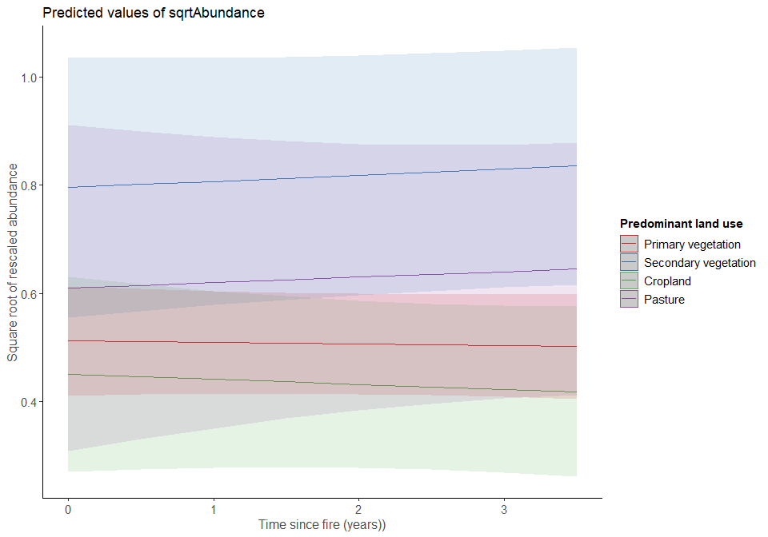
Model diagnostics:
par(mfrow=c(1,2))
qqnorm(resid(m1_years), main="normal qq-plot, residuals")
qqline(resid(m1_years)) ## not bad
plot(fitted(m1_years), resid(m1_years), main = "Residuals vs fitted") #residuals vs fitted
abline(h=0)
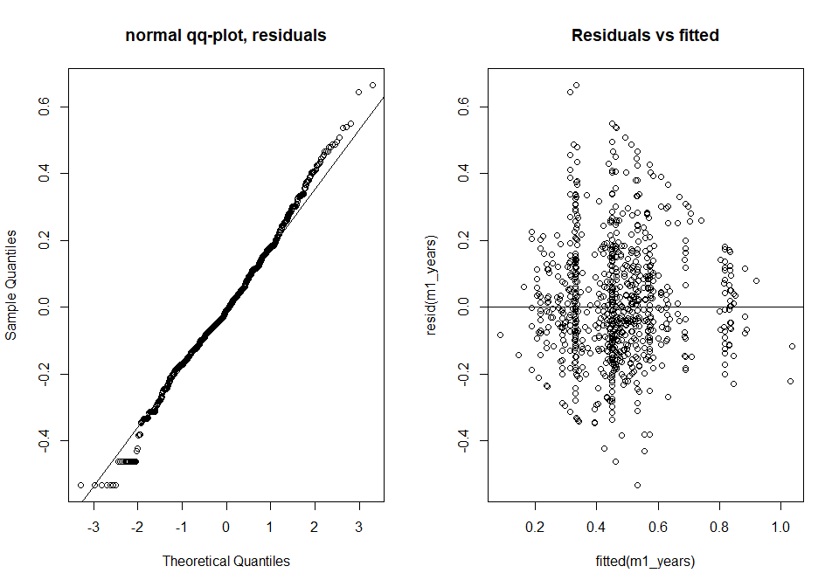
ran <- ranef(m1_years, condVar=TRUE)
a <- dotplot(ran)[["SSB"]]
b <- dotplot(ran)[["SS"]]
grid.arrange(a,b, nrow=2, ncol=1)
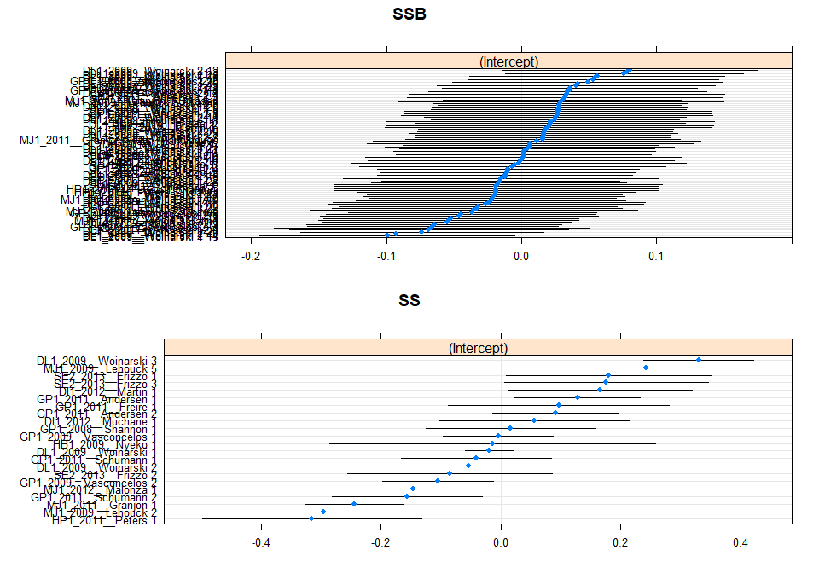
From the plot you can see that the values are bounded (as our response variable can only be between 0 and 1).
We can use the DHARMa package to see if there are missing predictors or quadratic effects.
years_output <- simulateResiduals(fittedModel = m1_years)
plot(years_output, quantreg = T)
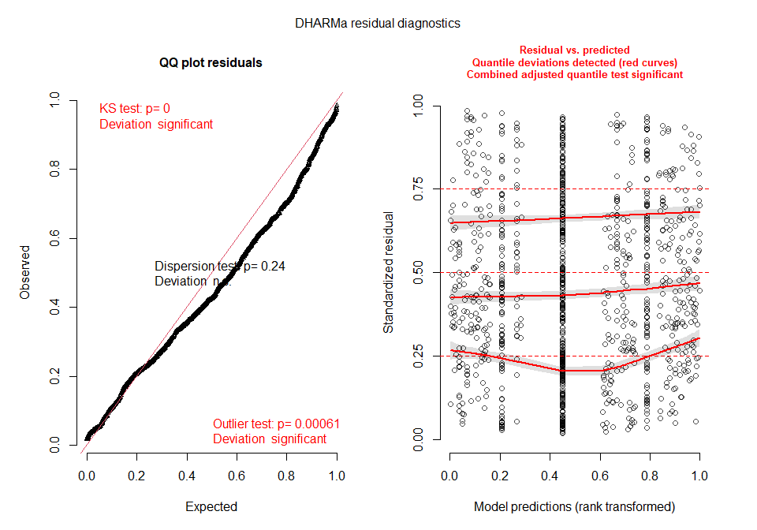
We can also plot the residuals against predictors:
plotResiduals(years_output, model_data$years_since_int)
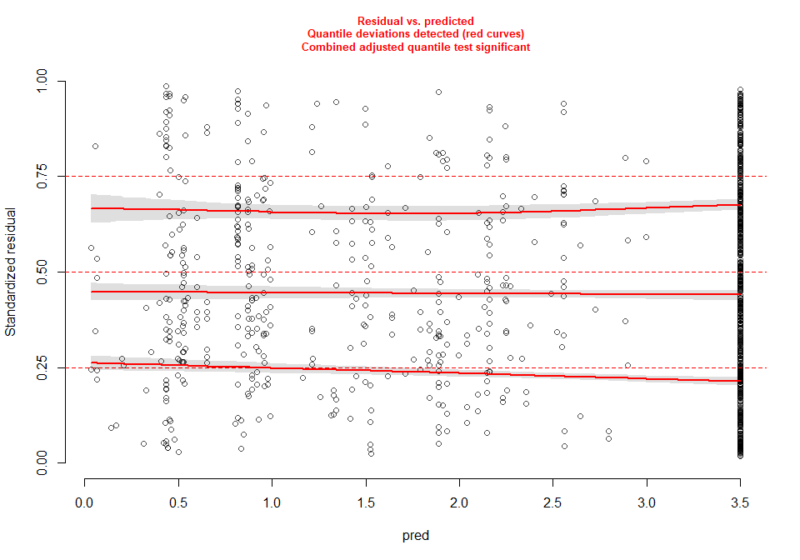
I think these plots suggest that there are some problems happening here but there isn’t too much to suggest nonlinearity. But we can check this further by trying some transformations of time.

Testing linearity
Using -1/time
model_data$time_transformed <- model_data$years_since_int
model_data$time_transformed <- -1/model_data$time_transformed
m1_years3 <- lmer(sqrtAbundance ~ Predominant_land_use + Use_intensity_2 + time_transformed +
Predominant_land_use:time_transformed +
Predominant_land_use:Use_intensity_2 +
(1|SS) + (1|SSB), data = model_data)
years_output2 <- simulateResiduals(fittedModel = m1_years3)
plot(years_output2, quantreg = T)
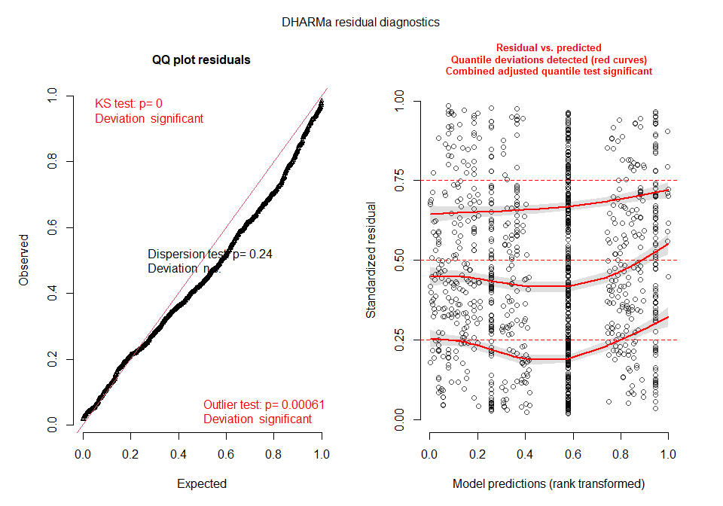
plotResiduals(years_output2, model_data$time_transformed)
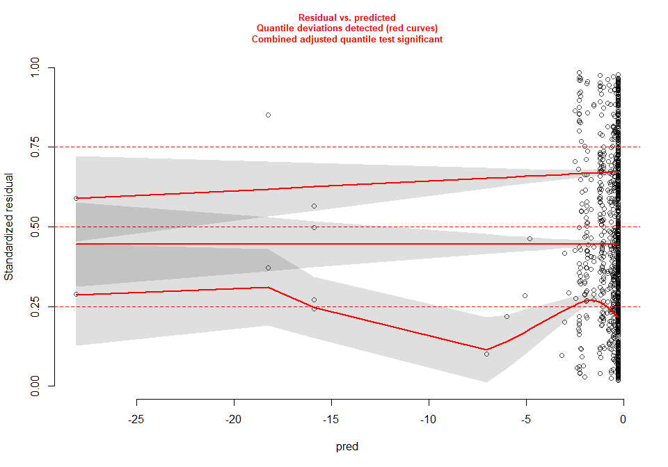
Plots still show some issues, now a worse model than when time was not transformed.
Log(time)
model_data$logtime <- model_data$years_since_int
model_data$logtime <- log(model_data$logtime)
m1_years4 <- lmer(sqrtAbundance ~ Predominant_land_use + Use_intensity_2 + logtime +
Predominant_land_use:logtime+
Predominant_land_use:Use_intensity_2 +
(1|SS) + (1|SSB), data = model_data)
years_output3 <- simulateResiduals(fittedModel = m1_years4)
plot(years_output3, quantreg = T)
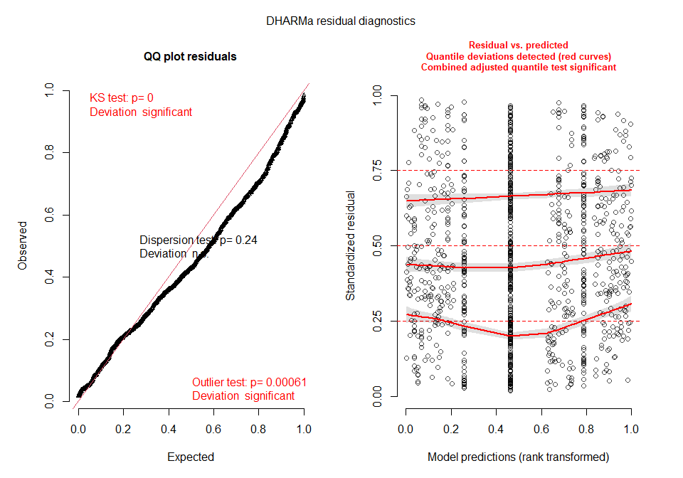
plotResiduals(years_output3, model_data$logtime)
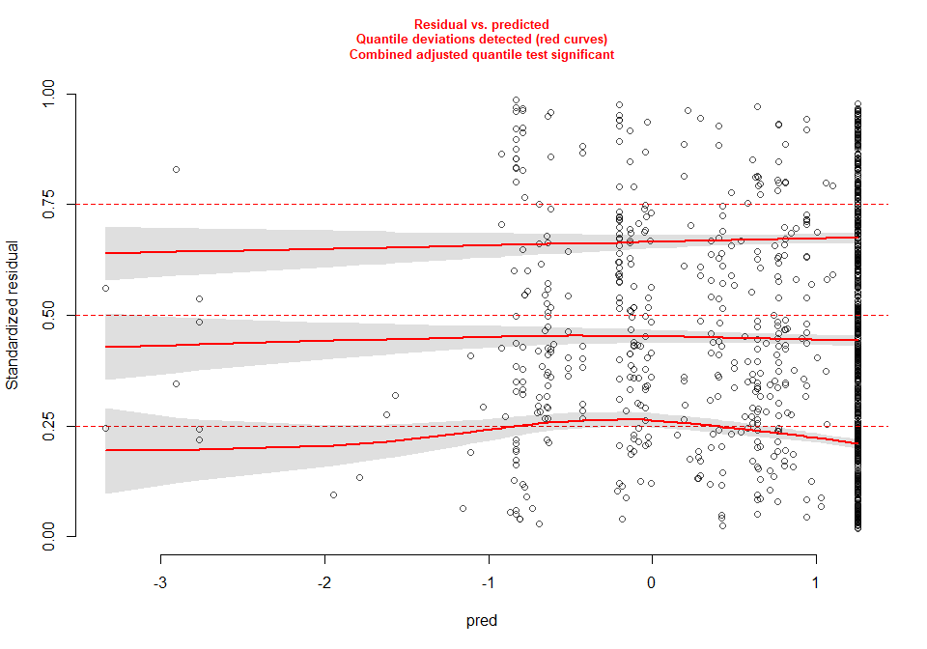
I think there is less of an issue with this transformation than the others, whether it is better than leaving time as it is, I am unsure. Nothing to suggest nonlinearity.
The above results imply that it is best to just simply use time as it is, as theres no obvious indication of a nonlinear relationship.

Comparing time since fire model to the other models…
Compare the years since fire model to some of the better models from earlier on:
m1_years.comp <- lmer(sqrtAbundance ~ Predominant_land_use + Use_intensity_2 + years_since_int +
Predominant_land_use:years_since_int+
Predominant_land_use:Use_intensity_2+
(1|SS) + (1|SSB), data = model_data, REML=FALSE)
AIC(m1.comp, m1.duration.comp, m1_years.comp, m1.durpres.comp)
## df AIC
## m1.comp 15 -332.9540
## m1.duration.comp 15 -334.0731
## m1_years.comp 15 -331.3520
## m1.durpres.comp 19 -333.7174
The duration model remains the best fire metric here, with duration and presence combined being second. Time is a worse predictor than presence.

Looking at the duration model in more detail:
m1.duration <- lmer(sqrtAbundance ~ Predominant_land_use + Use_intensity_2 + duration +
Predominant_land_use:duration +
Predominant_land_use:Use_intensity_2+
(1|SS) + (1|SSB), data = model_data)
Anova(m1.duration)
## Analysis of Deviance Table (Type II Wald chisquare tests)
##
## Response: sqrtAbundance
## Chisq Df Pr(>Chisq)
## Predominant_land_use 30.4289 3 1.121e-06 ***
## Use_intensity_2 0.7413 1 0.3892507
## duration 0.8511 1 0.3562348
## Predominant_land_use:duration 2.7251 3 0.4359790
## Predominant_land_use:Use_intensity_2 20.5953 3 0.0001277 ***
## ---
## Signif. codes: 0 '***' 0.001 '**' 0.01 '*' 0.05 '.' 0.1 ' ' 1
summary(m1.duration)
## Linear mixed model fit by REML ['lmerMod']
## Formula: sqrtAbundance ~ Predominant_land_use + Use_intensity_2 + duration +
## Predominant_land_use:duration + Predominant_land_use:Use_intensity_2 + (1 | SS) + (1 | SSB)
## Data: model_data
##
## REML criterion at convergence: -288.7
##
## Scaled residuals:
## Min 1Q Median 3Q Max
## -2.7472 -0.5977 -0.0492 0.5996 3.5027
##
## Random effects:
## Groups Name Variance Std.Dev.
## SSB (Intercept) 0.004118 0.06418
## SS (Intercept) 0.035041 0.18719
## Residual 0.037749 0.19429
## Number of obs: 1041, groups: SSB, 85; SS, 22
##
## Fixed effects:
## Estimate Std. Error t value
## (Intercept) 0.486356 0.048231 10.084
## Predominant_land_useSecondary vegetation 0.354241 0.107637 3.291
## Predominant_land_useCropland -0.063736 0.072159 -0.883
## Predominant_land_usePasture 0.144873 0.111013 1.305
## Use_intensity_2Greater use 0.052616 0.042712 1.232
## duration 0.002145 0.001236 1.735
## Predominant_land_useSecondary vegetation:duration -0.002908 0.002126 -1.368
## Predominant_land_useCropland:duration -0.002647 0.003316 -0.798
## Predominant_land_usePasture:duration -0.004103 0.004012 -1.023
## Predominant_land_useSecondary vegetation:Use_intensity_2Greater use -0.405774 0.109462 -3.707
## Predominant_land_useCropland:Use_intensity_2Greater use 0.033660 0.088873 0.379
## Predominant_land_usePasture:Use_intensity_2Greater use -0.308810 0.120973 -2.553
##
## Correlation of Fixed Effects:
## (Intr) Pr__Sv Prd__C Prd__P U__2Gu duratn P__Sv: Pr__C: Pr__P: P__Svu P__C:u
## Prdmnnt__Sv -0.142
## Prdmnnt_l_C -0.147 0.044
## Prdmnnt_l_P -0.053 0.007 0.008
## Us_ntns_2Gu -0.367 0.136 0.164 0.019
## duration -0.224 0.143 0.074 0.012 0.131
## Prdmnn__Sv: 0.123 -0.112 -0.039 -0.006 -0.053 -0.551
## Prdmnnt__C: 0.111 -0.077 -0.317 -0.006 -0.066 -0.335 0.185
## Prdmnnt__P: -0.017 -0.022 0.016 0.001 0.224 -0.293 0.193 0.098
## P__Sv:U__2u 0.111 -0.952 -0.038 -0.006 -0.146 -0.037 -0.098 0.040 -0.005
## P__C:U__2Gu 0.191 -0.020 -0.837 -0.010 -0.516 0.116 -0.075 0.141 -0.209 0.047
## P__P:U__2Gu 0.069 -0.001 -0.022 -0.919 -0.164 0.093 -0.060 -0.030 -0.278 0.023 0.128
We have significant effects of Land use and its interaction with use intensity, but no significant effects of duration, or its interaction.
Model criticism/diagnostics
duration_output <- simulateResiduals(fittedModel = m1.duration, n = 250)
plot(duration_output)
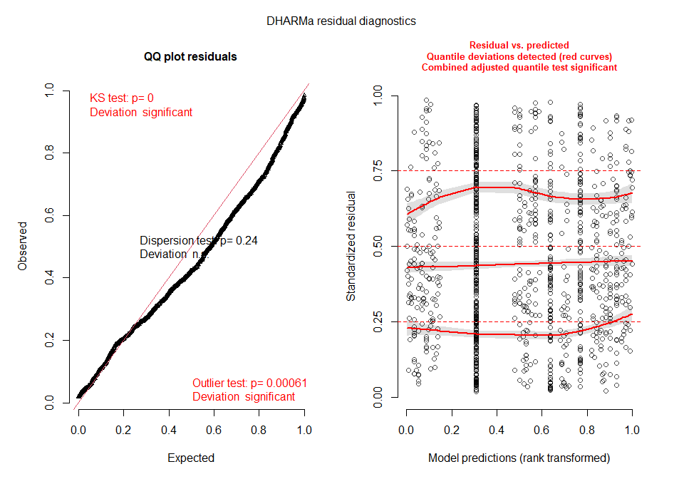
par(mfrow=c(1,3))
plotResiduals(duration_output, model_data$Predominant_land_use, main="Predominant land use")
plotResiduals(duration_output, model_data$Use_intensity_2, main="Use intensity")
plotResiduals(duration_output, model_data$duration, main="Duration")
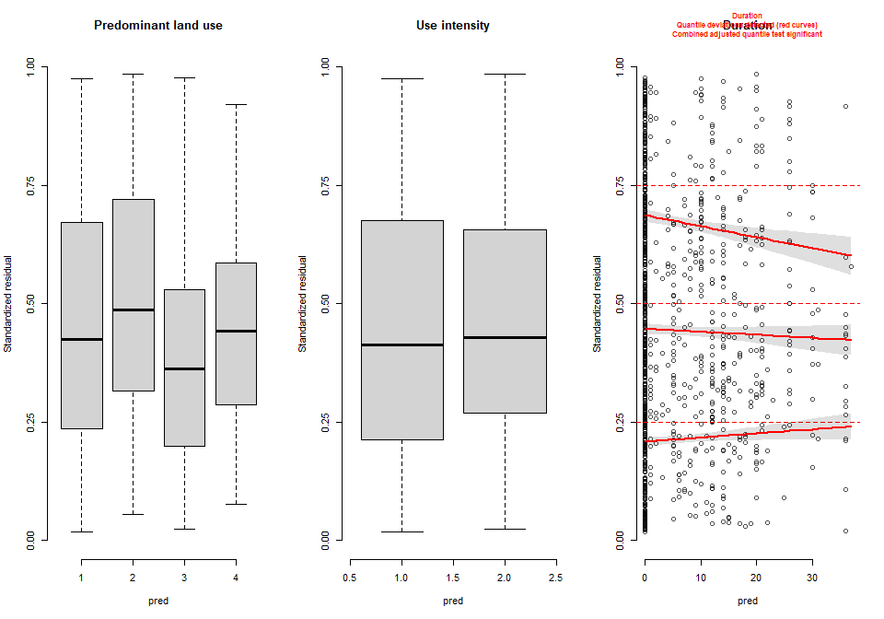
plot(m1.duration)
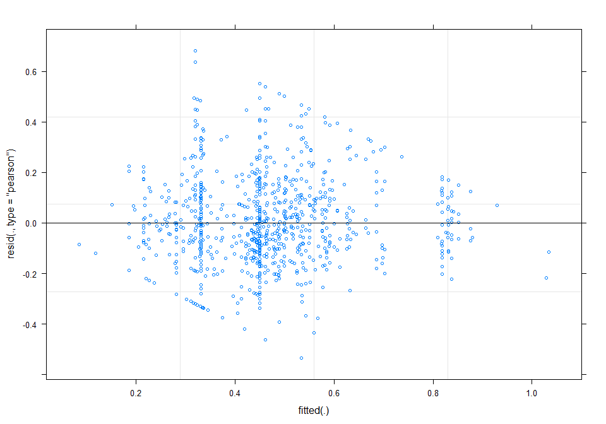
par(mfrow=c(1,2))
qqnorm(resid(m1.duration), main="normal qq-plot, residuals")
qqline(resid(m1.duration)) ## not bad
plot(fitted(m1.duration), resid(m1.duration), main = "Residuals vs fitted") #residuals vs fitted
abline(h=0)
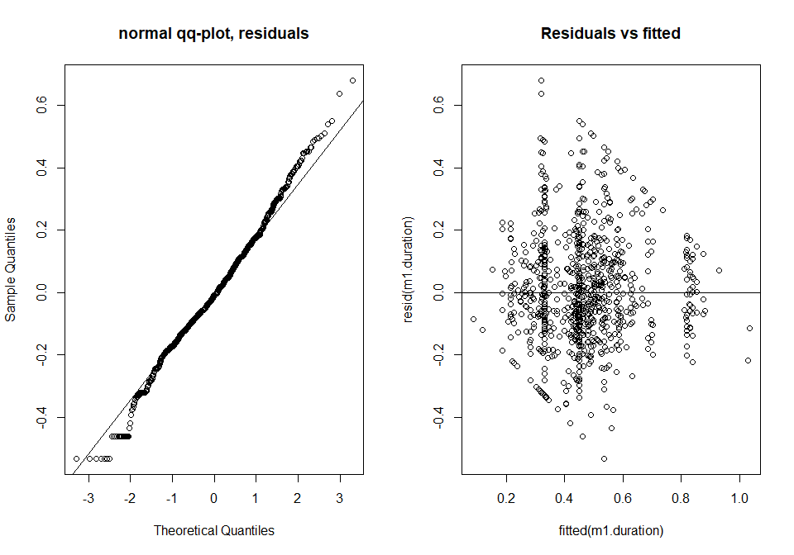
ran <- ranef(m1.duration, condVar=TRUE)
a <- dotplot(ran)[["SSB"]]
b <- dotplot(ran)[["SS"]]
grid.arrange(a,b, nrow=2, ncol=1)
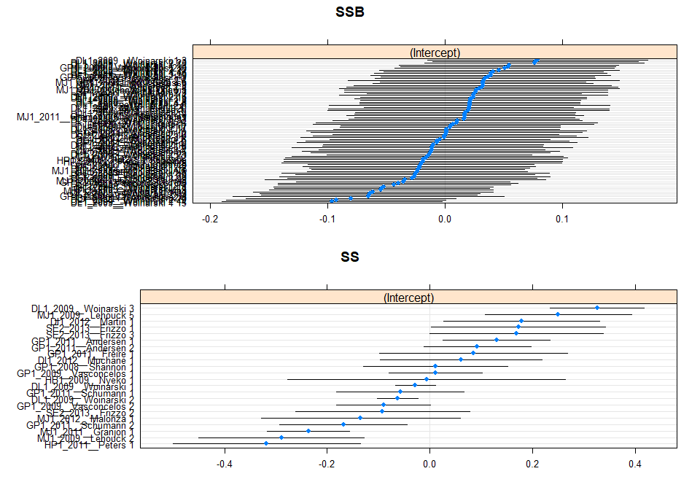
Overall, the model isn’t too bad. Plots indicate some issues in terms of normality but nothing that is not expected with this sort of data.
Residuals:
residuals <- resid(m1.duration)
summary(residuals)
## Min. 1st Qu. Median Mean 3rd Qu. Max.
## -0.533752 -0.116127 -0.009551 0.000000 0.116498 0.680535
hist(residuals)
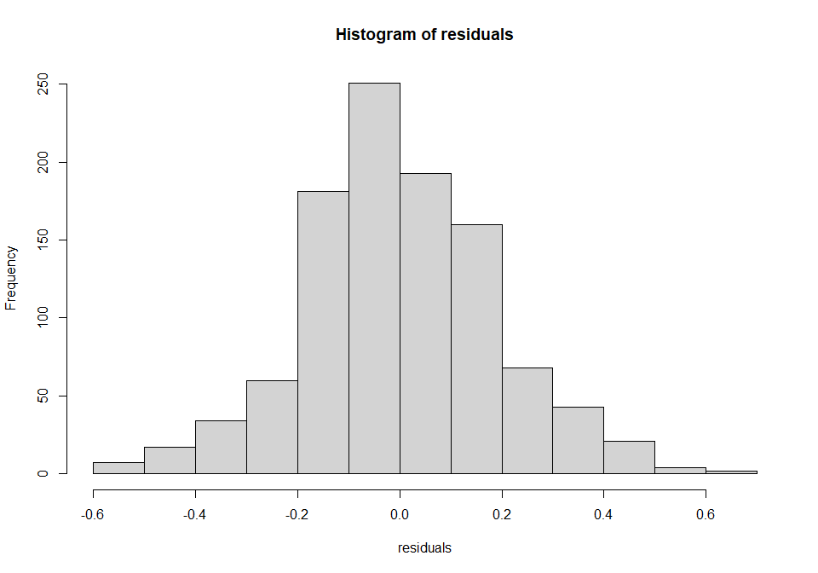
Residuals are ok suggesting normality.
Using the MuMIn package to get r2 values:
r.squaredGLMM(m1.duration)
## Warning: 'r.squaredGLMM' now calculates a revised statistic. See the help page.
## R2m R2c
## [1,] 0.03226605 0.525008
In this model only 0.03% of the data is explained by our fixed effects, very similar to the fire presence model.

Hypothesis testing:
m1.duration.2 <- lmer(sqrtAbundance ~ Predominant_land_use + Use_intensity_2 +
Predominant_land_use:Use_intensity_2+
(1|SS) + (1|SSB), data = model_data)
anova(m1.duration, m1.duration.2)
## refitting model(s) with ML (instead of REML)
## Data: model_data
## Models:
## m1.duration.2: sqrtAbundance ~ Predominant_land_use + Use_intensity_2 + Predominant_land_use:Use_intensity_2 +
## m1.duration.2: (1 | SS) + (1 | SSB)
## m1.duration: sqrtAbundance ~ Predominant_land_use + Use_intensity_2 + duration +
## m1.duration: Predominant_land_use:duration + Predominant_land_use:Use_intensity_2 +
## m1.duration: (1 | SS) + (1 | SSB)
## npar AIC BIC logLik deviance Chisq Df Pr(>Chisq)
## m1.duration.2 11 -338.46 -284.03 180.23 -360.46
## m1.duration 15 -334.07 -259.85 182.04 -364.07 3.6138 4 0.4608
No significant affect of duration on abundance.

