Choosing a savanna abundance model
Load the required data (both PREDICTS and fire history data).
diversity <- readRDS("~/Imperial/PROJECT/PREDICTS data/database.rds")
fire_hist <- read.csv("~/Imperial/PROJECT/Combined data/Fire_history.csv")

Data preparation
This section is the same as in previous markdowns when experimenting with models. PREDICTS data preparation:
## Move Measurement and Effort_corrected_measurement into the same thing, and Sampling_effort and
#Rescaled_sampling_effort
diversity <- mutate(diversity,
Measurement = Effort_corrected_measurement,
Sampling_effort = Rescaled_sampling_effort)
## Calculating diversity metrics including rescaled abundance.
sites <- diversity %>%
mutate(Diversity_metric_is_valid = TRUE) %>%
predictsFunctions::SiteMetrics(extra.cols = c("SSB", "SSBS", "Predominant_land_use", "Biome", "Country")) %>%
group_by(SS) %>%
mutate(MaxAbundance = ifelse(Diversity_metric_type == "Abundance",
max(Total_abundance),
NA)) %>%
ungroup() %>%
mutate(RescaledAbundance = ifelse(Diversity_metric_type == "Abundance",
Total_abundance/MaxAbundance,
NA))
## Tidying up the predominant land use category
sites <- sites %>%
mutate(
Predominant_land_use = recode_factor(Predominant_land_use,
"Primary forest" = "Primary vegetation",
"Primary non-forest" = "Primary vegetation"),
Predominant_land_use = na_if(Predominant_land_use, "Secondary vegetation (indeterminate age)"),
Predominant_land_use = na_if(Predominant_land_use, "Cannot decide"),
Use_intensity = na_if(Use_intensity, "Cannot decide"),
Predominant_land_use = factor(Predominant_land_use),
Predominant_land_use = relevel(Predominant_land_use, ref = "Primary vegetation"),
Use_intensity = factor(Use_intensity),
Use_intensity = relevel(Use_intensity, ref = "Minimal use")
)
## For my analysis I need to subset so that all sites are after 2006 (so that we can have 3yrs of
#fire data)
sites_post_2006 <- subset(sites, sites$Sample_start_earliest > "2006-01-01")
## Removing rows that have NAs in latitude and longitude as these won't have fire data
sites_post_2006_NA <- subset(sites_post_2006, (! is.na(Longitude) | ! is.na(Latitude)))
Combining with fire data and preparing that data:
PREDICTS_fire_hist <- merge(sites_post_2006_NA, fire_hist
[,c("SSBS", "Freq", "fire_ID", "size", "start_date", "duration", "days_since_fire",
"year", "years_since_fire")], by="SSBS", all.x=TRUE)
## Creating fire presence column (need to change NAs in freq to 0 as these sites have no fires in the
#last 3 years)
PREDICTS_fire_hist$Freq[is.na(PREDICTS_fire_hist$Freq)] <- 0
PREDICTS_fire_hist$fire_presence <- ifelse(PREDICTS_fire_hist$Freq==0, "No",
ifelse(PREDICTS_fire_hist$Freq!=0, "Yes",
NA))
PREDICTS_fire_hist$fire_presence <- as.factor(PREDICTS_fire_hist$fire_presence)
## Need to remove data which has NAs in categories required for our analysis
PREDICTS_fire_hist2 <- drop_na(PREDICTS_fire_hist, Total_abundance, Predominant_land_use, Use_intensity, fire_presence)
Subsetting the data to just look at the savanna:
sites_savanna <- subset(PREDICTS_fire_hist2, PREDICTS_fire_hist2$Biome == "Tropical & Subtropical Grasslands, Savannas & Shrublands")
Data exploration Need to make sure with have sufficient sites for analysis.
table(sites_savanna$Predominant_land_use, sites_savanna$fire_presence)
##
## No Yes
## Primary vegetation 434 285
## Young secondary vegetation 30 79
## Intermediate secondary vegetation 0 30
## Mature secondary vegetation 3 1
## Plantation forest 25 1
## Pasture 25 26
## Cropland 102 26
## Urban 4 0
To deal with the imbalances we need to remove land use classes with a lack of data (Plantation and Urban), and we need to merge intermediate and mature secondary vegetation together into one class.
# Removing land use level which lack data
sites_savanna<-sites_savanna[!(sites_savanna$Predominant_land_use == "Plantation forest"),]
sites_savanna<-sites_savanna[!(sites_savanna$Predominant_land_use == "Urban"),]
sites_savanna$Predominant_land_use <- as.factor(as.character(sites_savanna$Predominant_land_use))
## Merge together intermediate and mature secondary vegetation into one class
sites_savanna <- sites_savanna %>%
mutate( Predominant_land_use = recode_factor(Predominant_land_use,
"Intermediate secondary vegetation" = "Older secondary vegetation",
"Mature secondary vegetation" = "Older secondary vegetation"),
Predominant_land_use = factor(Predominant_land_use),
Predominant_land_use = relevel(Predominant_land_use, ref = "Primary vegetation")
)
sites_savanna$Predominant_land_use <- factor(sites_savanna$Predominant_land_use, levels = c("Primary vegetation", "Young secondary vegetation", "Older secondary vegetation", "Cropland", "Pasture"))
We now have a much better spread of the data.
table(sites_savanna$Predominant_land_use, sites_savanna$fire_presence)
##
## No Yes
## Primary vegetation 434 285
## Young secondary vegetation 30 79
## Older secondary vegetation 3 31
## Cropland 102 26
## Pasture 25 26
We also want to look at the distribution of use intensities and land use classes to be able to include this interaction.
table(sites_savanna$Predominant_land_use, sites_savanna$Use_intensity)
##
## Minimal use Light use Intense use
## Primary vegetation 457 62 200
## Young secondary vegetation 0 0 109
## Older secondary vegetation 4 0 30
## Cropland 13 114 1
## Pasture 5 33 13
We have 3 combinations which have no sites therefore if we were to model with this data we would have rank deficiency. Instead we can aggregate light and intense use together so that we only have one combination lacking data. In the savanna models markdown, models with and without this have been compared and it is better to do this aggregation than to leave it out, this will be re done and shown later in the analysis
sites_savanna <- sites_savanna %>%
mutate(
Use_intensity_2 = recode_factor(Use_intensity,
"Light use" = "Greater use",
"Intense use" = "Greater use"),
Use_intensity_2 = factor(Use_intensity_2),
Use_intensity_2 = relevel(Use_intensity_2, ref = "Minimal use")
)
table(sites_savanna$Predominant_land_use, sites_savanna$Use_intensity_2)
##
## Minimal use Greater use
## Primary vegetation 457 262
## Young secondary vegetation 0 109
## Older secondary vegetation 4 30
## Cropland 13 115
## Pasture 5 46
To avoid issues regarding rank deficiency we can also combine together the secondary age classes and compare how these models portray the data.
sites_savanna$Landuse <- sites_savanna$Predominant_land_use
sites_savanna <- sites_savanna %>%
mutate(Landuse = recode_factor(Landuse, "Young secondary vegetation" = "Secondary vegetation",
"Older secondary vegetation" = "Secondary vegetation"),
Landuse = factor(Landuse),
Landuse = relevel(Landuse, ref = "Primary vegetation"))
sites_savanna$Landuse <- factor(sites_savanna$Landuse, levels = c("Primary vegetation",
"Secondary vegetation",
"Cropland",
"Pasture"))
table(sites_savanna$Landuse, sites_savanna$fire_presence)
##
## No Yes
## Primary vegetation 434 285
## Secondary vegetation 33 110
## Cropland 102 26
## Pasture 25 26
table(sites_savanna$Landuse, sites_savanna$Use_intensity_2)
##
## Minimal use Greater use
## Primary vegetation 457 262
## Secondary vegetation 4 139
## Cropland 13 115
## Pasture 5 46

Assumption checking
Collinearity
source("https://highstat.com/Books/Book2/HighstatLibV10.R")
corvif(sites_savanna[ , c("Predominant_land_use", "Use_intensity", "fire_presence")])
##
##
## Variance inflation factors
##
## GVIF Df GVIF^(1/2Df)
## Predominant_land_use 2.875835 4 1.141157
## Use_intensity 3.165851 2 1.333898
## fire_presence 1.251848 1 1.118860
corvif(sites_savanna[ , c("Predominant_land_use", "Use_intensity_2", "fire_presence")])
##
##
## Variance inflation factors
##
## GVIF Df GVIF^(1/2Df)
## Predominant_land_use 1.537815 4 1.055269
## Use_intensity_2 1.530174 1 1.237002
## fire_presence 1.222296 1 1.105575
corvif(sites_savanna[ , c("Landuse", "Use_intensity_2", "fire_presence")])
##
##
## Variance inflation factors
##
## GVIF Df GVIF^(1/2Df)
## Landuse 1.525137 3 1.072881
## Use_intensity_2 1.523538 1 1.234317
## fire_presence 1.214554 1 1.102068
All the GVIF values are low suggesting there is low collinearity between variables, especially when the recoded categories are used.
Complete cases This was checked earlier but we can repeat it again here to be certain.
model_data <- drop_na(sites_savanna, Total_abundance, Predominant_land_use, Landuse, Use_intensity_2, fire_presence)
Normality in the response variable
par(mfrow=c(1,2))
hist(model_data$RescaledAbundance)
qqnorm(model_data$RescaledAbundance)
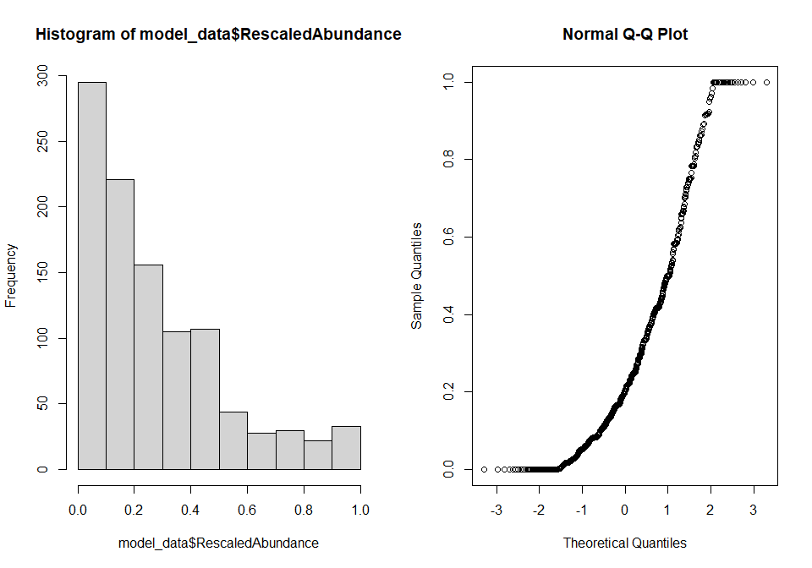
The above plots show that the response variable has a non-normal distribution therefore it needs transforming to be used. I am going to do both log+1 and square root transformations.
model_data <- mutate(model_data,
logAbundance = log(RescaledAbundance + 1),
sqrtAbundance = sqrt(RescaledAbundance))
par(mfrow=c(2,2))
hist(model_data$logAbundance)
qqnorm(model_data$logAbundance)
hist(model_data$sqrtAbundance)
qqnorm(model_data$sqrtAbundance)
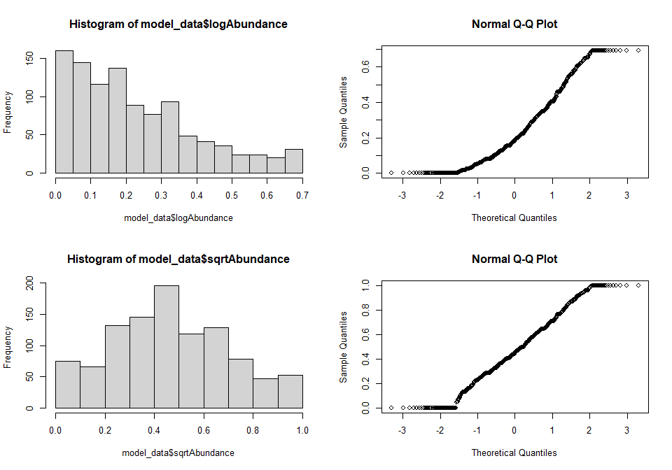
The square root transformation shows better normality therefore we are going to use this as the response variable in our model. It still has some small tails but as these are symetrical it is ok to use.

Model selection
Maximal/starting model
m1 <- lmer(sqrtAbundance ~ Predominant_land_use + Use_intensity + fire_presence +
Predominant_land_use:fire_presence + Predominant_land_use:Use_intensity +
(1|SS) + (1|SSB), data = model_data)
## fixed-effect model matrix is rank deficient so dropping 3 columns / coefficients

Should we use use intensity as is, or the recoded version
To compare different fixed effects in the models we need to ensure that REML=FALSE
m1.F <- lmer(sqrtAbundance ~ Predominant_land_use + Use_intensity_2 + fire_presence +
Predominant_land_use:fire_presence + Predominant_land_use:Use_intensity_2 +
(1|SS) + (1|SSB), data = model_data, REML = FALSE)
## fixed-effect model matrix is rank deficient so dropping 1 column / coefficient
m1.F2 <- lmer(sqrtAbundance ~ Predominant_land_use + Use_intensity + fire_presence +
Predominant_land_use:fire_presence + Predominant_land_use:Use_intensity +
(1|SS) + (1|SSB), data = model_data, REML = FALSE)
## fixed-effect model matrix is rank deficient so dropping 3 columns / coefficients
## Then test using AIC
AIC(m1.F, m1.F2)
## df AIC
## m1.F 17 -329.2951
## m1.F2 20 -328.3003
We can see that model m1.F has the lower AIC value and therefore we shall use that model, which is the one with the recoded land use intensity.

Should we use Predominant land use with secondary ages are without?
## Predominant land use model = m1.F
m1.F3 <- lmer(sqrtAbundance ~ Landuse + Use_intensity_2 + fire_presence +
Landuse:fire_presence + Landuse:Use_intensity_2 +
(1|SS) + (1|SSB), data = model_data, REML = FALSE)
AIC(m1.F, m1.F3)
## df AIC
## m1.F 17 -329.2951
## m1.F3 15 -332.9540
Lowest AIC is m1.F3 therefore we should use the model with the recoded land use categories.

Choosing the random effects structure
m1.re1 <- lmer(sqrtAbundance ~ Landuse + Use_intensity_2 + fire_presence +
Landuse:fire_presence + Landuse:Use_intensity_2 +
(1|SS) + (1|SSB), data = model_data)
m1.re2 <- lmer(sqrtAbundance ~ Landuse + Use_intensity_2 + fire_presence +
Landuse:fire_presence + Landuse:Use_intensity_2 +
(1+Landuse|SS) + (1|SSB), data = model_data)
## boundary (singular) fit: see ?isSingular
m1.re3 <- lmer(sqrtAbundance ~ Landuse + Use_intensity_2 + fire_presence +
Landuse:fire_presence + Landuse:Use_intensity_2 +
(1+Use_intensity_2|SS) + (1|SSB), data = model_data)
m1.re4 <- lmer(sqrtAbundance ~ Landuse + Use_intensity_2 + fire_presence +
Landuse:fire_presence + Landuse:Use_intensity_2 +
(1+fire_presence|SS) + (1|SSB), data = model_data)
Model 2 comes up with an error message about singular fit so it’s probably likely that this random effect structure won’t be used, but we need to compare all these models using AIC. To compare random effects REML=TRUE needs to be set (which is the default in lmer).
AIC(m1.re1, m1.re2, m1.re3, m1.re4)
## df AIC
## m1.re1 15 -281.0524
## m1.re2 24 -279.9783
## m1.re3 17 -279.7295
## m1.re4 17 -278.6908
Model 1 (just intercepts) has the lowest AIC value and therefore we shall use this random effect structure in the model.

Choosing the fixed effects structure
Creating models with different combinations of fixed effects. To compare different fixed effect, we need REML = false. We also need to create a null model to compare. I am using this method as we want to include fire presence in the model, so we want to select the best model which includes fire.
m1.ms <- lmer(sqrtAbundance ~ Landuse + Use_intensity_2 + fire_presence +
Landuse:fire_presence + Landuse:Use_intensity_2 +
(1|SS) + (1|SSB), data = model_data, REML = FALSE)
m2.ms <- lmer(sqrtAbundance ~ Landuse + Use_intensity_2 + fire_presence +
Landuse:fire_presence +
(1|SS) + (1|SSB), data = model_data, REML = FALSE)
m3.ms <- lmer(sqrtAbundance ~ Landuse + Use_intensity_2 + fire_presence +
Landuse:fire_presence + Use_intensity_2:fire_presence +
(1|SS) + (1|SSB), data = model_data, REML = FALSE)
m4.ms <- lmer(sqrtAbundance ~ Landuse + Use_intensity_2 + fire_presence +
Landuse:fire_presence + fire_presence:Use_intensity_2 +
Landuse:Use_intensity_2 +
(1|SS) + (1|SSB), data = model_data)
m.null <- lmer(sqrtAbundance ~
(1|SS) + (1|SSB), data = model_data, REML = FALSE)
Comparing the models using AIC:
AIC(m1.ms, m2.ms, m3.ms, m4.ms, m.null)
## df AIC
## m1.ms 15 -332.9540
## m2.ms 12 -320.0106
## m3.ms 13 -318.1608
## m4.ms 16 -275.0062
## m.null 4 -299.0575
Based off this table we should use the fixed effect structure in model 1, which include land use, use intensity, and fire presence, as well as the interactions between land use and use intensity and land use and fire presence.

Looking at the model
The model we have chosen via the above method is model 1.
m1 <- lmer(sqrtAbundance ~ Landuse + Use_intensity_2 + fire_presence +
Landuse:fire_presence + Landuse:Use_intensity_2+
(1|SS) + (1|SSB), data = model_data)
Looking at the model
Anova(m1)
## Analysis of Deviance Table (Type II Wald chisquare tests)
##
## Response: sqrtAbundance
## Chisq Df Pr(>Chisq)
## Landuse 30.6533 3 1.006e-06 ***
## Use_intensity_2 0.4124 1 0.5207661
## fire_presence 0.1013 1 0.7502381
## Landuse:fire_presence 2.3548 3 0.5021091
## Landuse:Use_intensity_2 18.9871 3 0.0002751 ***
## ---
## Signif. codes: 0 '***' 0.001 '**' 0.01 '*' 0.05 '.' 0.1 ' ' 1
The anova shows that Predominant land use and its interaction with use intensity are significant variables in this model. This does imply that we could remove fire presence from the model (as long as it didn’t remove too much explanatory power), however because we are specifically interested in the effects of fire we are going to keep it in.
summary(m1)
## Linear mixed model fit by REML ['lmerMod']
## Formula: sqrtAbundance ~ Landuse + Use_intensity_2 + fire_presence + Landuse:fire_presence +
## Landuse:Use_intensity_2 + (1 | SS) + (1 | SSB)
## Data: model_data
##
## REML criterion at convergence: -311.1
##
## Scaled residuals:
## Min 1Q Median 3Q Max
## -2.7468 -0.6341 -0.0545 0.6116 3.3406
##
## Random effects:
## Groups Name Variance Std.Dev.
## SSB (Intercept) 0.004173 0.0646
## SS (Intercept) 0.034857 0.1867
## Residual 0.037781 0.1944
## Number of obs: 1041, groups: SSB, 85; SS, 22
##
## Fixed effects:
## Estimate Std. Error t value
## (Intercept) 0.504308 0.049255 10.239
## LanduseSecondary vegetation 0.331840 0.108519 3.058
## LanduseCropland -0.104291 0.073265 -1.423
## LandusePasture 0.142793 0.111057 1.286
## Use_intensity_2Greater use 0.042276 0.043886 0.963
## fire_presenceYes 0.007604 0.025142 0.302
## LanduseSecondary vegetation:fire_presenceYes -0.040605 0.049589 -0.819
## LanduseCropland:fire_presenceYes 0.049205 0.050635 0.972
## LandusePasture:fire_presenceYes -0.034452 0.070849 -0.486
## LanduseSecondary vegetation:Use_intensity_2Greater use -0.380624 0.111518 -3.413
## LanduseCropland:Use_intensity_2Greater use 0.042614 0.089561 0.476
## LandusePasture:Use_intensity_2Greater use -0.322464 0.125003 -2.580
##
## Correlation of Fixed Effects:
## (Intr) LndsSv LndsCr LndsPs U__2Gu fr_prY LSv:_Y LnC:_Y LnP:_Y LSv:Uu LC:U_u
## LndsScndryv -0.159
## LandsCrplnd -0.179 0.064
## LandusePstr -0.054 0.009 0.010
## Us_ntns_2Gu -0.372 0.136 0.177 0.020
## fir_prsncYs -0.292 0.172 0.163 0.016 0.106
## LndsSvgt:_Y 0.135 -0.154 -0.078 -0.007 -0.039 -0.490
## LndsCrpl:_Y 0.180 -0.117 -0.356 -0.010 -0.081 -0.480 0.236
## LndsPstr:_Y -0.005 -0.033 -0.004 0.000 0.299 -0.349 0.177 0.158
## LnSv:U__2Gu 0.106 -0.912 -0.039 -0.006 -0.140 -0.010 -0.201 0.037 -0.014
## LndC:U__2Gu 0.207 -0.030 -0.824 -0.011 -0.548 0.058 -0.038 0.134 -0.250 0.054
## LndP:U__2Gu 0.064 0.005 -0.016 -0.889 -0.207 0.134 -0.068 -0.057 -0.368 0.026 0.158
From the summary we can see that most of the data is explained by the study identity. Looking at the fixed effects, secondary vegetation has increased abundance relative to primary vegetation. It is also clear that cropland has lower abundance than primary. The t values for all the fire presence interactions are small, suggesting that the true effect may be 0, but they still show some variation in different landuses, with increases in croplands where fires are present and declines in abundance in pastures and secondary vegetation with fires, compared to primary vegetation without fire. In Secondary vegetation with more intense land use, there is a large decline in aundance, the same is true for intensly used pastures, relative to minimally used primary vegetation.
Model criticism Dotplot of random effects:
dotplot(ranef(m1,condVar=TRUE))
## $SSB
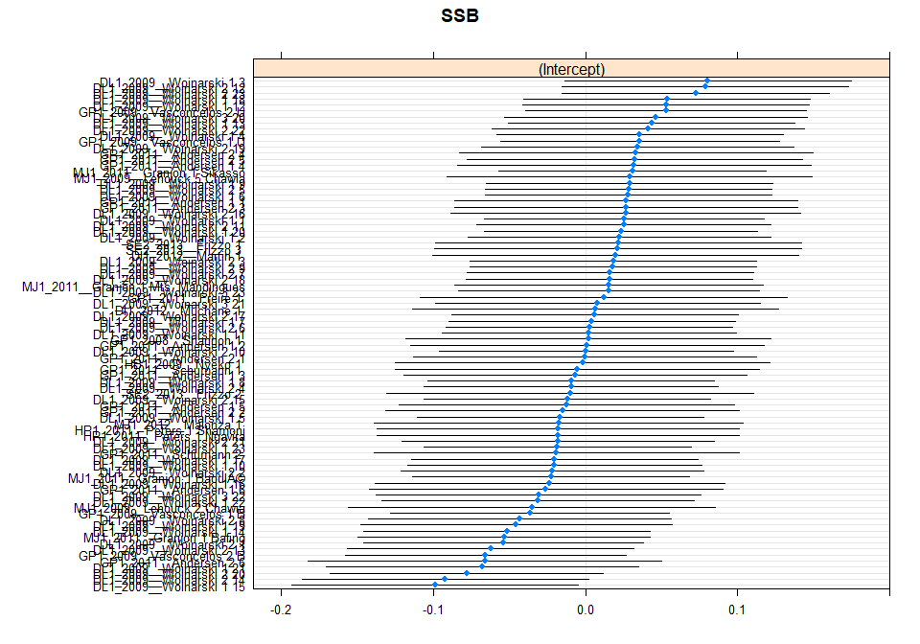
##
## $SS
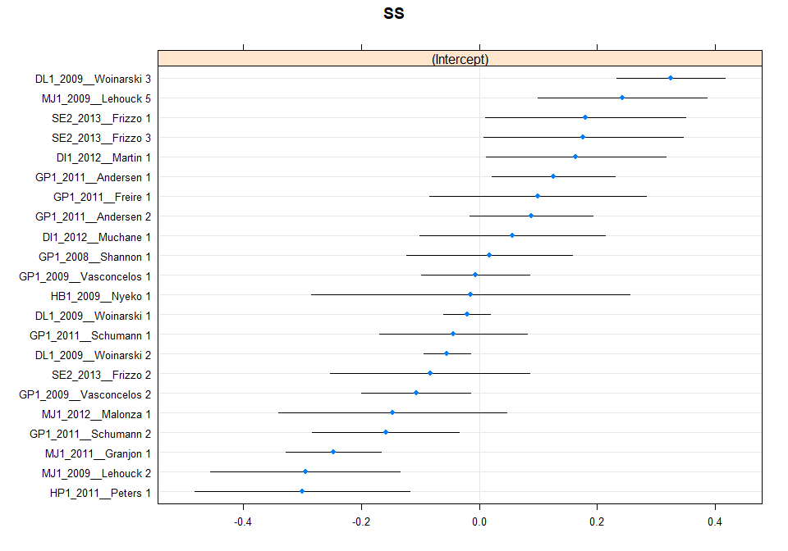
Plot is ok.
plot(m1)
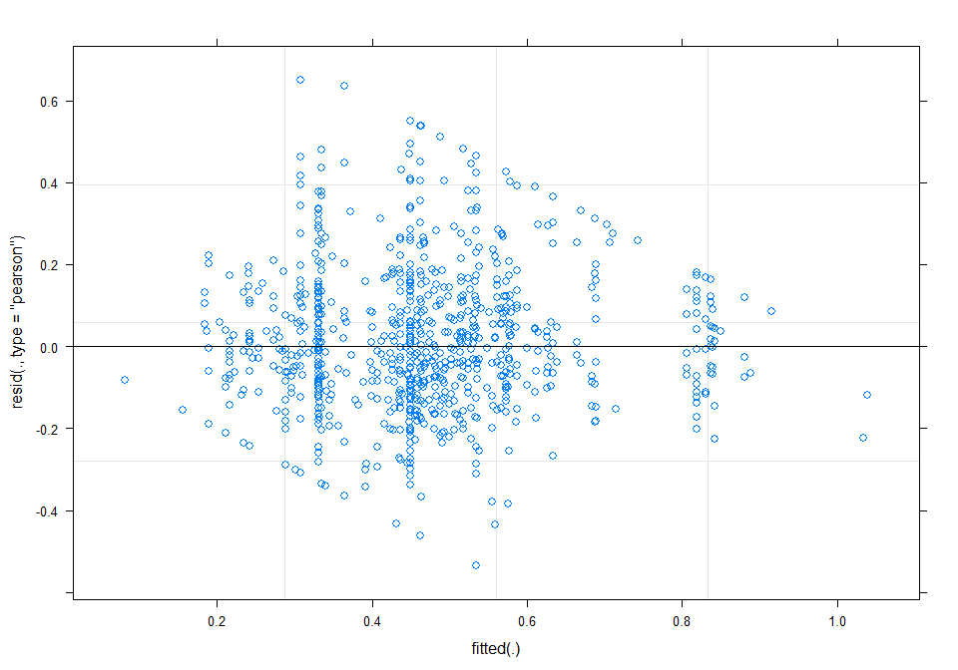
There is some bounding of rescaled abundance visible.
m1_output <- simulateResiduals(fittedModel = m1, n = 250)
plot(m1_output)
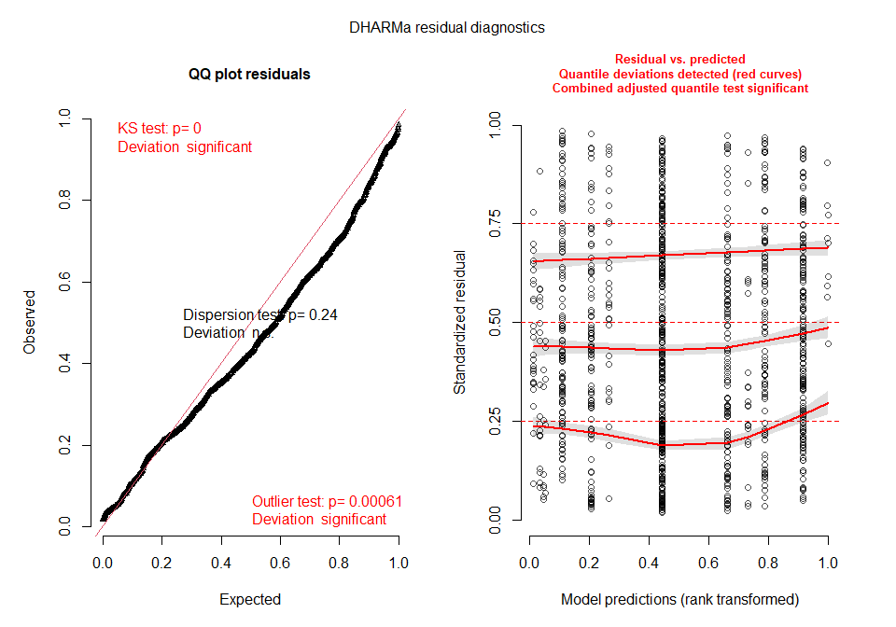
The QQ plot suggests some slight deviations away from normality but this is not too severe. The residuals vs predicted plots have some slight upward tendencies and we can look in more detail at this by looking at the residuals fitted against the predictors individually.
Looking at the residuals against specific predictors:
par(mfrow=c(1,3))
plotResiduals(m1_output, model_data$Landuse, main="Predominant land use")
plotResiduals(m1_output, model_data$Use_intensity_2, main="Use intensity")
plotResiduals(m1_output, model_data$fire_presence, main="fire presence")
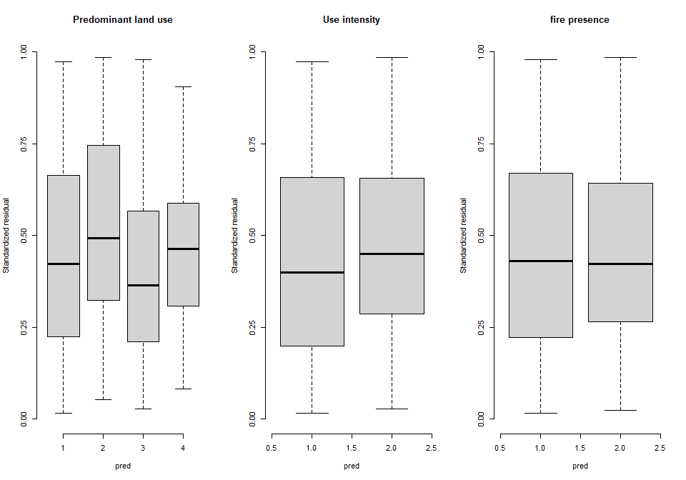
The boxes should sit between 0.25 and 0.75 with the medium line at 0.5, in general this is roughly of all predictors.
Checking normality in the residuals:
residuals <- resid(m1)
summary(residuals)
## Min. 1st Qu. Median Mean 3rd Qu. Max.
## -0.5339 -0.1233 -0.0106 0.0000 0.1189 0.6493
The summary of the residuals appears ok. There are small disparities in the maximum and minimum values but nothing serious and the mean is around 0 indicatinf normality in the residuals. This is supported by a historgram of the residuals.
hist(residuals)
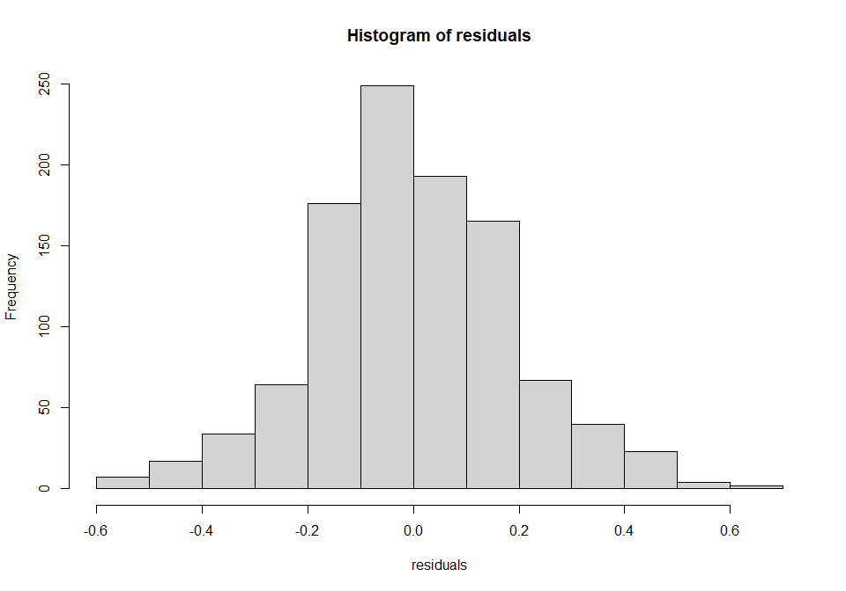
R2 values Use the MuMIn package to get r2 values.
r.squaredGLMM(m1)
## Warning: 'r.squaredGLMM' now calculates a revised statistic. See the help page.
## R2m R2c
## [1,] 0.03061229 0.5231862
R2m is the mariginal r2 and shows the variance explained by the fixed effects and the r2c is the conditional r squared and shows the variance explained by the random effects.
Plots
set_theme(base = theme_classic())
Effect of land use:
plot_model(m1, type = "pred", terms = c("Landuse"), show.intercept = TRUE,
axis.title = c("Predominant land use", "Square root of rescaled abundance"))
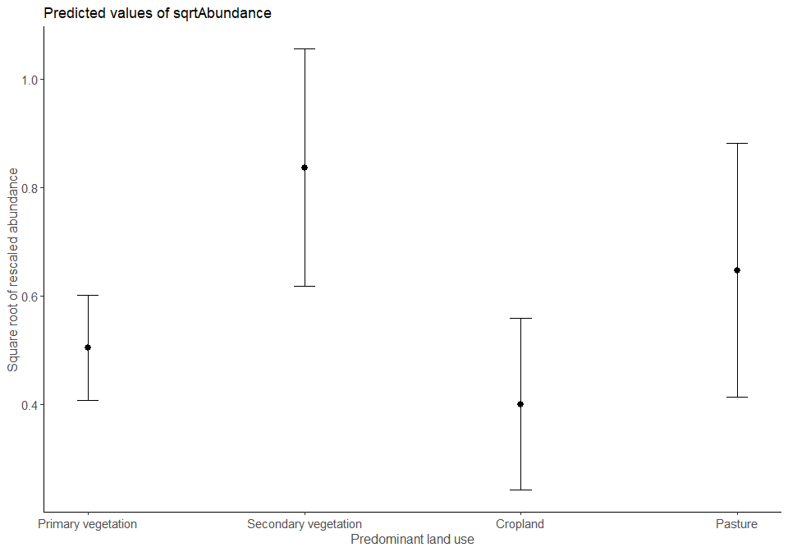
Effect of land use and fire presence:
plot_model(m1, type = "pred", terms = c("Landuse", "fire_presence"), legend.title = "Fire presence",
show.intercept = TRUE, axis.title = c("Predominant land use", "Square root of rescaled abundance"))
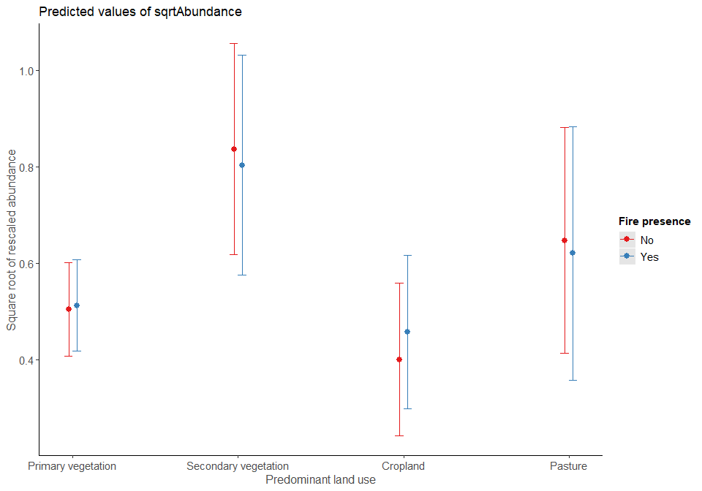
Effect of land use and use intensity:
plot_model(m1, type = "pred", terms = c("Landuse", "Use_intensity_2"),
legend.title = "Use intensity", show.intercept = TRUE,
axis.title = c("Predominant land use", "Square root of rescaled abundance"))
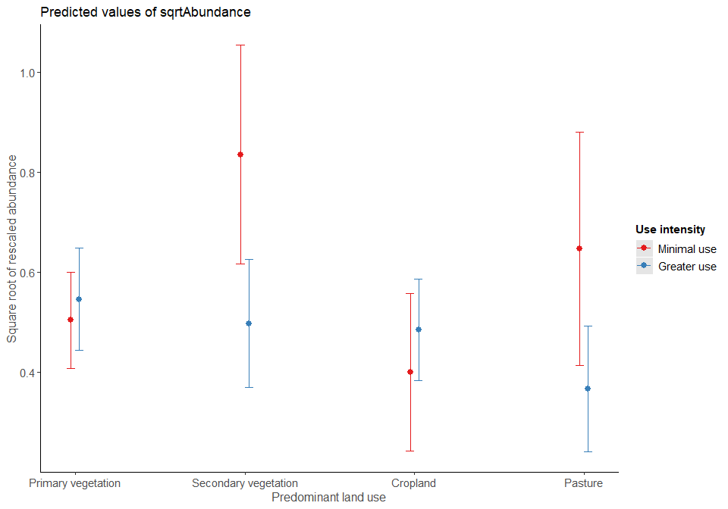

Hypothesis testing - Does fire have an effect on abundance in the savanna biome?
Need to fit models with and without fire using maximum liklihood (to compare fixed effects)
fire <- lmer(sqrtAbundance ~ Landuse + Use_intensity_2 + fire_presence +
Landuse:fire_presence + Landuse:Use_intensity_2+
(1|SS) + (1|SSB), data = model_data, REML = FALSE)
no_fire <- lmer(sqrtAbundance ~ Landuse + Use_intensity_2 + Landuse:Use_intensity_2+
(1|SS) + (1|SSB), data = model_data, REML = FALSE)
anova(fire, no_fire)
## Data: model_data
## Models:
## no_fire: sqrtAbundance ~ Landuse + Use_intensity_2 + Landuse:Use_intensity_2 +
## no_fire: (1 | SS) + (1 | SSB)
## fire: sqrtAbundance ~ Landuse + Use_intensity_2 + fire_presence + Landuse:fire_presence +
## fire: Landuse:Use_intensity_2 + (1 | SS) + (1 | SSB)
## npar AIC BIC logLik deviance Chisq Df Pr(>Chisq)
## no_fire 11 -338.46 -284.03 180.23 -360.46
## fire 15 -332.95 -258.74 181.48 -362.95 2.4947 4 0.6456
In the tropical and subtropical grasslands, savannas and shrublands fire does not have a significant effect on abundance (anova fitted by maximum liklihood: chisq=2.4947, df=4, p=0.6456)
AIC(fire, no_fire)
## df AIC
## fire 15 -332.9540
## no_fire 11 -338.4593
The AIC value for the model with fire is greater than that of the model without fire.

