Recovery of BII over time in the savanna
Load data
diversity <- readRDS("~/Imperial/PROJECT/PREDICTS data/database.rds")
fire_hist <- read.csv("~/Imperial/PROJECT/Combined data/Fire_history.csv")
Data preparation
diversity <- mutate(diversity,
Measurement = Effort_corrected_measurement,
Sampling_effort = Rescaled_sampling_effort)
#Subset the data to the fire atlas range
diversity_post_2006 <- subset(diversity, diversity$Sample_start_earliest > "2006-01-01")
## Removing rows that have NAs in latitude and longitude as these won't have fire data
diversity_post_2006_NA <- subset(diversity_post_2006, (! is.na(Longitude) | ! is.na(Latitude)))
## Merge with fire data
diversity_fire_hist <- merge(diversity_post_2006_NA, fire_hist
[,c("SSBS", "Freq", "fire_ID", "size", "start_date", "duration", "days_since_fire",
"year", "years_since_fire")], by="SSBS", all.x=TRUE)
## Change freq from NA to 0
diversity_fire_hist$Freq[is.na(diversity_fire_hist$Freq)] <- 0
## Adding a column of fire presence
diversity_fire_hist$fire_presence <- ifelse(diversity_fire_hist$Freq==0, "No",
ifelse(diversity_fire_hist$Freq!=0, "Yes",
NA))
diversity_fire_hist$fire_presence <- as.factor(diversity_fire_hist$fire_presence)
## Subset to just the savanna
savanna_diversity <- subset(diversity_fire_hist, diversity_fire_hist$Biome == "Tropical & Subtropical Grasslands, Savannas & Shrublands")
Exploring the data
table(savanna_diversity$Predominant_land_use, savanna_diversity$Use_intensity)
##
## Minimal use Light use Intense use Cannot decide
## Primary vegetation 23898 2420 24065 0
## Young secondary vegetation 0 0 12929 658
## Intermediate secondary vegetation 0 0 3750 0
## Mature secondary vegetation 326 0 0 0
## Secondary vegetation (indeterminate age) 225 0 0 730
## Plantation forest 0 1393 147 21
## Pasture 95 3975 13 12994
## Cropland 303 1443 127 10042
## Urban 84 0 0 0
## Cannot decide 0 0 0 216
Due to variations in the amounts of data I want to simplify the data so that I am not looking at every land use and use intensity.
savanna_diversity <- savanna_diversity %>%
mutate(
LandUse = ifelse(Predominant_land_use == "Primary vegetation" & Use_intensity == "Minimal use",
"Primary minimal",
paste(Predominant_land_use)),
LandUse = ifelse(grepl("secondary", tolower(LandUse)),
"Secondary vegetation",
paste(LandUse)),
LandUse = ifelse(Predominant_land_use == "Cannot decide",
NA,
paste(LandUse)),
LandUse = factor(LandUse),
LandUse = relevel(LandUse, ref = "Primary minimal"))
As I am interested in fires, I am going to remove urban and plantation forests due to lack of data (as in models of abundance). Also going to drop the rows containing NAs.
savanna_diversity<- drop_na(savanna_diversity, LandUse)
savanna_diversity<-savanna_diversity[!(savanna_diversity$LandUse == "Plantation forest"),]
savanna_diversity<-savanna_diversity[!(savanna_diversity$LandUse == "Urban"),]
savanna_diversity$LandUse <- as.factor(as.character(savanna_diversity$LandUse))
savanna_diversity <- savanna_diversity %>%
mutate( LandUse = factor(LandUse),
LandUse = relevel(LandUse, ref = "Primary minimal"))

Calculating total abundance
abundance_data <- savanna_diversity %>%
filter(Diversity_metric_type == "Abundance") %>%
group_by(SSBS) %>%
mutate(TotalAbundance = sum(Effort_corrected_measurement)) %>%
ungroup() %>%
distinct(SSBS, .keep_all = TRUE) %>%
group_by(SS) %>%
mutate(MaxAbundance = max(TotalAbundance)) %>%
ungroup() %>%
mutate(RescaledAbundance = TotalAbundance/MaxAbundance)

Calculating compositional similarity
First need to set up the data:
cd_data_input <- savanna_diversity %>%
filter(!is.na(LandUse)) %>%
filter(Diversity_metric_type == "Abundance") %>%
group_by(SS) %>%
mutate(n_sample_effort = n_distinct(Sampling_effort)) %>%
mutate(n_species = n_distinct(Taxon_name_entered)) %>%
mutate(n_primin_records = sum(LandUse == "Primary minimal")) %>%
ungroup() %>%
filter(n_sample_effort == 1) %>%
filter(n_species > 1) %>%
filter(n_primin_records > 0) %>%
droplevels()
Now need to create a function that will calculate the asymmetric Jaccard index.
getJacAbSym <- function(s1, s2, data){
s1species <- data %>%
filter(SSBS == s1) %>%
filter(Measurement > 0) %>%
distinct(Taxon_name_entered) %>%
pull
s2abundance_s1species <- data %>%
filter(SSBS == s2) %>%
filter(Taxon_name_entered %in% s1species) %>%
pull(Measurement) %>%
sum()
s2_sum <- data %>%
filter(SSBS == s2) %>%
pull(Measurement) %>%
sum()
sor <- s2abundance_s1species / s2_sum
return(sor)
}
Also need a vector of studies to loop the function over:
studies <- distinct(cd_data_input, SS) %>%
pull()
Now need to loop over each element in studies and calculate the compositional similarity between pairs of sites, the geographical distance between pairs and land uses for each pair.
registerDoParallel(cores = 2)
cd_data <- foreach(s = studies,
.combine = rbind,
.packages = c("dplyr", "magrittr", "geosphere")) %dopar% {
data_ss <- filter(cd_data_input, SS == s)
site_data <- data_ss %>%
dplyr::select(SSBS, LandUse) %>%
distinct(SSBS, .keep_all = TRUE)
baseline_sites <- site_data %>%
filter(LandUse == "Primary minimal") %>%
pull(SSBS)
site_list <- site_data %>%
pull(SSBS)
site_comparisons <- expand.grid(baseline_sites, site_list) %>%
rename(s1 = Var1, s2 = Var2) %>%
filter(s1 != s2)
sor <- apply(site_comparisons, 1, function(y) getJacAbSym(data = data_ss, s1 = y['s1'], s2 = y['s2']))
s1LatLong <- as.matrix(data_ss[match(site_comparisons$s1, data_ss$SSBS), c('Longitude','Latitude')])
s2LatLong <- as.matrix(data_ss[match(site_comparisons$s2, data_ss$SSBS), c('Longitude','Latitude')])
dist <- distHaversine(s1LatLong, s2LatLong)
Contrast <- paste(site_data$LandUse[match(site_comparisons$s1, site_data$SSBS)],
site_data$LandUse[match(site_comparisons$s2, site_data$SSBS)],
sep = "-")
study_results <- data.frame(site_comparisons,
sor,
dist,
Contrast,
SS = s,
stringsAsFactors = TRUE)
}
registerDoSEQ()

Adding in environmental distance
Need to obtain the data from worldclim using the raster package
r <- raster::getData('worldclim', var='bio', res=10) # dowload climate variables
alt <- raster::getData("worldclim", var="alt", res=10) #download elevation
#want BIO5(max temp of warmest) BIO6(min temp of coldest) BIO13(precip wettest) and
#BIO14(precip driest)
r <- r[[c(5,6,13,14)]]
names(r) <- c("max_temp", "min_temp", "max_precip", "min_precip")
Extracting data for PREDICTS sites:
cd_data_climate <- raster::extract(r, cd_data_input[,37:38])
cd_data_alt <- raster::extract(alt, cd_data_input[,37:38])
cd_data_envi <- cbind(cd_data_climate,cd_data_alt)
cd_data_input <- cbind(cd_data_input, cd_data_envi)
Calculate environmental distance for each comparison in the cd_data:
s1Enviro <- as.data.frame(cd_data_input[match(cd_data$s1, cd_data_input$SSBS),
c('max_temp', 'min_temp', 'max_precip', 'min_precip','cd_data_alt')])
s2Enviro <- as.data.frame(cd_data_input[match(cd_data$s2, cd_data_input$SSBS),
c('max_temp', 'min_temp', 'max_precip', 'min_precip', 'cd_data_alt')])
enviro_dist <- gower_dist(s1Enviro, s2Enviro)
cd_data <- cbind(cd_data, enviro_dist)
Add information on fire presence:
s1_fire <- as.data.frame(cd_data_input[match(cd_data$s1, cd_data_input$SSBS),
c('fire_presence')])
s2_fire <- as.data.frame(cd_data_input[match(cd_data$s2, cd_data_input$SSBS),
c('fire_presence')])
cd_fire <- cbind(s1_fire, s2_fire)
names(cd_fire) <- c("s1_fire", "s2_fire")
cd_data <- cbind(cd_data, cd_fire)
cd_data$fire_contrast <- paste(cd_data$s1_fire, cd_data$s2_fire, sep = "-")
Need to do some data manipulation before modelling. I only want to look at comparisons where primary minimal is the first site so these will be pulled out. Need to logit transform the compositional similarity as it is bounded between 0 and 1 so it will likely not have normal distribution of errors. Also need to log10 transform the distances between sites, and cuberoot the environmental distance.
cd_data <- cd_data %>%
separate(Contrast, c("s1_LandUse", "s2_LandUse"), sep = "-", remove = FALSE) %>%
filter(s1_LandUse == "Primary minimal") %>%
mutate(logitCS = logit(sor, adjust = 0.001, percents = FALSE)) %>%
mutate(log10geo = log10(dist + 1)) %>%
mutate(cuberoot_envi = enviro_dist^(1/3)) %>%
mutate(Contrast = factor(Contrast),
Contrast = relevel(Contrast, ref = "Primary minimal-Primary minimal"))

Setting up the abundance data and model:
Set up time since fire data:
ab_model_data <- drop_na(abundance_data, RescaledAbundance, LandUse, fire_presence)
str(ab_model_data$days_since_fire)
## int [1:1378] NA NA NA NA NA NA NA NA NA NA ...
ab_model_data$days_since_fire <- as.numeric(ab_model_data$days_since_fire)
ab_model_data$days_since_fire[is.na(ab_model_data$days_since_fire)] <- 1277
ab_model_data$time_since_fire <- ab_model_data$days_since_fire/365
Checking assumptions:
## Check complete cases:
ab_model_data <- drop_na(ab_model_data, RescaledAbundance, LandUse, fire_presence)
## Transform abundance
ab_model_data <- mutate(ab_model_data,
logAbundance = log(RescaledAbundance + 1),
sqrtAbundance = sqrt(RescaledAbundance))
## Check collinearity
corvif(ab_model_data[ , c("LandUse", "time_since_fire")])
##
##
## Variance inflation factors
##
## GVIF Df GVIF^(1/2Df)
## LandUse 1.203297 4 1.023403
## time_since_fire 1.203297 1 1.096949
Model
ab_m <- lmer(sqrtAbundance ~ LandUse + time_since_fire + LandUse:time_since_fire +
(1|SS) + (1|SSB), data = ab_model_data)
Anova(ab_m)
## Analysis of Deviance Table (Type II Wald chisquare tests)
##
## Response: sqrtAbundance
## Chisq Df Pr(>Chisq)
## LandUse 70.8951 4 1.469e-14 ***
## time_since_fire 0.0029 1 0.9571
## LandUse:time_since_fire 2.4305 4 0.6571
## ---
## Signif. codes: 0 '***' 0.001 '**' 0.01 '*' 0.05 '.' 0.1 ' ' 1
summary(ab_m)
## Linear mixed model fit by REML ['lmerMod']
## Formula: sqrtAbundance ~ LandUse + time_since_fire + LandUse:time_since_fire + (1 | SS) + (1 | SSB)
## Data: ab_model_data
##
## REML criterion at convergence: -462.1
##
## Scaled residuals:
## Min 1Q Median 3Q Max
## -2.7803 -0.6261 -0.0448 0.5895 3.6011
##
## Random effects:
## Groups Name Variance Std.Dev.
## SSB (Intercept) 0.003523 0.05935
## SS (Intercept) 0.021707 0.14733
## Residual 0.036799 0.19183
## Number of obs: 1378, groups: SSB, 153; SS, 23
##
## Fixed effects:
## Estimate Std. Error t value
## (Intercept) 0.56052 0.04755 11.787
## LandUseCropland -0.04241 0.06352 -0.668
## LandUsePasture -0.14859 0.08636 -1.721
## LandUsePrimary vegetation 0.06558 0.05321 1.232
## LandUseSecondary vegetation -0.03639 0.05800 -0.627
## time_since_fire -0.01702 0.01496 -1.138
## LandUseCropland:time_since_fire 0.01955 0.02311 0.846
## LandUsePasture:time_since_fire 0.02051 0.02889 0.710
## LandUsePrimary vegetation:time_since_fire 0.01818 0.01907 0.954
## LandUseSecondary vegetation:time_since_fire 0.03274 0.02117 1.547
##
## Correlation of Fixed Effects:
## (Intr) LndUsC LndUsP LndUPv LndUSv tm_sn_ LUC:__ LUP:__ LUPv:_
## LndUsCrplnd -0.259
## LandUsePstr -0.363 0.152
## LndUsPrmryv -0.518 0.236 0.539
## LndUsScndrv -0.504 0.217 0.527 0.673
## time_snc_fr -0.609 0.344 0.334 0.505 0.473
## LndUsCrp:__ 0.351 -0.880 -0.198 -0.281 -0.266 -0.640
## LndUsPst:__ 0.411 -0.199 -0.916 -0.511 -0.504 -0.568 0.394
## LndUsPvg:__ 0.467 -0.270 -0.300 -0.737 -0.403 -0.773 0.493 0.469
## LndUsSvg:__ 0.471 -0.253 -0.353 -0.475 -0.784 -0.723 0.478 0.516 0.571
Model simplification: Can remove the land use time since fire interaction as it is not significant.
ab_m.1 <- update(ab_m,~.- LandUse:time_since_fire)
anova(ab_m, ab_m.1)
## refitting model(s) with ML (instead of REML)
## Data: ab_model_data
## Models:
## ab_m.1: sqrtAbundance ~ LandUse + time_since_fire + (1 | SS) + (1 | SSB)
## ab_m: sqrtAbundance ~ LandUse + time_since_fire + LandUse:time_since_fire +
## ab_m: (1 | SS) + (1 | SSB)
## npar AIC BIC logLik deviance Chisq Df Pr(>Chisq)
## ab_m.1 9 -501.85 -454.79 259.93 -519.85
## ab_m 13 -496.30 -428.33 261.15 -522.30 2.4461 4 0.6543
No significant explanatory power lost therefore all ok. Could remove time since fire entirely but do not want to as I want to model effect of time since fire.
Anova(ab_m.1)
## Analysis of Deviance Table (Type II Wald chisquare tests)
##
## Response: sqrtAbundance
## Chisq Df Pr(>Chisq)
## LandUse 70.9791 4 1.41e-14 ***
## time_since_fire 0.0027 1 0.9589
## ---
## Signif. codes: 0 '***' 0.001 '**' 0.01 '*' 0.05 '.' 0.1 ' ' 1
summary(ab_m.1)
## Linear mixed model fit by REML ['lmerMod']
## Formula: sqrtAbundance ~ LandUse + time_since_fire + (1 | SS) + (1 | SSB)
## Data: ab_model_data
##
## REML criterion at convergence: -483.7
##
## Scaled residuals:
## Min 1Q Median 3Q Max
## -2.7836 -0.6346 -0.0485 0.5836 3.5674
##
## Random effects:
## Groups Name Variance Std.Dev.
## SSB (Intercept) 0.003545 0.05954
## SS (Intercept) 0.021558 0.14683
## Residual 0.036750 0.19170
## Number of obs: 1378, groups: SSB, 153; SS, 23
##
## Fixed effects:
## Estimate Std. Error t value
## (Intercept) 0.5254311 0.0396219 13.261
## LandUseCropland -0.0106836 0.0261533 -0.408
## LandUsePasture -0.1111393 0.0296862 -3.744
## LandUsePrimary vegetation 0.1052842 0.0336716 3.127
## LandUseSecondary vegetation 0.0318406 0.0341287 0.933
## time_since_fire 0.0003701 0.0071809 0.052
##
## Correlation of Fixed Effects:
## (Intr) LndUsC LndUsP LndUPv LndUSv
## LndUsCrplnd -0.145
## LandUsePstr -0.190 0.755
## LndUsPrmryv -0.266 0.551 0.629
## LndUsScndrv -0.278 0.555 0.629 0.775
## time_snc_fr -0.336 -0.405 -0.337 -0.268 -0.216
Plot:
theme_set(theme_classic())
plot_model(ab_m.1, type = "pred", terms = c("time_since_fire", "LandUse"),
legend.title = c("Land use"),
axis.title = c("Time since fire (years)", "Square root rescaled abundance"))
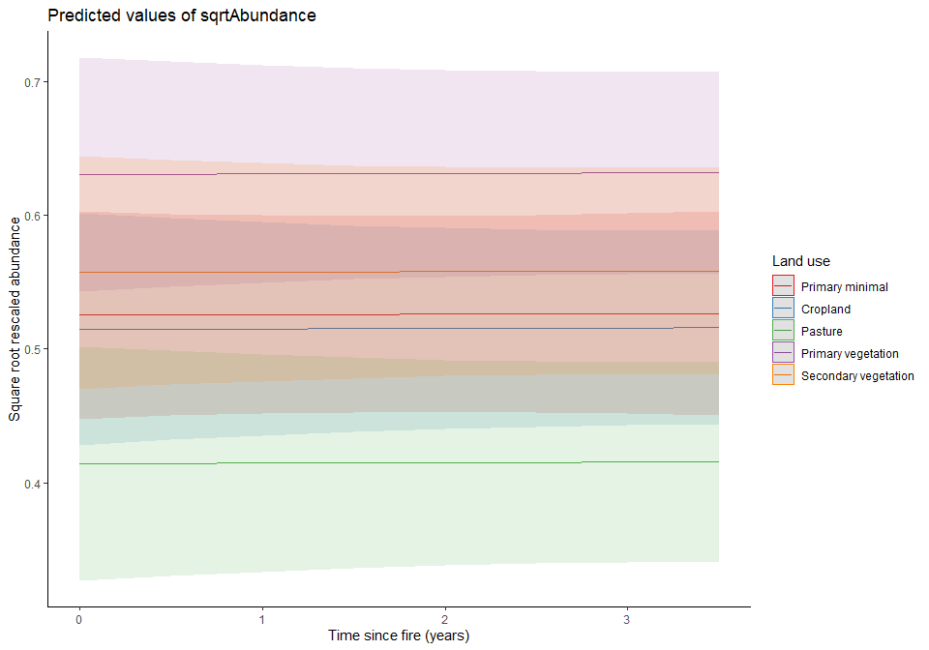

Compositional simialrity model:
Set up time since fire data:
cd_data_input$days_since_fire <- as.numeric(cd_data_input$days_since_fire)
cd_data_input$days_since_fire[is.na(cd_data_input$days_since_fire)] <- 1277
cd_data_input$time_since_fire <- cd_data_input$days_since_fire/365
s1_time <- as.data.frame(cd_data_input[match(cd_data$s1, cd_data_input$SSBS),
c('time_since_fire')])
s2_time <- as.data.frame(cd_data_input[match(cd_data$s2, cd_data_input$SSBS),
c('time_since_fire')])
cd_time <- cbind(s1_time, s2_time)
names(cd_time) <- c("s1_time", "s2_time")
cd_data <- cbind(cd_data, cd_time)
cd_data$time_since_fire <- cd_data$s2_time
Check assumptions:
## Complete cases:
cd_data <- drop_na(cd_data, Contrast, log10geo, cuberoot_envi, time_since_fire)
## Collinearity:
corvif(cd_data[ , c("Contrast", "log10geo", "cuberoot_envi", "time_since_fire")])
##
##
## Variance inflation factors
##
## GVIF Df GVIF^(1/2Df)
## Contrast 2.326256 4 1.111302
## log10geo 1.024971 1 1.012409
## cuberoot_envi 2.330731 1 1.526673
## time_since_fire 1.012705 1 1.006333
Model
cd_m <- lmer(logitCS ~ Contrast + log10geo + cuberoot_envi + time_since_fire +
(1|SS), data = cd_data)
Anova(cd_m)
## Analysis of Deviance Table (Type II Wald chisquare tests)
##
## Response: logitCS
## Chisq Df Pr(>Chisq)
## Contrast 2.5647 4 0.6331
## log10geo 3.2009 1 0.0736 .
## cuberoot_envi 0.9723 1 0.3241
## time_since_fire 0.0004 1 0.9842
## ---
## Signif. codes: 0 '***' 0.001 '**' 0.01 '*' 0.05 '.' 0.1 ' ' 1
summary(cd_m)
## Linear mixed model fit by REML ['lmerMod']
## Formula: logitCS ~ Contrast + log10geo + cuberoot_envi + time_since_fire + (1 | SS)
## Data: cd_data
##
## REML criterion at convergence: 212030
##
## Scaled residuals:
## Min 1Q Median 3Q Max
## -2.6702 -0.8717 -0.1203 0.7692 3.4033
##
## Random effects:
## Groups Name Variance Std.Dev.
## SS (Intercept) 7.989 2.826
## Residual 10.441 3.231
## Number of obs: 40900, groups: SS, 7
##
## Fixed effects:
## Estimate Std. Error t value
## (Intercept) 0.93532 1.93420 0.484
## ContrastPrimary minimal-Pasture -0.49776 0.74425 -0.669
## ContrastPrimary minimal-Cropland 1.63771 1.59185 1.029
## ContrastPrimary minimal-Primary vegetation 1.48786 1.36584 1.089
## ContrastPrimary minimal-Secondary vegetation 3.38666 3.49308 0.970
## log10geo -0.02633 0.01472 -1.789
## cuberoot_envi -2.35501 2.38834 -0.986
## time_since_fire -0.01254 0.63199 -0.020
##
## Correlation of Fixed Effects:
## (Intr) CnPm-P CnPm-C CPm-Pv CPm-Sv log10g cbrt_n
## CntrstPmn-P -0.018
## CntrstPmn-C 0.284 0.002
## CntrstPm-Pv 0.325 0.013 0.559
## CntrstPm-Sv -0.037 -0.003 0.115 0.123
## log10geo -0.006 -0.002 -0.001 0.000 -0.007
## cuberoot_nv -0.074 0.152 -0.082 -0.023 -0.159 -0.011
## time_snc_fr -0.789 -0.034 -0.400 -0.470 -0.185 -0.007 -0.047
Model simplification:
Remove the least significant element (which is not time since fire or contrast)
cd_m.1 <- update(cd_m,~.- cuberoot_envi)
anova(cd_m, cd_m.1)
## refitting model(s) with ML (instead of REML)
## Data: cd_data
## Models:
## cd_m.1: logitCS ~ Contrast + log10geo + time_since_fire + (1 | SS)
## cd_m: logitCS ~ Contrast + log10geo + cuberoot_envi + time_since_fire +
## cd_m: (1 | SS)
## npar AIC BIC logLik deviance Chisq Df Pr(>Chisq)
## cd_m.1 9 212058 212136 -106020 212040
## cd_m 10 212059 212146 -106020 212039 0.7504 1 0.3863
No signficant explanatory power lost so I can use this model.
Anova(cd_m.1)
## Analysis of Deviance Table (Type II Wald chisquare tests)
##
## Response: logitCS
## Chisq Df Pr(>Chisq)
## Contrast 2.1963 4 0.69970
## log10geo 3.2332 1 0.07216 .
## time_since_fire 0.0075 1 0.93104
## ---
## Signif. codes: 0 '***' 0.001 '**' 0.01 '*' 0.05 '.' 0.1 ' ' 1
summary(cd_m.1)
## Linear mixed model fit by REML ['lmerMod']
## Formula: logitCS ~ Contrast + log10geo + time_since_fire + (1 | SS)
## Data: cd_data
##
## REML criterion at convergence: 212034.5
##
## Scaled residuals:
## Min 1Q Median 3Q Max
## -2.6702 -0.8717 -0.1207 0.7692 3.4033
##
## Random effects:
## Groups Name Variance Std.Dev.
## SS (Intercept) 7.115 2.667
## Residual 10.441 3.231
## Number of obs: 40900, groups: SS, 7
##
## Fixed effects:
## Estimate Std. Error t value
## (Intercept) 0.81874 1.85937 0.440
## ContrastPrimary minimal-Pasture -0.37581 0.73511 -0.511
## ContrastPrimary minimal-Cropland 1.52710 1.57766 0.968
## ContrastPrimary minimal-Primary vegetation 1.47388 1.35515 1.088
## ContrastPrimary minimal-Secondary vegetation 2.85465 3.29428 0.867
## log10geo -0.02646 0.01472 -1.798
## time_since_fire -0.05326 0.61546 -0.087
##
## Correlation of Fixed Effects:
## (Intr) CnPm-P CnPm-C CPm-Pv CPm-Sv log10g
## CntrstPmn-P -0.006
## CntrstPmn-C 0.275 0.016
## CntrstPm-Pv 0.320 0.018 0.554
## CntrstPm-Sv -0.038 0.023 0.105 0.122
## log10geo -0.006 0.000 -0.002 0.000 -0.009
## time_snc_fr -0.805 -0.030 -0.398 -0.463 -0.199 -0.008
Removal of environmental distance helps to reduce the size of the insignificant coefficients.

Projecting BII
Creating new abundance data:
new_data_ab <- expand.grid(time_since_fire = seq(0,3.5, by=0.1),
LandUse = levels(ab_model_data$LandUse))
new_data_ab$ab_predicted <- predict(ab_m.1, newdata = new_data_ab, re.form=NA) ^ 2
Creating new compositional similarity data:
inv_logit <- function(f, a){
a <- (1-2*a)
(a*(1+exp(f))+(exp(f)-1))/(2*a*(1+exp(f)))
}
new_data_cd <- expand.grid(time_since_fire = seq(0,3.5, by=0.1),
Contrast = levels(cd_data$Contrast),
log10geo = 0,
cuberoot_envi = 0)
new_data_cd$cd_predicted <-predict(cd_m.1, newdata = new_data_cd, re.form=NA) %>%
inv_logit(a = 0.001)
Creating BII data:
bii_df <- new_data_ab
bii_df <- cbind(bii_df, new_data_cd$cd_predicted)
colnames(bii_df)
## [1] "time_since_fire" "LandUse" "ab_predicted"
## [4] "new_data_cd$cd_predicted"
names(bii_df)[names(bii_df) == "new_data_cd$cd_predicted"] <- "cd_predicted"
## Want to divide the predicted values by a reference value - reference value wants to be
#primary minimal with little fire disturbance so 3.5 years?
ref_value <- subset(bii_df, bii_df$LandUse == "Primary minimal" & bii_df$time_since_fire == "3.5")
bii_df$ab_predicted <- bii_df$ab_predicted/ref_value$ab_predicted
bii_df$cd_predicted <- bii_df$cd_predicted/ref_value$cd_predicted
bii_df$bii <- (bii_df$ab_predicted*bii_df$cd_predicted)*100
ggplot(data=bii_df, aes(x=time_since_fire, y=bii, group=LandUse)) +
geom_line(aes(col=LandUse))+
geom_point(aes(col=LandUse))+
xlab(label = "Time since fire (years)") +
ylab(label = "BII (%)")+
theme_classic()
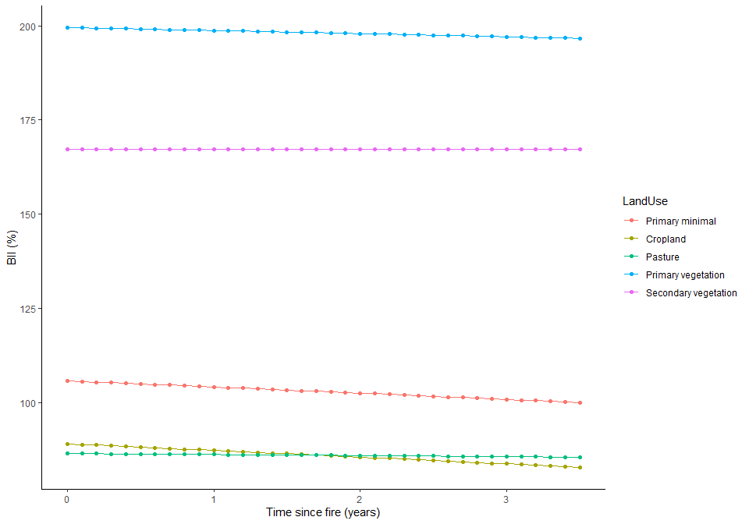

Trying modelling BII with a coarse baseline
Going to aggregate together all primary sites and mature secondary and use this as our baseline to increase the number of studies going into the model.
savanna_diversity <- subset(diversity_fire_hist, diversity_fire_hist$Biome == "Tropical & Subtropical Grasslands, Savannas & Shrublands")
savanna_diversity_v2 <- savanna_diversity %>%
mutate(Landuse2 = ifelse(Predominant_land_use == "Primary vegetation", "Baseline vegetation",
paste(Predominant_land_use)),
Landuse2 = ifelse(Predominant_land_use == "Mature secondary vegetation", "Baseline vegetation",
paste(Landuse2)),
Landuse2 = ifelse(Predominant_land_use == "Cropland", "Agriculture",
paste(Landuse2)),
Landuse2 = ifelse(Predominant_land_use == "Pasture", "Agriculture",
paste(Landuse2)),
Landuse2 = ifelse(grepl("secondary", tolower(Landuse2)), "Secondary vegetation",
paste(Landuse2)),
Landuse2 = ifelse(Predominant_land_use == "Cannot decide",
NA,
paste(Landuse2)),
Landuse2 = factor(Landuse2),
Landuse2 = relevel(Landuse2, ref = "Baseline vegetation"))
savanna_diversity_v2<- drop_na(savanna_diversity_v2, Landuse2)
savanna_diversity_v2<-savanna_diversity_v2[!(savanna_diversity_v2$Landuse2 == "Plantation forest"),]
savanna_diversity_v2<-savanna_diversity_v2[!(savanna_diversity_v2$Landuse2 == "Urban"),]
savanna_diversity_v2$Landuse2 <- as.factor(as.character(savanna_diversity_v2$Landuse2))
savanna_diversity_v2 <- savanna_diversity_v2 %>%
mutate( Landuse2 = factor(Landuse2),
Landuse2 = relevel(Landuse2, ref = "Baseline vegetation"))
Abundance data:
abundance_data <- savanna_diversity_v2 %>%
filter(Diversity_metric_type == "Abundance") %>%
group_by(SSBS) %>%
mutate(TotalAbundance = sum(Effort_corrected_measurement)) %>%
ungroup() %>%
distinct(SSBS, .keep_all = TRUE) %>%
group_by(SS) %>%
mutate(MaxAbundance = max(TotalAbundance)) %>%
ungroup() %>%
mutate(RescaledAbundance = TotalAbundance/MaxAbundance)
Compositional similarity data:
## data set up
cd_data_input <- savanna_diversity_v2 %>%
filter(!is.na(Landuse2)) %>%
filter(Diversity_metric_type == "Abundance") %>%
group_by(SS) %>%
mutate(n_sample_effort = n_distinct(Sampling_effort)) %>%
mutate(n_species = n_distinct(Taxon_name_entered)) %>%
mutate(n_primin_records = sum(Landuse2 == "Baseline vegetation")) %>%
ungroup() %>%
filter(n_sample_effort == 1) %>%
filter(n_species > 1) %>%
filter(n_primin_records > 0) %>%
droplevels()
studies <- distinct(cd_data_input, SS) %>%
pull()
Now have 12 studies instead of the 7 I had previously. Calculate compositional similarity:
registerDoParallel(cores = 2)
cd_data <- foreach(s = studies,
.combine = rbind,
.packages = c("dplyr", "magrittr", "geosphere")) %dopar% {
data_ss <- filter(cd_data_input, SS == s)
site_data <- data_ss %>%
dplyr::select(SSBS, Landuse2, Sample_start_earliest, Longitude, Latitude, Freq,
fire_presence, size, start_date, duration, days_since_fire) %>%
distinct(SSBS, .keep_all = TRUE)
baseline_sites <- site_data %>%
filter(Landuse2 == "Baseline vegetation") %>%
pull(SSBS)
site_list <- site_data %>%
pull(SSBS)
Site_comparisons <- expand.grid(baseline_sites, site_list) %>%
rename(s1 = Var1, s2 = Var2) %>%
filter(s1 != s2)
sor <- apply(Site_comparisons, 1, function(y) getJacAbSym(data = data_ss, s1 = y['s1'], s2 = y['s2']))
s1LatLong <- as.matrix(data_ss[match(Site_comparisons$s1, data_ss$SSBS), c('Longitude','Latitude')])
s2LatLong <- as.matrix(data_ss[match(Site_comparisons$s2, data_ss$SSBS), c('Longitude','Latitude')])
dist <- distHaversine(s1LatLong, s2LatLong)
Contrast <- paste(site_data$Landuse2[match(Site_comparisons$s1, site_data$SSBS)],
site_data$Landuse2[match(Site_comparisons$s2, site_data$SSBS)],
sep = "-")
study_results <- data.frame(Site_comparisons,
sor,
dist,
Contrast,
SS = s,
stringsAsFactors = TRUE)
}
registerDoSEQ()
Calculate environmental distance
r <- raster::getData('worldclim', var='bio', res=10)
alt <- raster::getData("worldclim", var="alt", res=10)
r <- r[[c(5,6,13,14)]]
names(r) <- c("max_temp", "min_temp", "max_precip", "min_precip")
## Extracting data for PREDICTS sites
cd_data_climate <- raster::extract(r, cd_data_input[,37:38])
cd_data_alt <- raster::extract(alt, cd_data_input[,37:38])
cd_data_envi <- cbind(cd_data_climate,cd_data_alt)
cd_data_input <- cbind(cd_data_input, cd_data_envi)
s1Enviro <- as.data.frame(cd_data_input[match(cd_data$s1, cd_data_input$SSBS),
c('max_temp', 'min_temp', 'max_precip', 'min_precip','cd_data_alt')])
s2Enviro <- as.data.frame(cd_data_input[match(cd_data$s2, cd_data_input$SSBS),
c('max_temp', 'min_temp', 'max_precip', 'min_precip', 'cd_data_alt')])
enviro_dist <- gower_dist(s1Enviro, s2Enviro)
cd_data <- cbind(cd_data, enviro_dist)

Setting up abundance data and model:
ab_model_data <- drop_na(abundance_data, RescaledAbundance, Landuse2, fire_presence)
## Transform abundance
ab_model_data <- mutate(ab_model_data,
logAbundance = log(RescaledAbundance + 1),
sqrtAbundance = sqrt(RescaledAbundance))
## Set up time since fire data:
str(ab_model_data$days_since_fire)
## int [1:1378] NA NA NA NA NA NA NA NA NA NA ...
ab_model_data$days_since_fire <- as.numeric(ab_model_data$days_since_fire)
ab_model_data$days_since_fire[is.na(ab_model_data$days_since_fire)] <- 1277
ab_model_data$time_since_fire <- ab_model_data$days_since_fire/365
corvif(ab_model_data[ , c("Landuse2", "time_since_fire")])
##
##
## Variance inflation factors
##
## GVIF Df GVIF^(1/2Df)
## Landuse2 1.166981 2 1.039360
## time_since_fire 1.166981 1 1.080269
Model:
ab_m <- lmer(sqrtAbundance ~ Landuse2 + time_since_fire + Landuse2:time_since_fire +
(1|SS) + (1|SSB), data = ab_model_data)
Anova(ab_m)
## Analysis of Deviance Table (Type II Wald chisquare tests)
##
## Response: sqrtAbundance
## Chisq Df Pr(>Chisq)
## Landuse2 28.5608 2 6.282e-07 ***
## time_since_fire 2.0716 1 0.1501
## Landuse2:time_since_fire 0.8609 2 0.6502
## ---
## Signif. codes: 0 '***' 0.001 '**' 0.01 '*' 0.05 '.' 0.1 ' ' 1
summary(ab_m)
## Linear mixed model fit by REML ['lmerMod']
## Formula: sqrtAbundance ~ Landuse2 + time_since_fire + Landuse2:time_since_fire + (1 | SS) + (1 | SSB)
## Data: ab_model_data
##
## REML criterion at convergence: -442
##
## Scaled residuals:
## Min 1Q Median 3Q Max
## -2.7449 -0.6377 -0.0513 0.5986 3.8739
##
## Random effects:
## Groups Name Variance Std.Dev.
## SSB (Intercept) 0.003556 0.05963
## SS (Intercept) 0.023481 0.15324
## Residual 0.037845 0.19454
## Number of obs: 1378, groups: SSB, 153; SS, 23
##
## Fixed effects:
## Estimate Std. Error t value
## (Intercept) 0.563315 0.041362 13.619
## Landuse2Agriculture -0.131066 0.048358 -2.710
## Landuse2Secondary vegetation -0.086190 0.042238 -2.041
## time_since_fire 0.004325 0.009408 0.460
## Landuse2Agriculture:time_since_fire 0.011463 0.017447 0.657
## Landuse2Secondary vegetation:time_since_fire 0.014989 0.017542 0.854
##
## Correlation of Fixed Effects:
## (Intr) Lnds2A Lnd2Sv tm_sn_ L2A:__
## Lnds2Agrclt -0.198
## Lnds2Scndrv -0.273 0.234
## time_snc_fr -0.509 0.353 0.465
## Lnds2Agr:__ 0.243 -0.897 -0.309 -0.555
## Lnds2Svg:__ 0.263 -0.218 -0.854 -0.555 0.377
Model simplification - remove the interaction
ab_m.1 <- update(ab_m,~.- Landuse2:time_since_fire)
anova(ab_m, ab_m.1)
## refitting model(s) with ML (instead of REML)
## Data: ab_model_data
## Models:
## ab_m.1: sqrtAbundance ~ Landuse2 + time_since_fire + (1 | SS) + (1 |
## ab_m.1: SSB)
## ab_m: sqrtAbundance ~ Landuse2 + time_since_fire + Landuse2:time_since_fire +
## ab_m: (1 | SS) + (1 | SSB)
## npar AIC BIC logLik deviance Chisq Df Pr(>Chisq)
## ab_m.1 7 -464.72 -428.12 239.36 -478.72
## ab_m 9 -461.57 -414.52 239.79 -479.57 0.8559 2 0.6519
Going to leave time since fire in the model as I need it to make projections:
Anova(ab_m.1)
## Analysis of Deviance Table (Type II Wald chisquare tests)
##
## Response: sqrtAbundance
## Chisq Df Pr(>Chisq)
## Landuse2 28.5845 2 6.208e-07 ***
## time_since_fire 2.0674 1 0.1505
## ---
## Signif. codes: 0 '***' 0.001 '**' 0.01 '*' 0.05 '.' 0.1 ' ' 1
summary(ab_m.1)
## Linear mixed model fit by REML ['lmerMod']
## Formula: sqrtAbundance ~ Landuse2 + time_since_fire + (1 | SS) + (1 | SSB)
## Data: ab_model_data
##
## REML criterion at convergence: -453.8
##
## Scaled residuals:
## Min 1Q Median 3Q Max
## -2.7469 -0.6381 -0.0475 0.5985 3.8162
##
## Random effects:
## Groups Name Variance Std.Dev.
## SSB (Intercept) 0.003582 0.05985
## SS (Intercept) 0.023215 0.15236
## Residual 0.037808 0.19444
## Number of obs: 1378, groups: SSB, 153; SS, 23
##
## Fixed effects:
## Estimate Std. Error t value
## (Intercept) 0.551641 0.039239 14.059
## Landuse2Agriculture -0.106679 0.020420 -5.224
## Landuse2Secondary vegetation -0.055588 0.021963 -2.531
## time_since_fire 0.010047 0.006987 1.438
##
## Correlation of Fixed Effects:
## (Intr) Lnds2A Lnd2Sv
## Lnds2Agrclt -0.009
## Lnds2Scndrv -0.103 0.275
## time_snc_fr -0.433 -0.308 -0.010
As I am using the maximal model for the compositional similarity model, I am also going to use the maximal model here.
Diagnostics:
ab_output <- simulateResiduals(ab_m)
plot(ab_output)
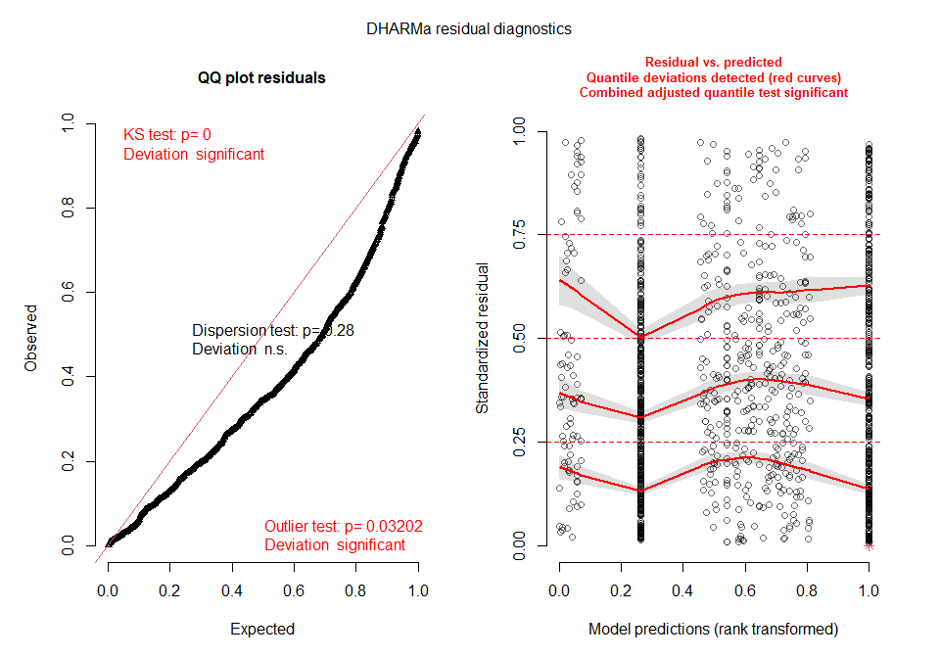
ab_resids <- residuals(ab_m)
summary(ab_resids)
## Min. 1st Qu. Median Mean 3rd Qu. Max.
## -0.533985 -0.124048 -0.009978 0.000000 0.116447 0.753623
hist(ab_resids)
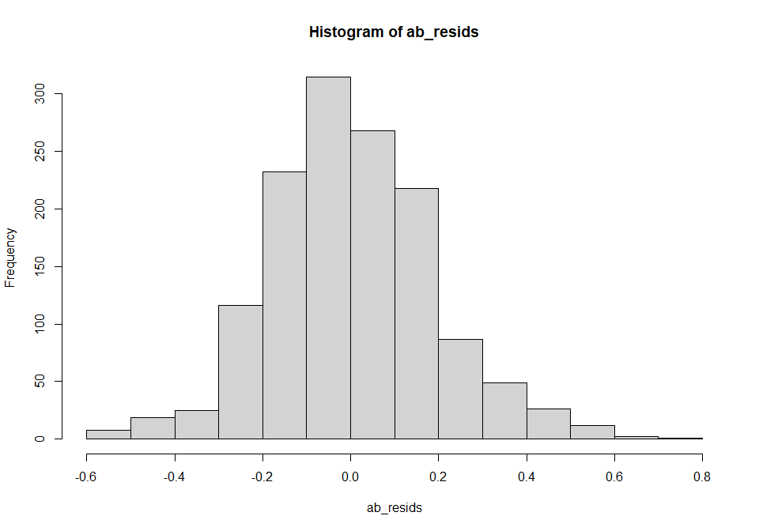
par(mfrow=c(1,2))
qqnorm(resid(ab_m), main="normal qq-plot, residuals")
qqline(resid(ab_m)) ## not bad
plot(fitted(ab_m), resid(ab_m), main = "Residuals vs fitted") #residuals vs fitted
abline(h=0)
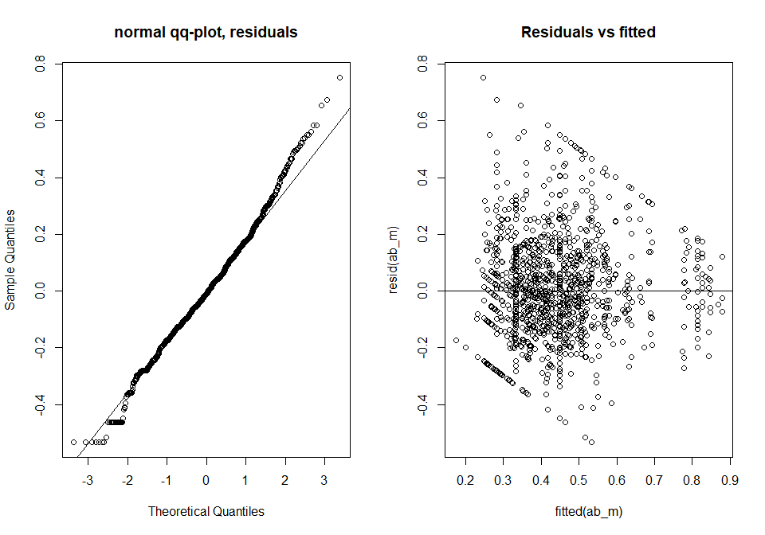
ran <- ranef(ab_m, condVar=TRUE)
a <- dotplot(ran)[["SSB"]]
b <- dotplot(ran)[["SS"]]
grid.arrange(a,b, nrow=2, ncol=1)
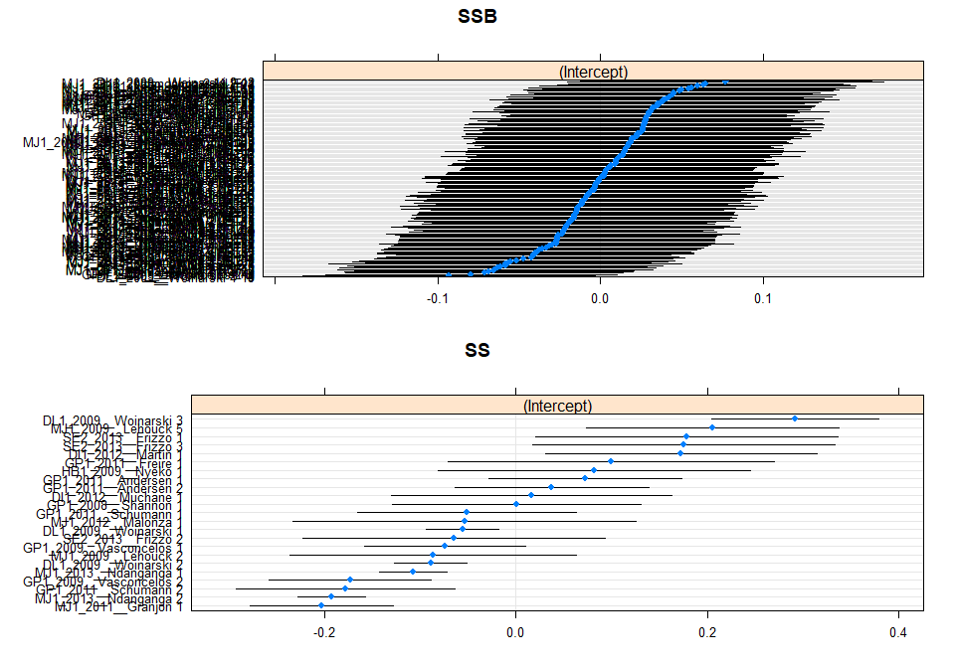
theme_set(theme_classic())
plot_model(ab_m, type = "pred", terms = c("time_since_fire", "Landuse2"),
legend.title = c("Land use"),
axis.title = c("Time since fire (years)", "Square root rescaled abundance"))
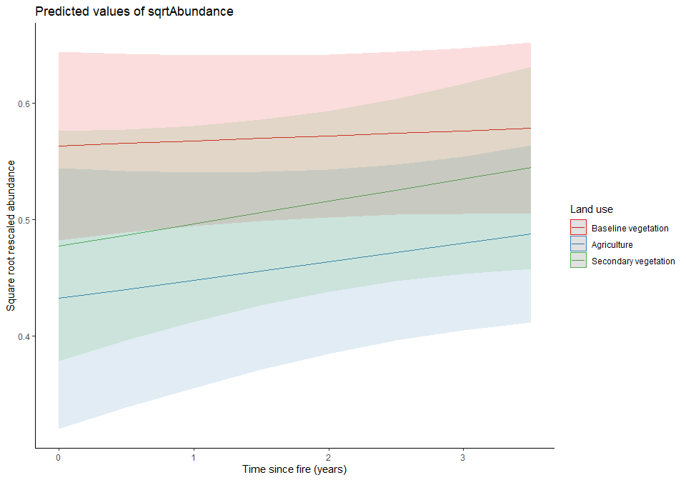

Setting up compositional similarity model
Transforming variables:
cd_data <- cd_data %>%
separate(Contrast, c("s1_LandUse", "s2_LandUse"), sep = "-", remove = FALSE) %>%
filter(s1_LandUse == "Baseline vegetation") %>%
mutate(logitCS = logit(sor, adjust = 0.001, percents = FALSE)) %>%
mutate(log10geo = log10(dist + 1)) %>%
mutate(cuberoot_envi = enviro_dist^(1/3)) %>%
mutate(Contrast = factor(Contrast),
Contrast = relevel(Contrast, ref = "Baseline vegetation-Baseline vegetation"))
Time since fire:
str(cd_data_input$days_since_fire)
## int [1:65208] NA NA NA NA NA NA NA NA NA NA ...
cd_data_input$days_since_fire <- as.numeric(cd_data_input$days_since_fire)
cd_data_input$days_since_fire[is.na(cd_data_input$days_since_fire)] <- 1277
cd_data_input$time_since_fire <- cd_data_input$days_since_fire/365
s1_time <- as.data.frame(cd_data_input[match(cd_data$s1, cd_data_input$SSBS),
c('time_since_fire')])
s2_time <- as.data.frame(cd_data_input[match(cd_data$s2, cd_data_input$SSBS),
c('time_since_fire')])
cd_time <- cbind(s1_time, s2_time)
names(cd_time) <- c("s1_time", "s2_time")
cd_data <- cbind(cd_data, cd_time)
cd_data$time_since_fire <- cd_data$s2_time
Assumption checking
cd_data <- drop_na(cd_data, Contrast, log10geo, cuberoot_envi, time_since_fire)
corvif(cd_data[ , c("Contrast", "log10geo", "cuberoot_envi", "time_since_fire")])
##
##
## Variance inflation factors
##
## GVIF Df GVIF^(1/2Df)
## Contrast 1.432325 2 1.093983
## log10geo 3.521321 1 1.876518
## cuberoot_envi 3.395942 1 1.842808
## time_since_fire 1.824042 1 1.350571
## Check normality of logitCS
hist(cd_data$logitCS)
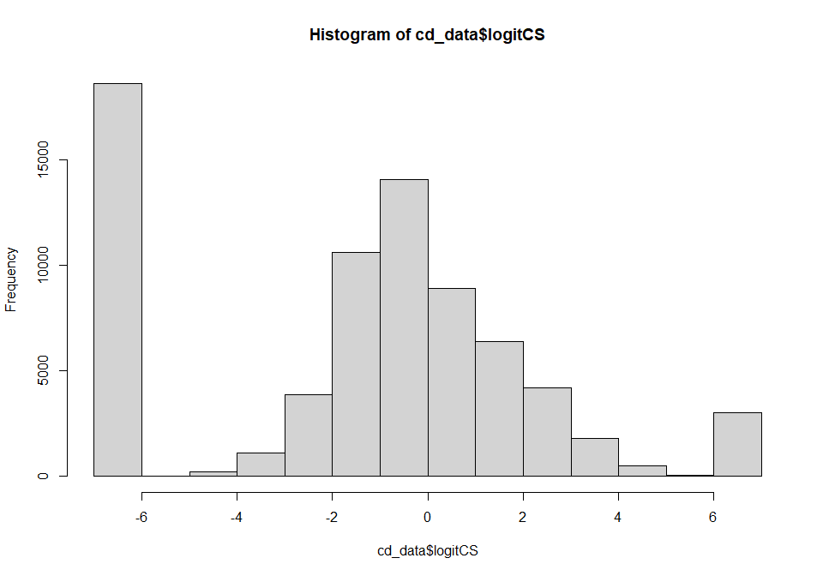
The normality seems quite off, but only at either end, the middle section shows a relatively normal distribution. Check the residuals of the model.
Model:
cd_m <- lmer(logitCS ~ Contrast + log10geo + cuberoot_envi + time_since_fire +
Contrast:time_since_fire +
(1|SS), data = cd_data)
Anova(cd_m)
## Analysis of Deviance Table (Type II Wald chisquare tests)
##
## Response: logitCS
## Chisq Df Pr(>Chisq)
## Contrast 407.734 2 < 2.2e-16 ***
## log10geo 18.851 1 1.414e-05 ***
## cuberoot_envi 588.543 1 < 2.2e-16 ***
## time_since_fire 26.107 1 3.230e-07 ***
## Contrast:time_since_fire 150.893 2 < 2.2e-16 ***
## ---
## Signif. codes: 0 '***' 0.001 '**' 0.01 '*' 0.05 '.' 0.1 ' ' 1
summary(cd_m)
## Linear mixed model fit by REML ['lmerMod']
## Formula: logitCS ~ Contrast + log10geo + cuberoot_envi + time_since_fire +
## Contrast:time_since_fire + (1 | SS)
## Data: cd_data
##
## REML criterion at convergence: 367354.7
##
## Scaled residuals:
## Min 1Q Median 3Q Max
## -2.9378 -0.9439 0.0505 0.6872 3.7409
##
## Random effects:
## Groups Name Variance Std.Dev.
## SS (Intercept) 4.852 2.203
## Residual 8.694 2.949
## Number of obs: 73445, groups: SS, 12
##
## Fixed effects:
## Estimate Std. Error t value
## (Intercept) 1.27003 0.65635 1.935
## ContrastBaseline vegetation-Agriculture -2.45921 0.12668 -19.413
## ContrastBaseline vegetation-Secondary vegetation -0.43307 0.07328 -5.910
## log10geo -0.05736 0.01321 -4.342
## cuberoot_envi -2.92787 0.12069 -24.260
## time_since_fire -0.05073 0.02073 -2.447
## ContrastBaseline vegetation-Agriculture:time_since_fire 0.64101 0.05405 11.858
## ContrastBaseline vegetation-Secondary vegetation:time_since_fire 0.20000 0.03381 5.915
##
## Correlation of Fixed Effects:
## (Intr) CnBv-A CnBv-Sv log10g cbrt_n tm_sn_ CBv-A:
## CntrstBvg-A -0.023
## CntrstBv-Sv -0.042 0.254
## log10geo -0.045 0.002 -0.007
## cuberoot_nv -0.009 -0.015 -0.178 -0.325
## time_snc_fr -0.069 0.337 0.604 0.017 -0.087
## CntrBv-A:__ 0.020 -0.897 -0.230 -0.005 0.032 -0.378
## CntBv-Sv:__ 0.036 -0.209 -0.868 0.002 0.178 -0.625 0.236
All aspects of this model are significant but due to pseudoreplication they may not be accurate.
Diagnostics:
## Diagnostics
cd_m_output <- simulateResiduals(cd_m)
plot(cd_m_output)
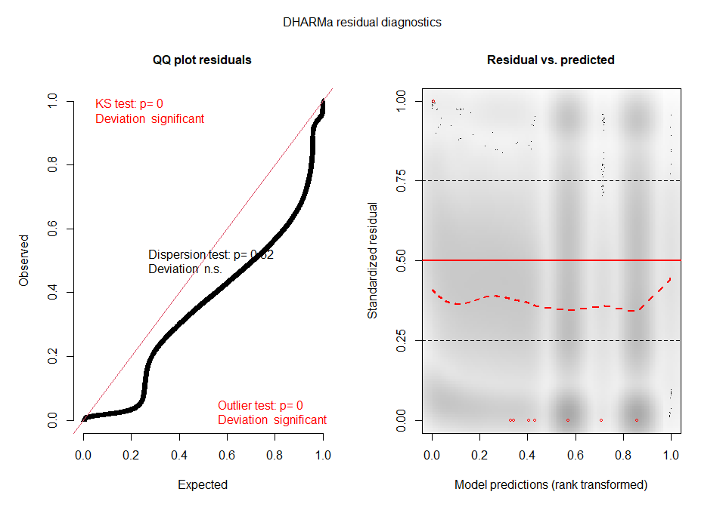
cd_resids <- residuals(cd_m)
summary(cd_resids)
## Min. 1st Qu. Median Mean 3rd Qu. Max.
## -8.6623 -2.7831 0.1489 0.0000 2.0261 11.0304
hist(cd_resids)
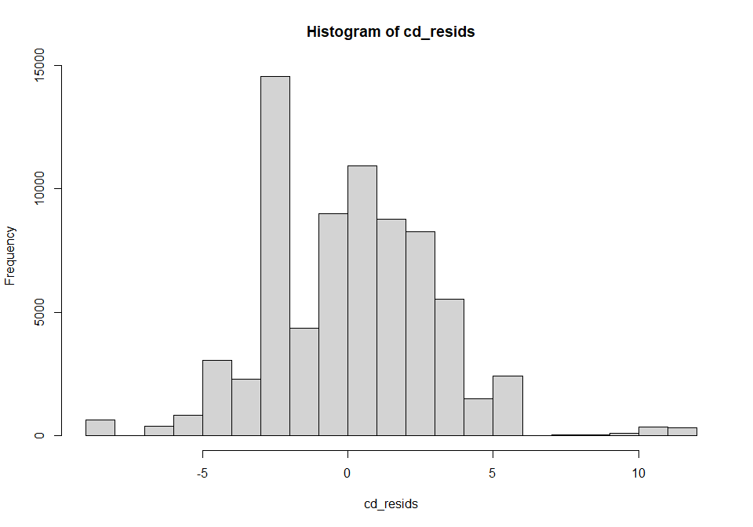
par(mfrow=c(1,2))
qqnorm(resid(cd_m), main="normal qq-plot, residuals")
qqline(resid(cd_m)) ## not bad
plot(fitted(cd_m), resid(cd_m), main = "Residuals vs fitted") #residuals vs fitted
abline(h=0)
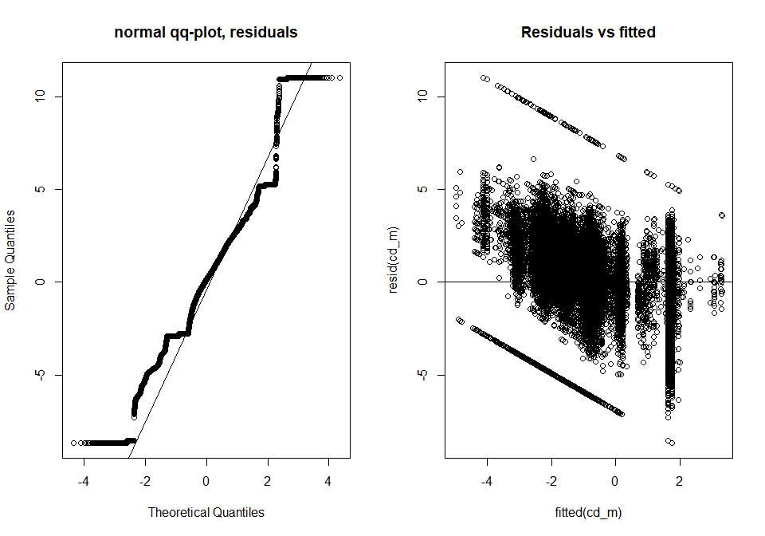
ran <- ranef(cd_m, condVar=TRUE)
dotplot(ran)[["SS"]]
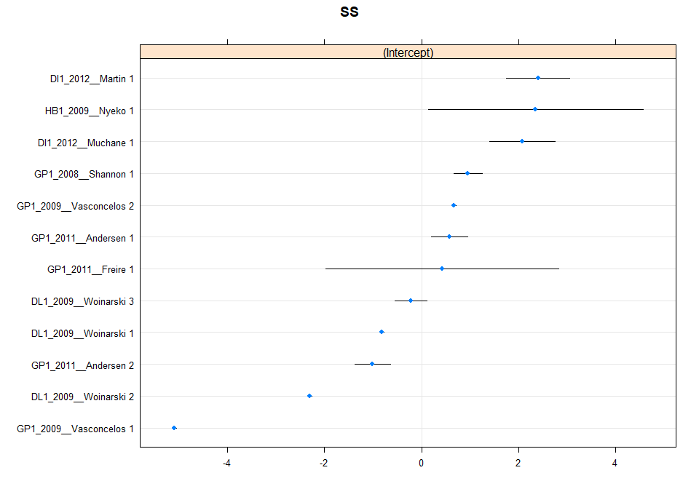
theme_set(theme_classic())
plot_model(cd_m, type = "pred", terms = c("time_since_fire", "Contrast"),
axis.title = c("Time since fire (years)", "Square root rescaled abundance"))
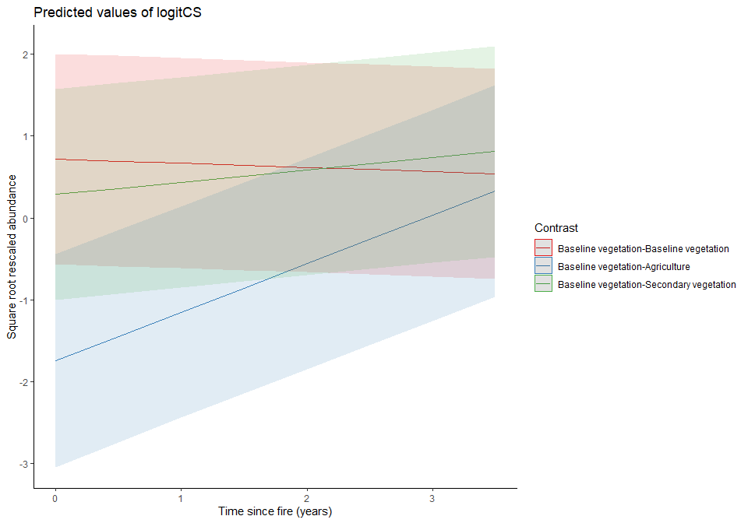

Projecting changes in BII over time
Abundance:
new_data_ab <- expand.grid(time_since_fire = seq(0,3.5, by=0.1),
Landuse2 = levels(ab_model_data$Landuse2))
new_data_ab$ab_predicted <- predict(ab_m, newdata = new_data_ab, re.form=NA) ^ 2
Compositional similarity:
inv_logit <- function(f, a){
a <- (1-2*a)
(a*(1+exp(f))+(exp(f)-1))/(2*a*(1+exp(f)))
}
new_data_cd <- expand.grid(time_since_fire = seq(0,3.5, by=0.1),
Contrast = levels(cd_data$Contrast),
log10geo = 0,
cuberoot_envi = 0)
new_data_cd$cd_predicted <-predict(cd_m, newdata = new_data_cd, re.form=NA) %>%
inv_logit(a = 0.001)
BII
bii_df <- new_data_ab
bii_df <- cbind(bii_df, new_data_cd$cd_predicted)
colnames(bii_df)
## [1] "time_since_fire" "Landuse2" "ab_predicted"
## [4] "new_data_cd$cd_predicted"
names(bii_df)[names(bii_df) == "new_data_cd$cd_predicted"] <- "cd_predicted"
## Want to divide the predicted values by a reference value - reference value wants to be
#primary minimal with little fire disturbance so 3.5 years since fire
ref_value <- subset(bii_df, bii_df$Landuse2 == "Baseline vegetation" & bii_df$time_since_fire == "3.5")
bii_df$ab_predicted <- bii_df$ab_predicted/ref_value$ab_predicted
bii_df$cd_predicted <- bii_df$cd_predicted/ref_value$cd_predicted
bii_df$bii <- (bii_df$ab_predicted*bii_df$cd_predicted)*100
Plotting BII:
ggplot(data=bii_df, aes(x=time_since_fire, y=bii, group=Landuse2)) +
geom_line(aes(col=Landuse2))+
xlab(label = "Time since fire (years)") +
ylab(label = "BII (%)")+
labs(col = "Land use")+
theme_classic()
