Savanna species richness models

Data:
diversity <- readRDS("~/Imperial/PROJECT/PREDICTS data/database.rds")
fire_hist <- read.csv("~/Imperial/PROJECT/Combined data/Fire_history.csv")

Data preparation:
diversity <- mutate(diversity,
Measurement = Effort_corrected_measurement,
Sampling_effort = Rescaled_sampling_effort)
## Calculating diversity metrics including rescaled abundance.
sites <- diversity %>%
mutate(Diversity_metric_is_valid = TRUE) %>%
predictsFunctions::SiteMetrics(extra.cols = c("SSB", "SSBS", "Predominant_land_use", "Biome", "Country")) %>%
group_by(SS) %>%
mutate(MaxAbundance = ifelse(Diversity_metric_type == "Abundance",
max(Total_abundance),
NA)) %>%
ungroup() %>%
mutate(RescaledAbundance = ifelse(Diversity_metric_type == "Abundance",
Total_abundance/MaxAbundance,
NA))
## Computing site metrics for 3250404 measurements
## The data contain 480 sources, 666 studies and 26112 sites
## Computing site-level values
## Computing total abundance
## Computing species richness
## Assembling site-level values
## Tidying up the predominant land use category
sites <- sites %>%
mutate(
Predominant_land_use = recode_factor(Predominant_land_use,
"Primary forest" = "Primary vegetation",
"Primary non-forest" = "Primary vegetation"),
Predominant_land_use = na_if(Predominant_land_use, "Secondary vegetation (indeterminate age)"),
Predominant_land_use = na_if(Predominant_land_use, "Cannot decide"),
Use_intensity = na_if(Use_intensity, "Cannot decide"),
Predominant_land_use = factor(Predominant_land_use),
Predominant_land_use = relevel(Predominant_land_use, ref = "Primary vegetation"),
Use_intensity = factor(Use_intensity),
Use_intensity = relevel(Use_intensity, ref = "Minimal use")
)
## For my analysis I need to subset so that all sites are after 2006 (so that we can have 3yrs of fire data)
sites_post_2006 <- subset(sites, sites$Sample_start_earliest > "2006-01-01")
## Removing rows that have NAs in latitude and longitude as these won't have fire data
sites_post_2006_NA <- subset(sites_post_2006, (! is.na(Longitude) | ! is.na(Latitude)))
## Merge with fire data
PREDICTS_fire_hist <- merge(sites_post_2006_NA, fire_hist
[,c("SSBS", "Freq", "fire_ID", "size", "start_date", "duration", "days_since_fire", "year", "years_since_fire")], by="SSBS", all.x=TRUE)
## Creating fire presence column (need to change NAs in freq to 0 as these sites have no fires in thelast 3 years)
PREDICTS_fire_hist$Freq[is.na(PREDICTS_fire_hist$Freq)] <- 0
PREDICTS_fire_hist$fire_presence <- ifelse(PREDICTS_fire_hist$Freq==0, "No",
ifelse(PREDICTS_fire_hist$Freq!=0, "Yes",
NA))
PREDICTS_fire_hist$fire_presence <- as.factor(PREDICTS_fire_hist$fire_presence)
## Need to remove data which has NAs in categories required for our analysis
PREDICTS_fire_hist2 <- drop_na(PREDICTS_fire_hist, Species_richness, Predominant_land_use, Use_intensity, fire_presence)
## Subset to just the Tropical & Subtropical Grasslands, Savannas & Shrublands
sites_savanna <- subset(PREDICTS_fire_hist2, PREDICTS_fire_hist2$Biome == "Tropical & Subtropical Grasslands, Savannas & Shrublands")
## Editing land use classes to remove classes with a lack of data
sites_savanna<-sites_savanna[!(sites_savanna$Predominant_land_use == "Plantation forest"),]
sites_savanna<-sites_savanna[!(sites_savanna$Predominant_land_use == "Urban"),]
sites_savanna$Predominant_land_use <- as.factor(as.character(sites_savanna$Predominant_land_use))
## Merge together intermediate and mature secondary vegetation into one class
sites_savanna <- sites_savanna %>%
mutate( Predominant_land_use = recode_factor(Predominant_land_use,
"Young secondary vegetation" = "Secondary vegetation",
"Intermediate secondary vegetation" = "Secondary vegetation",
"Mature secondary vegetation" = "Secondary vegetation"),
Predominant_land_use = factor(Predominant_land_use),
Predominant_land_use = relevel(Predominant_land_use, ref = "Primary vegetation")
)
sites_savanna$Predominant_land_use <- factor(sites_savanna$Predominant_land_use, levels = c("Primary vegetation", "Secondary vegetation",
"Cropland", "Pasture"))
table(sites_savanna$Predominant_land_use, sites_savanna$fire_presence)
##
## No Yes
## Primary vegetation 448 292
## Secondary vegetation 33 110
## Cropland 102 26
## Pasture 25 26
## Combining land use intensity classes to avoid empty land use:use intensity combinations
sites_savanna <- sites_savanna %>%
mutate(
Use_intensity_2 = recode_factor(Use_intensity,
"Light use" = "Greater use",
"Intense use" = "Greater use"),
Use_intensity_2 = factor(Use_intensity_2),
Use_intensity_2 = relevel(Use_intensity_2, ref = "Minimal use")
)

Assumption checking:
Collinearity:
corvif(sites_savanna[ , c("Predominant_land_use", "Use_intensity_2", "fire_presence")])
##
##
## Variance inflation factors
##
## GVIF Df GVIF^(1/2Df)
## Predominant_land_use 1.535244 3 1.074063
## Use_intensity_2 1.533586 1 1.238380
## fire_presence 1.210382 1 1.100174
GVIF values are low suggesting low levels of collinearity between variables.
Complete cases:
model_data <- drop_na(sites_savanna, Species_richness, Predominant_land_use, Use_intensity_2, fire_presence)
Removing any row with NAs in any of the variables we want to model. This has also already been done earlier on the the data preparation phase.
Normality:
par(mfrow=c(1,2))
hist(model_data$Species_richness)
qqnorm(model_data$Species_richness)
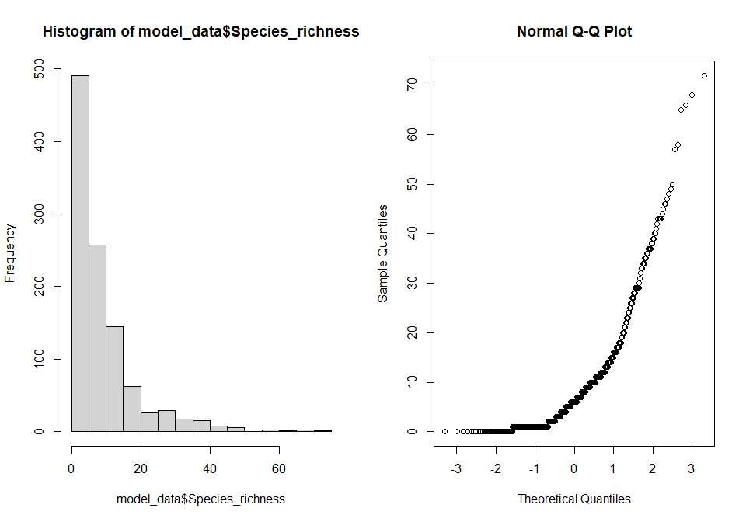
Data is not normally distributed, and species richness is count data and therefore a Poisson error structure will need to be used within the model.

Basic/starting model
m1 <- glmer(Species_richness ~ Predominant_land_use + Use_intensity_2 + fire_presence +
Predominant_land_use:Use_intensity_2 + Predominant_land_use:fire_presence +
(1|SS) + (1|SSB), data = model_data, family = poisson)
## Warning in checkConv(attr(opt, "derivs"), opt$par, ctrl = control$checkConv, : Model failed to converge with
## max|grad| = 0.00384297 (tol = 0.002, component 1)
This model fails to converge. We can check if this convergence warning is a false positive and try different optimisers
m1_check <- with(m1@optinfo$derivs,solve(Hessian,gradient))
max(abs(m1_check))
## [1] 0.0005368855
I believe this output implies this is a false positive result.
Trying different optimisers:
m1_all <- allFit(m1)
## Loading required namespace: dfoptim
## Loading required namespace: optimx
## bobyqa : [OK]
## Nelder_Mead :
## Warning in checkConv(attr(opt, "derivs"), opt$par, ctrl = control$checkConv, : Model failed to converge with
## max|grad| = 0.00257042 (tol = 0.002, component 1)
## [OK]
## nlminbwrap : [OK]
## nmkbw :
## Warning in checkConv(attr(opt, "derivs"), opt$par, ctrl = control$checkConv, : Model failed to converge with
## max|grad| = 0.00558537 (tol = 0.002, component 1)
## [OK]
## optimx.L-BFGS-B :
## Warning in checkConv(attr(opt, "derivs"), opt$par, ctrl = control$checkConv, : Model failed to converge with
## max|grad| = 0.0067508 (tol = 0.002, component 1)
## [OK]
## nloptwrap.NLOPT_LN_NELDERMEAD : [OK]
## nloptwrap.NLOPT_LN_BOBYQA :
## Warning in checkConv(attr(opt, "derivs"), opt$par, ctrl = control$checkConv, : Model failed to converge with
## max|grad| = 0.00290787 (tol = 0.002, component 1)
## [OK]
m1_sum <- summary(m1_all)
m1_sum$which.OK
## bobyqa Nelder_Mead nlminbwrap
## TRUE TRUE TRUE
## nmkbw optimx.L-BFGS-B nloptwrap.NLOPT_LN_NELDERMEAD
## TRUE TRUE TRUE
## nloptwrap.NLOPT_LN_BOBYQA
## TRUE
The output shows that many models have been successful in converging so we can try refitting the model with a different optimiser.
m1.1 <- glmer(Species_richness ~ Predominant_land_use + Use_intensity_2 + fire_presence +
Predominant_land_use:Use_intensity_2 + Predominant_land_use:fire_presence +
(1|SS) + (1|SSB), data = model_data, family = poisson,
control = glmerControl(optimizer ="bobyqa"))
Anova(m1.1)
## Analysis of Deviance Table (Type II Wald chisquare tests)
##
## Response: Species_richness
## Chisq Df Pr(>Chisq)
## Predominant_land_use 100.4543 3 < 2.2e-16 ***
## Use_intensity_2 4.7656 1 0.029033 *
## fire_presence 0.5552 1 0.456213
## Predominant_land_use:Use_intensity_2 8.9425 3 0.030065 *
## Predominant_land_use:fire_presence 11.5716 3 0.009005 **
## ---
## Signif. codes: 0 '***' 0.001 '**' 0.01 '*' 0.05 '.' 0.1 ' ' 1
summary(m1.1)
## Generalized linear mixed model fit by maximum likelihood (Laplace Approximation) ['glmerMod']
## Family: poisson ( log )
## Formula: Species_richness ~ Predominant_land_use + Use_intensity_2 + fire_presence +
## Predominant_land_use:Use_intensity_2 + Predominant_land_use:fire_presence + (1 | SS) + (1 | SSB)
## Data: model_data
## Control: glmerControl(optimizer = "bobyqa")
##
## AIC BIC logLik deviance df.resid
## 5326.7 5396.3 -2649.4 5298.7 1048
##
## Scaled residuals:
## Min 1Q Median 3Q Max
## -3.3972 -0.7416 0.0148 0.5511 5.0803
##
## Random effects:
## Groups Name Variance Std.Dev.
## SSB (Intercept) 0.04411 0.210
## SS (Intercept) 1.78840 1.337
## Number of obs: 1062, groups: SSB, 87; SS, 24
##
## Fixed effects:
## Estimate Std. Error z value Pr(>|z|)
## (Intercept) 2.098850 0.281394 7.459 8.73e-14 ***
## Predominant_land_useSecondary vegetation -0.186027 0.111957 -1.662 0.09659 .
## Predominant_land_useCropland -0.722332 0.216735 -3.333 0.00086 ***
## Predominant_land_usePasture 0.121874 0.206423 0.590 0.55492
## Use_intensity_2Greater use 0.107015 0.089805 1.192 0.23340
## fire_presenceYes -0.012676 0.039676 -0.319 0.74935
## Predominant_land_useSecondary vegetation:Use_intensity_2Greater use -0.053680 0.119520 -0.449 0.65334
## Predominant_land_useCropland:Use_intensity_2Greater use 0.488276 0.244871 1.994 0.04615 *
## Predominant_land_usePasture:Use_intensity_2Greater use -0.520773 0.247949 -2.100 0.03570 *
## Predominant_land_useSecondary vegetation:fire_presenceYes 0.008797 0.076008 0.116 0.90786
## Predominant_land_useCropland:fire_presenceYes 0.297957 0.209110 1.425 0.15419
## Predominant_land_usePasture:fire_presenceYes -0.503481 0.165557 -3.041 0.00236 **
## ---
## Signif. codes: 0 '***' 0.001 '**' 0.01 '*' 0.05 '.' 0.1 ' ' 1
##
## Correlation of Fixed Effects:
## (Intr) Pr__Sv Prd__C Prd__P U__2Gu fr_prY P__Svu P__C:u P__P:u P__Sv: P__C:_
## Prdmnnt__Sv -0.067
## Prdmnnt_l_C -0.055 0.080
## Prdmnnt_l_P -0.014 0.001 0.001
## Us_ntns_2Gu -0.124 0.304 0.181 0.002
## fir_prsncYs -0.075 0.242 0.074 0.001 0.133
## P__Sv:U__2u 0.048 -0.790 -0.067 -0.001 -0.322 0.007
## P__C:U__2Gu 0.069 -0.057 -0.917 -0.001 -0.438 -0.017 0.089
## P__P:U__2Gu 0.005 0.025 0.000 -0.832 -0.025 0.119 0.016 0.023
## Prdm__Sv:_Y 0.027 -0.221 -0.026 0.000 0.010 -0.481 -0.300 -0.033 -0.056
## Prdmn__C:_Y 0.016 -0.090 -0.233 0.000 -0.061 -0.159 0.045 0.172 -0.008 0.080
## Prdmn__P:_Y 0.014 -0.043 -0.006 0.000 0.018 -0.230 0.000 -0.026 -0.456 0.112 0.020
The Anova shows that everything in the model, apart from fire presence on its own, has a significant effect on species richness. There are large negative effects of secondary vegetation and cropland on species richness relative to primary vegetation. In croplands and pastures more intense land use causes a decline in species richness compared to minimally used primary vegetation. In pastures the presence of fire causes a large decline in species richness compared to primary without fires. In croplands there is a postive effect of fires on species richness.
Model criticism using DHARMa plots
m1_output <- simulateResiduals(fittedModel = m1.1, n = 250)
plot(m1_output)
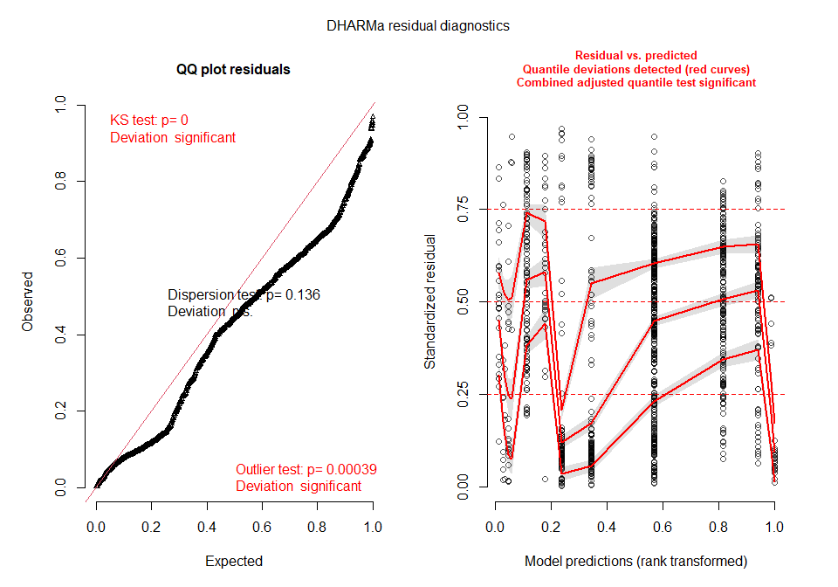
The QQ plot suggests that there is is some non normality in the model, however it does not imply that there is any overdispersion in the model despite the residual deviance being larger than the residual degrees of freedom. Further tests for overdispersion:
check_overdispersion(m1.1)
## # Overdispersion test
##
## dispersion ratio = 1.234
## Pearson's Chi-Squared = 1293.407
## p-value = < 0.001
## Overdispersion detected.
There is overdispersion in this model.
Site level random effect
Can try accounting for over dispersion by fitting an observation level random effect.
m2 <- glmer(Species_richness ~ Predominant_land_use + Use_intensity_2 + fire_presence +
Predominant_land_use:fire_presence + Predominant_land_use:Use_intensity_2 +
(1|SS) + (1|SSB) + (1|SSBS), data = model_data, family = poisson)
## Warning in checkConv(attr(opt, "derivs"), opt$par, ctrl = control$checkConv, : Model failed to converge with
## max|grad| = 0.00215358 (tol = 0.002, component 1)
This model also fails to converge, and we can try refitting with the same optimiser as before.
m2.1 <- glmer(Species_richness ~ Predominant_land_use + Use_intensity_2 + fire_presence +
Predominant_land_use:fire_presence + Predominant_land_use:Use_intensity_2 +
(1|SS) + (1|SSB) + (1|SSBS), data = model_data, family = poisson,
control = glmerControl(optimizer ="bobyqa"))
Anova(m2.1)
## Analysis of Deviance Table (Type II Wald chisquare tests)
##
## Response: Species_richness
## Chisq Df Pr(>Chisq)
## Predominant_land_use 68.1185 3 1.079e-14 ***
## Use_intensity_2 2.1206 1 0.1453
## fire_presence 0.9228 1 0.3367
## Predominant_land_use:fire_presence 8.7303 3 0.0331 *
## Predominant_land_use:Use_intensity_2 4.4840 3 0.2137
## ---
## Signif. codes: 0 '***' 0.001 '**' 0.01 '*' 0.05 '.' 0.1 ' ' 1
summary(m2.1)
## Generalized linear mixed model fit by maximum likelihood (Laplace Approximation) ['glmerMod']
## Family: poisson ( log )
## Formula: Species_richness ~ Predominant_land_use + Use_intensity_2 + fire_presence +
## Predominant_land_use:fire_presence + Predominant_land_use:Use_intensity_2 +
## (1 | SS) + (1 | SSB) + (1 | SSBS)
## Data: model_data
## Control: glmerControl(optimizer = "bobyqa")
##
## AIC BIC logLik deviance df.resid
## 5260.1 5334.6 -2615.0 5230.1 1047
##
## Scaled residuals:
## Min 1Q Median 3Q Max
## -2.7820 -0.5123 0.0026 0.3741 3.2604
##
## Random effects:
## Groups Name Variance Std.Dev.
## SSBS (Intercept) 0.04638 0.2154
## SSB (Intercept) 0.03849 0.1962
## SS (Intercept) 1.81904 1.3487
## Number of obs: 1062, groups: SSBS, 1062; SSB, 87; SS, 24
##
## Fixed effects:
## Estimate Std. Error z value Pr(>|z|)
## (Intercept) 2.08268 0.28635 7.273 3.51e-13 ***
## Predominant_land_useSecondary vegetation -0.19181 0.17934 -1.070 0.28483
## Predominant_land_useCropland -0.58064 0.26027 -2.231 0.02568 *
## Predominant_land_usePasture 0.12186 0.24087 0.506 0.61291
## Use_intensity_2Greater use 0.10612 0.12466 0.851 0.39464
## fire_presenceYes -0.02889 0.05242 -0.551 0.58149
## Predominant_land_useSecondary vegetation:fire_presenceYes 0.01514 0.09871 0.153 0.87806
## Predominant_land_useCropland:fire_presenceYes 0.28256 0.21980 1.285 0.19862
## Predominant_land_usePasture:fire_presenceYes -0.49446 0.19121 -2.586 0.00971 **
## Predominant_land_useSecondary vegetation:Use_intensity_2Greater use -0.03410 0.18572 -0.184 0.85430
## Predominant_land_useCropland:Use_intensity_2Greater use 0.32456 0.30100 1.078 0.28091
## Predominant_land_usePasture:Use_intensity_2Greater use -0.50887 0.28902 -1.761 0.07829 .
## ---
## Signif. codes: 0 '***' 0.001 '**' 0.01 '*' 0.05 '.' 0.1 ' ' 1
##
## Correlation of Fixed Effects:
## (Intr) Pr__Sv Prd__C Prd__P U__2Gu fr_prY P__Sv: P__C:_ P__P:_ P__Svu P__C:u
## Prdmnnt__Sv -0.087
## Prdmnnt_l_C -0.074 0.083
## Prdmnnt_l_P -0.016 0.001 0.001
## Us_ntns_2Gu -0.169 0.282 0.188 0.003
## fir_prsncYs -0.096 0.208 0.080 0.002 0.110
## Prdm__Sv:_Y 0.040 -0.192 -0.036 -0.001 -0.008 -0.501
## Prdmn__C:_Y 0.037 -0.109 -0.302 -0.001 -0.080 -0.208 0.108
## Prdmn__P:_Y 0.016 -0.039 -0.004 0.000 0.051 -0.264 0.134 0.037
## P__Sv:U__2u 0.066 -0.865 -0.067 -0.001 -0.289 -0.002 -0.238 0.061 -0.004
## P__C:U__2Gu 0.091 -0.052 -0.891 -0.002 -0.463 0.003 -0.029 0.202 -0.052 0.074
## P__P:U__2Gu 0.006 0.021 -0.002 -0.833 -0.049 0.132 -0.065 -0.016 -0.459 0.017 0.041
Use intensity is no longer significant in this model.
Checking for over dispersion:
check_overdispersion(m2.1)
## # Overdispersion test
##
## dispersion ratio = 0.660
## Pearson's Chi-Squared = 691.409
## p-value = 1
## No overdispersion detected.

Model selection
max <- glmer(Species_richness ~ Predominant_land_use + Use_intensity_2 + fire_presence +
Predominant_land_use:fire_presence + Predominant_land_use:Use_intensity_2 +
(1|SS) + (1|SSB) + (1|SSBS), data = model_data, family = poisson,
control = glmerControl(optimizer ="bobyqa"))
Anova(max)
## Analysis of Deviance Table (Type II Wald chisquare tests)
##
## Response: Species_richness
## Chisq Df Pr(>Chisq)
## Predominant_land_use 68.1185 3 1.079e-14 ***
## Use_intensity_2 2.1206 1 0.1453
## fire_presence 0.9228 1 0.3367
## Predominant_land_use:fire_presence 8.7303 3 0.0331 *
## Predominant_land_use:Use_intensity_2 4.4840 3 0.2137
## ---
## Signif. codes: 0 '***' 0.001 '**' 0.01 '*' 0.05 '.' 0.1 ' ' 1
summary(max)
## Generalized linear mixed model fit by maximum likelihood (Laplace Approximation) ['glmerMod']
## Family: poisson ( log )
## Formula: Species_richness ~ Predominant_land_use + Use_intensity_2 + fire_presence +
## Predominant_land_use:fire_presence + Predominant_land_use:Use_intensity_2 +
## (1 | SS) + (1 | SSB) + (1 | SSBS)
## Data: model_data
## Control: glmerControl(optimizer = "bobyqa")
##
## AIC BIC logLik deviance df.resid
## 5260.1 5334.6 -2615.0 5230.1 1047
##
## Scaled residuals:
## Min 1Q Median 3Q Max
## -2.7820 -0.5123 0.0026 0.3741 3.2604
##
## Random effects:
## Groups Name Variance Std.Dev.
## SSBS (Intercept) 0.04638 0.2154
## SSB (Intercept) 0.03849 0.1962
## SS (Intercept) 1.81904 1.3487
## Number of obs: 1062, groups: SSBS, 1062; SSB, 87; SS, 24
##
## Fixed effects:
## Estimate Std. Error z value Pr(>|z|)
## (Intercept) 2.08268 0.28635 7.273 3.51e-13 ***
## Predominant_land_useSecondary vegetation -0.19181 0.17934 -1.070 0.28483
## Predominant_land_useCropland -0.58064 0.26027 -2.231 0.02568 *
## Predominant_land_usePasture 0.12186 0.24087 0.506 0.61291
## Use_intensity_2Greater use 0.10612 0.12466 0.851 0.39464
## fire_presenceYes -0.02889 0.05242 -0.551 0.58149
## Predominant_land_useSecondary vegetation:fire_presenceYes 0.01514 0.09871 0.153 0.87806
## Predominant_land_useCropland:fire_presenceYes 0.28256 0.21980 1.285 0.19862
## Predominant_land_usePasture:fire_presenceYes -0.49446 0.19121 -2.586 0.00971 **
## Predominant_land_useSecondary vegetation:Use_intensity_2Greater use -0.03410 0.18572 -0.184 0.85430
## Predominant_land_useCropland:Use_intensity_2Greater use 0.32456 0.30100 1.078 0.28091
## Predominant_land_usePasture:Use_intensity_2Greater use -0.50887 0.28902 -1.761 0.07829 .
## ---
## Signif. codes: 0 '***' 0.001 '**' 0.01 '*' 0.05 '.' 0.1 ' ' 1
##
## Correlation of Fixed Effects:
## (Intr) Pr__Sv Prd__C Prd__P U__2Gu fr_prY P__Sv: P__C:_ P__P:_ P__Svu P__C:u
## Prdmnnt__Sv -0.087
## Prdmnnt_l_C -0.074 0.083
## Prdmnnt_l_P -0.016 0.001 0.001
## Us_ntns_2Gu -0.169 0.282 0.188 0.003
## fir_prsncYs -0.096 0.208 0.080 0.002 0.110
## Prdm__Sv:_Y 0.040 -0.192 -0.036 -0.001 -0.008 -0.501
## Prdmn__C:_Y 0.037 -0.109 -0.302 -0.001 -0.080 -0.208 0.108
## Prdmn__P:_Y 0.016 -0.039 -0.004 0.000 0.051 -0.264 0.134 0.037
## P__Sv:U__2u 0.066 -0.865 -0.067 -0.001 -0.289 -0.002 -0.238 0.061 -0.004
## P__C:U__2Gu 0.091 -0.052 -0.891 -0.002 -0.463 0.003 -0.029 0.202 -0.052 0.074
## P__P:U__2Gu 0.006 0.021 -0.002 -0.833 -0.049 0.132 -0.065 -0.016 -0.459 0.017 0.041
Land use:use intensity interaction is not significant therefore we can remove this from the model so long as it does not remove significant explanatory power.
max.1 <- update(max,~.- Predominant_land_use:Use_intensity_2)
anova(max, max.1)
## Data: model_data
## Models:
## max.1: Species_richness ~ Predominant_land_use + Use_intensity_2 + fire_presence +
## max.1: (1 | SS) + (1 | SSB) + (1 | SSBS) + Predominant_land_use:fire_presence
## max: Species_richness ~ Predominant_land_use + Use_intensity_2 + fire_presence +
## max: Predominant_land_use:fire_presence + Predominant_land_use:Use_intensity_2 +
## max: (1 | SS) + (1 | SSB) + (1 | SSBS)
## npar AIC BIC logLik deviance Chisq Df Pr(>Chisq)
## max.1 12 5258.5 5318.1 -2617.2 5234.5
## max 15 5260.1 5334.6 -2615.0 5230.1 4.4189 3 0.2196
Have not lost significant explanatory power
Anova(max.1)
## Analysis of Deviance Table (Type II Wald chisquare tests)
##
## Response: Species_richness
## Chisq Df Pr(>Chisq)
## Predominant_land_use 67.8094 3 1.257e-14 ***
## Use_intensity_2 2.1811 1 0.139719
## fire_presence 0.9830 1 0.321467
## Predominant_land_use:fire_presence 15.7802 3 0.001258 **
## ---
## Signif. codes: 0 '***' 0.001 '**' 0.01 '*' 0.05 '.' 0.1 ' ' 1
Can also move use intensity entirely as a fixed effect.
max.2 <- update(max.1,~.- Use_intensity_2)
anova(max.1, max.2)
## Data: model_data
## Models:
## max.2: Species_richness ~ Predominant_land_use + fire_presence + (1 |
## max.2: SS) + (1 | SSB) + (1 | SSBS) + Predominant_land_use:fire_presence
## max.1: Species_richness ~ Predominant_land_use + Use_intensity_2 + fire_presence +
## max.1: (1 | SS) + (1 | SSB) + (1 | SSBS) + Predominant_land_use:fire_presence
## npar AIC BIC logLik deviance Chisq Df Pr(>Chisq)
## max.2 11 5258.6 5313.3 -2618.3 5236.6
## max.1 12 5258.5 5318.1 -2617.2 5234.5 2.1432 1 0.1432
Have not lost significant explanatory power, so this is now the final model.

Selected model:
richness_model <- glmer(Species_richness ~ Predominant_land_use + fire_presence +
Predominant_land_use:fire_presence +
(1|SS) + (1|SSB) + (1|SSBS), data = model_data, family = poisson,
control = glmerControl(optimizer ="bobyqa"))
Anova(richness_model)
## Analysis of Deviance Table (Type II Wald chisquare tests)
##
## Response: Species_richness
## Chisq Df Pr(>Chisq)
## Predominant_land_use 65.1824 3 4.585e-14 ***
## fire_presence 1.3972 1 0.23719
## Predominant_land_use:fire_presence 15.9334 3 0.00117 **
## ---
## Signif. codes: 0 '***' 0.001 '**' 0.01 '*' 0.05 '.' 0.1 ' ' 1
summary(richness_model)
## Generalized linear mixed model fit by maximum likelihood (Laplace Approximation) ['glmerMod']
## Family: poisson ( log )
## Formula: Species_richness ~ Predominant_land_use + fire_presence + Predominant_land_use:fire_presence +
## (1 | SS) + (1 | SSB) + (1 | SSBS)
## Data: model_data
## Control: glmerControl(optimizer = "bobyqa")
##
## AIC BIC logLik deviance df.resid
## 5258.6 5313.3 -2618.3 5236.6 1051
##
## Scaled residuals:
## Min 1Q Median 3Q Max
## -2.7635 -0.5045 -0.0116 0.4058 3.2116
##
## Random effects:
## Groups Name Variance Std.Dev.
## SSBS (Intercept) 0.04865 0.2206
## SSB (Intercept) 0.03829 0.1957
## SS (Intercept) 1.91435 1.3836
## Number of obs: 1062, groups: SSBS, 1062; SSB, 87; SS, 24
##
## Fixed effects:
## Estimate Std. Error z value Pr(>|z|)
## (Intercept) 2.11440 0.28914 7.313 2.62e-13 ***
## Predominant_land_useSecondary vegetation -0.22329 0.09029 -2.473 0.013395 *
## Predominant_land_useCropland -0.21743 0.09581 -2.269 0.023247 *
## Predominant_land_usePasture -0.23655 0.13150 -1.799 0.072047 .
## fire_presenceYes -0.02748 0.05198 -0.529 0.597012
## Predominant_land_useSecondary vegetation:fire_presenceYes 0.01593 0.09606 0.166 0.868321
## Predominant_land_useCropland:fire_presenceYes 0.21040 0.21546 0.976 0.328824
## Predominant_land_usePasture:fire_presenceYes -0.64084 0.16912 -3.789 0.000151 ***
## ---
## Signif. codes: 0 '***' 0.001 '**' 0.01 '*' 0.05 '.' 0.1 ' ' 1
##
## Correlation of Fixed Effects:
## (Intr) Pr__Sv Prd__C Prd__P fr_prY P__Sv: P__C:_
## Prdmnnt__Sv -0.050
## Prdmnnt_l_C -0.074 0.247
## Prdmnnt_l_P -0.032 0.116 0.115
## fir_prsncYs -0.080 0.399 0.318 0.221
## Prdm__Sv:_Y 0.046 -0.813 -0.243 -0.106 -0.507
## Prdmn__C:_Y 0.022 -0.123 -0.330 -0.042 -0.221 0.136
## Prdmn__P:_Y 0.027 -0.065 -0.097 -0.774 -0.244 0.127 0.045
Diagnostics:
check_overdispersion(richness_model)
## # Overdispersion test
##
## dispersion ratio = 0.645
## Pearson's Chi-Squared = 677.482
## p-value = 1
## No overdispersion detected.
par(mfrow=c(1,2))
qqnorm(resid(richness_model), main="normal qq-plot, residuals")
qqline(resid(richness_model)) ## not bad
plot(fitted(richness_model), resid(richness_model), main = "Residuals vs fitted") #residuals vs fitted
abline(h=0)
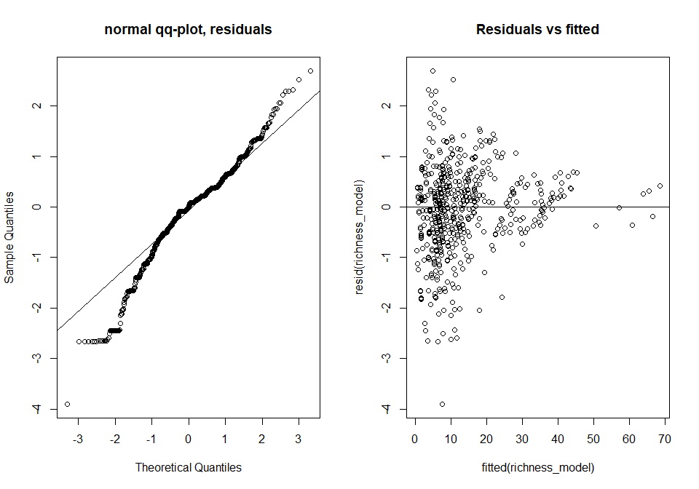
ran <- ranef(richness_model, condVar=TRUE)
a <- dotplot(ran)[["SSBS"]]
b <- dotplot(ran)[["SSB"]]
c <- dotplot(ran)[["SS"]]
grid.arrange(a,b,c, nrow=2, ncol=2)
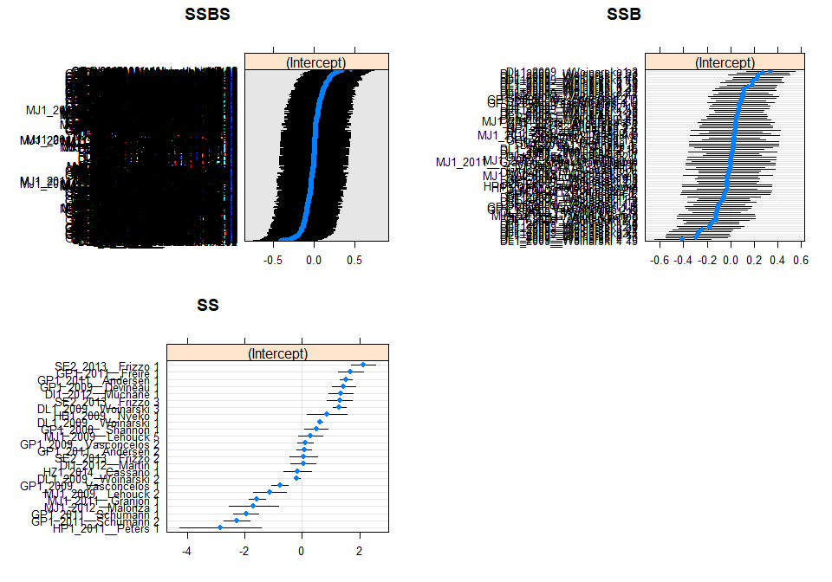
Residuals
residuals <- resid(richness_model)
summary(residuals)
## Min. 1st Qu. Median Mean 3rd Qu. Max.
## -3.9082 -0.5212 -0.0116 -0.1186 0.3777 2.7040
hist(residuals)
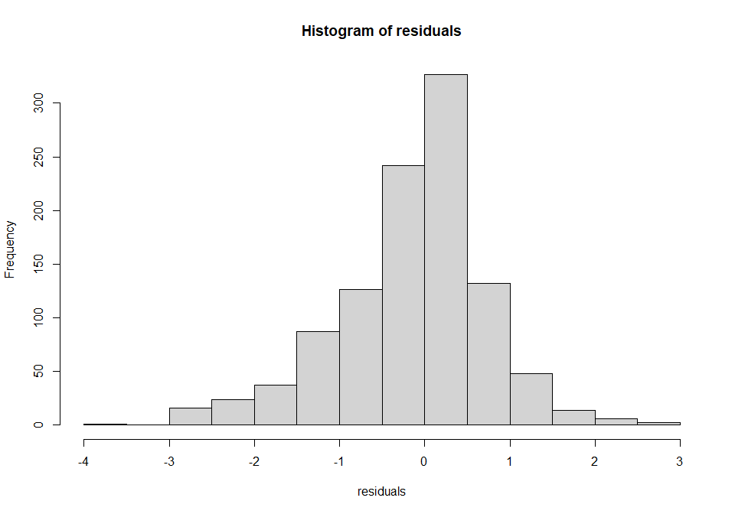
Plotting:
set_theme(base = theme_classic(), legend.item.backcol = "white")
plot_model(richness_model, type = "pred", terms = c("Predominant_land_use", "fire_presence"),
legend.title = "Fire presence", show.intercept = TRUE,
axis.title = c("Predominant land use", "Species richness"))
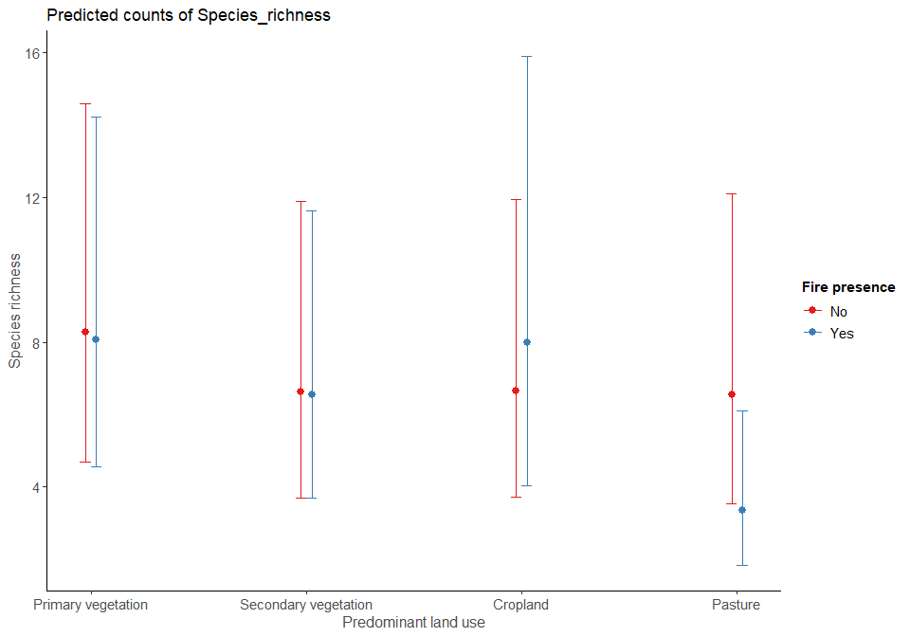

Hypothesis testing - does fire have a significant effect on species richness in the savanna
Create models with and with out fire and then compare them by maximum liklihood.
fire <- glmer(Species_richness ~ Predominant_land_use + fire_presence +
Predominant_land_use:fire_presence +
(1|SS) + (1|SSB) + (1|SSBS), data = model_data, family = poisson,
control = glmerControl(optimizer ="bobyqa"))
no_fire <- glmer(Species_richness ~ Predominant_land_use +
(1|SS) + (1|SSB) + (1|SSBS), data = model_data, family = poisson,
control = glmerControl(optimizer ="bobyqa"))
anova(max, no_fire)
## Data: model_data
## Models:
## no_fire: Species_richness ~ Predominant_land_use + (1 | SS) + (1 | SSB) +
## no_fire: (1 | SSBS)
## max: Species_richness ~ Predominant_land_use + Use_intensity_2 + fire_presence +
## max: Predominant_land_use:fire_presence + Predominant_land_use:Use_intensity_2 +
## max: (1 | SS) + (1 | SSB) + (1 | SSBS)
## npar AIC BIC logLik deviance Chisq Df Pr(>Chisq)
## no_fire 7 5267.3 5302.1 -2626.7 5253.3
## max 15 5260.1 5334.6 -2615.0 5230.1 23.257 8 0.00305 **
## ---
## Signif. codes: 0 '***' 0.001 '**' 0.01 '*' 0.05 '.' 0.1 ' ' 1
AIC(max, no_fire)
## df AIC
## max 15 5260.058
## no_fire 7 5267.315
The model that includes fire is a better model than the model with no fire (based of AIC values). The anova shows that the presence of fire has a significant impact on species richness (Chisq=23.257, df=8, p=0.003(<0.01))

