**Project Overview**

This project requires you to do a web blog, a kind of personal website such as wordpress or blogspot. Suppose that you are working on a project of personal website for yourself.

**Why do I need to do this project?**

As described, using a database is a way to store data persistently.

In this project, you will need to use all the knowledge learned previously to apply to this project and at the same time, interactively store MySQL database. New knowledge to learn is:

* + Apply more JavaScript libraries as Editor - HTML editor
  + Use JDBC to interact with the database

**What do I learn from this project?**

In this project, you will learn about:

* + Editor for HTML or Markdown text. Learn more about this editor to choose the right one for you.
  + Work with relational database, particularly MySQL. You need to design the database as required.
  + Works with JDBC, the tool that allows you to work with database in Java.

**How does this project help my work?**

You will learn about database design and persistent storage. When you simulate the last user to access the website, you will see that the database access needs to be optimized and you will get proper suggestions to optimize it.

**How to complete the project?**

To complete this assignment, you need to understand:

* + Text is stored in the database as HTML or Markdown text; however, when text is displayed to the last user, it is on the browser, so all should be converted to HTML for browser to read.
  + You need to install MySQL database on your computer.
  + You need to learn how to use MySQL client tool.
  + You design the database yourself according to the project requirements.
  + Use JDBC to connect to the database.
  + Use Pool to optimize database interaction.

**Reference resources**

* + Editor: look for keywords on the search engine (keywords html editor, markdown text editor etc.).
  + Install MySQL on your computer by using pre-packaged software such as WAMP (for window), XAMP etc.
  + Use MySQL workbench to connect (or your preference): <https://www.mysql.com/products/workbench/>
  + Java JDBC: <https://www.javatpoint.com/java-jdbc>
  + JDBC Driver for MySQL: keyword MySQL JDBC Driver

**Blog Application Development**

Create a web application as required below: Write a website blog that uses a database as a persistent layer and contains:

* + An interface for the reader (reader GUI):

- PostDetail.jsp: view a single post, anyone can view this page. On this page, there must be a section displaying the message to welcome back-reader. An article contains the title, content, author, and date of publication, status (in draft or published). The content must be in a separate format.

- Posts.jsp: display all published articles, sorting by date of publication.

* An interface for the author (author GUI):

Authoring page: As a writer, I want to write articles, mark them as published or drafts, I also want to format the content myself. For security, I have to log in before accessing this page. The content of the form may look like this:

- If you intend to save the content in html format:

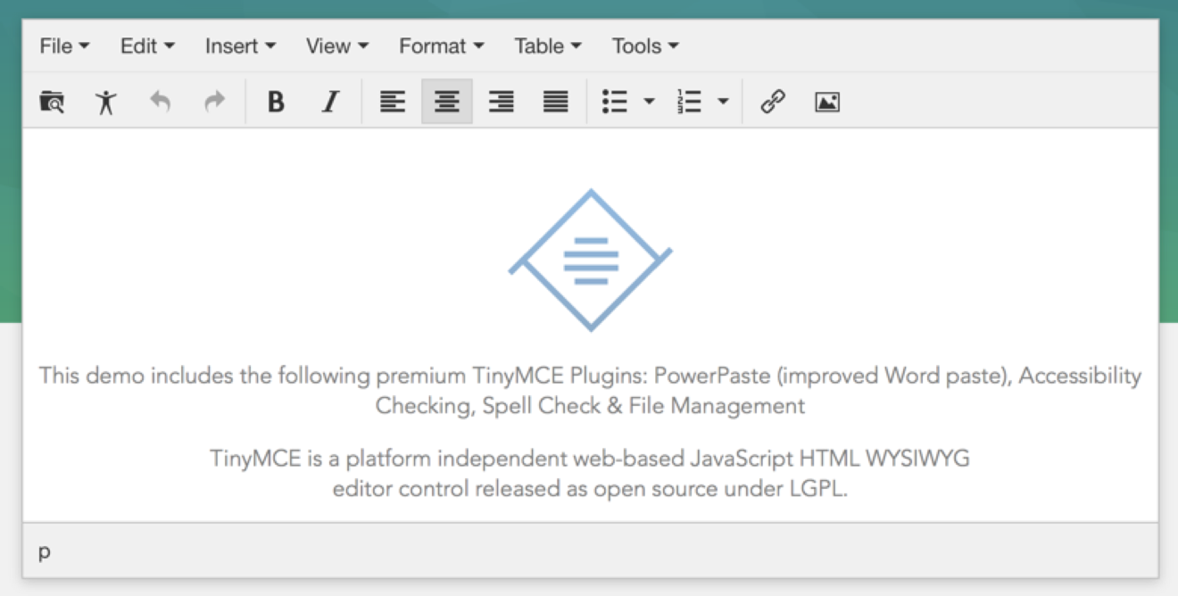

- If you intend to save the content in markdown format:

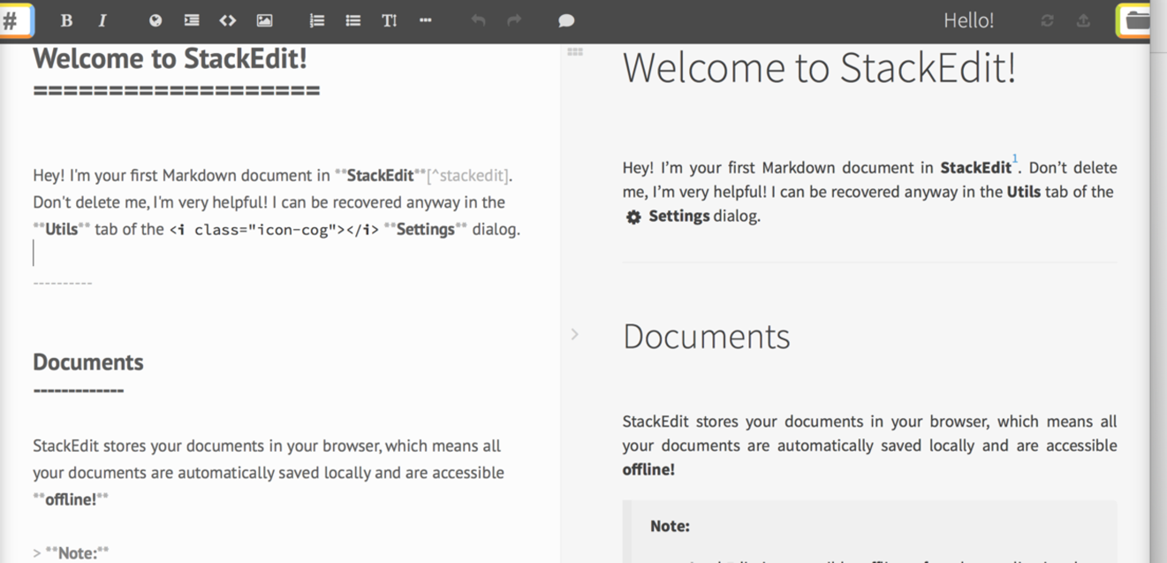

Article-updating page: to update the articles. It must have a GUI like the authoring page above.

Logout function

**Important notes:**

* + You are free to design the table to save the post, the user in the database and the user interface must be responsive.
  + Post's content in the database can be either: text in the form of markdown or HTML for formatting. For each format, you need to find the appropriate API javascript.
  + When designing a database, you can add a category to an article; However, this is not a compulsory requirement.

**Some reference images:**

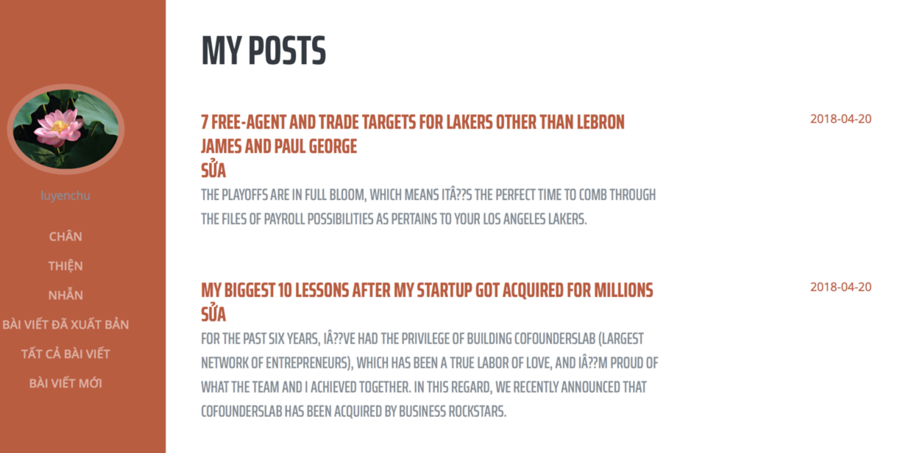

Display the list of published articles

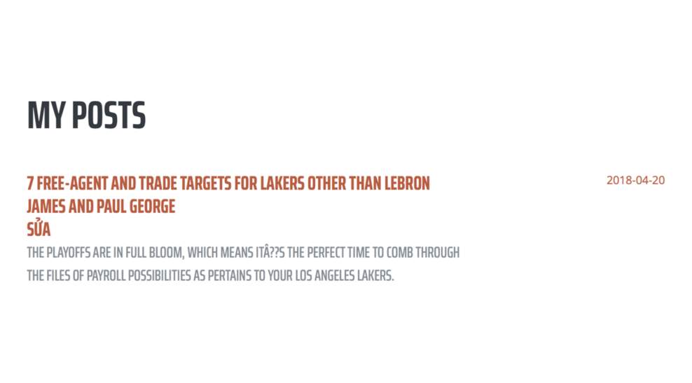

Post that can select "Edit" when login

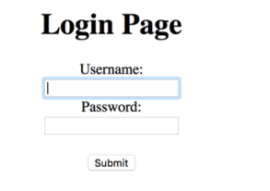

The login page for the author

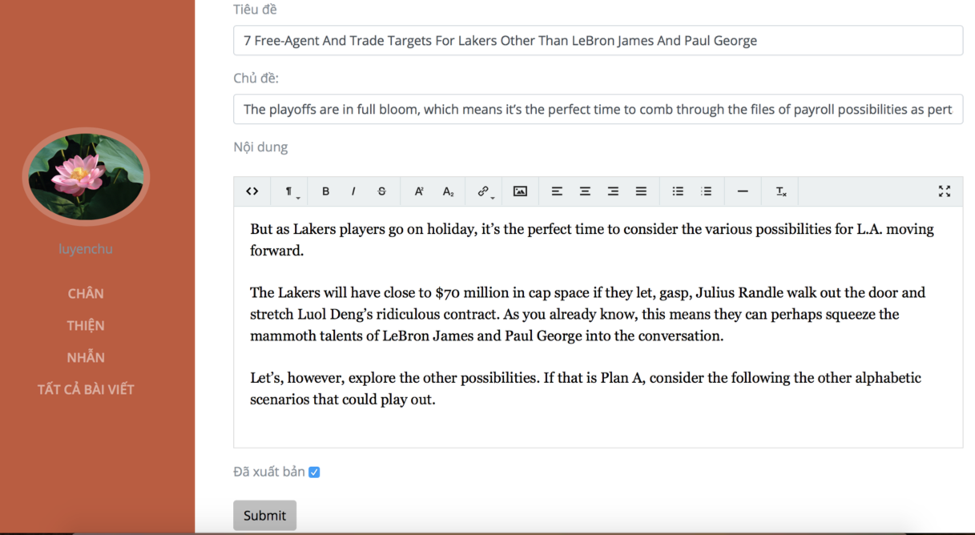

Authoring page (edit or add new)