***Question***

How pleiotropic is the genomic architecture underlying response to industrial inhibitors? Of this pleiotropy, how pervasive is antagonism? Can specific tradeoffs be identified?

***Preliminary results***

There is considerable antagonistic pleiotropy underlying resistance to industrial inhibitors. A number of highly responsive deletions underlie both resistance and susceptibility across the panel of industrial inhibitors. Specific tradeoffs between conditions can be identified, for example between Ionic Liquids and Phenolic Acids.

***Approach***

These questions first require an approach that finds the most affected gene deletions in each condition. To do this, I took a liberal approach where I identified those genes that were in *both* the top 10% of log fold change values and the bottom 10% of p-values for each inhibitor condition.

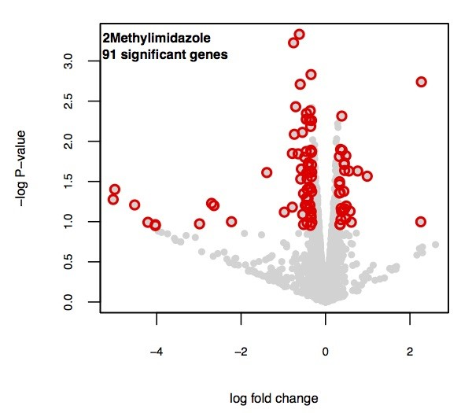

With these top genes I took 2 approaches to looking for pleiotropy.

1. ***Identify pleiotropic genes by identifying those deletions that are significantly affected in multiple conditions.***
2. ***Look for pairwise correlations between normalized log fold change data amongst inhibitors.***
3. ***Individual gene pleiotropy –***

The number of conditions (*n*) each deletion was identified as significant was tallied in the observed data. I then repeated this on 1,000 simulated datasets by independently permuting the data for each inhibitor. There is a significant excess of deletions that are significant in *n>=5* conditions.

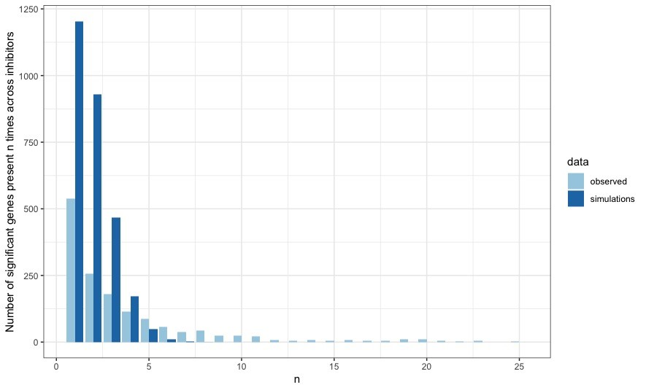

I plotted the significant log fold change values for the 100 most pleiotropic genes – those significant in 11 conditions or more – to look for antagonism (or lack of). The values span both positive and negative and most genes appear to have a signature of antagonism.

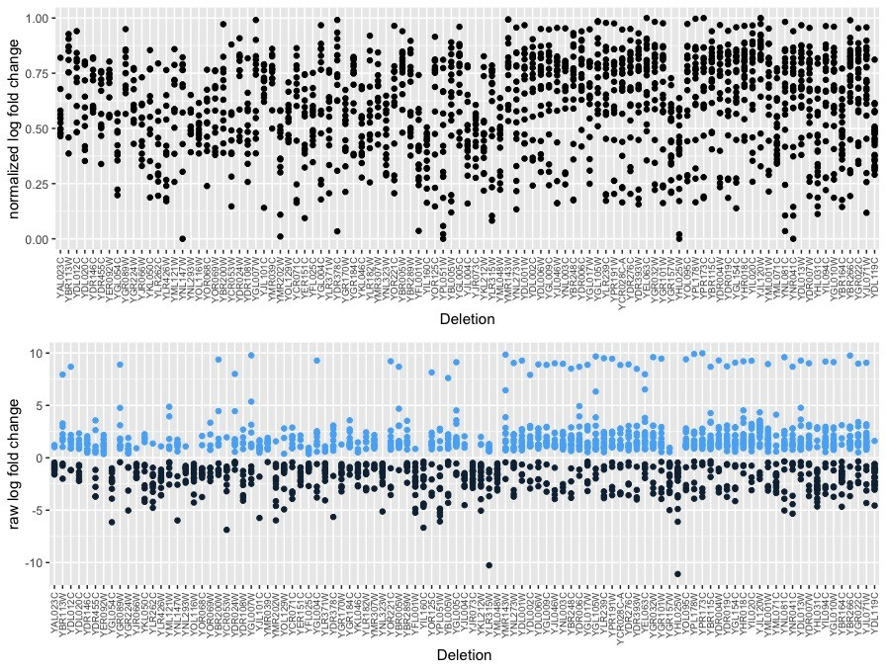

1. ***Condition specific tradeoffs***

Hierarchical clustering of the normalized log fold change distance matrix reveals modules of genes showing trade-offs across inhibitors.

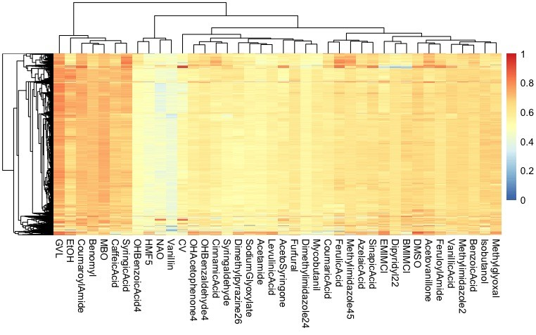

To identify pairwise tradeoffs, I looked for significant correlations in the normalized log-fold change profiles of all pairs of inhibitors. Most, but not all, significant correlations are positive.

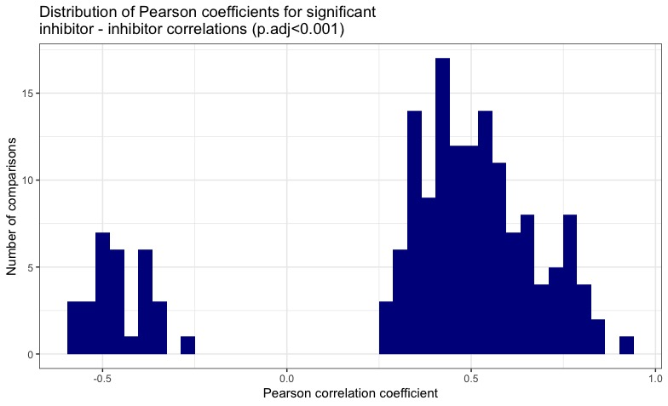

I binned inhibitors into chemical classes. I ignored correlations between inhibitors of the same class (all were positive) and focused on inter-class pairs of inhibitors. The plot below shows the Pearson correlation coefficient for all the significant pairwise comparisons within each class shown. The labels indicate how many of the total possible pairwise comparisons were significant for each class comparison. Blue points indicate that all correlations for that comparison were either positive or negative. Red points indicate a mix of positive and negative correlations.

