Library system documentation

This document describes the functional and non-functional requirements of the system supporting the work of the librarian and library client.
Contractors:
Katarzyna Klatka
Magdalena Lebiedziewicz
Damian Redkiewicz
Group:
I7B4S4
Date of completion:
07.04.2019

Table of Contents:

1. General description of the system and actors.
2. Use case diagram - functional requirements.
3. Non-functional requirements of the system.
4. Activity diagrams.
5. Domain model.
6. Integration with an external system.

Section 1

General description of the system and actors:

The system collects basic data about library clients allowing for their unambiguous identification. Its main task is to suport librarian in library management. The system allows the customer to book items online and gives him the ability to check the status of loans and orders related to his account.
Actors:
• Library client - A person who can use the library services.
• Librarian - A library employee responsible for customer service and modification of files in the library.
• Administrator - A library employee who manages the IT system.

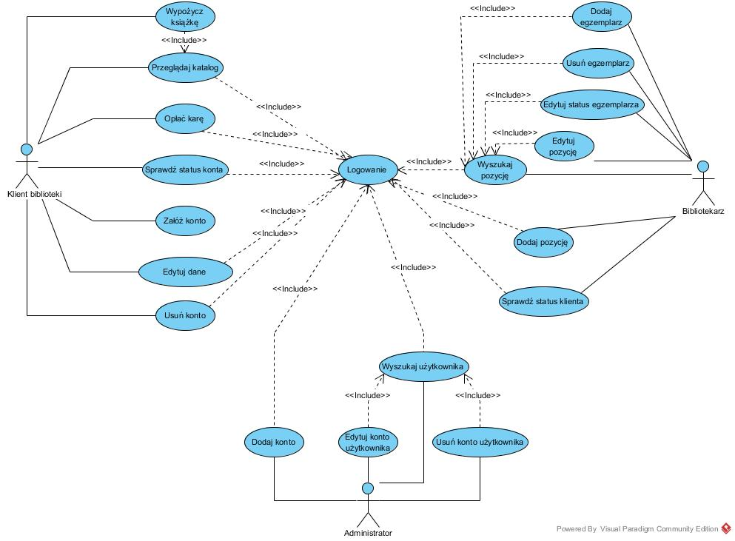

Use case diagram:

Non-functional system requirements table
Identyfikator wymagania | Nazwa | Treść | Autor wymagania
1 | Catalogue search time | Catalogue search time takes up to 5 s | Librarian - Emil Kwiatkowski
2 | Simultaneous handling of multiple users | The system has the ability to handle 1000 users simultaneously | Project Manager - Damian Kajetanowicz
3 | Availability in browsers | The system works on all popular browsers, that is: Firefox, Google Chrome, Safari, Opera, Internet Explorer, Edge Project | Manager - Damian Kajetanowicz
4 | Availability on smartphones | The system is supported by smartphones | President of the company - Janusz Kowalski
5 | Time of uninterrupted operation of the system | The system have to be available for 95% of the time | President of the company - Janusz Kowalski
6 | Response time in case of failure | Failure have to be repaired within 1 day from its occurrence | President of the company - Janusz Kowalski

Section 2

Activity diagrams.

Logging - The diagram shows the functionality of logging in by the user depending on whether it is a library client, librarian or administrator. The system does not describe the logout function, but it is also available.
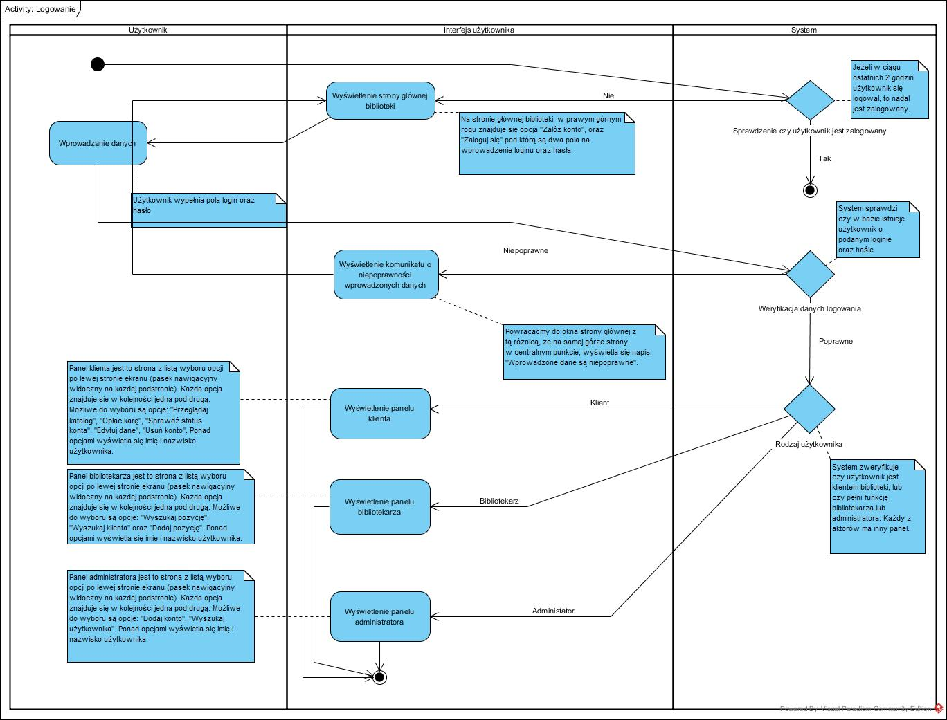
Book rental - The diagram describes the functionality of book rental by the library client.
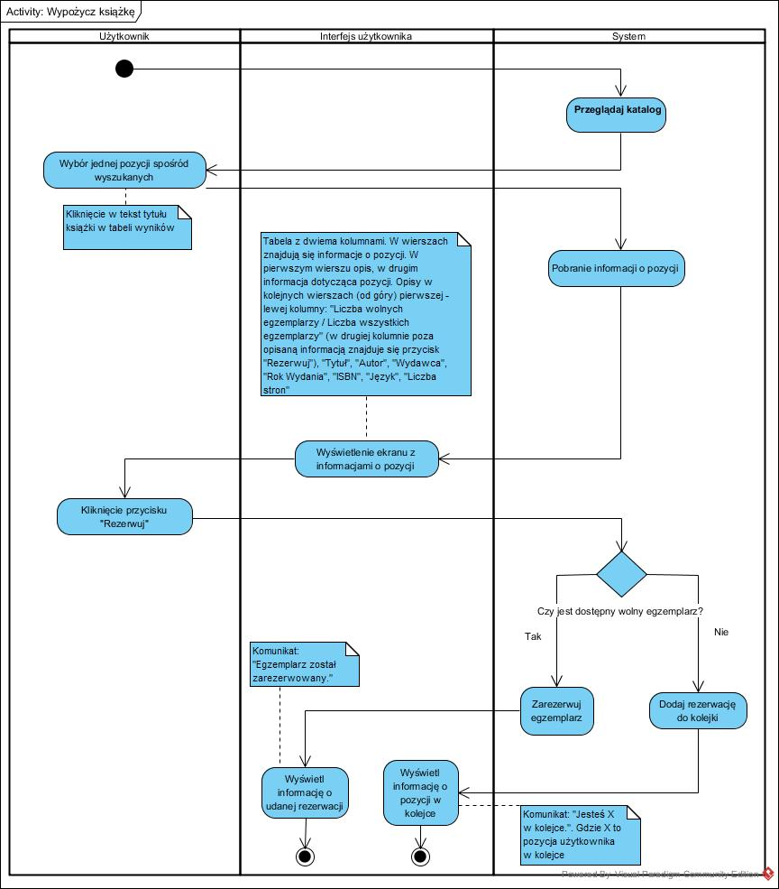

Browse the directory - function designed for the library client and librarian. The functionality Allows to browse catalogues after logging in.
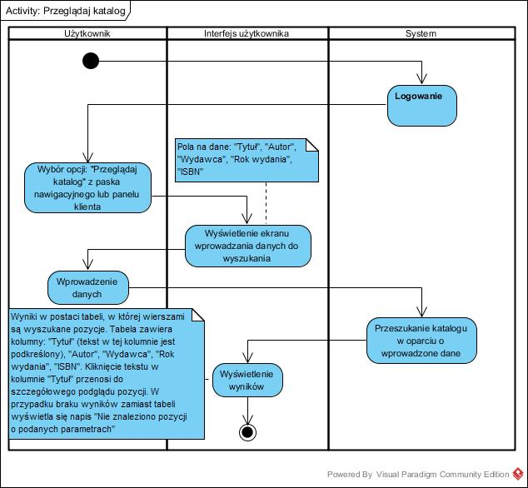

Pay the fine - the diagram below presents the functionality of paying a fine by the user who is in arrears with payments for not returing books in a proper time.
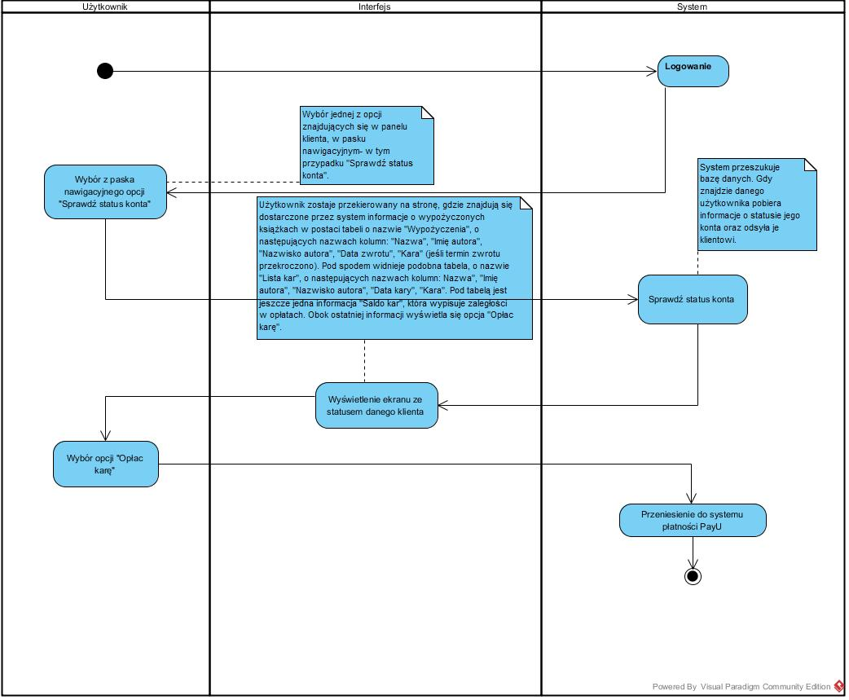

Check the account status - function intended for the library client. Librarian can check the information about his account, such as arrears in fees.

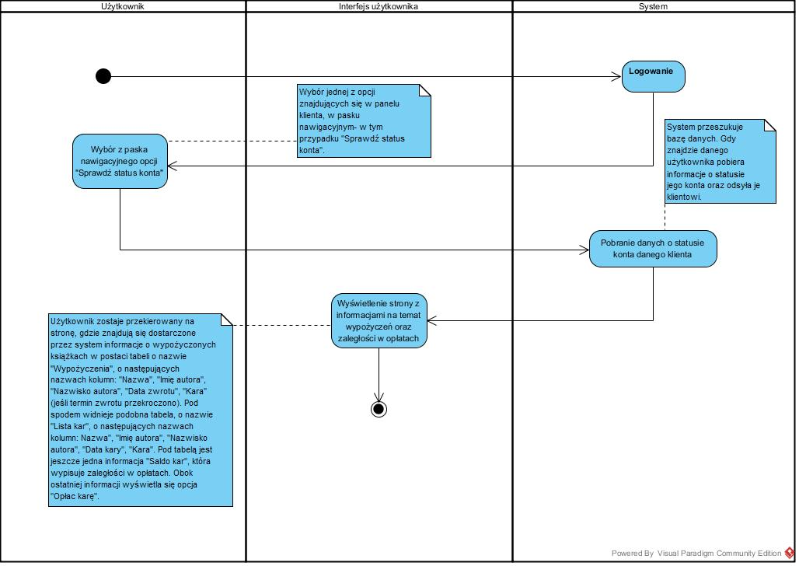

Create an account - below is a diagram of activities describing the functionality of creating an account by a new user.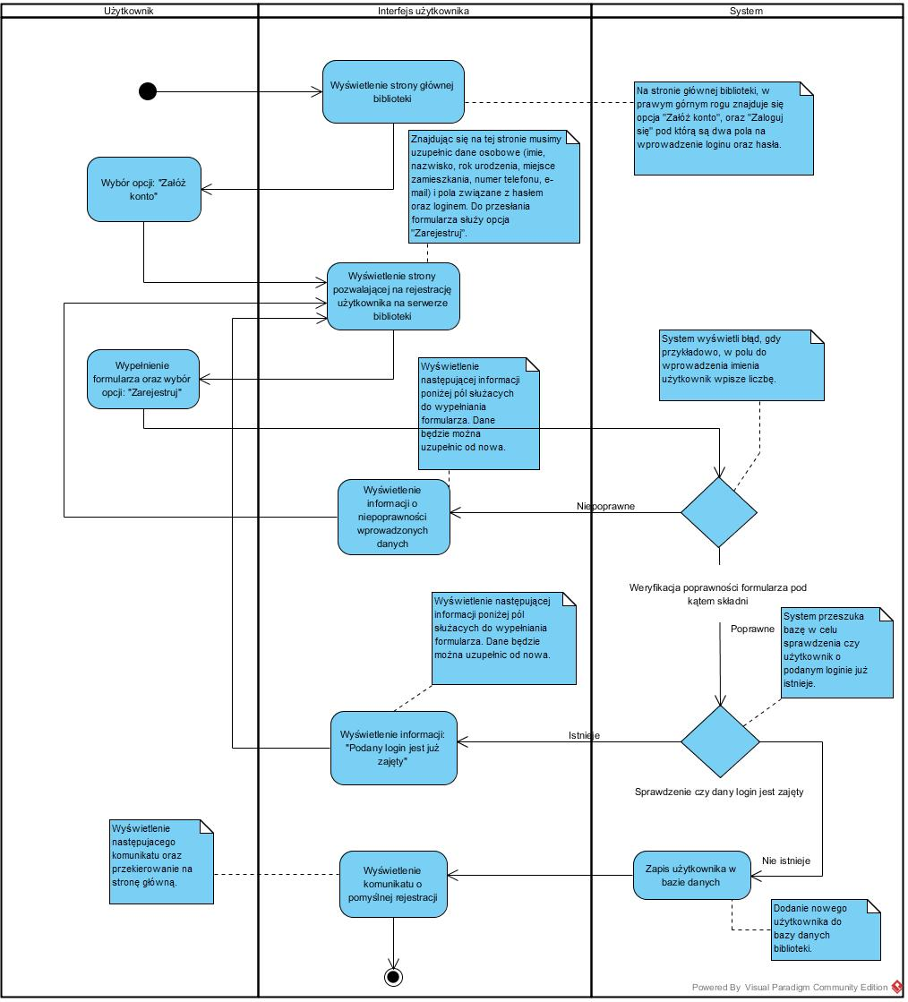

Edit data - function for the library client. Allows client to edit his personal data.
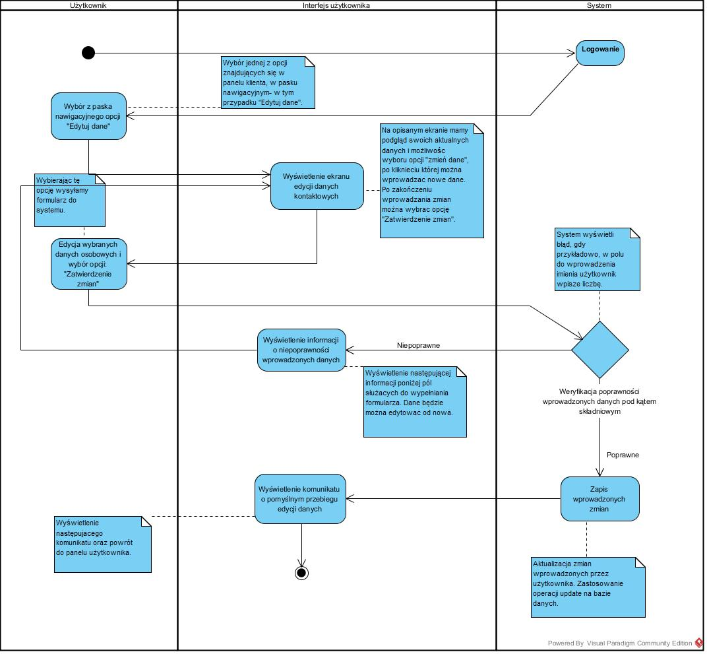

Delete account - functionality that allows you to delete an account. This is a function designed for the library client.
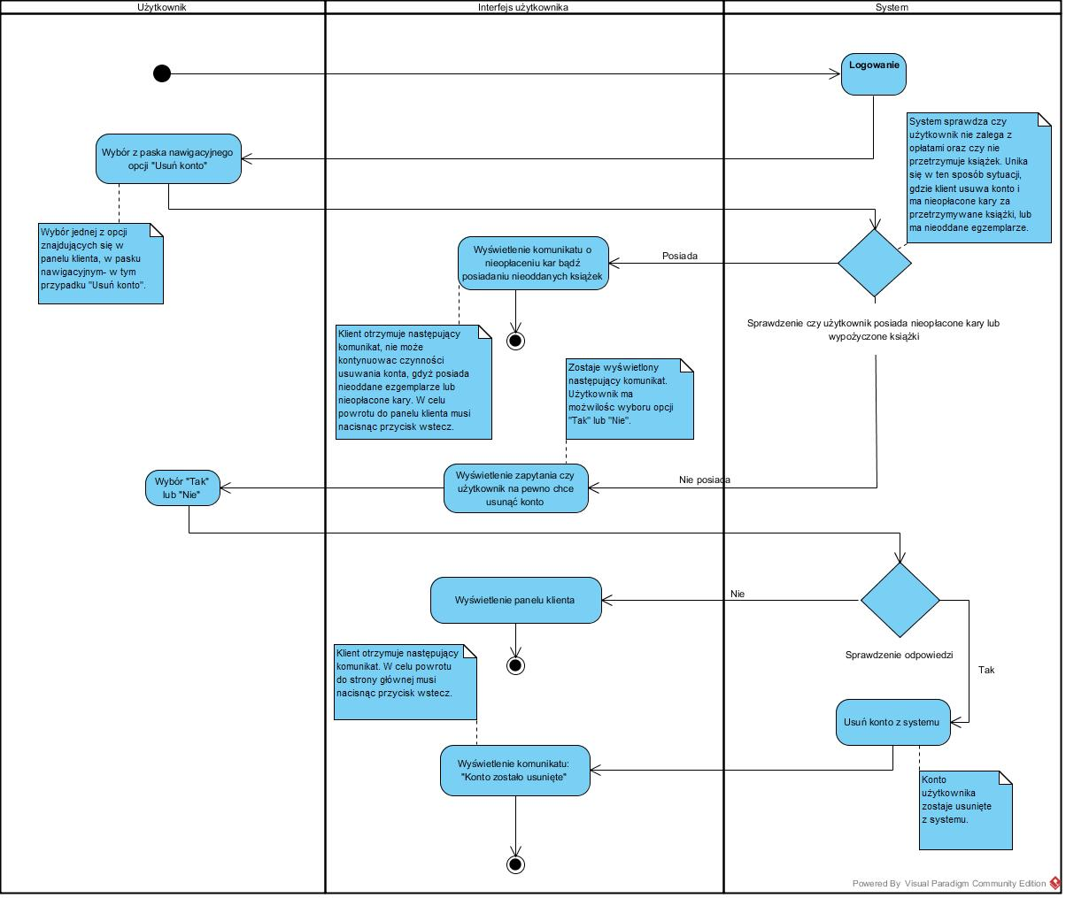

Add account - the diagram below describes the functionality of adding a new account by the administrator.
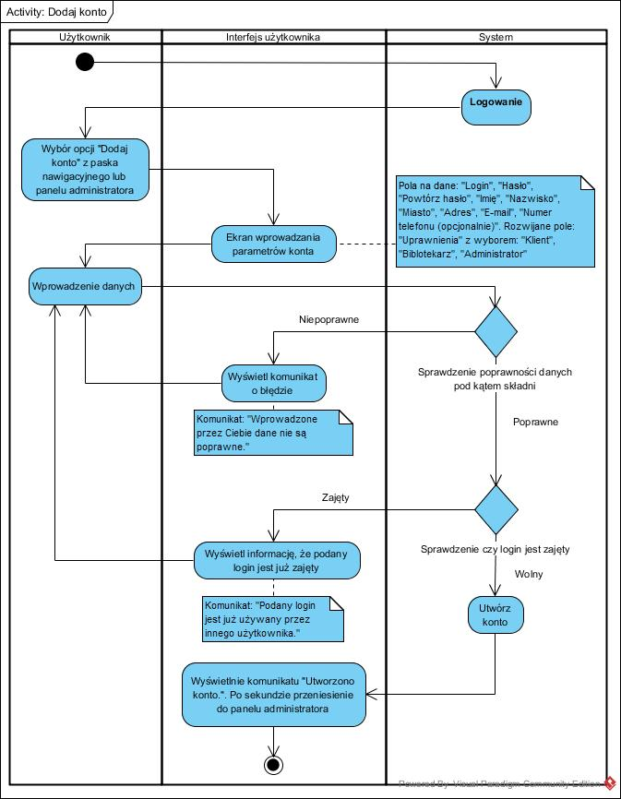
Edit user account - a function designed for the administrator allowing to edit the library user account.
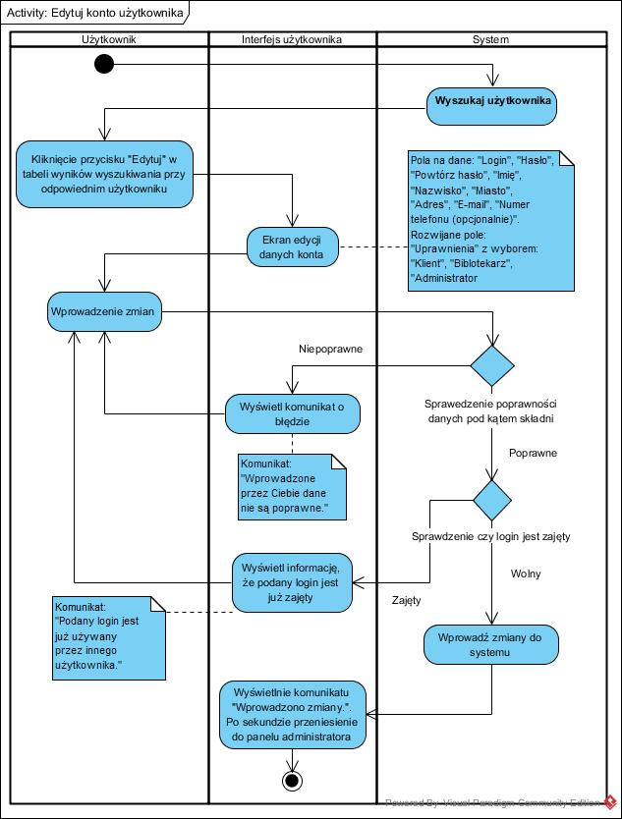
Delete user account - this function is intended for the administrator. Function allows to delete a library user account.
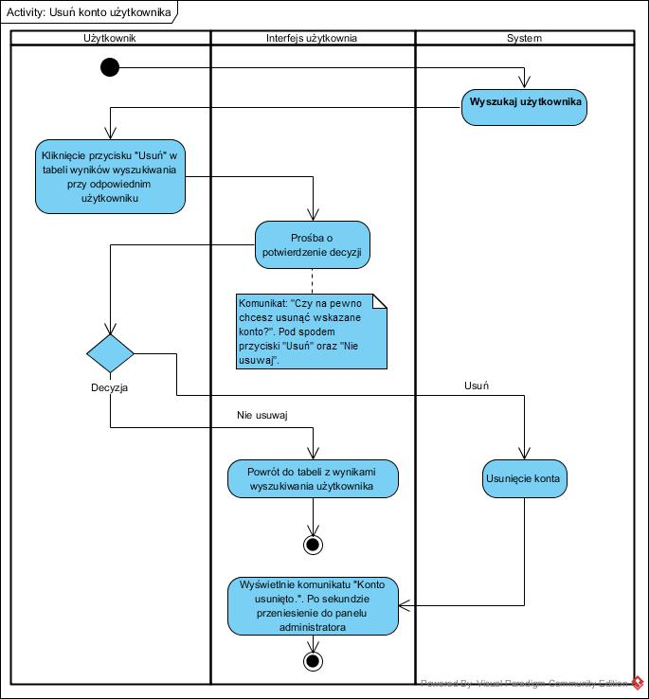

Search for user - library client search functionality, designed for being use by the administrator.
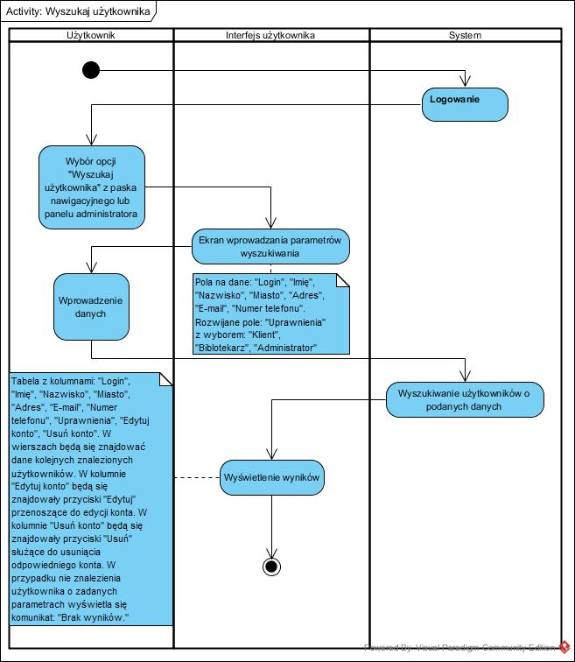

Edit item - with this function the librarian can edit an item belonging to the library collections.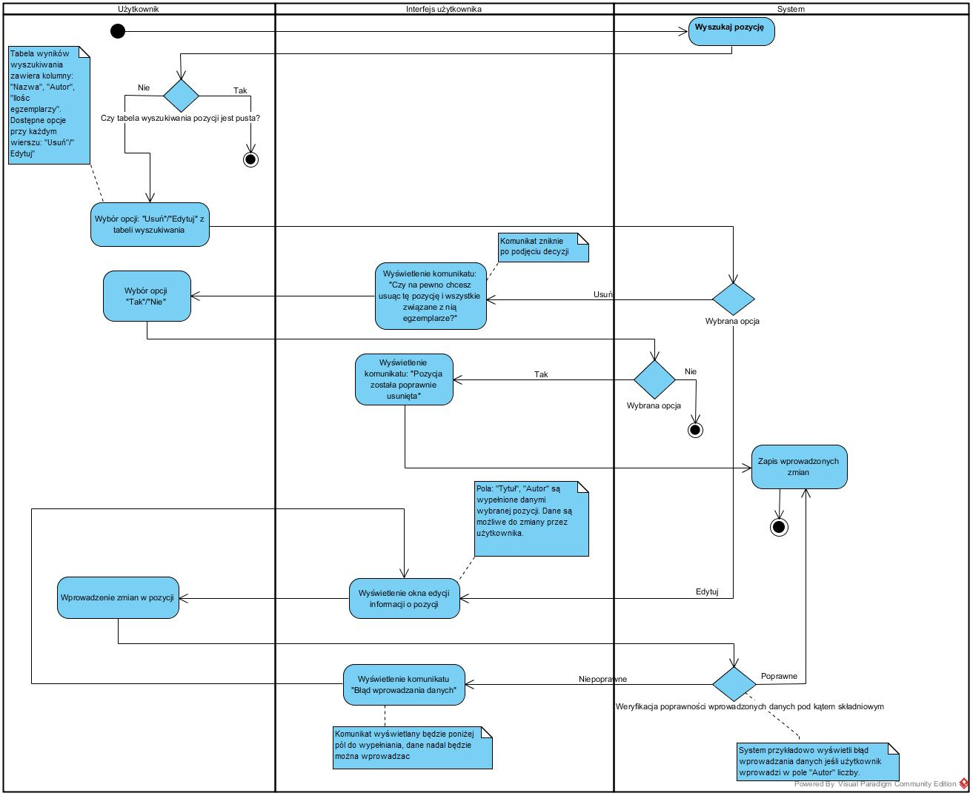
Add a new book - the diagram below describes the functionality of adding a new book to the library's book collection. This function is intended for librarian.
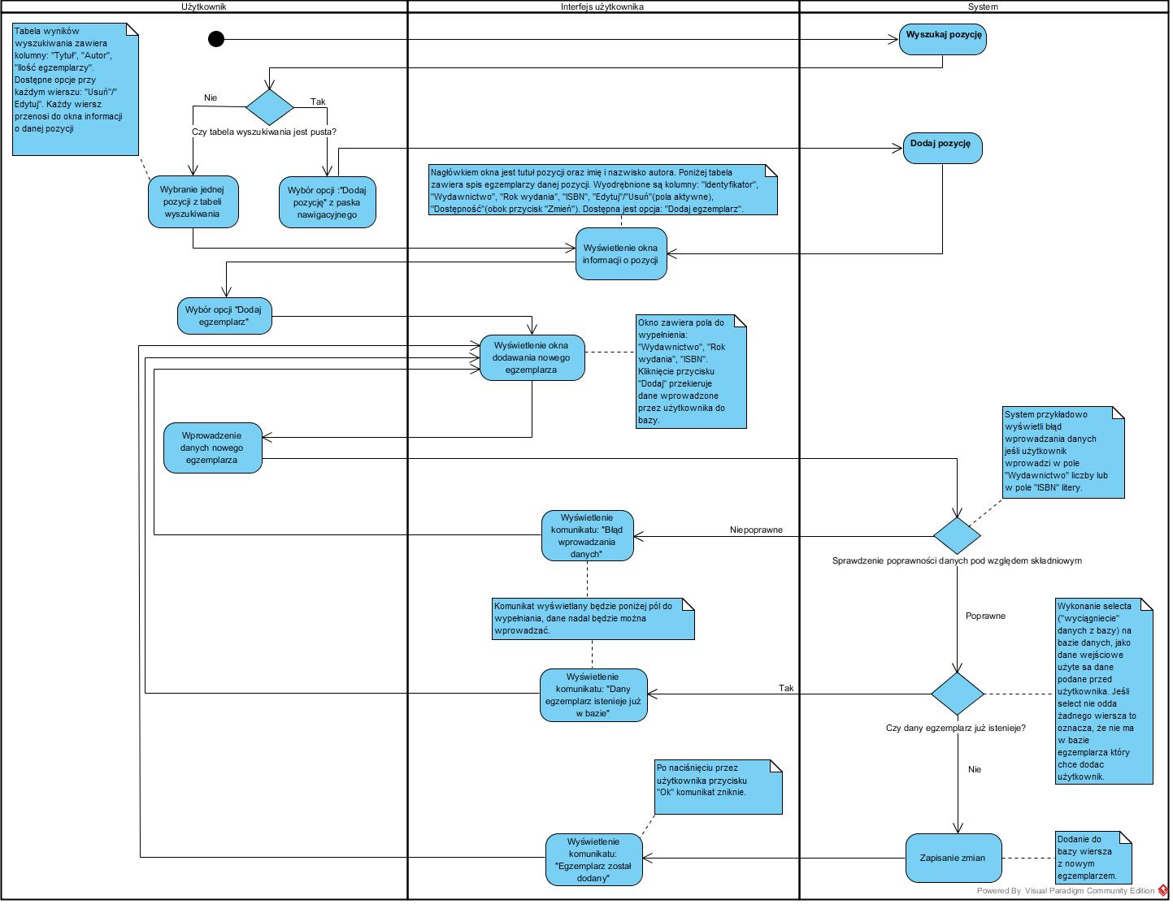

Delete a book - a function intend for librarian that allows to delete a book from book’s collection.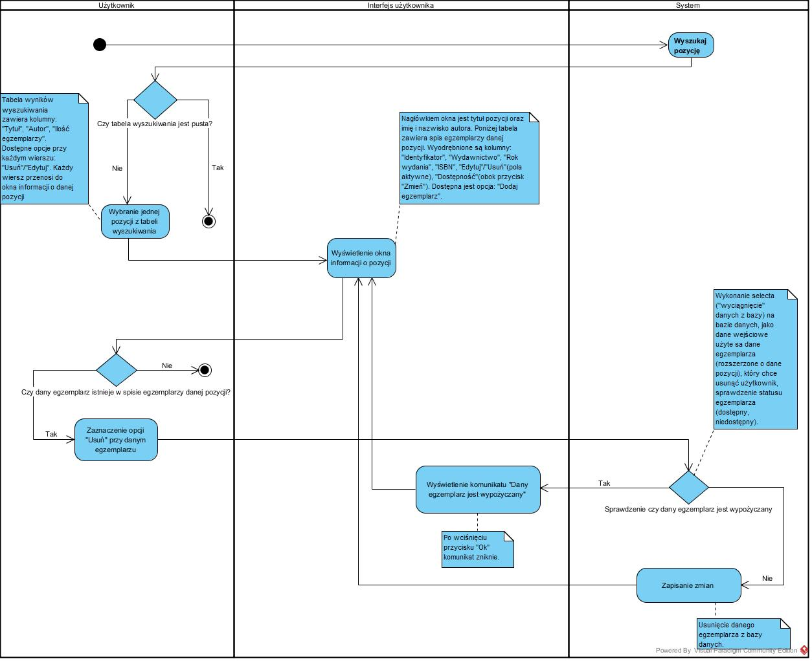

Edit the book status – functionality allows to edit the book status in the library by the librarian.
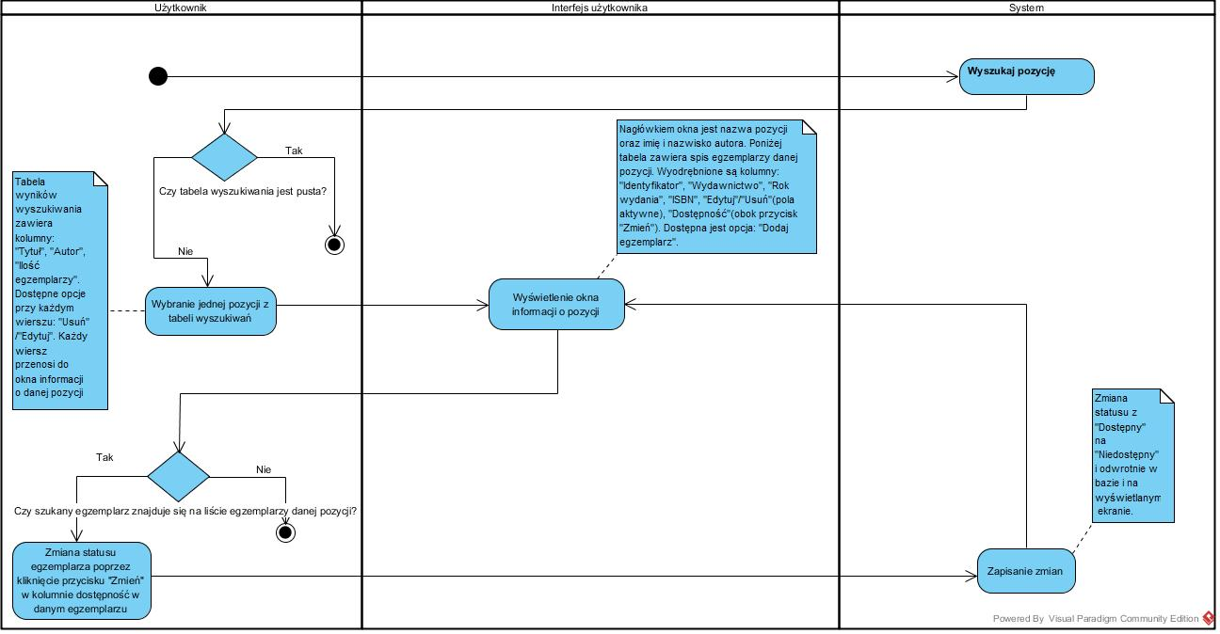

Search item - after logging in, the librarian can search for an item to check if it is available in the library's book collection.
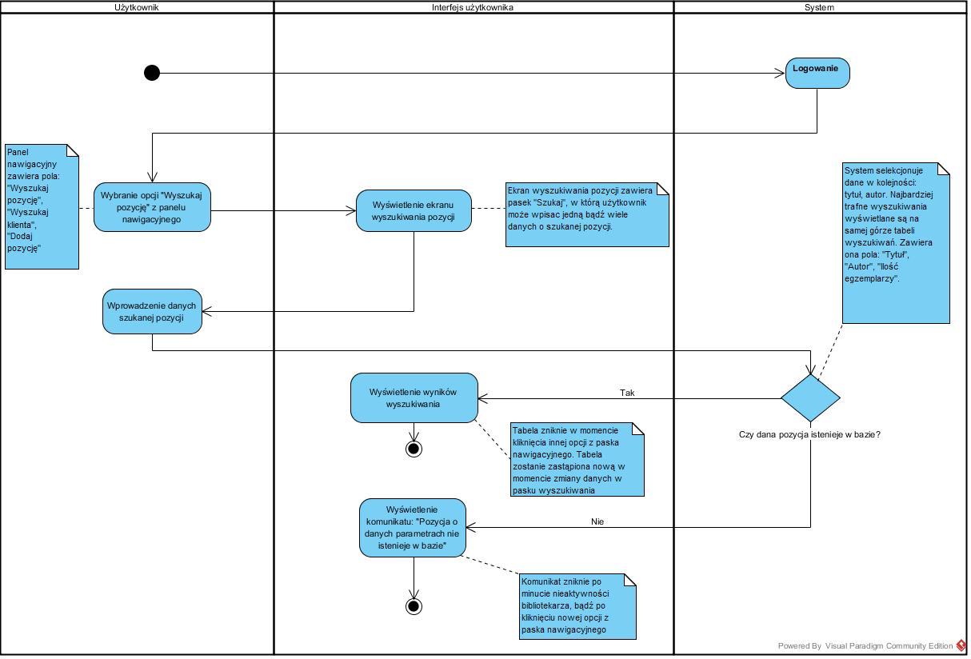

Add an item - the librarian can add a new item to the library's book collection.
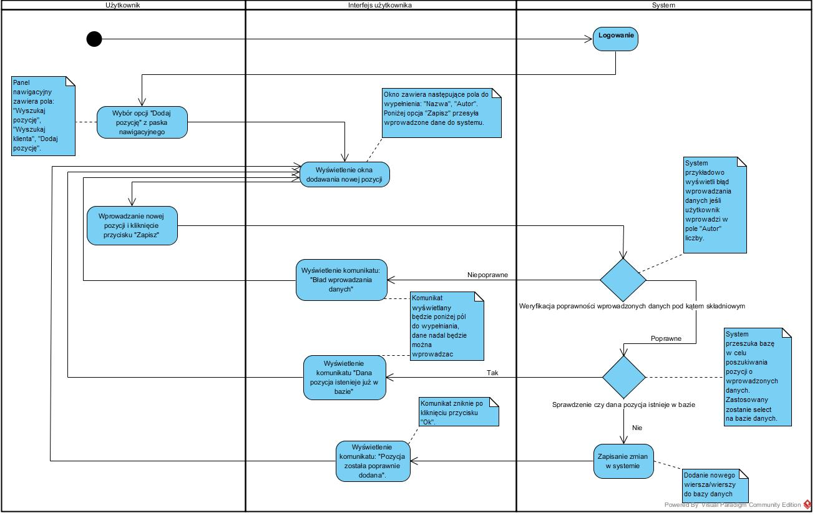

Check the client status - the function allows the librarian to check information about a particular user.
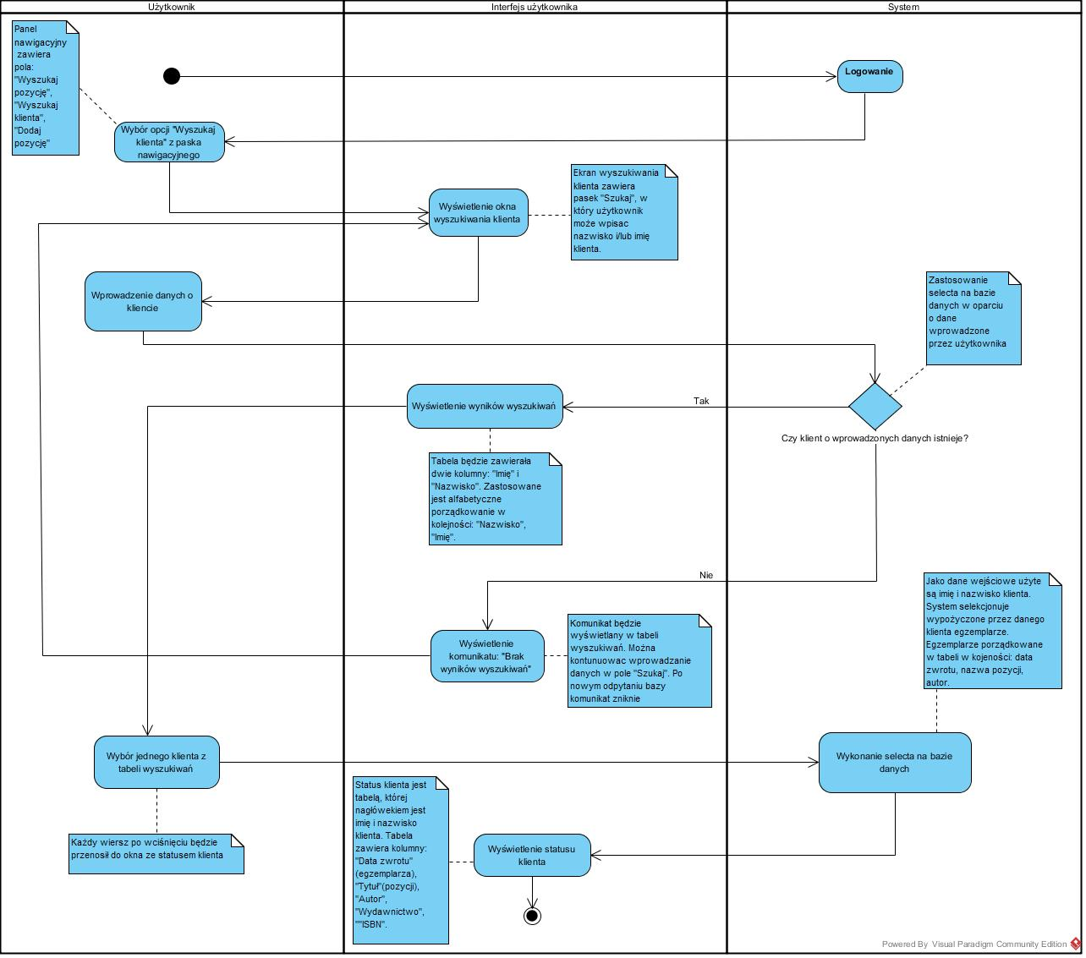

Section 3

Domain model . Class diagram
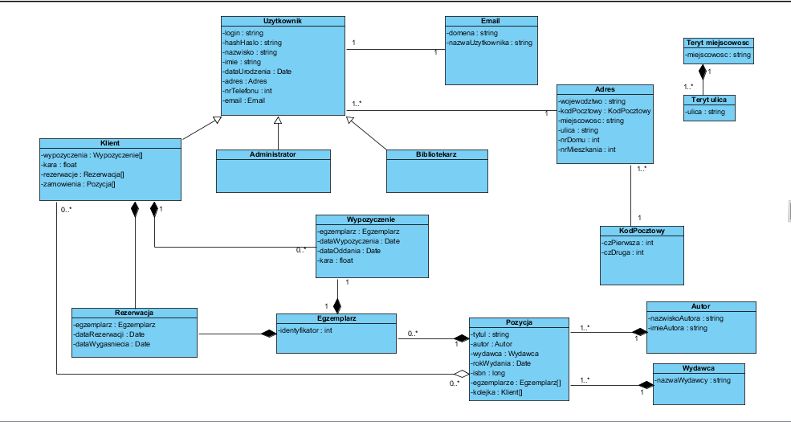
The class diagram shows the types of objects in the system, relations between objects and their attributes. The Library, Administrator and Client classes inherit from the User class - each of these classes has personal data fields stored in the appropriate classes. The customer has the possibility to book an item, which can be booked or rented. The Rental and Booking classes are connected by the relationship of composition with the item and the customer - there must be objects of both classes for the existence of the Rental or Booking class instance. The Item is connected by composition relations with the Position class, which is connected by the same relationship with the Author and Publisher class.
State Machine Diagram

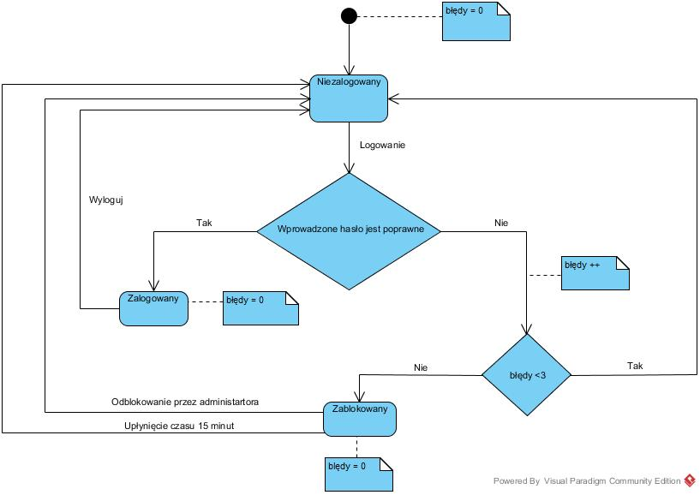

Section 4

Definition of the external system - PayU, used for payment processing. Diagrams of usecase, classes and sequences. The PayU system is used by the library system when the client wants to pay a fine for the books kept. The diagrams below describe how the library system connects to PayU.

Usecase diagram for library system and external system.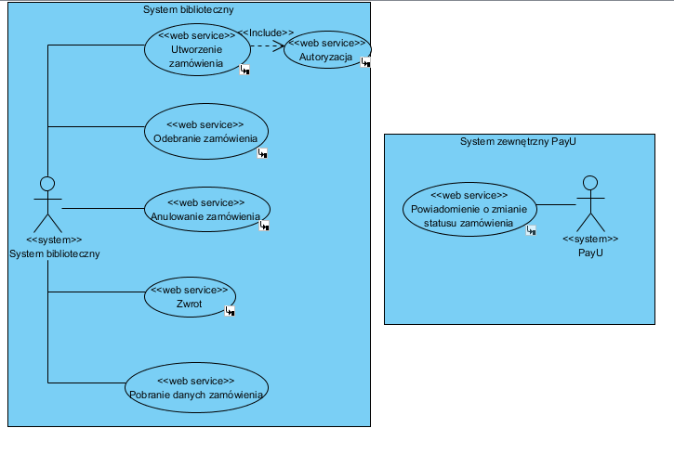
Class diagram : Create an order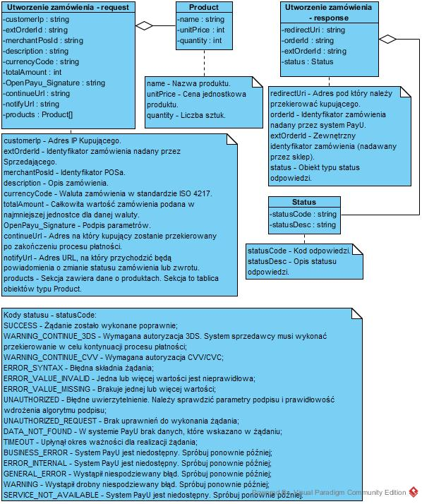

Sequence diagram : Create an order
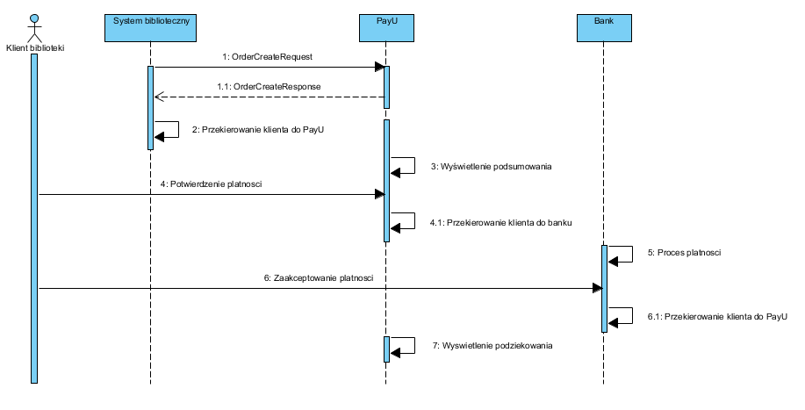

Class diagram : Order realisation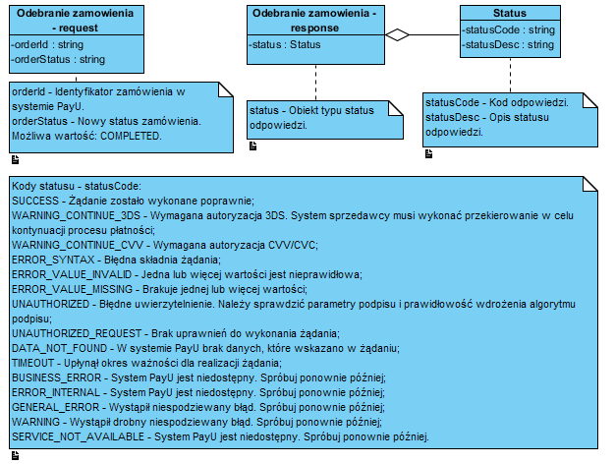
Sequence diagram: Order realisation
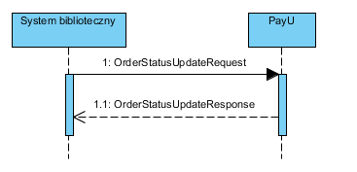

Class diagram : Cancelation of an order
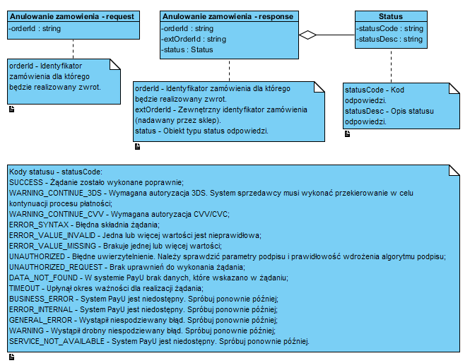

Sequence diagram: Cancelation of an order

Class diagram : Return of the book
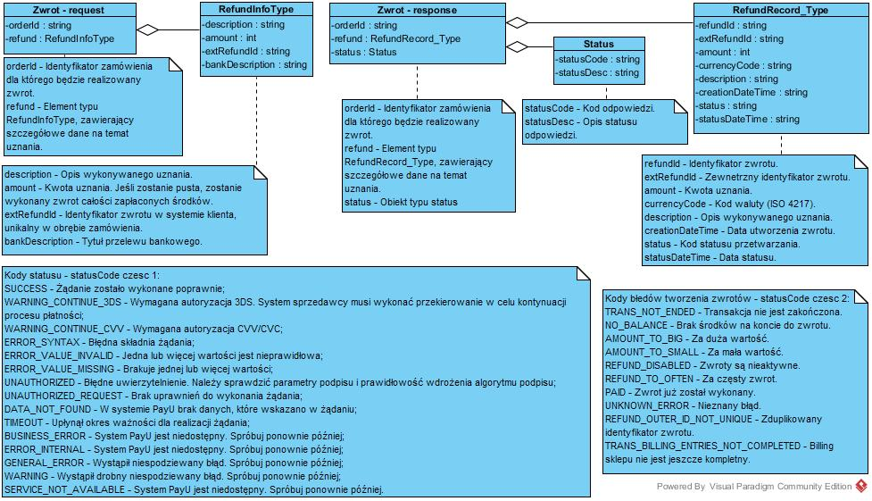

Sequence diagram : Return of the book
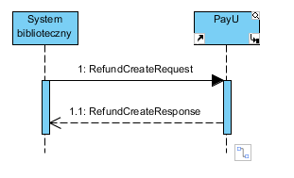

Class diagram : Download order data
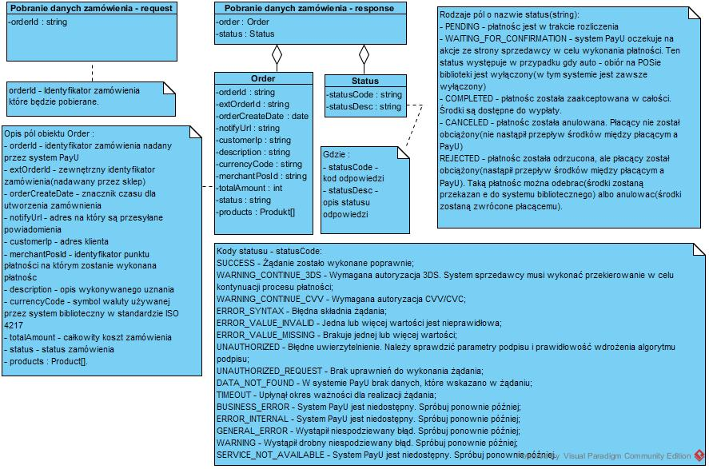

Sewuence diagram : Download order data
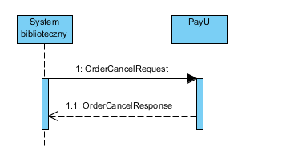

Class diagram : Notification of a change in the order status
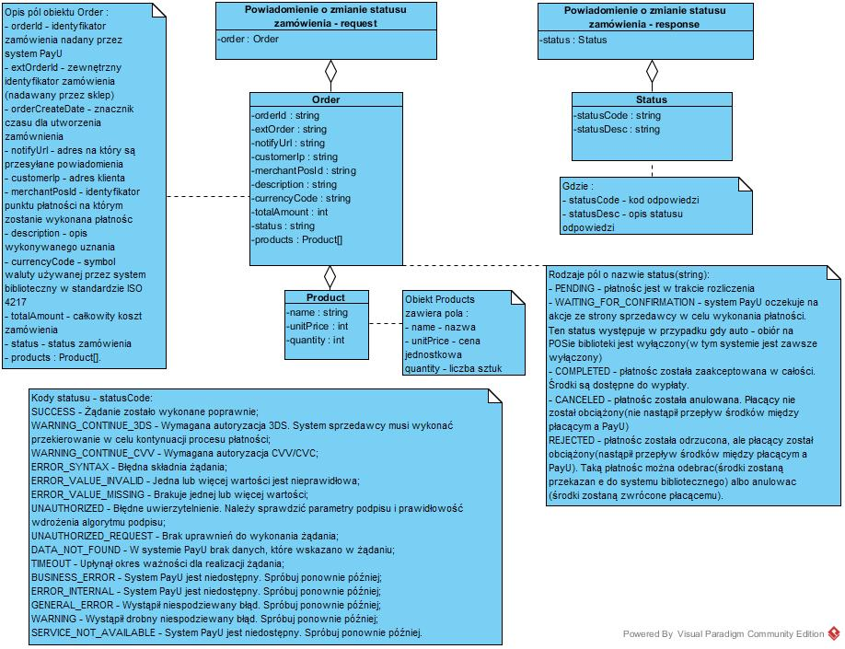
Sequence diagram : Notification of a change in the order status

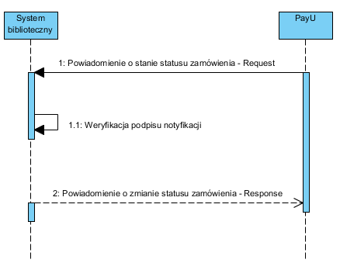
Class diagram : Authorisation
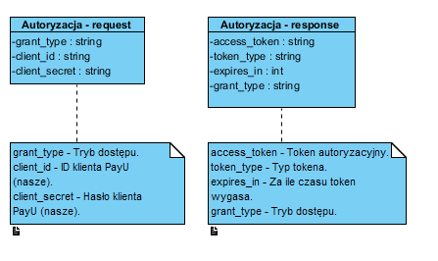

Sequence diagram : Authorisation

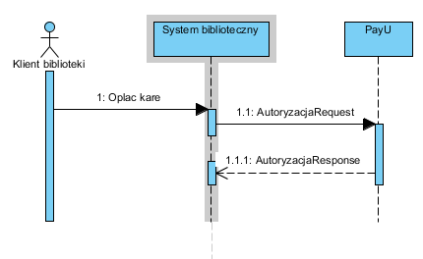

Deployment Diagram Component

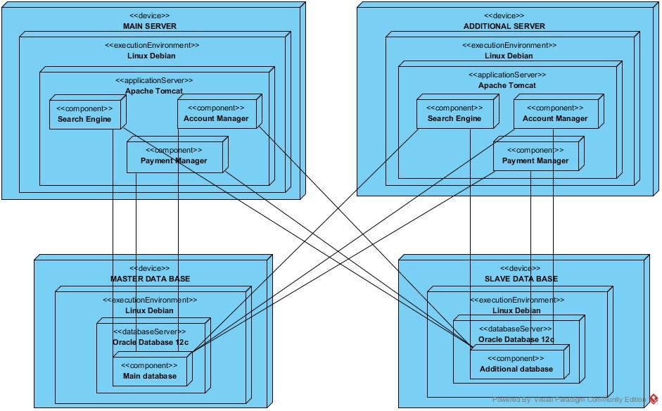
Deployment Diagram Hardware

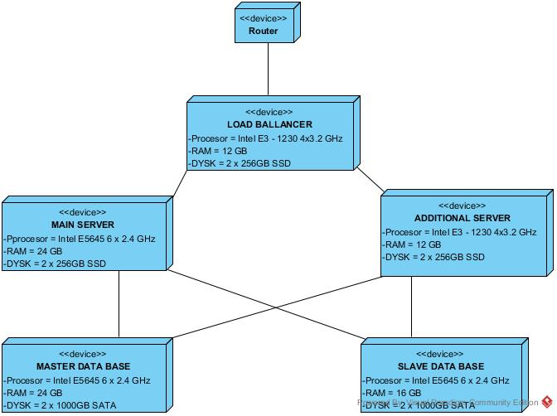

Deployment Diagram Runtime Environment

