# Module 4 Assignment 1

## Underwood, Katie

#install.packages("caret")  
#install.packages("rpart")  
#install.packages("rpart.plot")  
#install.packages("rattle")  
#install.packages("RColorBrewer")  
library(tidyverse)

## -- Attaching packages --------------------------------------- tidyverse 1.3.0 --

## v ggplot2 3.3.2 v purrr 0.3.4  
## v tibble 3.0.4 v dplyr 1.0.2  
## v tidyr 1.1.2 v stringr 1.4.0  
## v readr 1.4.0 v forcats 0.5.0

## -- Conflicts ------------------------------------------ tidyverse_conflicts() --  
## x dplyr::filter() masks stats::filter()  
## x dplyr::lag() masks stats::lag()

library(tidymodels)

## -- Attaching packages -------------------------------------- tidymodels 0.1.2 --

## v broom 0.7.2 v recipes 0.1.15  
## v dials 0.0.9 v rsample 0.0.8   
## v infer 0.5.4 v tune 0.1.2   
## v modeldata 0.1.0 v workflows 0.2.1   
## v parsnip 0.1.5 v yardstick 0.0.7

## -- Conflicts ----------------------------------------- tidymodels_conflicts() --  
## x scales::discard() masks purrr::discard()  
## x dplyr::filter() masks stats::filter()  
## x recipes::fixed() masks stringr::fixed()  
## x dplyr::lag() masks stats::lag()  
## x yardstick::spec() masks readr::spec()  
## x recipes::step() masks stats::step()

library(caret)

## Loading required package: lattice

##   
## Attaching package: 'caret'

## The following objects are masked from 'package:yardstick':  
##   
## precision, recall, sensitivity, specificity

## The following object is masked from 'package:purrr':  
##   
## lift

library(rpart)

##   
## Attaching package: 'rpart'

## The following object is masked from 'package:dials':  
##   
## prune

library(rpart.plot)  
library(rattle)

## Loading required package: bitops

## Rattle: A free graphical interface for data science with R.  
## Version 5.4.0 Copyright (c) 2006-2020 Togaware Pty Ltd.  
## Type 'rattle()' to shake, rattle, and roll your data.

library(RColorBrewer)

parole = read_csv("parole (1).csv")

##   
## -- Column specification --------------------------------------------------------  
## cols(  
## male = col_double(),  
## race = col_double(),  
## age = col_double(),  
## state = col_double(),  
## time.served = col_double(),  
## max.sentence = col_double(),  
## multiple.offenses = col_double(),  
## crime = col_double(),  
## violator = col_double()  
## )

parole = parole %>% mutate(male= as_factor(male)) %>%  
 mutate(male = fct_recode(male, "male"= "1", "female" = "0"))  
parole = parole %>% mutate(race= as_factor(race)) %>%  
 mutate(race = fct_recode(race, "white" = "1", "other" = "2"))  
parole = parole %>% mutate(state= as_factor(state)) %>%  
 mutate(state = fct_recode(state, "other" = "1", "Kentucky" = "2", "Louisiana" = "3", "Virginia" = "4"))  
parole = parole %>% mutate(crime= as_factor(crime)) %>%  
 mutate(crime = fct_recode(crime, "other" = "1", "larceny" = "2", "drug" = "3", "drive" = "4"))  
parole = parole %>% mutate(multiple.offenses= as_factor(multiple.offenses)) %>%  
 mutate(multiple.offenses = fct_recode(multiple.offenses, "yes" = "1", "no" = "0"))  
parole = parole %>% mutate(violator= as_factor(violator)) %>%  
 mutate(violator = fct_recode(violator, "yes" = "1", "no" = "0"))

## Task 1

set.seed(12345)  
parole_split = initial_split(parole, prop = .7, strata = violator)  
train = training(parole_split)  
test = testing(parole_split)

## Task 2

parole_recipe = recipe(violator ~., train)  
  
tree_model = decision_tree() %>%  
 set_engine("rpart", model = TRUE) %>%  
 set_mode("classification")  
  
parole_wflow =   
 workflow() %>%  
 add_model(tree_model) %>%  
 add_recipe(parole_recipe)  
  
parole_fit = fit(parole_wflow, train)  
  
tree = parole_fit %>%  
 pull_workflow_fit() %>%  
 pluck("fit")  
  
rpart.plot(tree)

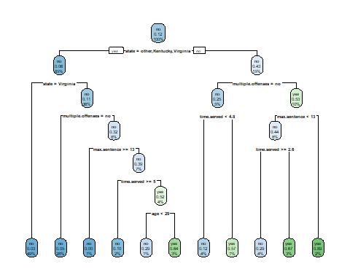

fancyRpartPlot(tree, tweak=1.5)

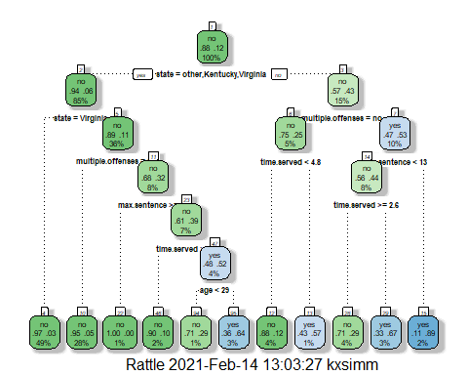

## Task 3

For the given example (40 yo, Louisiana, served 5 years, sentence 10, multiple offenses)

* First decision point is “no” (state=Louisiana)
* Second point is “no” (multiple.offenses=yes)
* Third point is “no” (time served > 4.8 years)

Leads me to a prediction that this person will NOT violate parole. 4% of the population is in this group.

## Task 4

The optimal CP value is .0545 (0 splits) based on the lowest xerror of 1.0. This is not the same as the model from Task 2.

parole_fit$fit$fit$fit$cptable

## CP nsplit rel error xerror xstd  
## 1 0.05454545 0 1.0000000 1.000000 0.1267582  
## 2 0.01818182 4 0.7818182 1.090909 0.1316005  
## 3 0.01454545 5 0.7636364 1.090909 0.1316005  
## 4 0.01000000 10 0.6909091 1.127273 0.1334515

## Task 5

set.seed(123)  
folds = vfold_cv(train, v = 5)  
  
parole_model2 = decision_tree(cost_complexity = tune()) %>%  
 set_engine("rpart", model = TRUE) %>%  
 set_mode("classification")  
  
parole_grid = grid_regular(cost_complexity(), levels = 25)  
  
parole_wflow2 =  
 workflow() %>%  
 add_model(parole_model2) %>%  
 add_recipe(parole_recipe)  
  
tree_res =   
 parole_wflow2 %>%  
 tune_grid(  
 resamples = folds,  
 grid = parole_grid  
 )

##   
## Attaching package: 'rlang'

## The following objects are masked from 'package:purrr':  
##   
## %@%, as_function, flatten, flatten_chr, flatten_dbl, flatten_int,  
## flatten_lgl, flatten_raw, invoke, list_along, modify, prepend,  
## splice

##   
## Attaching package: 'vctrs'

## The following object is masked from 'package:dplyr':  
##   
## data_frame

## The following object is masked from 'package:tibble':  
##   
## data_frame

tree_res %>%  
 collect_metrics() %>%  
 ggplot(aes(cost_complexity, mean)) +  
 geom_line(size = 1.5, alpha = 0.6) +  
 geom_point(size = 2) +  
 facet_wrap(~ .metric, scales = "free", nrow = 2)

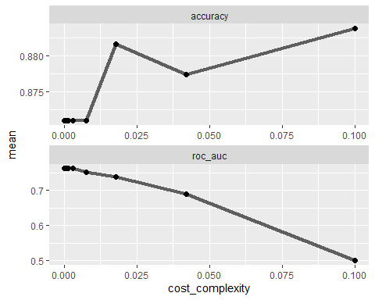

## Task 6

Optimal cp value is .1

best_tree = tree_res %>%  
 select_best("accuracy")  
  
best_tree

## # A tibble: 1 x 2  
## cost_complexity .config   
## <dbl> <chr>   
## 1 0.1 Preprocessor1_Model25

## Task 7

final_wf =   
 parole_wflow2 %>%  
 finalize_workflow(best_tree)  
  
final_fit = fit(final_wf, train)  
  
tree2 = final_fit %>%  
 pull_workflow_fit() %>%  
 pluck("fit")  
  
#fancyRpartPlot(tree2, tweak = 1.5)

## Task 8

Accuracy is 88% (on the testing set)

treepred = predict(final_fit, train, type = "class")  
head(treepred)

## # A tibble: 6 x 1  
## .pred_class  
## <fct>   
## 1 no   
## 2 no   
## 3 no   
## 4 no   
## 5 no   
## 6 no

confusionMatrix(treepred$.pred_class,train$violator,positive="yes")

## Confusion Matrix and Statistics  
##   
## Reference  
## Prediction no yes  
## no 418 55  
## yes 0 0  
##   
## Accuracy : 0.8837   
## 95% CI : (0.8513, 0.9112)  
## No Information Rate : 0.8837   
## P-Value [Acc > NIR] : 0.5358   
##   
## Kappa : 0   
##   
## Mcnemar's Test P-Value : 3.305e-13   
##   
## Sensitivity : 0.0000   
## Specificity : 1.0000   
## Pos Pred Value : NaN   
## Neg Pred Value : 0.8837   
## Prevalence : 0.1163   
## Detection Rate : 0.0000   
## Detection Prevalence : 0.0000   
## Balanced Accuracy : 0.5000   
##   
## 'Positive' Class : yes   
##

## Task 9

Blood <- read_csv("Blood.csv")

##   
## -- Column specification --------------------------------------------------------  
## cols(  
## Mnths_Since_Last = col_double(),  
## TotalDonations = col_double(),  
## Total_Donated = col_double(),  
## Mnths_Since_First = col_double(),  
## DonatedMarch = col_double()  
## )

Blood = Blood %>% mutate(DonatedMarch= as_factor(DonatedMarch)) %>%  
 mutate(DonatedMarch = fct_recode(DonatedMarch, "No"= "1", "Yes" = "0"))  
set.seed(1234)  
blood_split = initial_split(Blood, prop = .7, strata = DonatedMarch)  
train2 = training(blood_split)  
test2 = testing(blood_split)

blood_recipe = recipe(DonatedMarch ~., train2)  
  
tree_model = decision_tree() %>%  
 set_engine("rpart", model = TRUE) %>%  
 set_mode("classification")  
  
blood_wflow =   
 workflow() %>%  
 add_model(tree_model) %>%  
 add_recipe(blood_recipe)  
  
blood_fit = fit(blood_wflow, train2)  
  
treeblood = blood_fit %>%  
 pull_workflow_fit() %>%  
 pluck("fit")  
  
rpart.plot(treeblood)

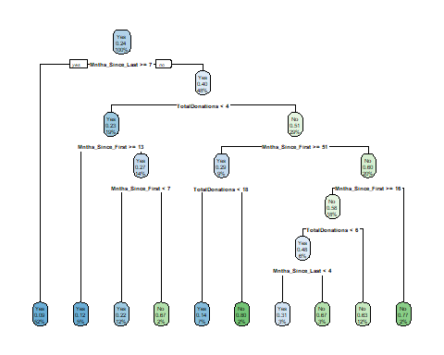

set.seed(1234)  
folds = vfold_cv(train2, v = 5)  
  
blood_model2 = decision_tree(cost_complexity = tune()) %>%  
 set_engine("rpart", model = TRUE) %>%  
 set_mode("classification")  
  
blood_grid = grid_regular(cost_complexity(), levels = 25)  
  
blood_wflow2 =  
 workflow() %>%  
 add_model(blood_model2) %>%  
 add_recipe(blood_recipe)  
  
tree_res2 =   
 blood_wflow2 %>%  
 tune_grid(  
 resamples = folds,  
 grid = blood_grid  
 )  
  
tree_res2 %>%  
 collect_metrics() %>%  
 ggplot(aes(cost_complexity, mean)) +  
 geom_line(size = 1.5, alpha = 0.6) +  
 geom_point(size = 2) +  
 facet_wrap(~ .metric, scales = "free", nrow = 2)

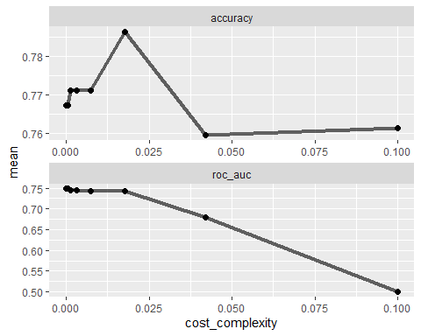 The best CP value for the highest accuracy looks to be somewhere between .017-.018

best_tree2 = tree_res2 %>%  
 select_best("accuracy")  
  
best_tree2

## # A tibble: 1 x 2  
## cost_complexity .config   
## <dbl> <chr>   
## 1 0.0178 Preprocessor1_Model23

## Task 10 & Task 11

Accuracy on the training set is .81 and on the testing set is .73.The performance is a decent bit lower on the testing set which makes me concerned about the quality of this model.

final_wf2 =   
 blood_wflow2 %>%  
 finalize_workflow(best_tree2)  
  
final_fit2 = fit(final_wf2, train2)  
  
treeblood2 = final_fit2 %>%  
 pull_workflow_fit() %>%  
 pluck("fit")  
  
treepred2 = predict(final_fit2, train2, type = "class")  
head(treepred2)

## # A tibble: 6 x 1  
## .pred_class  
## <fct>   
## 1 No   
## 2 No   
## 3 No   
## 4 No   
## 5 No   
## 6 No

confusionMatrix(treepred2$.pred_class,train2$DonatedMarch,positive="Yes")

## Confusion Matrix and Statistics  
##   
## Reference  
## Prediction Yes No  
## Yes 355 53  
## No 44 72  
##   
## Accuracy : 0.8149   
## 95% CI : (0.7789, 0.8472)  
## No Information Rate : 0.7615   
## P-Value [Acc > NIR] : 0.001931   
##   
## Kappa : 0.4775   
##   
## Mcnemar's Test P-Value : 0.416633   
##   
## Sensitivity : 0.8897   
## Specificity : 0.5760   
## Pos Pred Value : 0.8701   
## Neg Pred Value : 0.6207   
## Prevalence : 0.7615   
## Detection Rate : 0.6775   
## Detection Prevalence : 0.7786   
## Balanced Accuracy : 0.7329   
##   
## 'Positive' Class : Yes   
##

treepred3 = predict(final_fit2, test2, type = "class")  
head(treepred3)

## # A tibble: 6 x 1  
## .pred_class  
## <fct>   
## 1 No   
## 2 No   
## 3 No   
## 4 No   
## 5 No   
## 6 Yes

confusionMatrix(treepred3$.pred_class,test2$DonatedMarch,positive="Yes")

## Confusion Matrix and Statistics  
##   
## Reference  
## Prediction Yes No  
## Yes 144 34  
## No 27 19  
##   
## Accuracy : 0.7277   
## 95% CI : (0.6644, 0.7848)  
## No Information Rate : 0.7634   
## P-Value [Acc > NIR] : 0.9077   
##   
## Kappa : 0.2102   
##   
## Mcnemar's Test P-Value : 0.4424   
##   
## Sensitivity : 0.8421   
## Specificity : 0.3585   
## Pos Pred Value : 0.8090   
## Neg Pred Value : 0.4130   
## Prevalence : 0.7634   
## Detection Rate : 0.6429   
## Detection Prevalence : 0.7946   
## Balanced Accuracy : 0.6003   
##   
## 'Positive' Class : Yes   
##