# Final Project - BAN 502

## Underwood, Katie

library(tidyverse)

## -- Attaching packages --------------------------------------- tidyverse 1.3.0 --

## v ggplot2 3.3.2 v purrr 0.3.4  
## v tibble 3.0.4 v dplyr 1.0.2  
## v tidyr 1.1.2 v stringr 1.4.0  
## v readr 1.4.0 v forcats 0.5.0

## -- Conflicts ------------------------------------------ tidyverse_conflicts() --  
## x dplyr::filter() masks stats::filter()  
## x dplyr::lag() masks stats::lag()

ames_student <- read_csv("ames_student.csv")

## Warning: Missing column names filled in: 'X1' [1]

##   
## -- Column specification --------------------------------------------------------  
## cols(  
## .default = col_character(),  
## X1 = col_double(),  
## Lot_Frontage = col_double(),  
## Lot_Area = col_double(),  
## Year_Built = col_double(),  
## Year_Remod_Add = col_double(),  
## Mas_Vnr_Area = col_double(),  
## BsmtFin_SF_1 = col_double(),  
## BsmtFin_SF_2 = col_double(),  
## Bsmt_Unf_SF = col_double(),  
## Total_Bsmt_SF = col_double(),  
## First_Flr_SF = col_double(),  
## Second_Flr_SF = col_double(),  
## Low_Qual_Fin_SF = col_double(),  
## Gr_Liv_Area = col_double(),  
## Bsmt_Full_Bath = col_double(),  
## Bsmt_Half_Bath = col_double(),  
## Full_Bath = col_double(),  
## Half_Bath = col_double(),  
## Bedroom_AbvGr = col_double(),  
## Kitchen_AbvGr = col_double()  
## # ... with 15 more columns  
## )  
## i Use `spec()` for the full column specifications.

ames_student_clean = ames_student %>%   
 mutate(Street = factor(Street)) %>%  
 mutate(Alley = factor(Alley)) %>%  
 mutate(Lot_Shape = factor(Lot_Shape)) %>%  
 mutate(Land_Contour = factor(Land_Contour)) %>%  
 mutate(Utilities = factor(Utilities)) %>%  
 mutate(Lot_Config = factor(Lot_Config)) %>%  
 mutate(Land_Slope = factor(Land_Slope)) %>%  
 mutate(Neighborhood = factor(Neighborhood)) %>%  
 mutate(MS_Zoning = factor(MS_Zoning)) %>%  
 mutate(MS_SubClass = factor(MS_SubClass)) %>%  
 mutate(Condition_1 = factor(Condition_1)) %>%  
 mutate(Condition_2 = factor(Condition_2)) %>%  
 mutate(Bldg_Type = factor(Bldg_Type)) %>%  
 mutate(House_Style = factor(House_Style)) %>%  
 mutate(Overall_Qual = factor(Overall_Qual)) %>%  
 mutate(Overall_Cond = factor(Overall_Cond)) %>%  
 mutate(Roof_Style = factor(Roof_Style)) %>%  
 mutate(Roof_Matl = factor(Roof_Matl)) %>%  
 mutate(Exterior_1st = factor(Exterior_1st)) %>%  
 mutate(Exterior_2nd = factor(Exterior_2nd)) %>%  
 mutate(Mas_Vnr_Type = factor(Mas_Vnr_Type)) %>%  
 mutate(Exter_Qual = factor(Exter_Qual)) %>%  
 mutate(Exter_Cond = factor(Exter_Cond)) %>%  
 mutate(Foundation = factor(Foundation)) %>%  
 mutate(Bsmt_Qual = factor(Bsmt_Qual)) %>%  
 mutate(Bsmt_Cond = factor(Bsmt_Cond)) %>%  
 mutate(Bsmt_Exposure = factor(Bsmt_Exposure)) %>%  
 mutate(BsmtFin_Type_1 = factor(BsmtFin_Type_1)) %>%  
 mutate(BsmtFin_Type_2 = factor(BsmtFin_Type_2)) %>%  
 mutate(Heating = factor(Heating)) %>%  
 mutate(Heating_QC = factor(Heating_QC)) %>%  
 mutate(Central_Air = factor(Central_Air)) %>%  
 mutate(Electrical = factor(Electrical)) %>%  
 mutate(Kitchen_Qual = factor(Kitchen_Qual)) %>%  
 mutate(Fireplace_Qu = factor(Fireplace_Qu)) %>%  
 mutate(Garage_Type = factor(Garage_Type)) %>%  
 mutate(Garage_Finish = factor(Garage_Finish)) %>%  
 mutate(Garage_Qual = factor(Garage_Qual)) %>%  
 mutate(Garage_Cond = factor(Garage_Cond)) %>%  
 mutate(Paved_Drive = factor(Paved_Drive)) %>%  
 mutate(Pool_QC = factor(Pool_QC)) %>%  
 mutate(Fence = factor(Fence)) %>%  
 mutate(Misc_Feature = factor(Misc_Feature)) %>%  
 mutate(Sale_Type = factor(Sale_Type)) %>%  
 mutate(Sale_Condition = factor(Sale_Condition)) %>%  
 mutate(Above_Median = factor(Above_Median)) %>%  
 mutate(Functional = factor(Functional)) %>%  
 mutate(Mo_Sold = factor(Mo_Sold)) %>%  
 mutate(Year_Sold = factor(Year_Sold))  
  
#str(ames_student_clean)  
#summary(ames_student_clean)

ggplot(ames_student_clean, aes(x = MS_SubClass, fill = Above_Median)) + geom_bar(position = "fill")

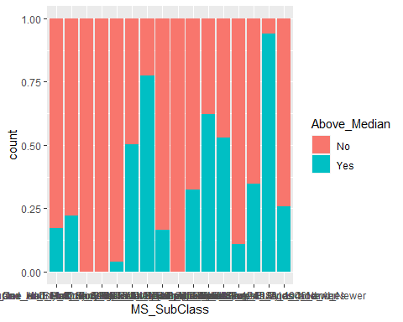

ggplot(ames_student_clean, aes(x = Street, fill = Above_Median)) + geom_bar(position = "fill")

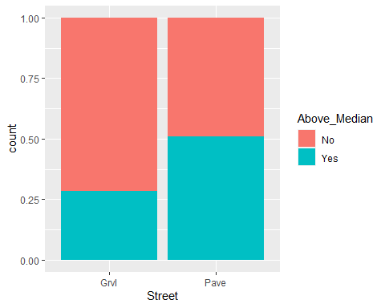

ggplot(ames_student_clean, aes(x = Alley, fill = Above_Median)) + geom_bar(position = "fill")

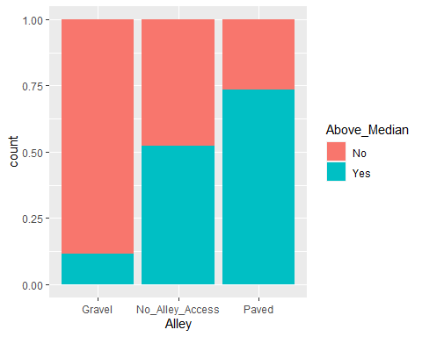

ggplot(ames_student_clean, aes(x = Lot_Shape, fill = Above_Median)) + geom_bar(position = "fill")

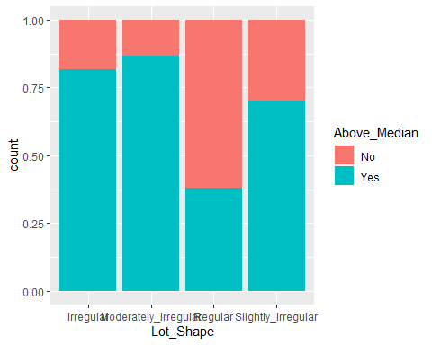

ggplot(ames_student_clean, aes(x = Land_Contour, fill = Above_Median)) + geom_bar(position = "fill")

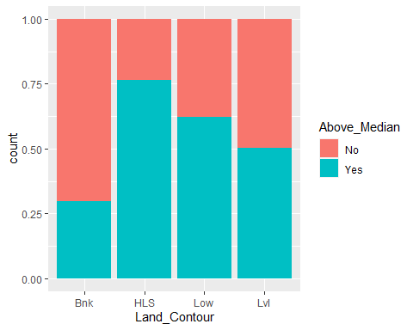

ggplot(ames_student_clean, aes(x = Utilities, fill = Above_Median)) + geom_bar(position = "fill")

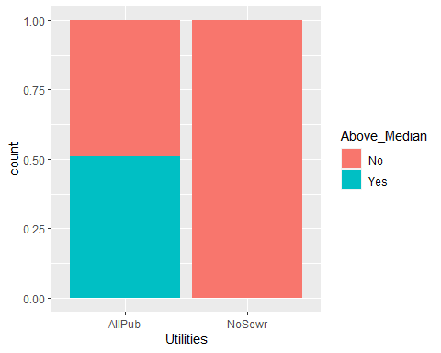

ggplot(ames_student_clean, aes(x = Lot_Config, fill = Above_Median)) + geom_bar(position = "fill")

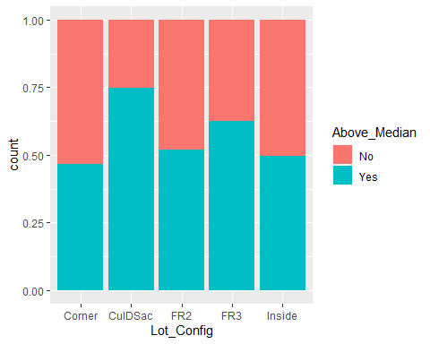

ggplot(ames_student_clean, aes(x = Land_Slope, fill = Above_Median)) + geom_bar(position = "fill")

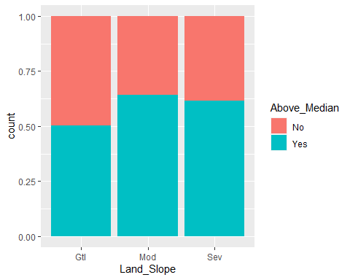

ggplot(ames_student_clean, aes(x = Neighborhood, fill = Above_Median)) + geom_bar(position = "fill")

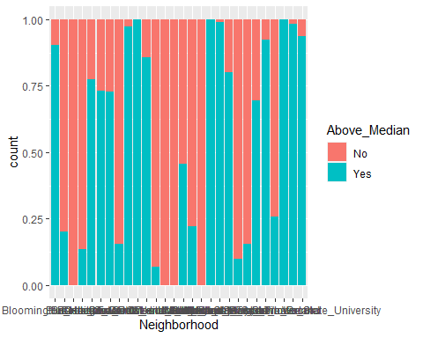

ggplot(ames_student_clean, aes(x = Condition_1, fill = Above_Median)) + geom_bar(position = "fill")

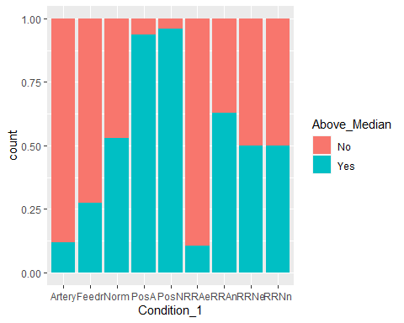

ggplot(ames_student_clean, aes(x = Condition_2, fill = Above_Median)) + geom_bar(position = "fill")

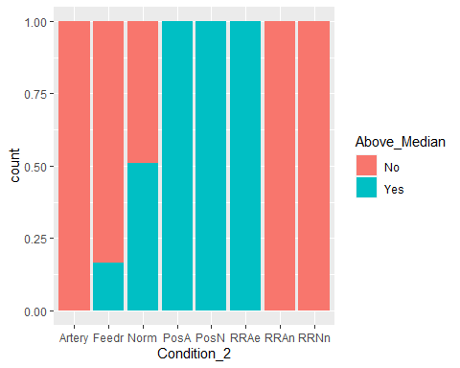

ggplot(ames_student_clean, aes(x = Bldg_Type, fill = Above_Median)) + geom_bar(position = "fill")

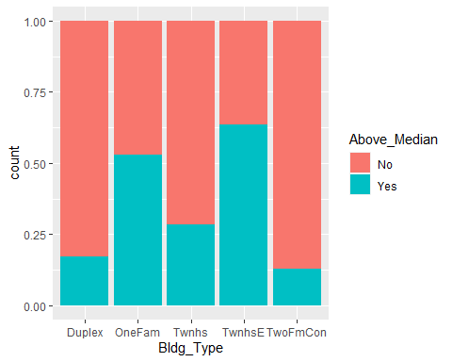

ggplot(ames_student_clean, aes(x = House_Style, fill = Above_Median)) + geom_bar(position = "fill")

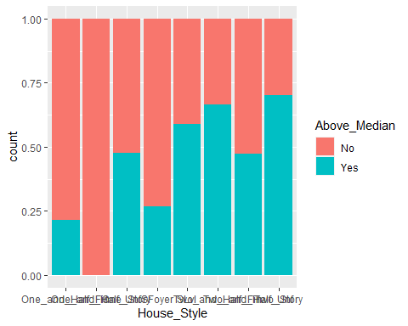

ggplot(ames_student_clean, aes(x = Overall_Qual, fill = Above_Median)) + geom_bar(position = "fill")

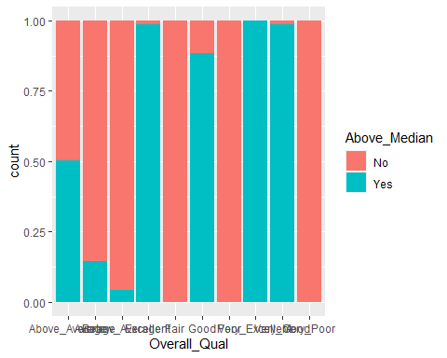

ggplot(ames_student_clean, aes(x = Overall_Cond, fill = Above_Median)) + geom_bar(position = "fill")

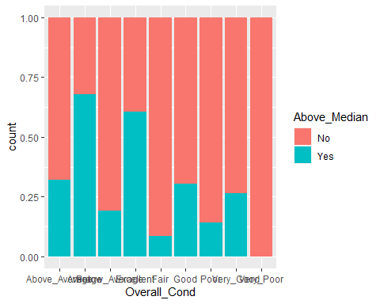

ggplot(ames_student_clean, aes(x = Roof_Style, fill = Above_Median)) + geom_bar(position = "fill")

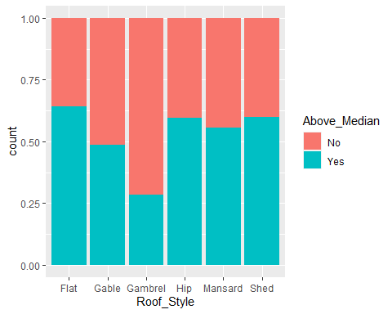

ggplot(ames_student_clean, aes(x = Roof_Matl, fill = Above_Median)) + geom_bar(position = "fill")

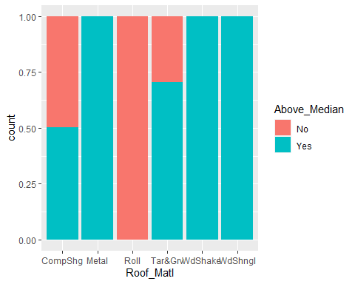

ggplot(ames_student_clean, aes(x = Exterior_1st, fill = Above_Median)) + geom_bar(position = "fill")

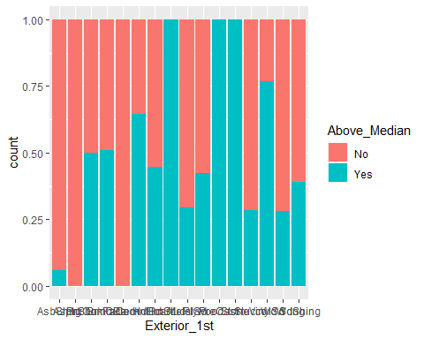

ggplot(ames_student_clean, aes(x = Exterior_2nd, fill = Above_Median)) + geom_bar(position = "fill")

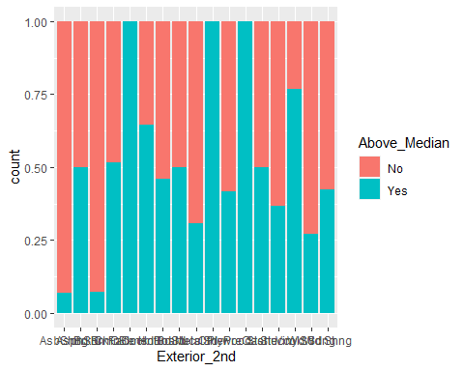

ggplot(ames_student_clean, aes(x = Mas_Vnr_Type, fill = Above_Median)) + geom_bar(position = "fill")

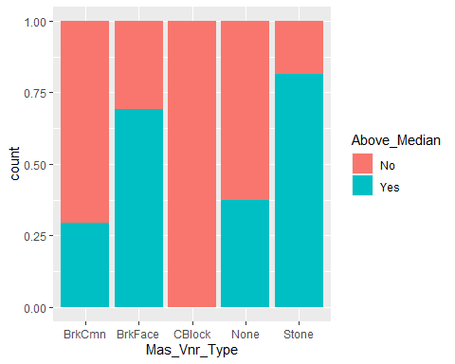

ggplot(ames_student_clean, aes(x = Exter_Qual, fill = Above_Median)) + geom_bar(position = "fill")

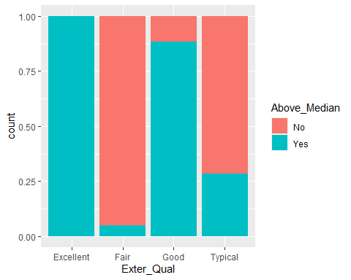

ggplot(ames_student_clean, aes(x = Exter_Cond, fill = Above_Median)) + geom_bar(position = "fill")

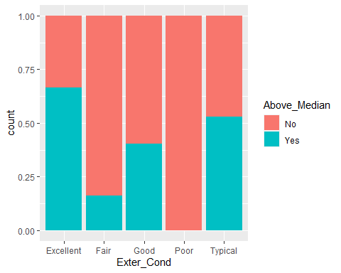

ggplot(ames_student_clean, aes(x = Foundation, fill = Above_Median)) + geom_bar(position = "fill")

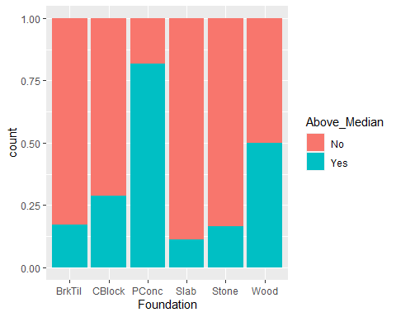

ggplot(ames_student_clean, aes(x = Bsmt_Qual, fill = Above_Median)) + geom_bar(position = "fill")

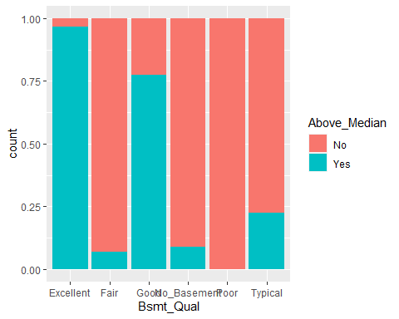

ggplot(ames_student_clean, aes(x = Bsmt_Cond, fill = Above_Median)) + geom_bar(position = "fill")

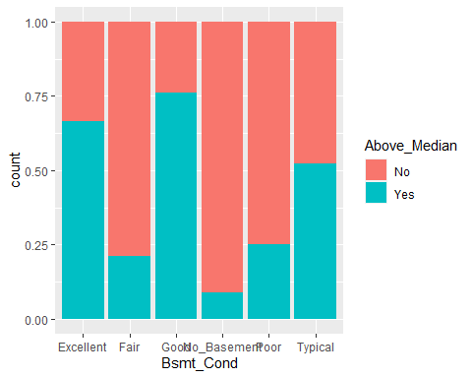

ggplot(ames_student_clean, aes(x = Bsmt_Exposure, fill = Above_Median)) + geom_bar(position = "fill")

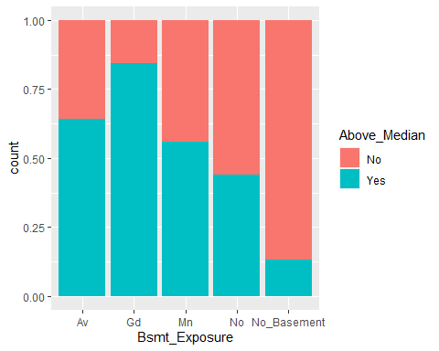

ggplot(ames_student_clean, aes(x = BsmtFin_Type_1, fill = Above_Median)) + geom_bar(position = "fill")

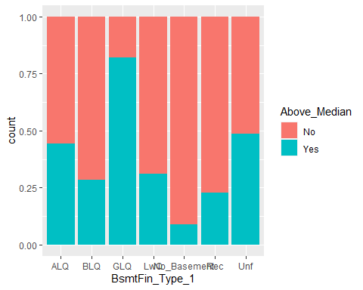

ggplot(ames_student_clean, aes(x = BsmtFin_Type_2, fill = Above_Median)) + geom_bar(position = "fill")

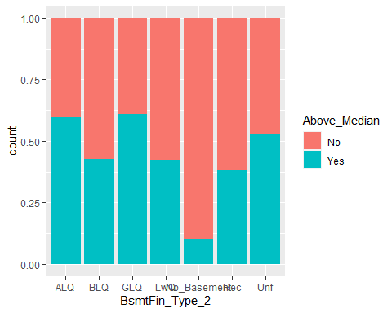

ggplot(ames_student_clean, aes(x = Heating, fill = Above_Median)) + geom_bar(position = "fill")

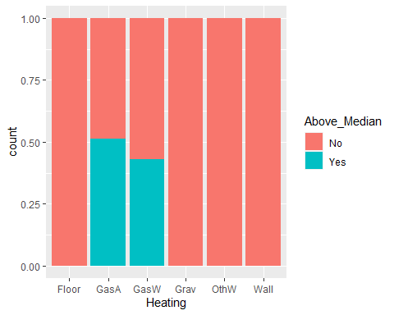

ggplot(ames_student_clean, aes(x = Heating_QC, fill = Above_Median)) + geom_bar(position = "fill")

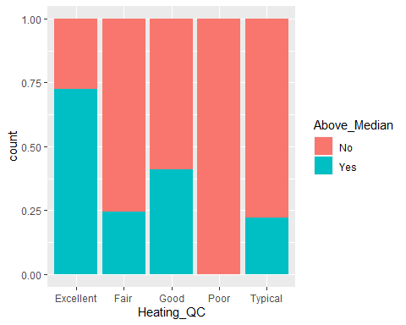

ggplot(ames_student_clean, aes(x = Central_Air, fill = Above_Median)) + geom_bar(position = "fill")

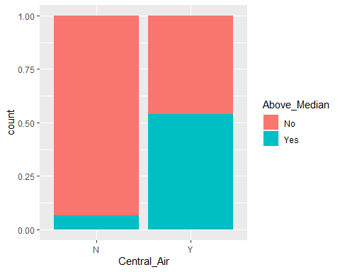

ggplot(ames_student_clean, aes(x = Electrical, fill = Above_Median)) + geom_bar(position = "fill")

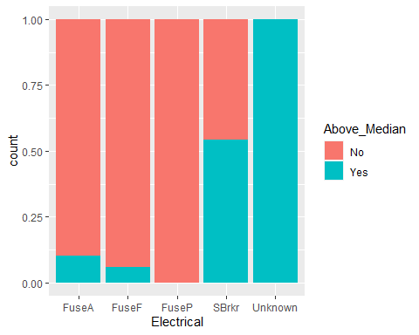

ggplot(ames_student_clean, aes(x = Kitchen_Qual, fill = Above_Median)) + geom_bar(position = "fill")

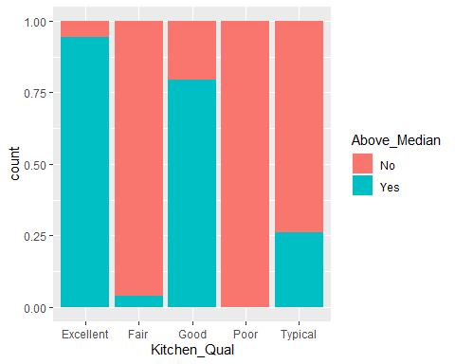

ggplot(ames_student_clean, aes(x = Functional, fill = Above_Median)) + geom_bar(position = "fill")

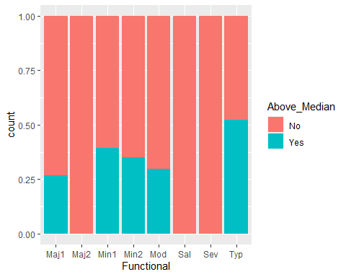

ggplot(ames_student_clean, aes(x = Fireplace_Qu, fill = Above_Median)) + geom_bar(position = "fill")

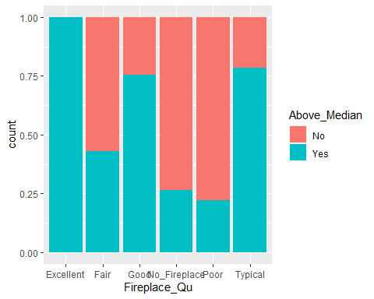

ggplot(ames_student_clean, aes(x = Garage_Type, fill = Above_Median)) + geom_bar(position = "fill")

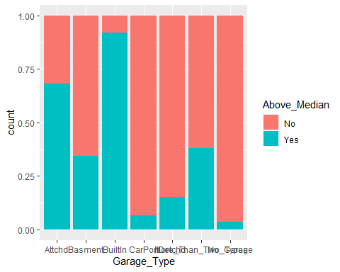

ggplot(ames_student_clean, aes(x = Garage_Finish, fill = Above_Median)) + geom_bar(position = "fill")

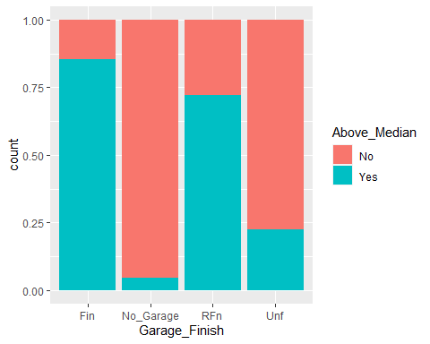

ggplot(ames_student_clean, aes(x = Garage_Qual, fill = Above_Median)) + geom_bar(position = "fill")

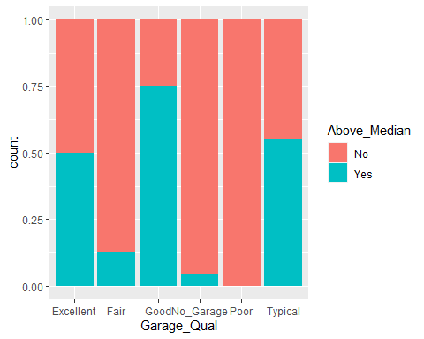

ggplot(ames_student_clean, aes(x = Garage_Cond, fill = Above_Median)) + geom_bar(position = "fill")

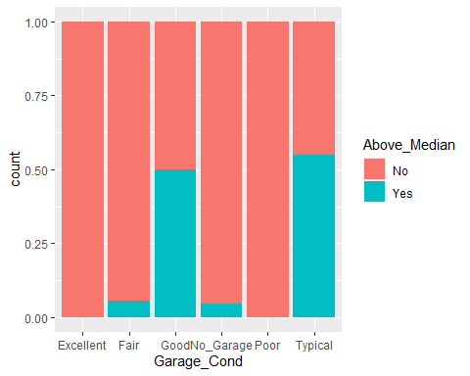

ggplot(ames_student_clean, aes(x = Paved_Drive, fill = Above_Median)) + geom_bar(position = "fill")

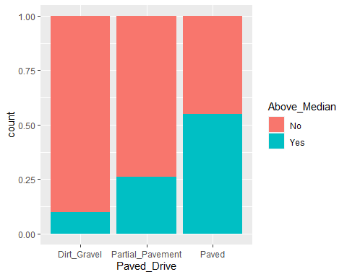

ggplot(ames_student_clean, aes(x = Pool_QC, fill = Above_Median)) + geom_bar(position = "fill")

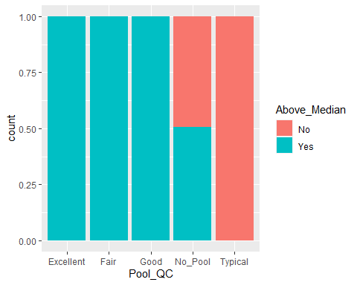

ggplot(ames_student_clean, aes(x = Fence, fill = Above_Median)) + geom_bar(position = "fill")

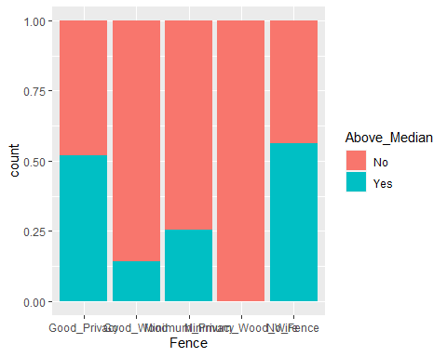

ggplot(ames_student_clean, aes(x = Misc_Feature, fill = Above_Median)) + geom_bar(position = "fill")

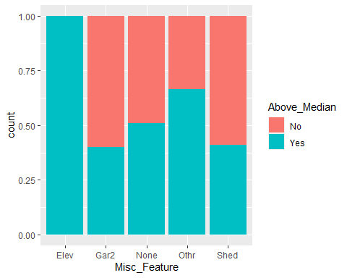

ggplot(ames_student_clean, aes(x = Sale_Type, fill = Above_Median)) + geom_bar(position = "fill")

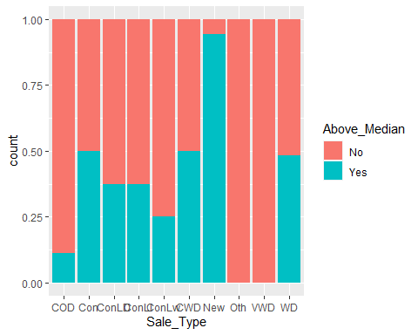

ggplot(ames_student_clean, aes(x = Sale_Condition, fill = Above_Median)) + geom_bar(position = "fill")

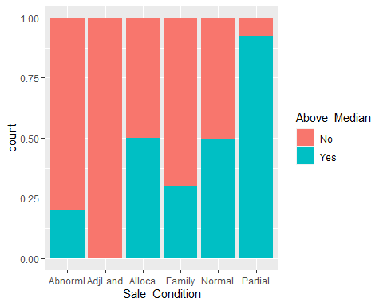

ggplot(ames_student_clean, aes(x = Mo_Sold, fill = Above_Median)) + geom_bar(position = "fill")

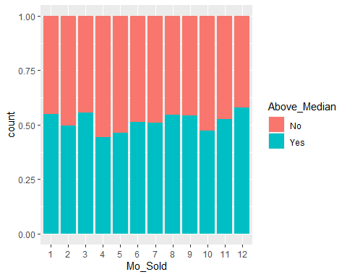

ggplot(ames_student_clean, aes(x = Year_Sold, fill = Above_Median)) + geom_bar(position = "fill")

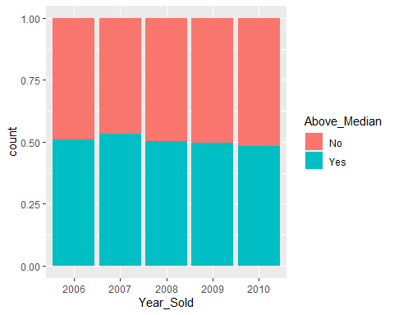

ggplot(ames_student_clean, aes(x = Above_Median, y=Lot_Frontage)) + geom_boxplot()

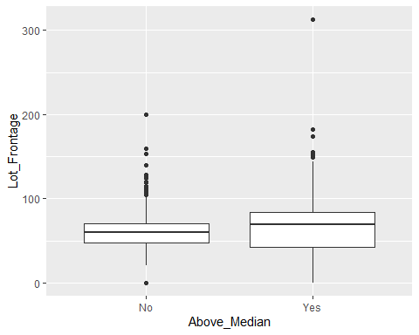

ggplot(ames_student_clean, aes(x = Above_Median, y=Lot_Area)) + geom_boxplot()

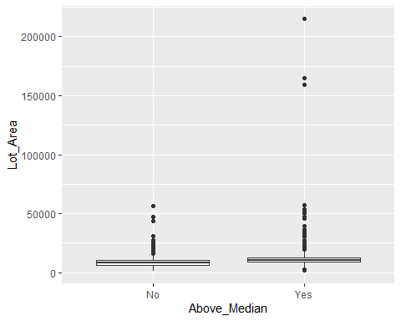

ggplot(ames_student_clean, aes(x = Above_Median, y=Year_Built)) + geom_boxplot()

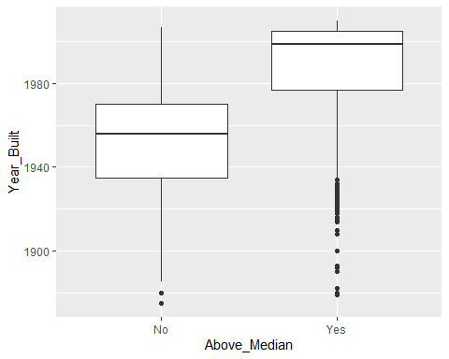

ggplot(ames_student_clean, aes(x = Above_Median, y=Year_Remod_Add)) + geom_boxplot()

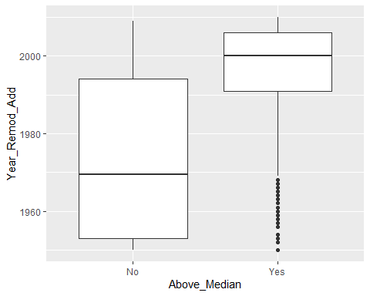

ggplot(ames_student_clean, aes(x = Above_Median, y=Mas_Vnr_Area)) + geom_boxplot()

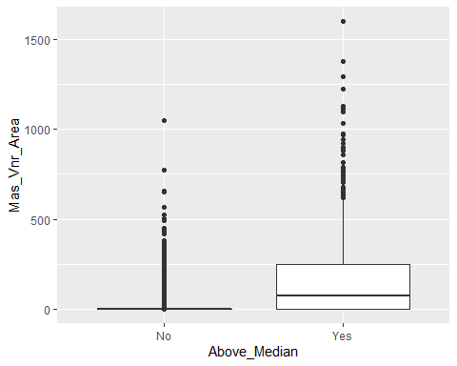

ggplot(ames_student_clean, aes(x = Above_Median, y=BsmtFin_SF_1)) + geom_boxplot()

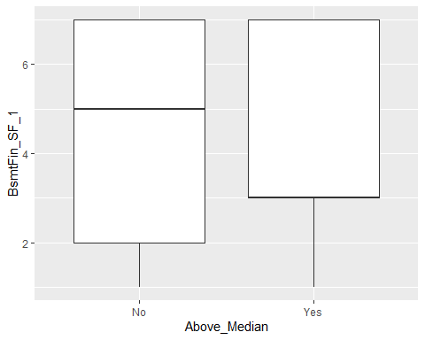

ggplot(ames_student_clean, aes(x = Above_Median, y=BsmtFin_SF_2)) + geom_boxplot()

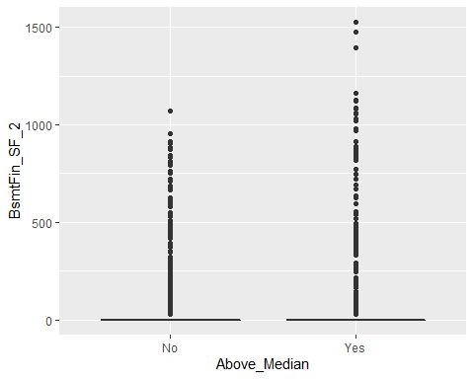

ggplot(ames_student_clean, aes(x = Above_Median, y=Bsmt_Unf_SF)) + geom_boxplot()

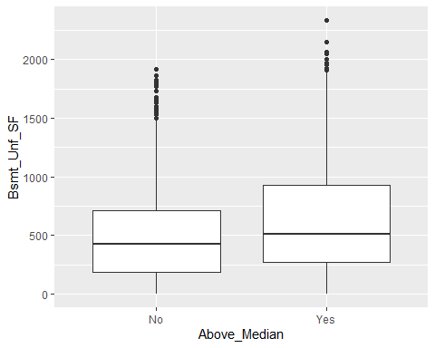

ggplot(ames_student_clean, aes(x = Above_Median, y=Total_Bsmt_SF)) + geom_boxplot()

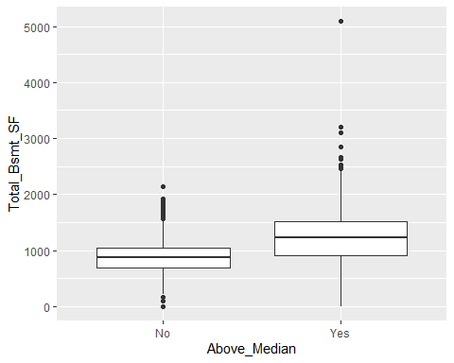

ggplot(ames_student_clean, aes(x = Above_Median, y=First_Flr_SF)) + geom_boxplot()

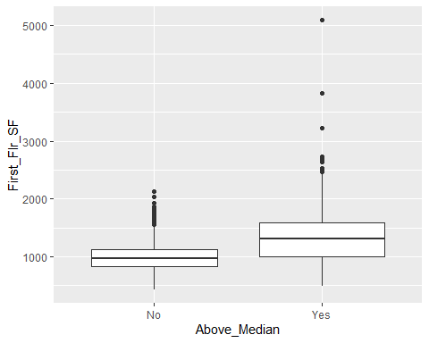

ggplot(ames_student_clean, aes(x = Above_Median, y=Second_Flr_SF)) + geom_boxplot()

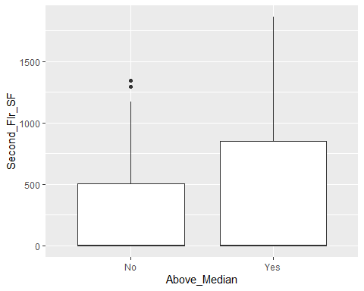

ggplot(ames_student_clean, aes(x = Above_Median, y=Low_Qual_Fin_SF)) + geom_boxplot()

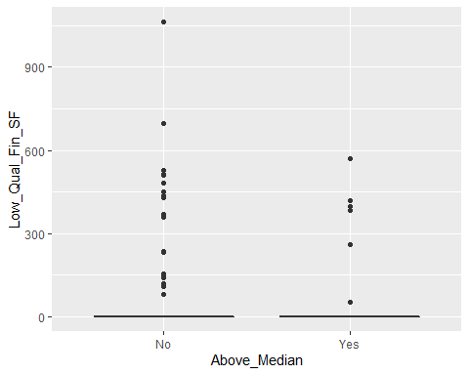

ggplot(ames_student_clean, aes(x = Above_Median, y=Gr_Liv_Area)) + geom_boxplot()

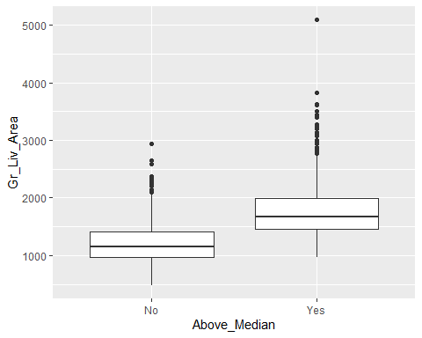

ggplot(ames_student_clean, aes(x = Above_Median, y=Bsmt_Full_Bath)) + geom_boxplot()

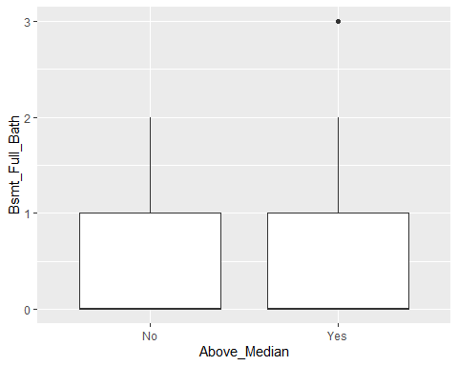

ggplot(ames_student_clean, aes(x = Above_Median, y=Bsmt_Half_Bath)) + geom_boxplot()

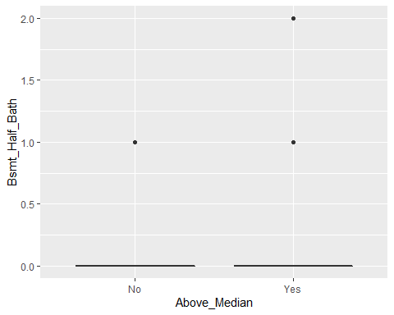

ggplot(ames_student_clean, aes(x = Above_Median, y=Full_Bath)) + geom_boxplot()

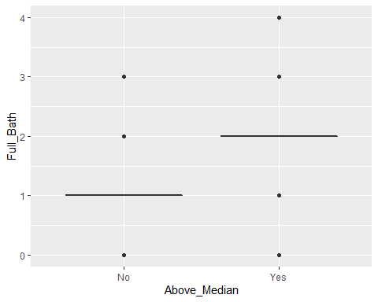

ggplot(ames_student_clean, aes(x = Above_Median, y=Half_Bath)) + geom_boxplot()

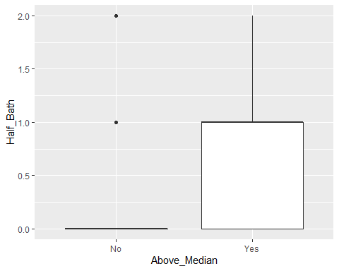

ggplot(ames_student_clean, aes(x = Above_Median, y=Bedroom_AbvGr)) + geom_boxplot()

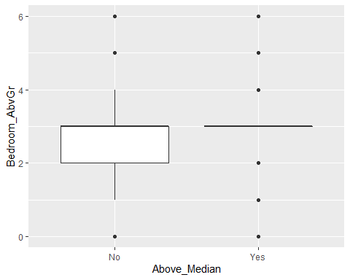

ggplot(ames_student_clean, aes(x = Above_Median, y=Kitchen_AbvGr)) + geom_boxplot()

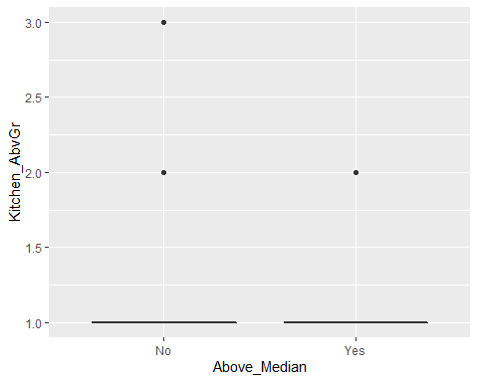

ggplot(ames_student_clean, aes(x = Above_Median, y=TotRms_AbvGrd)) + geom_boxplot()

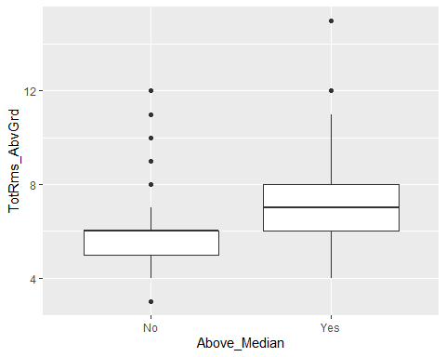

ggplot(ames_student_clean, aes(x = Above_Median, y=Fireplaces)) + geom_boxplot()

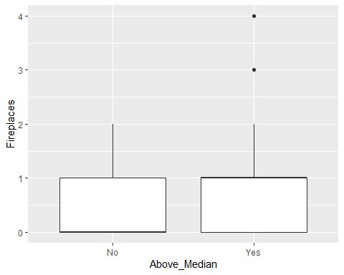

ggplot(ames_student_clean, aes(x = Above_Median, y=Garage_Cars)) + geom_boxplot()

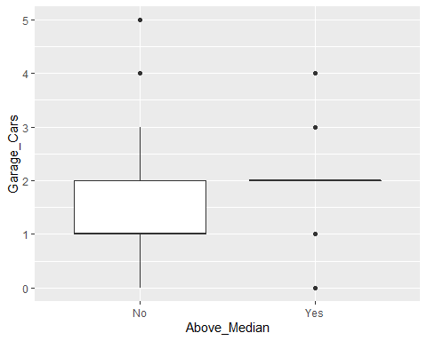

ggplot(ames_student_clean, aes(x = Above_Median, y=Garage_Area)) + geom_boxplot()

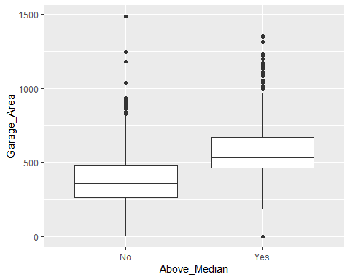

ggplot(ames_student_clean, aes(x = Above_Median, y=Wood_Deck_SF)) + geom_boxplot()

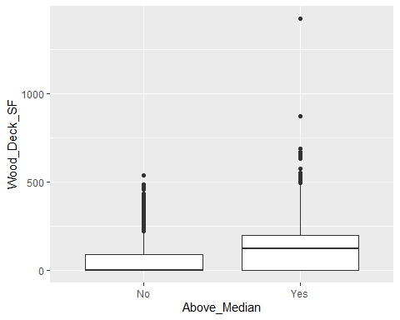

ggplot(ames_student_clean, aes(x = Above_Median, y=Open_Porch_SF)) + geom_boxplot()

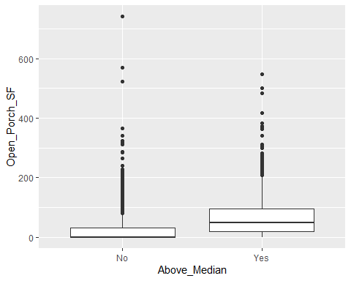

ggplot(ames_student_clean, aes(x = Above_Median, y=Enclosed_Porch)) + geom_boxplot()

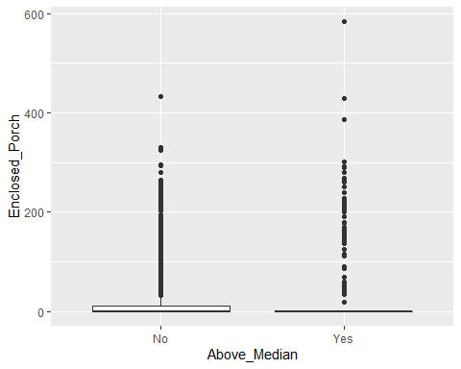

ggplot(ames_student_clean, aes(x = Above_Median, y=Three_season_porch)) + geom_boxplot()

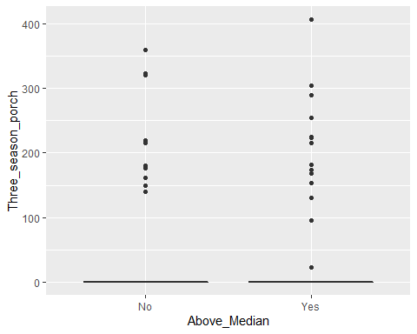

ggplot(ames_student_clean, aes(x = Above_Median, y=Screen_Porch)) + geom_boxplot()

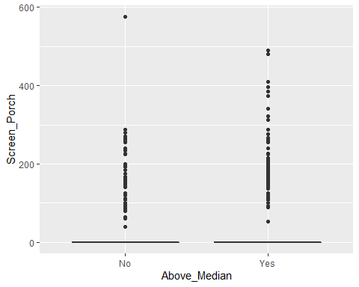

ggplot(ames_student_clean, aes(x = Above_Median, y=Pool_Area)) + geom_boxplot()

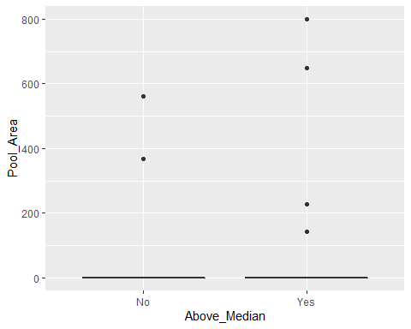

ggplot(ames_student_clean, aes(x = Above_Median, y=Misc_Val)) + geom_boxplot()

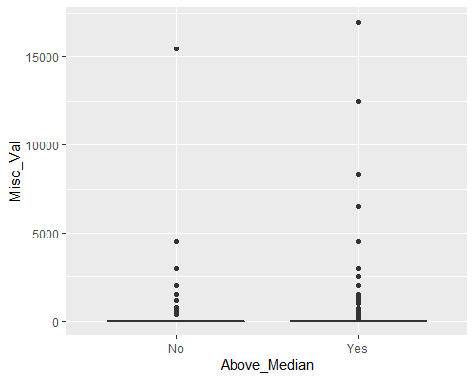

ggplot(ames_student_clean, aes(x = Above_Median, y=Longitude)) + geom_boxplot()

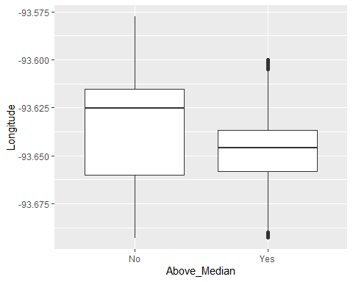

ggplot(ames_student_clean, aes(x = Above_Median, y=Latitude)) + geom_boxplot()

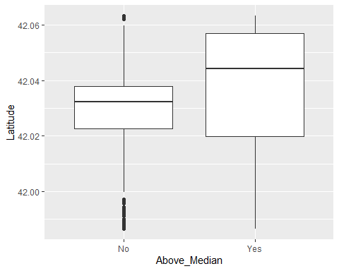

library(GGally)

## Registered S3 method overwritten by 'GGally':  
## method from   
## +.gg ggplot2

ggpairs(ames_student_clean, columns = c(44:53,55,59,60,64:69,73,79,82))

## `stat_bin()` using `bins = 30`. Pick better value with `binwidth`.

## `stat_bin()` using `bins = 30`. Pick better value with `binwidth`.  
## `stat_bin()` using `bins = 30`. Pick better value with `binwidth`.  
## `stat_bin()` using `bins = 30`. Pick better value with `binwidth`.  
## `stat_bin()` using `bins = 30`. Pick better value with `binwidth`.  
## `stat_bin()` using `bins = 30`. Pick better value with `binwidth`.  
## `stat_bin()` using `bins = 30`. Pick better value with `binwidth`.  
## `stat_bin()` using `bins = 30`. Pick better value with `binwidth`.  
## `stat_bin()` using `bins = 30`. Pick better value with `binwidth`.  
## `stat_bin()` using `bins = 30`. Pick better value with `binwidth`.  
## `stat_bin()` using `bins = 30`. Pick better value with `binwidth`.  
## `stat_bin()` using `bins = 30`. Pick better value with `binwidth`.  
## `stat_bin()` using `bins = 30`. Pick better value with `binwidth`.  
## `stat_bin()` using `bins = 30`. Pick better value with `binwidth`.  
## `stat_bin()` using `bins = 30`. Pick better value with `binwidth`.  
## `stat_bin()` using `bins = 30`. Pick better value with `binwidth`.  
## `stat_bin()` using `bins = 30`. Pick better value with `binwidth`.  
## `stat_bin()` using `bins = 30`. Pick better value with `binwidth`.  
## `stat_bin()` using `bins = 30`. Pick better value with `binwidth`.  
## `stat_bin()` using `bins = 30`. Pick better value with `binwidth`.  
## `stat_bin()` using `bins = 30`. Pick better value with `binwidth`.  
## `stat_bin()` using `bins = 30`. Pick better value with `binwidth`.  
## `stat_bin()` using `bins = 30`. Pick better value with `binwidth`.  
## `stat_bin()` using `bins = 30`. Pick better value with `binwidth`.  
## `stat_bin()` using `bins = 30`. Pick better value with `binwidth`.  
## `stat_bin()` using `bins = 30`. Pick better value with `binwidth`.  
## `stat_bin()` using `bins = 30`. Pick better value with `binwidth`.  
## `stat_bin()` using `bins = 30`. Pick better value with `binwidth`.  
## `stat_bin()` using `bins = 30`. Pick better value with `binwidth`.  
## `stat_bin()` using `bins = 30`. Pick better value with `binwidth`.  
## `stat_bin()` using `bins = 30`. Pick better value with `binwidth`.  
## `stat_bin()` using `bins = 30`. Pick better value with `binwidth`.  
## `stat_bin()` using `bins = 30`. Pick better value with `binwidth`.  
## `stat_bin()` using `bins = 30`. Pick better value with `binwidth`.  
## `stat_bin()` using `bins = 30`. Pick better value with `binwidth`.  
## `stat_bin()` using `bins = 30`. Pick better value with `binwidth`.  
## `stat_bin()` using `bins = 30`. Pick better value with `binwidth`.  
## `stat_bin()` using `bins = 30`. Pick better value with `binwidth`.  
## `stat_bin()` using `bins = 30`. Pick better value with `binwidth`.  
## `stat_bin()` using `bins = 30`. Pick better value with `binwidth`.  
## `stat_bin()` using `bins = 30`. Pick better value with `binwidth`.  
## `stat_bin()` using `bins = 30`. Pick better value with `binwidth`.  
## `stat_bin()` using `bins = 30`. Pick better value with `binwidth`.  
## `stat_bin()` using `bins = 30`. Pick better value with `binwidth`.  
## `stat_bin()` using `bins = 30`. Pick better value with `binwidth`.  
## `stat_bin()` using `bins = 30`. Pick better value with `binwidth`.  
## `stat_bin()` using `bins = 30`. Pick better value with `binwidth`.  
## `stat_bin()` using `bins = 30`. Pick better value with `binwidth`.  
## `stat_bin()` using `bins = 30`. Pick better value with `binwidth`.  
## `stat_bin()` using `bins = 30`. Pick better value with `binwidth`.  
## `stat_bin()` using `bins = 30`. Pick better value with `binwidth`.  
## `stat_bin()` using `bins = 30`. Pick better value with `binwidth`.  
## `stat_bin()` using `bins = 30`. Pick better value with `binwidth`.  
## `stat_bin()` using `bins = 30`. Pick better value with `binwidth`.  
## `stat_bin()` using `bins = 30`. Pick better value with `binwidth`.  
## `stat_bin()` using `bins = 30`. Pick better value with `binwidth`.  
## `stat_bin()` using `bins = 30`. Pick better value with `binwidth`.  
## `stat_bin()` using `bins = 30`. Pick better value with `binwidth`.  
## `stat_bin()` using `bins = 30`. Pick better value with `binwidth`.  
## `stat_bin()` using `bins = 30`. Pick better value with `binwidth`.  
## `stat_bin()` using `bins = 30`. Pick better value with `binwidth`.  
## `stat_bin()` using `bins = 30`. Pick better value with `binwidth`.  
## `stat_bin()` using `bins = 30`. Pick better value with `binwidth`.  
## `stat_bin()` using `bins = 30`. Pick better value with `binwidth`.  
## `stat_bin()` using `bins = 30`. Pick better value with `binwidth`.  
## `stat_bin()` using `bins = 30`. Pick better value with `binwidth`.  
## `stat_bin()` using `bins = 30`. Pick better value with `binwidth`.  
## `stat_bin()` using `bins = 30`. Pick better value with `binwidth`.  
## `stat_bin()` using `bins = 30`. Pick better value with `binwidth`.  
## `stat_bin()` using `bins = 30`. Pick better value with `binwidth`.  
## `stat_bin()` using `bins = 30`. Pick better value with `binwidth`.  
## `stat_bin()` using `bins = 30`. Pick better value with `binwidth`.  
## `stat_bin()` using `bins = 30`. Pick better value with `binwidth`.  
## `stat_bin()` using `bins = 30`. Pick better value with `binwidth`.  
## `stat_bin()` using `bins = 30`. Pick better value with `binwidth`.  
## `stat_bin()` using `bins = 30`. Pick better value with `binwidth`.  
## `stat_bin()` using `bins = 30`. Pick better value with `binwidth`.  
## `stat_bin()` using `bins = 30`. Pick better value with `binwidth`.  
## `stat_bin()` using `bins = 30`. Pick better value with `binwidth`.  
## `stat_bin()` using `bins = 30`. Pick better value with `binwidth`.  
## `stat_bin()` using `bins = 30`. Pick better value with `binwidth`.  
## `stat_bin()` using `bins = 30`. Pick better value with `binwidth`.  
## `stat_bin()` using `bins = 30`. Pick better value with `binwidth`.  
## `stat_bin()` using `bins = 30`. Pick better value with `binwidth`.  
## `stat_bin()` using `bins = 30`. Pick better value with `binwidth`.  
## `stat_bin()` using `bins = 30`. Pick better value with `binwidth`.  
## `stat_bin()` using `bins = 30`. Pick better value with `binwidth`.  
## `stat_bin()` using `bins = 30`. Pick better value with `binwidth`.  
## `stat_bin()` using `bins = 30`. Pick better value with `binwidth`.  
## `stat_bin()` using `bins = 30`. Pick better value with `binwidth`.  
## `stat_bin()` using `bins = 30`. Pick better value with `binwidth`.  
## `stat_bin()` using `bins = 30`. Pick better value with `binwidth`.  
## `stat_bin()` using `bins = 30`. Pick better value with `binwidth`.  
## `stat_bin()` using `bins = 30`. Pick better value with `binwidth`.  
## `stat_bin()` using `bins = 30`. Pick better value with `binwidth`.  
## `stat_bin()` using `bins = 30`. Pick better value with `binwidth`.  
## `stat_bin()` using `bins = 30`. Pick better value with `binwidth`.  
## `stat_bin()` using `bins = 30`. Pick better value with `binwidth`.  
## `stat_bin()` using `bins = 30`. Pick better value with `binwidth`.  
## `stat_bin()` using `bins = 30`. Pick better value with `binwidth`.  
## `stat_bin()` using `bins = 30`. Pick better value with `binwidth`.  
## `stat_bin()` using `bins = 30`. Pick better value with `binwidth`.  
## `stat_bin()` using `bins = 30`. Pick better value with `binwidth`.  
## `stat_bin()` using `bins = 30`. Pick better value with `binwidth`.  
## `stat_bin()` using `bins = 30`. Pick better value with `binwidth`.

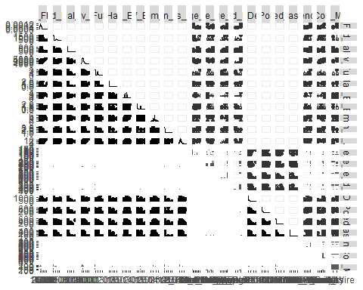

ggpairs(ames_student_clean, columns = c(4,5,29,21,27,35,37,38,39,82))

## `stat_bin()` using `bins = 30`. Pick better value with `binwidth`.  
## `stat_bin()` using `bins = 30`. Pick better value with `binwidth`.  
## `stat_bin()` using `bins = 30`. Pick better value with `binwidth`.  
## `stat_bin()` using `bins = 30`. Pick better value with `binwidth`.  
## `stat_bin()` using `bins = 30`. Pick better value with `binwidth`.  
## `stat_bin()` using `bins = 30`. Pick better value with `binwidth`.  
## `stat_bin()` using `bins = 30`. Pick better value with `binwidth`.  
## `stat_bin()` using `bins = 30`. Pick better value with `binwidth`.  
## `stat_bin()` using `bins = 30`. Pick better value with `binwidth`.  
## `stat_bin()` using `bins = 30`. Pick better value with `binwidth`.  
## `stat_bin()` using `bins = 30`. Pick better value with `binwidth`.  
## `stat_bin()` using `bins = 30`. Pick better value with `binwidth`.  
## `stat_bin()` using `bins = 30`. Pick better value with `binwidth`.  
## `stat_bin()` using `bins = 30`. Pick better value with `binwidth`.  
## `stat_bin()` using `bins = 30`. Pick better value with `binwidth`.  
## `stat_bin()` using `bins = 30`. Pick better value with `binwidth`.

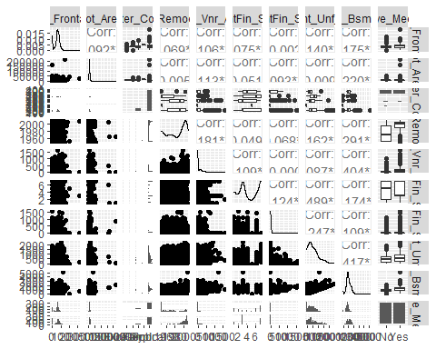

library(ranger)  
library(vip)

##   
## Attaching package: 'vip'

## The following object is masked from 'package:utils':  
##   
## vi

library(tidymodels)

## -- Attaching packages -------------------------------------- tidymodels 0.1.2 --

## v broom 0.7.2 v recipes 0.1.15  
## v dials 0.0.9 v rsample 0.0.8   
## v infer 0.5.4 v tune 0.1.2   
## v modeldata 0.1.0 v workflows 0.2.1   
## v parsnip 0.1.5 v yardstick 0.0.7

## -- Conflicts ----------------------------------------- tidymodels_conflicts() --  
## x scales::discard() masks purrr::discard()  
## x dplyr::filter() masks stats::filter()  
## x recipes::fixed() masks stringr::fixed()  
## x dplyr::lag() masks stats::lag()  
## x yardstick::spec() masks readr::spec()  
## x recipes::step() masks stats::step()

rf_folds = vfold_cv(ames_student_clean, v =5)  
  
ames_recipe = recipe(Above_Median ~., ames_student_clean) %>%  
 step_dummy(all_nominal(), -all_outcomes())  
  
rf_model = rand_forest(mtry = tune(), min_n = tune(), trees = 100) %>%  
 set_engine("ranger", importance = "permutation") %>%  
 set_mode("classification")  
  
ames_wflow =  
 workflow() %>%  
 add_model(rf_model) %>%  
 add_recipe(ames_recipe)  
  
rf_grid = grid_regular(  
 mtry(range = c(2, 8)),  
 min_n(range = c(5, 20)), levels = 10  
)  
  
rf_res_tuned = tune_grid(ames_wflow,   
 resamples = rf_folds,  
 grid = rf_grid)

##   
## Attaching package: 'rlang'

## The following objects are masked from 'package:purrr':  
##   
## %@%, as_function, flatten, flatten_chr, flatten_dbl, flatten_int,  
## flatten_lgl, flatten_raw, invoke, list_along, modify, prepend,  
## splice

##   
## Attaching package: 'vctrs'

## The following object is masked from 'package:dplyr':  
##   
## data_frame

## The following object is masked from 'package:tibble':  
##   
## data_frame

rf_res_tuned %>%  
 collect_metrics() %>%  
 filter(.metric == "accuracy") %>%  
 select(mean, min_n, mtry) %>%  
 pivot_longer(min_n:mtry,  
 values_to = "value",  
 names_to = "parameter"  
 ) %>%  
 ggplot(aes(value, mean, color = parameter)) +  
 geom_point(show.legend = FALSE) +  
 facet_wrap(~parameter, scales = "free_x") +  
 labs(x = NULL, y = "Accuracy")

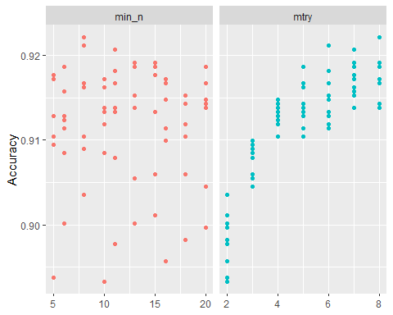

best_rf = select_best(rf_res_tuned, "accuracy")  
  
final_rf = finalize_workflow(  
 ames_wflow,  
 best_rf  
)  
  
final_rf_fit = fit(final_rf, ames_student_clean)  
  
final_rf_fit %>% pull_workflow_fit() %>% vip(geom = "point")

