HOT SLICE PIZZERIA SALES DATA PERFORMANCE
REPORT FOR 2015

ANALYZED BY

IHEDIOHAMMA, CONFIDENCE CHIAMAKA

AN SQL CAPSTONE PROJECT FOR THE DATA IMMERSED
COHORT INTERNSHIP PROGRAM

JANUARY, 2025.
ABSTRACT
This dataset provides a comprehensive overview of pizza sales trends over various time periods, including daily, hourly, and seasonal fluctuations. The analysis reveals key patterns in consumer behavior, such as increased sales during peak hours at 12 PM, 1 PM, 5 PM, and 6 PM, which align with typical lunch and dinner times. Seasonal variations are also observed, with notable sales spikes in May, July, March, and November, driven by factors such as holidays, school breaks, and weather changes. Conversely, pizza sales tend to decrease in September and October, likely due to routine shifts following the summer months. This dataset offers valuable insights for optimizing marketing strategies, menu offerings, and staffing levels to align with peak demand periods.
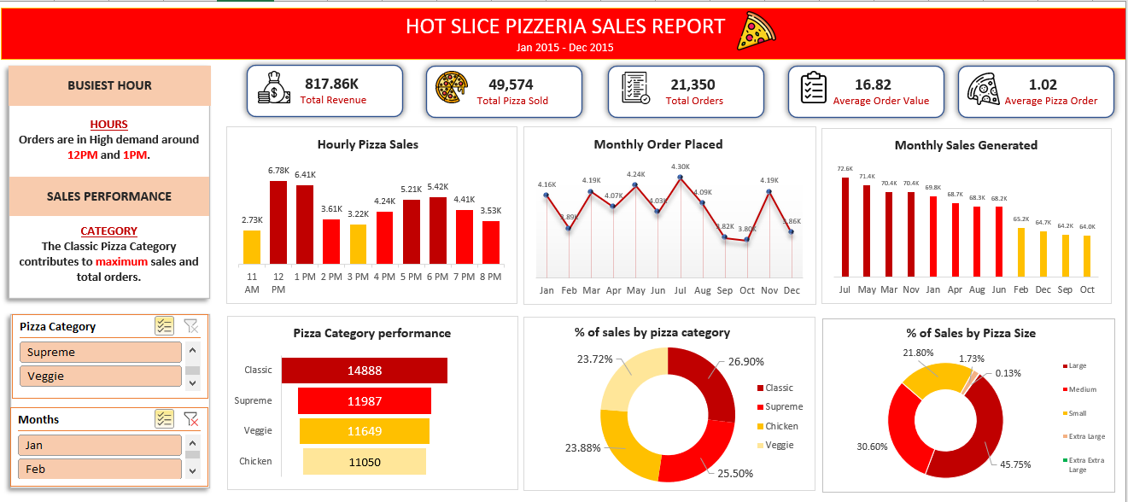

INTRODUCTION
Background of Hot Slice’s Pizzeria Sales Report 2015
Hot Slice Pizzeria is a fictional family-owned pizzeria located in the heart of a bustling city, specializing in gourmet, hand-tossed pizzas. Established in 2013, the pizzeria has gained a loyal customer base due to its commitment to fresh ingredients and a personalized customer experience. In 2015, Hot Slice’s Pizzeria decided to start analyzing its sales data to better understand customer preferences, and drive revenue growth for the single location.
The dataset includes detailed records of pizza orders from January 2015 to December 2015, capturing critical metrics such as the number of pizzas sold, revenue, popular pizza varieties, size, and customer ordering patterns. With a focus on understanding the peak hours and days for pizza orders, as well as preferences (e.g., local demand for vegetarian or meat-heavy pizzas), the data provides valuable insights into what drives sales.
By analyzing this data, Hot Slice’s Pizzeria aims to enhance its menu offerings, streamline its operations, and improve customer satisfaction in an increasingly competitive pizza market.

Problem Statement
Hot Slice's Pizzeria, a local pizza shop, aims to improve its sales performance and operational efficiency by analyzing its order data. The company struggles with understanding customer preferences, managing inventory, and identifying peak sales periods. By analyzing the sales data, Hot Slice's Pizzeria seeks to uncover trends in popular pizza types, order volume, and customer behavior. The goal is to optimize the menu, reduce waste, and enhance customer satisfaction while maximizing revenue through data-driven insights.

Objectives of the Dataset Analysis:
1. Analyze Sales Trends:
- Identify seasonal fluctuations in pizza sales, including peak times of day, week, and month.
- Determine which pizza varieties and size are most popular across different customer.

2. Optimize Menu Offerings:
- Assess customer preferences for various pizza styles (e.g., vegetarian, meat-heavy) to refine the menu.
- Introduce or phase out menu items based on their sales performance and customer demand.

3. Improve Inventory Management:
- Predict ingredient demand based on historical sales data to minimize waste and ensure popular items are always in stock.
- Optimize order quantities and inventory turnover by aligning stock levels with peak sales periods.

4. Enhance Customer Experience:
- Use demographic and ordering data to create targeted promotions and personalized offers for frequent customers.
- Analyze customer ordering behavior to streamline the ordering process and improve service efficiency.
5. Monitor Business Growth:
- Track revenue growth over time, highlighting the impact of marketing campaigns, promotions, and new menu introductions.
DATA COLLECTION AND CHARACTERISTICS
Data Collection and Dataset Overview
This dataset was collected from Kaggle and contains detailed information about pizza orders, pizza types, and their associated sales. The dataset is divided into multiple tables to store information about individual orders, pizzas, and ingredients. The data provides insight into order details, customer preferences, and pizza sales trends, enabling a better understanding of product popularity and sales performance.
Tables and Data Structure
1. Order_details Table
This table provides specific information about the details of each pizza order, such as the quantity ordered and the unique identifiers for both the order and the pizza.
Columns:
- Order_details_id: Unique identifier for each entry in the order details (integer).
- Order_id: Unique identifier for each order (integer).
- Pizza_id: Unique identifier for the pizza type ordered (integer).
- Quantity: The number of pizzas of the given type ordered (integer).

2. Orders Table
This table contains general information about each order, such as the date and time the order was placed.
Columns:
- Order_id: Unique identifier for each order (integer).
- Date: Date when the order was placed (date).
- Time: Time when the order was placed (time).
3. Pizzas Table
This table provides details about the pizzas available, including their size, price, and associated pizza type.
Columns:
- Pizza_id: Unique identifier for each pizza (integer).
- Pizza_type_id: Foreign key referencing the pizza type in the Pizza_types table (integer).
- Size: Size of the pizza (e.g., Small, Medium, Large).
- Price: Price of the pizza (float).

4. Pizza_types Table
This table contains information about different types of pizza, such as the category (e.g., Classic, Veggies, Chicken and Supreme) and the ingredients used in each type.
Columns:
- Pizza_type_id: Unique identifier for each pizza type (integer).
- Name: Name of the pizza type (e.g., The Spinach supreme, The Barbecue chicken).
- Category: Category of the pizza (e.g., Classic, Veggies, Chicken and Supreme).
- Ingredients: List of ingredients used in the pizza type (text).

METHODOLOGY
- Four (4) CSV files were obtained from Kaggle which contained Order Details, Orders, Pizzas and Pizza Types records respectively, these datasets were cleaned, checked for duplicates, blanks and missing values.
- SQL queries were written to analyze key metrics and answer research questions like
- What is the total Revenue Generated?
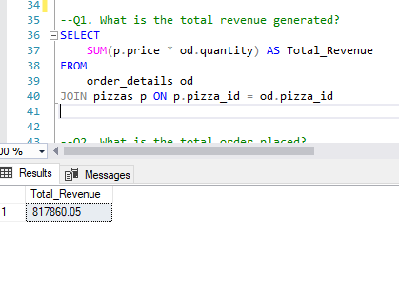
- What is the total order placed?
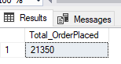
- What is the total number of Pizza sold?
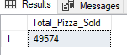
- What time of the day do Pizza sale the most and amount sold?
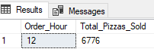
- With the use of a pivot table, the research questions were further analyzed and visualized
- Lastly, an interactive Dashboard was created to visualize the key finding and insights of the analysis.

SOME FINDINGS GENERATED ON EXCEL.
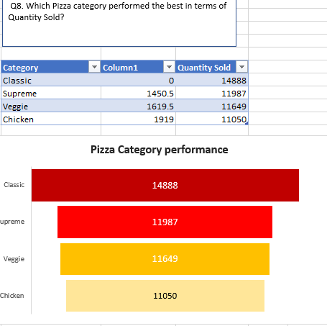

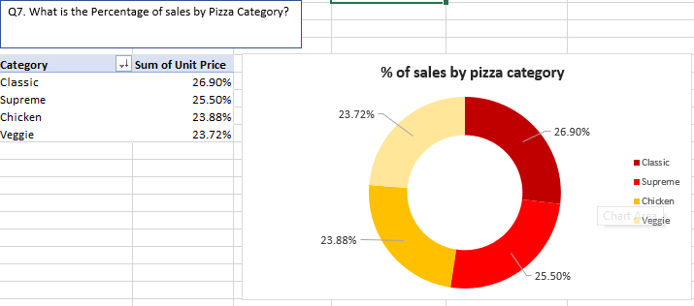
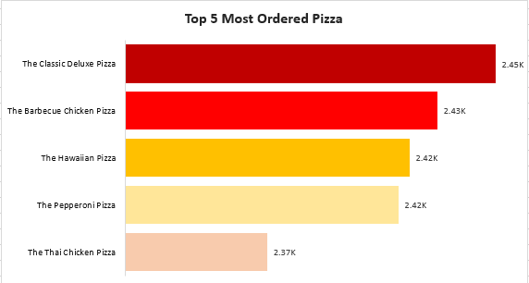
KEY FINDINGS
1. Peak Sales Times: Sales data showed significant spikes in orders during peak hours at 12 PM, 1 PM, 5 PM, and 6 PM, which align with typical lunch and dinner times. Additionally, holidays and local events during the months of May, July, March and November led to higher-than-average order volumes and most sales generated.

2. Popular Pizza Varieties: The analysis revealed that certain pizza types, such as Classic and Supreme pizza, consistently ranked as the most ordered, while specialty pizzas like Chicken and Veggie had a lower volume of orders.

3. Customer Preferences: Customers favored large-sized pizzas, with a strong preference for common toppings like Pepperoni, Red Onions, Red Pepper, Bacon and Mushrooms. The Extra extra-large pizza with toppings like Brie Carre cheese, Prosciutto and Caramelized Onion, pear, Thyme and Garlic is the least customer preference.

4. Inventory Optimization: Ingredient usage patterns indicated that certain ingredients (e.g., Pepperoni, Onion, Red Pepper) were in high demand, while others (e.g., Duja Salami, Garlic, Brie Carre Cheese ) saw irregular usage. This insight suggests the need for better inventory forecasting to reduce waste and ensure popular items are always available.

RECOMMENDATIONS FOR HOT SLICE PIZZERIA
1. Optimize Menu Offerings:
- Focus on promoting popular pizza varieties like Classic and Supreme while experimenting with new variations of these pizzas to cater to customer preferences.

2. Promote Off-Peak Sales:
- Create special promotions or discounts for time duration like 3PM and 11AM, to balance demand and increase sales during slower periods.
- Introduce bundle deals that encourage larger orders, especially for families or groups, to increase sales during off-peak hours.

3. Improve Inventory Management:
- Use predictive analytics based on order history to better forecast ingredient usage and prevent overstocking or stockouts of popular items like Pepperoni, Onion, Red Pepper.
- Implement just-in-time inventory practices for less frequently used ingredients to reduce waste and optimize storage costs.

4. Enhance Customer Experience:
- Personalize marketing campaigns by targeting customers based on their previous order history (e.g., offering discounts on their favorite pizzas or introducing new toppings).
- Offer loyalty rewards for frequent customers to encourage repeat business and foster customer retention.

CONCLUSION
In conclusion, the analysis of Hot Slice Pizzeria sales data highlights clear trends that can inform both operational strategies and marketing efforts. Sales are significantly influenced by time of day, with peak hours observed during lunch (12 PM - 1 PM) and dinner (5 PM - 6 PM). Additionally, seasonal fluctuations play a crucial role, with sales surging in May, July, March, and November due to holidays, vacations, and weather-related factors. Conversely, sales tend to dip in September and October as routines settle and consumers turn to homemade meals. Additionally, ingredient usage alongside pizza sales trends provides valuable insights for inventory management and menu optimization. By leveraging these insights, Hot Slice Pizzeria can better plan promotions, staffing, and product offerings to maximize sales during peak times and seasons, while adjusting strategies during slower periods to maintain consistent growth and customer satisfaction.

