Homework #2

Katie Daisey

Friday, March 27, 2015

## Warning: package 'scatterplot3d' was built under R version 3.1.3

## Question 1 - Comparing Methods

New method development requires a comparison to the old or accepted method. In the case of glucose, a newly developed method involving direct measurement by an implanted electrochemical sensor needs to be compared to the standard method (a kinetic analysis using glucose oxidase and spectroscopy).

The data, containing 111 observations of glucose levels using both methods, were downloaded and read into R.

glucose<-read.csv("data/glucose.csv")

The standard method two compare two techniques is the ["Bland-Altman" plot](http://www.sciencedirect.com/science/article/pii/S0140673695917489)(1). By plotting the difference between the techniques versus the means and checking for a strong regression with a slope of 0, Bland and Altman argue that a measurement of correlation between the two techniques without bias can be made.

Here, code from [Ken Kleinman](http://www.r-bloggers.com/example-9-34-bland-altman-type-plot/) was adapted to create a function BAplot() which produces a Bland-Altman plot.(2)

BAplot <- function(x,y,xmeth=deparse(substitute(x)),ymeth=deparse(substitute(y))){  
 #adapted from Ken Kleinman   
 #http://www.r-bloggers.com/example-9-34-bland-altman-type-plot/  
 #removed standardization and diff=0 line  
 #added regression line and title options  
  
 bamean = (x+y)/2  
 badiff = (y-x)  
 reg_line<-summary(lm(badiff~bamean))  
 reg_slope<-round(reg_line[[4]][2],4)  
 reg_incpt<-round(reg_line[[4]][1],4)   
   
 plot(badiff~bamean, pch=20, xlab="mean", ylab="difference")  
# in the following, the deparse(substitute(varname)) retrieves name of argument  
 title(main=paste("Bland-Altman plot of ",  
 xmeth, "\n minus", ymeth  
 ), adj=".5")  
 text(280,-70,col="red",paste("y = ",reg_slope,"x + ",reg_incpt,sep=""))  
#construct the reference lines on the fly  
 abline(h = c( mean(badiff)+1.96 * sd(badiff),  
 mean(badiff)-1.96 * sd(badiff), mean(badiff)), lty=2)  
 abline(lm(badiff~bamean),col="red")  
}

Applying this function to the glucose data comparing the sensor measurements to the accepted venous glucose measurements produces the following plot:

BAplot(glucose$Sensor,glucose$Venous_glucose,"Sensor","Venous Glucose")

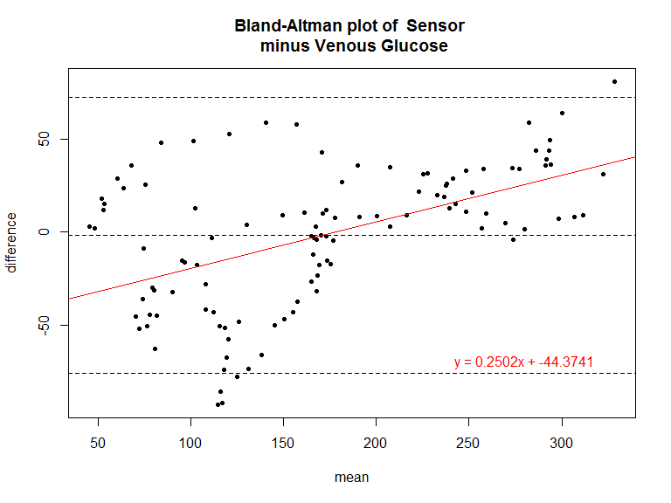

Here we see that the majority of the readings fall within the 95% confidence intervals around 0 difference. We do note an upward trend in the readings. At low mean glucose readings, the difference between methods is spread fairly evenly around 0, but at higher glucose levels, the difference is overwhelmingly positive. Since the difference is Sensor minus Venous Glucose, a positive difference shows the new Sensor method readings are higher than the accepted method Venous readings.

## Question 2 - Modeling Data

Measurements of the concentration and absorbance of trace cyanide in waste water samples was gathered by Meier and Zeund.

#### a) Linear Least-Squares Model

The data needed basic pre-processing in order to be read into R. It was copied and pasted into a text file and the first line (column names) was removed.

#read data  
 conc<-read.table("data/conc.txt",header=T,sep=" ")  
 colnames(conc)<-c("Concentration","Absorbance")

We wish to fit a linear model of the form to the data. This can be done with the lm() function in base-R. Here we specify that there is a linear relationship between absorbance and concentration.

#use base least squares regression  
fit.linear<-lm(Absorbance~Concentration,conc)  
intercept<-fit.linear[[1]][[1]]  
slope<-fit.linear[[1]][[2]]  
fit.linear

##   
## Call:  
## lm(formula = Absorbance ~ Concentration, data = conc)  
##   
## Coefficients:  
## (Intercept) Concentration   
## 0.005902 0.004990

We see that the found model has a slope of 0.0049896 and an intercept of 0.0059021. We can overlay this model on data and examine the goodness of fit.

plot(conc$Concentration,conc$Absorbance,  
 xlab=expression(paste("Concentration (",mu,"g/100mL)")),ylab="Absorbance",  
 main="Trace Cynaide in Waste Water")  
abline(lm(Absorbance~Concentration,conc),col="red",lty=2)  
text(200,0,col="red",paste("y = ",round(slope,4),"x + ",round(intercept,4),sep=""))

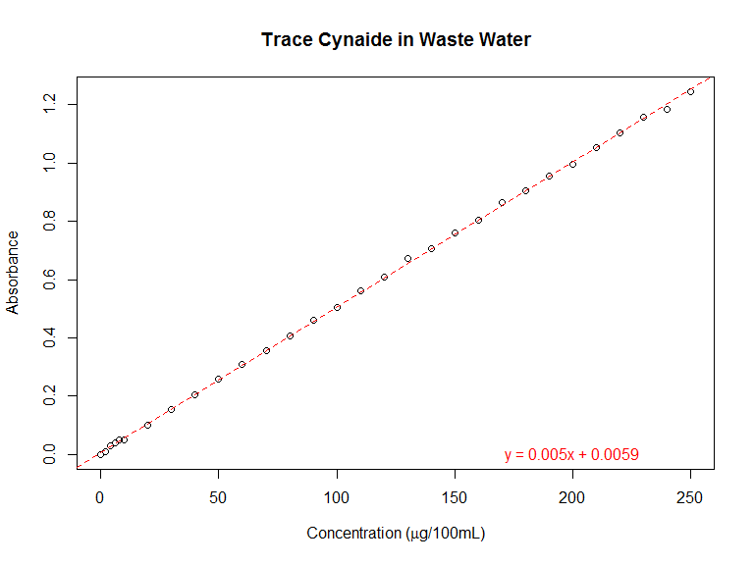

#### b) Linear Least-Squares Residuals

It appears that our linear least squares model fits the data well, but we can quantify this belief.

(s.fit.linear<-summary(fit.linear))

##   
## Call:  
## lm(formula = Absorbance ~ Concentration, data = conc)  
##   
## Residuals:  
## Min 1Q Median 3Q Max   
## -0.017402 -0.005749 0.000400 0.004351 0.016452   
##   
## Coefficients:  
## Estimate Std. Error t value Pr(>|t|)   
## (Intercept) 5.902e-03 1.836e-03 3.214 0.00312 **   
## Concentration 4.990e-03 1.397e-05 357.124 < 2e-16 ***  
## ---  
## Signif. codes: 0 '***' 0.001 '**' 0.01 '*' 0.05 '.' 0.1 ' ' 1  
##   
## Residual standard error: 0.006501 on 30 degrees of freedom  
## Multiple R-squared: 0.9998, Adjusted R-squared: 0.9998   
## F-statistic: 1.275e+05 on 1 and 30 DF, p-value: < 2.2e-16

#r squared value - standard

The usual parameter is the value, here calculated as 0.9998. Our line has a slope of 0.00499 and an intercept of 0.0059. We can also look at the residuals directly. A least-squares equation is found by minimizing the residuals (i.e., finding the line that is the closest, on average, to all the points) so the residuals should be small and randomly spread above and below the line.

#find and plot residuals from the linear fit  
par(mar=c(5,4,4,2)+0.1,fig=c(0,1,0,1),mfrow=c(1,1))  
plot(conc[,1], resid(fit.linear), ylim=c(-0.020,0.020),  
 xlab=expression(paste("Concentration (",mu,"g/100mL)")),ylab="Residuals", main="Residuals of Least Squares Fit\n of Absorbance on Concentration")   
abline(0,0,col="red",lty=2)

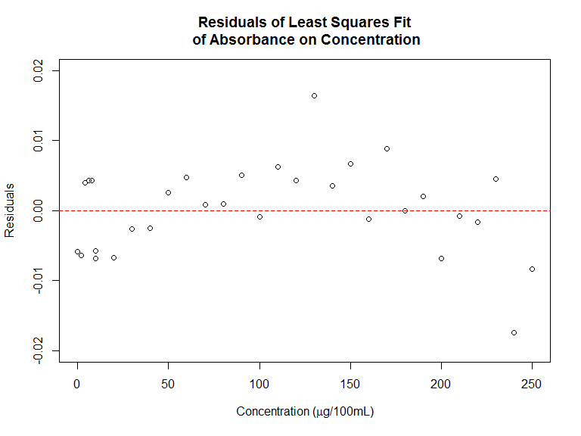

Taking a look at this plot, the residuals are small, but the residuals tend to be positive in the middle concentrations and negative at high concentrations. This means our model under estimates absorbance in the middle concentrations and over estimates absorbance at high concentrations. There is significant lack of fit.

#### c) Additional Terms

This curvature suggests we should investigate a quadratic model by adding a concentration-squared term, Conc_sq.

#adding square term  
 conc[,3]<-(conc[,1]^2)  
 colnames(conc)<-c("Concentration","Absorbance","Conc_sq")  
  
fit.quad<-lm(Absorbance~(Concentration+Conc_sq),data=conc)  
intercept<-fit.quad[[1]][[1]]  
slope<-fit.quad[[1]][[2]]  
sq_term<-fit.quad[[1]][[3]]  
s.fit.quad<-summary(fit.quad)

#calculate predicted values  
#R will not use multiple terms when plotting abline(lm(),...)  
pred.quad<-as.data.frame(matrix(seq(-10,250,length.out=10000),ncol=1))  
pred.quad[,2]<-(intercept+pred.quad[,1]*slope + pred.quad[,1]*pred.quad[,1]*sq_term)  
  
# plot  
par(mar=c(5,4,4,2)+0.1,fig=c(0,1,0,1),mfrow=c(1,1))  
plot(conc$Concentration,conc$Absorbance,  
 xlab=expression(paste("Concentration (",mu,"g/100mL)")),ylab="Absorbance",  
 main="Trace Cynaide in Waste Water")  
 abline(lm(Absorbance~Concentration,conc),col="red",lty=2)  
 points(pred.quad[,1],pred.quad[,2],type="l",col="blue",lty=1)  
 legend("bottomright",bty="n",pch=c(1,NA,NA), lty=c(NA,2,1),  
 col=c("black","red","blue"), legend = c("Data","Linear","Quadratic"),cex=1)  
  
# calculate position of inset  
 plotdim <- par("plt")  
 xleft = plotdim[1] + 0.02  
 xright = plotdim[1] + (plotdim[2] - plotdim[1])*.30 + 0.02  
 ybottom = plotdim[4] - (plotdim[4] - plotdim[3])*.40 - 0.03  
 ytop = plotdim[4] - 0.03 #  
  
# set position for inset  
par(  
 fig = c(xleft, xright, ybottom, ytop)  
 , mar=c(0,0,0,0)  
 , new=TRUE  
 )  
  
# add inset  
plot(conc$Concentration,conc$Absorbance,xlim=c(0,11),ylim=c(0,.06),xaxt='n',yaxt='n')  
 abline(lm(Absorbance~Concentration,conc),col="red",lty=2)  
 points(pred.quad[,1],pred.quad[,2],type="l",col="blue",lty=1)

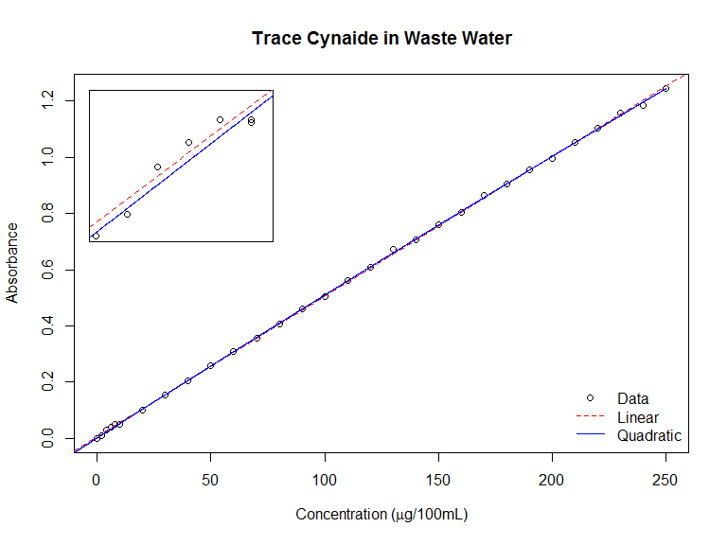

The new value is 0.9999 with our line having a coefficients of 0.00516 and -7.394010110^{-7} and an intercept of 0.00153. While it's not immediately obvious that the lines are distinct, more so in the inset, it becomes clearer if we instead examine the residuals.

par(mar=c(5,4,4,2)+0.1,fig=c(0,1,0,1),mfrow=c(1,1))  
plot(conc[,1], resid(fit.quad), ylim=c(-0.015,0.015),  
 xlab=expression(paste("Concentration (",mu,"g/100mL)")),ylab="Residuals", main="Residuals of Least Squares Fit\n of Absorbance on Concentration")   
abline(0,0,col="blue",lty=2)

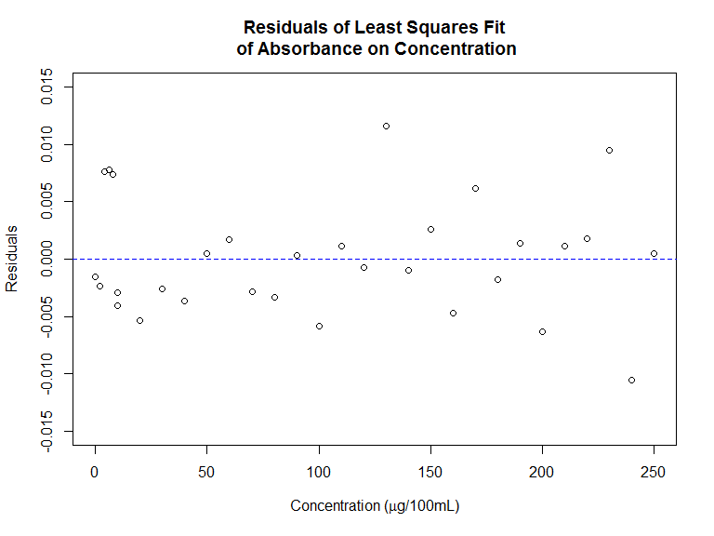

Our has increased, but more importantly a visual examination of our residuals reveals no obvious relationship.

#### d) Testing Residuals

Formally, we might like to describe the "randomness" of our residuals. There are several tests

We might also like to quantify the fit between two parameters (linear) and three parameters (quadratic). We would use an F-test on the variance of the residuals from the two models. Here our null hypothesis is the two sets residuals are equally random, while our alternative hypothesis is that the quadratic model will have a smaller variance.

rss0<-s.fit.linear[[8]]  
rss1<-s.fit.quad[[8]]  
p1<-2  
p0<-1  
N<-length(conc[,1])  
(Fstat<-(((rss1-rss0)/(p1-p0))/((rss1)/(N-p1-1))))

## [1] 0.002684469

With an F statistic of 0.0027, we would reject the null hypothesis and conclude the quadratic model fits our data better than the linear model.

Visually, this is seen in a comparision of our Normal Q-Q plots, where the dashed line is the expected value for random noise and the circles are our actual residuals from the plots.

par(mfrow=c(1,2))  
plot(fit.linear, which=2)  
plot(fit.quad, which=2)

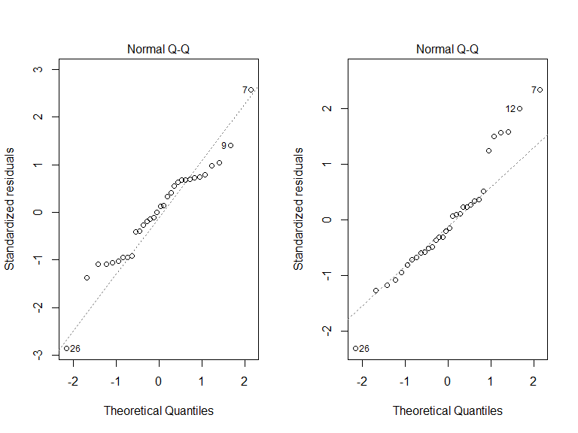

## Question 3 - Exploring Data

We might wish to explore data before testing an hypotheses. We wish to perform an exploratory data analysis (EDA) on some various properties of elements to see if we can extract periodic trends.

elem<-read.table("data/homework2-1.csv",sep=",",row.names=1,header=T)

#### a) Scatterplot

plot(elem)

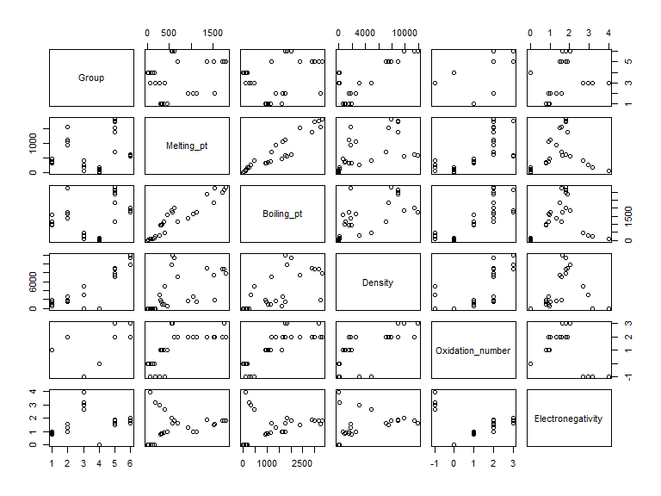

A set of simple scatterplots allows us to quickly examine the data for any obvious trends between any two dimensions in the data. It seems that Melting Point and Boiling Point are highly correlated. Density is more loosely correlated with Group, Melting Point, and Boiling Point. We also see at a glance that many of the variables are discreet rather than continuous.

#### b) Boxplots

#fix labels  
boxplot(elem, xaxt='n')  
text(c(1:6)*1,-800,labels=colnames(elem),srt=25,xpd=T,cex=.75,adj=1)

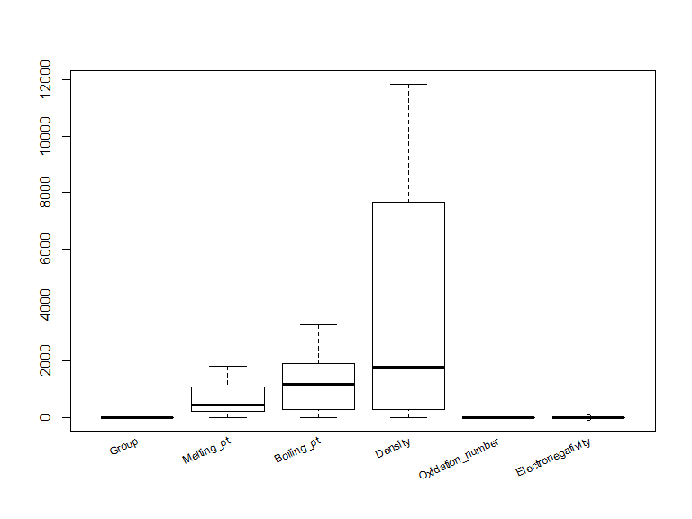

These boxplots show a broad range in the data for the Density variable which would overwhelm the other variables, especially Group, Oxidation Number, and Electronegative which range from -1 to 6. We would want to center (mean = 0) and scale (var = 1) the data.

#### c) Hierarchical Cluster Analysis

When looking for trends, we wish to determine which elements are similar taking into account all variables, or which lie closest to each other when plotted in a high-dimensional space.

To do so we use hierarchical cluster analysis, which groups closest neighbors together and keeps track at what distance the groups merged, with varying methods of determining distance between groups. We also want to account for our variables having different units and therefore differing scales for means and spreads which will bias the distance measurements towards the larger valued variables. We can center and scale the data to eliminate this bias (if desirable).

elem_c<-scale(elem, center=T, scale=F) #centered only  
elem_a<-scale(elem, center=T, scale=T) #centered and autoscaled  
#hcluster on c data complete & ward.D  
hc_c_complete<-hclust(dist(elem_c),method="complete")  
hc_c_ward<-hclust(dist(elem_c),method="ward.D")  
#on autoscale data complete & ward.D  
hc_a_complete<-hclust(dist(elem_a),method="complete")  
hc_a_ward<-hclust(dist(elem_a),method="ward.D")

Here we have performed "complete" (measuring distance between the two farthest points in each group) and "ward" (measuring distance between centroids with a scaling factor) hierarchical cluster analyses on centered and auto-scaled (centered and scaled) data.

par(mfrow=c(2,2))  
plot(hc_c_complete, main="Centered - Complete", xlab=NA)  
abline(h=3750,lty=2,col=2)  
plot(hc_c_ward, main="Centered - Ward",xlab=NA)  
abline(h=7000,lty=2, col=2)  
plot(hc_a_complete, main="Autoscaled - Complete", xlab=NA)  
abline(h=3,lty=2, col=2)  
plot(hc_a_ward, main="Autoscaled - Ward", xlab=NA)  
abline(h=5,lty=2, col=2)

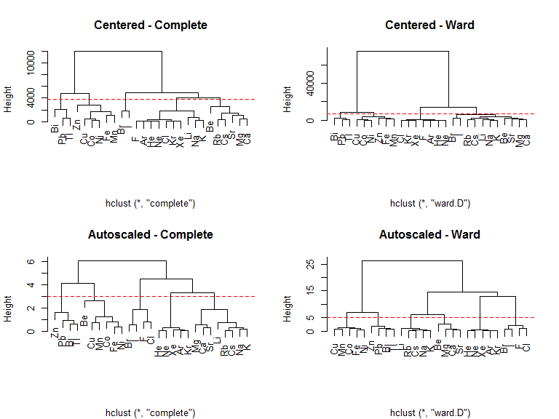

We can see the centered data has a much larger separation between the largest two groups than the auto-scaled data but this is a sign that the range of at least one of the variables is much larger than the others, not that these provide a "better" separation of the elements.

To find groups we look for a large difference in height between when two groups merge and when those groups were themselves created. For example, in the centered-complete analysis, we see there are clearly two separate groups (Bi, Pb, Tl, Zn, Cu, Co, Ni, Fe) and (Br, I, F, Ar, He, Ne, Cl, Kr, Xe, Li, Na, K, Be, Rb, Cs, Sr, Mg, Ca). We could argue a separation of 5 groups with a height of approximately 3750, but the choice of height for separation is arbitrary (as it is for all hierarchical cluster analyses).

The centered-ward analysis very clearly separates the same two groups from the centered-complete analysis, but even less clearly separates further groups. We could argue for the same 5 groups.

The auto-scaled analyses seem to provide more clearly separated groups by accounting for the large differences in the ranges of the variables. The auto-scaled-complete analysis finds 5 distinct groups cleanly. The auto-scaled-ward analysis finds 6 very clear groups. I would argue that the auto-scaled analyses work better here because the we have no *a priori* reason to bias the data towards the variable with the large range.

Looking at the elements contained in each group I would say that Autoscaled-Ward gives us the expected separation, but Autoscaled-Complete gives an interesting separation by placing Be with the 3d transition metals.

#### d) Principal Components Analysis

Using a principal components analysis (PCA), we can separate transform the data so the axes lie upon the line of maximum variance. This can help us to identify and visualize separation in the data. Using auto-scaled elemental data we perform a PCA and plot the eigenvalues to determine how many principal components represent unique information in our data and how many represent noise.

elem_a_pc<-princomp(elem_a,cor=TRUE)  
screeplot(elem_a_pc,type="lines", col="red", main ="PCA of Element Data")

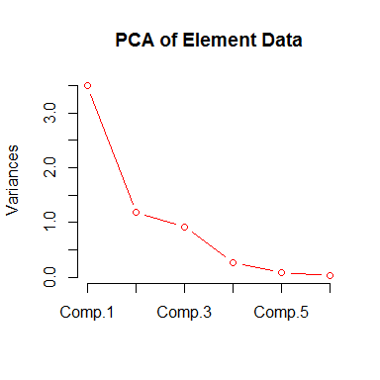

Here we see a large difference in the eigenvalues between components 1 and 2 and components 3 and 4. We would keep at most 3 components, but it may be possible to separate the data with only two components.

variances <-elem_a_pc$sdev^2/(nrow(elem_a)-1)  
totvariances<- sum(variances)  
relvars<- variances/totvariances  
vars<- 100*round(relvars, digits=3)  
  
plot(elem_a_pc$scores[,1],elem_a_pc$scores[,2],  
 xlab=paste("PC#1(",vars[1],"%)", sep=" "),  
 ylab=paste("PC#2(",vars[2],"%)",sep=" "),  
 main="Scores of Element Data",pch=elem$Group, col=elem$Group)  
abline(h=0, col="gray");abline(v=0, col="gray")  
text(elem_a_pc$scores[,1], elem_a_pc$scores[,2],labels=rownames(elem),cex=.5, pos=1)  
text(elem_a_pc$scores[10,1], elem_a_pc$scores[10,2],labels="F",cex=.5, pos=2)

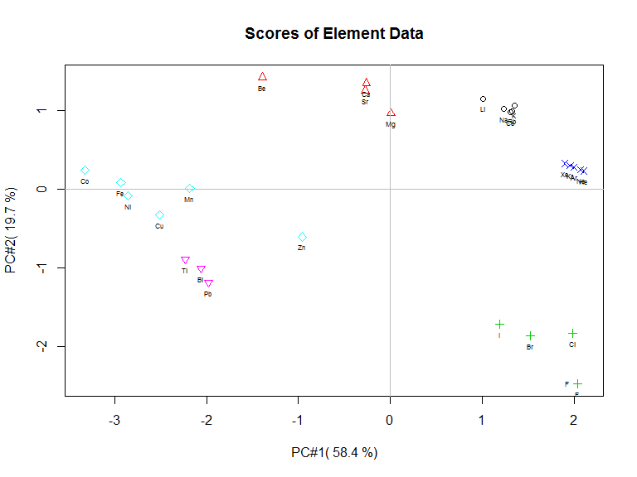

Looking at the first two principal components, we see good separation by group with the exception of groups 5 (3d transition metals) and 6 (6p metals). Groups 1 (alkali metals) and 1 (rare gases) group tightly within themselves, while groups 2 (alkaline earth metals) and 3 (halogens) are more spread. Chemically thesee groupings are familiar. The difference in spread is also expected since the transition metals often have unique properities while the alkali metals and rare gases are very similar in nature.

plot(elem_a_pc$loadings[,1],elem_a_pc$loadings[,2],  
 main="Loadings of Element Data",pch=elem$Group, col=elem$Group,xlim=c(-0.52,-.11),  
 xlab="Loadings #1",ylab="Loadings #2")  
abline(h=0, col="gray");abline(v=0, col="gray")  
text(elem_a_pc$loadings[,1], elem_a_pc$loadings[,2],labels=colnames(elem),cex=.5, pos=c(1,1,3,1,4,2))

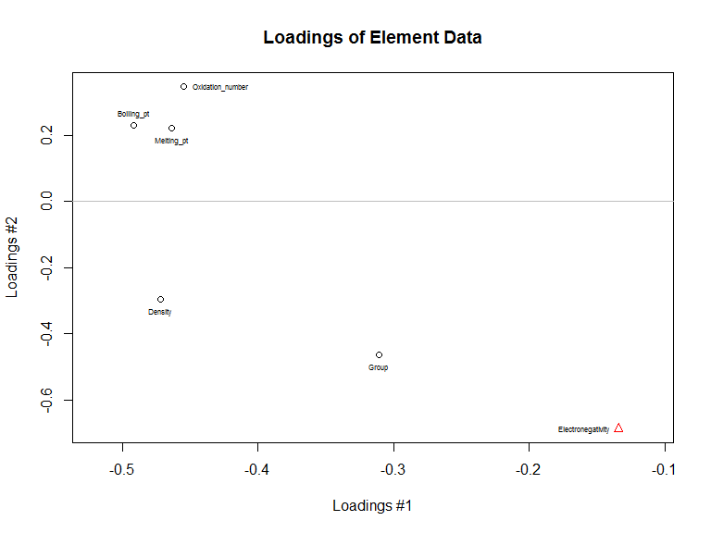

A vast majority of the variance is represented by component 1, but we also see that boiling point, melting point, and oxidation number group noticed in the earlier scatterplot.

#### e) Excluding a Variable

Suppose we wished to exlude the variable with high loadings in PC#2. We would exclude electronegativity as sign is not important.

elem2<-elem[,1:5]  
elem2_a<-scale(elem2)  
elem2_a_pc<-princomp(elem2_a, cor=T)  
screeplot(elem2_a_pc,type="lines", col="red", main ="PCA of Element Data")

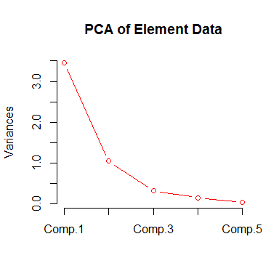

We see that the about of variance explained by each component has changed, and that it seems likely we will need 3 components to separate the data.

variances <-elem2_a_pc$sdev^2/(nrow(elem2_a)-1)  
totvariances<- sum(variances)  
relvars<- variances/totvariances  
vars<- 100*round(relvars, digits=3)  
  
m<-matrix(c(1,1,2,3),2,2,byrow=TRUE)  
layout(m,heights=c(.1,.9))  
par(mar=c(0,0,0,0))  
plot(5, type = "n", axes=FALSE, xlab="", ylab="")  
text(5,labels="Scores of Element Data without Electronegativity",cex=1.7)  
par(mar=c(5,4,1,2)+.1)  
plot(elem2_a_pc$scores[,1],elem2_a_pc$scores[,2],  
 xlab=paste("PC#1 (",vars[1],"%)", sep=""),  
 ylab=paste("PC#2 (",vars[2],"%)",sep=""),  
 pch=elem2$Group, col=elem2$Group)  
abline(h=0, col="gray");abline(v=0, col="gray")  
text(elem2_a_pc$scores[,1], elem2_a_pc$scores[,2],labels=rownames(elem),cex=.75, pos=1)  
text(elem2_a_pc$scores[6,1], elem2_a_pc$scores[6,2],labels="Be",cex=.75, pos=4)  
  
plot(elem2_a_pc$scores[,1],elem2_a_pc$scores[,3],  
 xlab=paste("PC#1 (",vars[1],"%)", sep=""),  
 ylab=paste("PC#3 (",vars[3],"%)",sep=""),  
 pch=elem2$Group, col=elem2$Group)  
abline(h=0, col="gray");abline(v=0, col="gray")  
text(elem2_a_pc$scores[,1], elem2_a_pc$scores[,3],labels=rownames(elem),cex=.75, pos=1)  
text(elem2_a_pc$scores[10,1], elem2_a_pc$scores[10,3],labels="F",cex=.75, pos=2)

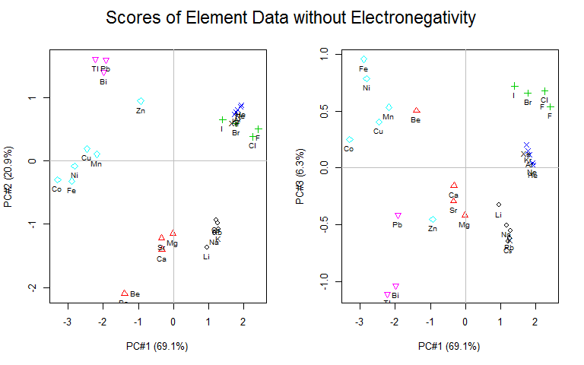

Plotting the first two components, we do indeed see that while most groups separate well, the rare gases and the halogens do not. However plotting components 1 and 3 separate the rare gases and the halogens, so three principal components are necessary to separate the data if electronegativity is removed.

#m<-matrix(c(1,1,2,3),2,2,byrow=TRUE)  
layout(m,heights=c(.1,.9))  
par(mar=c(0,0,0,0))  
plot(5, type = "n", axes=FALSE, xlab="", ylab="")  
text(5,labels="Loadings of Element Data without Electronegativity",cex=1.7)  
par(mar=c(5,4,1,2)+.1)  
plot(elem2_a_pc$loadings[,1],elem2_a_pc$loadings[,2],  
 pch=elem$Group, col=elem$Group,  
 xlab="Loadings #1", ylab="Loadings #2")  
abline(h=0, col="gray");abline(v=0, col="gray")  
text(elem2_a_pc$loadings[,1], elem2_a_pc$loadings[,2],labels=colnames(elem2),cex=.75,   
 pos=c(2,4,4,4,4))  
plot(elem2_a_pc$loadings[,1],elem2_a_pc$loadings[,3],  
 pch=elem$Group, col=elem$Group,  
 xlab="Loadings #1", ylab="Loadings #2")  
abline(h=0, col="gray");abline(v=0, col="gray")  
text(elem2_a_pc$loadings[,1], elem2_a_pc$loadings[,3],labels=colnames(elem2),cex=.75,   
 pos=c(2,4,4,4,4))

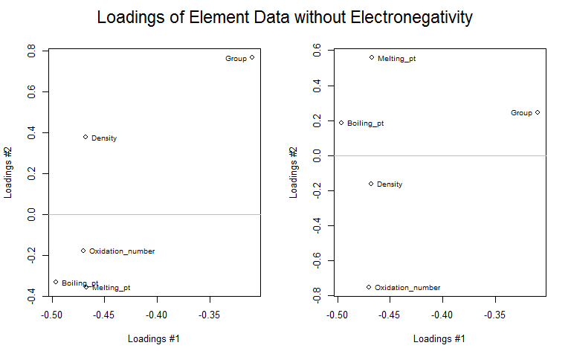

## Question 4 - PCA for Identification

A common use for PCA is identification of samples via comparison to a known dataset. Here we are examining a series of two-types optical filters, made and measured at NIST, where some have gone unlabeled ('Y'-type).

#### a) Load and Examine data

opt<-read.csv("data/homework2-3.csv")  
plot(opt)

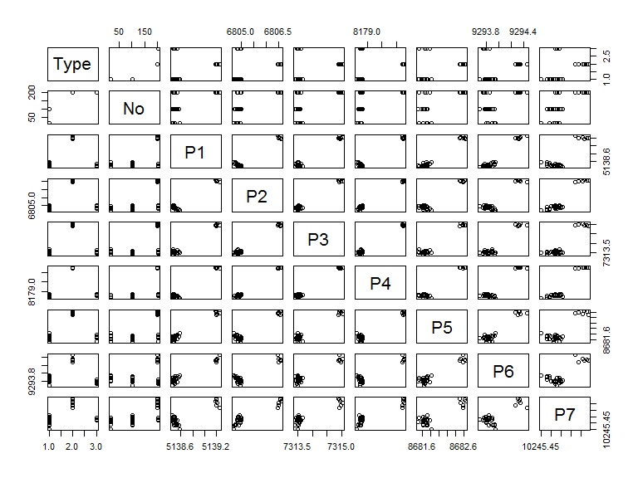 A quick look at the data reveals a strong correlation and separation in the P-variables. Type would be excluded from the PCA.

str(opt)

## 'data.frame': 35 obs. of 9 variables:  
## $ Type: Factor w/ 3 levels "2035","2035a",..: 1 1 1 1 1 1 1 1 1 1 ...  
## $ No : int 18 18 18 18 18 18 101 101 101 101 ...  
## $ P1 : num 5139 5138 5138 5138 5138 ...  
## $ P2 : num 6805 6805 6805 6805 6805 ...  
## $ P3 : num 7313 7313 7313 7314 7314 ...  
## $ P4 : num 8179 8179 8179 8179 8179 ...  
## $ P5 : num 8682 8682 8682 8682 8682 ...  
## $ P6 : num 9294 9294 9294 9294 9294 ...  
## $ P7 : num 10245 10245 10246 10246 10246 ...

summary(opt)

## Type No P1 P2 P3   
## 2035 :24 Min. : 18.0 Min. :5138 Min. :6805 Min. :7313   
## 2035a: 6 1st Qu.:101.0 1st Qu.:5138 1st Qu.:6805 1st Qu.:7314   
## Y : 5 Median :102.0 Median :5138 Median :6805 Median :7314   
## Mean :118.5 Mean :5139 Mean :6805 Mean :7314   
## 3rd Qu.:200.0 3rd Qu.:5139 3rd Qu.:6805 3rd Qu.:7314   
## Max. :201.0 Max. :5139 Max. :6807 Max. :7315   
## P4 P5 P6 P7   
## Min. :8179 Min. :8682 Min. :9294 Min. :10245   
## 1st Qu.:8179 1st Qu.:8682 1st Qu.:9294 1st Qu.:10246   
## Median :8179 Median :8682 Median :9294 Median :10246   
## Mean :8179 Mean :8682 Mean :9294 Mean :10246   
## 3rd Qu.:8179 3rd Qu.:8682 3rd Qu.:9294 3rd Qu.:10246   
## Max. :8180 Max. :8683 Max. :9294 Max. :10246

(apply(opt[,3:9],2,var))

## P1 P2 P3 P4 P5 P6   
## 0.078171429 0.389810588 0.297716303 0.309059664 0.125266387 0.042854958   
## P7   
## 0.003591092

The data needs to be centered, but looking at the variance, I would argue it should not be scaled.

#### b) Exclude "Y" and Pre-process data

#split out "unknown/type-y data"  
opt2<-opt[opt$Type != "Y",]  
opty<-opt[opt$Type == "Y",]  
  
opt3<-opt2[,3:9]  
opt3_means<-colMeans(opt3)  
opt3_var<-apply(opt3,2,var)  
opt3<-scale(opt3, scale=F)

The data was split into known and unknown filters. Type was excluded as we do not wish to bias the PCA. No was also excluded since this is highly correlated with Type (possibly lot numbers). The data was mean-centered only, not scaled.

#### c) Preform PCA. Plot scores and labels

opt3_c_pc<-princomp(opt3,cor=T)  
screeplot(opt3_c_pc,type="lines", col="red", main ="PCA of Optical Filters")

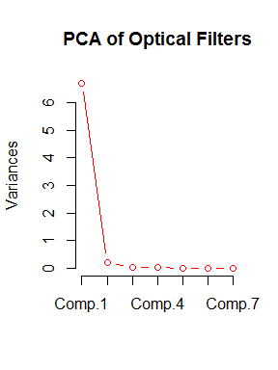

A plot of the variances shows the vast majority of the variance lies in the first principal component, with very little in the second and almost none in the third through seventh. Arguably, this data can be separate with only one principal component (as was seen in the scatterplot before processing), but we will plot two simply to easier visualization.

variances <-opt3_c_pc$sdev^2/(nrow(opt3)-1)  
totvariances<- sum(variances)  
relvars<- variances/totvariances  
vars<- 100*round(relvars, digits=3)  
  
plot(opt3_c_pc$scores[,1],opt3_c_pc$scores[,2], col=as.factor(opt2$Type), xlab=paste("PC#1 - ",vars[1],"% of Variance"), ylab=paste("PC#2 - ",vars[2],"% of Variance"))  
abline(h=0, col="gray")  
abline(v=0, col="gray")  
text(opt3_c_pc$scores[,1],opt3_c_pc$scores[,2],labels=rownames(opt3),cex=.7, pos=4)  
legend("bottom",inset=0,legend=c("2305","2305a"),col=c("black","red"), pch=1,cex=1,horiz=T)

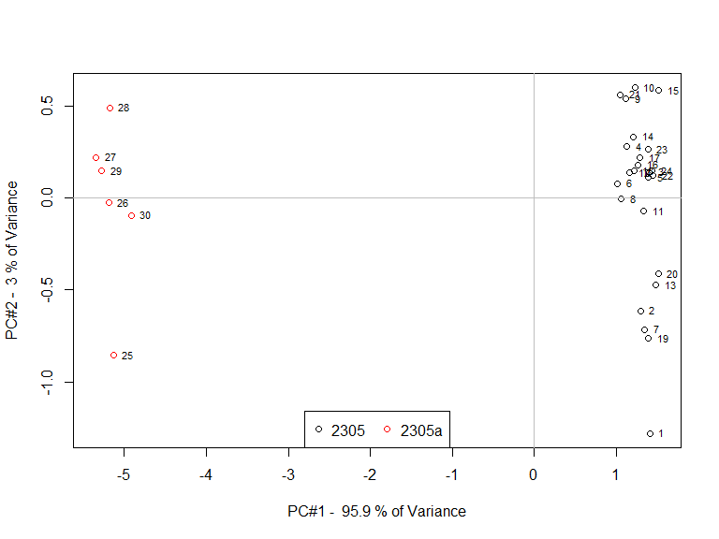

#### d) Loadings

plot(opt3_c_pc$loadings[,1],opt3_c_pc$loadings[,2], xlab="PC#1 - Loadings", ylab="PC#2 - Loadings")  
abline(h=0, col="gray")  
abline(v=0, col="gray")  
text(opt3_c_pc$loadings[,1],opt3_c_pc$loadings[,2],labels=colnames(opt3),cex=1,pos=c(4,4,4,4,4,4,2))

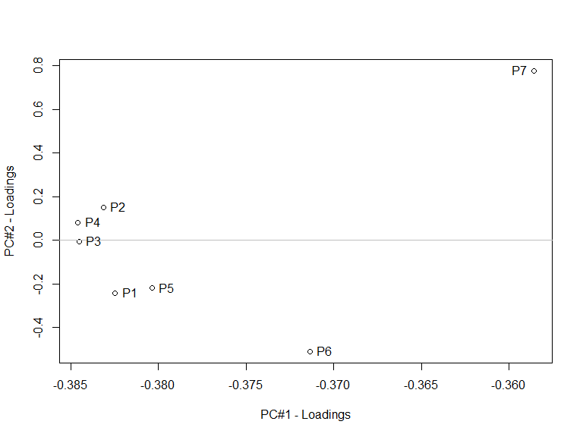

Loadings which are different from 0, contribute to the differences in the filters. If only one measurement could be taken, P3 would be optimal. P7 contributes the least to the difference in filters along the first principal component, which explains an overwhelming amount (96%) of the variance.

#### e) Project Y samples onto PCA model

We need to pre-process the "Y"-type filters identically to the known filters (using the same mean and variances for scaling as necessary).

opty<-opt[opt$Type=="Y",]  
scalec<-attributes(opt3)$"scaled:center"  
opty_c<-opty[,3:9]  
opty_c<-scale(opty_c,center=scalec,scale=F)

We then project the data onto the new principal component axes found with the known data using the loadings.

newscores<-opty_c%*%opt3_c_pc$loadings

Finally we plot the new data as see which type it more closely resembles.

plot(opt3_c_pc$scores[,1],opt3_c_pc$scores[,2], col=as.factor(opt2$Type), xlab=paste("PC#1 - ",vars[1],"% of Variance"), ylab=paste("PC#2 - ",vars[2],"% of Variance"))  
abline(h=0, col="gray")  
abline(v=0, col="gray")  
text(opt3_c_pc$scores[,1],opt3_c_pc$scores[,2],labels=rownames(opt3),cex=.5, pos=3)  
legend("bottom",inset=0,legend=c("2305","2305a","Y"),col=c("black","red","green"), pch=1,cex=1, horiz=T)  
points(newscores[,1],newscores[,2],col=3)

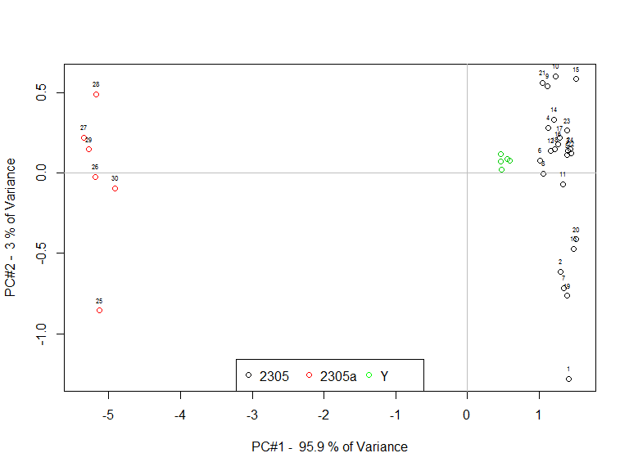

Here, the "Y"-type filters closely resemble "2305"-type filters, but do seem to have slight differences, perhaps as a separate production run, however, they are clearly not "2305a"-type filters.

## Question 5 - Determining differences between Fire Ants

Fire ants can be distinguished through hydrocarbon signals. Using 5 chromatographic hydrocarbon peaks, we wish to distinguish between two types of fire ant.

#### a) Load and Preprocess Data

ants<-read.csv("data/homework2-4.csv")  
summary(ants)

## Type heptacosane X13.methylheptacosane  
## Forager :51 Min. : 1.008 Min. : 1.038   
## Reserver:50 1st Qu.: 2.221 1st Qu.: 2.049   
## Median : 3.594 Median : 3.770   
## Mean : 5.719 Mean : 5.596   
## 3rd Qu.: 6.344 3rd Qu.: 6.231   
## Max. :150.540 Max. :125.320   
## X13.15.dimethylheptacosane X3.methylheptacosane X3.9.dimethylheptacosane  
## Min. : 1.016 Min. : 1.176 Min. : 1.018   
## 1st Qu.: 2.309 1st Qu.: 4.719 1st Qu.: 3.870   
## Median : 4.393 Median : 7.268 Median : 5.674   
## Mean : 6.164 Mean : 8.556 Mean : 7.177   
## 3rd Qu.: 6.749 3rd Qu.: 9.212 3rd Qu.: 8.041   
## Max. :165.780 Max. :187.230 Max. :146.340

A quick look at the data shows the type of ant (Forager/Reserver) is located in column 1 and should be removed for PCA.

plot(ants[,2:6])

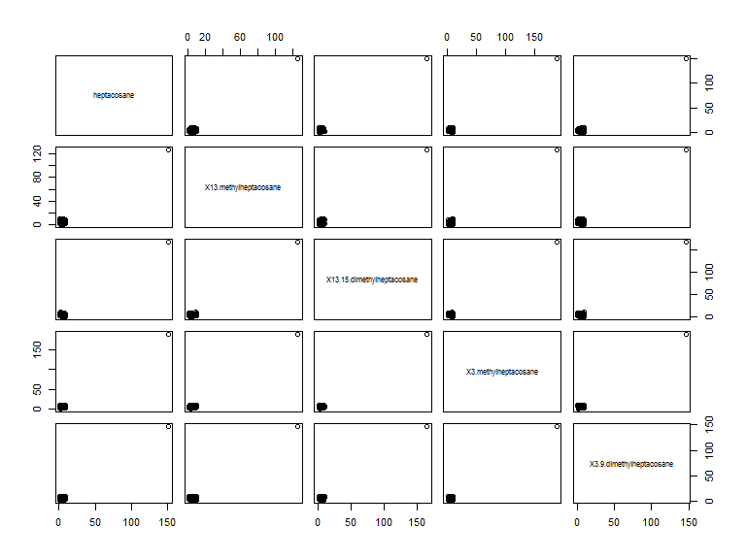

The scatterplots show a clear outlier, ant #1, in all categories.

ants_out<-ants[-1,]  
ants_out2<-ants_out[,-1]  
plot(ants_out2)

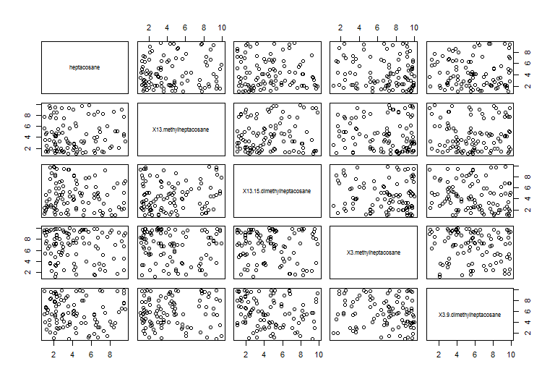

boxplot(ants_out2)

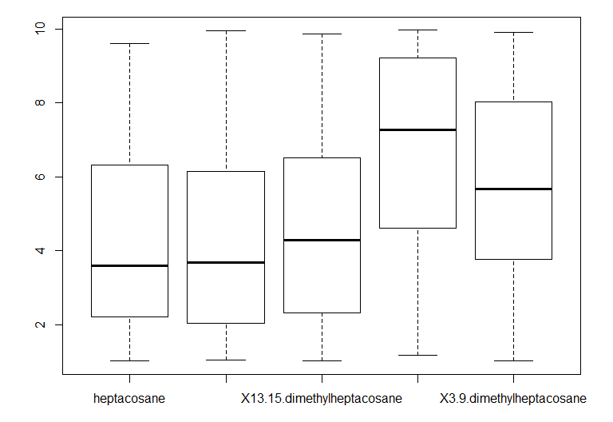

apply(ants_out2,2,var)

## heptacosane X13.methylheptacosane   
## 6.241634 7.464978   
## X13.15.dimethylheptacosane X3.methylheptacosane   
## 6.558687 7.123367   
## X3.9.dimethylheptacosane   
## 6.598363

Looking at the data without the outlier, no obvious trends appear. The variances are close enough that auto-scale may be not be helpful for PCA.

ants_c<-scale(ants_out2, scale=F)  
ants_a<-scale(ants_out2, scale=T)

#### b) Distance between ants and centroid

We can find the centroid simply by finding the mean for each variable.

ants_forager<-ants_out[ants_out$Type=="Forager",2:6]  
ants_reserver<-ants_out[ants_out$Type=="Reserver",2:6]  
ants_forg_cent<-colMeans(ants_forager)  
ants_res_cent<-colMeans(ants_reserver)  
  
m<-matrix(c(1,1,2,3),2,2,byrow=TRUE)  
layout(m,heights=c(.1,.9))  
par(mar=c(0,0,0,0))  
plot(5, type = "n", axes=FALSE, xlab="", ylab="")  
text(5,labels="Centroid of Ants by Type",cex=2)  
par(mar=c(5,4,4,2)+.1)  
plot(ants_forager[,1]~ants_forager[,2],   
 main="Forager", xlab="heptacosane", ylab="methylheptacosane")  
points(ants_forg_cent[1],ants_forg_cent[2],col="green",pch=16)  
  
plot(ants_reserver[,1]~ants_reserver[,2], col='red',   
 main="Reserver", xlab="heptacosane", ylab="methylheptacosane")  
points(ants_res_cent[1],ants_res_cent[2],col='green', pch=16)

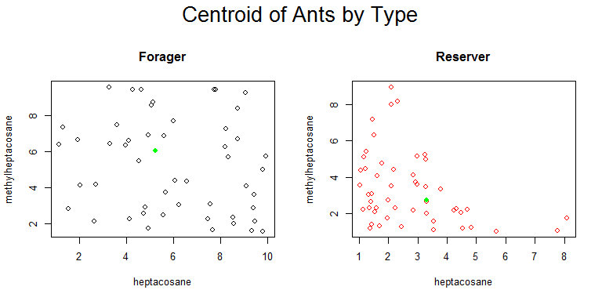

Here are the centroids for each type of ant in the first two dimensions. We can write a quick function to measure the euclidean distance between a single point (point) and a set of points (y).

#euclidean distance function  
e_dist<-function(point,y){  
 dist_vect<-NULL  
 for(i in 1:length(y[,1])){  
 a<-y[i,]-point  
 a<-a*a  
 a<-sqrt(sum(a))  
 dist_vect<-append(dist_vect,a)  
 }  
 dist_vect  
 }  
  
#run function  
edist_for<-e_dist(ants_forg_cent, ants_out2)  
edist_res<-e_dist(ants_res_cent, ants_out2)  
  
par(mfrow=c(1,1))  
plot(edist_for,edist_res,col=ants_out$Type, main="Euclidean Distance from Centroids", xlab="Distance from Forager Centroid", ylab="Distance from Reserver Centroid")  
legend('topleft', col=c("black","red"), legend=c("Forager","Reserver"),pch=1)

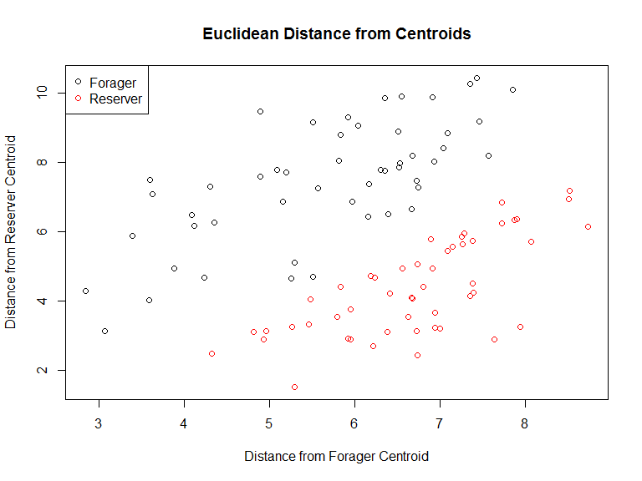

This separates the ants well, but requires us to know the types of the ant beforehand.

#### c) Determine Mahalanobis Distances

We can also measure the Mahalanobis distances between points

mdist_for<-mahalanobis(ants_out2,ants_forg_cent,cov(ants_out2))  
mdist_res<-mahalanobis(ants_out2,ants_res_cent,cov(ants_out2))  
  
plot(mdist_for,mdist_res,col=ants_out$Type, main="Mahalanobis Distance from Centroids", xlab="Distance from Forager Centroid", ylab="Distance from Reserver Centroid")  
legend('bottomright', col=c("black","red"), legend=c("Forager","Reserver"),pch=1)

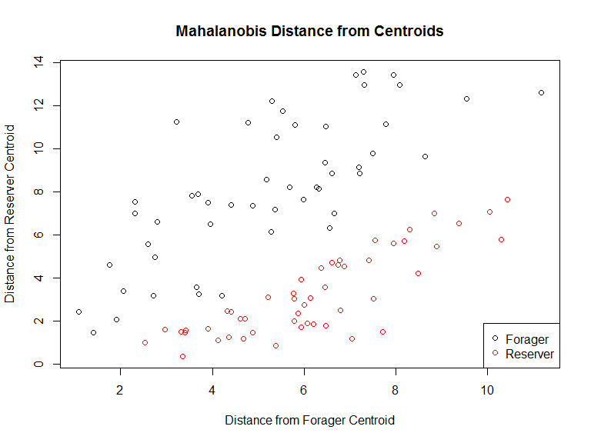

Mahalanobis distances create an even wider separation between the two ant types.

#### d) Calculating Assignments using Distance

Suppose we wish to classify each ant by the centroid they are closer to.

euc<-as.data.frame(cbind(ants_out$Type,edist_for,edist_res,2,0))  
colnames(euc)<-c("Type","edist_for","edist_res","Predict","Match")  
  
euc[edist_for<edist_res,4]<-1  
euc[euc$Type==euc$Predict,5]<-1  
text1<-100*summary(euc[,5])[4]  
  
plot(edist_for,edist_res,col=euc$Type,pch=euc$Predict,  
 xlab="Distance from Forager Centroid", ylab="Distance from Reserver Centroid")  
text(8,2.2,labels=paste0(text1,"% agreement"),cex=.75)  
legend('topleft', col=c("black","red"), legend=c("Actual Forager","Actual Resever"), lty=1)  
legend('bottomleft', col="grey", legend=c("Predicted Forager","Predicted Resever"),pch=c(1,2))

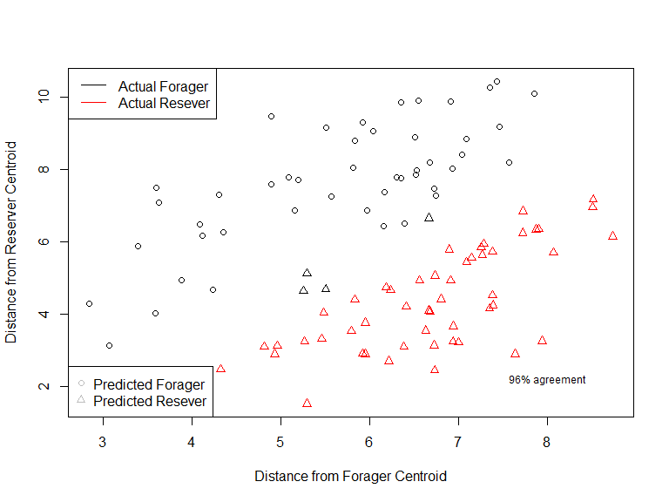

The type of the ants is known and represented by the color of points. Our predictions are represent by the shape. We can see that there is 96% agreement between our predictions and the actual type, but that some ants have been misclassified (ie black triangles).

mah<-as.data.frame(cbind(ants_out$Type,mdist_for,mdist_res,2,0))  
colnames(mah)<-c("Type","mdist_for","mdist_res","Predict","Match")  
  
mah[mdist_for<mdist_res,4]<-1  
mah[mah$Type==mah$Predict,5]<-1  
text1<-100*summary(mah[,5])[4]  
  
plot(mdist_for,mdist_res,col=mah$Type,pch=mah$Predict,  
 xlab="Distance from Forager Centroid", ylab="Distance from Reserver Centroid")  
text(10,1,labels=paste0(text1," % agreement"),cex=.75)  
legend('topright', col=c("black","red"), legend=c("Actual Forager","Actual Resever"),pch=1)  
legend('bottomright', col="grey", legend=c("Predicted Forager","Predicted Resever"),pch=c(1,2))

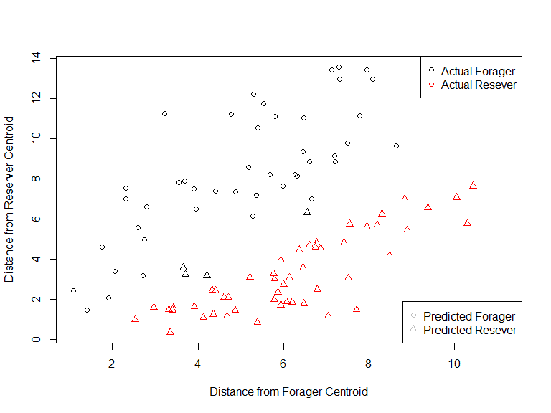

We see that Mahalnobis distances have the same 96% agreement but some ants are still misclassified (ie black triangles).

#### e) PCA

Perhaps PCA will be able to definitely separate the two groups.

ants_c_pc<-princomp(ants_c,cor=T)  
ants_a_pc<-princomp(ants_a,cor=T)  
#m<-matrix(c(1,1,2,3),2,2,byrow=TRUE)  
layout(m,heights=c(.1,.9))  
par(mar=c(0,0,0,0))  
plot(5, type = "n", axes=FALSE, xlab="", ylab="")  
text(5,labels="PC of Ants",cex=2)  
par(mar=c(5,4,4,2)+.1)  
screeplot(ants_c_pc,type="lines", col="red", main ="Mean-Centered")  
screeplot(ants_a_pc,type="lines", col="red", main ="Auto-Scaled")

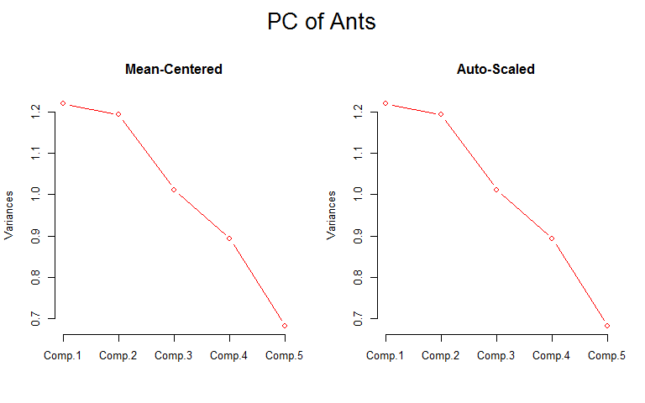

Plots of the eigenvalues show little difference between mean-centered and auto-scaled data so we will only plot the scores and loadings from mean-centered data. It is highly likely that we will need three principal components to separate the two ant types.

variances <-ants_c_pc$sdev^2/(nrow(ants_c)-1)  
totvariances<- sum(variances)  
relvars<- variances/totvariances  
vars<- 100*round(relvars, digits=3)  
  
par(mfrow=c(1,1))  
plot(ants_c_pc$scores[,1],ants_c_pc$scores[,2], col=as.factor(ants_out$Type), xlab=paste("PC#1 - ",vars[1],"% of Variance"), ylab=paste("PC#2 - ",vars[2],"% of Variance"), main="PC of Fire Ants")  
abline(h=0, col="gray")  
abline(v=0, col="gray")

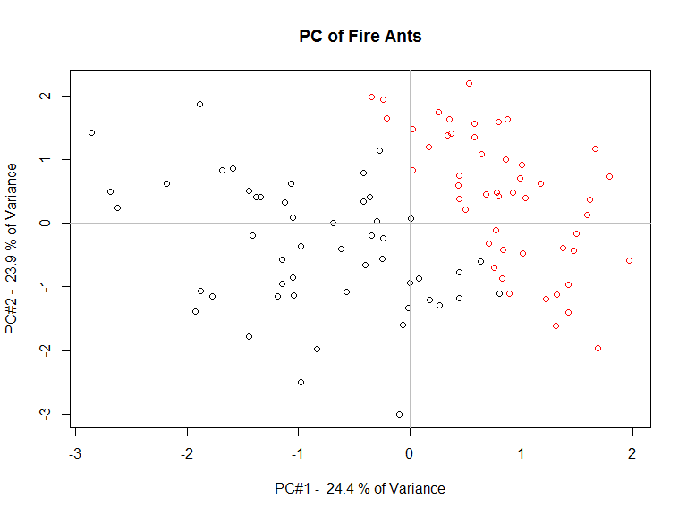

Indeed the first two components mostly separate the two types, but a third may be helpful.

plot(ants_c_pc$scores[,1],ants_c_pc$scores[,3], col=as.factor(ants_out$Type), xlab=paste("PC#1 - ",vars[1],"% of Variance"), ylab=paste("PC#3 - ",vars[3],"% of Variance"), main="PC of Fire Ants")  
abline(h=0, col="gray")  
abline(v=0, col="gray")

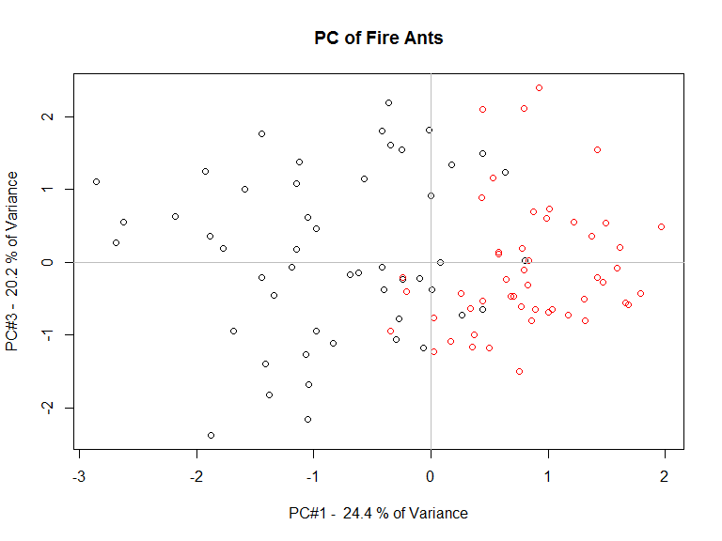

It is difficult to see the additional separation in two dimensions.

ants_color<-rep(c(1,2),each=50)  
scatterplot3d(ants_c_pc$scores[,1],ants_c_pc$scores[,2],ants_c_pc$scores[,3], color=ants_color, angle=45, xlab=paste("PC#1 - ",vars[1],"% of Variance"), ylab=paste("PC#2 - ",vars[2],"% of Variance"), main="PC of Fire Ants", zlab=paste("PC#3 - ",vars[3],"% of Variance"))

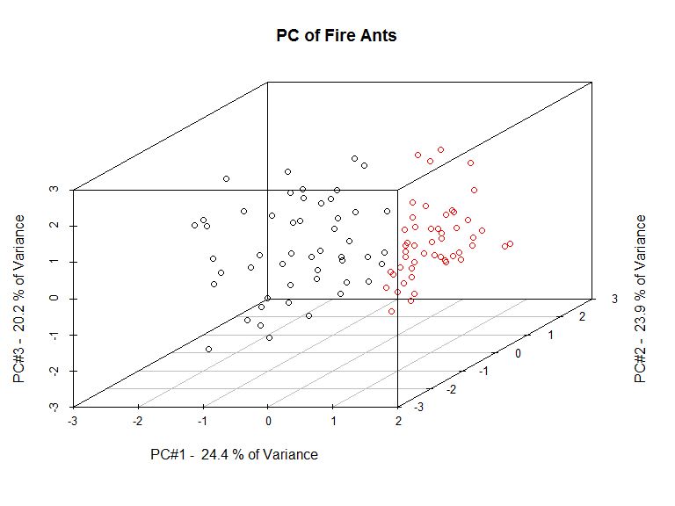

layout(m,heights=c(.1,.9))  
par(mar=c(0,0,0,0))  
plot(5, type = "n", axes=FALSE, xlab="", ylab="")  
text(5,labels="Loadings of PC of Ants",cex=2)  
par(mar=c(5,4,2,2)+.1)  
plot(ants_c_pc$loadings[,1],ants_c_pc$loadings[,2], xlab="PC#1 - Loadings", ylab="PC#2 - Loadings")  
abline(h=0, col="gray")  
abline(v=0, col="gray")  
text(ants_c_pc$loadings[,1],ants_c_pc$loadings[,2], labels=colnames(ants_out2),pos=c(4,4,3,2,4), cex=0.7)  
plot(ants_c_pc$loadings[,1],ants_c_pc$loadings[,3], xlab="PC#1 - Loadings", ylab="PC#3 - Loadings")  
abline(h=0, col="gray")  
abline(v=0, col="gray")  
text(ants_c_pc$loadings[,1],ants_c_pc$loadings[,3], labels=colnames(ants_out2), pos=c(4,4,3,2,4), cex=0.7)

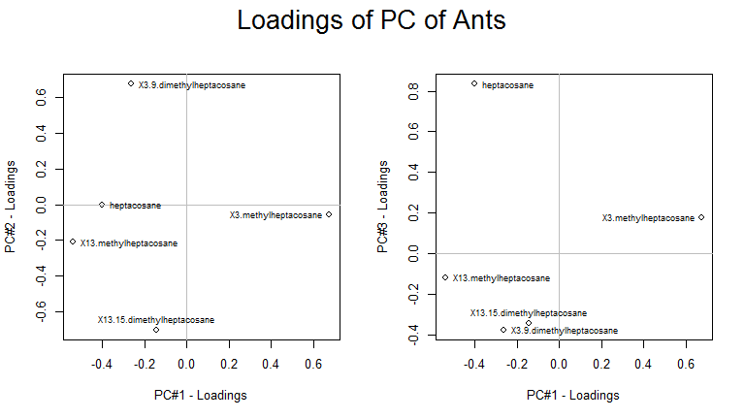

## References

1. "JM Bland and DG Altman, Lancet (1995) 346(8982) 1085-1087"
2. Kleinman, K. "Example 9.34: Bland-Altman type plot" June 5, 2012. <http://www.r-bloggers.com/example-9-34-bland-altman-type-plot/>