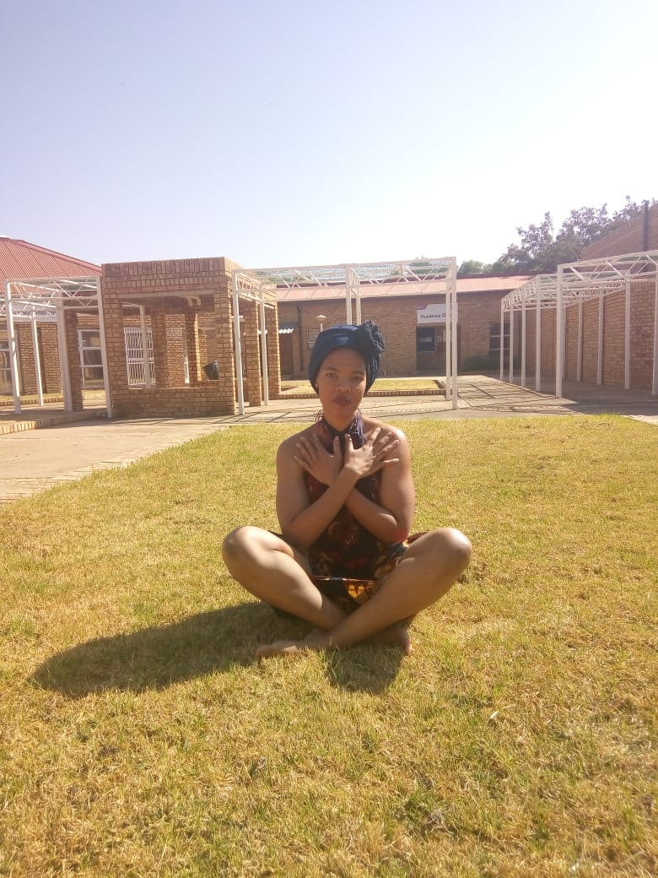

KUTLWANO : 0792577058 : KUTLWANOMELAMU93@GMAIL.COM

# About me

& C:/Users/NWUUSER/AppData/Local/Programs/Python/Python39/python.exe c:/Users/NWUUSER/Desktop/PYTHON/my_App.py

# Work experience

**& C:/Users/NWUUSER/AppData/Local/Programs/Python/Python39/python.exe c:/Users/NWUUSER/Desktop/PYTHON/my_App.py** *& C:/Users/NWUUSER/AppData/Local/Programs/Python/Python39/python.exe c:/Users/NWUUSER/Desktop/PYTHON/my_App.py-& C:/Users/NWUUSER/AppData/Local/Programs/Python/Python39/python.exe c:/Users/NWUUSER/Desktop/PYTHON/my_App.py*& C:/Users/NWUUSER/AppData/Local/Programs/Python/Python39/python.exe c:/Users/NWUUSER/Desktop/PYTHON/my_App.py

# Skills

* & C:/Users/NWUUSER/AppData/Local/Programs/Python/Python39/python.exe c:/Users/NWUUSER/Desktop/PYTHON/my_App.py