Reindeer –
a Result Render Tool

Configuration

General
Tool Log | C:\temp\git\reindeer\out\Reindeer.log
Tool Output | C:\temp\git\reindeer\out\final_result.docx
Tool PDF Output | C:\temp\git\reindeer\out\final_result.pdf
Tool Template | C:\temp\git\reindeer\doc\Reindeer_TemplateCourierNav.docx
Result Base Path | C:\temp\git\reindeer\out
Configuration
Content
FigureMaxHeight
FigureMaxWidth
TodayDateFormat
SpecialPageHandling | Yes

Styles
Heading 1 | CustomHeader 1
Heading 2 | CustomHeader 2
Heading 3
Title Caption | CustomCaption
Content Font Text | CustomTextResult
Content Font RTF | CustomRTFResult

Replace
[todayDate] | [todayDate]
[reportID] | REPI025889
[creator] | Katja Glass Consulting
[sponsor] | ClinStat

Content
Header1 | Reindeer Example Document
Header2 | Listing Outputs with[linefeed]many fancy outputs
Listing | 01_class.lst
Listing | 02_cars.lst
Listing | 03_cars_page.lst
Listing | 04_cars_multioutput.lst
Header2 | RTF Outputs
RTF | 07_class.rtf
RTF | 08_cars.rtf
RTF | 09_cars.rtf
RTF | 10_12_cars.rtf
RTF | 13_class.rtf
Header2 | Graphic Outputs
FigureTitle | Figure 1: Class overview by sex and age
Figure | img1_image.jpg
FigureTitle | Figure 2: Huge sized graphic
Figure | img2_width.gif
FigureTitle | Figure 3: Portrait graphic
Figure | img3_height.png
FigureTitle | Figure 4: repetition[linefeed]with a second line
Figure | img1_image.jpg
Header2 | TAGSETS.RTF Outputs
TAGSETS.RTF | 14_class.rtf
TAGSETS.RTF | 15_cars.rtf
TAGSETS.RTF | 16_cars.rtf
TAGSETS.RTF | 17_19_cars.rtf
TAGSETS.RTF | 20_class.rtf
TAGSETS.RTF | 100_cars.rtf
TAGSETS.RTF | 103_class.rtf
Header2 | Outputs including page numbers in titles
Listing | 30_class.lst
RTF | 31_class.rtf
TAGSETS.RTF | 32_class_tagset.rtf
Listing | 33_cars.lst
RTF | 34_cars.rtf
TAGSETS.RTF | 35_cars_tagset.rtf

Table of Contents

Configuration 1
General 1
Styles 1
Replace 1
Content 2
Table of Contents 2
About 4
Future Plans 4
Help 5
Usage 5
Example 5
Configuration Settings 5
Content Settings 7
Configuration – Tool Log 8
Configuration – Tool Output 9
Configuration – Tool PDF Output 9
Configuration – Tool Template 9
Configuration - Result Base Path 12
Configuration – Configuration specification 12
Configuration – Content specification 12
Configuration – FigureMaxHeight & FigureMaxWidth 13
Configuration - TodayDateFormat 13
Configuration – SpecialPageHandling 13
Configuration – Batch 14
Configuration - Styles 16
Content – Replace Tags 17
Content – Header1, Header2, Header3 18
Content – Listing 19
Content – RTF 20
Content – TAGSETS.RTF 21
Tipps 22
Operating Systems & Word Versions 24
MIT License 25
Environment 25

About
The Reindeer Result Render open-source tool contains a VBA macro which can be used to render multiple outputs created with SAS® into one Word document. Currently the listing (.lst or .txt) and rtf outputs are supported. Options can be set either through a configuration in this file (see configuration section) or through a text file which is references in configuration. For more information about the usage, please go into the help section.
This open-source tool is developed by Katja Glass Consulting and sponsored by ClinStat GmbH. By investing in open source ClinStat enabled this project, which is available under the MIT license. Feel free to use and modify this tool, but be aware that there is no warranty. Please feel free to perform push requests in GitHub or mail me if you want to further enhance this tool. If you consider to become an open-source sponsor, please reach out to me as well. You can mail me via info@glacon.eu.

Future Plans
To be able to further enhance the tool, I am looking for additional sponsors. The following features are currently missing.
- Performance optimization
- Option to check page breaks for text results (for example SAS PS Option selected accordingly)
- Abort/Continue on Missing File specification
- SAS macro to create configuration file
- SAS macro to create content file (create from dataset, addFile, addFigure, AddHeader)

Help
This document contains a VBA macro which can be used to render outputs created with SAS® into a Word file. Various options are available which are explained here. To view the macro source, please press alt+F11 to open the macro view from Word.

Usage
The following prerequisites must be available to run this tool:
- Template file (all content is rendered into this file)
- Configuration details (either in this file or in a configuration text file)
- Content specifications (either trough a configuration or a separate text file)
To run the macro, please press the “Run” button on the first page. You can also start the VBA macro “RunReindeer”.

Example
A running example is available. If the complete reindeer package is downloaded, then the example is already included with all required files. Please update the paths in the “Configuration – General” section. Then by pressing the “Run” button, the example will execute. Make sure that the “content” is enabled, as the execution of VBA macros is for security reasons per default not allowed.
To run an example with a configuration and content text file, please include the appropriate updated values and press the “Run” button for execution.
Configuration | C:\Reindeer\doc\config.txt
Content | C:\Reindeer\doc\content.txt

To run an example with many outputs, please run the following configuration:
Configuration | C:\Reindeer\doc\config_full.txt

To run a batch example, you can use the following example:
Configuration | C:\Reindeer\doc\config_batch.txt

You can also run examples by filling the table without using a configuration text file.

Configuration Settings
The configuration can be done either in this file directly under the configuration section in the “General” and “Fonts” table or provided through a text file, which could for example be created with SAS. When options are configured in this Word file and in the configuration text file at the same time, then the value from the text file is used. Text configurations overwrite configuration of this file.
The following table shows supported options. Further details can be found in the corresponding sections below.
Option | Description
Tool Log | Path and name of the created log file. General information like start, end time and which files are included are printed to the log as well as warnings and issues if available.
Tool Output | Path and name of the output file.
Tool PDF Output | Path and name of the PDF output file.
Tool Template | Path and name of the input template file – all referenced Styles must be included in this document.
Result Base Path | The path where all result files are located which should be included into the template,
Configuration | Optional: Configuration text file to be used, Single option values of the text file overwrites options of this word file (General & Styles table).
Content | Optional: Content text file to be used. When this is specified, “Replace” and “Content” of this word file is completely ignored and only the content specification from the text file is used.
FigureMaxHeight | Maximum Height of included figures
FigureMaxWidth | Maximum Width of included figures
TodayDateFormat | VBA Date format for “[todayDate]” tag
SpecialPageHandling | No/Yes indicator whether to perform special handling for the first title line having “page x of x” handling
Batch | Special Batch Processing, configuration/content coming after this tag are executed as a separate batch processing, Multiple batch Processings can be included with this process.
Style definitions
Heading 1 | Optional, style to be used for “Heading 1”
Heading 2 | Optional, style to be used for “Heading 1”
Heading 3 | Optional, style to be used for “Heading 1”
Title Caption | Optional, style to be used for all captions – the first line of the outputs is considered as title, these titles are formatted as captions
Content Font Text | Optional, style to be used for “Listing” inputs – except for titles/captions
Content Font RTF | Optional, style to be used for “RTF” inputs – except for titles/captions

If this document is used for specification, then the values must be entered into the corresponding tables under the corresponding values. When a configuration text file should be used, the options and values are to be separated by a semicolon. The content could look like the following:
Tool Log;C:\Reindeer\out\Reindeer_log.log
Tool Output;C:\Reindeer\out\final_result.docx
Tool PDF Output; C:\Reindeer\out\final_result.pdf
Tool Template;C:\Reindeer\doc\Reindeer_ExampleTemplate.docx
Result Base Path;C:\Reindeer\out
Content;C:\Reindeer\doc\content.txt
Heading 1;CustomHeader 1
Heading 2;CustomHeader 2
Heading 3;CustomHeader 3
Title Caption;CustomCaption
Content Font Text;CustomTextResult
Content Font RTF;CustomRTFResult

Content Settings
The content what texts, headings, listings and rtf outputs should go into the template including the order can be done either through the configuration in this file in the “Replace” and “Content” table, or through a text file. When a text file is provided, then the content from this file is completely ignored.
Apart from the replacement definition which are executed at the beginning of the program execution, the order of the content specification is of crucial importance. The order of the content is the order of how the content is included into the template.
The following table shows the supported content groups. Further details can be found in the corresponding sections below.
Option | Description
Replacement Tags | Any text can be replaced with any other text. It is recommended to use a special syntax like using special brackets for the replacement tags to avoid possible conflicts.  If the text “[todayDate]” appears as replacement text, then the date of today is included in the format of DDMMMYYYY UK-English in uppercase.
Content Tag  “Header1” | A document heading is included formatted according the style definition “Heading 1”. The text is put into one standalone page.  If the text “[linefeed]” is added, then a soft line feed is included at that space.
Content Tag  “Header2” | A document heading is included formatted according the style definition “Heading 2”. The text is put into one standalone page.  If the text “[linefeed]” is added, then a soft line feed is included at that space.
Content Tag  “Header2” | A document heading is included formatted according the style definition “Heading 3”. The text is put into one standalone page.  If the text “[linefeed]” is added, then a soft line feed is included at that space.
Content Tag  “Listing” | This tag can be used to include a text file at the specific position. This is typically for “.lst” or “.txt” files. The first line(s) is expected to contain the title of the result.
Content Tag  “RTF” | This tag can be used to include a rich text file at the specific position. This is typically for “.rtf” files. The first line(s) is expected to contain the title of the result.

The content tags can be used multiple times to include multiple different contents. For example, by using a “Listing” of “01_class.lst” followed by a “Listing” of “02_class.lst”, two different output files are included into the template, first the content from 01_class.lst and then the content from 02_class.lst.
By using a text file, the replacement tags have to be specified using “Replace;” as indicator followed by the replace tag and separated by another semicolon followed by the replace value. Direct content like headers, listings and RTFs can be included by the tag and the value separated by a semicolon. For example, the content specification could look like this:
Replace;[todayDate];[todayDate]
Replace;[reportID];REPI025889
Replace;[creator];Katja Glass Consulting (2)
Replace;[sponsor];ClinStat GmbH
Header1;Reindeer Example Document According Content File
Header2;Listing Outputs Below
Listing;01_class.lst
Listing;02_cars.lst
Listing;03_cars_page.lst
Listing;04_cars_multioutput.lst
Header2;RTF Outputs Below
RTF;07_class.rtf
RTF;08_cars.rtf
RTF;09_cars.rtf
RTF;10_12_cars.rtf

Configuration – Tool Log
When a log output file is specified through “Tool Log”, then various information is printed into the log file. If there are issues with the general configuration or the tool log itself, e.g. no write access or invalid files – the log will not be created. Instead warnings and error are printed into an alert window directly in Word stating the issue. General information is printed with “INFO;” at the beginning, warnings with “WARNING:” and errors with “ERROR:”.
Next to information about the start and finish of the macro and which files and headers has been included, also information about the parameter values used are printed into the log.
The following is an example log:
INFO: Reindeer Reindeer starting : 06.01.2020 08:42:00
INFO: ConfigurationFile = C:\Reindeer\doc\config.txt
INFO: ContentFile = C:\Reindeer\doc\content.txt
INFO: ResultsBasePath = C:\Reindeer\out
INFO: ToolLog = C:\Reindeer\out\Reindeer_log.log
INFO: ToolOutput = C:\Reindeer\out\final_result.docx
INFO: ToolTemplate = C:\Reindeer\doc\Reindeer_ExampleTemplate.docx
INFO: FontHeading1 = CustomHeader 1
INFO: FontHeading2 = CustomHeader 2
INFO: FontHeading3 =
INFO: FontTitleCaption = CustomCaption
INFO: FontContentText = CustomTextResult
INFO: FontContentRTF = CustomRTFResult
INFO: Process Listing File: 01_class.lst
INFO: Process Listing File: 02_cars.lst
INFO: Process Listing File: 03_cars_page.lst
INFO: Process Listing File: 04_cars_multioutput.lst
INFO: Process RTF file: 07_class.rtf
INFO: Process RTF file: 08_cars.rtf
INFO: Process RTF file: 09_cars.rtf
INFO: Process RTF file: 10_12_cars.rtf
INFO: Reindeer Reindeer finished : 06.01.2020 08:42:11

Configuration – Tool Output
The template file is used as input, content is included into this file. Finally, the file has to be stores as final output file. The file name and path must be provided through “Tool Output”. An example value could be “C:\Reindeer\out\final_out.docx”.

Configuration – Tool PDF Output
The final created file will be saved as PDF output when “Tool PDF Output” is specified. The file name and path must be available as value. An example value could be “C:\Reindeer\out\final_out.pdf”.
For Macintosh the PDF save settings are a bit different. Here, the settings for PDF are available as the last “save as” PDF settings which have been set. If different options are needed – for example to contain a navigation – then this can be set by store any Word file in PDF with the desired settings.

Configuration – Tool Template
The template file which is used as input to include all content into, must be specified through “Tool Template”. An example value could be “C:\Reindeer\doc\template.docx”. All content is included into the last paragraph of this document. What ever content is in this template will stay in – apart from replacement tags. The header and footer of the document is also not changed. When styles are specified in the configuration area, then these styles must be available also in the template document. All fields which are available in the document like a table of contents or a page reference, will be updated by the tool.
The template could for example contain a cover sheet in portrait and then an empty new section in landscape where the content should be included to. The landscape content section could contain a specific header and footer section which will be kept for all content included.
The header could look like the following:

When a replacement tag is defined, the tags will be replaced with the corresponding value. This is working for headers, footers as well as parts of the body content.
The content could for example also contain replacement tags and other word fields like a table of contents:
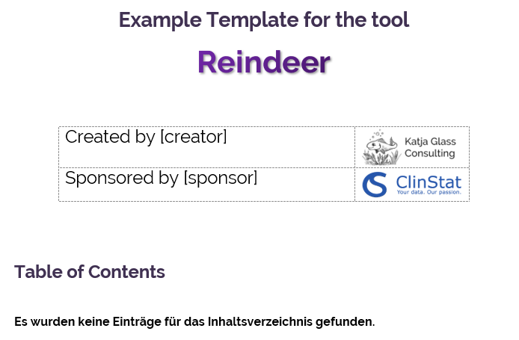
The table of contents could be created that way, that custom defined styles appears at various levels:
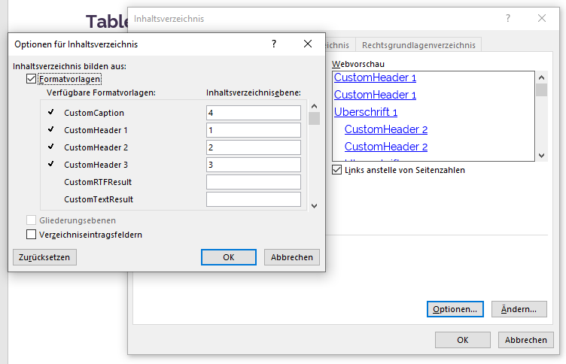
Make also sure to define the custom styles in Word, so they are available by the tool to be used:
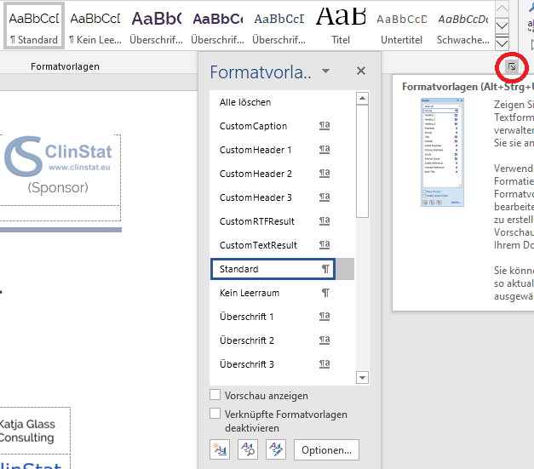

Configuration - Result Base Path
The path where all the results are located must be provided through “Result Base Path”. An example value could be “C:\Reindeer\out”. This folder should contain all results to be included.
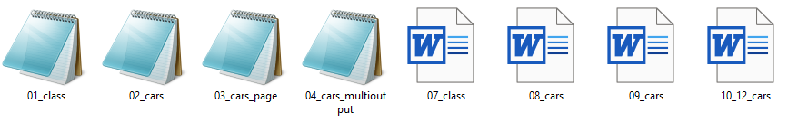

Configuration – Configuration specification
The value “Configuration” could contain a path and name of a text file with a specific format containing additional or different configuration values. An example value could be “C:\Reindeer\doc\config.txt”. Possible values are explained under
To run an example with many outputs, please run the following configuration:
Configuration | C:\Reindeer\doc\config_full.txt

To run a batch example, you can use the following example:
Configuration | C:\Reindeer\doc\config_batch.txt

You can also run examples by filling the table without using a configuration text file.
Configuration.
When configuration values are specified in the Word files and in the text file, the value from the text file is used.
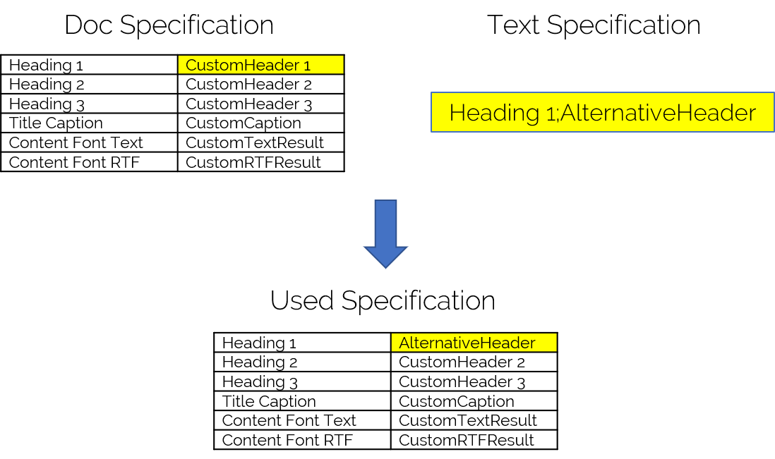

Configuration – Content specification
The value “Content” could contain a path and name of a text file with a specific format containing the complete content containing replacements and results to include. An example value could be “C:\Reindeer\doc\content.txt”. Possible values are explained under Content section.
When replacements and content values are specified in the Word files and in the content text file is provided, then only the text file values including replacements are used.
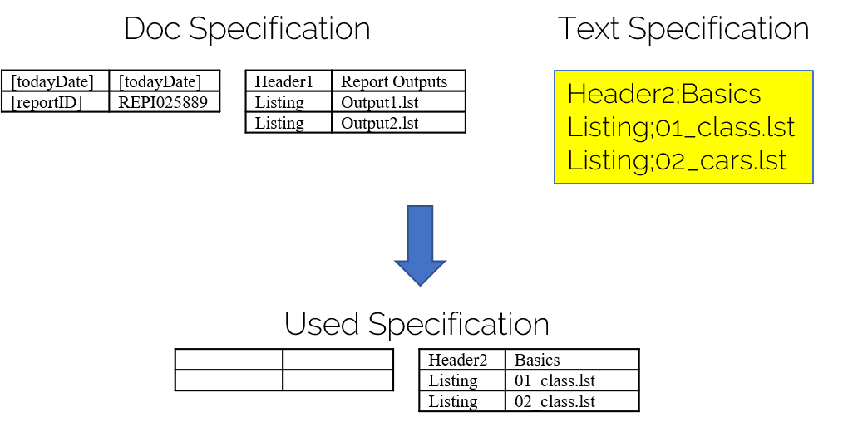
If the replacement tags should be used as well, then this needs to be specified in the content specification file itself.
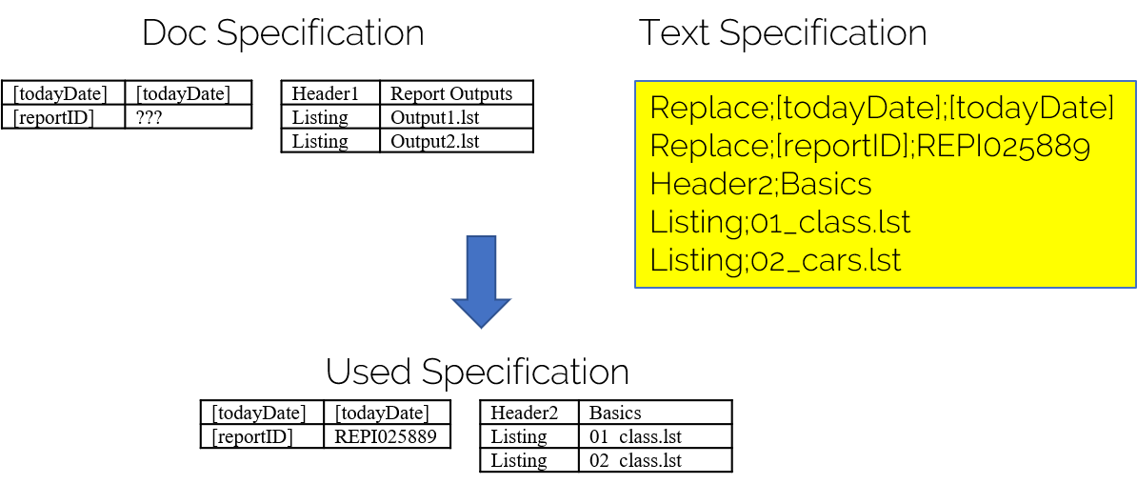

Configuration – FigureMaxHeight & FigureMaxWidth
When figures are included, the size is adjusted to fit the page. To allow correct calculation, a maximum height and width of the figure can be specified in the configurations. The default value which is working for the example template is a FigureMaxHeight of 374 and a FigureMaxWidth of 709.

Configuration - TodayDateFormat
Per default the [todayDate] is replaced by the date of today in the English format of two-digit day, month in upper case and four-digit year. If another date format should be used, this can be specified through the TodayDateFormat specification. A description of possible formats configurations can be found in the Microsoft support pages. The value of TodayDateFormat is used at the format position (Format(Now(),<TodayDateFormat>)). VBA uses the current locale, so if running on a German setting, then the German date formats will be used.

Configuration – SpecialPageHandling
With the indicator SpecialPageHandling a special handling can be done when the first title line contains a “Page” and “of”. It is common to have a “Page X of Y” in the first output line to show the number of current pages of a table. Per default no special handling is performed – the default is No. When “Yes” is entered, then the following handling is performed:
- Check whether the first title line contains “Page” and “of”
- If so, right align this paragraph
- If so, do not consider this line as title line
  - do not combine this line with the next line(s) as title combination
  - do not format this line as caption line
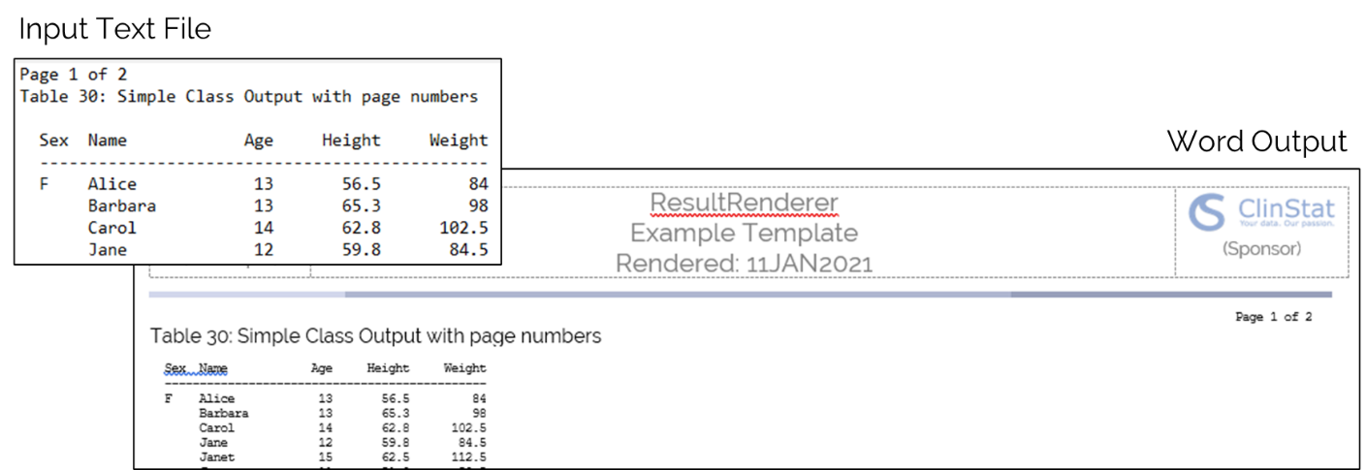

Configuration – Batch
Reindeer supports also batch processing. For this the keyword “Batch” can be included into the configuration. This can either be done in the configuration table or in a separate configuration file. What ever configuration follows after the “Batch”-Keyword will update the settings and run reindeer again.
The following table shows a batch example configuration:
Tool Log | C:\temp\git\sas-dev\Reindeer\out\Reindeer.log
Tool Output | C:\temp\git\sas-dev\Reindeer\out\out_batch1.docx
Tool PDF Output | C:\temp\git\sas-dev\Reindeer\out\out_batch1.pdf
Tool Template | C:\temp\git\sas-dev\Reindeer\doc\Reindeer_TemplateCourierNav.docx
Result Base Path | C:\temp\git\sas-dev\Reindeer\out
Configuration
Content | C:\temp\git\sas-dev\Reindeer\doc\content_batch1.txt
FigureMaxHeight
FigureMaxWidth
TodayDateFormat
SpecialPageHandling | Yes
Batch
Tool Output | C:\temp\git\sas-dev\Reindeer\out\out_batch2.docx
Tool PDF Output | C:\temp\git\sas-dev\Reindeer\out\out_batch2.pdf
Content | C:\temp\git\sas-dev\Reindeer\doc\content_batch2.txt
Batch
Tool Output | C:\temp\git\sas-dev\Reindeer\out\out_batch3.docx
Tool PDF Output | C:\temp\git\sas-dev\Reindeer\out\out_batch3.pdf
Content | C:\temp\git\sas-dev\Reindeer\doc\content_batch3.txt
In this example, there will be three runs of “Reindeer”. The first settings are global settings and additionally will be used for the first batch set. The “Style” settings are used for all three batches – if these should change as well, then please use the text configuration. The first run will create the outputs names “out_batch1” and will have the content as specified in the content configuration.
The second batch changes the content settings as well as the output name settings – if these are not changed, the content will not change or files will be overwritten – so remember to change at least these three settings. What ever settings follow will apply for the current (and next) batches if not overwritten by the next settings.
This concept goes on and on. The example provides three batch runs, so finally three files with three different contents are created.
Recommended usage
The ideal way for a batch processing is to store all information in a text configuration file. Then the “Reindeer” needs only the configuration file as input:
Tool Log
Tool Output
Tool PDF Output
Tool Template
Result Base Path
Configuration | C:\temp\git\sas-dev\Reindeer\doc\config_batch.txt
Content
FigureMaxHeight
FigureMaxWidth
TodayDateFormat
SpecialPageHandling

Then all other settings can be set in the text file:
Tool Log;C:\temp\git\sas-dev\Reindeer\out\Reindeer_log.log
Tool Output;C:\temp\git\sas-dev\Reindeer\out\out_batch1.docx
Tool PDF Output;C:\temp\git\sas-dev\Reindeer\out\out_batch1.pdf
Tool Template;C:\temp\git\sas-dev\Reindeer\doc\Reindeer_TemplateCourierNav.docx
Result Base Path;C:\temp\git\sas-dev\Reindeer\out
Content;C:\temp\git\sas-dev\Reindeer\doc\content_batch1.txt
SpecialPageHandling;Yes
Heading 1;CustomHeader 1
Heading 2;CustomHeader 2
Heading 3;CustomHeader 3
Title Caption;CustomCaption
Content Font Text;CustomTextResult
Content Font RTF;CustomRTFResult
Batch
Tool Output;C:\temp\git\sas-dev\Reindeer\out\out_batch2.docx
Tool PDF Output;C:\temp\git\sas-dev\Reindeer\out\out_batch2.pdf
Content;C:\temp\git\sas-dev\Reindeer\doc\content_batch2.txt
Batch
Tool Output;C:\temp\git\sas-dev\Reindeer\out\out_batch3.docx
Tool PDF Output;C:\temp\git\sas-dev\Reindeer\out\out_batch3.pdf
Content;C:\temp\git\sas-dev\Reindeer\doc\content_batch3.txt

Comments
As the “Replace” tags are content related, these can be modified in the content specification text files.

Configuration - Styles
Six differ styles can be defined. The first three styles are named “Heading 1”, “Heading 2” and “Heading 3”. These styles are applied to included “Header1”, “Header2” and “Header3” texts. These texts are included into the document at a separate page each and the corresponding style is applied. If the style contains a numbering scheme, then the headings will contain also preceding numbers. If no style is defined, the text is included as pure text without any styling.
When the “Content Font Text” style is provided, then the complete “Listing” content part will be styled with the provided style. This could be used to include all listing content formatted as “SAS Monospace 10pt” or similar. This formatting is overwritten by the “Title Caption” for some parts, if specified.
When the “Content Font Text” style is provided, then the complete “RTF” content part will be styled with the provided style. This could be used to include all content formatted as “Times New Roman 10pt” or similar. This formatting is overwritten by the “Title Caption” for some parts, if specified. If no style is provided, the original formatting is kept.
When “Title Caption” is provided, after a special title processing, identified titles are styled according the provided style. For content types “RTF” and “Listing” titles are combined into a single line, when multiple lines are used. When “Title Caption” is provided, then the titles are styled accordingly with the following algorithm:
- Investigate first title (first paragraph of the processed listing of RTF file
- Format first title
- Loop
  - Find the next title (first paragraph after page break)
  - If title is different than previous, format as “Title Caption” value
Due to this algorithm, repeated titles are not styled as “Title Caption”, but only the first one.
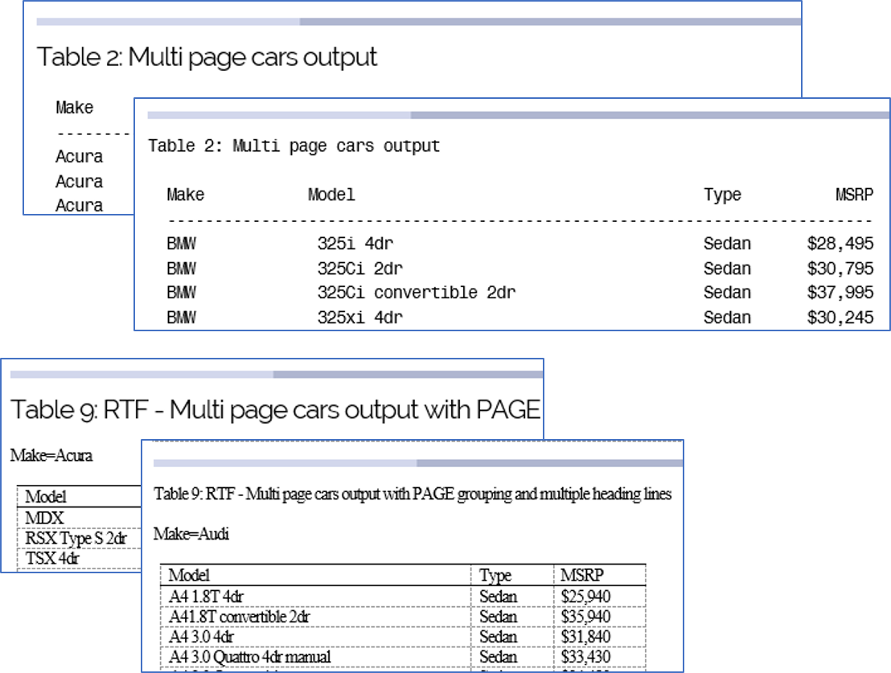

Content – Replace Tags
Any text can be replaced with any other text. It is recommended to use a special syntax like using special brackets for the replacement tags to avoid possible conflicts. If the text “[todayDate]” appears as replacement text, then the date of today is included in the format of DDMMMYYYY UK-English in upper case.
When the replace content-definition is specified in this word file and additionally a “content” configuration text file is used, then only replacements which are specified in the “content” configuration text file will be used.
When a replacement tag is defined, the tags will be replaced with the corresponding value. This is working for headers, footers as well as parts of the body content.
The following replacements tags could for example be specified:
Replace Specification:
[todayDate] | [todayDate]
[reportID] | REPI025889

When these tags are used in the template, for example in the header:

These tags are exchanged with the corresponding values, expecting “today” is the 8th February 2020:


Content – Header1, Header2, Header3
When headers should be included into the document, these will be included each on a separate page. Depending on the level of the header, the corresponding style is applied to this header. When headers should have consequtive numbering, then the corresponding style must use a numbering scheme.
If Header1 is for example defined with “Reindeer Example Document”, then this header will receive the applied style as provided and be included on a stand-alone page.
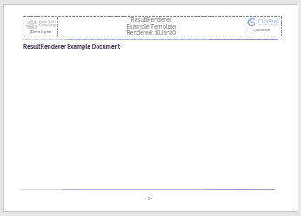
If a vertical alignment is more suitable for the output, then the template can be modified to use a vertical alignment. To apply so, go to layout settings, page setup, then on the layout panel use vertical alignment with “center” and apply this to the complete document.
For the header options, there is additionally the special tag “[linefeed}”, when this tag is used, the header is printed to two lines using a “soft” line feed. Due to this the header line is available as whole in the TOC, but on the single page, multiple lines are used. The [linefeed] tag can also be used to provide an indention from the top with free lines.
Example header 2: Listing Outputs with[linefeed]many fancy outputs
TOC:
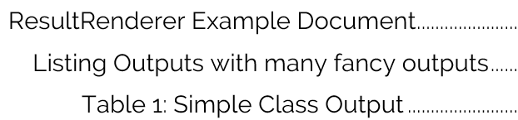
Page output:
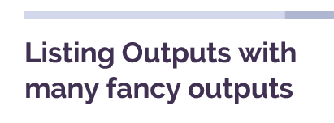

Content – Listing
Any kind of text files can be included through the “Listing” content specifciation. Typical listing file extensions would be “.txt” and “.lst”. Finally, the extension does not matter. When a file is provided, it is handled and processed as text file.
It is expected that the listing file contains already approriate page breaks, no checks of whether the breaks are correct or not are perfomred. Furthermore, it is expected, that the first line contains the table caption which will be processed and formatted in a special way. It is also expected that each new page containt the repeated table table. This enables the tool to combine multiple title lines into a single line and to investigate and format title captions appropriately, also when different tables are available within the listing file.
The input listing file including page breaks and titles in the first line could look like the following:
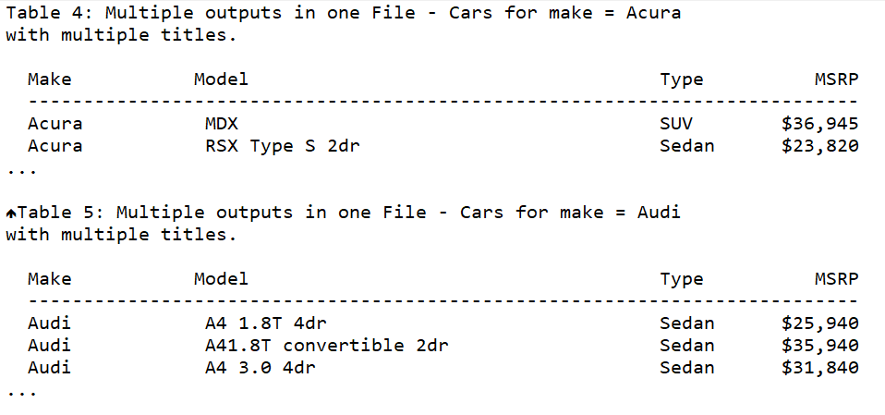
This tool includes this content into Word. The pagebreaks will stay available in Word which enables an appropriate page layout. The complete content is styled as the specified “Content Font Text” if defined. The titles are proceesed. Multiple title lines (first line of each page) are combined into a single logical line. When a line is too long in Word, it will break automatically. After the title line there must be an empty line.
The first title line of this file will get the title caption style applied if provided. On each following page, the title line will also get the title caption style, when the title differs.
When there are different titles, each one will get the caption style like this example:
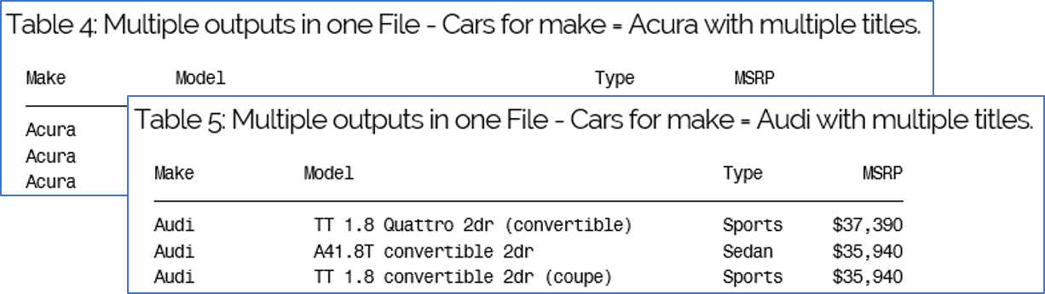
When the title is identically, the title on the following page will be styled according to the specified “Content Font Text”.
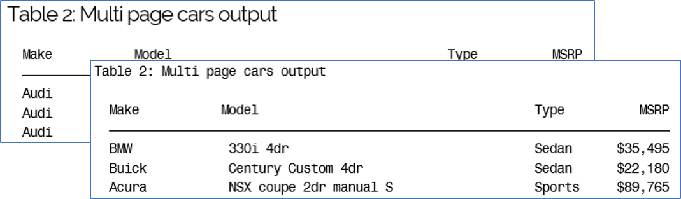
If a Table of Contents is included in the document which will include the “Title Caption” style in the display, then the titles will appear in this TOC.

Content – RTF
RTF word files can be included into the final word file by using the “RTF” or “TAGSETS.RTF” content specification. The “RTF” type should be used when files are created with ODS RTF. If TAGSETS.RTF is used, then please use the TAGSETS.RTF content type.
If page breaks should be available at special positions, e.g. before a new table starts, it is expected that these page breaks are already available in the document. Long logical tables which will split through multiple pages in the RTF file will likely also be split in the final word file.
It is also expected that the first line after each page break and the first line of the document contained the caption.
The input RTF file could look like the following:
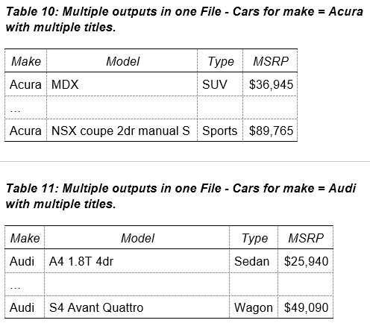
This tool includes this content into Word. The page breaks will stay available in Word which enables an appropriate page layout. The complete content is styled as the specified “Content Font RTF” if defined. The titles are processed. Multiple title lines (first line of each page) are combined into a single logical line. When a line is too long in Word, it will break automatically. After the title line there must be an empty line or the table start.
The output file might then look like the following:
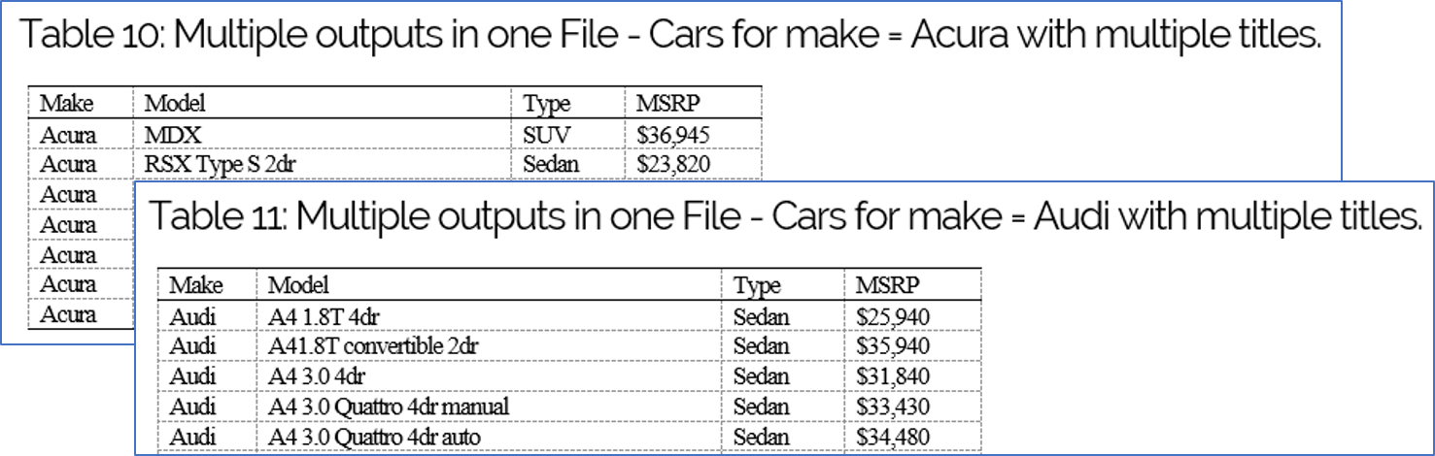

Content – TAGSETS.RTF
RTF word files can be included into the final word file by using the “RTF” or “TAGSETS.RTF” content specification. The “TAGSSETS.RTF” type should be used when files are created with TAGSSETS.RTF. If ODS RTF is used, then please use the RTF content type.
If page breaks should be available at special positions, e.g. before a new table starts, it is expected that these page breaks are already available in the document. Long logical tables which will split through multiple pages in the RTF file will likely also be split in the final word file.
It is also expected that the first line after each page break and the first line of the document contained the caption.
The input RTF file could look like the following:
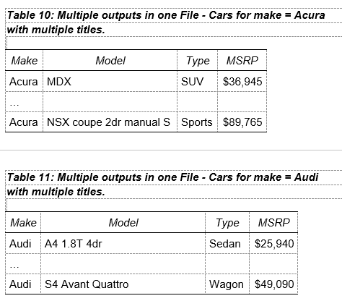
This tool includes this content into Word. The page breaks will stay available in Word which enables an appropriate page layout. The complete content is styled as the specified “Content Font RTF” if defined. The titles are processed. Multiple title lines (first line of each page) are combined into a single logical line. When a line is too long in Word, it will break automatically. After the title line there must be an empty line or the table start.
The output file might then look like the following:
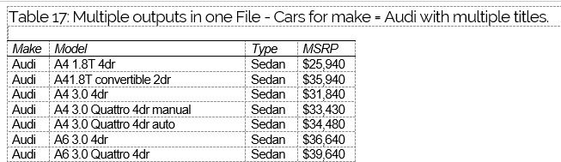
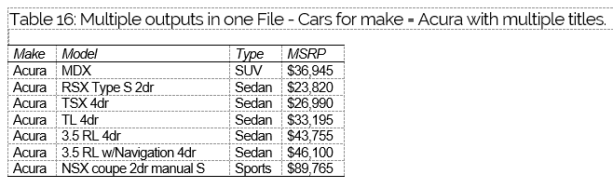

Tipps
Numbering. If headings should contain a numbering schema, then create a style containing using numbers. When the style is applied, the numbering will be done accordingly.
Vertical Alignment. The complete document can be vertically aligned, by using a vertical alignment in the template document. To apply so, go to layout settings, page setup, then on the layout panel use vertical alignment with “center” and apply this to the complete document. Then the contents of the pages are vertically aligned.
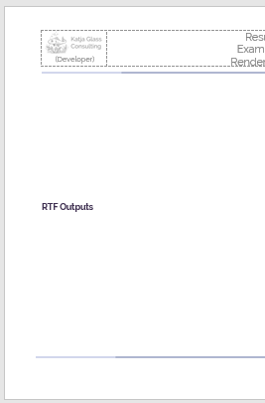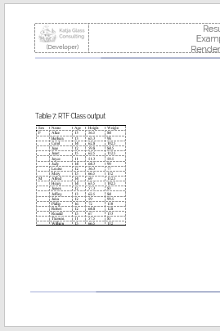
Navigation Panel. The navigation panel can be made available when the template contains the corresponding style setting. The Caption style should be based on any of the header styles, like “heading 3” in the following example. Then this will be included in the navigation pane for Word and if created for PDF.
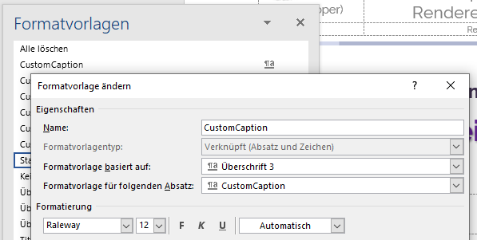
For PDF it might not be made available in the first time. If this is the case, then please manually save one Word file as PDF and active the option “create text marks according titles”. The next time files are saved as PDF with Reindeer, the navigation will be created accordingly.

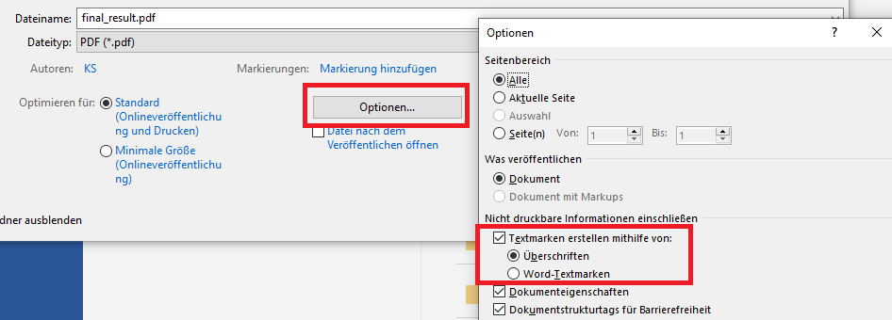
With these settings the navigation area in Word and PDF are available:
Word Navigation Pane  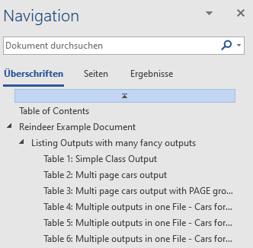 | PDF Navigation Pane  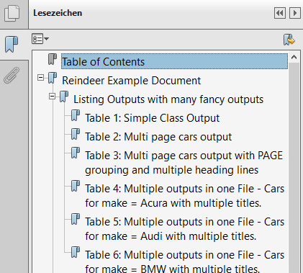

 | Be aware that captions which are inside table does not appear on the navigation pane. This is a Microsoft Word limitation.  When using TAGSETS.RTF and having the titles in table cells, this will never be in the navigation pane.

Operating Systems & Word Versions
Reindeer has been tested and is working for Windows with Office 2019 and Office 2016. It likely will also work with other versions, but this has not been tested,
Under Macintosh, reindeer is working apart from the LISTING functionality. Due to different handling of line breaks, the listings are currently not supported. When RTF outputs of TAGSETS.RTF outputs are created, these can be combined under Mac as well. The macro has to be started by manually starting the macro “RunReindeer”. Microsoft Word is working in a “Sandbox” environment under Mac. For this the app is asking for permission for each file. To avoid this, files might be renamed using a prefix of “~$”. Then access permission is not required. The VBA command “GrantAccessToMultipleFiles” had been tested and not working.

MIT License
Copyright 2020 Katja Glass Consulting
Permission is hereby granted, free of charge, to any person obtaining a copy of this software and associated documentation files (the "Software"), to deal in the Software without restriction, including without limitation the rights to use, copy, modify, merge, publish, distribute, sublicense, and/or sell copies of the Software, and to permit persons to whom the Software is furnished to do so, subject to the following conditions:
The above copyright notice and this permission notice shall be included in all copies or substantial portions of the Software.
THE SOFTWARE IS PROVIDED "AS IS", WITHOUT WARRANTY OF ANY KIND, EXPRESS OR IMPLIED, INCLUDING BUT NOT LIMITED TO THE WARRANTIES OF MERCHANTABILITY, FITNESS FOR A PARTICULAR PURPOSE AND NONINFRINGEMENT. IN NO EVENT SHALL THE AUTHORS OR COPYRIGHT HOLDERS BE LIABLE FOR ANY CLAIM, DAMAGES OR OTHER LIABILITY, WHETHER IN AN ACTION OF CONTRACT, TORT OR OTHERWISE, ARISING FROM, OUT OF OR IN CONNECTION WITH THE SOFTWARE OR THE USE OR OTHER DEALINGS IN THE SOFTWARE.

Environment
This tool is NOT validated, but a functionality test is performed. To perform the test, SAS output created with the educational version of SAS® was used (Unix). Furthermore, Word in the version of Office 2016 was used.

