Минимальные затраты составят: F(x) = 1*6 + 2*4 + 1*5 = 19

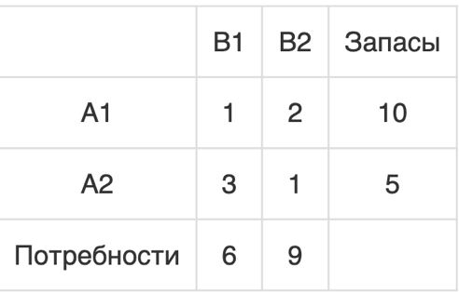

Результат работы программы:

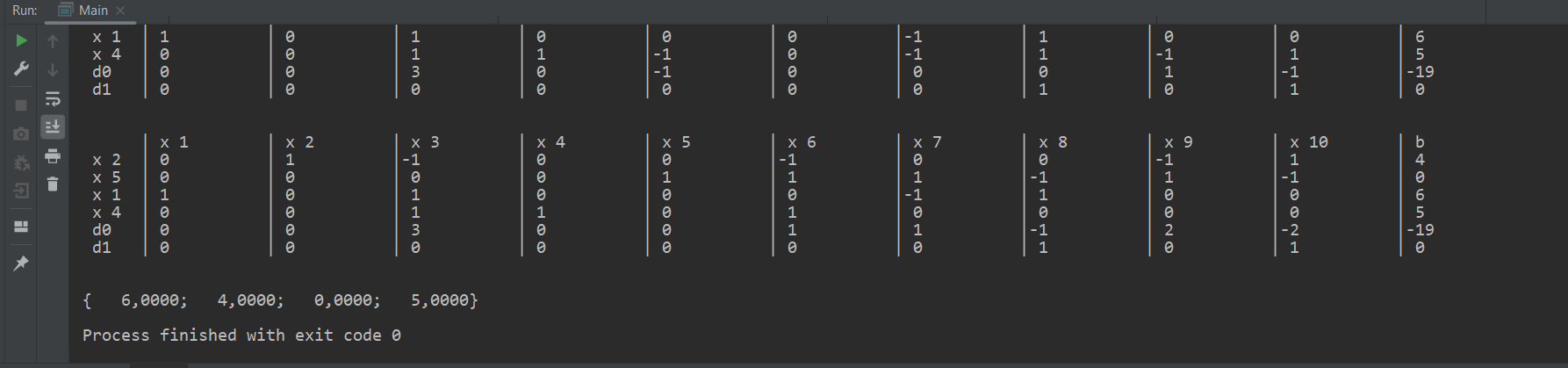

Минимальные затраты составят: F(x) = 1*6 + 2*4 + 1*4 + 2*1 = 20



Результат работы программы:

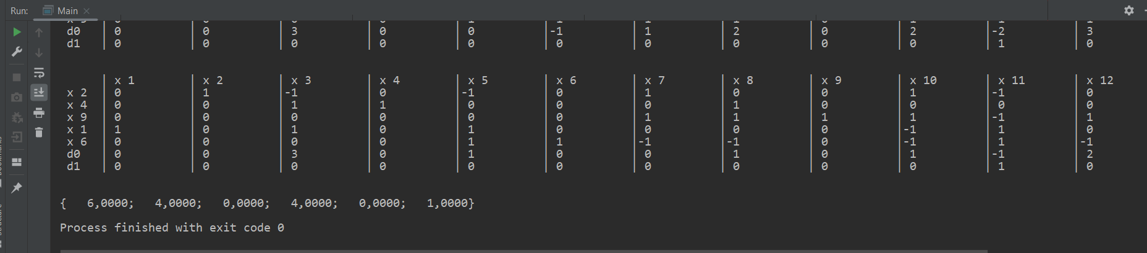

Минимальные затраты составят: F(x) = 1*115 + 2*25 + 5*10 + 1*130 + 3*65 + 2*55 = 650



Результат работы программы:

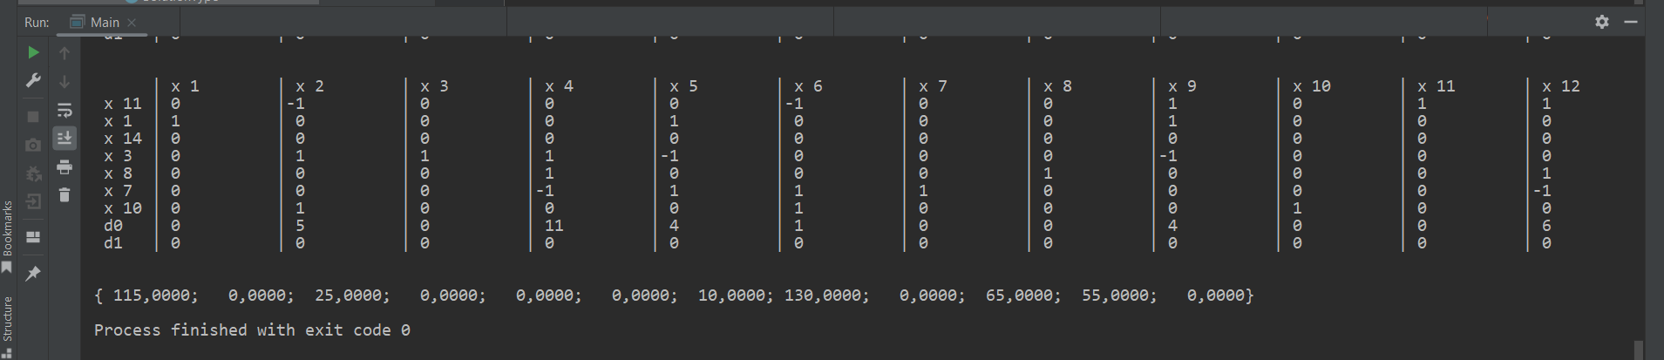

Таблицы бля Java-модуля:

1)

|  |  |  |  |
| --- | --- | --- | --- |
| 1 | 1 | 0 | 0 |
| 0 | 0 | 1 | 1 |
| 1 | 0 | 1 | 0 |
| 0 | 1 | 0 | 1 |
| * |  |  |  |
| 10 | 5 |  |  |
| * |  |  |  |
| 6 | 9 |  |  |
| * |  |  |  |
| 1 | 2 | 3 | 1 |

2)

|  |  |  |  |  |  |
| --- | --- | --- | --- | --- | --- |
| 1 | 1 | 0 | 0 | 0 | 0 |
| 0 | 0 | 1 | 1 | 0 | 0 |
| 0 | 0 | 0 | 0 | 1 | 1 |
| 1 | 0 | 1 | 0 | 1 | 0 |
| 0 | 1 | 0 | 1 | 0 | 1 |
| * |  |  |  |  |  |
| 10 | 4 | 1 |  |  |  |
| * |  |  |  |  |  |
| 6 | 9 |  |  |  |  |
| * |  |  |  |  |  |
| 1 | 2 | 3 | 1 | 2 | 2 |

3)

|  |  |  |  |  |  |  |  |  |  |  |  |
| --- | --- | --- | --- | --- | --- | --- | --- | --- | --- | --- | --- |
| 1 | 1 | 1 | 1 | 0 | 0 | 0 | 0 | 0 | 0 | 0 | 0 |
| 0 | 0 | 0 | 0 | 1 | 1 | 1 | 1 | 0 | 0 | 0 | 0 |
| 0 | 0 | 0 | 0 | 0 | 0 | 0 | 0 | 1 | 1 | 1 | 1 |
| 1 | 0 | 0 | 0 | 1 | 0 | 0 | 0 | 1 | 0 | 0 | 0 |
| 0 | 1 | 0 | 0 | 0 | 1 | 0 | 0 | 0 | 1 | 0 | 0 |
| 0 | 0 | 1 | 0 | 0 | 0 | 1 | 0 | 0 | 0 | 1 | 0 |
| 0 | 0 | 0 | 1 | 0 | 0 | 0 | 1 | 0 | 0 | 0 | 1 |
| * |  |  |  |  |  |  |  |  |  |  |  |
| 140 | 140 | 120 |  |  |  |  |  |  |  |  |  |
| * |  |  |  |  |  |  |  |  |  |  |  |
| 115 | 65 | 90 | 130 |  |  |  |  |  |  |  |  |
| * |  |  |  |  |  |  |  |  |  |  |  |
| 1 | 8 | 2 | 9 | 8 | 7 | 5 | 1 | 5 | 3 | 2 | 4 |