

**Kruidfontein Flourspar Project**

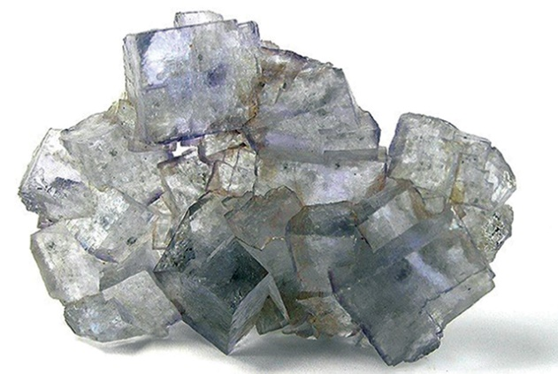

Prepared by

**Wilson B Hlangwane (Pr.Sci.Nat), Director**

**Phanwanda Resources (Pty) Ltd**

Prepared on

**22/8/2023**

**Table of Contents**

**Kruidfontein Fluorspar Project** **Error! Bookmark not defined.**

**1.** **Overview** 2

**2.** **Objectives** 2

**3.** **proposed plan** 3

**4.** **Contractual Aspects** 3

**5.** **Personnel** 4

**6.** **Schedules & Resource Requirement** 4

**7.** **Costs and Budget** 5

**8.** **Evaluation** 5

**9.** **Potential Risks** 5

**10.** **Appendix A (**BUDGET). 6

1. **Overview**

Mr Wilson Hlangwane was approached by the SepFluor Ltd team to prepare a proposal for the initial development of the Kruidfontein Project which is on the Kruidfontein Carbonatite Complex covering Kruidfontein 139 JQ, Doornkloof 141 JQ, and Elandsfontein 23 JQ farms.

The Kruidfontein Carbonatite Complex is situated in a small town of Atlanta, approximately 160 km north northwest of Pretoria, and about 80 km north of the town of Brits.

The Kruidfontein Carbonatite Complex is described by Schurman (2002) as a cluster of two calderas, with the inner hosting the carbonatitic volcanoclastic rocks closely associated with dykes, plugs and mineralization. It contains fluorspar, iron ore and other minerals, but the current proposal is based on fluorspar mineralization development.

Fluorspar was previously explored on Kruidfontein by companies such as metallgesellschaft in the 1970`s, and Southern Sphere between 1972 and 1981. The historical data will be used to guide the exploration. More boreholes will be drilled in order to verify the historical data. The historical and the new data will be used to evaluate the Mineral Resource potential of the Kruidfontein Project.

The main goal of Kruidfontein project plan is to indicate how the value will be added through technical evaluation of fluorspar which will lead to a SAMREC compliant Mineral Resource and a Scoping study.

1. **Objectives**

* To make sure that the geological historical data is in a useable format.
* Interpret the data to generate drilling targets.
* Consultation and access agreements with the land owners
* Do the initial ground truthing and mapping around the targeted areas
* Verify the drilling targets and layout boreholes positions within the fluorspar targets
* Verify the fluorspar layers within the orebody by borehole drilling, logging, sampling and analysis.
* Prepare a report based on the new generated data and the historical data
* Possible discussion with a Competent Person as described by the SAMREC Code
* To possibly get a signed-off Inferred or Indicated Mineral Resource estimate using both the historical and new data.
* Do a Scoping study to understand the value added by the new and historical data combined. This will include a report with recommendations.

1. **proposed plan**

The Kruidfontein deposit was mapped and drilled historically. The historical data acquired will form basis with as indicated by table 1 below:

Table 1. Planned activities

|  |  |
| --- | --- |
|  |  |
| **Activities** | **Description** |
| Activity A. | Making sure the Historical data is in useable format |
| Activity B | Interpreting the historical data to generate drilling targets |
| Activity C | Consultation and access agreements with land owners |
| Activity D | Initial ground truthing and mapping of target areas |
| Activity E | Verify drilling targets and layout of borehole positions within fluorspar targets |
| Activity F | Verify the fluorspar layers within the orebody by borehole drilling, logging, sampling and analysis. |
| Activity G | Prepare a report based on the new generated data and the historical data |
| Activity H | Possible discussion with a Competent Person as described by the SAMREC Code |
| Activity I | To possibly get a SAMREC compliant signed-off Inferred or Indicated Mineral Resource estimate using both the historical and new data. |
| Activity J | Do a Scoping study to understand the value added by the new and historical data combined. This will include a report with recommendations. |

1. **Contractual Aspects**

The suppliers for all resources needed during the implementation have been identified and some have been contacted to ensure that the project will implemented smoothly. All the legal aspects and contracts needed for the project are being discussed with the Legal department, including access agreements.

1. **Personnel**

The project will be implemented and managed by Mr. Wilson B Hlangwane (and team) together with the SepFluor team

* Wilson B Hlangwane (Competent Responsible Person)
* Geologist
* Field team (three field personnel)

1. **Schedules & Resource Requirement**

Table 2. Planned Schedule and Resource Requirements

|  |  |  |  |
| --- | --- | --- | --- |
| **Activity** | **Planned Time** | **Responsible Person** | **Equipments** |
| **A** | Sept 2023 - | Wilson and team | Laptop & GIS software |
| **B** | Sept 2023 - | Wilson and team | Laptop & GIS software |
| **C** | Sept 2023 | SepFluor Legal and Wilson | Transport to the meeting |
| **D** | Oct 2023 - | Wilson and team | Transport, Geo Hammer, GPS, fieldbook |
| **E** | Oct 2023 - | Wilson and team | Transport, Geo Hammer, GPS, fieldbook |
| **F** | Nov 2023 – Jan 2023 | Wilson and Team | Transport, Drilling Machine, Geo Hammer, GPS, fieldbook |
| **G** | Jan 2023 - | Wilson and Team | Laptop & GIS software |
| **H** | Jan 2023 - | Independent CP, Wilson and Team, SepFluor Team | Laptop & GIS software, 3D modelling & estimations |
| **I** | Jan 2023 – Feb 2023 | Independent CP, Wilson and Team, SepFluor Team | Laptop & GIS software, 3D modelling & estimations |
| **J** | Feb 2023 – March 2023 | Wilson and team | Laptop & GIS software |

1. **Costs and Budget**

Table 3. Costs and Budget (5 boreholes at 100m each)

|  |  |  |  |  |  |
| --- | --- | --- | --- | --- | --- |
| **Activity** | **Planned Time** | **Wilson team Monthly Cost** | **Diesel, ACC & Transport** | **Drilling & Cutting** | **Other Costs** |
| **A, B C** | Sept 2023 | R 120k | Not included | R 0 | R0 |
| **D, E** | Oct 2023 | R120k | Not included | R 0 | R0 |
| **F** | Nov 2023 | R120k | Not included | R312 500 |  |
| **F** | Dec 2023 | R120k | Not included | R 625 000 |  |
| **F, G, H** | Jan 2023 | R120k | Not included | R312 500 |  |
| **I** | Feb 2023 | R120k | Not included | R 0 | R450k |
| **J** | March 2023 | R120k | Not included | R 0 | R 0 |
|  |  |  |  |  |  |

1. **Evaluation**

The project will continuously be evaluated against this plan in order to assist the project team to remain on schedule or re-plan where necessary. Monthly meetings will be held and progress reports will be submitted.

1. **Potential Risks**

There is a game farm on and adjacent to the project area. Communications with the land owners need to be ongoing in order to gain access to the project area. There also communities around the area. A good relationship need to be developed.

1. **Appendix A (**BUDGET).

See accompanying Spreadsheet