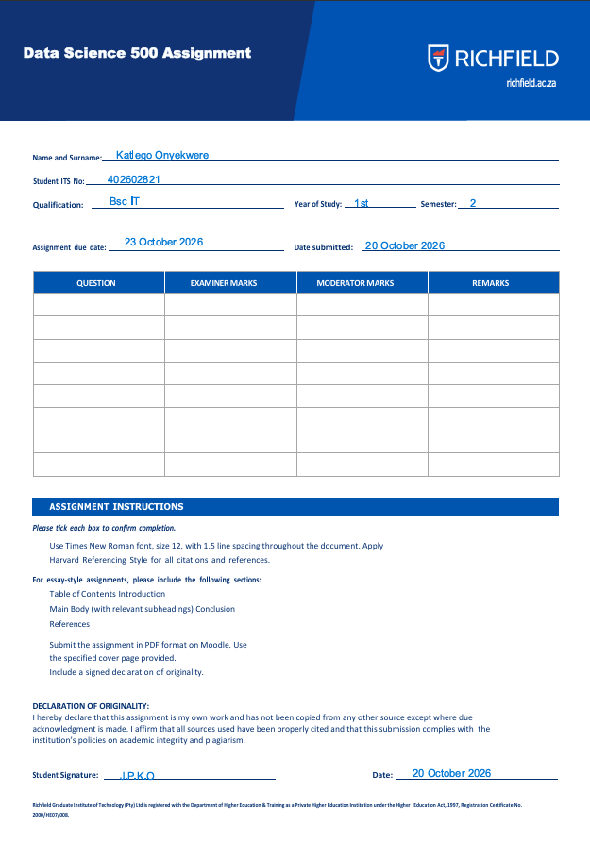
Table of Contents

1. Introduction

1.1 Background and Purpose
Online retailers and bookstores must decide how to price, stock and promote thousands of titles. Pricing that is out of line with comparable titles can reduce sales, while a poor understanding of what drives ratings and popularity makes catalogue curation harder. Data-driven analysis of catalogue data allows publishers and retailers to replace intuition with evidence.
This project simulates the work of a Junior Data Scientist supporting a publishing analytics team. The task is to build a complete pipeline: acquire real-world structured data from the Books to Scrape website, clean it, explore it visually, and build a linear regression model that estimates book price from publicly available information.

1.2 Objectives
- To scrape the full Books to Scrape catalogue using the BeautifulSoup library.
- To transform the raw listings into a clean, analysis-ready dataset.
- To explore pricing, rating and genre patterns through visualisation.
- To build and evaluate a linear regression model for price prediction.
- To translate the findings into practical recommendations for retailers, publishers and book buyers.

1.3 Scope and Tools
The analysis covers the entire catalogue of 1 000 books across 50 genres. The workflow was implemented in Python within a Jupyter Notebook using requests and BeautifulSoup for acquisition, pandas and NumPy for data handling, Matplotlib and seaborn for visualisation, and scikit-learn for modelling. The report follows the stages of the workflow: acquisition, cleaning, visualisation, modelling, implications and conclusion. All code is included in the relevant sections.
The complete project, including the code, notebook and datasets, is available in the author's GitHub repository: https://github.com/Katman-de-ninja/402602821_DSC500.git.

2. Data Acquisition

2.1 Source and Ethical Considerations
Books to Scrape is a sandbox website created specifically for practising web scraping, so scraping it is permitted for learning purposes. Good scraping practice was nevertheless followed: a descriptive user-agent header was sent, a short delay was inserted between requests to avoid overloading the server, and error handling was added so that a single failed page does not stop the process.

2.2 Approach
The catalogue is split over 50 listing pages of 20 books each. Each listing page supplies the title, price, star rating (as a word) and a link to the book's detail page. The detail page supplies the stock quantity, genre (from the breadcrumb navigation), product description, UPC and number of reviews. The scraper therefore works in two stages: it loops through every listing page, then visits each book's detail page and merges the two sets of fields into one record. The raw output is saved to books_raw.csv, and the script reuses this file on later runs so the analysis can be reproduced without re-scraping. The code was written as a single Python script (book_analytics.py) that can be run in PyCharm.
The required fields (title, price in GBP, star rating, and stock availability with quantity) were extracted for every book. Genre, description, UPC and review count were collected as additional features.

2.3 Scraping Code
import os
import re
import time
import requests
import numpy as np
import pandas as pd
import matplotlib.pyplot as plt
import seaborn as sns
from bs4 import BeautifulSoup
from urllib.parse import urljoin

BASE_URL = "https://books.toscrape.com/catalogue/"
HEADERS = {"User-Agent": "Mozilla/5.0 (Data Science 500 student project)"}

def get_soup(url):
resp = requests.get(url, headers=HEADERS, timeout=15)
resp.raise_for_status()
resp.encoding = "utf-8"
return BeautifulSoup(resp.text, "html.parser")

def parse_listing_page(soup):
books = []
for art in soup.select("article.product_pod"):
books.append({
"title": art.h3.a["title"],
"price_raw": art.select_one("p.price_color").text.strip(),
"rating_word": art.select_one("p.star-rating")["class"][1],
"availability_raw": art.select_one(
"p.availability").get_text(strip=True),
"detail_url": urljoin(BASE_URL, art.h3.a["href"]),
})
return books

def parse_detail_page(url):
soup = get_soup(url)
crumbs = soup.select("ul.breadcrumb li a")
genre = crumbs[2].text.strip() if len(crumbs) > 2 else None

desc_tag = soup.select_one("#product_description")
description = None
if desc_tag is not None:
description = desc_tag.find_next_sibling("p").get_text(strip=True)

table = {row.th.text.strip(): row.td.text.strip()
for row in soup.select("table.table-striped tr")}
return {
"genre": genre,
"description": description,
"upc": table.get("UPC"),
"num_reviews": table.get("Number of reviews"),
"availability_detail": soup.select_one(
"p.availability").get_text(strip=True),
}

def scrape_catalogue(max_pages=50, delay=0.3):
rows = []
for page in range(1, max_pages + 1):
try:
soup = get_soup(f"{BASE_URL}page-{page}.html")
except requests.HTTPError:
break
for book in parse_listing_page(soup):
try:
book.update(parse_detail_page(book["detail_url"]))
except Exception as err:
print("Skipped:", book["title"], "-", err)
rows.append(book)
time.sleep(delay)
print(f"Page {page} done - {len(rows)} books collected")
return pd.DataFrame(rows)

if os.path.exists("books_raw.csv"):
raw_df = pd.read_csv("books_raw.csv")
print("Loaded existing books_raw.csv")
else:
raw_df = scrape_catalogue()
raw_df.to_csv("books_raw.csv", index=False)
print(raw_df.shape)
print(raw_df.head())

2.4 Resulting Dataset
The scraper collected 1 000 books across 50 genres, comfortably above the minimum requirement of 200 books. Table 1 describes the variables in the raw and derived dataset.
Table 1: Data dictionary
Variable | Type | Description
title | Text | Book title from the listing page
price_gbp | Numeric | Price in pounds sterling (target variable)
rating_word / rating_num | Text / Integer | Star rating as a word (One to Five) and as a number (1 to 5)
in_stock / stock_qty | Binary / Integer | Availability flag and number of units available
genre | Categorical | Category taken from the breadcrumb on the detail page
description | Text | Product description (some books have none)
desc_word_count | Integer | Number of words in the cleaned description
title_word_count | Integer | Number of words in the title
num_reviews | Integer | Review count from the product information table
upc | Text | Unique product code used to detect duplicates

3. Data Cleaning and Preparation

3.1 Issues Identified and Decisions Made
Raw scraped data is rarely analysis-ready. The following issues were addressed, and each decision is justified below.
- Price stored as text. Prices such as "£51.77" contain a currency symbol (and may show encoding artefacts). The numeric value was extracted with a regular expression and converted to a float so that it can be summarised and modelled.
- Rating stored as a word. The words One to Five were mapped to the integers 1 to 5, which preserves the natural order of the ratings.
- Availability stored as a sentence. The text "In stock (22 available)" was split into a binary in_stock flag and a numeric stock_qty. Where no quantity was shown, the quantity was set to zero.
- Missing descriptions. Some books have no description. Rather than deleting these rows, which would waste valid price and rating data, the gap was filled with an empty string and a has_description flag was added.
- Text inconsistencies. Descriptions were trimmed, whitespace was normalised, and a lower-case, punctuation-free version (desc_clean) was created for analysis. Word counts were derived from it.
- Duplicates and validity. Duplicates were removed using the UPC. Assertions confirm that prices are positive and ratings lie between 1 and 5.
- Outliers. Prices outside 1.5 times the interquartile range were flagged but retained, because high-priced books are legitimate products rather than errors.
- Tags. The brief mentions tags, but Books to Scrape does not publish tags, so the genre and the description were used as the text-based descriptors instead.
- Placeholder genres. The site assigns many books to the categories "Default" and "Add a comment". These are genuine values on the site, so they were kept, but they do not describe a real literary genre and are interpreted with caution in the genre analysis.

3.2 Cleaning Code
df = pd.read_csv("books_raw.csv")
print("Raw shape:", df.shape)
print(df.isna().sum())

df = df.drop_duplicates(subset=["upc"]).reset_index(drop=True)

df["price_gbp"] = df["price_raw"].str.extract(r"(\d+\.\d+)")[0].astype(float)

rating_map = {"One": 1, "Two": 2, "Three": 3, "Four": 4, "Five": 5}
df["rating_num"] = df["rating_word"].map(rating_map)

df["in_stock"] = (df["availability_detail"]
.str.contains("In stock", case=False).astype(int))
df["stock_qty"] = (df["availability_detail"]
.str.extract(r"\((\d+) available\)")[0]
.astype(float).fillna(0).astype(int))

df["num_reviews"] = (pd.to_numeric(df["num_reviews"], errors="coerce")
.fillna(0).astype(int))

df["description"] = (df["description"].fillna("")
.str.replace(r"\s+", " ", regex=True).str.strip())
df["has_description"] = (df["description"] != "").astype(int)
df["desc_clean"] = (df["description"].str.lower()
.str.replace(r"[^a-z\s]", " ", regex=True)
.str.replace(r"\s+", " ", regex=True).str.strip())
df["desc_word_count"] = df["desc_clean"].str.split().str.len()
df["title_word_count"] = df["title"].str.split().str.len()

df["genre"] = df["genre"].fillna("Unknown").str.strip()

assert df["price_gbp"].gt(0).all(), "Non-positive price found"
assert df["rating_num"].between(1, 5).all(), "Rating out of range"
assert df["rating_num"].notna().all(), "Unmapped rating"

q1, q3 = df["price_gbp"].quantile([0.25, 0.75])
iqr = q3 - q1
df["price_outlier"] = ~df["price_gbp"].between(q1 - 1.5 * iqr, q3 + 1.5 * iqr)
print("Price outliers flagged:", df["price_outlier"].sum())

final_cols = ["title", "upc", "genre", "price_gbp", "rating_word",
"rating_num", "in_stock", "stock_qty", "num_reviews",
"has_description", "desc_word_count", "title_word_count",
"price_outlier", "description", "desc_clean"]
df[final_cols].to_csv("books_clean.csv", index=False)
print("Clean shape:", df[final_cols].shape)
print(df[final_cols].describe(include="all").T)

The cleaned dataset contains 1 000 rows and 15 columns. Only 2 books had a missing description, and no price outliers were flagged because every price lies within 1.5 times the interquartile range. All 1 000 UPCs were unique, so no rows were removed as duplicates. One title appears twice, but under different product codes, so both rows were kept. Every book is in stock and every book has zero reviews, so in_stock and num_reviews are constant and carry no information for modelling. The dataset was saved as books_clean.csv and is submitted with this report.

4. Data Visualisation and Exploration

4.1 Visualisation Code
Eight figures were produced to examine price distribution, ratings, genre differences and relationships between numeric variables.
sns.set_theme(style="whitegrid")
plt.rcParams["font.family"] = "serif"

plt.figure(figsize=(8, 4.5))
sns.histplot(df["price_gbp"], bins=30, kde=True, color="#1f4e9c")
plt.title("Distribution of Book Prices")
plt.xlabel("Price (GBP)"); plt.ylabel("Number of books")
plt.tight_layout(); plt.savefig("fig1_price_dist.png", dpi=200); plt.show()

order = ["One", "Two", "Three", "Four", "Five"]
plt.figure(figsize=(7, 4.5))
sns.countplot(data=df, x="rating_word", order=order, color="#1f4e9c")
plt.title("Number of Books by Star Rating")
plt.xlabel("Star rating"); plt.ylabel("Number of books")
plt.tight_layout(); plt.savefig("fig2_rating_counts.png", dpi=200); plt.show()

plt.figure(figsize=(8, 4.5))
sns.boxplot(data=df, x="rating_word", y="price_gbp", order=order,
color="#9db8e0")
plt.title("Price by Star Rating")
plt.xlabel("Star rating"); plt.ylabel("Price (GBP)")
plt.tight_layout(); plt.savefig("fig3_price_by_rating.png", dpi=200); plt.show()

top15 = df["genre"].value_counts().head(15).index
genre_stats = (df[df["genre"].isin(top15)].groupby("genre")["price_gbp"]
.agg(["mean", "count"]).sort_values("mean"))
plt.figure(figsize=(8, 6))
plt.barh(genre_stats.index, genre_stats["mean"], color="#1f4e9c")
plt.title("Average Price by Genre (15 Largest Genres)")
plt.xlabel("Average price (GBP)")
plt.tight_layout(); plt.savefig("fig4_price_by_genre.png", dpi=200); plt.show()

plt.figure(figsize=(8, 6))
df["genre"].value_counts().head(15).sort_values().plot.barh(color="#1f4e9c")
plt.title("Number of Books per Genre (Top 15)")
plt.xlabel("Number of books")
plt.tight_layout(); plt.savefig("fig5_genre_counts.png", dpi=200); plt.show()

plt.figure(figsize=(7, 4.5))
sns.regplot(data=df, x="desc_word_count", y="price_gbp",
scatter_kws={"alpha": 0.4}, line_kws={"color": "red"})
plt.title("Description Length vs Price")
plt.xlabel("Words in description"); plt.ylabel("Price (GBP)")
plt.tight_layout(); plt.savefig("fig6_desc_vs_price.png", dpi=200); plt.show()

plt.figure(figsize=(7, 4.5))
sns.scatterplot(data=df, x="stock_qty", y="price_gbp", alpha=0.4)
plt.title("Stock Quantity vs Price")
plt.xlabel("Units in stock"); plt.ylabel("Price (GBP)")
plt.tight_layout(); plt.savefig("fig7_stock_vs_price.png", dpi=200); plt.show()

num_cols = ["price_gbp", "rating_num", "stock_qty",
"desc_word_count", "title_word_count"]
plt.figure(figsize=(6.5, 5))
sns.heatmap(df[num_cols].corr(), annot=True, fmt=".2f", cmap="Blues")
plt.title("Correlation Matrix")
plt.tight_layout(); plt.savefig("fig8_correlation.png", dpi=200); plt.show()

print(df.groupby("rating_word")["price_gbp"].agg(["mean", "median", "count"]))
print(genre_stats.sort_values("mean", ascending=False))

4.2 Findings
Price distribution. Book prices run from about 10 pounds up to a maximum of 59.99 pounds, with a mean of 35.07 pounds and a median of 35.98 pounds. The upper quartile is 47.46 pounds, and the interquartile-range rule flagged no outliers. These values suggest that prices are spread fairly evenly across the range and are not bunched at the low end. Figure 1 confirms this: the bars are of broadly similar height across the whole range, with roughly 25 to 45 books in each price band, and there is no pronounced skew.
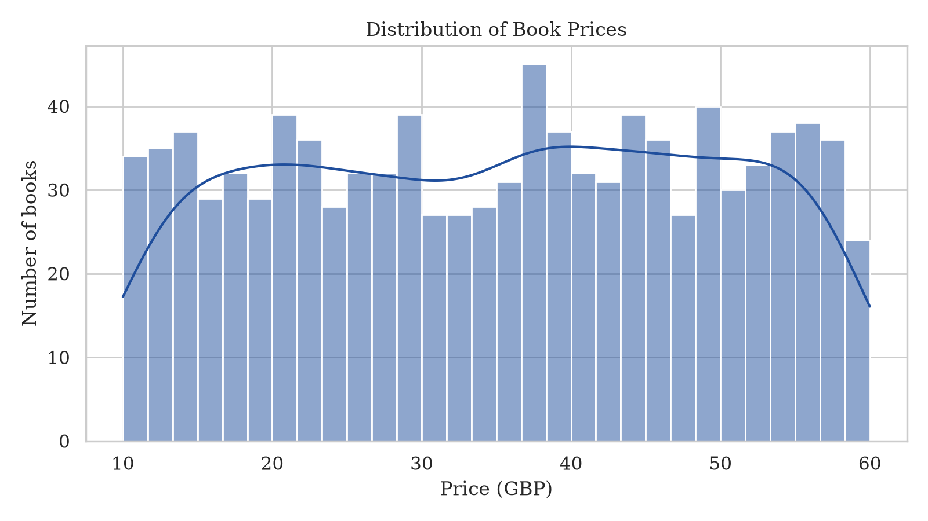
Figure 1: Distribution of book prices
Ratings. Figure 2 shows that one-star books are the most frequent (226 books), followed by three-star (203), two-star and five-star (196 each) and four-star (179). Figure 3 compares prices across ratings. The median price is similar for every rating, and the boxes overlap almost completely. Four-star books have the highest mean (36.09 pounds) and median (37.80 pounds), and one-star books have a mean of 34.56 pounds, but the gap between the highest and lowest group mean is only about 1.50 pounds and there is no steady rise or fall as ratings increase. In this catalogue, a higher rating does not signal a higher price.
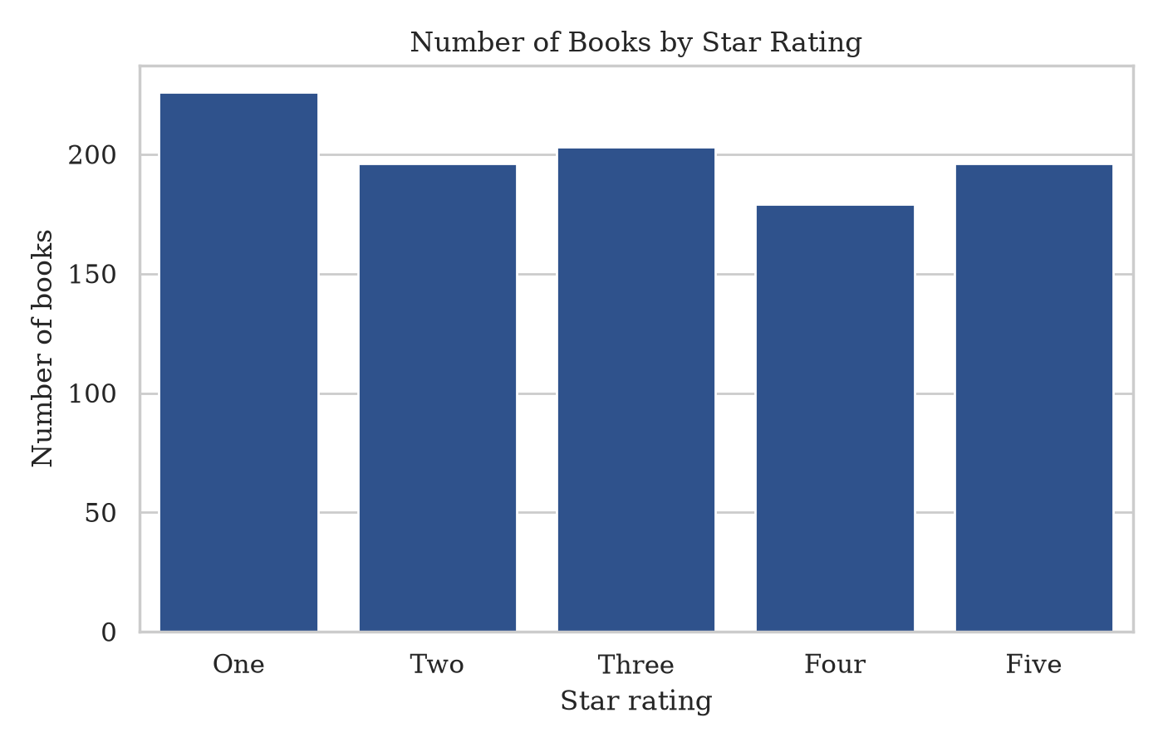
Figure 2: Number of books by star rating
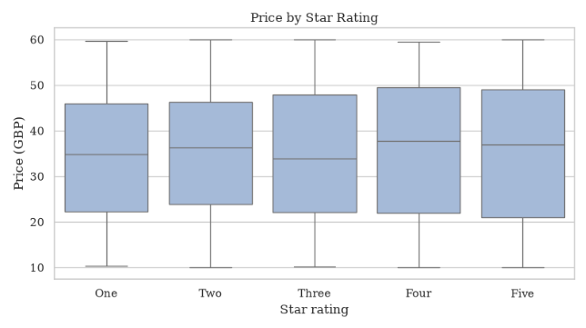
Figure 3: Price by star rating
Genre. Figures 4 and 5 compare average price and number of books by genre. Fantasy has the highest average price (39.59 pounds), followed by History (37.30 pounds) and Classics (36.55 pounds). The lowest averages are Food and Drink (31.41 pounds) and Mystery (31.72 pounds), so the gap between the highest and lowest of the 15 largest genres is about 8.18 pounds. Two of the largest categories, "Default" (152 books) and "Add a comment" (67 books), are placeholder categories on the site rather than real genres. Among real genres, Nonfiction (110 books) and Sequential Art (75 books) are the largest. History, Poetry and Classics each contain only 18 to 19 books, so their averages are less reliable, which matters because History and Classics are among the highest-priced groups.
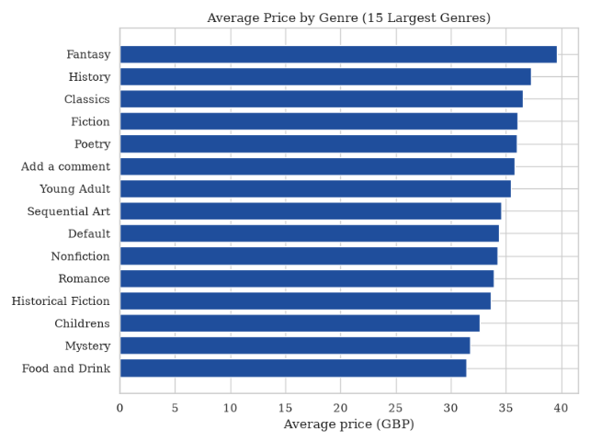
Figure 4: Average price by genre (15 largest genres)
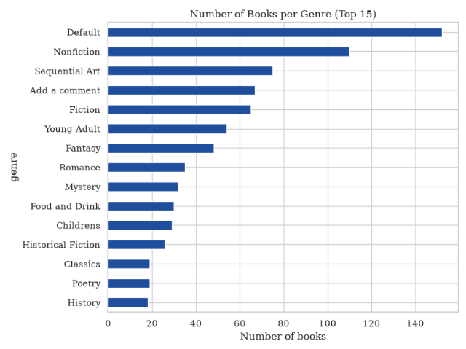
Figure 5: Number of books per genre (top 15)
Relationships between variables. Figure 6 plots description length against price. The median description has 231 words and three quarters have 291 words or fewer, but the longest has 1 408 words. The fitted line has a very slight upward slope, but the points are scattered across the whole price range and the confidence band widens sharply beyond about 600 words, where only a handful of books exist. Figure 7 shows stock quantity against price. Stock levels range from 1 to 22 units (median 7), and no pattern is visible: cheap and expensive books appear at every stock level.
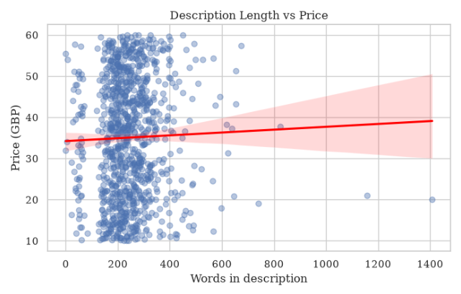
Figure 6: Description length vs price
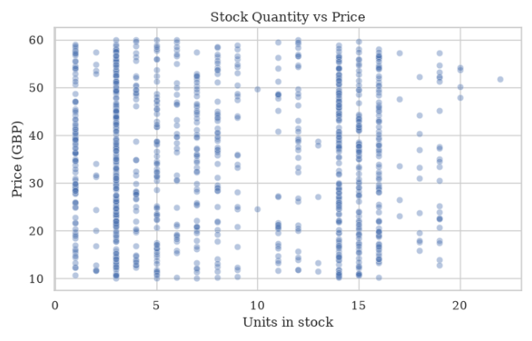
Figure 7: Stock quantity vs price
The correlation matrix in Figure 8 confirms these impressions. The correlations of price with star rating (0.03), stock quantity (-0.01), description length (0.03) and title length (0.02) are all very close to zero. The largest value in the matrix is 0.12, between description length and title length, which are both predictors and not price. None of the numeric variables is a strong linear predictor of price.
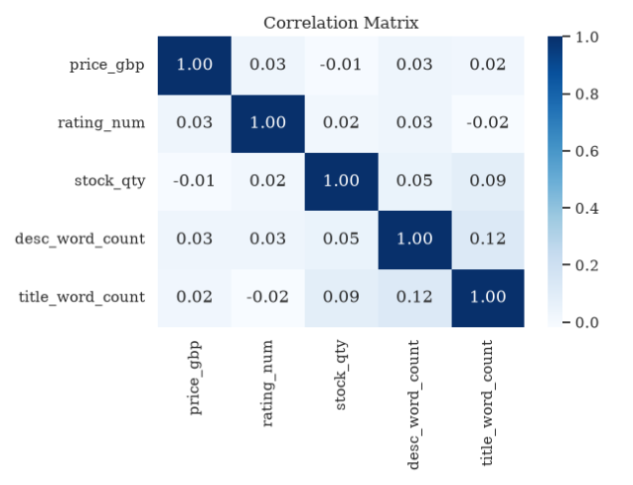
Figure 8: Correlation matrix

5. Predictive Modelling

5.1 Modelling Dataset and Feature Choice
The target variable is price_gbp. Linear regression requires numeric inputs, so the following features were selected:
- rating_num: customer-perceived quality may be linked to price.
- stock_qty: stock depth may reflect expected demand or pricing strategy.
- desc_word_count and title_word_count: proxies for the amount of marketing effort and the type of title.
- genre (grouped): price norms differ between genres. To avoid a very wide, sparse set of dummy variables, the 10 largest genres were kept and the rest were grouped as "Other". One-hot encoding was applied with the first category dropped to avoid the dummy-variable trap.
The variables in_stock and num_reviews were removed automatically because they are constant across the catalogue and carry no predictive information. An 80/20 train-test split with a fixed random seed was used so that results are reproducible, and a naive baseline that always predicts the mean price was included for comparison.

5.2 Modelling Code
from sklearn.model_selection import train_test_split, cross_val_score, KFold
from sklearn.linear_model import LinearRegression
from sklearn.dummy import DummyRegressor
from sklearn.metrics import mean_absolute_error, mean_squared_error, r2_score

top_genres = df["genre"].value_counts().head(10).index
df["genre_grouped"] = np.where(df["genre"].isin(top_genres),
df["genre"], "Other")

features = ["rating_num", "stock_qty", "desc_word_count",
"title_word_count", "genre_grouped"]
X = pd.get_dummies(df[features], columns=["genre_grouped"], drop_first=True)
X = X.astype(float)
X = X.loc[:, X.nunique() > 1]
y = df["price_gbp"]
print("Predictors used:", list(X.columns))

X_train, X_test, y_train, y_test = train_test_split(
X, y, test_size=0.2, random_state=42)

model = LinearRegression().fit(X_train, y_train)
baseline = DummyRegressor(strategy="mean").fit(X_train, y_train)

def evaluate(name, mdl):
pred = mdl.predict(X_test)
return {"Model": name,
"MAE": mean_absolute_error(y_test, pred),
"RMSE": np.sqrt(mean_squared_error(y_test, pred)),
"R2": r2_score(y_test, pred)}

results = pd.DataFrame([evaluate("Linear Regression", model),
evaluate("Baseline (mean price)", baseline)])
print(results.round(3))

kf = KFold(n_splits=5, shuffle=True, random_state=42)
cv_r2 = cross_val_score(LinearRegression(), X, y, cv=kf, scoring="r2")
cv_mae = -cross_val_score(LinearRegression(), X, y, cv=kf,
scoring="neg_mean_absolute_error")
print(f"CV R2 : {cv_r2.mean():.3f} (+/- {cv_r2.std():.3f})")
print(f"CV MAE: {cv_mae.mean():.3f} (+/- {cv_mae.std():.3f})")

coefs = (pd.DataFrame({"feature": X.columns, "coefficient": model.coef_})
.sort_values("coefficient", key=abs, ascending=False))
print("Intercept:", round(model.intercept_, 3))
print(coefs.round(3).to_string(index=False))

pred = model.predict(X_test)
fig, ax = plt.subplots(1, 2, figsize=(12, 4.5))
ax[0].scatter(y_test, pred, alpha=0.5)
lims = [y.min(), y.max()]
ax[0].plot(lims, lims, "r--")
ax[0].set_title("Actual vs Predicted Price")
ax[0].set_xlabel("Actual (GBP)"); ax[0].set_ylabel("Predicted (GBP)")
ax[1].scatter(pred, y_test - pred, alpha=0.5)
ax[1].axhline(0, color="red", linestyle="--")
ax[1].set_title("Residuals vs Predicted")
ax[1].set_xlabel("Predicted (GBP)"); ax[1].set_ylabel("Residual (GBP)")
plt.tight_layout(); plt.savefig("fig9_model_diagnostics.png", dpi=200)
plt.show()

5.3 Evaluation
Model performance was assessed with three metrics: Mean Absolute Error (MAE, the average error in pounds), Root Mean Squared Error (RMSE, which penalises large errors) and R-squared (the share of price variation explained). Five-fold cross-validation was added to check that results do not depend on one particular split.
Table 2: Model performance on the test set
Model | MAE (GBP) | RMSE (GBP) | R-squared
Linear Regression | 12.704 | 14.671 | -0.025
Baseline (mean price) | 12.662 | 14.530 | -0.005

The linear regression is marginally worse than the baseline of always predicting the mean price on every metric. A negative R-squared means the model predicts new data slightly worse than simply using the average price. Five-fold cross-validation agrees: the mean R-squared was -0.025 (standard deviation 0.016) and the mean MAE was 12.609 pounds (standard deviation 0.237). Because prices run from about 10 to 60 pounds, an average error of about 12.7 pounds is large, and the model is not useful for predicting price.
The model has an intercept of 33.61 pounds. The genre coefficients are measured against the reference genre "Add a comment", which was dropped during encoding. Holding the other variables constant, the largest effects were Mystery (-6.89 pounds), Food and Drink (-4.72 pounds), Nonfiction (-4.02 pounds) and Fantasy (+2.43 pounds). The numeric coefficients are tiny: each extra star adds about 0.32 pounds, each extra title word 0.19 pounds, each extra unit of stock 0.02 pounds and each extra description word 0.005 pounds. These effects are negligible compared with the average error, and they should not be read as real relationships.
The diagnostic plots in Figure 9 show the same picture. The predicted prices are squeezed into a narrow band of roughly 30 to 42 pounds, while the actual prices run from about 10 to 60 pounds, so the points sit far from the red line of perfect prediction. The residuals are scattered fairly evenly around zero with no obvious curve or funnel shape, but they are large, reaching about 28 pounds in both directions. This agrees with the near-zero correlations in Figure 8: the available features carry almost no information about price, so the model cannot beat the baseline.
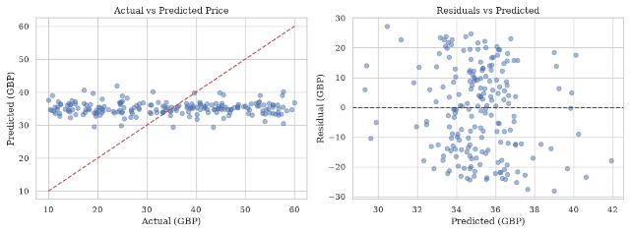
Figure 9: Actual vs predicted price (left) and residuals vs predicted price (right)

5.4 Limitations
- Books to Scrape is a practice website, so its prices and ratings may not follow real market behaviour. Weak relationships between the features and price should therefore be expected and do not necessarily indicate a flawed method.
- Important real-world drivers of price, such as author reputation, publisher, format, page count and publication date, are not available on the site.
- Linear regression assumes a linear relationship, constant error variance and independent errors. The residual plot should be inspected for violations of these assumptions.
- Several genres contain few books, so their coefficients are estimated imprecisely.
- The model is associative, not causal: it shows which features move with price, not what causes price changes.
- Possible improvements include text features from descriptions (for example TF-IDF), regularised regression and tree-based models.

6. Practical Implications and Recommendations
The recommendations below follow from the results in Sections 4 and 5.

6.1 For Retailers
- Use genre-level price benchmarks from Figure 4 when setting prices for new titles, and review titles priced far from their genre norm.
- Star rating shows almost no link to price in this catalogue, so do not assume that highly rated books justify a premium; test premiums on a small set of titles before applying them across the catalogue.
- Monitor stock levels, since stock quantity may signal over-ordering of slow-moving lines.

6.2 For Publishers
- Position new releases against the typical price range of their genre rather than the catalogue as a whole.
- Description length shows almost no link to price, so invest in richer descriptions only where there is evidence of a benefit, and collect additional attributes (format, page count, author profile) to improve future pricing models.

6.3 For Data-Driven Book Buyers
- Compare a book's price with its genre average to identify potential bargains.
- Treat a model prediction as a rough guide only. The model explains none of the price variation (its R-squared is slightly negative), so it should not be used to judge whether a price is fair.

7. Conclusion
This project delivered a complete data science pipeline for the Books to Scrape catalogue. Using BeautifulSoup, 1 000 books across 50 genres were scraped with their title, price, rating, stock availability, genre and description. The raw data was cleaned into a structured dataset of 1 000 rows and 15 columns, with each cleaning decision justified. Visual exploration showed that price has almost no relationship with star rating, stock quantity or description length, with correlations of 0.03 or less. Average prices differ modestly by genre, from 31.41 pounds for Food and Drink to 39.59 pounds for Fantasy, and some of the largest categories are placeholder labels rather than real genres.
A linear regression model using rating, stock quantity, text length and genre achieved an R-squared of -0.025 and a mean absolute error of 12.70 pounds on unseen data. This is marginally worse than a baseline that always predicts the mean price (R-squared of -0.005 and MAE of 12.66 pounds), so the available features explain essentially none of the variation in price. The limitations in Section 5.4, particularly the sandbox nature of the data and the absence of key real-world variables, should be kept in mind when interpreting these results.
Overall, the project shows how scraped catalogue data can be turned into insight and a baseline predictive model, and it also shows the limits of a simple model built on weak predictors. Future work should enrich the dataset with attributes such as author, publisher, format and page count, apply text mining to descriptions, and compare regularised and non-linear models against this linear baseline.

