

**The University of Zambia**

**School of Engineering**

**Department of Geomatic Engineering**

**GEE 5610 – GEOGRAPHIC INFORMATION INFRASTRUCTURE.**

**ASSIGNMENT 5**

NAME: SHILENGWE CHRISTOPHER

COMPUTER NUMBER: 2016132669

ATTENTION: Mr Munsanje

DUE DATE: 25/10/2021

**QUESTION 1**

**SELECT * FROM** Parcels;

The query above will select all the attributes from the table Parcels. In short it has no filter on the tuples selected and will display all the records in the table.

**SELECT** OBJECTID, Shape, PARCELS_ID, Shape_Length, Shape_Area **FROM** Parcels;

The query above will select the attributes in fields; OBJECTID, Shape, PARCELS_ID, Shape_Length and Shape_Area in the table Parcels. All the attributes in the selected fields will be outputted.

From the above it can be seen that both queries give the same result which is outputting all the records in the table Parcels.

**QUESTION 2**

This will produce a NULL value as there is no tuple with both PARCELS_ID = 224 AND Shape_Length > 1500

**QUESTION 3**

|  |  |  |  |  |
| --- | --- | --- | --- | --- |
| **OBJECTID\*** | **Shape\*** | **PARCELS_ID** | **Shape_Length** | **Shape_Area** |
| 6 | Polygon | 224 | 575 | 17960 |
| 5 | Polygon | 223 | 953 | 21397 |
| 7 | Polygon | 225 | 714 | 31394 |
| 1 | Polygon | 219 | 771 | 34756 |
| 2 | Polygon | 220 | 951 | 37783 |
| 3 | Polygon | 222 | 1094 | 74870 |
| 10 | Polygon | 242 | 1212 | 81143 |
| 8 | Polygon | 241 | 1309 | 96184 |
| 11 | Polygon | 227 | 1609 | 161872 |
| 4 | Polygon | 221 | 3841 | 367909 |
| 9 | Polygon | 226 | 5870 | 1830162 |

**QUESTION 4**

|  |  |  |  |  |  |  |  |  |
| --- | --- | --- | --- | --- | --- | --- | --- | --- |
| **OBJECTID\*** | **Shape\*** | **PARCELS_ID** | **Shape_Length** | **Shape_Area** | **CUST_ID** | **NAME** | **Parc_Loc** | **ADDRESS** |
| 4 | Polygon | 221 | 3841 | 367909 | 197302 | Eastern Graphics | 221 | 150 6TH ST NE |
| 5 | Polygon | 223 | 953 | 21397 | 914582 | Gelroy Associates | 223 | 762 ARGONNE AVE NE |
| 6 | Polygon | 224 | 575 | 17960 | 107892 | Homes For Sale | 224 | 500 RANKIN ST NE |
| 7 | Polygon | 225 | 714 | 31394 | 308574 | Industrial Supply Co | 225 | 751 JUNIPER |
| 8 | Polygon | 241 | 1309 | 96184 | 840367 | Accessories Inc | 241 | 725 LAKEVIEW AVE NE |
| 9 | Polygon | 226 | 5870 | 1830162 | 291063 | Antiques Inc | 226 | 491 BISHOP ST NE |
| 10 | Polygon | 242 | 1212 | 81143 | 520746 | Damar Sales | 242 | 388 7TH ST NE |

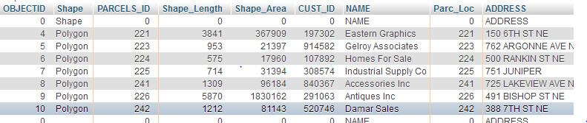

**QUESTION 5**

|  |  |  |  |  |  |  |  |  |
| --- | --- | --- | --- | --- | --- | --- | --- | --- |
| **OBJECTID\*** | **Shape\*** | **PARCELS_ID** | **Shape_Length** | **Shape_Area** | **CUST_ID** | **NAME** | **Parc_Loc** | **ADDRESS** |
| 4 | Polygon | 221 | 3841 | 367909 | 197302 | Eastern Graphics | 221 | 150 6TH ST NE |
| 5 | Polygon | 223 | 953 | 21397 | 914582 | Gelroy Associates | 223 | 762 ARGONNE AVE NE |
| 6 | Polygon | 224 | 575 | 17960 | 107892 | Homes For Sale | 224 | 500 RANKIN ST NE |
| 7 | Polygon | 225 | 714 | 31394 | 308574 | Industrial Supply Co | 225 | 751 JUNIPER |
| 8 | Polygon | 241 | 1309 | 96184 | 840367 | Accessories Inc | 241 | 725 LAKEVIEW AVE NE |
| 9 | Polygon | 226 | 5870 | 1830162 | 291063 | Antiques Inc | 226 | 491 BISHOP ST NE |
| 10 | Polygon | 242 | 1212 | 81143 | 520746 | Damar Sales | 242 | 388 7TH ST NE |

SELECT *

FROM parcels INNER JOIN `table 3` ON PARCELS_ID = Parc_Loc;



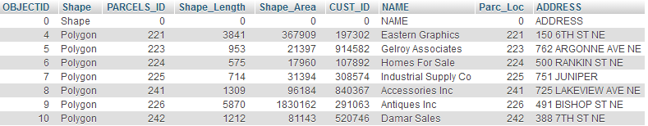

**QUESTION 6**

|  |  |  |  |  |  |  |  |  |
| --- | --- | --- | --- | --- | --- | --- | --- | --- |
| **OBJECTID\*** | **Shape\*** | **PARCELS_ID** | **Shape_Length** | **Shape_Area** | **CUST_ID** | **NAME** | **Parc_Loc** | **ADDRESS** |
| 1 | Polygon | 219 | 771 | 34756 | NULL | NULL | NULL | NULL |
| 2 | Polygon | 220 | 951 | 37783 | NULL | NULL | NULL | NULL |
| 3 | Polygon | 222 | 1094 | 74870 | NULL | NULL | NULL | NULL |
| 4 | Polygon | 221 | 3841 | 367909 | 197302 | Eastern Graphics | 221 | 150 6TH ST NE |
| 5 | Polygon | 223 | 953 | 21397 | 914582 | Gelroy Associates | 223 | 762 ARGONNE AVE NE |
| 6 | Polygon | 224 | 575 | 17960 | 107892 | Homes For Sale | 224 | 500 RANKIN ST NE |
| 7 | Polygon | 225 | 714 | 31394 | 308574 | Industrial Supply Co | 225 | 751 JUNIPER |
| 8 | Polygon | 241 | 1309 | 96184 | 840367 | Accessories Inc | 241 | 725 LAKEVIEW AVE NE |
| 9 | Polygon | 226 | 5870 | 1830162 | 291063 | Antiques Inc | 226 | 491 BISHOP ST NE |
| 10 | Polygon | 242 | 1212 | 81143 | 520746 | Damar Sales | 242 | 388 7TH ST NE |
| 11 | Polygon | 227 | 1609 | 161872 | NULL | NULL | NULL | NULL |

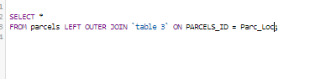

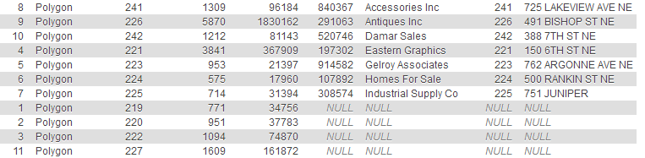

**QUESTION 7**

FULL OUTER JOIN

This is a join between tables which combines the results of both the left and right outer joins and returns all matches and unmatched rows from both tables in the join query. Essentially in terms of set notation the output of the full outer join is union of the tables in the query. The syntax uses FULL OUTER JOIN.

SELF JOIN

This is a join in which a table is join with itself and is useful for comparing rows within the same table when there is a foreign key in the table that references to the primary key. It uses the syntax [INNER|LEFT] JOIN which means it applies the inner and left joins on the same table which essentially creates the self join.