**Program 1**

**Write a python program to import and export data using Pandas library functions. Demonstrate various data pre-processing techniques for a given dataset.**

Code:

import pandas as pd

airbnb_data = pd.read_csv("austinHousingData.csv")

airbnb_data.head()

# Webpage URL

url = "https://archive.ics.uci.edu/ml/machine-learning-databases/iris/iris.data"

# Define the column names

col_names = ["sepal_length_in_cm",

"sepal_width_in_cm",

"petal_length_in_cm",

"petal_width_in_cm",

"class"]

# Read data from URL

iris_data = pd.read_csv(url, names=col_names)

iris_data.head()

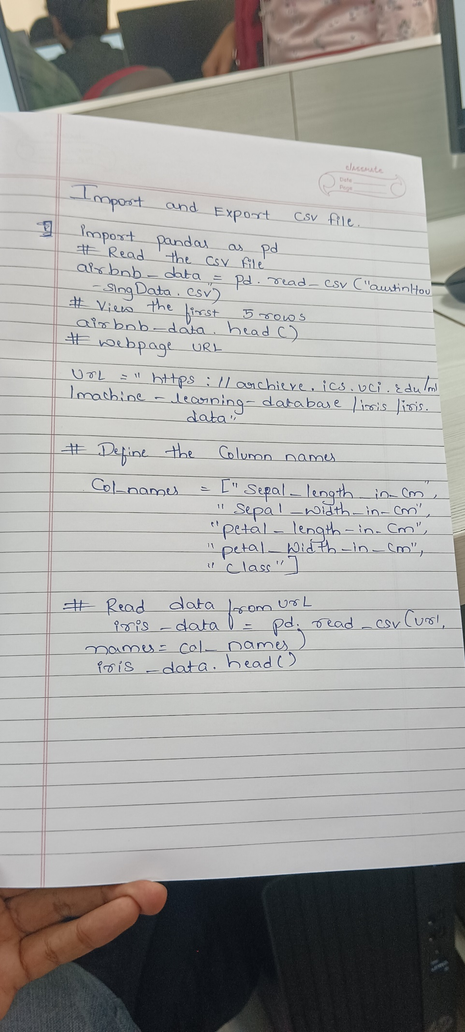

Output:

