

JIRA

For V SEMESTER

**Department of CSE(Data Science)**

By

Pooja Ahuja S

Assistant Professor, Department of CSE(Data Science)

**INDEX**

|  |  |
| --- | --- |
| **Sl.**  **No.** | **Program Name** |
| **1** | Navigating the JIRA interface  Creating and managing user accounts  Setting up projects and workflows  Issue Types and Workflows: |
| **2** | Understanding different issue types (e.g., task, bug, epic)  Customizing workflows to match your team's processes  Creating and Managing Issues: |
| **3** | Creating new issues and specifying details  Assigning, prioritizing, and scheduling issues  Using labels, components, and versions for issue organization  Advanced Searching and Filters: |
| **4** | Creating custom filters for specific views  Using JIRA Query Language (JQL) for advanced searches  Dashboards and Reports: |
| **5** | Creating personalized dashboards  Generating and interpreting various reports (e.g., burndown charts, velocity charts)  Agile Development with JIRA: |
| **6** | Implementing Scrum or Kanban boards  Managing sprints, backlogs, and boards  Estimating and tracking story points  Integration and Automation: |

1.Navigating the JIRA interface

Creating and managing user accounts

Setting up projects and workflows

**Creating JIRA Account**

**Following the below steps to create Account**

1. **Create free account**
2. **Choose site**
3. **Select Template**
4. **Make Project**

**1.Go to the browser and search jira software ,Then click on the jira software version shown by the Atlassian website:**

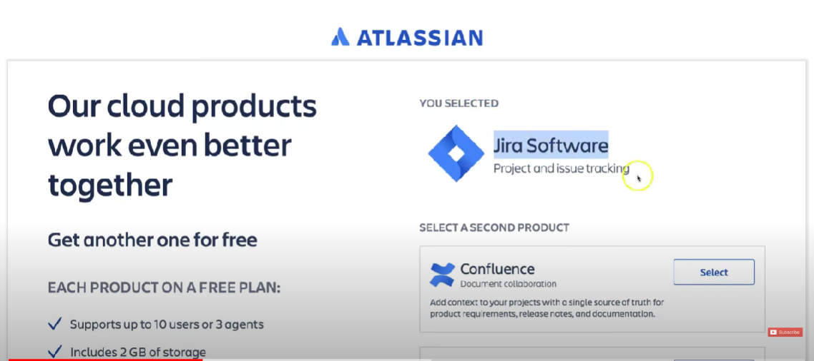

**2.Next window will be asking for the login credential for setting up of account ,you can either create your new account and password or continue with google.**

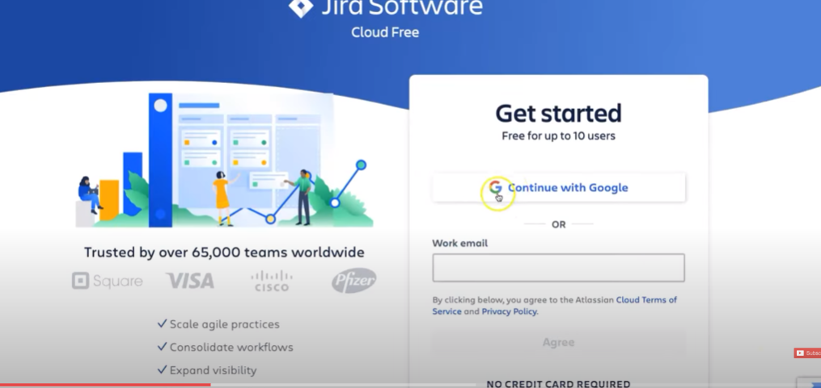

**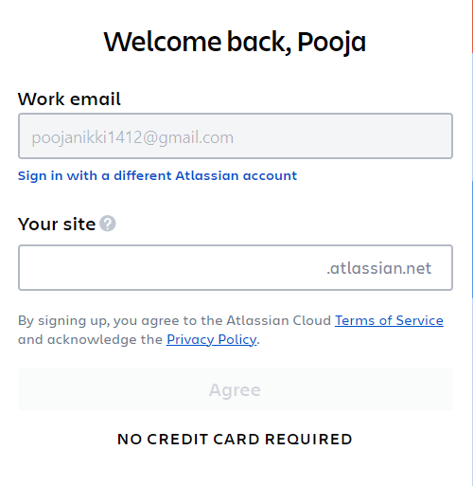  
After creating account it will navigate to the project window,give the project name ex:Here E-Com is the project name and it will ask you to select the template   
 Will select the SCRUM Template**

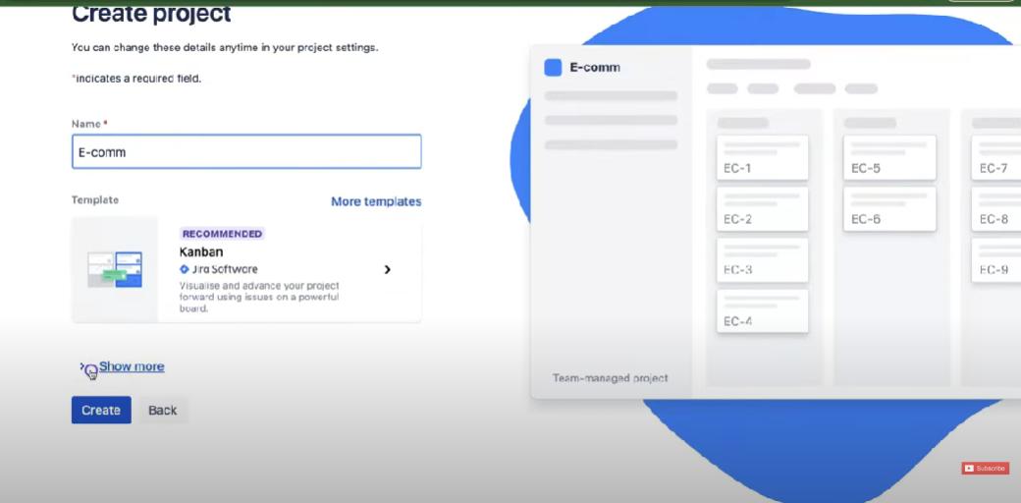

**By clicking on more template will select SCRUM:**

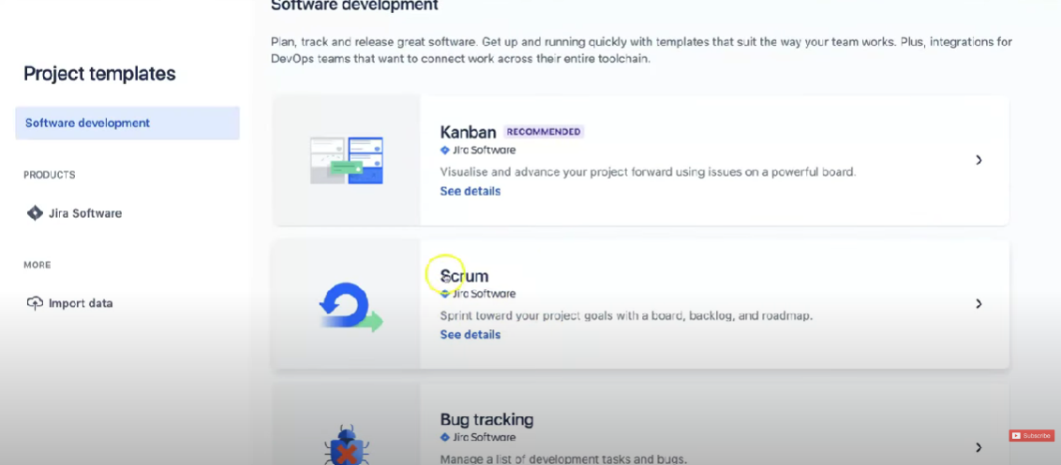

**After selecting the scrum template click on create**

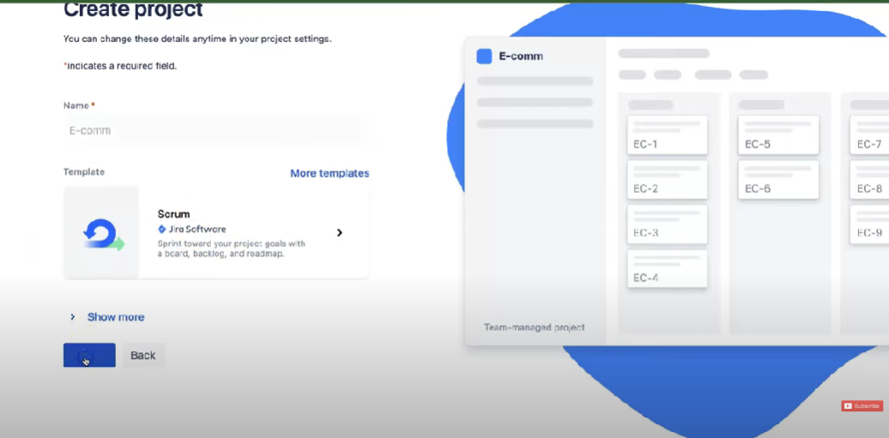

**After Clicking on the create the project will be created and the below window will be shown.**

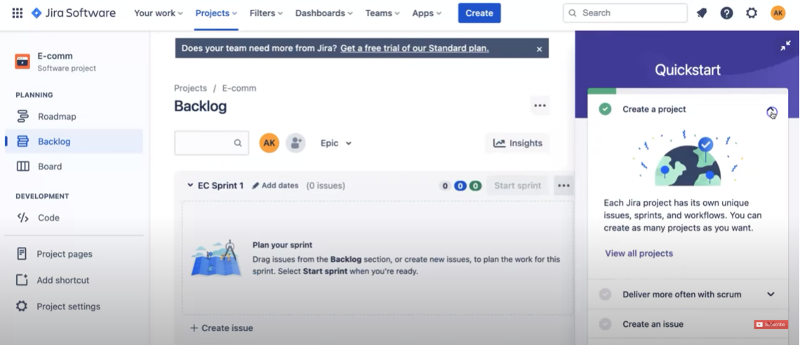

**2.** Understanding different issue types (e.g., task, bug, epic).Customizing workflows to match your team's processes. Creating and Managing Issues:

1.Go to jira project window click on create window.

2.Then select the issue type in drop down window either task,story,epic.

3.After selecting specify the asssigne and all and click on the impediment.

4.After issue is created click on the view issue.

5/You can move the issue from to do column to the done column and the status will be displayed as done.

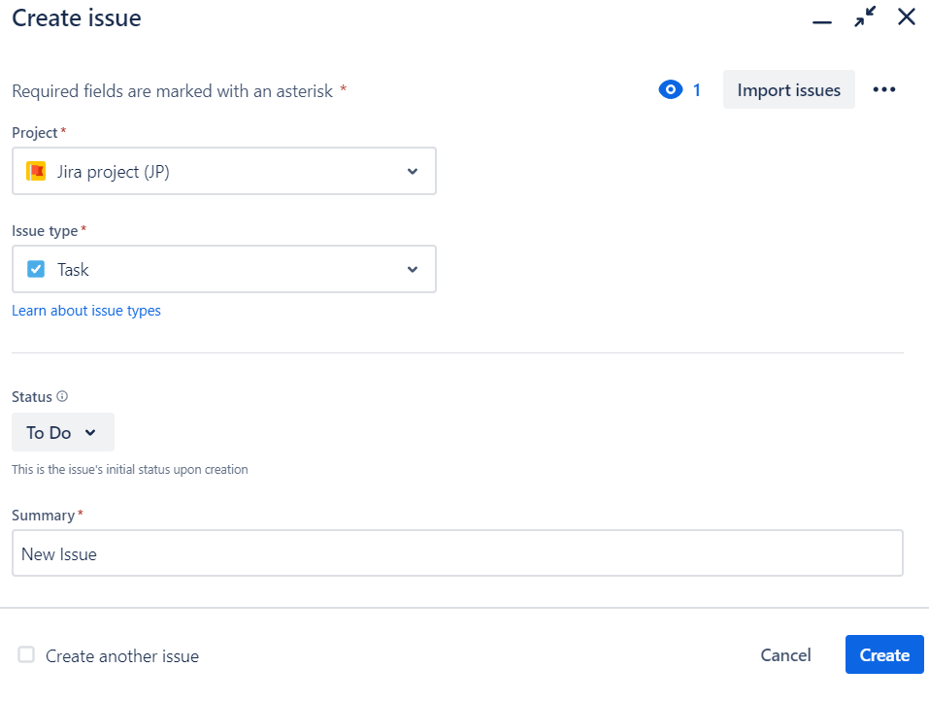

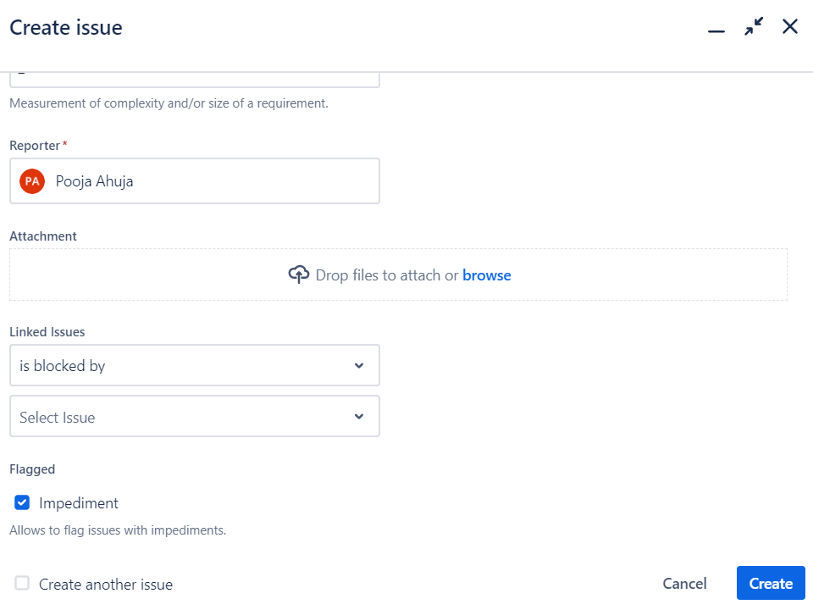

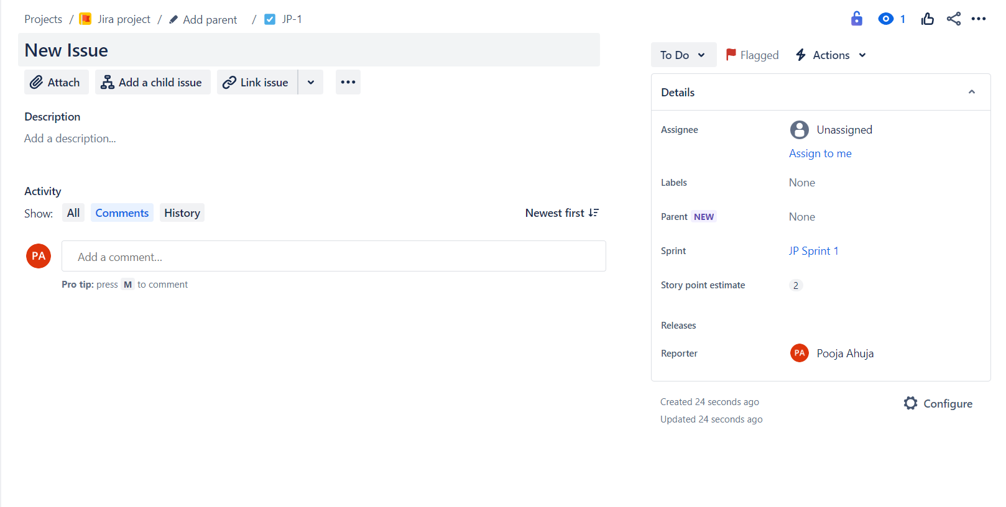

3. Creating new issues and specifying details

Assigning, prioritizing, and scheduling issues

Using labels, components, and versions for issue organization

Steps:

1. To add and create new issues go to project settings and click issues types
2. In issue types select add issue
3. Give issue name and in change icon select the icon for the issue
4. In the issue type the new issue will be shown
5. Go back to backlog and check in the create section,In drop down menu new issue will be shown

Steps to create Label

1. Click on any existing issue and in the label section give label name.
2. In the board page click on the labels and select the label name that you want to check
3. The issue with the corresponding label will be displayed
4. To check through query click on the filters and then give the following query in the search bar
5. Labels=”label name”(EG:labels=”frontend”)

