1. Wk3

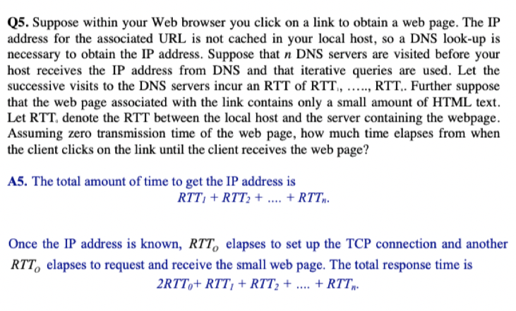

Q: For this question, I have 3RTT0 for transferring (1 for connection, 1 for index and 1 for the object), but the answer only contains 2RTT0. Is that because when the web page has only 1 object, it’s not necessary to send the index file?

A:

1. Wk4

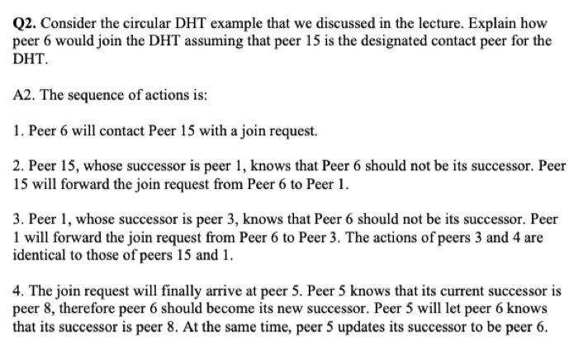

Q: From my understanding from last lab, the new peer should request for its expected successor (e.g. peer 6 send request to peer 8) and then “insert” itself between the expected successor and the expected successor’s predecessor (e.g. 6 make 8 be its successor and make 8’s predecessor be its predecessor). In the answer, the new peer only send request up to its expected predecessor (peer 6 only request 5 but not 8). I’m a bit confused that if the new peer send request to its expected successor or not?

A:

1. Wk5

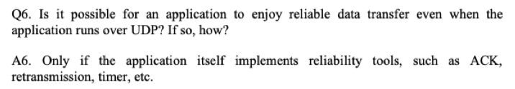

Q: How can the application layer implements reliability tools if the transferring layer is not reliable?

A:

1. Wk4

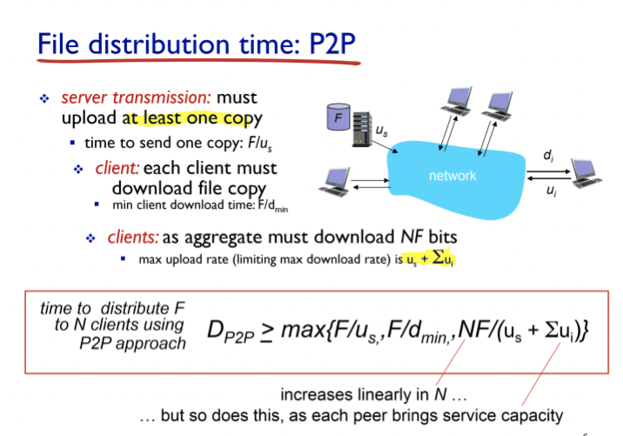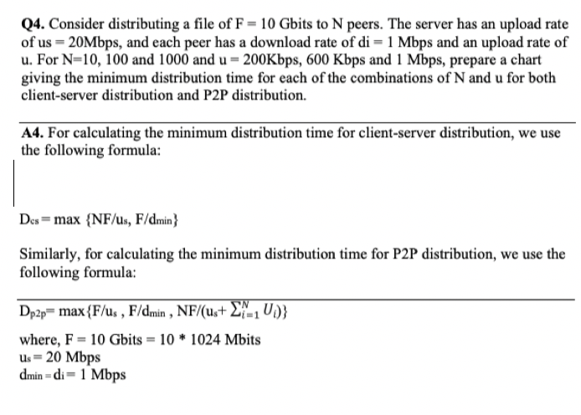

Q: About the Dp2p formula, I understand that the first element is time for server upload file and the second element is time for each peer download file; for the third element, it might be the time for peers upload the files, but I don’t get why the denominator is (us+∑ui) but not ∑ui. What does the us stand for here?

A:

1. General

Q: I found that the answers suggests 1Gbits = 1024 Mbits and 1 Mbits/sec = 1000000 bits/sec. I’m quite confused that when to use 1024 and when to use 1000 for unit conversion?

A: