**References**

Often times issues are dependent on other issues, or at least relate to them and you’d like to connect the two. You can reference issues by typing in a hashtag plus the issue number.

Hey @kneath, I think the problem started in #42

When you do this, we’ll create an event inside of issue #42 that looks something like this:



Issue in another repository? Just include the repository before the name like kneath/example-project#42.

One of the more interesting ways to use GitHub Issues is to reference issues directly from commits. Include the issue number inside of the commit message.

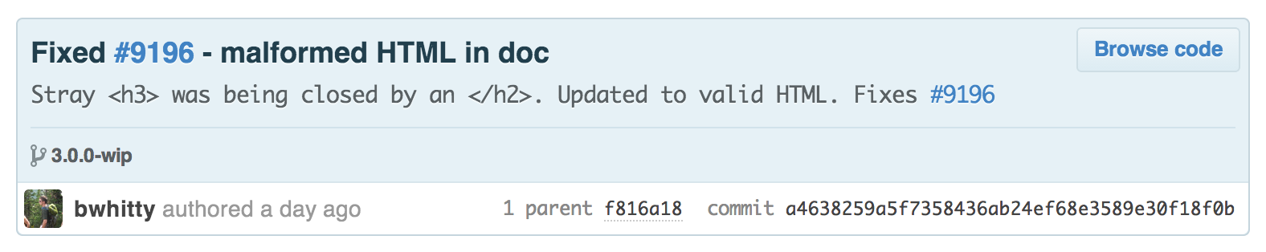

By prefacing your commits with “Fixes”, “Fixed”, “Fix”, “Closes”, “Closed”, or “Close” when the commit is merged into master, it will also automatically close the issue.

References make it possible to deeply connect the work being done with the bug being tracked, and are a great way to add visibility into the history of your project.