PART 1
1. Download MySQL server for your OS
2. Install MySQL server
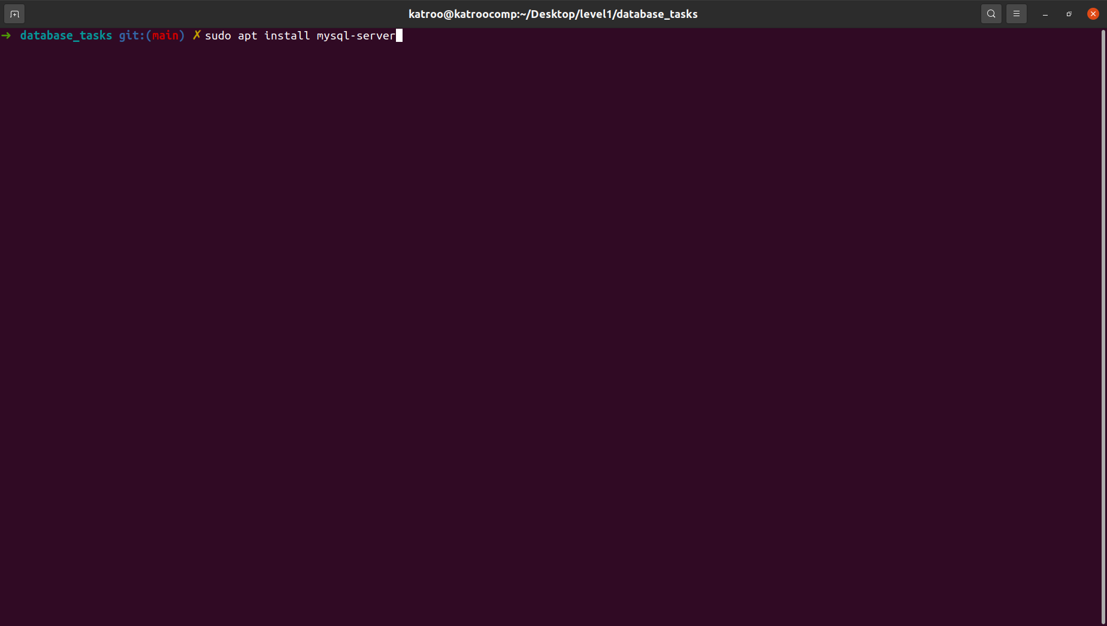
3. Select a subject area and describe the database schema, (minimum 3 tables)

Subject – cats
3 tables:
-main info
-weight
-food

4. Create a database on the server through the console
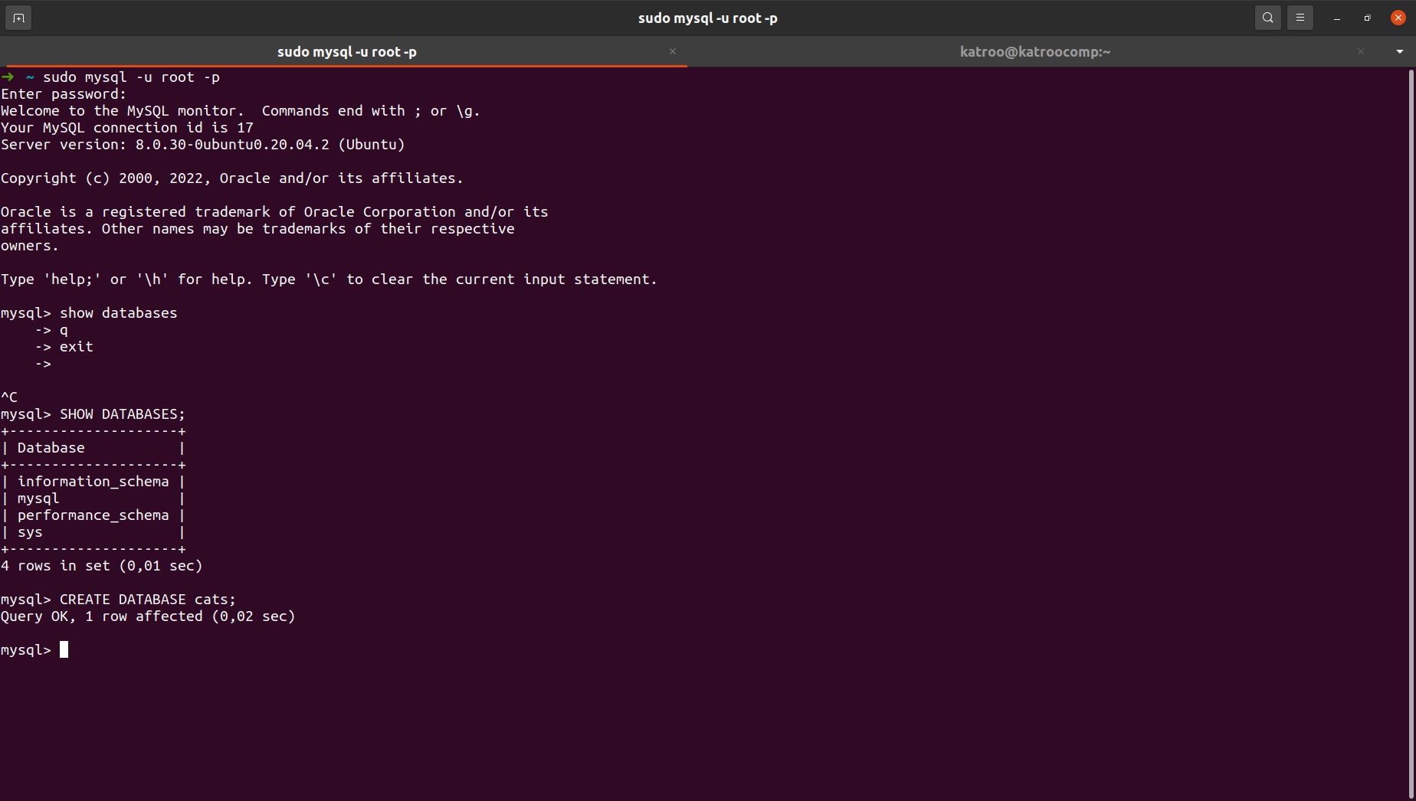
5. Fill in tables
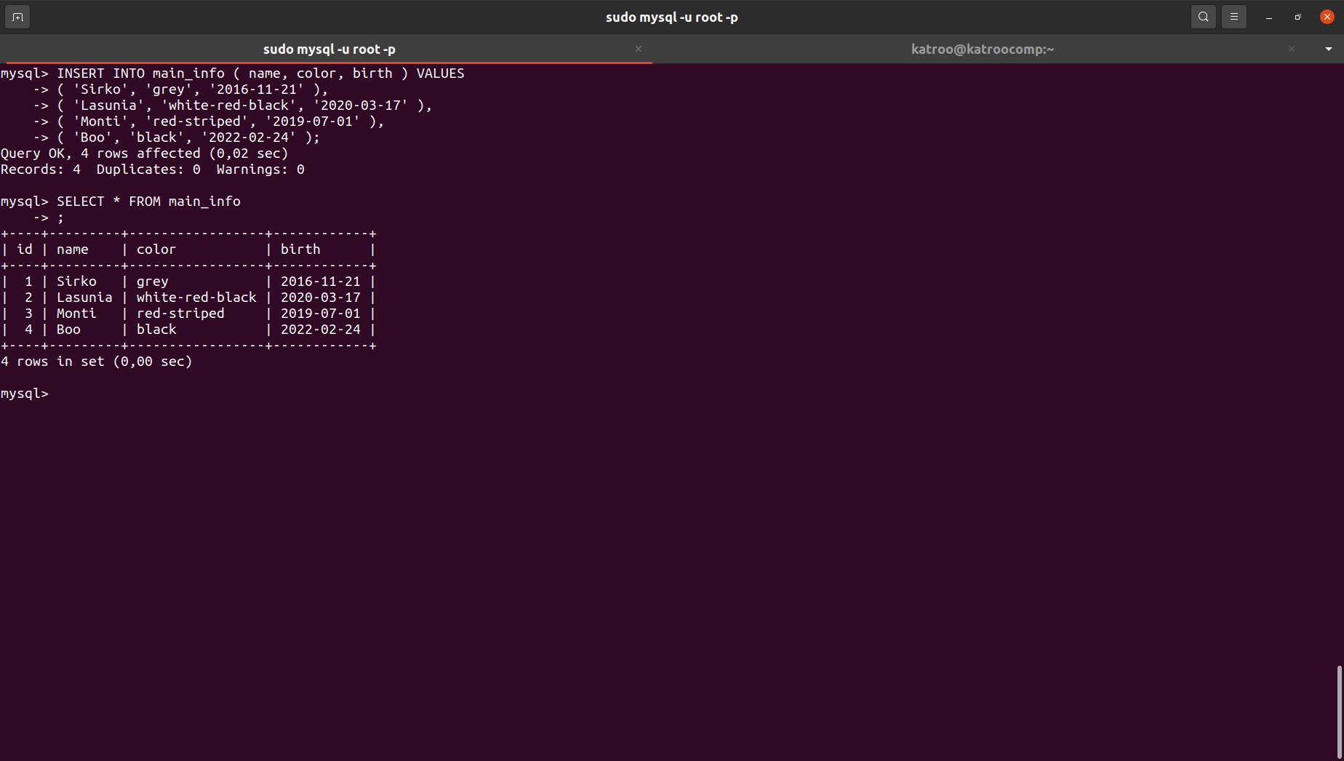
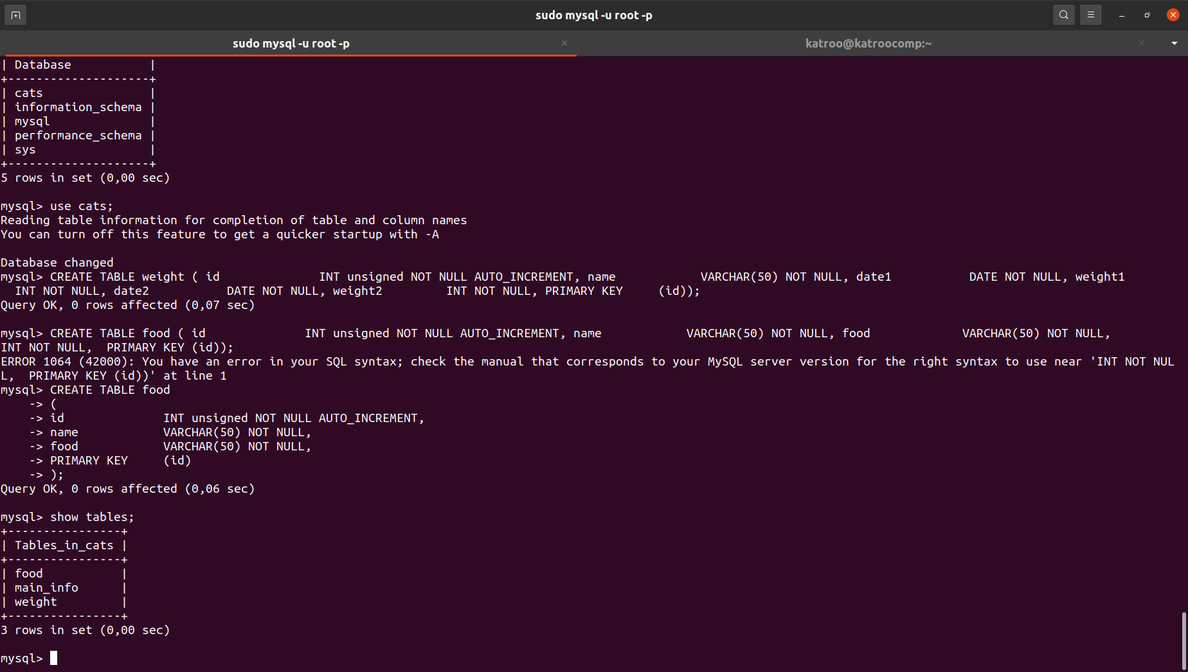

6. Construct and execute SELECT operator with WHERE, GROUP BY and ORDER BY
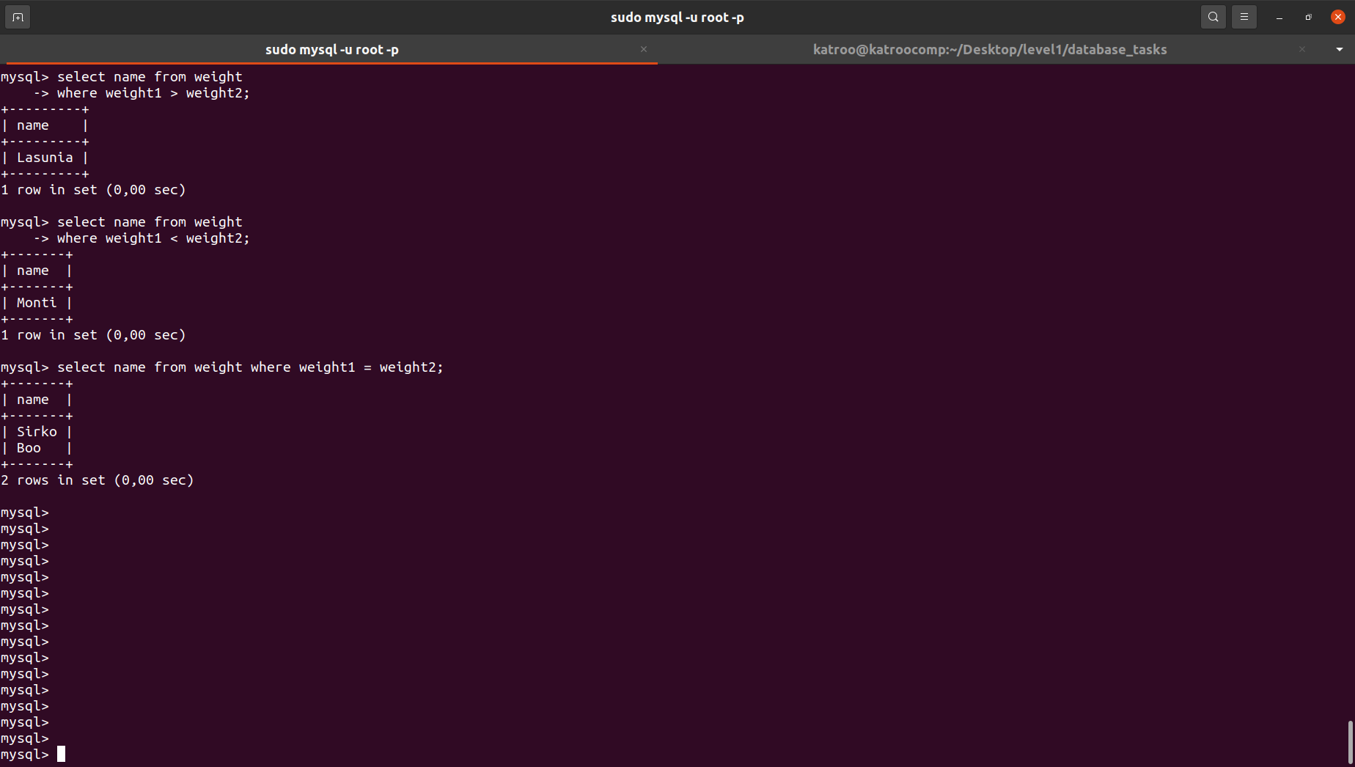
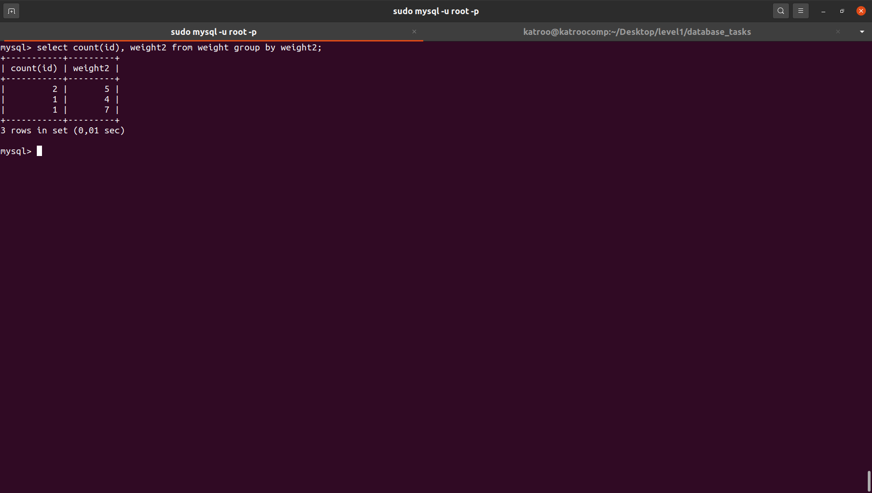
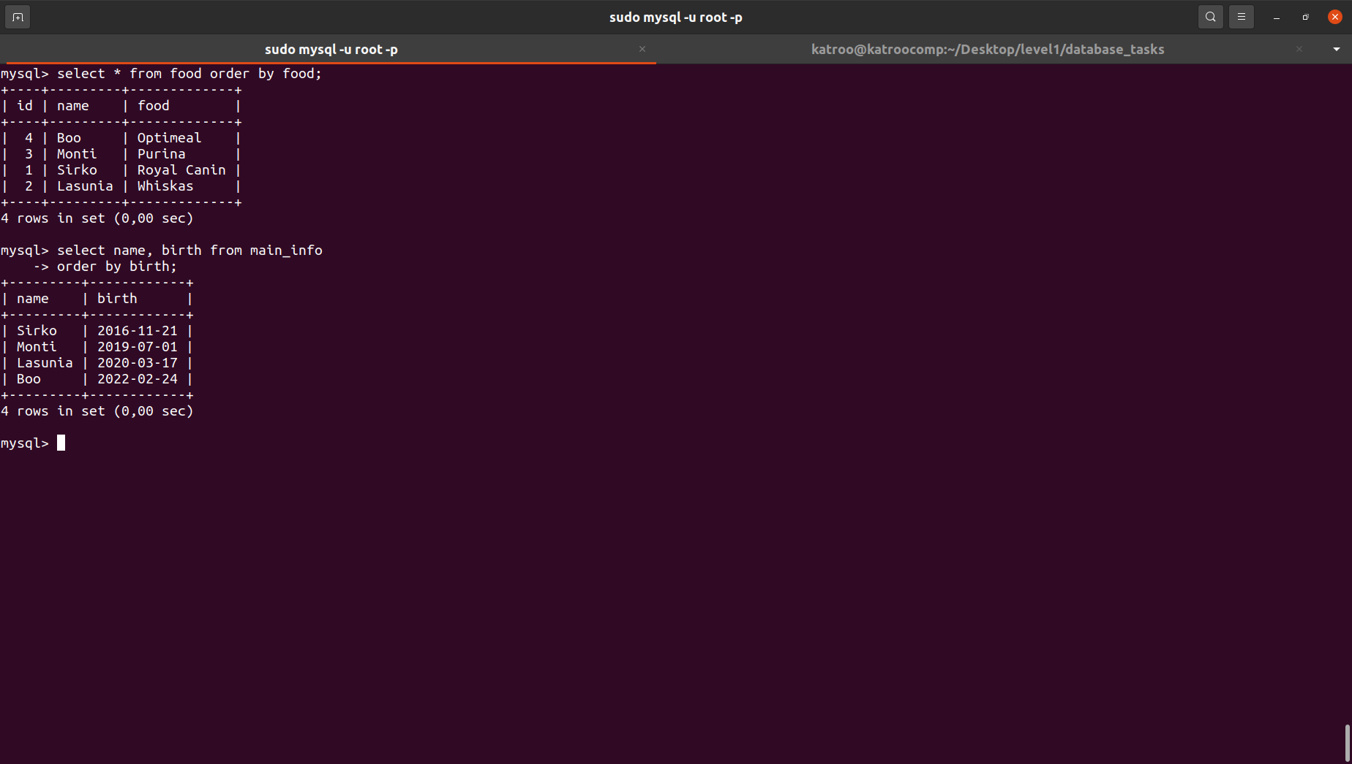
7. Execute other different SQL queries DDL, DML, DCL
DDL (ALTER TABLE – ADD, DROP COLUMN, MODIFY COLUMN; RENAME TABLE)
DML (SELECT, UPDATE, INSERT used earlier)
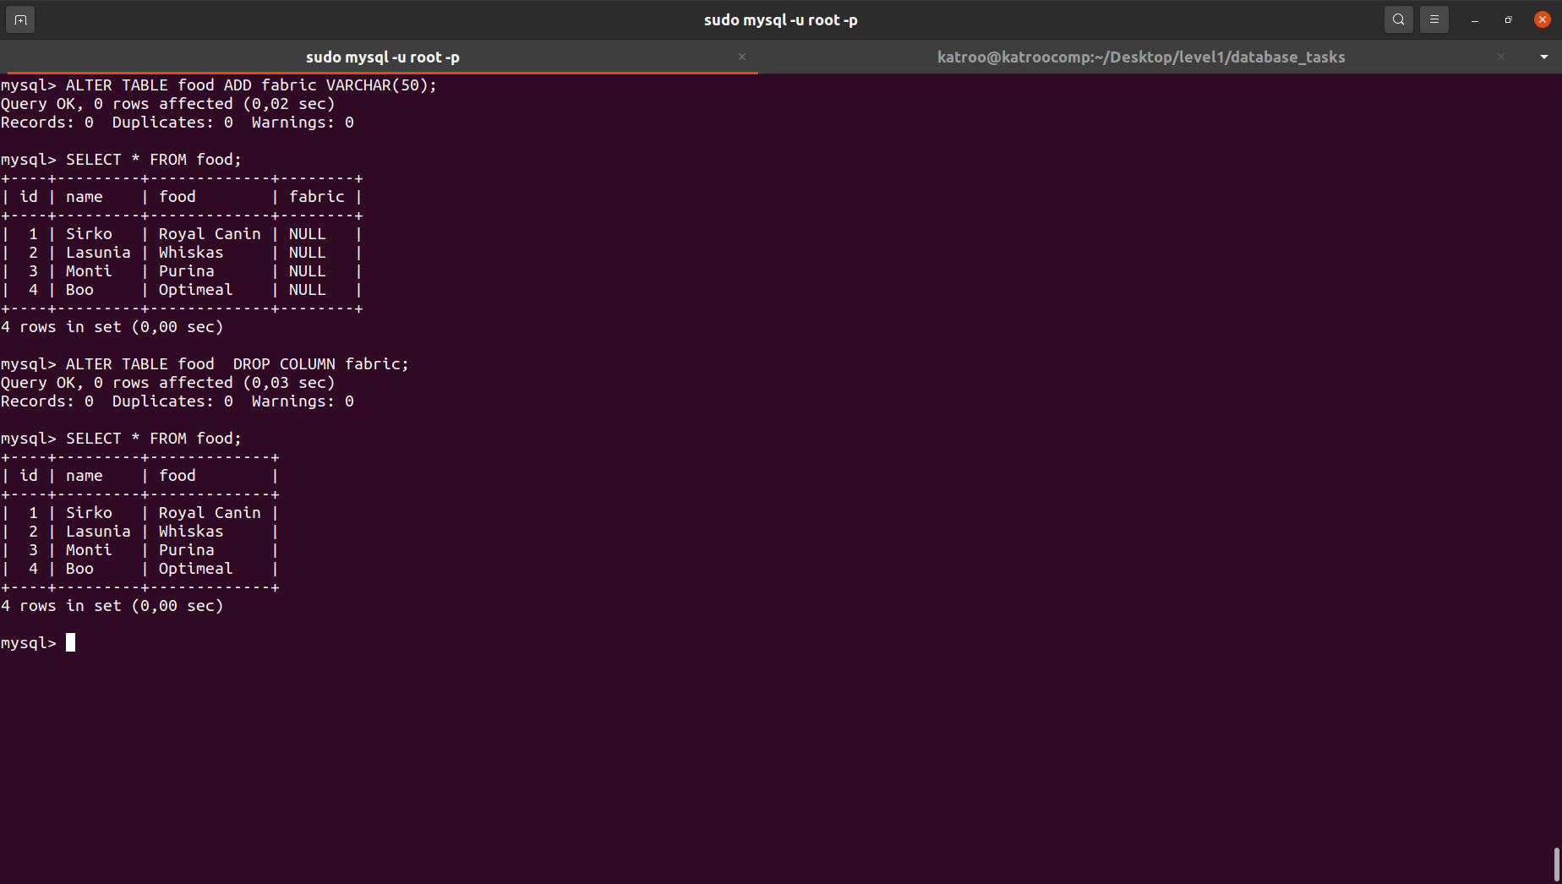
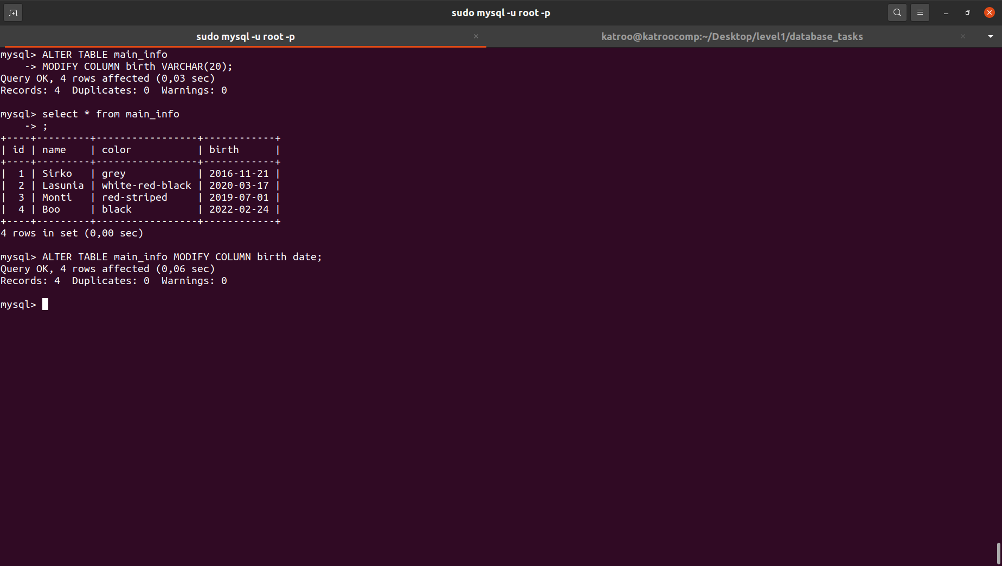
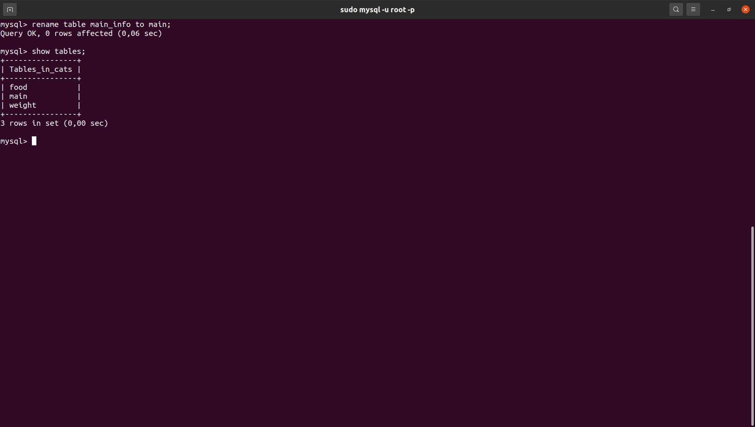
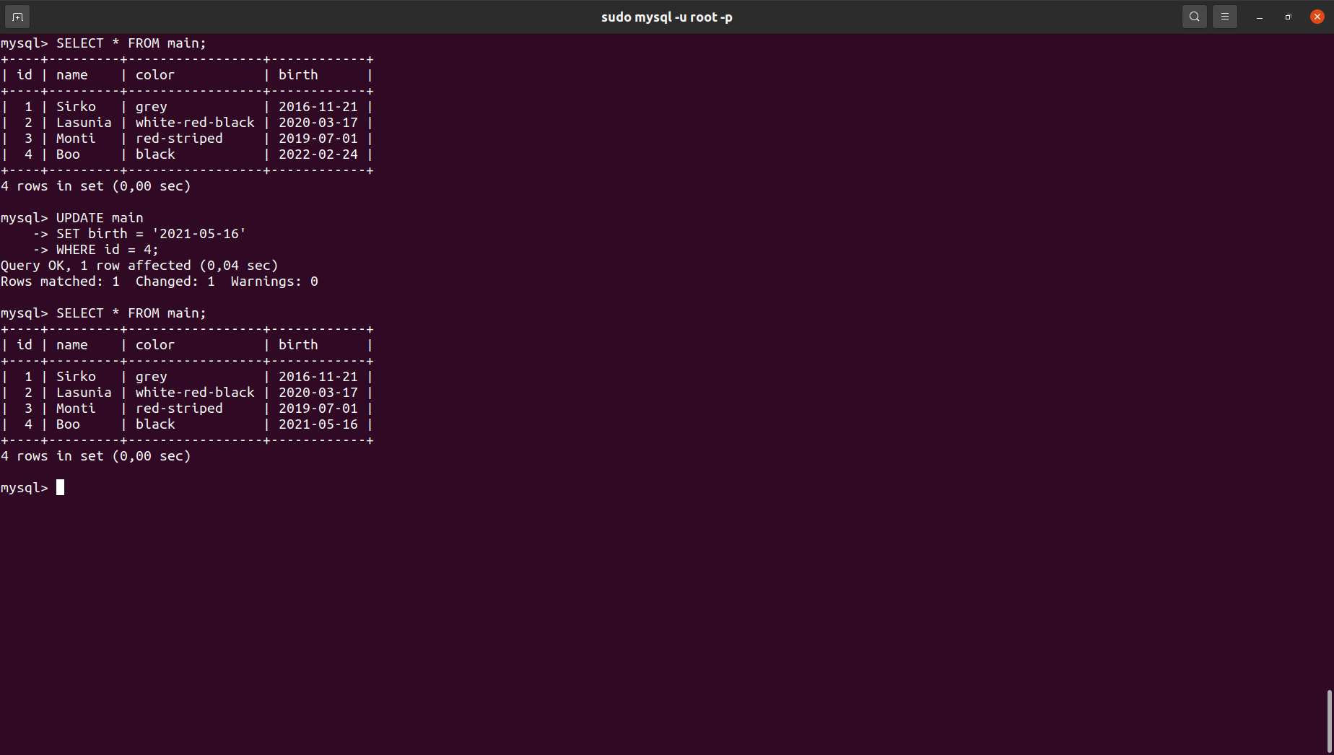

8. Create a database of new users with different privileges.
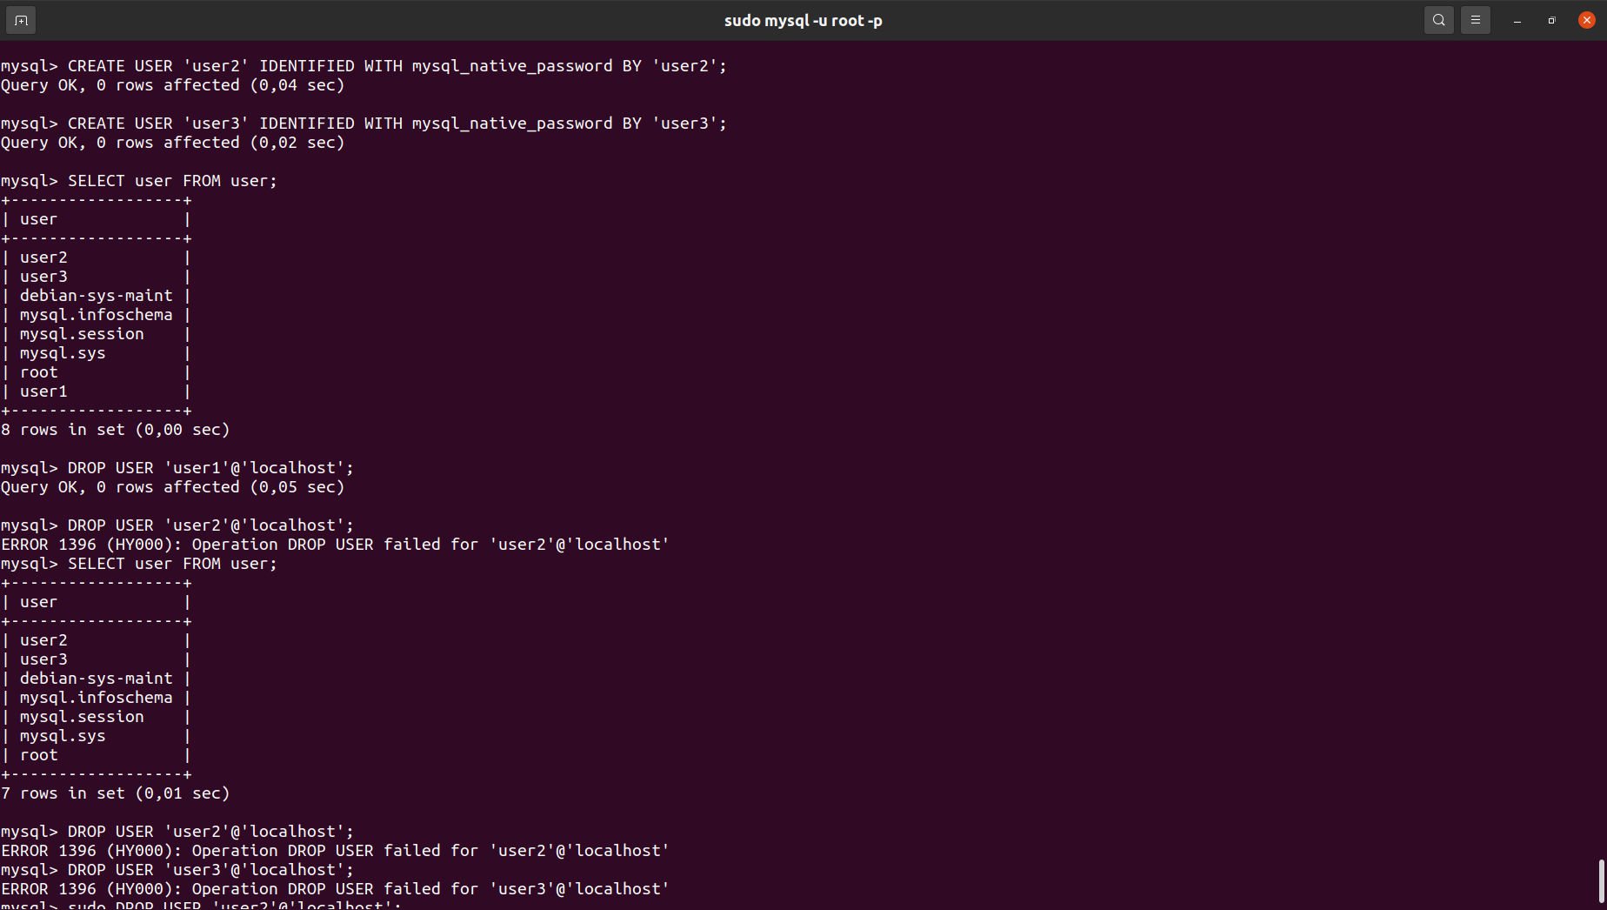
DCL
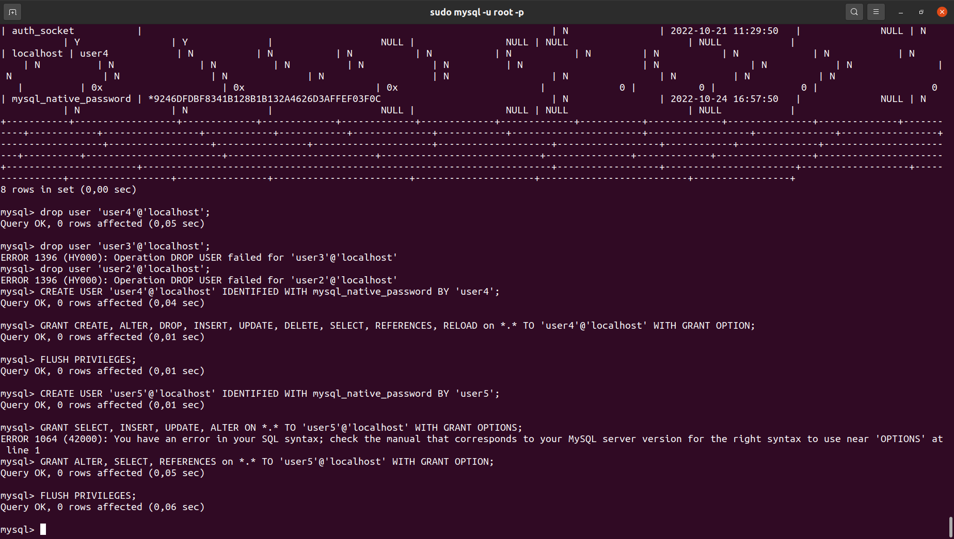
Connect to the database as a new user and verify that the privileges allow or deny certain actions.
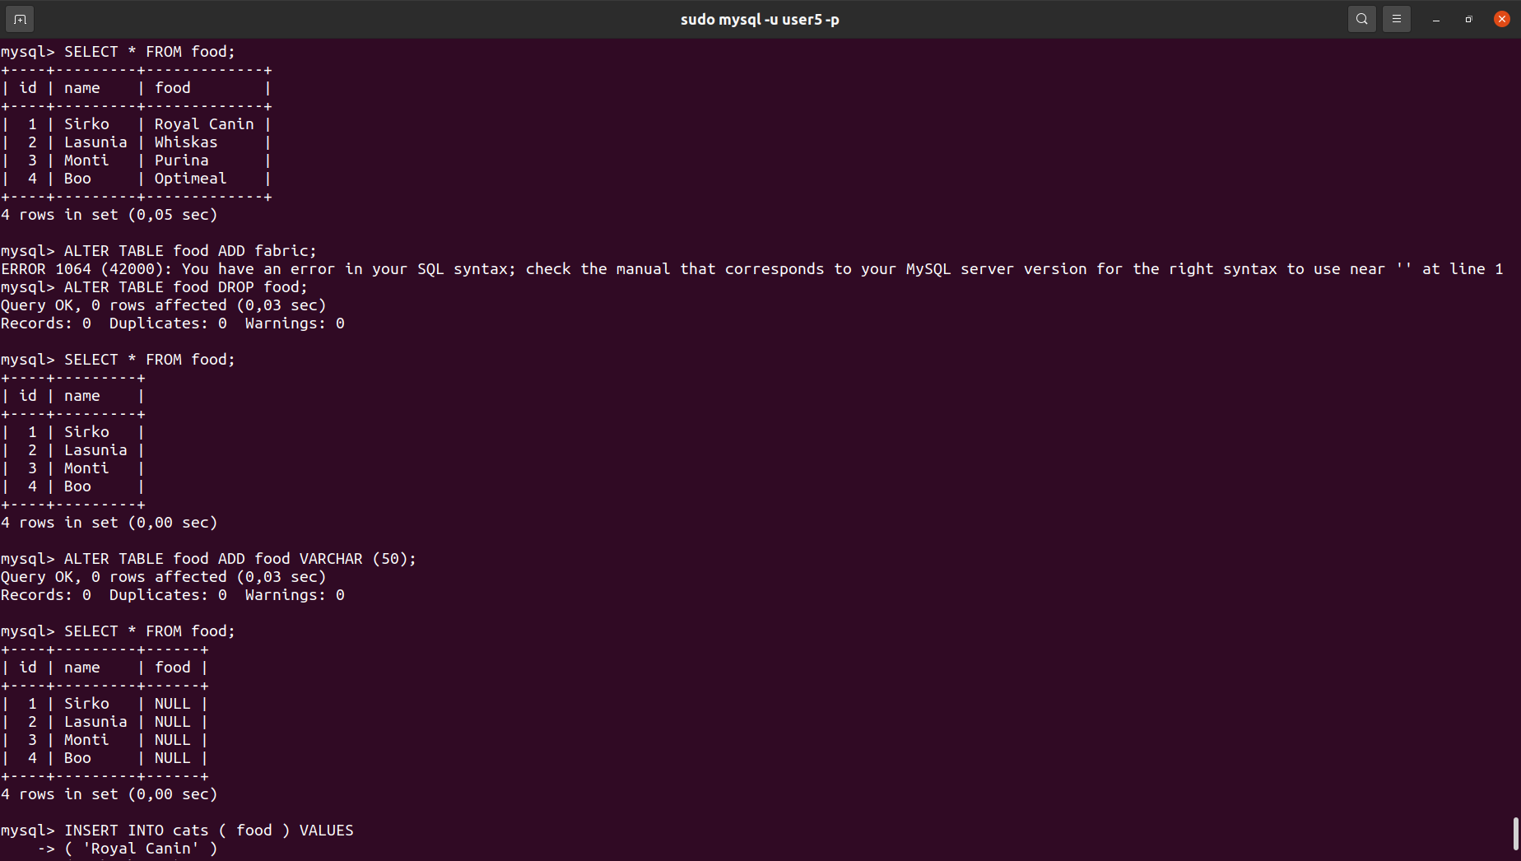
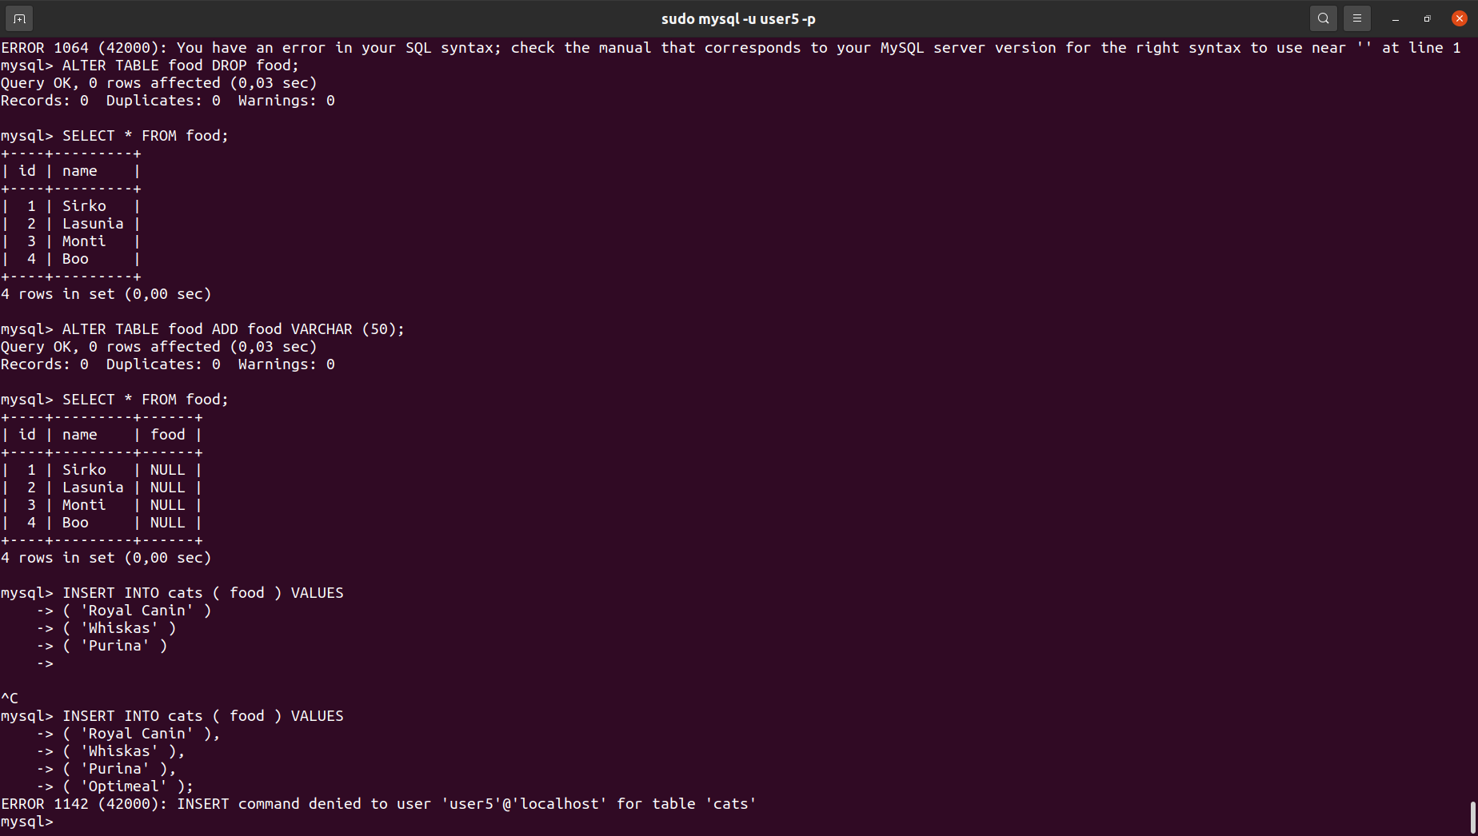

9. Make a selection from the main table DB MySQL
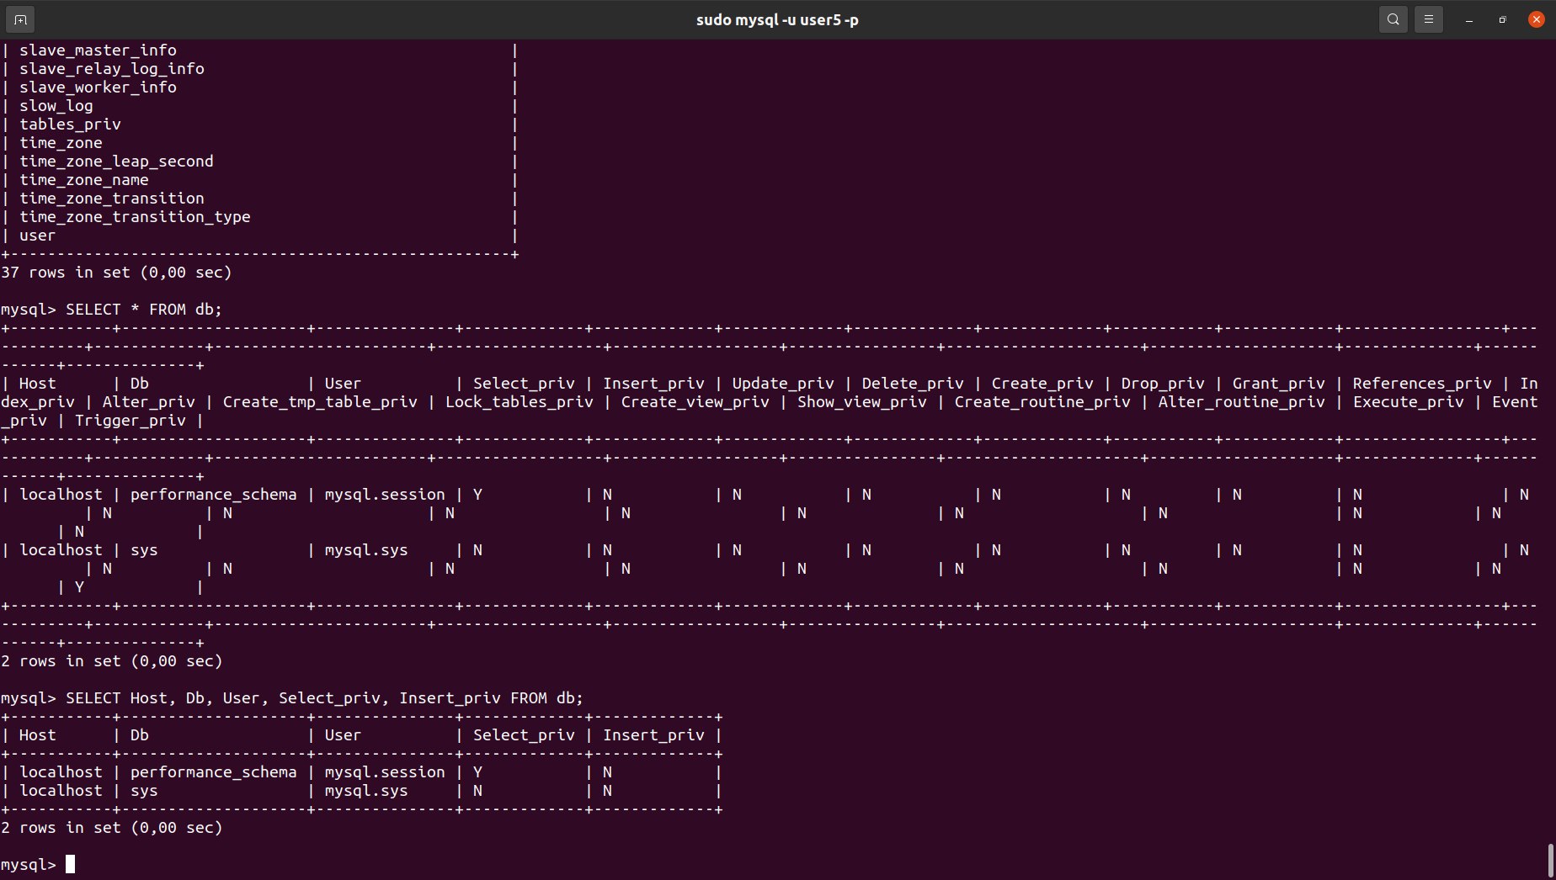

PART 2
10.Make backup of your database
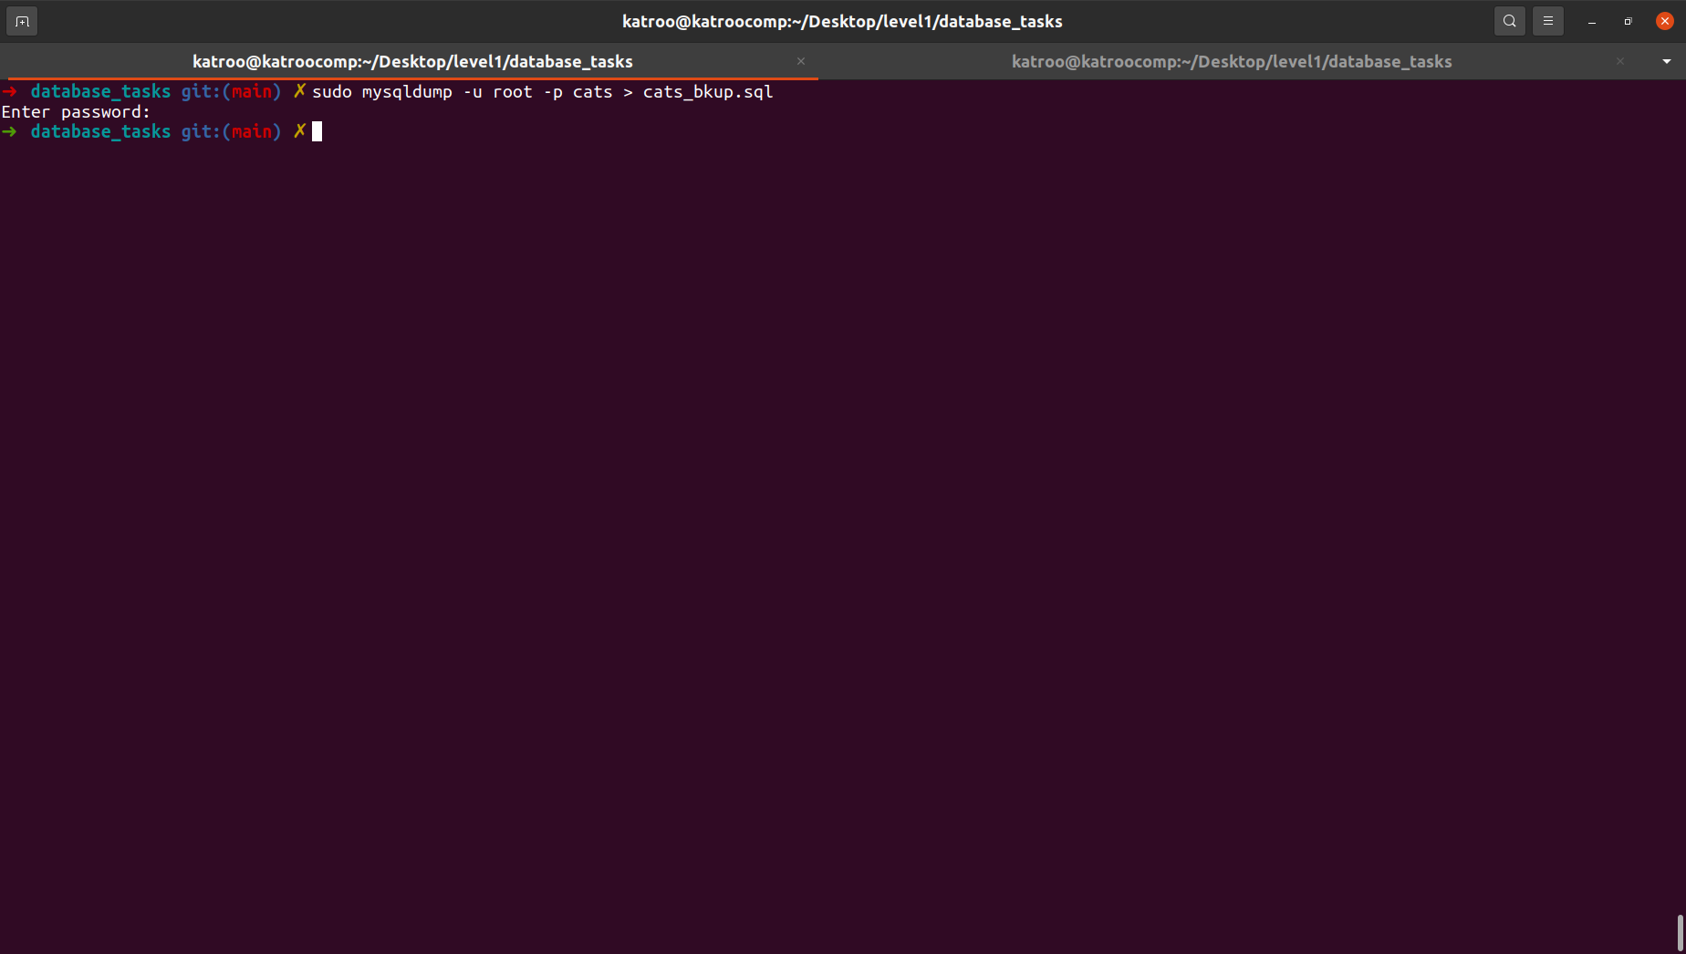
11.Delete the table and/or part of the data in the table
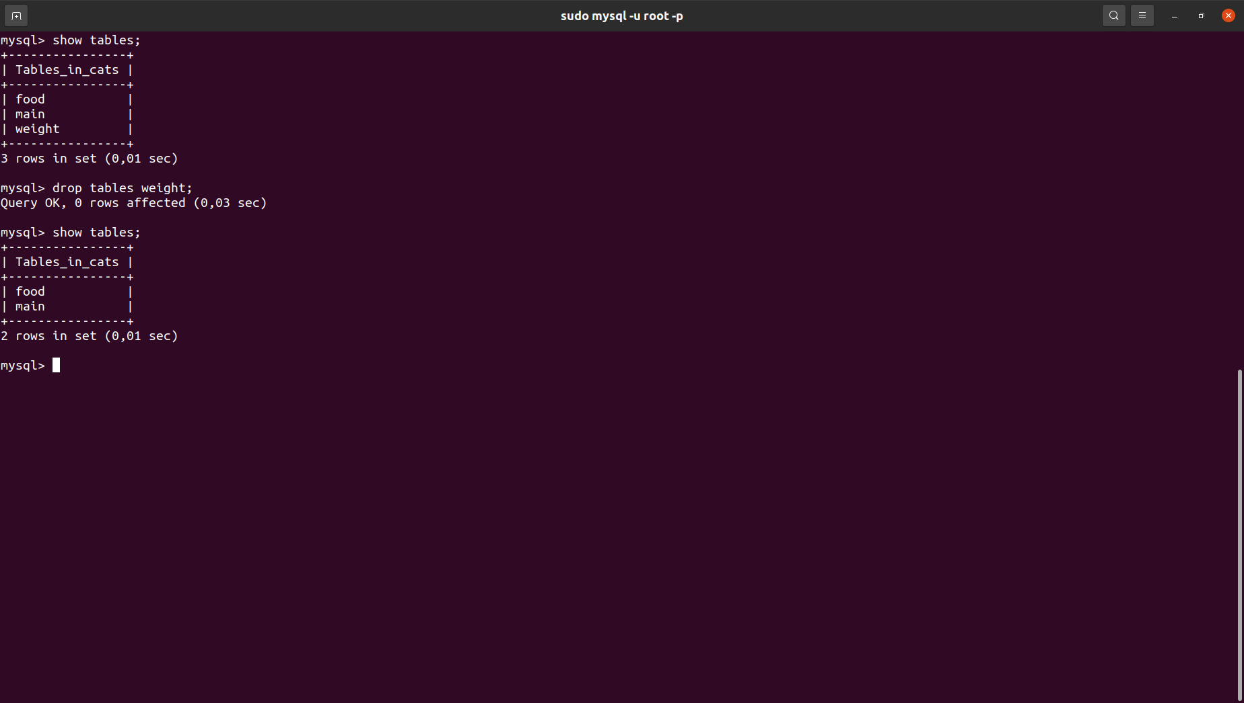
12.Restore your database
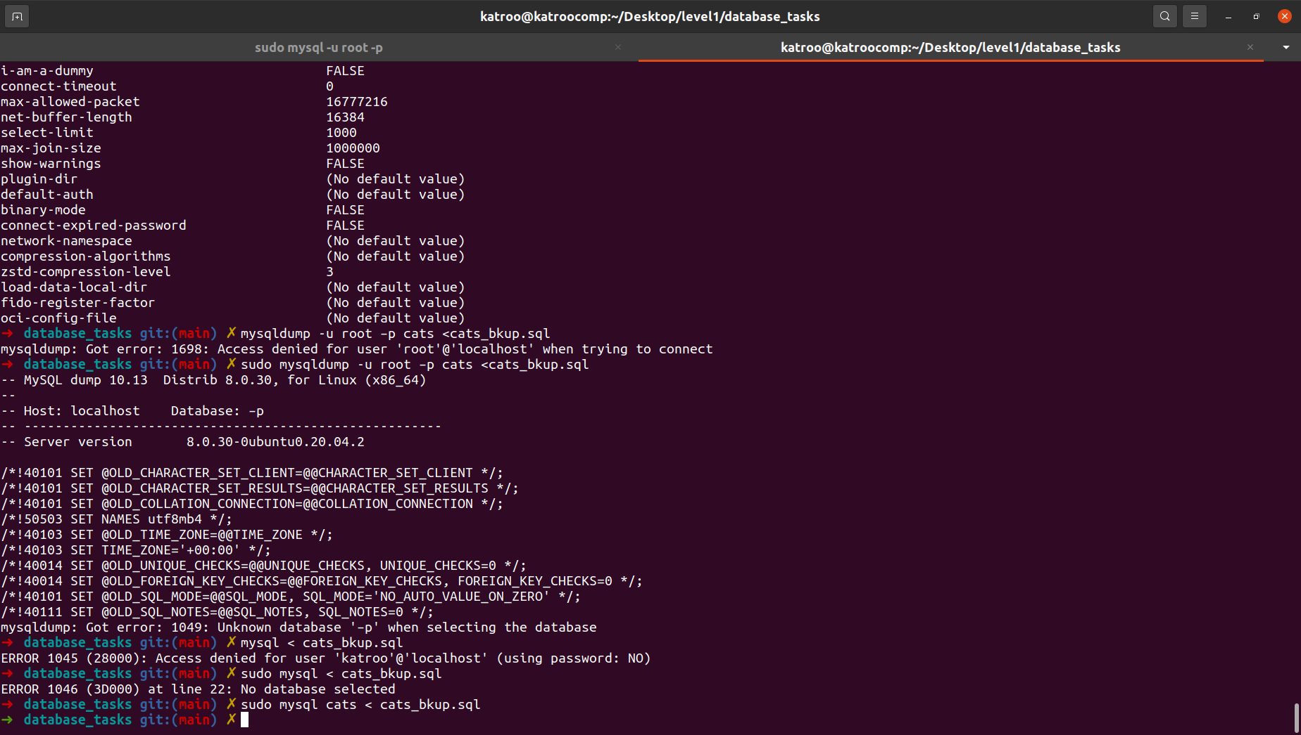
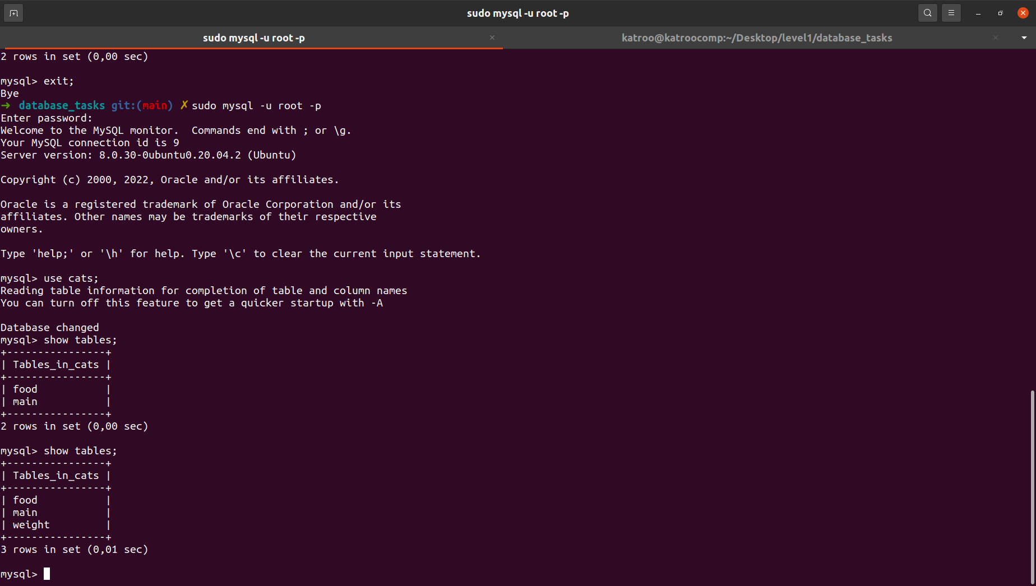
13.Transfer your local database to RDS AWS.
14.Connect to your database.
15.Execute SELECT operator similar step 6.
16.Create the dump of your database.

PART 3 – MongoDB
17. Create a database. Use the use command to connect to a new database
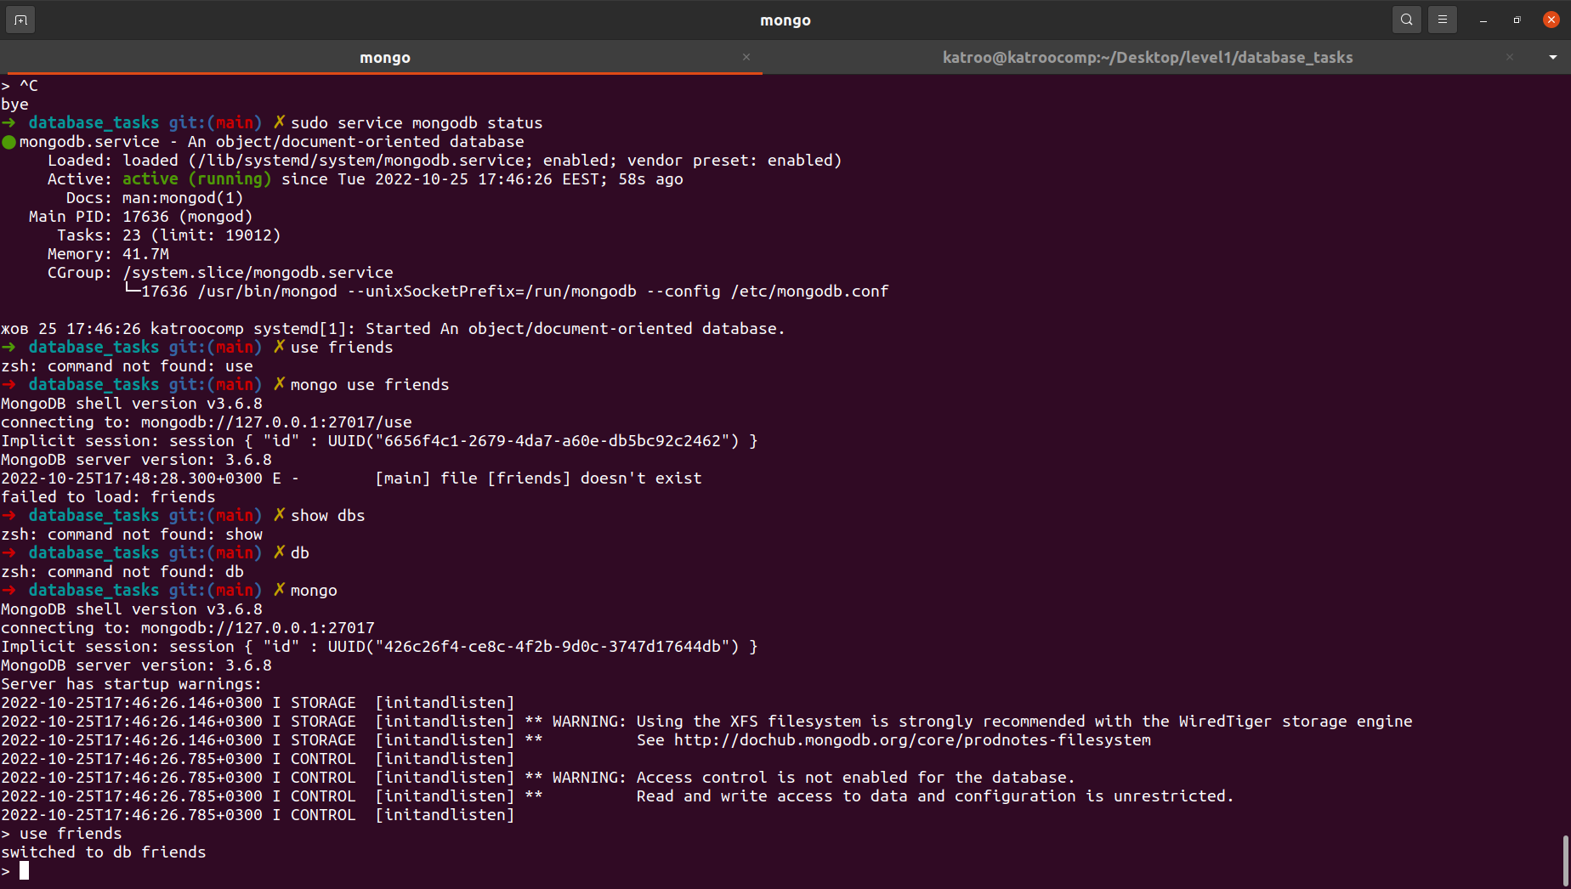
18. Create a collection. Use db.createCollection to create a collection. Run show dbs and show collections to view your database and collections.
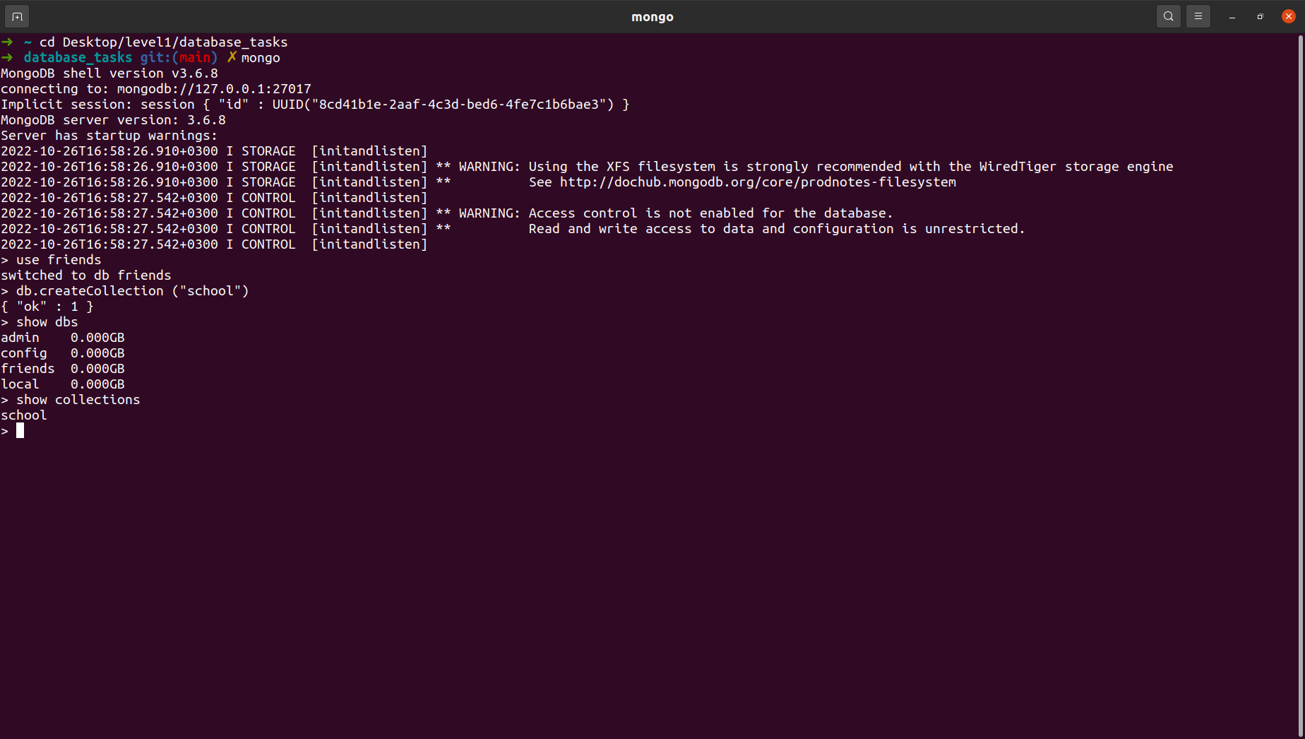
19. Create some documents. Insert a couple of documents into your collection
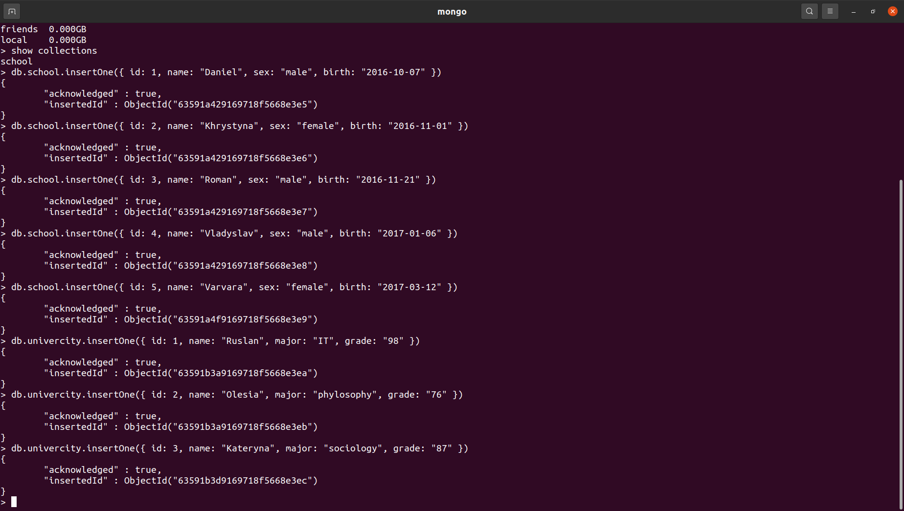
20. Use find() to list documents out
