SECURE MOBILE COMMUNICATION FRAMEWORK
Using Hybrid Cryptographic Techniques
PROJECT REPORT
Submitted by
M. Kavya Amrutha
Roll No.: 2023BCS0221
Department of Computer Science and Engineering
IIIT Kottayam
2026

Abstract
This project presents a Python-based Secure Mobile Communication Framework that combines multiple cryptographic techniques to provide confidentiality, integrity, authentication, secure key exchange, and protection against common communication attacks. The framework uses ECDH over the SECP256R1 curve for session-key establishment, AES-256-GCM for authenticated encryption, and RSA-2048 digital signatures for message authenticity. A registration and login mechanism uses salted PBKDF2 password hashing rather than storing plaintext passwords. A PySide6 graphical dashboard provides security monitoring and demonstrations of eavesdropping, tampering, and replay attacks. The project is intended as an educational demonstration of how hybrid cryptographic mechanisms can be combined to secure communication.
Table of Contents
Use Microsoft Word: References → Table of Contents → Automatic Table. The numbered headings in this document are already formatted for automatic generation.

1. Introduction
Modern networked applications exchange information over channels that may be exposed to interception, modification, impersonation, or message replay. A secure communication system therefore needs more than a single encryption algorithm. It must establish keys securely, protect message confidentiality and integrity, authenticate participants, and detect invalid or reused messages. This project implements these principles in a modular Python client-server framework with a PySide6 graphical dashboard.
2. Problem Statement
Plain or weakly protected communication can expose sensitive information to attackers. Even when encryption is used, a complete system must also address key establishment, authentication, message integrity, and replay protection. The project addresses this problem by combining complementary cryptographic mechanisms and providing practical attack demonstrations.
3. Objectives
Provide confidentiality using AES-256-GCM.
Establish a shared session key using ECDH on SECP256R1.
Provide authenticity using RSA-2048 digital signatures.
Protect account passwords using salted PBKDF2 hashing.
Detect modifications to protected communication data.
Detect and reject replayed communication packets.
Demonstrate eavesdropping, tampering, and replay attacks.
Provide a user-friendly PySide6 security dashboard.
4. Existing System
A basic communication system may transmit information without strong confidentiality or integrity controls. A single encryption mechanism may also leave gaps in authentication, key establishment, or replay protection. Manual security testing can make it difficult to demonstrate these weaknesses clearly.
5. Proposed System
The proposed framework combines user authentication, ECDH key exchange, AES-256-GCM authenticated encryption, RSA digital signatures, replay protection, and attack simulation. Each mechanism addresses a different security requirement.
Requirement | Mechanism
User authentication | Username/password with PBKDF2 hashing
Secure key exchange | ECDH using SECP256R1
Confidentiality | AES-256-GCM
Integrity | AES-GCM authentication tag
Message authenticity | RSA-2048 digital signature
Replay protection | Packet freshness/replay detection logic
Attack demonstration | Eavesdropping, tampering, replay
GUI | PySide6 dashboard

6. System Requirements
6.1 Hardware Requirements
Laptop or desktop computer
At least 4 GB RAM recommended
Network interface for TCP communication
6.2 Software Requirements
Software / Library | Purpose
Python 3 | Application development and execution
PySide6 | Graphical user interface
cryptography | Cryptographic primitives
TCP sockets | Client-server communication
Git / GitHub | Version control

7. System Architecture
The framework follows a client-server architecture. The user interacts with the PySide6 interface. The client prepares protected packets and communicates with the server. Cryptographic operations are organized in reusable utility functions.
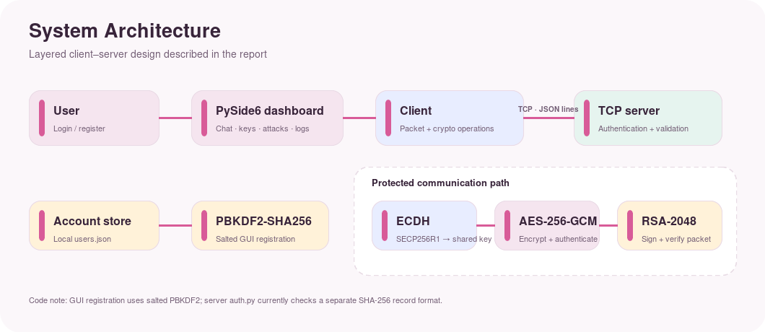

Architecture flow:
User → Login/Register → PySide6 Dashboard → Client → TCP Communication → Server
↓
ECDH → Session Key → AES-256-GCM → RSA Signature
↓
Replay / Tamper Verification
8. Cryptographic Techniques
8.1 AES-256-GCM
AES-256-GCM is used to encrypt communication messages. It provides authenticated encryption, allowing the receiver to detect unauthorized modification of protected data.
8.2 ECDH with SECP256R1
ECDH establishes a shared secret between communicating parties. Each party generates a key pair and exchanges public keys while keeping its private key local.
8.3 RSA-2048 Digital Signatures
RSA-2048 digital signatures provide an additional mechanism for verifying message authenticity and detecting changes to signed data.
8.4 PBKDF2 Password Hashing
Passwords are processed with PBKDF2 using SHA-256 and a randomly generated salt. The application stores the salt and derived hash rather than the plaintext password.
9. Authentication and Registration
The application includes separate login and registration interfaces. During registration, a username and password are entered. The password is converted into a salted PBKDF2-derived hash before storage. During login, the entered password is processed with the stored salt and compared with the stored derived value. Invalid usernames or passwords are rejected.
Registration flow:
Registration Form → Generate Salt → PBKDF2-SHA256 → Store Salt + Hash → Login Verification
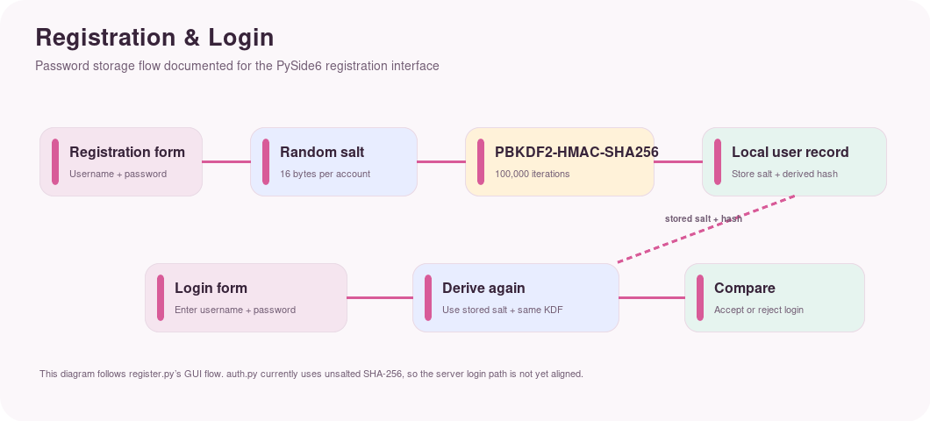
[ SCREENSHOT / DIAGRAM PLACEHOLDER ]
Login Screen
Insert final project screenshot/diagram here.

[ SCREENSHOT / DIAGRAM PLACEHOLDER ]
Registration Screen
Insert final project screenshot/diagram here.

10. Secure Communication Workflow
After authentication, the communication workflow establishes a shared session key using ECDH. Messages are encrypted using AES-256-GCM and can be protected with RSA signatures. Packets are checked before they are accepted.
Authentication → ECDH Key Exchange → Session Key → AES-256-GCM Encryption → RSA Signature → Protected Packet → Server Verification → Decryption
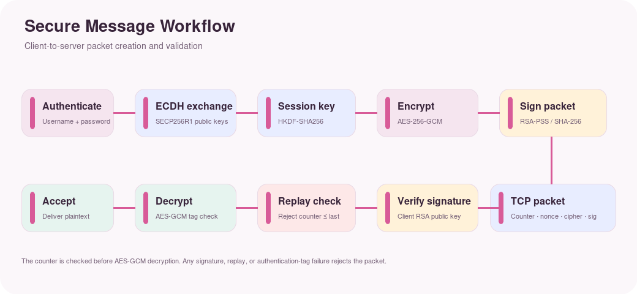
[ SCREENSHOT / DIAGRAM PLACEHOLDER ]
Secure Chat / Communication Page
Insert final project screenshot/diagram here.

11. Attack Simulation
11.1 Eavesdropping
The eavesdropping demonstration represents an attacker observing network traffic. The purpose is to show that intercepted ciphertext does not directly reveal the original plaintext without the appropriate key.
11.2 Tampering
The tampering demonstration modifies protected communication data. Authentication and integrity checks should detect that the received data differs from the original protected message.
11.3 Replay Attack
A replay attack attempts to resend a previously captured valid packet. Replay detection logic is used to prevent a packet that has already been processed from being accepted again.
Attack | Action | Expected Result
Eavesdropping | Observe encrypted traffic | Plaintext not directly exposed
Tampering | Modify protected packet | Integrity verification fails
Replay | Resend captured packet | Packet is rejected

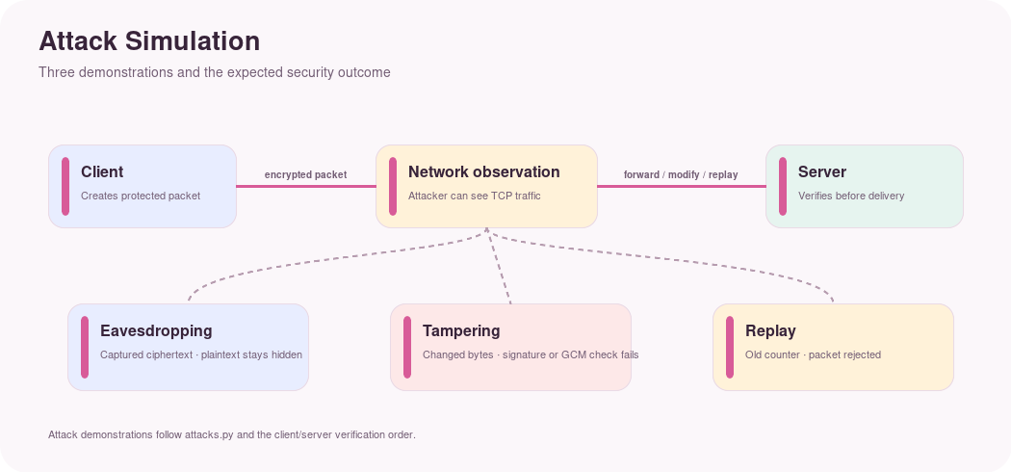

[ SCREENSHOT / DIAGRAM PLACEHOLDER ]
Attack Result
Insert final project screenshot/diagram here.

12. Graphical User Interface
The PySide6 dashboard uses a pink and marble-inspired visual theme. It provides navigation between the dashboard, secure chat, cryptographic keys, attack simulator, and activity logs.
Security Dashboard
Secure Chat
Cryptographic Keys
Attack Simulator
Activity Logs
[ SCREENSHOT / DIAGRAM PLACEHOLDER ]
Main Security Dashboard
Insert final project screenshot/diagram here.

[ SCREENSHOT / DIAGRAM PLACEHOLDER ]
Cryptographic Keys Page
Insert final project screenshot/diagram here.

[ SCREENSHOT / DIAGRAM PLACEHOLDER ]
Activity Logs Page
Insert final project screenshot/diagram here.

13. Implementation
File | Responsibility
login.py | Login interface and password verification
register.py | Registration and password hashing
dashboard.py | Main PySide6 dashboard and navigation
client.py | Client-side secure packet creation and communication
server.py | Server-side communication and security processing
crypto_utils.py | Cryptographic helper functions
attacks.py | Eavesdropping, tampering, replay demonstrations
pages.py | Dashboard sub-pages
users.json | Local user records; excluded from version control

The project is run in a Python virtual environment. The main external packages are cryptography and PySide6.
14. Testing and Results
Test Case | Action | Expected Result | Final Status
Valid registration | New username and matching password | Account created | Insert result
Duplicate registration | Existing username | Registration rejected | Insert result
Password mismatch | Different confirmation | Registration rejected | Insert result
Valid login | Correct credentials | Dashboard opens | Insert result
Invalid password | Wrong password | Login error shown | Insert result
ECDH exchange | Client-server connection | Session established | Insert result
Encryption | Send message | Ciphertext produced | Insert result
Tampering | Modify packet | Integrity failure | Insert result
Replay | Resend packet | Packet rejected | Insert result
Eavesdropping | Observe encrypted packet | Plaintext not directly exposed | Insert result

Use the final live demonstration and screenshots to fill the Final Status column before submission.
15. Security Analysis
The framework demonstrates defense in depth by assigning different security responsibilities to different mechanisms. ECDH addresses shared-key establishment, AES-GCM protects message confidentiality and integrity, RSA signatures support authenticity, and PBKDF2 protects stored passwords.
The attack simulator demonstrates that encryption alone is not sufficient: authentication, integrity validation, and replay protection are also important.
This is an educational prototype and should not be treated as a production security protocol without further protocol analysis, key-management design, secure deployment practices, and independent security review.
16. Advantages and Limitations
16.1 Advantages
Combines asymmetric and symmetric cryptography
Uses authenticated encryption
Uses ECDH for session-key establishment
Uses RSA signatures
Does not store plaintext passwords
Includes practical attack simulations
Provides a visual security dashboard
16.2 Limitations
Educational/local prototype
Limited production-grade identity and certificate management
Requires additional hardening for public-network deployment
No independent cryptographic audit
17. Future Scope
Add secure persistent key management and key rotation.
Add certificate-based identity verification.
Support multiple concurrent clients.
Add stronger server-side account management.
Extend the framework to mobile platforms.
Add richer security analytics and visualization.
Add automated security and penetration tests.
Perform formal protocol analysis and independent security review.
18. Conclusion
The Secure Mobile Communication Framework demonstrates how hybrid cryptographic techniques can be combined to build a layered secure communication workflow. ECDH provides shared-key establishment, AES-256-GCM protects message confidentiality and integrity, RSA signatures support authenticity, and PBKDF2 protects user passwords. The project also provides practical demonstrations of eavesdropping, tampering, and replay scenarios through a graphical interface.
The modular implementation provides a useful foundation for future extensions such as stronger identity management, key rotation, mobile deployment, and formal security evaluation.
19. References
NIST, Advanced Encryption Standard (AES), FIPS PUB 197.
NIST, Recommendation for Block Cipher Modes of Operation: Galois/Counter Mode (GCM) and GMAC, SP 800-38D.
NIST, Digital Signature Standard (DSS), FIPS PUB 186-5.
NIST, Recommendation for Password-Based Key Derivation: Part 1: Storage Applications, SP 800-132.
RFC 5869, HMAC-based Extract-and-Expand Key Derivation Function (HKDF).
Python Cryptography Documentation.
Qt for Python (PySide6) Documentation.
Appendix A: Project Execution
Create and activate the virtual environment:
python3 -m venv venv
source venv/bin/activate
pip install cryptography PySide6
python login.py
Start the server in a separate terminal when secure client-server communication is required:
python server.py

