<Belhard Academy>

<Google image translator>

TEST PLAN

Version <February 28, 2023>

TEST PLAN OUTLINE

**1. TEST PLAN IDENTIFIER 3**

**2. GLOSSARY 3**

**3. REFERENCES 4**

**4. INTRODUCTION 4**

**5. TEST ITEMS (FUNCTIONS) 4**

**6. SOFTWARE RISK ISSUES 5**

**7. FEATURES TO BE TESTED 6**

**8. FEATURES NOT TO BE TESTED 7**

**9. APPROACH 8**

**A. TEST APPROACH 8**

**B. TYPES OF TESTING 9**

**1) Functional testing 9**

**2) Integration testing 9**

**3) Compatibility testing 10**

**C. TESTING TOOLS 10**

**D. METRICS 10**

**E. BUGS SEVERITY 11**

**F. BUGS LIFE CYCLE 12**

**J. TESTING-START CRITERIA 12**

**10. ITEM PASS/FAIL CRITERIA 13**

**11. SUSPENSION CRITERIA AND RESUMPTION REQUIREMENTS 13**

**12. TEST DELIVERABLES 13**

**13. REMAINING TEST TASKS 14**

**14. ENVIRONMENTAL NEEDS 14**

**15. STAFFING AND 15**

**TRAINING NEEDS 15**

**16. RESPONSIBILITIES 15**

**17. SCHEDULE 15**

**18. PLANNING RISKS 16**

**AND CONTINGENCIES 16**

**19. APPROVALS 17**

# TEST PLAN IDENTIFIER

Test plan ID: **TP-GP_23.2.1**

Test plan is used for describing testing flow of new functionality for Google Image Translator <Adding an image from the Internet>.

Date of creation: 03/09/23

The current application version for implementing the functionality: <February 28, 2023>.

| Date | Version | Description | Author |
| --- | --- | --- | --- |
| 03/03/23 | TP.GP.23.2.1 | Creating test plan | Katsiaryna Lazerko |
| 09/03/23 | TP.GP.23.2.1 | Making changes | Katsiaryna Lazerko |
| 13/03/23 | TP.GP.23.2.1 | Making changes after review | Katsiaryna Lazerko |
|  |  |  |  |
|  |  |  |  |
|  |  |  |  |
|  |  |  |  |

Test plan was confirmed by ___________

# GLOSSARY

| ID | Identifier |
| --- | --- |
| UI | User Interface |
| Test Env | Test Environment |
| Integration Env | Integration Environment |
| QA | Quality Assurance |
| Dev | Developer |
| PM | Project Manager |
| RTM | Requirements Traceability Matrix |

# REFERENCES

Project documentation is stored in Jira and in Confluences:

* Main test plan <LINK/name>
* Requirements <LINK/name>
* Project plan <LINK/name>
* Development and Test process standards <LINK/name>
* High Level design document <LINK/name>
* Design Specifications <LINK/name>

# INTRODUCTION

This test plan is a plan for functional and integration testing of new functionality for Google Image Translator, such as <Adding an image from the Internet - searching for an image inside an additional application module>.

Bug reports will be stored in Jira.

Test documentation will be stored in GitHub.

Design Specifications are stored in Confluences.

Goals of the test plan:

* description of manual integration testing of a new feature;
* definition of test strategies;
* estimation of testing time;
* bug lifecycle definition;
* description of the regression testing scope.

A primary objective of testing is to assure that the system meets the full requirements,

including quality requirements (functional and non-functional requirements) and fits

metrics for each quality requirement and satisfies the use case scenarios and maintain the

quality of the product. At the end of the project development cycle, the user should find

that the project meets or exceeds all of their expectations as detailed in the

requirements.

# TEST ITEMS (FUNCTIONS)

1) **The main test element on the Google Translator page is:**

the new button “Search in web” in the image adding form for translation.

Module “Adding-image-web” v1.2.1 <link/spec>

2) **Additional elements for testing are all functionalities (that have been implemented before) related to the new feature:**

* Navigation buttons in the header.

Module “Key-Buttons-Translator” v3.29.2 <link/spec>

* Module with languages.

Module “Languages-Translator” v1.17.1 <link/spec>

* Image selection from your computer.

Module “Adding-image-local-machine” v5.1.1 <link/spec>

The main types of testing that will be performed:

* Functional testing;
* Integration testing;
* Usability testing;
* UI testing;
* Regression testing;
* Compatibility testing.

Types of testing that will not be performed as part of the test plan:

* Performance testing;
* Security testing;
* Acceptance Testing.

These types of testing are excluded due to their uselessness at this stage of development and will be applied in the next versions of the functionality.

# SOFTWARE RISK ISSUES

This section describes the software risks related to this feature that may affect the estimation of implementation.

| Risk | Risk Level | Solution | Responsible person |
| --- | --- | --- | --- |
| The documentation is incomplete, the functionality is not fully described, and the testing team does not have access to the full version of the requirements | moderate to high | The testing team needs to be provided with a complete scope of documentation: requirements, specifications, and prototypes. Otherwise, the team will be relied on incorrect expected results, during testing the functionality | QA  Katsiaryna Lazerka |
| Requirements changes on the customer side during implementation | moderate to high | Adjustment of requirements, estimation and test documentation in accordance with changes on the part of the customer | QA  Katsiaryna Lazerka |
| Inconsistency in release plan | moderate to high | It is necessary to change the estimation and inform the customer, if developer team delay delivery of builds to the testing team | Dev team |
| Extremely complex features | moderate to high | The development and testing team should spend more time on the functionality and fix the estimation | PM |
| Incorrect estimations | moderate to high | In the case of incorrectly set estimates, the testing team must review the timeline and immediately provide a new version of the test plan to the customer | QA  Katsiaryna Lazerka |
| New version of interfacing software | low to moderate | It is necessary to correct all test documentation in accordance with possible changes in functionality | QA  Katsiaryna Lazerka |
| Staff layoff/reassignment | low to moderate | Responsibilities must be reassigned to another employee | QA lead  Katsiaryna Lazerka |
| Government regulations and rules | low to moderate | The problem will be solved at the project manager-customer level | PM |

# FEATURES TO BE TESTED

| What should be tested | Specifications | Risk level |
| --- | --- | --- |
| Adding an image from an external site through the "Search in web" button | <link_to_spec> | High |
| Language detection | <link_to_spec> | High |
| Translating text in a picture into different languages | <link_to_spec> | High |
| Language switching after loading an image | <link_to_spec> | High |
| Correct displaying of search results | <link_to_spec> | High |
| Correctness of translation of images with text | <link_to_spec> | High |
| Introducing a new button on the Google translator page in the page header | <link_to_spec> | Middle |
| Introducing a new button in the "Choose image" form on the Google translator page | <link_to_spec> | Middle |
| Reverse translation | <link_to_spec> | Middle |
| Saving/downloading data to personal computer | <link_to_spec> | Middle |
| Correctness of translation of images without text | <link_to_spec> | Middle |
| Adding an image from personal computer | <link_to_spec> | Middle |
| Selecting a specific language | <link_to_spec> | Low |
| Language menu appearance | <link_to_spec> | Low |
| Language switching before loading an image | <link_to_spec> | Low |
| Language search in the language menu | <link_to_spec> | Low |

# FEATURES NOT TO BE TESTED

| What should not be tested | Why should not be tested | Risk level |
| --- | --- | --- |
| Relevance of search results based on user request | Will be allowed to testing in the following iterations.  <link_to_spec> | High |
| “Translations History” feature | Not a new feature, it is stable in other parts of the application.  <link_to_spec> | Low |
| “Save translations” feature | Not a new feature, it is stable in other parts of the application.  <link_to_spec> | Low |
| “Propose translation” feature | Not a new feature, it is stable in other parts of the application.  <link_to_spec> | Low |
| Send feedback | Not a new feature, it is stable in other parts of the application.  <link_to_spec> | Low |
| Database logic | Will be tested in the next iterations.  <link_to_spec> | High |
| Website Security and Performance | Not a new feature, it is stable in other parts of the application.  <link_to_spec> | Low |

# APPROACH

##### **A. TEST APPROACH**

Test approach is described in this section. The section contains actions to be done for successful testing of the application.

1. First stage - the test team does the project documentation reviewing and logs issues to Jira (if it is needed). Then test cases are written according to the (changed or not) version of the documentation. Also a part of functional testing must be performed for better understanding of the system.
2. Second stage - test suites are formed from the existing test cases before testing for the given build:

* Smoke Test Suite;
* Functional tests of new functionality;
* Critical Path Test Suite;
* Extended Tests;
* Regression Tests Suite.

All the found bugs are reported to the Bug Tracking System with the appropriate priority.

3) Third stage - the next build is issued with the fixed found bugs and new functionality. The following order of tests is executed:

* Smoke Suite;
* Retesting of bugs fixes (to check that all the bugs were fixed);
* Critical Path Test Suite;
* Regression Tests Suite;
* Integration Testing.

4) Fourth stage - cross-browser testing with a description of the defects found and retesting bug fixes.

5) Fifth stage - global regression testing to check the bugs fixed by the developers team and that the functionality that was working before is not broken.

**Test levels**

Smoke Test is a type of test when a test engineer makes sure that all the main functionality of the product works properly.

Critical Path Test is a type of test during which a test engineer goes through all the main functional units of the application using correct and incorrect data and actions.

Extended Tests – rarely utilized paths of the application use are tested. Must be executed at least once during the cycle of testing.

##### **B. TYPES OF TESTING**

Testing will be done manually, by black box functional, integration and regression testing from the end-user perspective of the application. Part of the time ( approx. 20%) will be used for testing of non-typical/potentially error-causing usage scenarios.

###### Functional testing

| Summary | Functional testing is carried out in order to find out unexpected behavior of the report. Will be performed based on requirements that can be traced by use cases, business rules and specifications, requirements. Functional testing will also include usability and UI testing. |
| --- | --- |
| Participants | Test team |
| Methodology | * Functional testing will begin when the testing team receives a ready-for-testing build (Test Env) with the implemented functionality. * Testing will be done with the use of test documentation. * All user scenarios will be tested. * All bugs will be reported to the bug tracking system (if they will be). * The main characteristics of quality functional testing will be the correctness of the module, reliability and relevance according to the expected results. * Retest will be performed after bug fixing. * The (acceptable) actual testing result will be considered as the reason for stopping the testing and moving to the next type/level of testing. |

###### Integration testing

| Summary | Guarantees that all application modules are well integrated and work as expected together. Will be performed based on requirements that can be traced by use cases, business rules and specifications. |
| --- | --- |
| Participants | Test team |
| Methodology | * Integration testing will begin after passing module functional testing. * Integration testing will begin when the testing team receives a ready-for-testing build (Integration Env) with the implemented functionality. * Integration testing will be done using the Bottom Up Integration method. * The scope of integration testing will be stored HERE <link/github> . * All bugs will be reported to the bug tracking system (if they will be). * Retest will be performed after bug fixing. * Regression testing will be performed after implementation to ensure that a change to the system does not introduce new defects. The scope of regression testing will be based on the severity of detected defects in functional testing. * An (acceptable) actual testing result will be considered as the reason for stopping the testing and moving to the next type/level of testing. |

###### Compatibility testing

| Summary | Testing is focused on checking the support and correct display of the functionality in different browsers and operating systems on screens with different resolutions. Will be performed based on requirements that can be traced by business rules and specifications. |
| --- | --- |
| Participants | Test team |
| Methodology | * Compatibility testing will begin after passing all types of testing (except regression) . * Compatibility testing will be done using BrowserStack. * The scope of browsers and operating systems for testing was described HERE <link/name> * All bugs will be reported to the bug tracking system (if they will be). * Retest will be performed after bug fixing. * The (acceptable) actual testing result will be considered as the reason for stopping the testing and moving to the next type/level of testing. |

##### **C. TESTING TOOLS**

The following tools will be used:

| Tool | Purpose | Version |
| --- | --- | --- |
| JIRA | Bug tracking system | *version n* |
| Confluences | Specifications and requirements | *version n* |
| GitHub | Test documentation and test builds | *version n* |
| Google docs/ Microsoft Word, Excel | Test documentation | *version n* |
| Screenshots / Video capture | Image Capture | *version n* |
| BrowserStack | Environment emulator | *version n* |

##### **D. METRICS**

The following metrics will be collected and reported to the test lead at the end of each build and on passing the next type of testing:

* Passed/Failed Test Cases;
* Test Cases Not Run;
* Open/Closed Bugs;
* Reopened/Closed Bugs;
* Bugs by Severity/Priority;
* Ratio of passed tests to bugs;
* Coverage by Test Cases;
* Test Execution Metrics;
* Information about the Status of Tasks, Testers, Load and Effort;
* Estimation time.

Test reports will be available to the customer at the end of each sprint.

Final test report will be available to the customer by the date of the final release.

##### **E. BUGS SEVERITY**

| Severity | Impact |
| --- | --- |
| 1 (Critical) | This bug is critical enough to crash the system, cause file corruption, or cause potential data loss. It causes an abnormal return to the operating system (crash or a system failure message appears). It causes the application to hang and requires rebooting the system. |
| 2 (High) | It causes a lack of vital program functionality with workaround. |
| 3 (Medium) | This Bug will degrade the quality of the System. However there is an intelligent workaround for achieving the desired functionality. This bug prevents other areas of the product from being tested. However other areas can be independently tested. |
| 4 (Low) | There is an insufficient or unclear error message, which has minimum impact on a product use. |
| 5(Cosmetic) | There is an insufficient or unclear error message that has no impact on product use. |

##### **F. BUGS LIFE CYCLE**

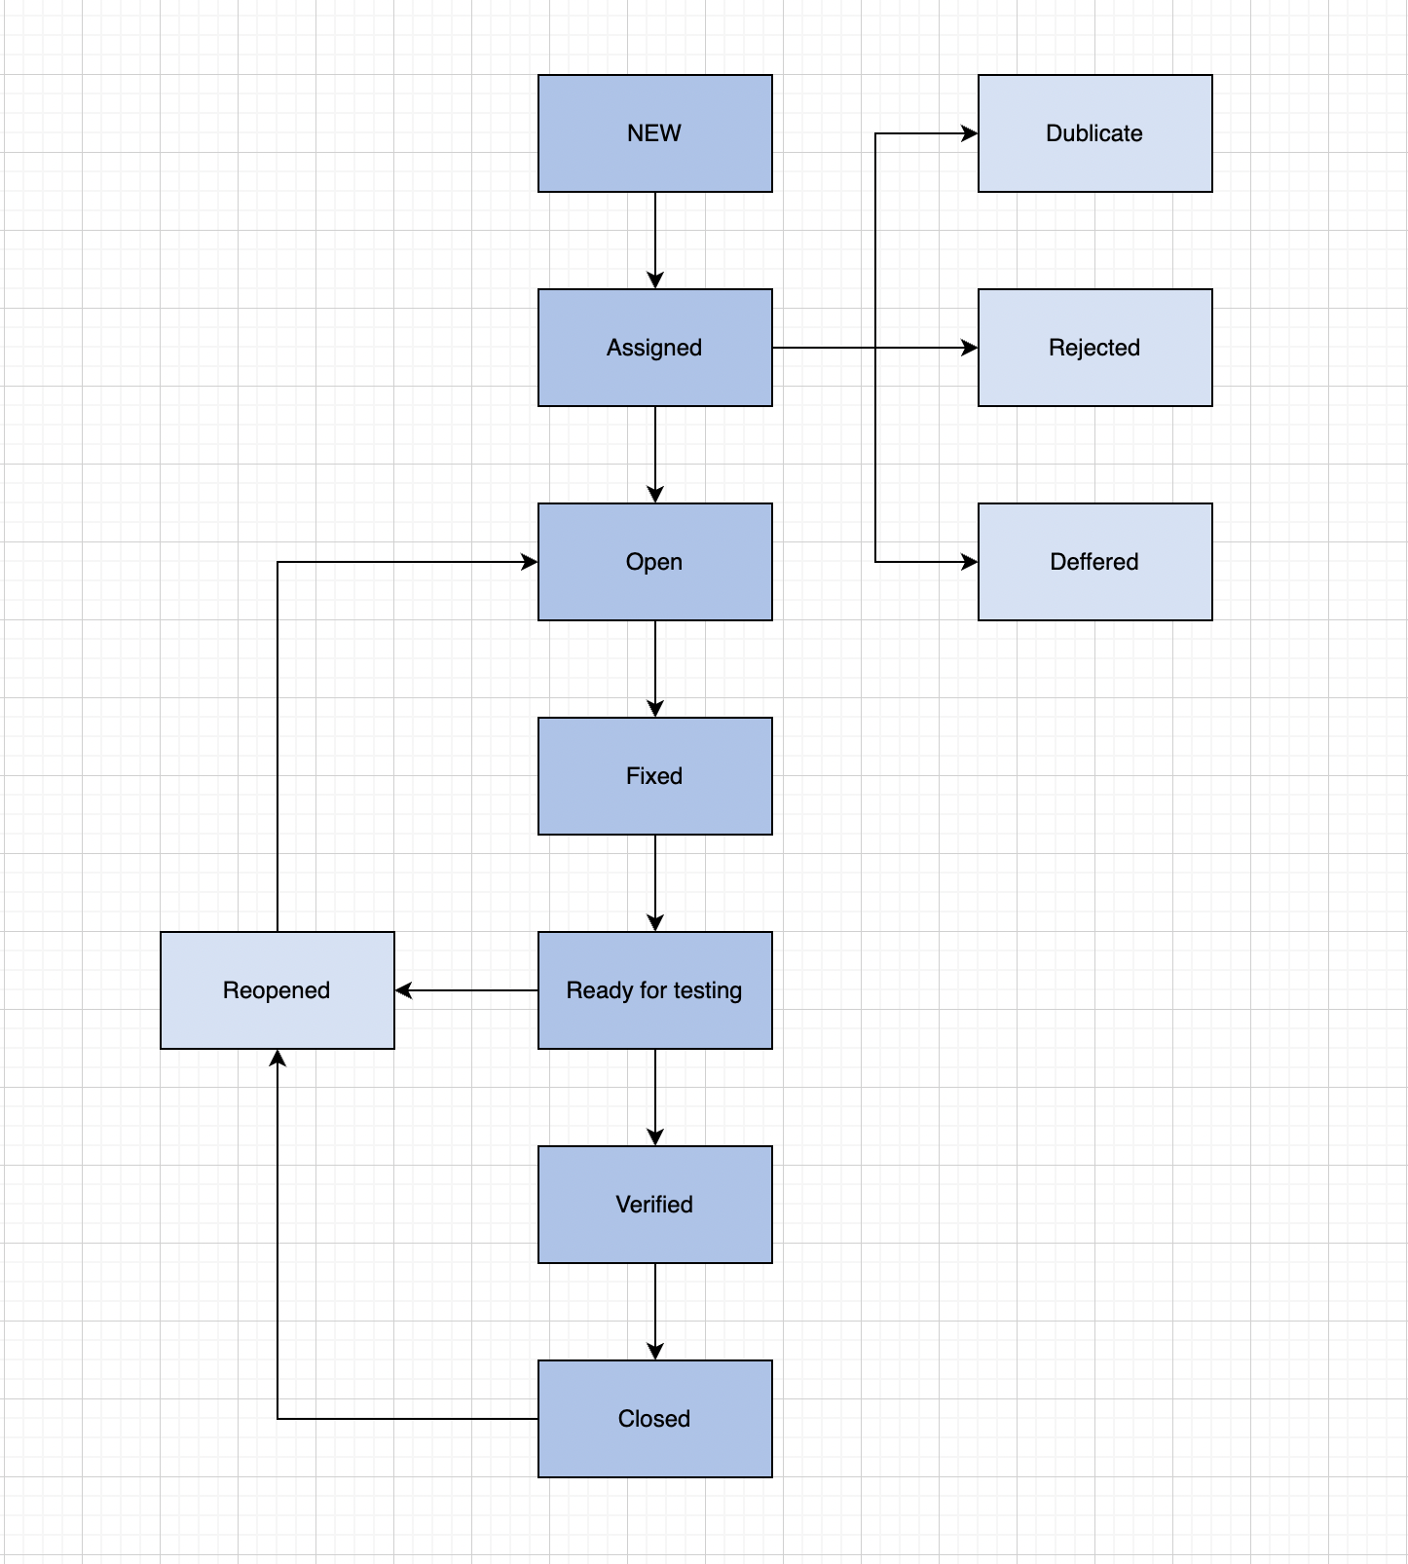

##### **J. TESTING-START CRITERIA**

* All test hardware platforms have been successfully installed, configured, and functioning properly.
* All the necessary documentation, design, and requirements information are available that will allow the QA team to operate the system and judge the correct behavior.
* All the standard software tools including the testing tools must have been successfully installed and functioning properly.
* Proper test data is available.
* The test environment such as hardware, software, and system administration support should be ready.
* The QA team has completely understood the requirements.
* The QA team has an understanding of the functionality.
* Reviewed test scenarios, test cases and other test documentation.
* The QA team has a ready-to-test build.

# ITEM PASS/FAIL CRITERIA

The testing process can be completed after the successful completing all these points:

* All the identified (blocker, critical, major) defects are fixed and verified.
* All the test cases are executed and passed.
* All the test results are documented.
* Implemented functionality is ready to be released.
* A certain level of requirements coverage has been achieved.
* All high-risk areas have been fully tested, with only minor residual risks left outstanding.
* The implemented element works in accordance with the requirements and expected results.

# SUSPENSION CRITERIA AND RESUMPTION REQUIREMENTS

The testing process can be stopped in case of these points:

* The build contains many serious defects which negatively affect testing progress.
* Significant changes in requirements suggested by the customer.
* Software/Hardware problems.
* Assigned resources are not available when needed by the test team.
* After failing smoke testing on each module.

Resumption will only occur when the problem(s) that caused the suspension have been resolved.

# TEST DELIVERABLES

Test deliverables can be found in this table:

| Test deliverable | Link |
| --- | --- |
| Main checklist for new functionality | <LINK/name> |
| Checklist for all functionality | <LINK/name> |
| Test cases | <LINK/name> |
| Test reports | <LINK/name> |
| Use-Case reports | <LINK/name> |
| RTM | <LINK/name> |
| Functional Specification | <LINK/name> |
| Requirements | <LINK/name> |
| Detail design document | <LINK/name> |
| Bug reports | <LINK/name> |

# REMAINING TEST TASKS

| Task title | Description | Build version | Responsible |
| --- | --- | --- | --- |
|  |  |  |  |
|  |  |  |  |

# ENVIRONMENTAL NEEDS

| Support level 1 | |
| --- | --- |
| Browsers | Chrome, Safari, Opera, Edge, Mozilla Firefox |
| Operating systems | Windows 10 (latest), Windows 11 (latest), macOS Ventura |
| Screen resolution | 1366х768; 1280х800; 1280х1024; 1680х1050; 1929х1080; 2048x1080; 4096×2160 |
| Support level 2 | |
| Browsers | Chrome, Safari, Opera, Edge, Mozilla Firefox |
| Operating systems | Windows 7 (latest), Windows 8 (latest), macOS Monterey, macOS Catalina, Linux Ubuntu |
| Screen resolution | 1366х768; 1280х800; 1280х1024; 1680х1050; 1929х1080; 2048x1080; 4096×2160 |

| QA Stand | <Link/URL> |
| --- | --- |
| Dev Stand | <Link/URL> |

# STAFFING AND

# TRAINING NEEDS

It may be necessary to align time for the testing team to become familiar with the functionality, tools or test environments used during testing, if these tools are not known by them.

# RESPONSIBILITIES

| Role | Members | Responsibilities |
| --- | --- | --- |
| Project Manager | Vladislav Leshko | 1. Acts as a primary contact for development and QA team. 2. Responsible for Project schedule and the overall success of the project. 3. Responsible for communication with the customer. |
| QA Lead | Katsiaryna Lazerka | 1. Reviewing testing documentation 2. Planning and organization of the test process for the release. 3. Coordinate with QA analysts/engineers on any issues/problems encountered during testing. 4. Reporting progress on work assignments to the PM |
| QA | Katsiaryna Lazerka | 1. Researching requirements 2. Writing and executing test cases, checklists, use cases 3. Preparing RTM 4. Functional, integration, cross-browser testing 5. Defect reporting and tracking 6. Retesting and regression testing 7. Bug Review meetings |

# SCHEDULE

PROJECT ESTIMATES

| Tasks | Estimate effort, h | Members | Due Date |
| --- | --- | --- | --- |
| Requirements analysis | 16 | Katsiaryna L, QA | 01/03/23 |
| Functionality analysis | 8 | Katsiaryna L, QA | 05/03/23 |
| Test plan creation | 36 | Katsiaryna L, QA | 17/03/23 |
| Test documentation creation | 40 | Katsiaryna L, QA | 27/03/23 |
| Performing functional testing | 40 | Katsiaryna L, QA | 03/04/23 |
| Bug fixing, execution | 40 | Dev team, QA team | open date |
| Performing integration testing | 40 | Katsiaryna L, QA | 14/04/23 |
| Performing Compatibility testing | 16 | Katsiaryna L, QA | 28/04/23 |
| Regression testing | 20 | Katsiaryna L, QA | open date |
| Test report creation | 8 | Katsiaryna L, QA | open date |

# PLANNING RISKS

# AND CONTINGENCIES

This section describes the project risks related to this feature that may affect the estimation of implementation.

| Risk | Risk Level | Solution | Responsible person |
| --- | --- | --- | --- |
| Smoke test was failed | moderate to high | The test team should report the problem to the QA lead. Testing must be stopped until QA lead restarts it | QA  Katsiaryna Lazerka |
| Blocker, critical or major in the pre-prod | moderate to high | The test team should report the problem to the QA lead, PM and Dev team | QA  Katsiaryna Lazerka |
| Blocker, critical or major on the 1 or 2 days before the release | moderate to high | The test team should report the problem to the QA lead, PM and Dev team | QA  Katsiaryna Lazerka |
| Feature implementation period is out of estimation | low to moderate | The problem will be solved at the project manager-customer level | PM |
| The budget has been spent | low to moderate | The problem will be solved at the project manager-customer level | PM |
| The customer stopped the testing | low to moderate | The problem will be solved at the project manager-customer level | PM |

# APPROVALS

| Signature: | Name: | Role: | Date: |
| --- | --- | --- | --- |
|  |  |  |  |
|  |  |  |  |
|  |  |  |  |
|  |  |  |  |