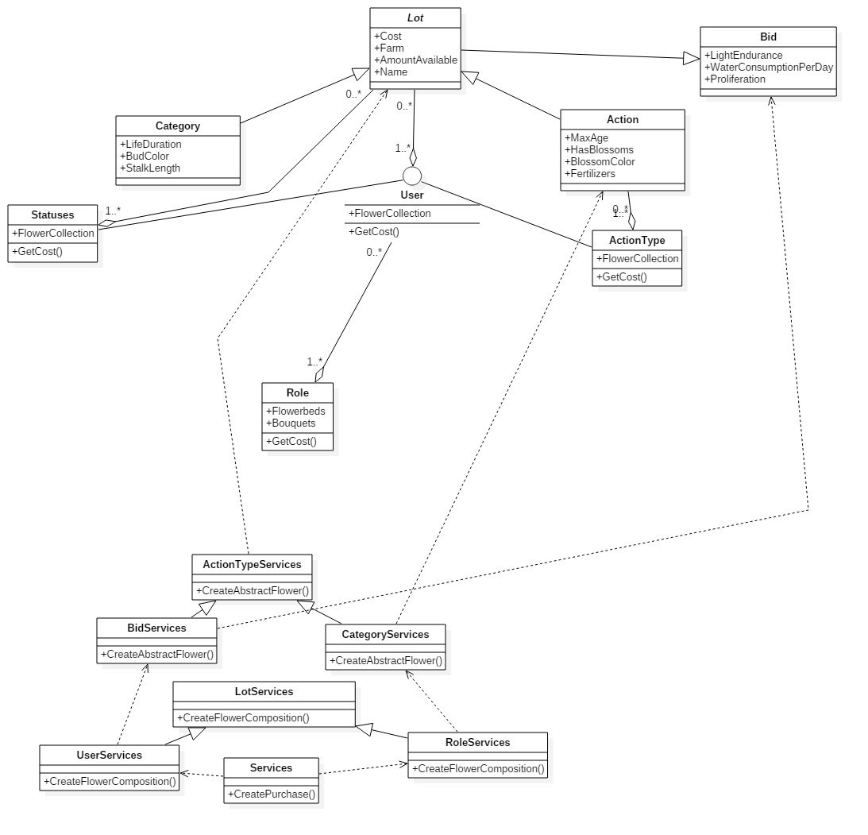

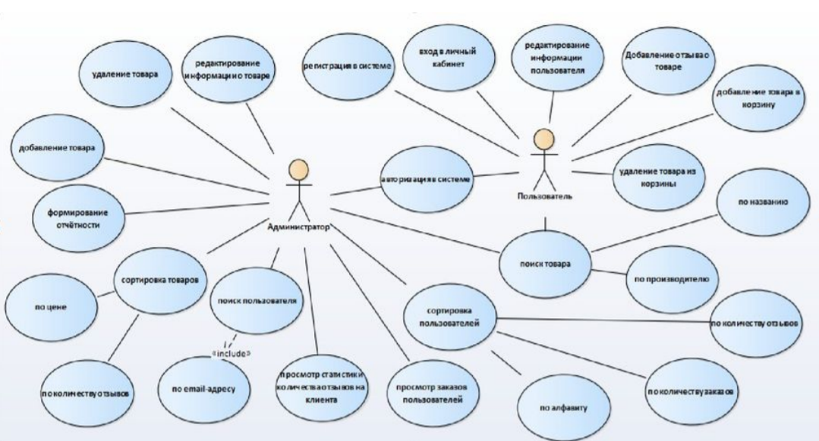

***Database:***

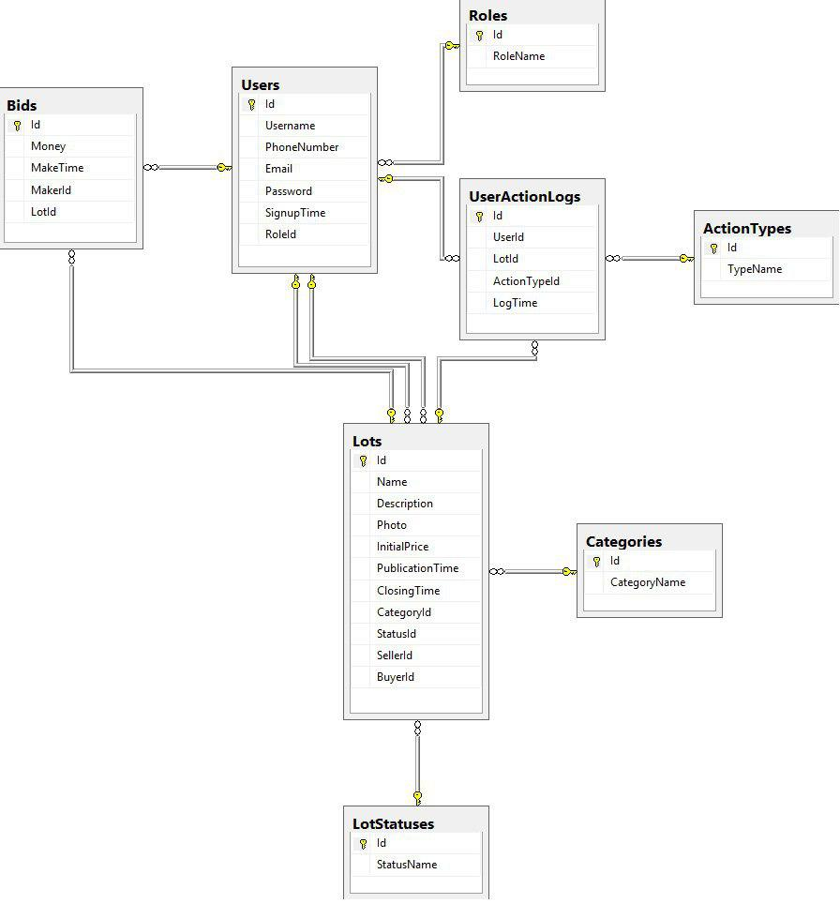

procedure remove_signature(current_user_id in integer, signature_id in integer)

is

creator_id integer;

begin

select c.creator_id into creator_id from contracts c, signatures s where s.contract_id = c.id and s.id = signature_id;

if not is_user_admin(current_user_id) and creator_id <> current_user_id then

raise_application_error(-20005, 'Not admin');

end if;

delete from signatures where id=signature_id;

end remove_signature;

procedure remove_contract(current_user_id in integer, contract_id in integer)

is

begin

if not is_user_admin(current_user_id) then

raise_application_error(-20005, 'Not admin');

end if;

delete from contracts where id=contract_id;

end remove_contract;

procedure remove_status(current_user_id in integer, status_id in integer)

is

begin

if not is_user_admin(current_user_id) then

raise_application_error(-20005, 'Not admin');

end if;

delete from statuses where id=status_id;

end remove_status;

procedure remove_currency(current_user_id in integer, currency_id in integer)

is

begin

if not is_user_admin(current_user_id) then

raise_application_error(-20005, 'Not admin');

end if;

delete from currencies where id=currency_id;

end remove_currency;

function is_user_admin(id in integer) return boolean

is

admin_count integer;

begin

select count(*) into admin_count from users u where u.id=id and is_admin='Y';

if admin_count = 0 then

return false;

end if;

return true;

end is_user_admin;

create table statuses

(

id integer generated always as identity primary key,

name nvarchar2(20) not null,

constraint unique_status_name unique(name)

);

create table parties (

id integer primary key,

full_name nvarchar2(150) not null,

phone nvarchar2(20) not null,

address nvarchar2(100) not null,

company_phone_fax nvarchar2(20) null,

company_name nvarchar2(250) null,

company_address nvarchar2(100) null,

UPN integer null

);

create table users (

id integer primary key,

username nvarchar2(50) not null,

party_id integer null,

is_admin char(1) default('N'),

email nvarchar2(50) not null,

phone_number nvarchar2(20) not null,

password_hash nvarchar2(50) not null,

constraint fk_user_party foreign key (party_id) references parties(id) on delete set null,

constraint unique_name unique(username)

);

create table currencies (

id integer generated always as identity primary key,

short_name nvarchar2(5) not null,

full_name nvarchar2(20) not null,

to_USD_factor decimal(38, 25)

);

create table contracts (

id integer generated always as identity primary key,

creator_id integer not null,

text blob not null,

stake integer not null,

currency_id integer not null,

status_id integer not null,

start_time timestamp not null,

expiry_time date not null,

constraint fk_contract_currency foreign key (currency_id) references currencies(id),

constraint fk_contract_status foreign key (status_id) references statuses(id),

constraint fk_contract_user foreign key (creator_id) references users(id)

);

create table signatures (

id integer generated always as identity primary key,

party_id integer not null,

contract_id integer not null,

signed char(1) default('N'),

constraint fk_signature_party foreign key (party_id) references parties(id),

constraint fk_signature_contract foreign key (contract_id) references contracts(id) on delete cascade,

constraint unique_signature unique(party_id, contract_id)

);

create table action_types (

id integer generated always as identity primary key,

type_name nvarchar2(30) not null,

constraint unique_type_name unique(type_name)

);

create table logs (

id integer generated always as identity primary key,

who_id integer null,

when date not null,

action_type_id integer not null,

contract_id integer null,

user_id integer null,

constraint fk_log_actor foreign key (who_id) references users(id) on delete cascade,

constraint fk_log_action_type foreign key (action_type_id) references action_types(id),

constraint fk_log_user foreign key (user_id) references users(id) on delete cascade,

constraint fk_log_contract foreign key (contract_id) references contracts(id) on delete cascade

);

create sequence user_pk start with 1;

create sequence party_pk start with 1;