**ANSWER**

1. What is Boolean?

- A Boolean value is either true or false.

- In Python, the two Boolean values are True and False (the capitalization must be exactly as shown), and the Python type is **bool**.

Write down 3 different expression that results a Boolean type.

+ 10 == (2 * 5)

+ 6 <= 5

+ ‘sci’ + ‘ence’ == ‘science’

2. What is a flow chart?

- A flowchart is a chart of steps, and conditions are arranged in a certain order to solve a problem.

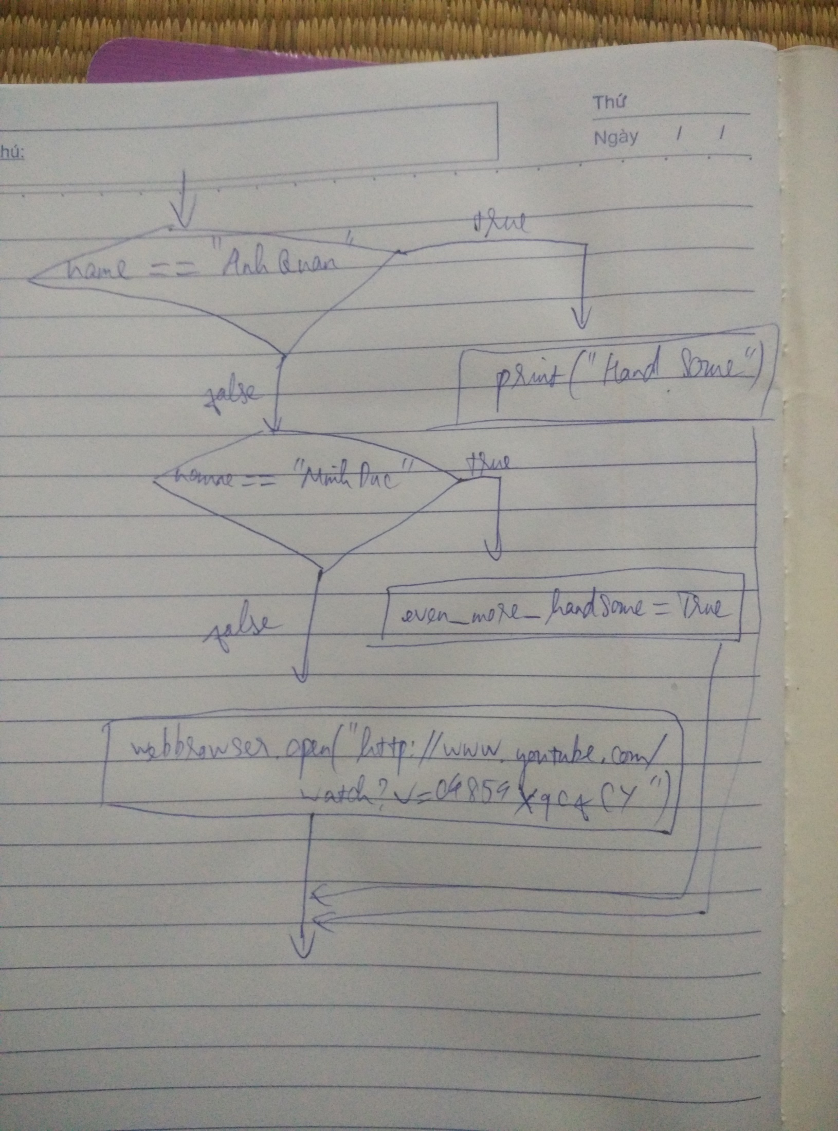

3. What is nested conditionals?

- One conditional can also be nested within another.

E.g: if x < 5:

print(‘x thoa man dieu kien’)

else:

if x < 10:

print(‘x khong thoa man dieu kien’)

else:

print(‘x khong xac dinh’)