MILITARY TECHNICAL ACADEMY

FACULTY OF INFORMATION TECHNOLOGY

**HOTEL MANAGEMENT**

**SOFTWARE DESIGN DOCUMENT**

**Ha Noi, 12/2018**

**CATALOG**

1. Introduce 4

1.1. Purpose of document 4

1.2. Scope 4

1.3. Definitions. 4

1.4. References 4

1.5. Document description 4

2. Overview of software 6

3. Architectural design 7

3.1. Architectural models 7

3.2. Architectural description 7

4. Database Design 8

4.1 Relational Database Design 8

4.2 Database Design 8

4.3 Database diagrams 12

5. Component design 13

5.1 Manager 13

5.2 Salesman 15

5.3 Import staff 16

6. User interface design 18

6.1 FormLogin 18

6.2 FormForgetAccount 19

6.3 FormRegister 20

6.4 FormMain 21

6.5 FormBook 23

6.6 FormStationary 26

6.7 FormStaff 28

6.8 FormCustomer 30

6.9 FormSale 32

6.10 FormImport 35

6.11 FormAccount 38

# 1. Introduce

### 1.1. Purpose of document

## This is a detailed description of bookstore management software design, which is the basis for programming functions as well as scripting testing and program testing.

### 1.2. Scope

Documentation is the result of the software design process, which is the communication basis of the developer, which is the basis for testing, commissioning, maintenance, and provision of book management functions.

### 1.3. Definitions.

| **Configuration** | **Definition** | **Explaining** |
| --- | --- | --- |
| BSM | Bookstore Management | Name of project |
| GB | Group book |  |
| DB | Database | Where to store information and allow access. |
| PK | Primary Key | Main key |
| UK | Unique Key | Unique key |

### 

### 1.4. References

|  |  |  |
| --- | --- | --- |
| **Number** | **Name of document** | **File Name** |
| 1 | Requirements specification document | Requirements specification document.doc |

### 

### 1.5. Document description

The structure of the document consists of 5 parts:

* **Part 1** **- Introduce**: General introduction of the document, help the reader visualize the content, purpose and general layout of the document.
* **Part 2 - Software Overview:** Pose the most basic requirements that software must have.
* **Part 3** **- Architectural Design**.:Building architectural models and describing system architecture.
* **Part 4** **– Data Structure Design**: Describe data dictionary and build data dictionary.
* **Part 5** **– Design components (module):** Design subsystems of the system.
* **Part 6 – User Interface Design:** An overview of the interfaces, interface images, and accompanying operations.

# 2. Overview of software

Book management software must response the following general requirements:

* Administering users by access.
* Process catalog update, update data, update user information.

# 3. Architectural design

### 3.1. Architectural models

The system is divided into 3 modules as follows:

* General Management module: Perform functions related to updating goods, staff, customers, import operations, sales.
* Sales Modules: Create and print bill.
* Import module: Create and print receipt note.

Physical architecture: The Client-Server architecture consists of two distinct components: the server plays the role of providing functionality and storing data, and the client as a consumer uses those functions.

### 3.2. Architectural description

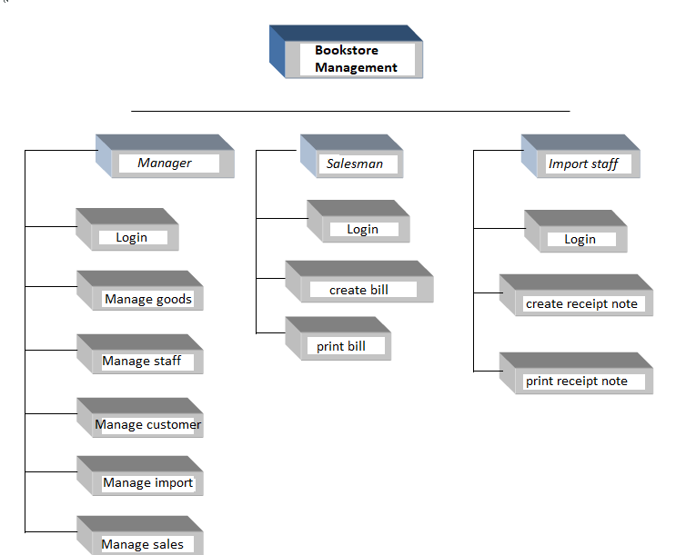

# 4. Database Design

### 4.1 Relational Database Design

* **Entities**

Based on the specific activities of the bookstore management system and based on the above functional decomposition model, we identify the entities:

* Book
* Stationary
* Staff
* Customer
* Bill
* Detail of Bill (Book and Stationary)
* Receipt note
* Detail of Receipt note (Book and Stationary)
* Manufacturer
* **Relationship between entities**
* Staff create bill
* Bill contains information of goods(Book and Stationary) sold
* Staff create receipt note
* Receipt note contains information of goods(Book and Stationary) imported.
* Customer buy book
* Customer buy Stationary.
* Import goods from Manufacturer

### 4.2 Database Design

* **Specification tables**

**+ BOOK**

|  |  |  |  |  |
| --- | --- | --- | --- | --- |
| **Number** | **Attribute** | **Data type** | **Constraint** | **Note** |
| 1 | IDB | nchar(10) | Primary key | ID of book |
| 2 | NAMEB | nvarchar(50) |  | Name of book |
| 3 | PUBLISHING_HOUSE | nvarchar(50) |  |  |
| 4 | QUANTITY | Int |  |  |
| 5 | PRICE | Int |  |  |
| 6 | SALEOFF | Float |  |  |
| 7 | AUTHOR | nvarchar(50) |  |  |
| 8 | KIND | nvarchar(50) |  |  |

**+ STATIONARY**

|  |  |  |  |  |
| --- | --- | --- | --- | --- |
| **Number** | **Attribute** | **Data type** | **Constraint** | **Note** |
| 1 | IDSTA | nchar(10) | Primary key | ID of stationary |
| 2 | NAMESTA | nvarchar(50) |  | Name of stationary |
| 3 | SALEOFF | float |  |  |
| 4 | PRICE | Int |  |  |
| 5 | QUANTITY | Int |  |  |
| 6 | UNIT | Nchar(10) |  |  |

**+ STAFF**

|  |  |  |  |  |
| --- | --- | --- | --- | --- |
| **Number** | **Attribute** | **Data type** | **Constraint** | **Note** |
| 1 | IDS | nchar(10) | Primary key | ID of satff |
| 2 | NAME | nvarchar(50) |  | Name of staff |
| 3 | DATEOFBIRTH | date |  |  |
| 4 | GENDER | Nchar(3) |  |  |
| 5 | ADDRESS | Nvarchar(50) |  |  |
| 6 | PHONE_NUMBER | int |  |  |
| 7 | DATE | date |  | Date start working |
| 8 | FUNTION | nvarchar(50) |  |  |

**+ CUSTOMER**

|  |  |  |  |  |
| --- | --- | --- | --- | --- |
| **Number** | **Attribute** | **Data type** | **Constraint** | **Note** |
| 1 | ID | nchar(10) | Primary key | ID of staff |
| 2 | NAME | nvarchar(50) |  | Name of staff |
| 3 | DATEOFBIRTH | nvarchar(50) |  |  |
| 4 | GENDER | Nvarchar(3) |  |  |
| 5 | PHONENUMBER | Int |  |  |
| 6 | ADDRESS | nvarchar(50) |  |  |

**+ BILL**

|  |  |  |  |  |
| --- | --- | --- | --- | --- |
| **Number** | **Attribute** | **Data type** | **Constraint** | **Note** |
| 1 | IDB | nchar(10) | Primary key | ID of bill |
| 2 | IDS | nchar(10) |  | ID of staff |
| 3 | IDC | nchar(10) |  | ID of customer |
| 4 | DATE | date |  |  |

**+ DETAILBSTA**

|  |  |  |  |  |
| --- | --- | --- | --- | --- |
| **Number** | **Attribute** | **Data type** | **Constraint** | **Note** |
| 1 | IDDBSTA | nchar(10) | Primary key | ID of stationary sold |
| 2 | IDSTA | nchar(10) |  | ID of stationary sold |
| 3 | QUANTITY | nchar(10) |  |  |

**+ DETAILBB**

|  |  |  |  |  |
| --- | --- | --- | --- | --- |
| **Number** | **Attribute** | **Data type** | **Constraint** | **Note** |
| 1 | IDDBB | nchar(10) | Primary key | ID of book sold |
| 2 | IDB | nchar(10) |  | ID of book sold |
| 3 | QUANTITY | nchar(10) |  |  |

**+ MANUFACTURE**

|  |  |  |  |  |
| --- | --- | --- | --- | --- |
| **Number** | **Attribute** | **Data type** | **Constraint** | **Note** |
| 1 | IDMANU | nchar(10) | Primary key | ID of manufacturer |
| 2 | NAME | nvarchar(50) |  |  |
| 3 | PHONE_NUMBER | int |  |  |
| 4 | ADDRESS | Nvarchar(50) |  |  |

**+ RECEIP_NOTE**

|  |  |  |  |  |
| --- | --- | --- | --- | --- |
| **Number** | **Attribute** | **Data type** | **Constraint** | **Note** |
| 1 | IDRCN | nchar(10) | Primary key | ID of receipt note |
| 2 | IDS | nchar(10) |  | ID of staff |
| 3 | IDMANU | nchar(10) |  | ID of manufacture |
| 4 | DATE | date |  |  |

**+DETAILRCNSTA**

|  |  |  |  |  |
| --- | --- | --- | --- | --- |
| **Number** | **Attribute** | **Data type** | **Constraint** | **Note** |
| 1 | IDRCN | nchar(10) | Primary key | ID of stationary imported |
| 2 | IDS | nchar(10) |  | ID of stationary imported |
| 3 | QUANTITY | nchar(10) |  |  |
| 4 | INPUT_PRICE | int |  |  |

**+ DETAILRCNB**

|  |  |  |  |  |
| --- | --- | --- | --- | --- |
| **Number** | **Attribute** | **Data type** | **Constraint** | **Note** |
| 1 | IDDBB | nchar(10) | Primary key | ID of book imported |
| 2 | IDB | nchar(10) |  | ID of book imported |
| 3 | QUANTITY | nchar(10) |  |  |
| 4 | INPUT_PRICE | int |  |  |

**+ ACCOUNT**

|  |  |  |  |  |
| --- | --- | --- | --- | --- |
| **Number** | **Attribute** | **Data type** | **Constraint** | **Note** |
| 1 | USERNAME | nchar(10) | Primary key | ID of book imported |
| 2 | PASSWORD | nchar(20) |  | ID of book imported |
| 3 | EMAIL | nchar(20) |  |  |
| 4 | ROLE | nvarchar(50) |  |  |

### 4.3 Database diagrams

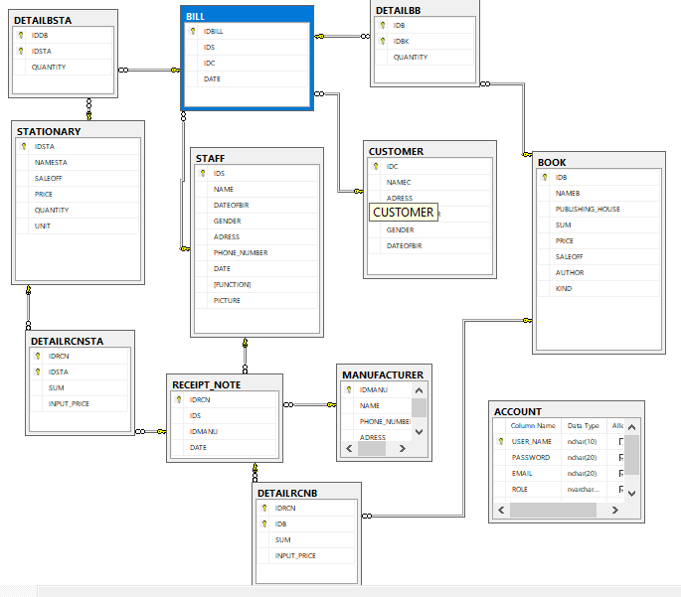

# 5. Component design

### 5.1 Manager

#### 5.1.1 Manage book

- Function information: Allow manager update (insert, edit, delete) book information

- Input: Book information

- Output: Book information was updated

- Describe the steps:

+ Step 1: Show form display book information

+ Step 2: Manager enter information

+ Step 3: Confirm information and display result

#### 5.1.2 Manage stationary

- Function information: Allow manager update (insert, edit, delete) stationary information

- Input: Stationary information

- Output: Stationary information was updated

- Describe the steps:

+ Step 1: Show form display stationary information

+ Step 2: Manager enter information

+ Step 3: Confirm information and display result

#### 5.1.3 Manage staff

- Function information: Allow manager update ( insert, edit, delete) staff information

- Input: Staff information

- Output: Staff information was updated

- Describe the steps:

+ Step 1: Show form display staff information

+ Step 2: Manager enter information

+ Step 3: Confirm information and display result

#### 5.1.4 Manage customer

- Function information: Allow manager update (insert, edit, delete) customer information

- Input: Customer information

- Output: Customer information was updated

- Describe the steps:

+ Step 1: Show form display customer information

+ Step 2: Manager enter information

+ Step 3: Confirm information and display result

#### 5.1.5 Manage sales

- Function information: Allow manager update (insert, edit, delete) sales information

- Input: Sales information

- Output: Sales information was updated

- Describe the steps:

+ Step 1: Show form display sales information

+ Step 2: Manager enter information

+ Step 3: Confirm information and display result

#### 5.1.6 Manage importing

- Function information: Allow manager update (insert, edit, delete) importing information

- Input: Importing information

- Output: Importing information was updated

- Describe the steps:

+ Step 1: Show form display importing information

+ Step 2: Manager enter information

+ Step 3: Confirm information and display result

#### 5.1.7 Manage account

- Function information: Allow manager list of account information

- Input: Account list information

- Output: Account list information was updated

- Describe the steps:

+ Step 1: Show form display list of account

+ Step 2: Manager choose account will be remove

+ Step 3: Account deleted

### 5.2 Salesman

#### 5.2.1 Create bill

- Function information: Allow salesman create bill when have customer buy goods

- Input: Information of goods and customer

- Output: Bill was created

- Describe the steps:

+ Step 1: Show form create bill

+ Step 2: Salesman enter information

+ Step 3: Confirm information and display result

#### 5.2.2 Print bill

- Function information: Allow salesman print bill chose

- Input: Information of bill

- Output: Bill was printed

- Describe the steps:

+ Step 1: Show form bill information

+ Step 2: Salesman chose bill will be printed

+ Step 3: Confirm information and display result

### 5.3 Import staff

#### 5.3.1 Create receipt note

- Function information: Allow import staff create receipt note when import goods

- Input: Information of goods and manufacturer

- Output: Receipt note was created

- Describe the steps:

+ Step 1: Show form create receipt note

+ Step 2: Import staff enter information

+ Step 3: Confirm information and display result

#### 5.3.2 Print receipt note

- Function information: Allow import staff print receipt note

- Input: Information of receipt note

- Output: Receipt note was printed

- Describe the steps:

+ Step 1: Show form receipt note information

+ Step 2: Import staff chose receipt note will be printed

+ Step 3: Confirm information and display result

# 6. User interface design

### 6.1 FormLogin

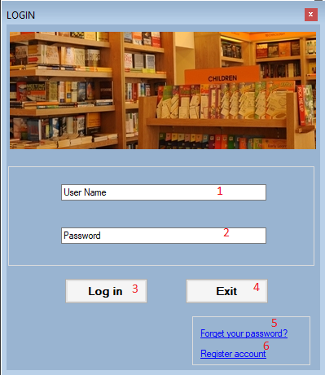

Description:

|  |  |  |  |  |
| --- | --- | --- | --- | --- |
| **ID** | **Name** | **Type** | **Note** | **Describe** |
| 1 | txtUserName | Textbox | None | Allow the user to enter username |
| 2 | txtPassword | Textbox | PasswordChar = * | Allow the user to enter Password |
| 3 | btnLogIn | Botton | None | When the user click the button, the system check the values of texboxs, if information is correct, announces to user log in successfully, the system will hide this form and load FormMain |
| 4 | btnExit | button | none | Exit |
| 5 | linkForget | linklabel | none | Reset password |
| 6 | linkRegister | linklabel | none | Register Account |

### 6.2 FormForgetAccount

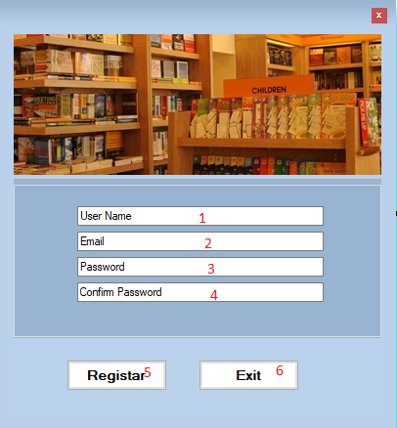

Description

|  |  |  |  |  |
| --- | --- | --- | --- | --- |
| **ID** | **Name** | **Type** | **Note** | **Describe** |
| 1 | txtUserName | MaskedTextbox | none | Allow the user enter User Name |
| 2 | txtEmail | MaskedTextbox | none | Allow the user enter Email |
| 3 | txtPassword | MaskedTextbox | PasswordChar = * | Allow the user to enter password |
| 4 | txtConfirmPass | MaskedTextbox | PasswordChar = * | Allow the user to enter password to confirm |
| 5 | btnRegister | button | none | Register |
| 6 | btnExit | button | none | Exit |

### 6.3 FormRegister

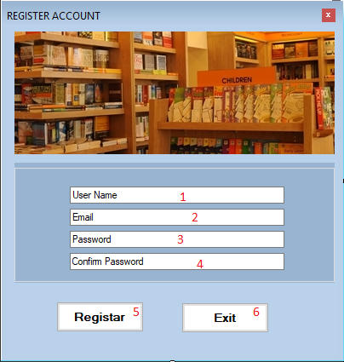

Description

|  |  |  |  |  |
| --- | --- | --- | --- | --- |
| **ID** | **Name** | **Type** | **Note** | **Describe** |
| 1 | txtUserName | MaskedTextbox | none | Allow the user enter User Name |
| 2 | txtEmail | MaskedTextbox | none | Allow the user enter Email |
| 3 | txtPassword | MaskedTextbox | PasswordChar = * | Allow the user to enter password |
| 4 | txtConfirmPass | MaskedTextbox | PasswordChar = * | Allow the user to enter password to confirm |
| 5 | btnRegister | button | none | Register |
| 6 | btnExit | button | none | Exit |

### 6.4 FormMain

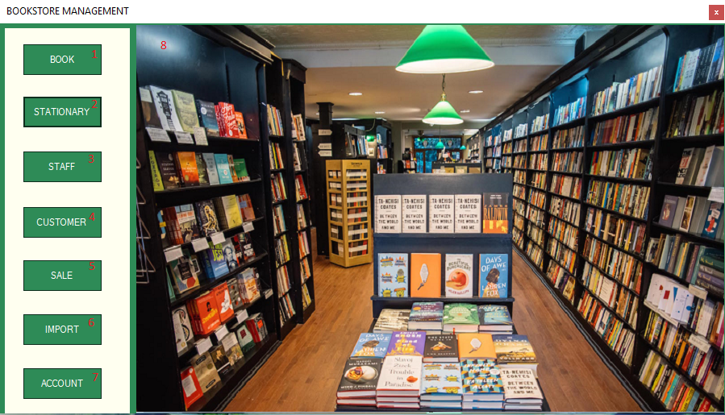

Description

|  |  |  |  |  |
| --- | --- | --- | --- | --- |
| **ID** | **Name** | **Type** | **Note** | **Describe** |
| 1 | btnBook | Button | none | when the users click this button, the system will show FormBook which shows list of book and information of each book |
| 2 | btnStationary | Button | none | when the users click this button, the system will show FormStationary which shows list of stationary and information of each stationary |
| 3 | btnsSaff | Button | none | when the users click this button, the system will show FormStaff which shows list of staff and information of each staff |
| 4 | btnCustomer | Button | none | when the users click this button, the system will show FormCustomer which shows list of customer and information of each customer |
| 5 | btnSale | Button | none | when the users click this button, the system will show FormSale which shows list of bill and information of each bill |
| 6 | btnImport | Button | none | when the users click this button, the system will show FormImport which shows list of receipt note and information of each note |
| 7 | btnAccount | Button | none | when the users click this button, the system will show FormAccount which shows list of account. Manager can delete account |
| 8 | panelMain | Panel | none | Load user control when users click fuction buttons |

### 6.5 FormBook

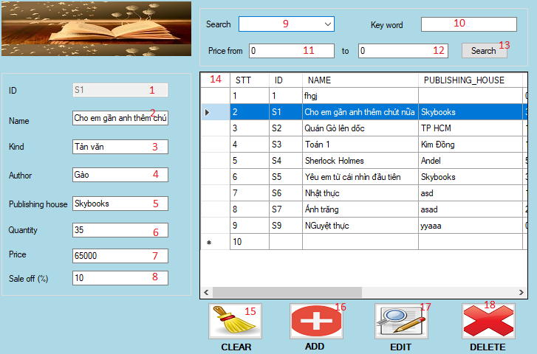

Description:

|  |  |  |  |  |
| --- | --- | --- | --- | --- |
| **ID** | **Name** | **Type** | **Note** | **Describe** |
| 1 | txtId | textbox | none | Allow the user to enter id of book and display id when user click on a row in datagridview |
| 2 | txtName | textbox | none | Allow the user to enter Name and display name when user click on a row in datagridview |
| 3 | txtKind | Textbox | none | Allow the user to enter group book and display kind of book when user click on a row in datagridview |
| 4 | txtAuthor | textbox | none | Allow the user to enter author and display author when user click on a row in datagridview |
| 5 | txtPub | textbox | none | Allow the user to enter Publishing house and display publishing house when user click on a row in datagridview |
| 6 | txtQuantity | textbox | none | Allow the user to enter quantity and display quantity when user click on a row in datagridview |
| 7 | txtPrice | textbox | none | Allow the user to enter price and display price when user click on a row in datagridview |
| 8 | txtSaleOff | textbox | none | Allow the user to enter percent of saleoff and display percent of sale off when user click on a row in datagridview |
| 9 | cmbSearch | combobox | none | Display area to find |
| 10 | txtKey | textbox | none | Display key to find |
| 11 | txtPriceFrom | textbox | none | Allow users enter price need to find |
| 12 | txtPriceTo | textbox | none | Allow users enter price need to find |
| 13 | btnSearch | button | none | Search book have price entered |
| 14 | dgvbook | DataGridView | none | Display list of book.  When the user clicks a cell, display information of book who is selected |
| 15 | btnClear | button | Visible  =False | Clear all text in textbox |
| 16 | btnAdd | button | Visible  =False | Add a book with information inputted |
| 17 | btnEdit | button | Visible  =False | Edit information of book selected when have changing or it is not true |
| 18 | btnDelete | button | none | Delete book is not sold |

### 6.6 FormStationary

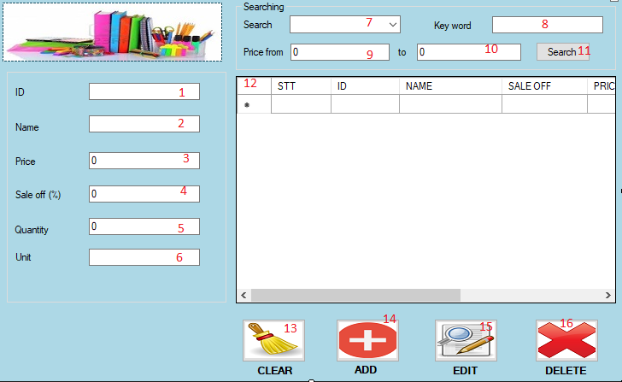

Description:

|  |  |  |  |  |
| --- | --- | --- | --- | --- |
| **ID** | **Name** | **Type** | **Note** | **Describe** |
| 1 | txtId | textbox | none | Allow the user to enter id of book and display id when user click on a row in datagridview |
| 2 | txtName | textbox | none | Allow the user to enter Name and display name when user click on a row in datagridview |
| 3 | txtPrice | textbox | none | Allow the user to enter price and display price when user click on a row in datagridview |
| 4 | txtSaleOff | textbox | none | Allow the user to enter percent of saleoff and display percent of sale off when user click on a row in datagridview |
| 5 | txtQuantity | textbox | none | Allow the user to enter quantity and display quantity when user click on a row in datagridview |
| 6 | txtUnit | textbox | none | Allow the user to enter unit and display unit when user click on a row in datagridview |
| 7 | cmbSearch | combobox | none | Display area to find |
| 8 | txtKey | textbox | none | Display key to find |
| 9 | txtPriceFrom | textbox | none | Allow users enter price need to find |
| 10 | txtPriceTo | textbox | none | Allow users enter price need to find |
| 11 | btnSearch | button | none | Search stationary have price entered |
| 12 | dgvStationary | DataGridView | none | Display list of stationary.  When the user clicks a cell, display information of sattionary which is selected |
| 13 | btnClear | button | Visible  =False | Clear all text in textbox |
| 14 | btnAdd | button | Visible  =False | Add a stationary with information inputted |
| 15 | btnEdit | button | Visible  =False | Edit information of stationary selected when have changing or it is not true |
| 16 | btnDelete | button | none | Delete stationary is not sold |

### 6.7 FormStaff

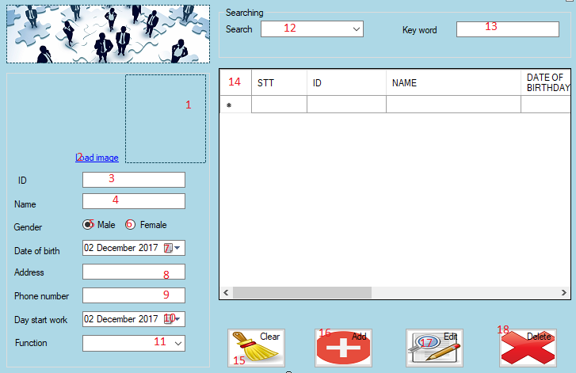

Description:

|  |  |  |  |  |
| --- | --- | --- | --- | --- |
| **ID** | **Name** | **Type** | **Note** | **Describe** |
| 1 | pictureStaff | picturebox | none | Show staff’s picture |
| 2 | LinkImage | linklabel | none | Link to image file |
| 3 | txtId | Textbox | none | Allow the user to enter id and show id staff when click on a row in the datagridview |
| 4 | txtName | Textbox | none | Allow the user to enter Name |
| 5 | radioMale | radiobutton | none | Allow the user choose gender |
| 6 | radioFemale | radiobutton | none | Allow the user choose gender |
| 7 | DateOfBirth | DateTimePicker | none | Display Birthday of the staff, allow enter day of birth |
| 8 | txtAddress | Textbox | none | Display Addresss of the staff,  Allow enter address |
| 9 | txtPhone | textbox | none | Display phone number of the staff, allow enter phone number |
| 10 | DateStart | DateTimePicker | none | Display date start working of the staff, allow enter date start work |
| 11 | cbFunction | combobox | none | Display function of staff and allow choose function |
| 12 | cbSearch | combobox | none | Display area users choose to find |
| 13 | txtKey | textbox | none | Display key to find |
| 14 | DgvStaff | DataGridView | none | Display list of staff.  When the user clicks a cell, display information of staff which is selected |
| 15 | btnClear | Button | none | Clear all text in textbox, combobox, datetimepicker |
| 16 | btnAdd | Button | none | Add a staff with information entered |
| 17 | btnEdit | Button | none | Edit information of staff selected when have changing or it is not true |
| 18 | btnDel | button | none | Delete staff if staff don’t work at store |

### 6.8 FormCustomer

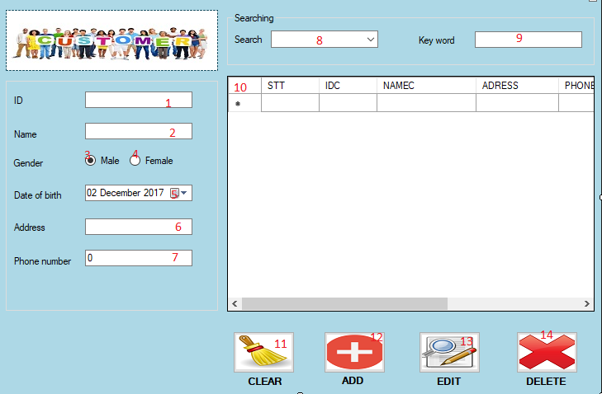

Description:

|  |  |  |  |  |
| --- | --- | --- | --- | --- |
| **ID** | **Name** | **Type** | **Note** | **Describe** |
| 1 | txtId | Textbox | none | Allow the user to enter id and display id when users click on a row in the datagridview |
| 2 | txtName | Textbox | none | Allow the user to enter name, display name when users click on a row in the datagridview |
| 3 | radioMale | Textbox | none | Allow the user choose gender |
| 4 | radioFemale | Textbox | none | Allow the user choose gender |
| 5 | DateOfBirth | DateTimePicker | none | Display Birthday of the customer, allow enter day of birth |
| 6 | txtAddress | Textbox | none | Display Address of the customer, allow enter address |
| 7 | txtPhoneNumber | textbox | none | Display Phone Number of the customer, allow enter phone number |
| 8 | cbSearch | combobox | none | Display area which user choose to find |
| 9 | txtKey | textbox | none | Display key to find |
| 10 | DgvCustomer | DataGridView | none | Display list of customer.  When the user clicks a cell, display information of customer who is selected |
| 11 | btnClear | Button | Visible  =False | Clear all text in textbox, datetimepicker which are displaying information of customer |
| 12 | btnAdd | Button | Visible  =False | Add a customer with information entered |
| 13 | btnEdit | button | Visible  =False | Edit information of customer selected when have changing or it is not true |
| 14 | btnDelete | button | none | Delete customer |

### 6.9 FormSale

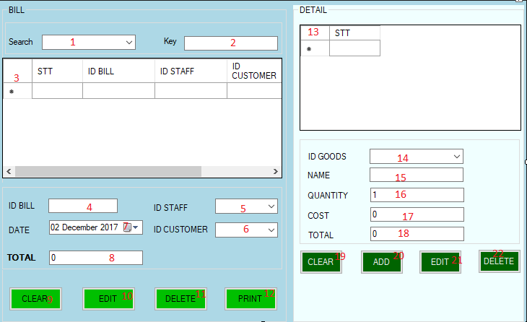

Descriptions

|  |  |  |  |  |
| --- | --- | --- | --- | --- |
| **STT** | **Name** | **Type** | **Note** | **Describe** |
| 1 | cbSearch | combobox | None | Allow users choose area to find |
| 2 | txtKey | textbox | None | Allow users enter key to find |
| 3 | dgvBill | datagridview | None | Display list of bill |
| 4 | txtIdBill | textbox | None | Display id of bill when users click on a row in the datagidview and allow users enter id of bill |
| 5 | cbIdStaff | combobox | none | Display id of staff create bill when users click on a row in the datagidview and allow users enter id of the staff |
| 6 | cbIdCustomer | combobox | None | Display id of customer bought goods when users click on a row in the datagidview and allow users enter id of customer |
| 7 | DateBill | datetimepicker | None | Display day create bill when users click on a row in the datagidview and allow users enter day create bill |
| 8 | txtTotal | textbox | None | Display total of bill when users click on a row in the datagidview and allow users enter total of bill |
| 9 | btnClear | button | None | Clear all text on textbox,combobox,… |
| 10 | btnEdit | button | N one | Edit information of bill selected when have changing or it is not true |
| 11 | btnDelete | Button | None | Delete bill |
| 12 | btnPrint | Button | None | Print bill |
| 13 | dgvDetail | Datagridview | None | Display list of bill |
| 14 | cbIdGoods | Combobox | None | Display id of goods when users click on a row in the datagidview and allow users enter id of goods |
| 15 | txtName | Textbox | None | Display name of goods when users click on a row in the datagidview and allow users enter name of goods |
| 16 | txtQuantity | Textbox | None | Display quantity of goods when users click on a row in the datagidview and allow users enter quantity of goods |
| 17 | txtCost | Textbox | None | Display cost of goods when users click on a row in the datagidview and allow users enter cost of goods |
| 18 | txtTotalDetail | Textbox | None | Display total of goods when users click on a row in the datagidview and allow users enter total of gooods |
| 19 | btnClear | Button | None | Clear all text on textbox,combobox,… |
| 20 | btnAdd | Button | None | Add a bill with information entered |
| 21 | btnEdit | Button | None | Edit information of goods selected when have changing or it is not true |
| 22 | btnDelete | Button | None | Delete goods |

### 6.10 FormImport

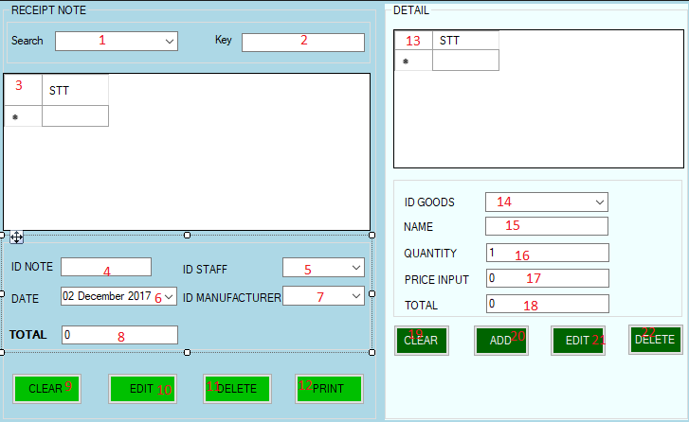

Descriptions

|  |  |  |  |  |
| --- | --- | --- | --- | --- |
| **STT** | **Name** | **Type** | **Note** | **Describe** |
| 1 | cbSearch | combobox | None | Allow users choose area to find |
| 2 | txtKey | textbox | None | Allow users enter key to find |
| 3 | dgvReceiptNote | datagridview | None | Display list of receipt note |
| 4 | txtIdNote | textbox | None | Display id of receipt note when users click on a row in the datagidview and allow users enter id of receipt note |
| 5 | cbIdStaff | combobox | none | Display id of staff create receipt note when users click on a row in the datagidview and allow users enter id of the staff |
| 6 | cbIdManufacturer | combobox | None | Display id of manufacturer when users click on a row in the datagidview and allow users enter id of manufacturer |
| 7 | DateImport | datetimepicker | None | Display day import goods when users click on a row in the datagidview and allow users enter day create note |
| 8 | txtTotal | textbox | None | Display total of receipt note when users click on a row in the datagidview and allow users enter total of receipt note |
| 9 | btnClear | button | None | Clear all text on textbox,combobox,… |
| 10 | btnEdit | button | N one | Edit information of receipt note selected when have changing or it is not true |
| 11 | btnDelete | Button | None | Delete receipt note |
| 12 | btnPrint | Button | None | Print receipt note |
| 13 | dgvDetail | Datagridview | None | Display list of receipt note |
| 14 | cbIdGoods | Combobox | None | Display id of goods when users click on a row in the datagidview and allow users enter id of goods |
| 15 | txtName | Textbox | None | Display name of goods when users click on a row in the datagidview and allow users enter name of goods |
| 16 | txtQuantity | Textbox | None | Display quantity of goods when users click on a row in the datagidview and allow users enter quantity of goods |
| 17 | txtCost | Textbox | None | Display cost of goods when users click on a row in the datagidview and allow users enter cost of goods |
| 18 | txtTotalDetail | Textbox | None | Display total of goods when users click on a row in the datagidview and allow users enter total of gooods |
| 19 | btnClear | Button | None | Clear all text on textbox,combobox,… |
| 20 | btnAdd | Button | None | Add a bill with information entered |
| 21 | btnEdit | Button | None | Edit information of goods selected when have changing or it is not true |
| 22 | btnDelete | Button | None | Delete goods |

### 6.11 FormAccount

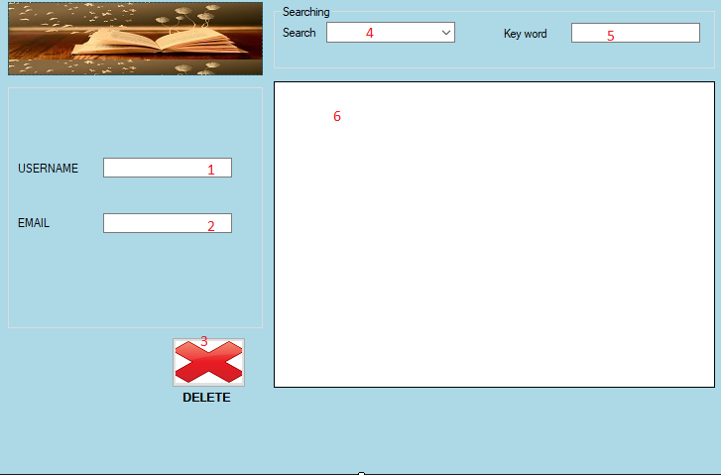

Description

|  |  |  |  |  |
| --- | --- | --- | --- | --- |
| **ID** | **Name** | **Type** | **Note** | **Describe** |
| 1 | txtUserName | textbox | none | Allow the user to display username and display username when users click on arrow in the datagridview |
| 2 | txtEmail | textbox | none | Allow the user to display email and display email when users click on arrow in the datagridview |
| 3 | btnDelete | button | none | Delete account |
| 4 | cmbSearch | combobox | none | Display area to search |
| 5 | txtKey | textbox | none | Display key |
| 6 | dgvAccount | datagridview | none | Display list of account |