Step 1: created Jenkins-master and ssh into it and downloaded java-21 and git and Jenkins.
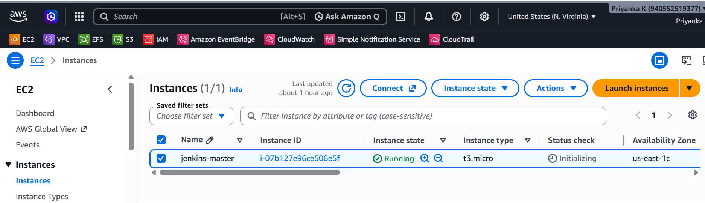
Step 2 : created three jobs in Jenkins with job 1 ,job 2 ,job 3
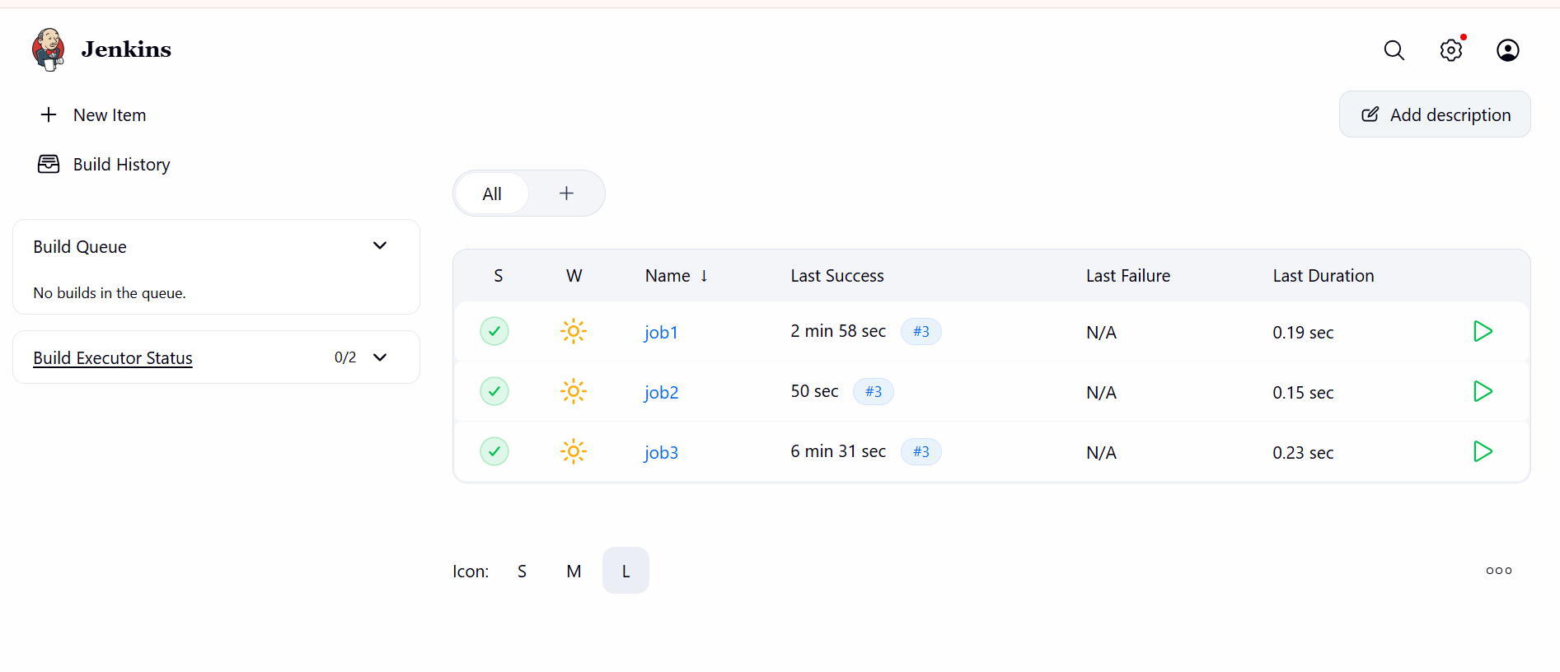
Step 3 : configure git into three all three jobs.
In job1 added velocity main brach repository
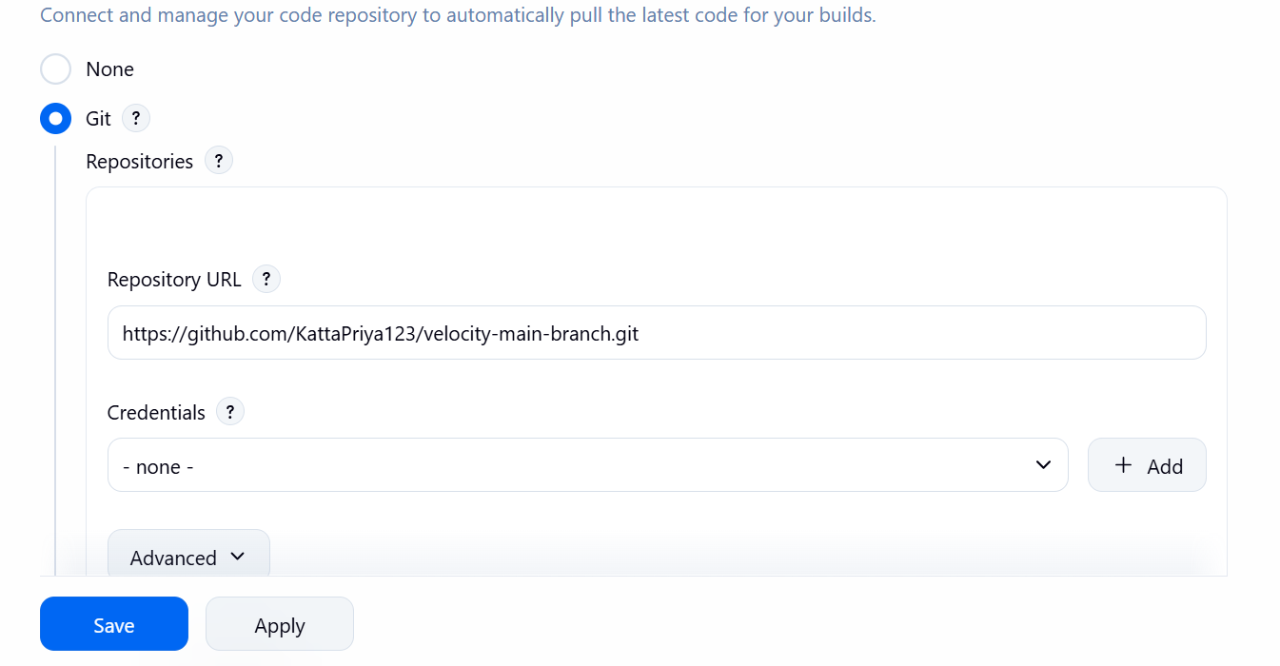

In job 2 added Jenkins-test repo
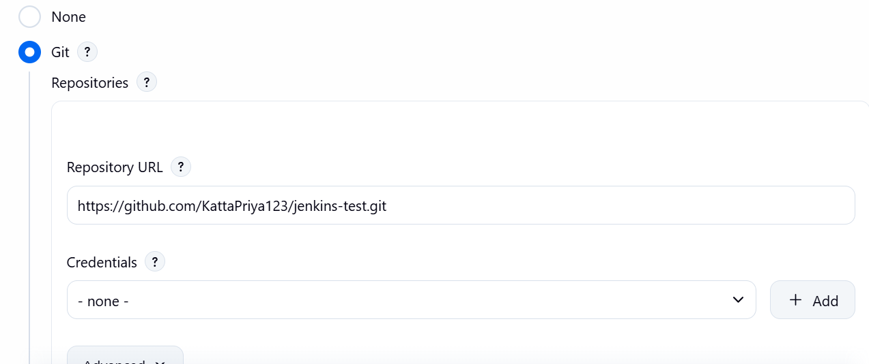
In job3 added devops-journey reo
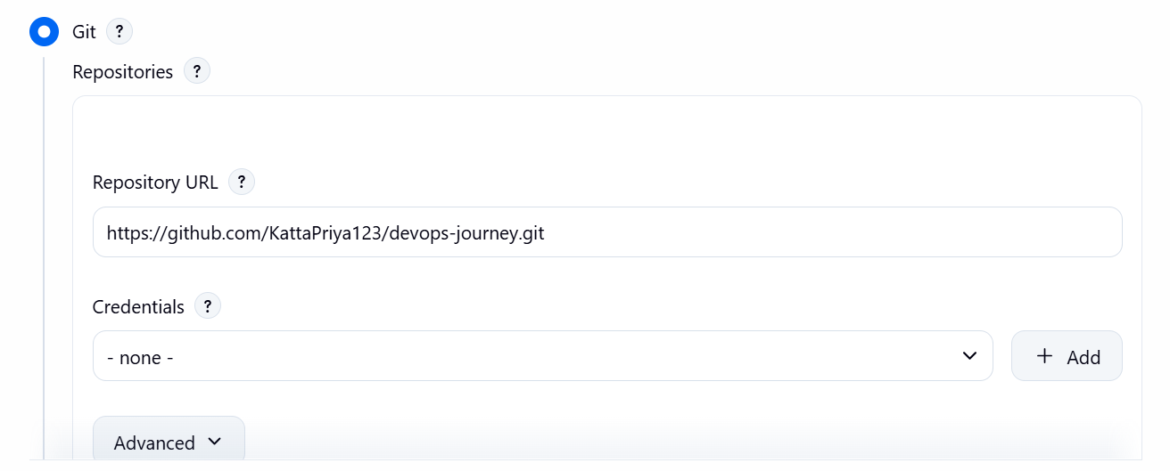
Step 4 : configure and added github server : system---githubserver
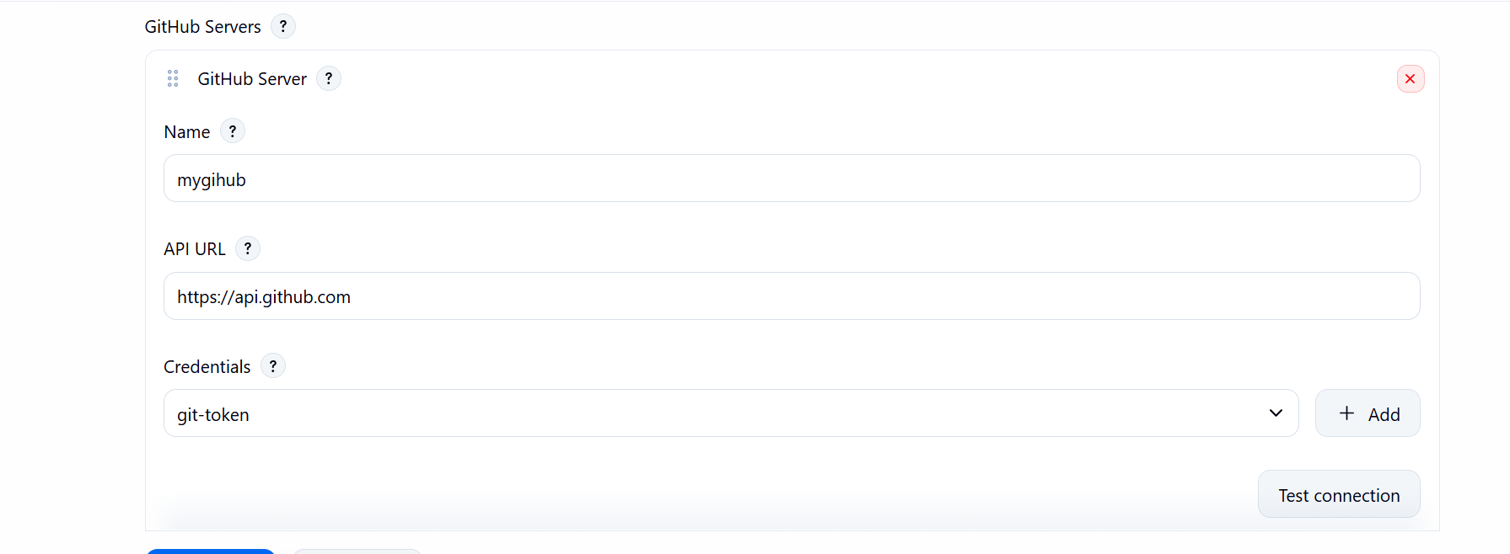

Step 5 : configure webhook setting in three repositories.
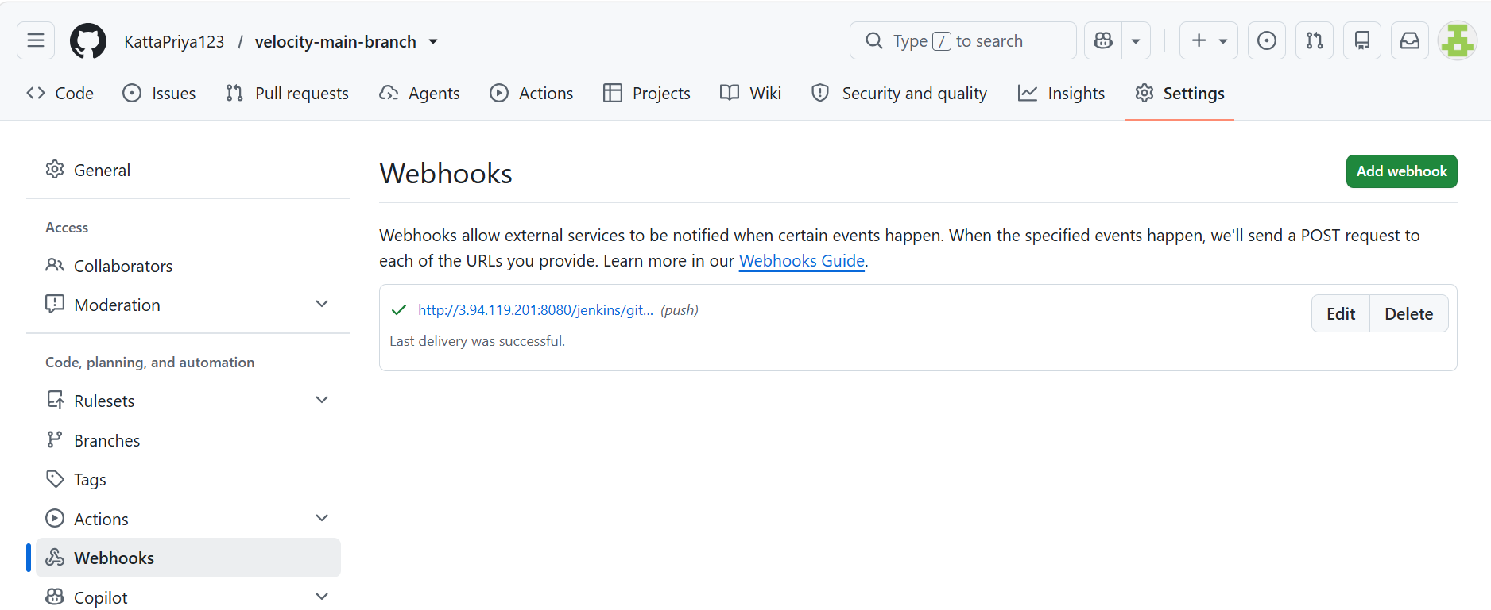
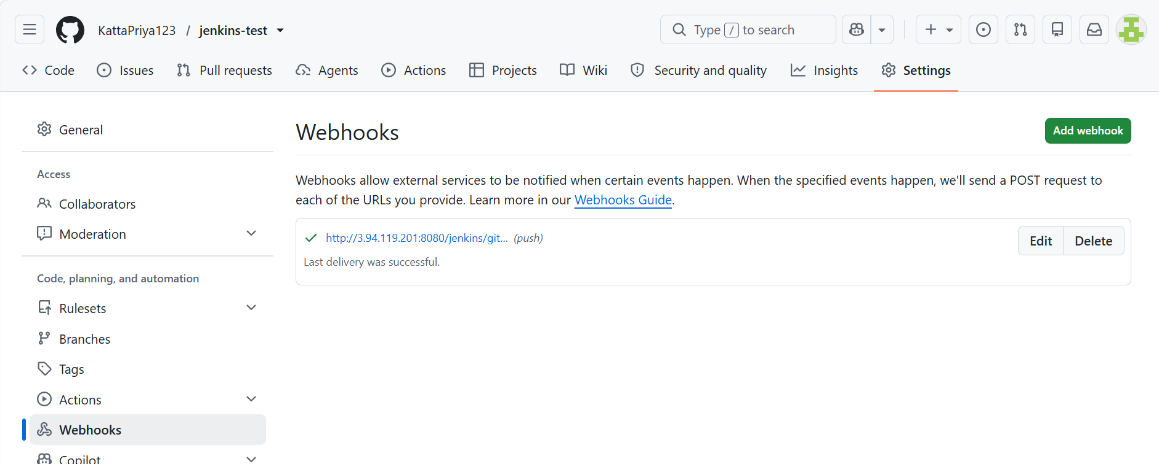
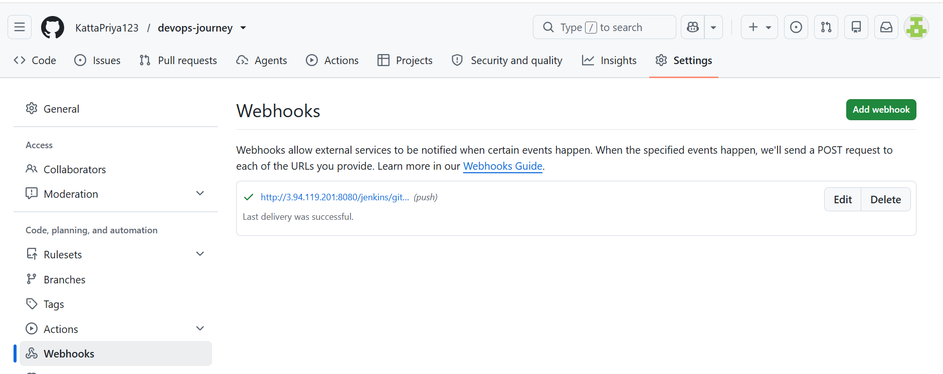

Step 6 : checked this triggering option all three jobs.
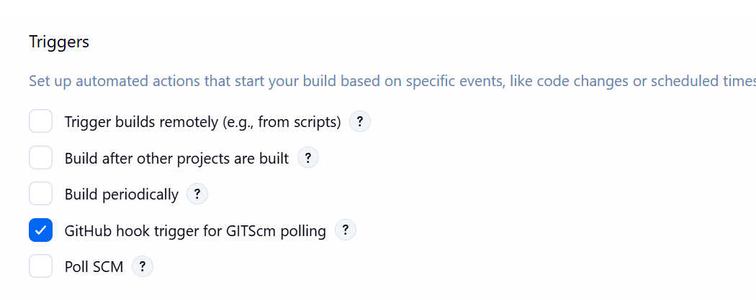
Step 7 : cloning project from workspace to tomcat server . did same with job2,job3.
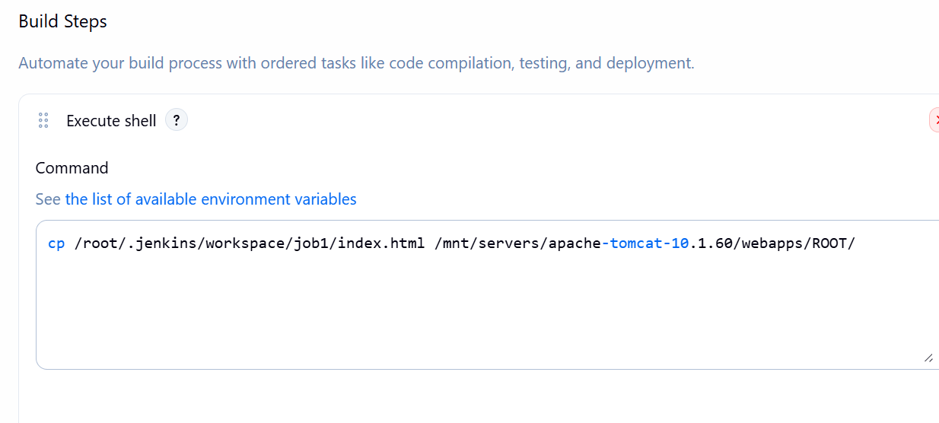
Step 8 : checking if any changes are made in github that job will build in Jenkins.
Changing in repository
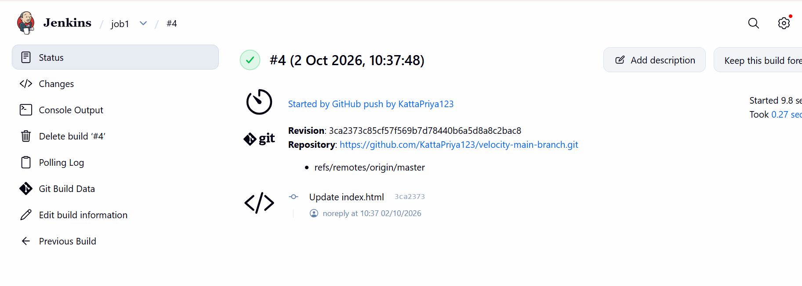

Changing in repository
