Created ec2 instance and ssh into it.
Install java-21 and git
than cd mnt---mkdir servers
cd servers---wget apache-tomcat
Give permission apache-tomcat
cd apache ----cd webapps---wget Jenkins
cd apache—bin--./startup.sh tomcat
cd /root/mnt/---mkdir build-tools---wget apache maven
set environment variable of maven .bash_profile
than logout and login and run mvn command from anywhere.
And install Jenkins using password which is present in apaxhe-tomcat/logs/---tail -100f Catalina.out
Cloning myapp-project

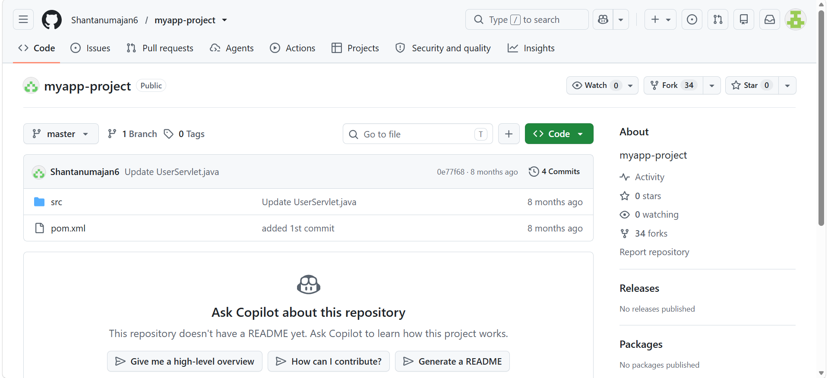

Created job
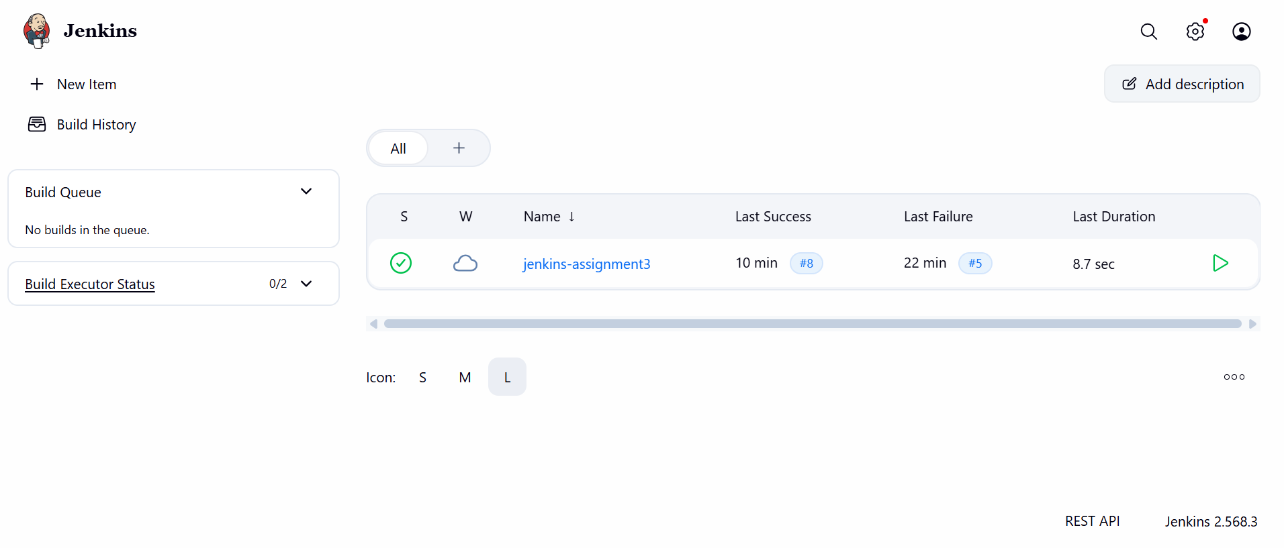

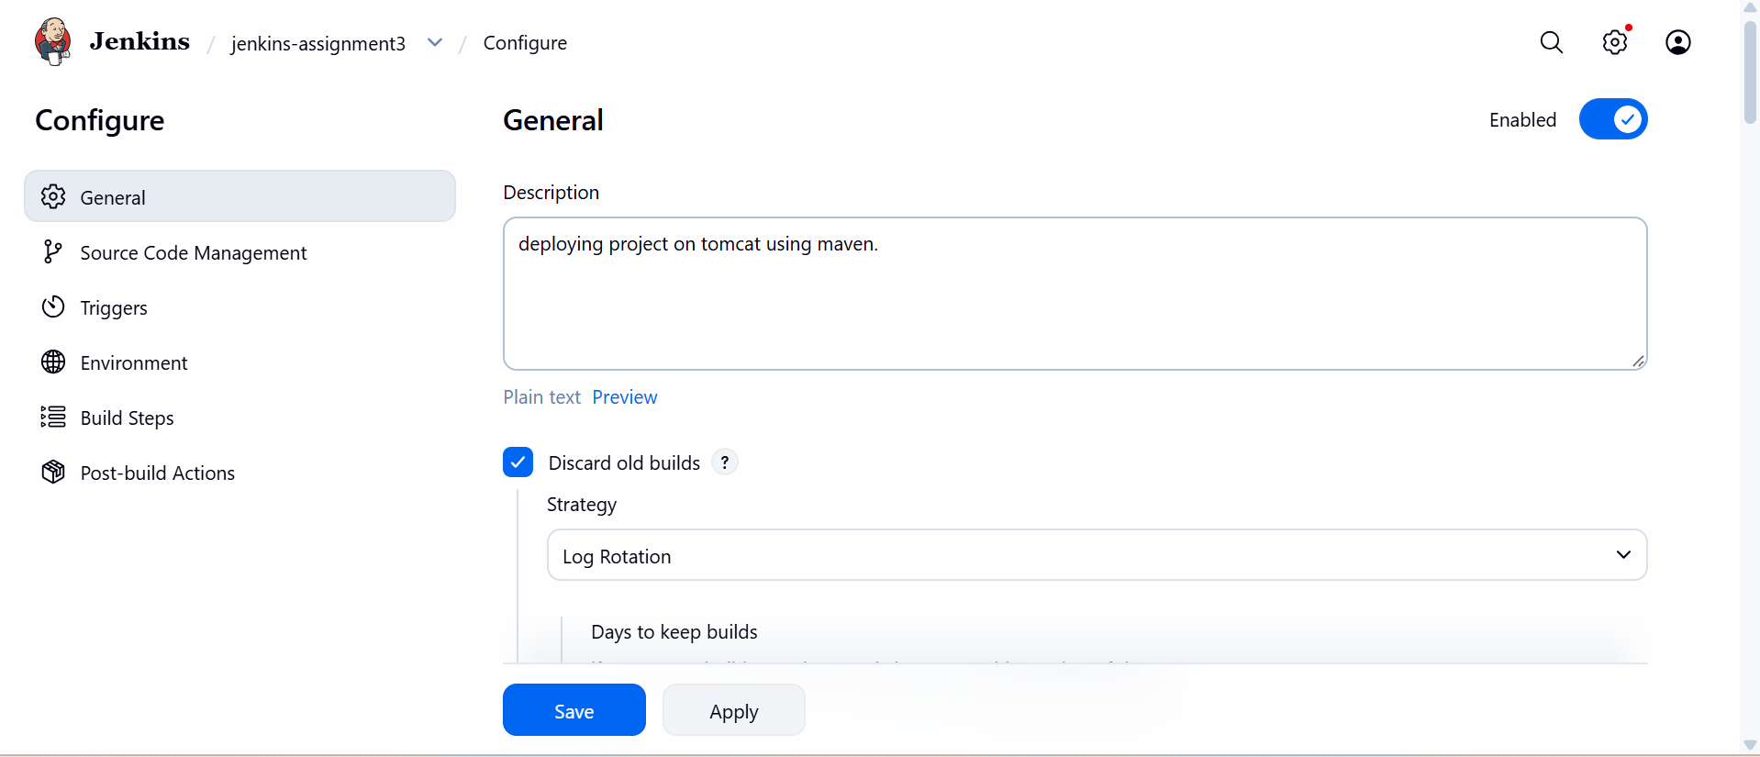

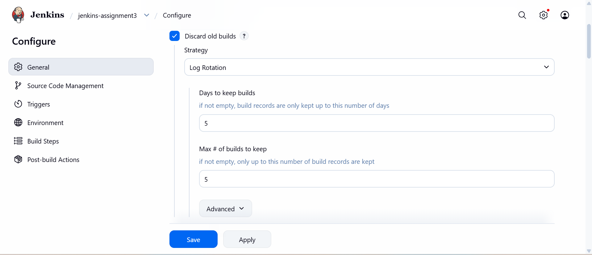

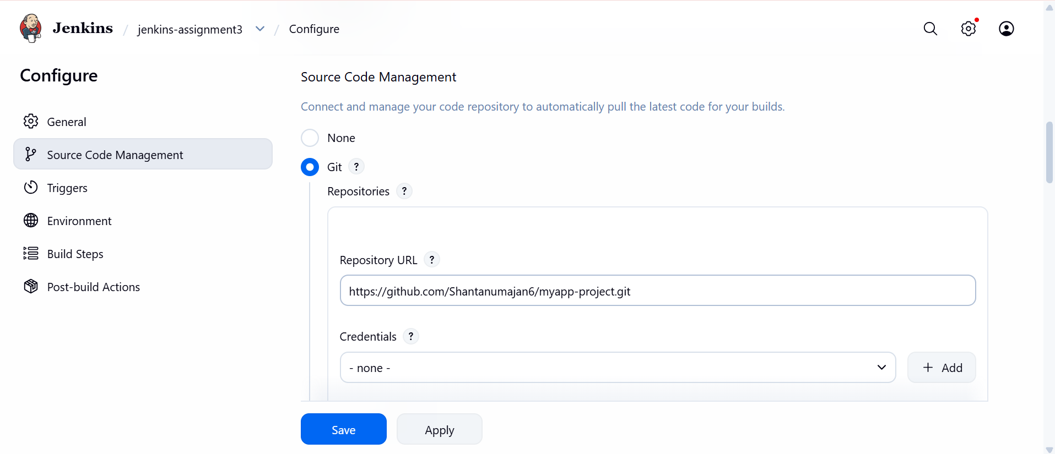

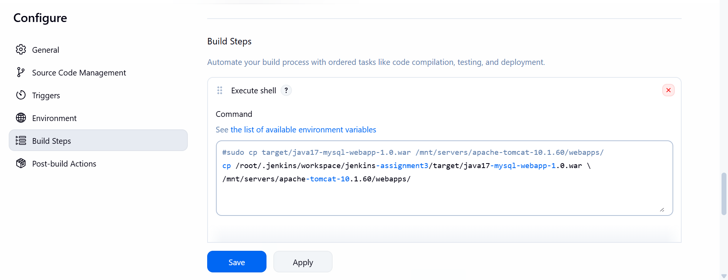

In tools section
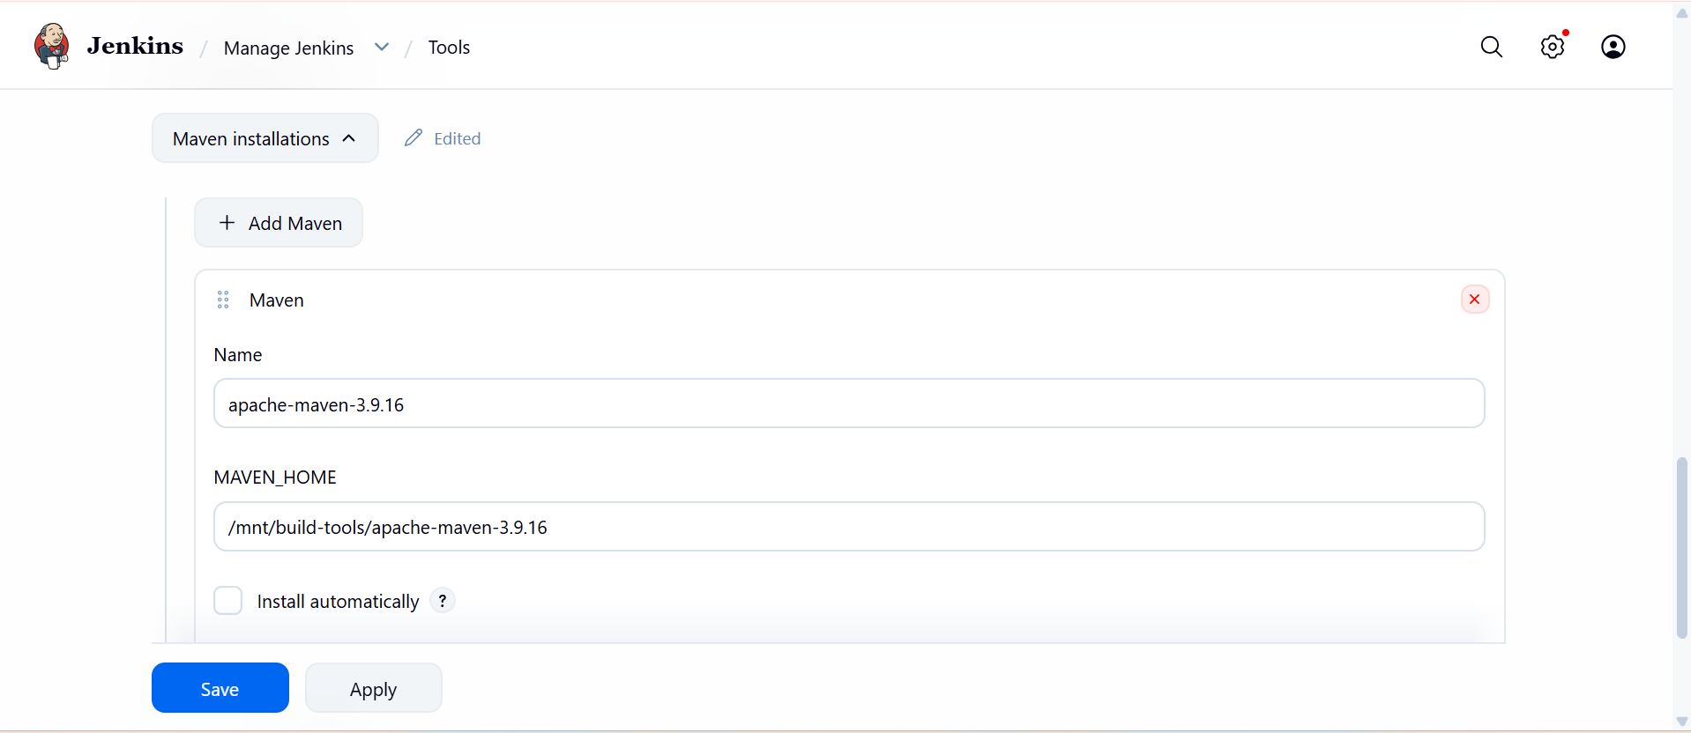

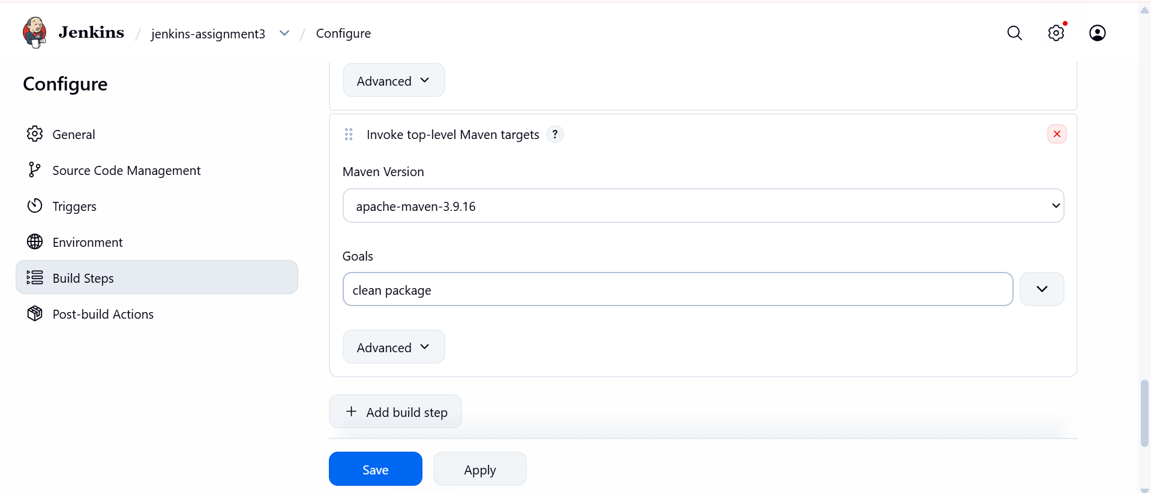
http://public-ip:8080/extract war file name

