Step 1:launch an instance and ssh into it and login into Jenkins.
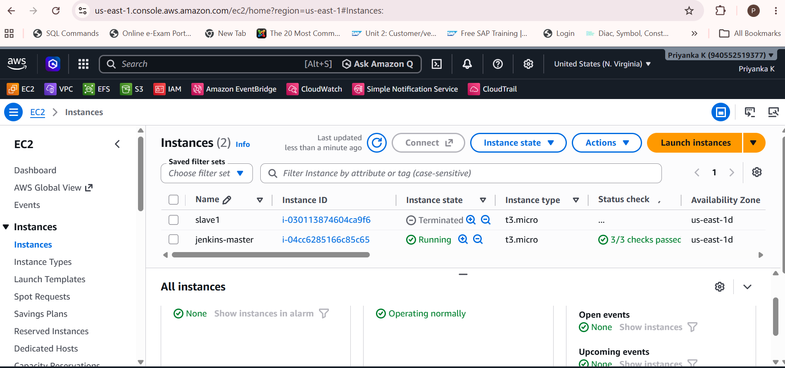

Step 2: create job
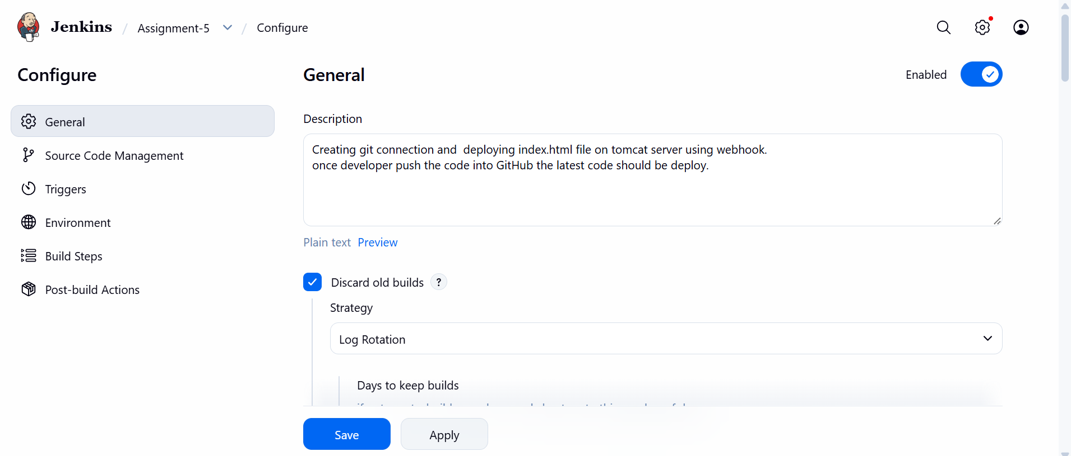
Step 3: configure github for cloning project & create git-token credentials.
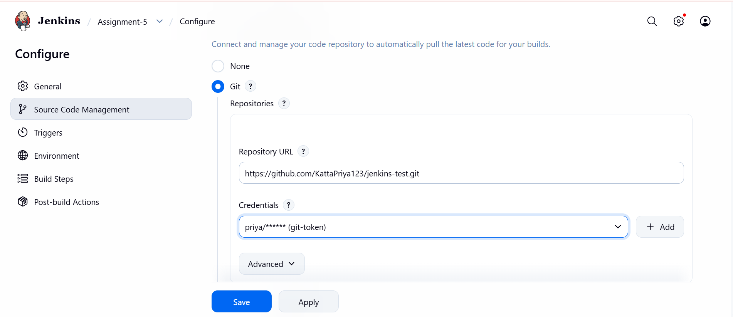

Step 4:check branch name
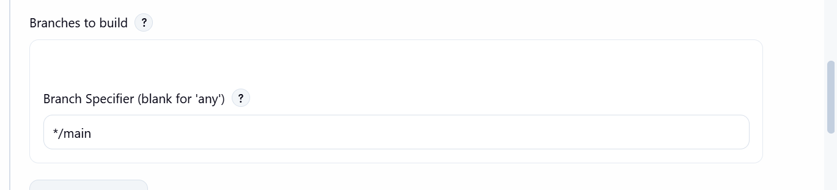
Step 5: clone project from workspace to tomcat server .
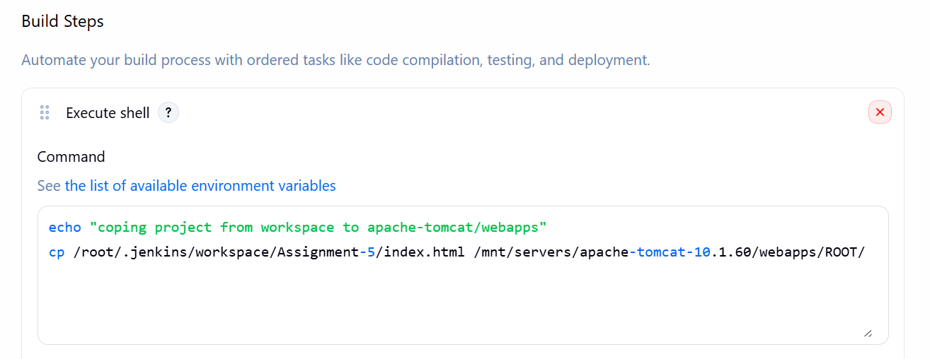
Step 6: configure github server with
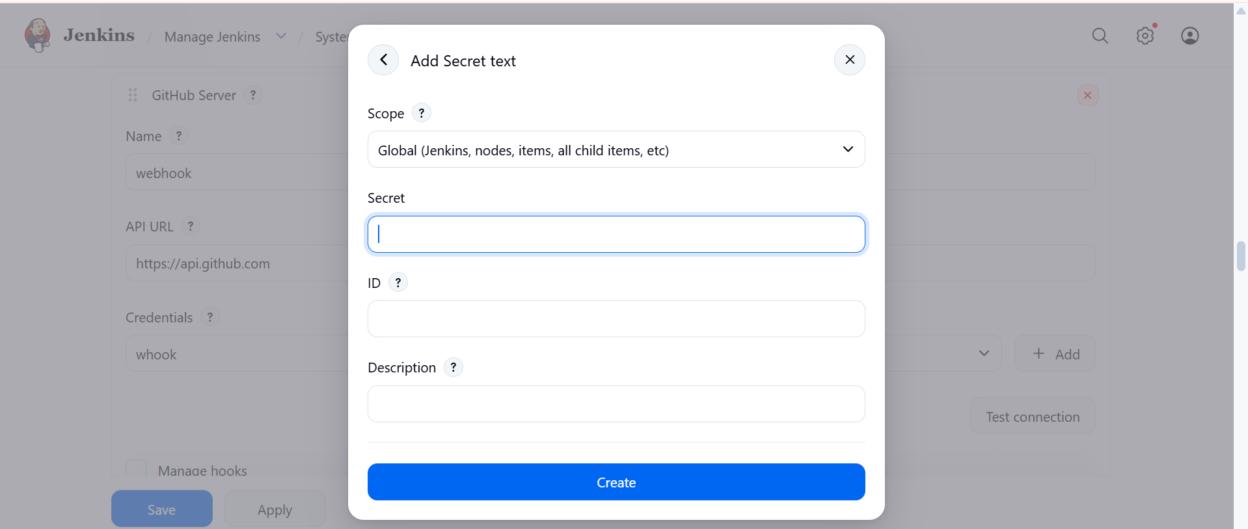
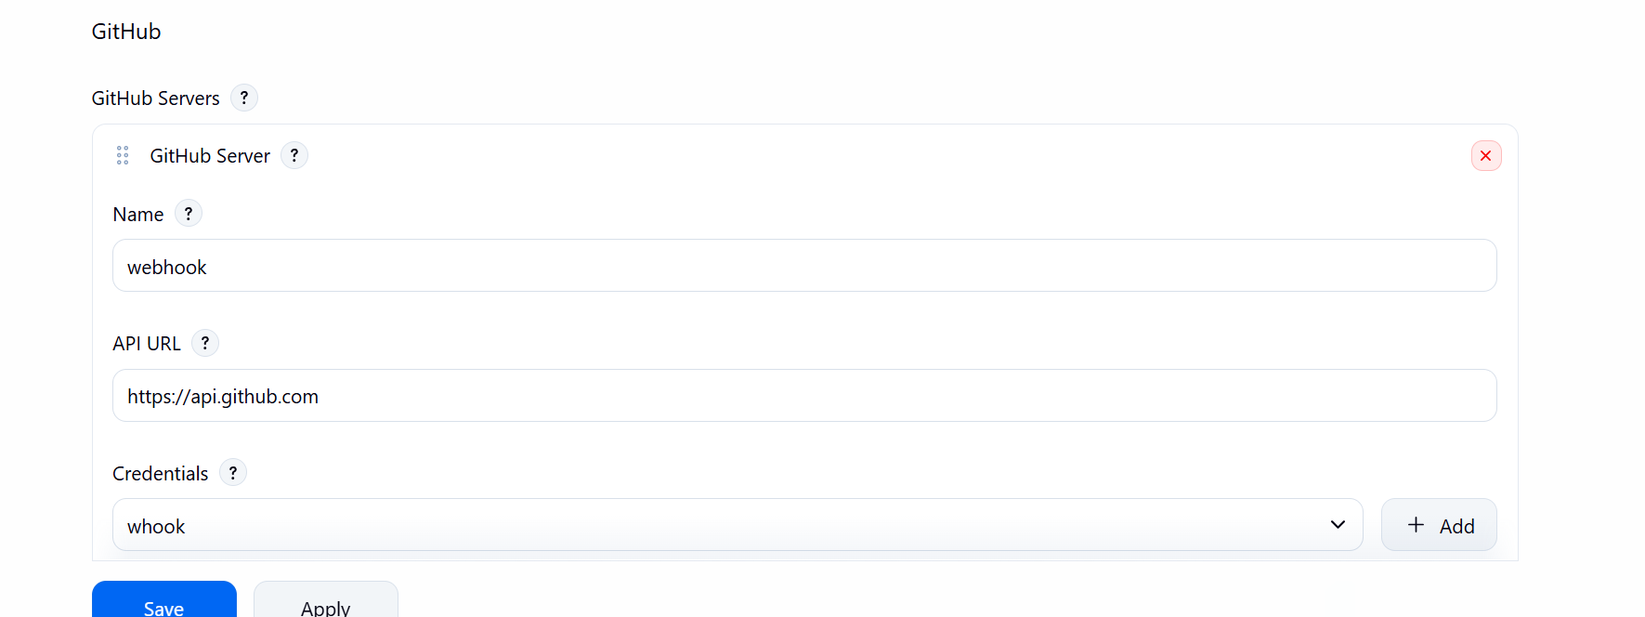
Step 7 : go to the github account and select repository ----click webhook ---create with Jenkins url : http://public-ip/jenkins/github-webhook/
And select json format ----click save
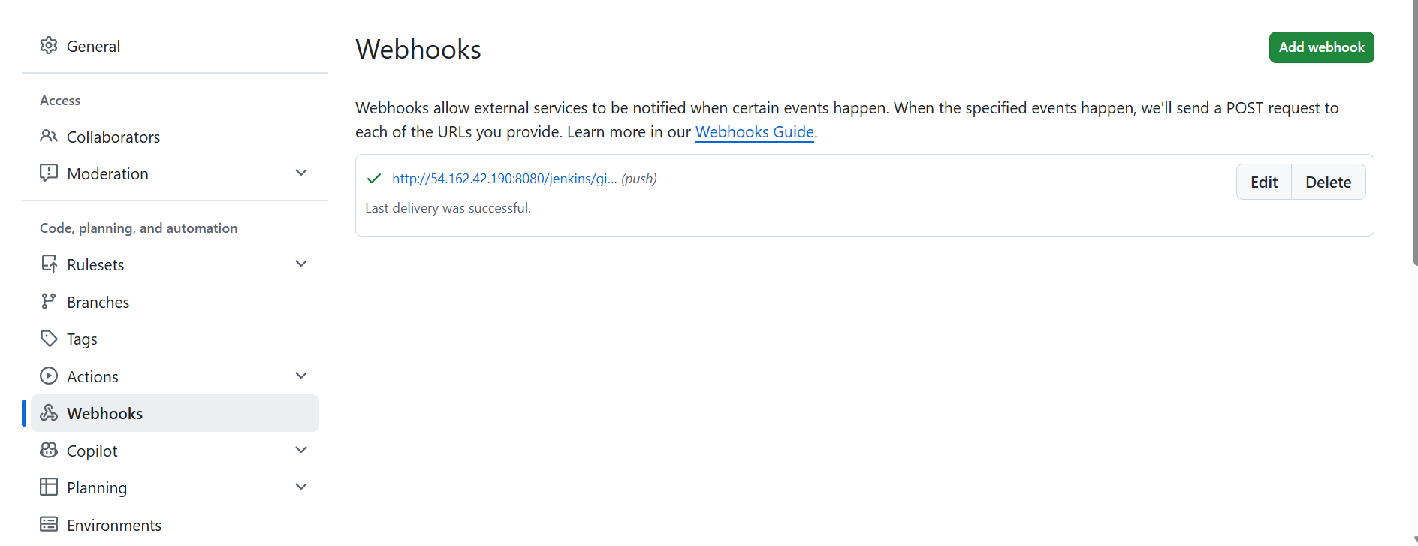

Step 8 : important --- click to this open and click on build project .
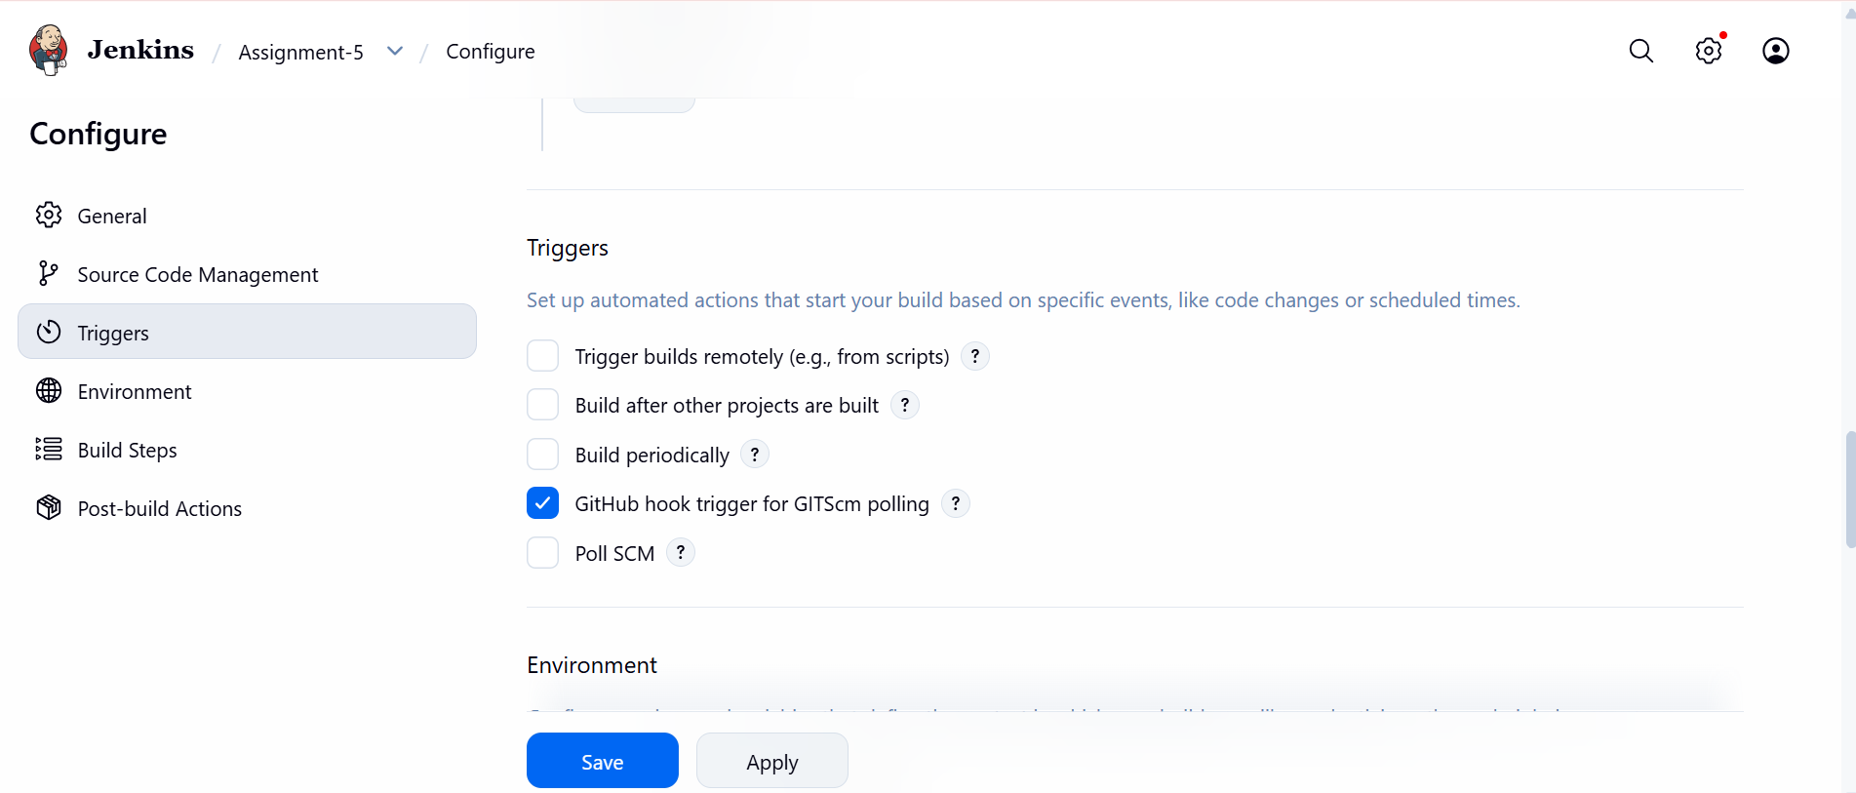
Step 9 : when I pushed new commit or file its trigger by webhook .
