Created index.html file in my private repository in github
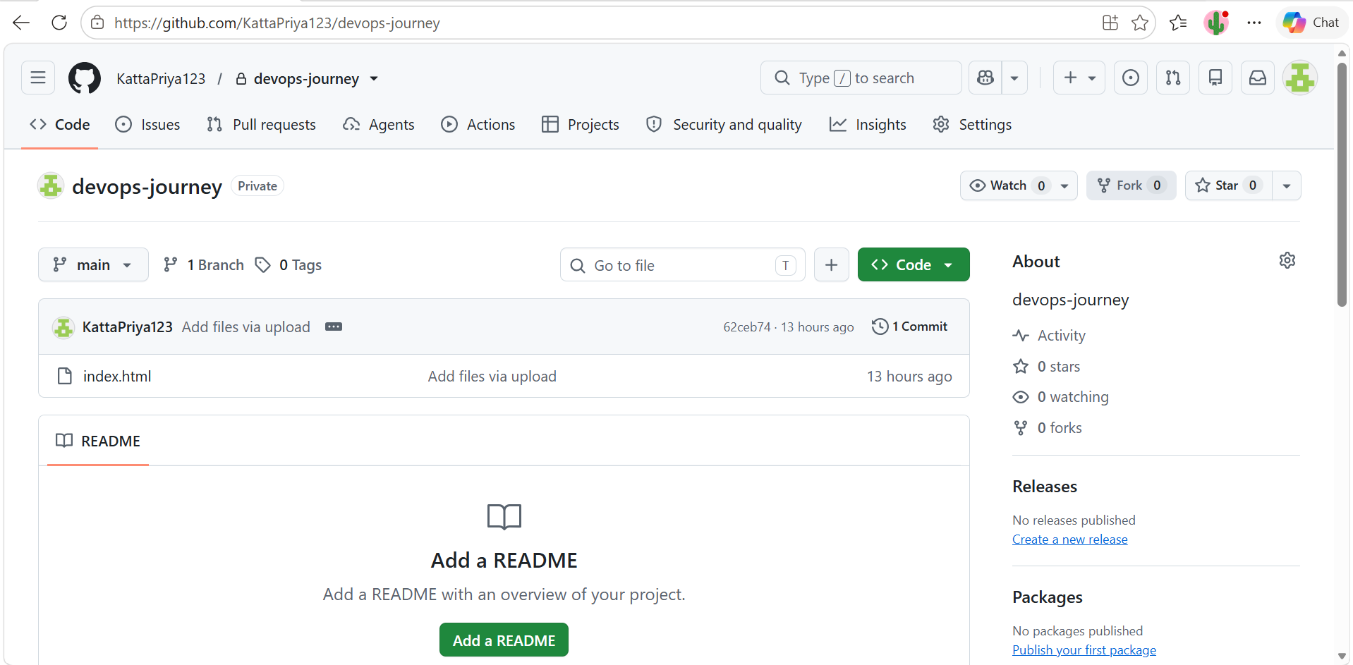

And created Jenkins-master ec2 instance

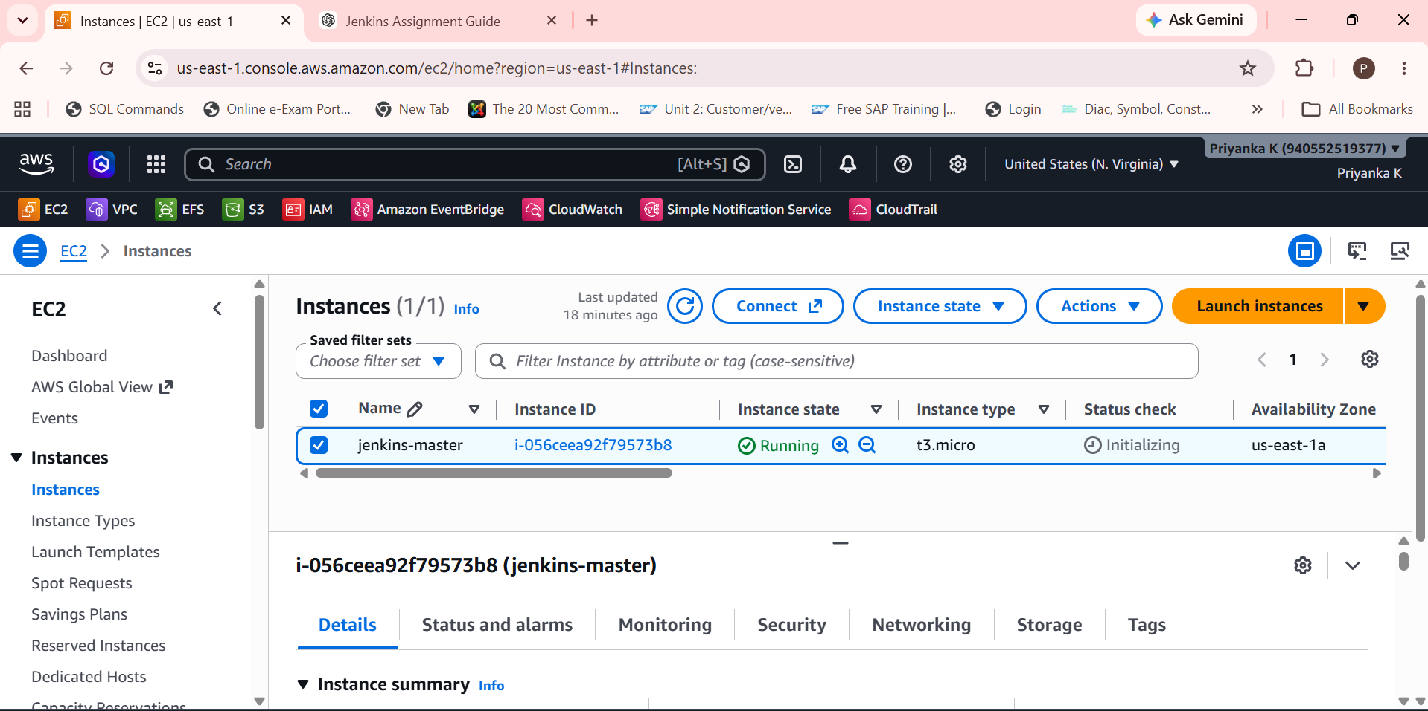
SSH into instance and installed java-21 and git
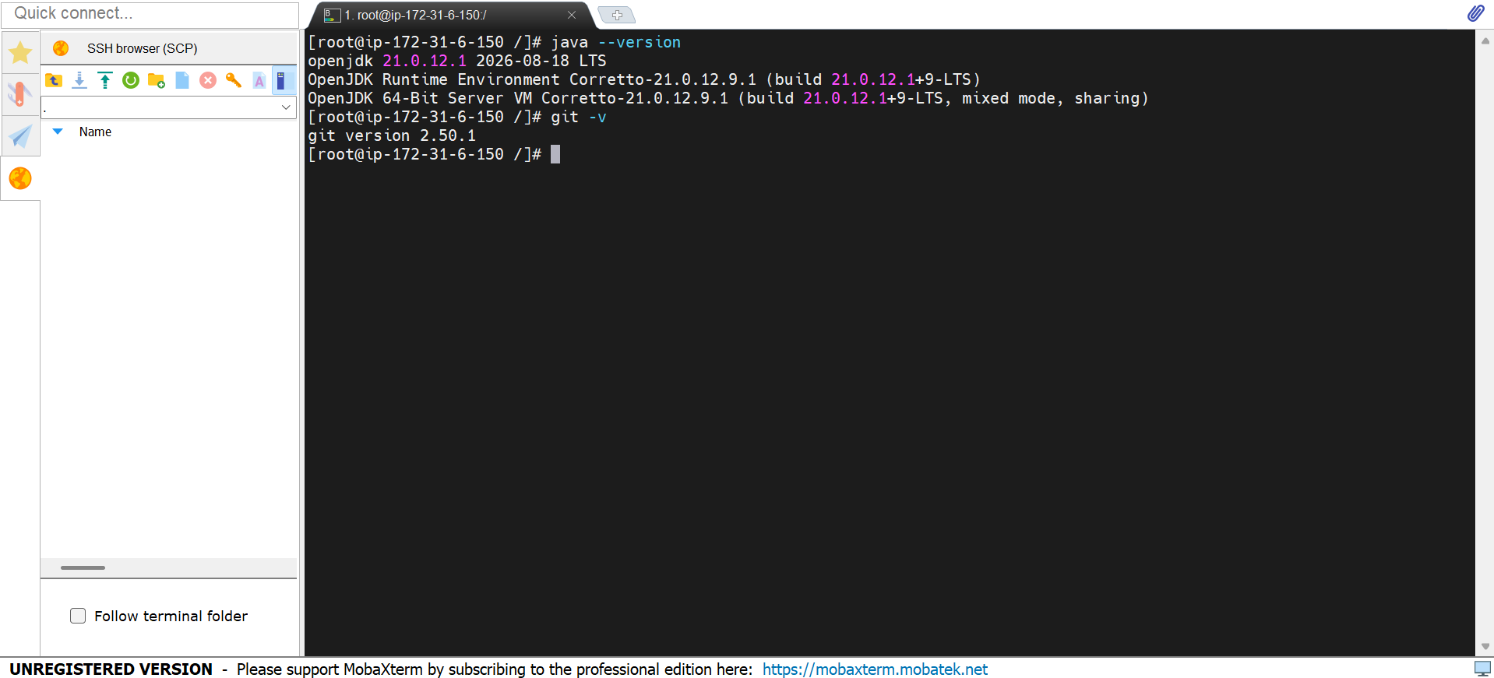
Install Jenkins with these steps
cd /
2 pwd
3 clear
4 yum list java-21*
5 yum install java-21-amazon-corretto.x86_64
6 java --version
7 yum install git -y
8 git -v
9 cd /
10 ls -ltr
11 pwd
12 cd /
13 clear
14 java --version
15 git -v
16 cd mnt/
17 mkdir servers
18 cd servers
19 wget https://dlcdn.apache.org/tomcat/tomcat-10/v10.1.60/bin/apache-tomcat-10.1.60.zip
20 ls -ltr
21 unzip apache-tomcat-10.1.60.zip
22 ls -ltr
23 rm -rf apache-tomcat-10.1.60.zip
24 ls -ltr
25 cd apache-tomcat-10.1.60
26 ls -ltr
27 cd webapps/
28 wget https://get.jenkins.io/war-stable/2.568.3/jenkins.war
29 ls -ltr
30 cd ..
31 cd bin
32 cd ..
33 cd .
34 cd ..
35 chmod -R 777 apache-tomcat-10.1.60
36 cd apache-tomcat-10.1.60
37 cd bin
38 ./startup.sh
39 cd /mnt/servers
40 cd ..
41 cd mnt
42 mkdir build-tools
43 cd build-tools
44 wget https://dlcdn.apache.org/maven/maven-3/3.9.16/binaries/apache-maven-3.9.16-bin.zip
45 ls -ltr
46 unzip apache-maven-3.9.16-bin.zip
47 rm -rf apache-maven-3.9.16-bin.zip
48 ls -ltr
49 cd apache-maven-3.9.16
50 ls -ltr
51 cd bin
52 ls -ltr
53 mvn
54 cd /root
55 ls -ltra
56 vi .bash_profile
57 logout
58 mvn
59 cd mnt
60 ls -ltr
61 cd /
62 cd mnt
63 ls -ltr
64 cd servers
65 la -ltr
66 ls -ltr
67 cd apache-tomcat-10.1.60
68 ls -ltr
69 cd logs
70 ls -ltr
71 tail -100f catalina.out

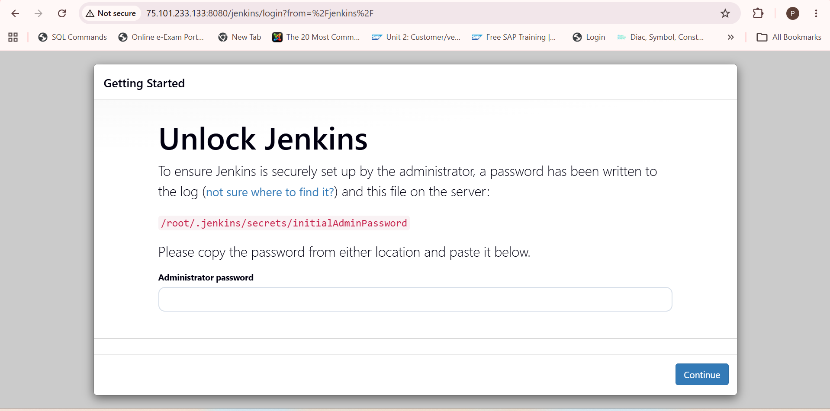

Integarate private github repository in Jenkins ,created global credentials in Jenkins .

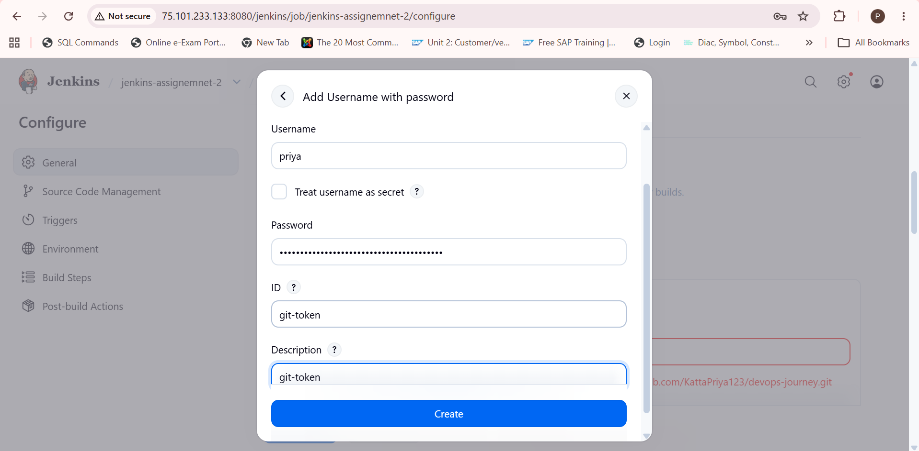

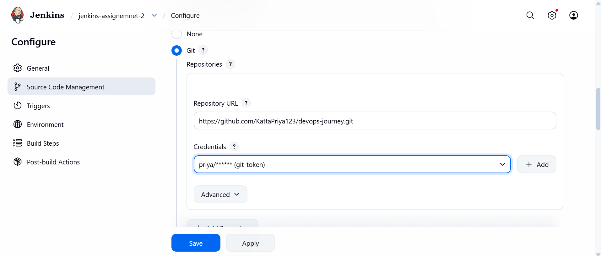
Created job2 with name of Jenkins-assignment2
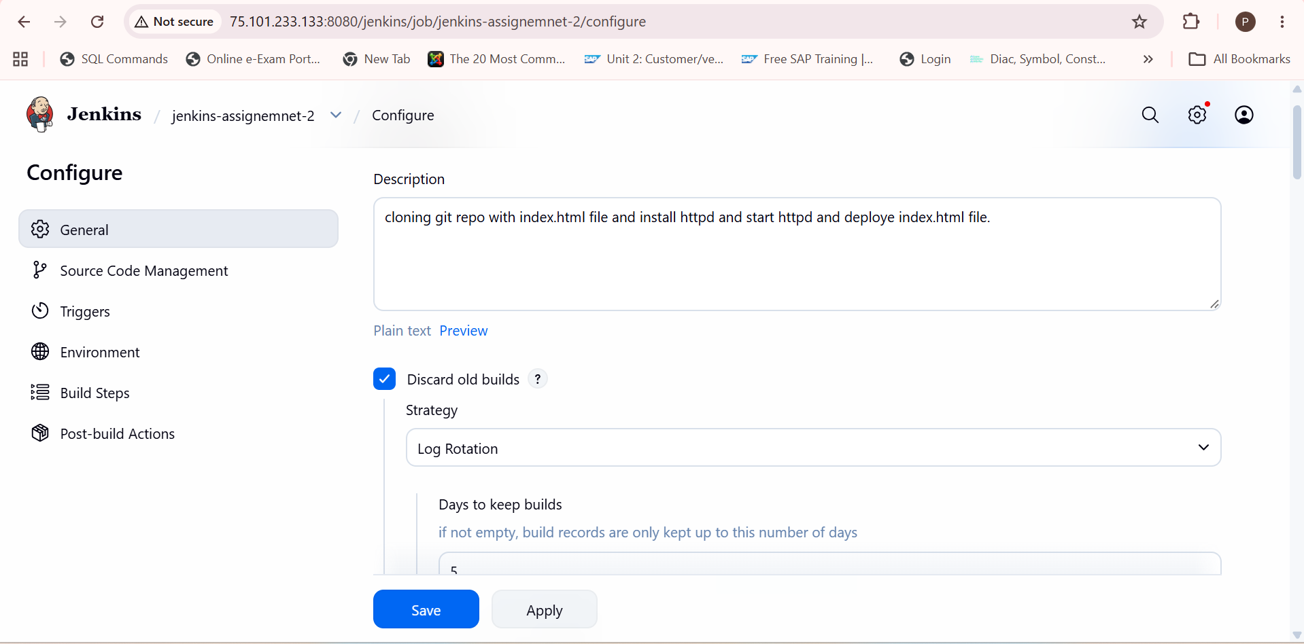
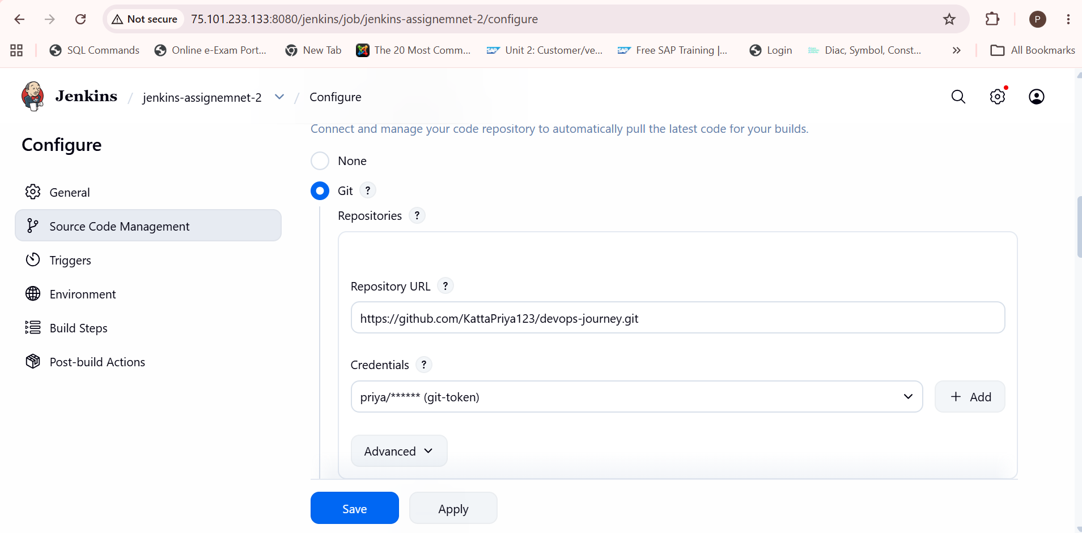

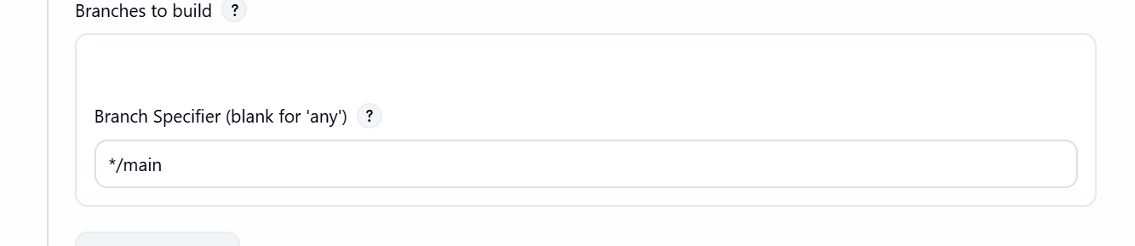

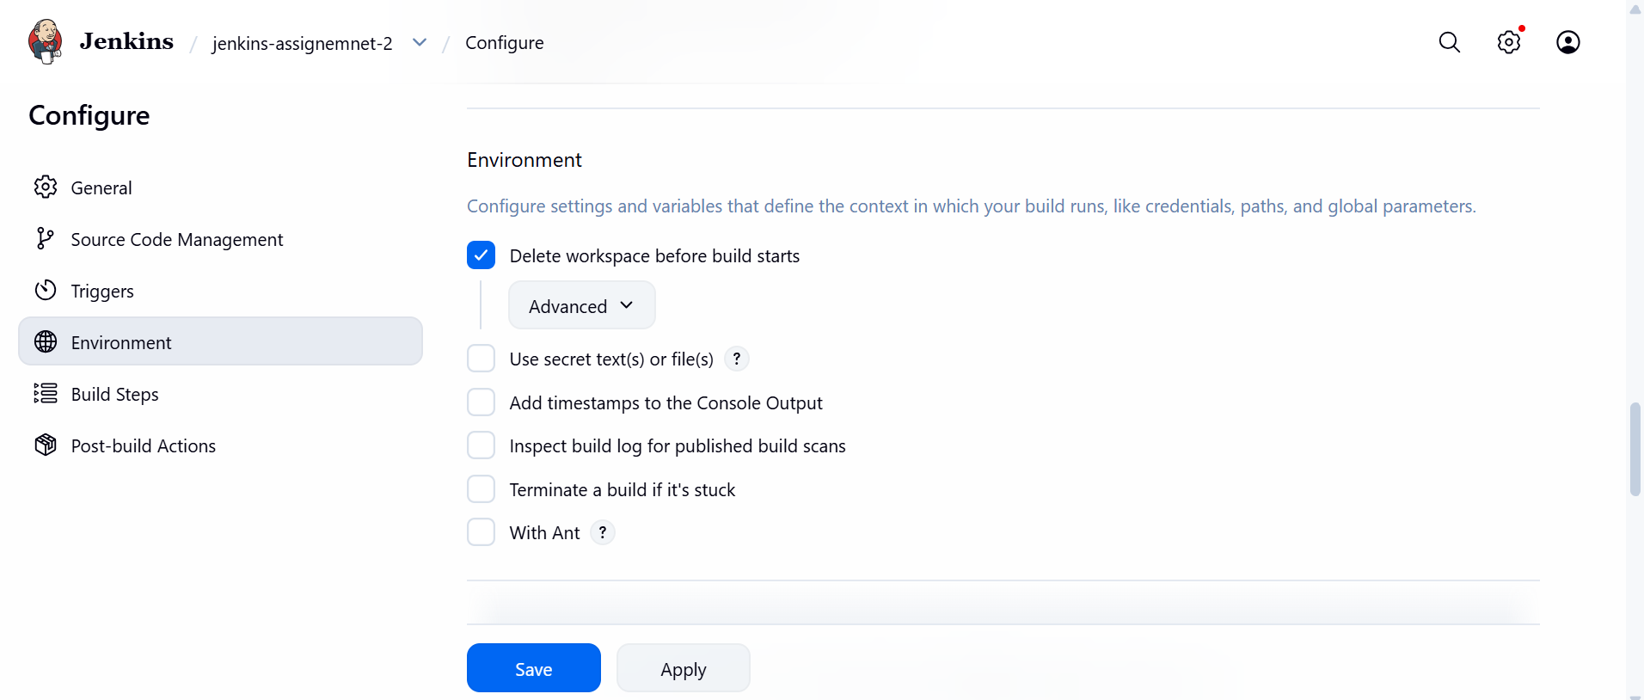

Whenever we integrate github repo with credential then run job its shows you in console where our file is created and stored or we can say where our repositories files are stored and cloned already . so we don’t need to git clone again in execute shell script.

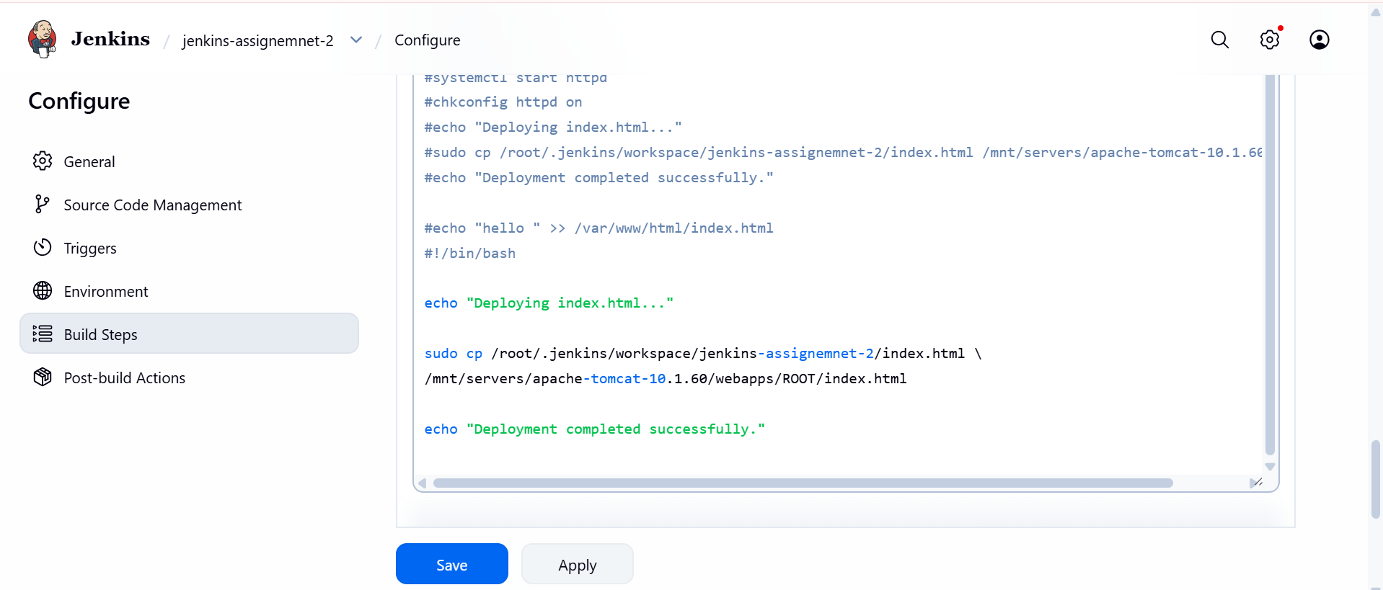
I was copied index.html file and deployed inside apache-tomcat/webapps directory.
Run http://public-ip:8080/index.html

