Step 1: launch ec2 instance
http port no 8080 for tomcat server in SG
add http port no 80 for browser
add ssh 22 for linux machine and launch the machine.

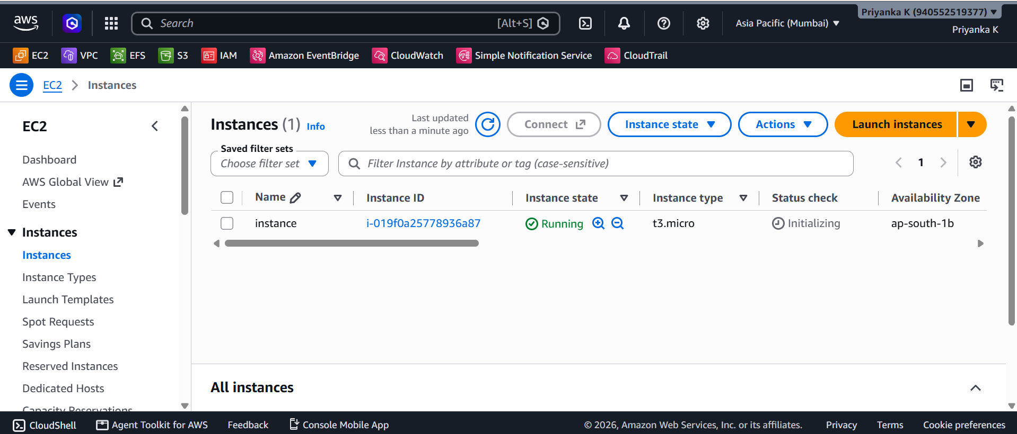

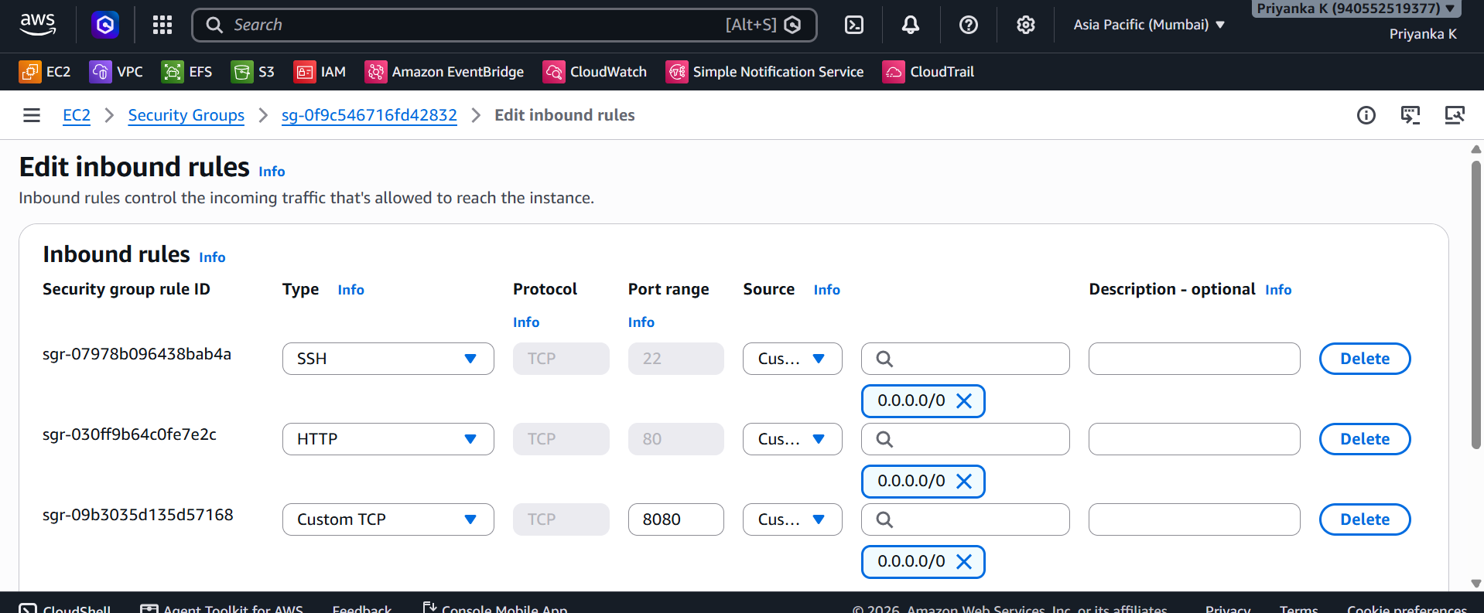

Step 2 : install jenkins
1 clear
2 yum list java-21*
3 yum install java-21-amazon-corretto.x86_64 -y
4 cd /mnt
5 mkdir servers
6 cd servers/
7 wget https://dlcdn.apache.org/tomcat/tomcat-10/v10.1.60/bin/apache-tomcat-10.1.60.zip
8 unzip apache-tomcat-10.1.60.zip
9 chmod -R 777 apache-tomcat-10.1.60
10 cd apache-tomcat-10.1.60/
11 pwd
12 ls -ltr
13 cd we
14 cd webapps/
15 ls -ltr
16 wget https://get.jenkins.io/war-stable/2.568.3/jenkins.war

18 ./startup.sh
19 cd ../
20 cd logs/
21 tail -100f catalina.out
22 cd /root/.jenkins/
23 ls -ltr

