Pass practical course <https://www.katacoda.com/courses/git>

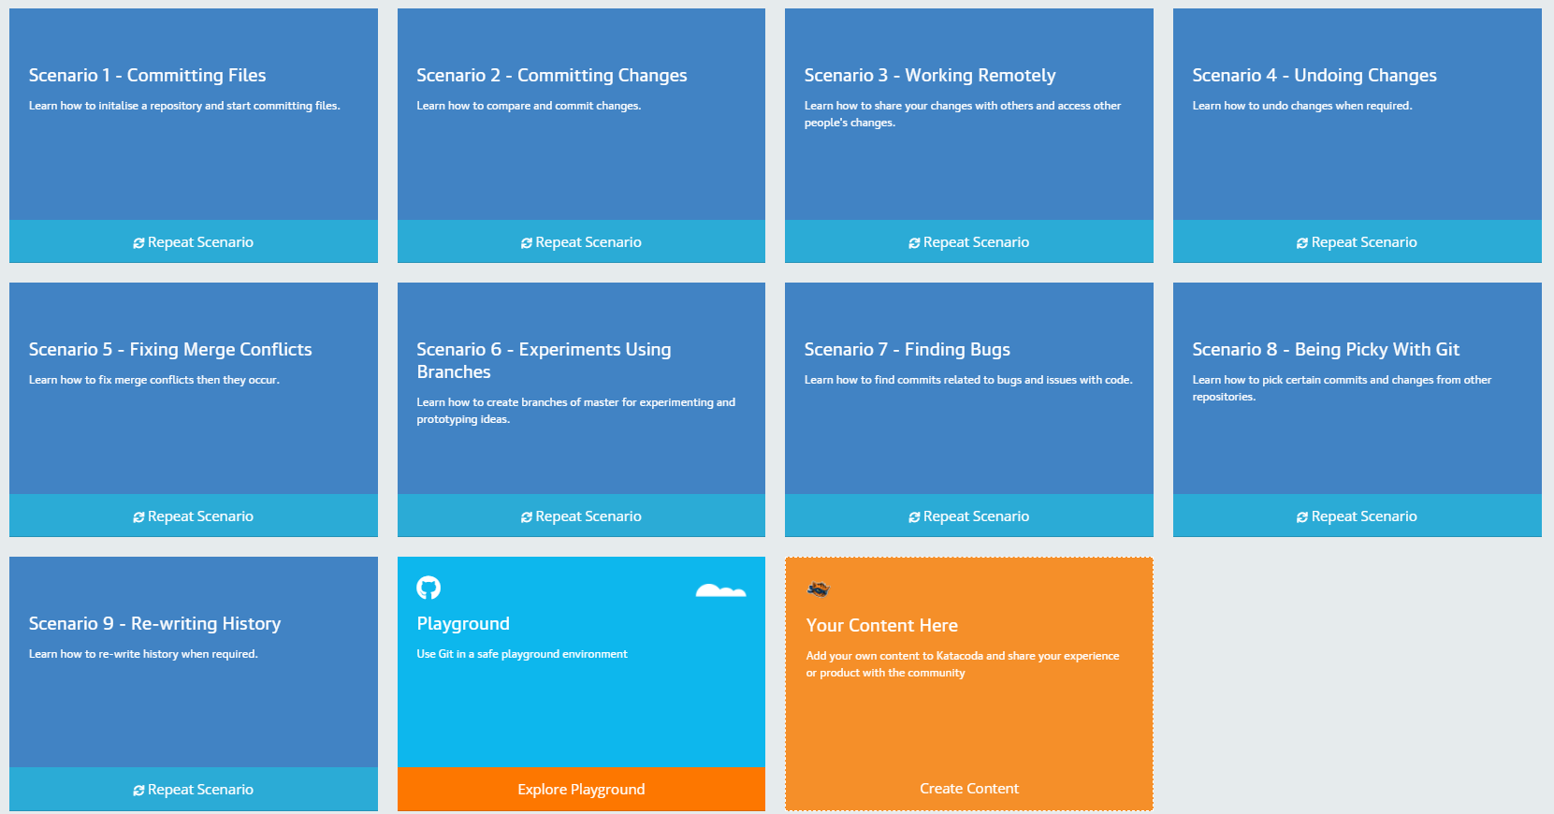

Pass practical scenario <https://www.katacoda.com/aossama/scenarios/git-scm-lab-101>  
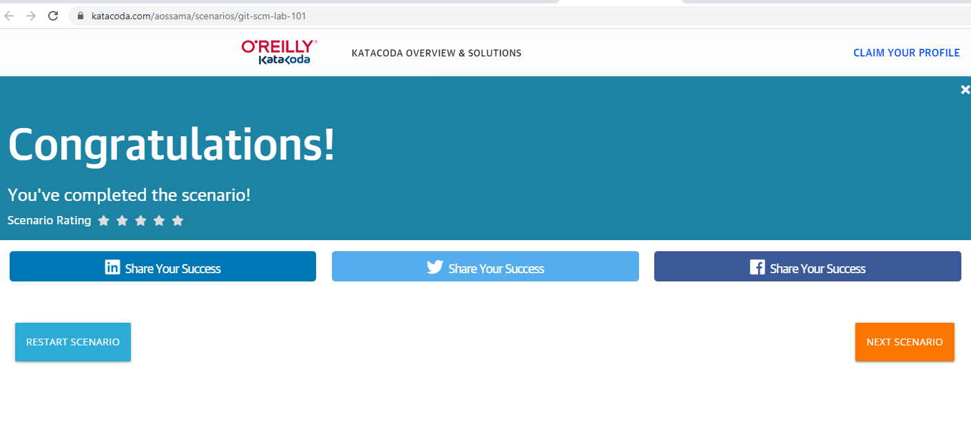

Pass practical scenario <https://www.katacoda.com/aossama/scenarios/git-scm-lab-102>  
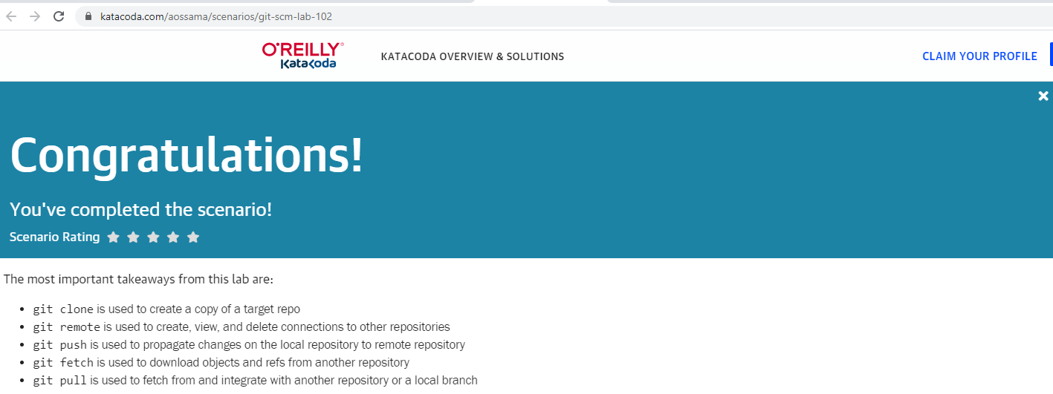

Pass practical scenario <https://www.katacoda.com/aossama/scenarios/git-scm-lab-201>  
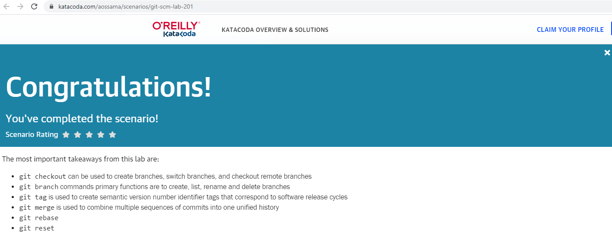

Pass practical scenario <https://www.katacoda.com/aossama/scenarios/git-scm-lab-202>

