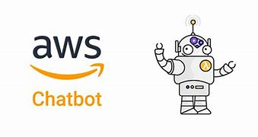

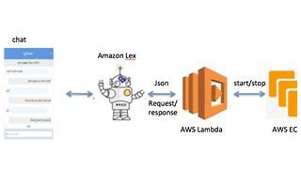

**Step 1: Set Up AWS Account**

* If you don’t already have an AWS account, sign up at [AWS Management Console](https://aws.amazon.com/console/).
* Ensure you have appropriate permissions to access AWS services like Amazon Lex, Lambda, and Dynamo DB. 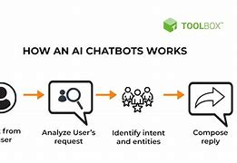

**Step 2: Create an Amazon Lex Bot**

* Go to the Amazon Lex service in the AWS Console.
* Click on "Create bot" and choose a name for your bot.
* Select the bot's language, voice, and functionalities.
* Define intents (e.g., "Book a ticket") and sample utterances (e.g., "I want to book a ticket").
* Specify slots and slot types to capture required user inputs.

**Step 3: Build and Test the Bot**

* Use the Lex Console to build the bot. Click "Build."
* Test it in the console to ensure the intents and responses work as expected.

**Step 4: Set Up Amazon Lambda Function (Optional)**

* Create a Lambda function to enhance your bot’s functionality, like connecting to external APIs or databases.
* Write code using languages like Python or Node.js.
* Link the Lambda function to your Lex bot under "Fulfillment" settings.

**Step 5: Connect to Amazon Dynamo DB (Optional)**

* If you need data persistence, create a Dynamo DB table to store user data.
* Use the Lambda function to read/write data to the table.

**Step 6: Deploy the Bot**

* Set up integration options, such as AWS Connect or Amazon Alexa , or embed the bot into a webpage or app using APIs.
* Test the deployment to ensure smooth interactions.

**Step 7: Monitor and Improve**

* Use AWS Cloud Watch for monitoring the bot’s usage and debugging.
* Continuously refine intents, utterances, and responses based on user feedback and logs.

Does this guide align with what you're aiming to accomplish? Let me know if you need help with any specific step!

