Here's a general overview of how you can incorporate JavaScript into your login page:

1. Create the HTML structure: Design and create an HTML form that includes fields for the username and password. You can use HTML tags like **<form>**, **<input>**, and **<button>** to build the login form.
2. Handle form submission: Attach a JavaScript event handler to the form's submit event to intercept the form submission and perform necessary actions. You can use the **addEventListener** method to listen for the submit event and prevent the default form submission behavior.
3. Validate user input: In the JavaScript event handler, validate the user input by checking if the username and password fields are filled out appropriately. You can use JavaScript functions to perform validation, such as checking for empty fields or verifying input patterns.
4. Send data to the server: Use JavaScript's **fetch** API or XMLHttpRequest to send the username and password data to your Node.js server for authentication. This involves making an HTTP request to a specific endpoint on your server and sending the data in the request payload.
5. Server-side authentication: In your Node.js server code, implement the logic to authenticate the user's credentials. This typically involves checking the username and password against a database or some other form of user data storage. You can use libraries like Passport.js or implement your own authentication logic using bcrypt for password hashing.
6. Return the authentication result: Once the authentication is performed on the server-side, the server should send a response back to the client-side JavaScript. This response can be in the form of a success or failure message, or it can include additional data such as a session token or user information.
7. Handle the server response: In the client-side JavaScript, handle the response received from the server based on the authentication result. You can display appropriate messages or redirect the user to different pages depending on the authentication outcome.

Remember to implement proper security measures when handling user authentication, such as securely storing passwords, using encryption, and protecting against common security vulnerabilities like cross-site scripting (XSS) and cross-site request forgery (CSRF).

This is a high-level overview of how you can use JavaScript for the login page of your library management system. The specific implementation details may vary based on your project requirements and the libraries/frameworks you choose to use.

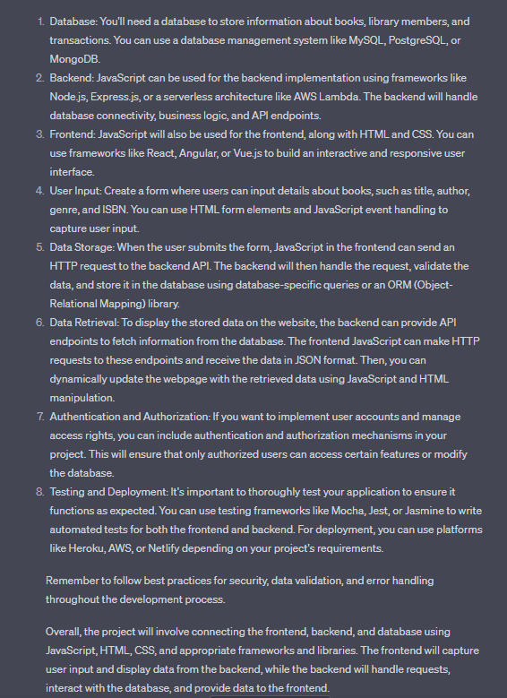

in this project i want to store the input data in mysql databse as i have mysql workbenchin my pc, how can i do so? plz guide ma a procedure in most precise way.

ChatGPT

To store the input data from your form in a MySQL database using MySQL Workbench, you can follow these steps:

1. Set up MySQL: Ensure that you have MySQL Server installed and running on your PC. If not, download and install MySQL from the official website (<https://dev.mysql.com/downloads/>).
2. Create a database: Open MySQL Workbench and establish a connection to your MySQL Server. Create a new schema (database) for your project by right-clicking on the "SCHEMAS" section in the sidebar and selecting "Create Schema...". Give it a name, such as "library_management_system", and click "Apply" and then "Finish".
3. Design the table: In the newly created schema, right-click on the "Tables" section and select "Create Table...". Define the table structure that will hold the form data. For example, you can create columns for the date, category, name, number of books, author/publication, and price. Specify the data types and any constraints, such as primary key or not null.
4. Execute the SQL script: After defining the table structure, click the "Apply" button to generate the SQL script. Review the generated script to ensure it matches your table structure. Then, click the "Apply" button again to execute the script and create the table.
5. Establish a server-side backend: Set up a server-side backend using Node.js and Express.js. Install the necessary dependencies, such as the **mysql** library, using npm.
6. Connect to the database: In your backend code, establish a connection to your MySQL database using the connection parameters (host, port, username, password) for your MySQL Server. You can use the **mysql** library in Node.js to handle the database connection.
7. Process and insert form data: In your backend code, receive the form data from the HTTP request, extract the values, and validate them. Then, use the **INSERT** SQL statement to insert the data into the MySQL database table. Bind the form data to the SQL query parameters to prevent SQL injection.
8. Test and validate: Test your backend API endpoints, ensuring that the form data is correctly processed and inserted into the MySQL database. Verify the data by querying the table using MySQL Workbench or by retrieving the data through API endpoints.

Remember to handle errors and implement appropriate error handling mechanisms in your backend code. Also, consider implementing security measures such as input validation and sanitization to protect against SQL injection vulnerabilities.

Please note that the exact implementation details may vary depending on the specific libraries and frameworks you choose for your backend. It's recommended to consult the documentation and resources specific to the technologies you're using for more detailed instructions.

when i create a table in database should I keep the book_name in auto-incremental data-type beacause a student can have multiple books some times and when the input from the form is stored in a dbms, how will it be stored?

No, you should not use the auto-incremental data type (such as INT with auto-increment) for the book_name field in your table because it appears that the book_name field represents the name of a book, which is a string, not a numeric value.

In the provided code, the book_name field is being collected as an input from the form using the <input type="text"> element. It is being stored as a string value.

When the input from the form is stored in a DBMS (such as MySQL), the book_name field would typically be stored as a character data type, such as VARCHAR or TEXT, depending on the expected length of the book names.

To store multiple books for a single student, you could create another table, such as a "Books" table, with a foreign key referencing the student. This way, each book can be stored as a separate record, associated with the corresponding student.

Here's an example of how the tables might be structured:

Table: Students

| id | name | program | semester |
| --- | --- | --- | --- |
| 1 | John Doe | BIM | 3 |
| 2 | Jane Smith | BSc. CSIT | 2 |

Table: Books

| id | student_id | book_name |
| --- | --- | --- |
| 1 | 1 | Introduction to Computer Science |
| 2 | 1 | Database Systems |
| 3 | 2 | Algorithms and Data Structures |

In the "Books" table, the **student_id** column serves as a foreign key referencing the **id** column of the "Students" table, establishing the relationship between books and students.

This way, each student can have multiple books associated with them, and the book names can be stored as separate records in the "Books" table.

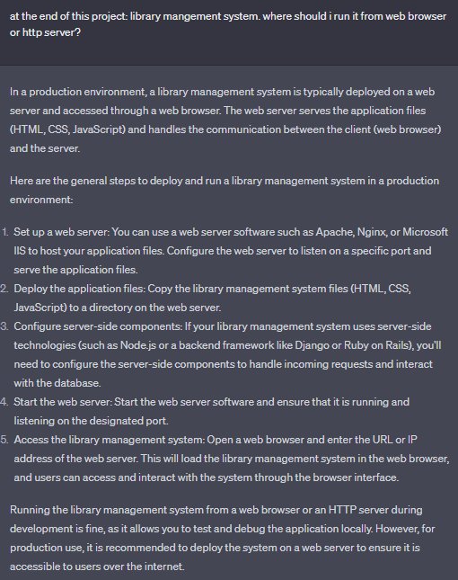

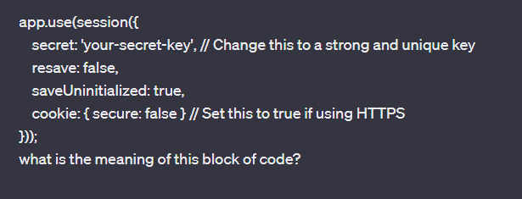

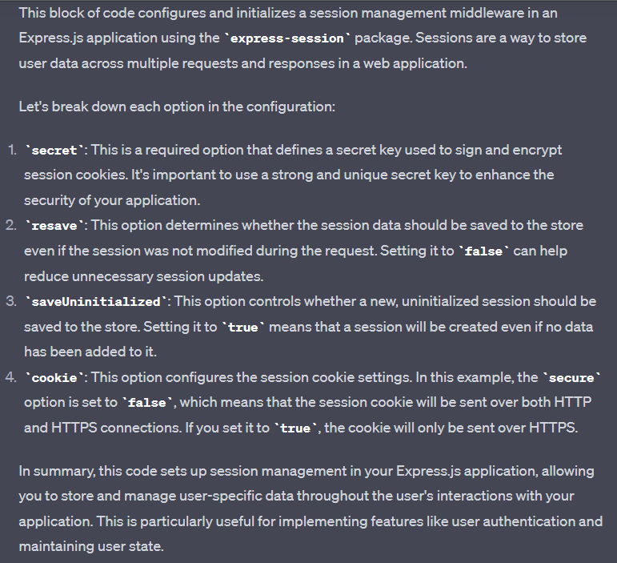

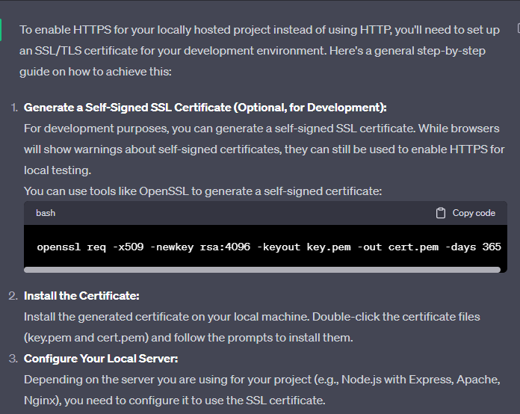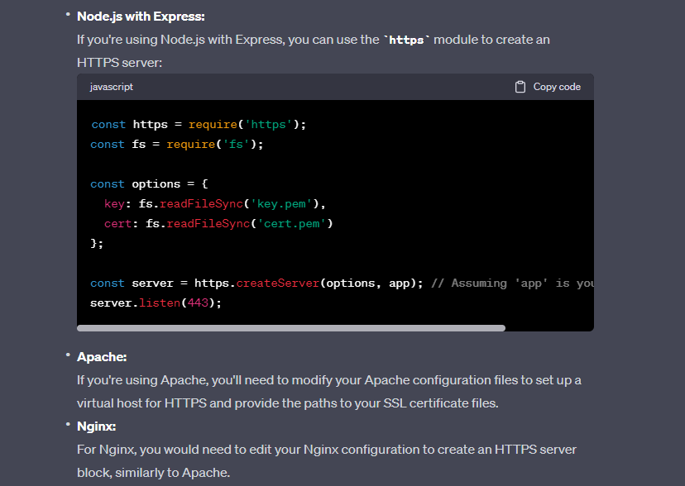



**HOSTING THE SYSTEM PRIVATELY**

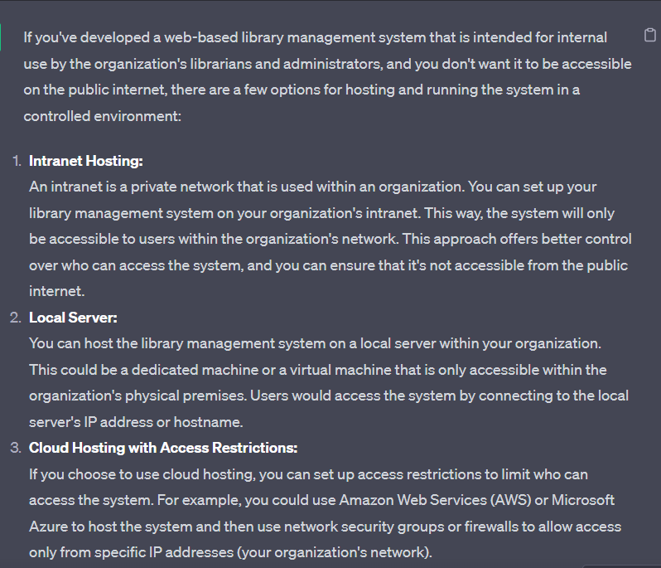



………………………………………………………………………………………………..



**USING ENVIRONMENT VARIABLES**

