**Survival toolkit for result analysis**

Hope everyone will survive!!

(by K. Kittivibul)

**Sequence alignment**

Sequence: Uniprot, NCBI, or wherever you can find sequence.

Alignment: MAFFT, Clustal Omega, Tcoffee, etc.

View: Jalview, ESPript3.x

* Download sequence
* Align more than 2 sequences on MAFFT, Clustal Omega, Tcoffee or whatever (just choose one, ok?). **But my suggestion is just doing the sequence alignment in Jalview, then save the aln file. Very easy ☺ **
* Save the output in .aln file (clustal w file)
* Go to ESPript3.x
* Add input .aln file, select submit.
* If you want the secondary depiction, select .pdb file
* You will get the sequence alignment result for publication like this:

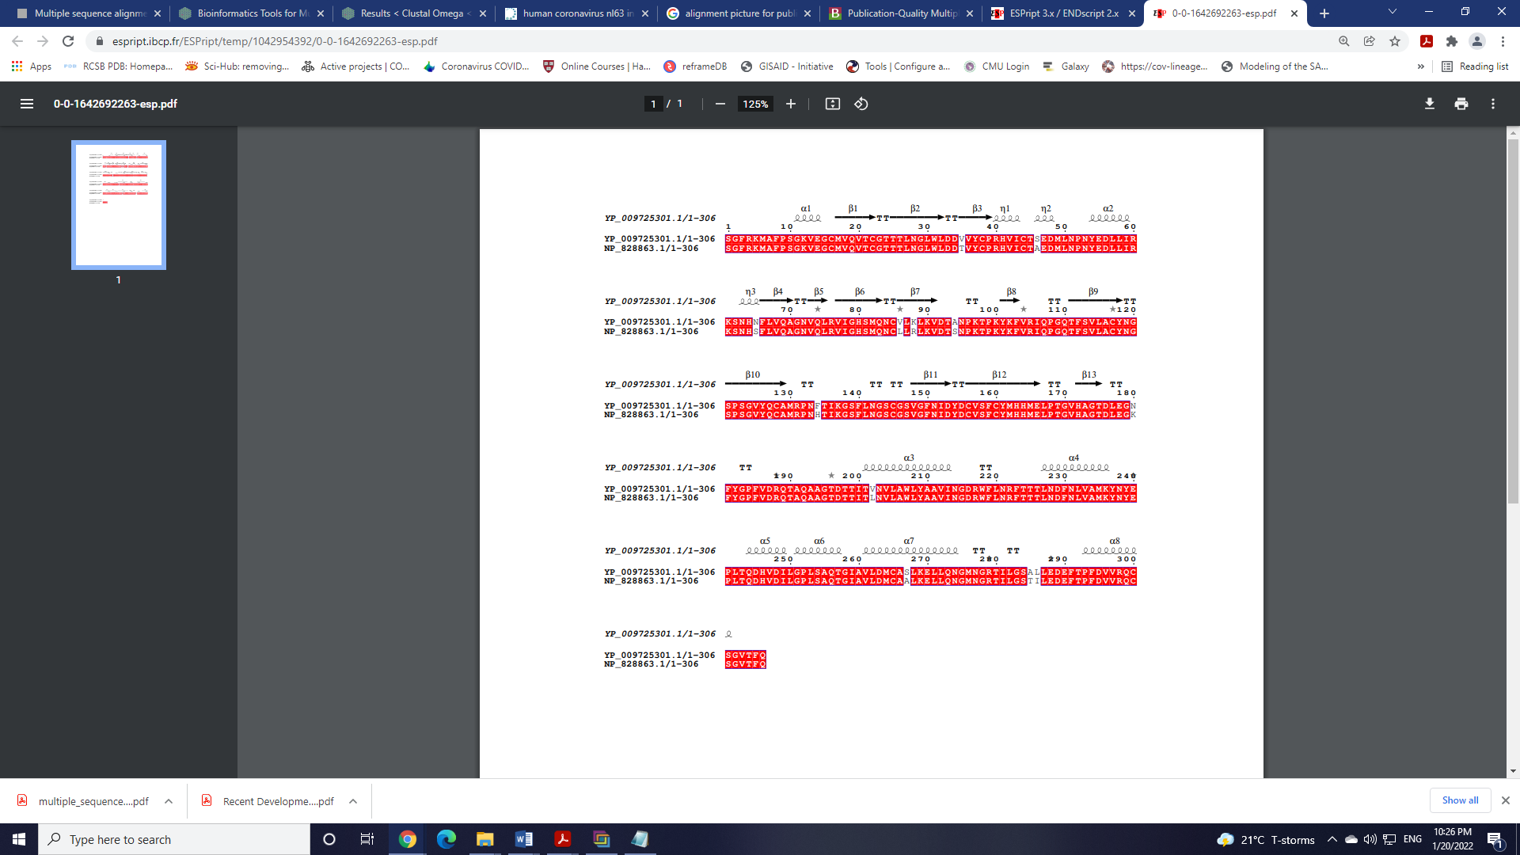

GNUPLOT

* Prepare your data in separate file > e.g. data.dat or data.xvg **the most important part!!**
* > Plot “data.dat” : program will automatically generate a default graph.
* > Set key or unset key : to set or unset a previous command line.
* > Plot “data.dat” title “RMSD” linetype 7 line color 0
* > replot : plot again
* > test : will bring up another window that is very helpful for you. :D
* > set xrange [-1:10] : plot x-axis from -1 to 10
* > set xlabel “rmsd” : label x-axis
* > set terminal png size 800,600
* > set output “data.png”

RMSD

* > plot 'apo.txt' with lines title 'Mpro-apo' lw 1 lc rgb 'black', 'N3.txt' with lines title 'Mpro-N3' lw 1 lc rgb 'blue'
* > set title ‘Rood-mean-square deviation’
* > set xlabel ‘Time (ns)
* > set ylabel ‘RMSD (angstrom)’