

**Faculty of Engineering & Technology**

**Electrical & Computer Engineering Department**

**ARTIFICIAL INTELLIGENCE - ENCS3340**

**Project # 1: Magnetic Cave**

**Prepared by:**

Jehad Hamayel 1200348

Katya Kobari 1201478

**Instructors:** Dr. Yazan Abu Farha & Dr. Ismail Khater

**Sections:** 4 & 3

**Date:** 19/6/2023

**Place:** Masri 302&404

Table of Contents

**Table of Table** 2

**Implementation of The Project:** 3

**Introduction about the game:** 3

**The structure of the project and the heuristic used:** 5

**the heuristic used:** 5

**The structure of the project:** 6

**How the Program Runs:** 7

**Rivalries with colleagues:** 9

# **Table of Table**

Figure 1: 8x8 chessboard 3

Figure 2:Illegal configuration 4

Figure 3:player □ wins column 4

Figure 4:player □ wins diagonal 4

Figure 5:win cases 6

Figure 6:Game start interface 7

Figure 7:Show play 7

Figure 8:Game with automatic player 8

Figure 9:some results of playing with colleagues 9

# **Implementation of The Project:**

## **Introduction about the game:**

We used Java language to implement our project using eclipse program, which is a 2-player adversary game where each player tries to build a “bridge” of 5 magnetic bricks within a cave whose left and right walls are magnetic, where we represented the bricks of one of the players with ■ and the bricks of the other with □ through three modes as follows:

1. manual entry for both ■'s moves and □'s moves
2. manual entry for ■'s moves & automatic moves for □
3. manual entry for □'s moves & automatic moves for ■

The version of the magnetic cave that we implemented was played on an 8x8 chessboard as shown in Figure 1:

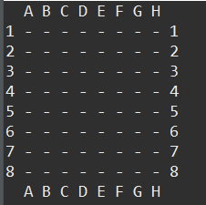

Figure 1: 8x8 chessboard

The rules of the game that we applied are:

* At first, the cave (the blackboard) is empty.
* Player ■ (the first player) and player □ (the second player) move in an alternate manner, if we start with ■. Followed by □, then ■ again, then □ again..., until the end with either a win or a tie (the board is full).
* Given that there are two large magnets on each side of the cave, the player can only place a brick on an empty place of the cave, provided that the bricks are stacked directly on the left or right wall, or stacked to the left or right of another brick (of any color).
* Once one player can line up 5 consecutive bricks in a row, in a column or on a diagonal, that player wins the game.
* If no player can achieve a winning combination and the board is full, the game stops and there is a tie. As we mentioned at the beginning.

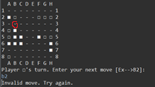

Figure 2:Illegal configuration

Brick B3 cannot be placed there as shown in Figure2.

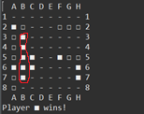

Figure 3:player □ wins column

Here, player □ wins, he built a bridge from B3 to B7.

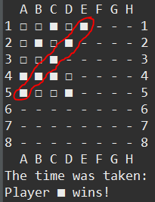

Figure 4:player □ wins diagonal

Here, player □ wins, he built a bridge from E1 to A5.

## **The structure of the project and the heuristic used:**

### **the heuristic used:**

The algorithm used is alpha-beta pruning with a depth of 5 and a case of less than three real seconds for decision-making, but when using Depth 6 it always works less than 3 but only one case needs more than 3 seconds and that is when the best solution is very deep and also the pruning is low.

The heuristic we used in the project is as follows:

We made loops that search in columns, rows, and diagonals so that it passes through all the possible cases in which the player can win in the event that the five places where the stone is to be placed do not contain the opponent’s stone, otherwise we move to the next possible case, and if the case is allowed, that is, there is no A stone for the opponent player from among the five places we calculate as follows:

There is a variable in which the sum of the points and the heuristic is placed. If the five places are empty, we do not add any points to the existing situation, and the same is the case if there is one stone for the player who is playing. As for the other cases of finding two, three, four, or five stones, we add values for the heuristic score, which includes the following: two stones, add 1000, if three stones, 10000, if four stones, 100000, and if 5 stones, that is, winning, we add 10,000,000, and this indicates that the victory is very close and gives this movement a high priority. The reason for taking these values is that in the case of two stones, they are weaker than the rest of the cases. Also, three stones are 10 times better than the previous ones, and four are also 10 times the points of the three stones, but in the case of 5, they are times more than all the previous cases.

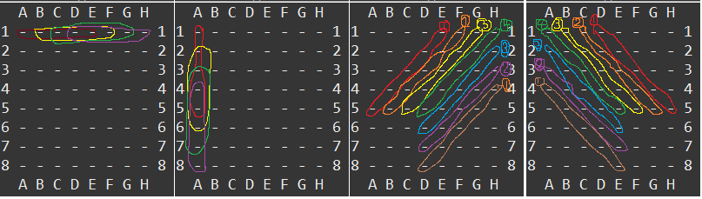

Figure 5:win cases

As we mentioned previously about winning cases, which is as shown in the Figure 5, winning cases in all cases, rows as it is in the Figure 5, and also the same thing for each row and column as the case, and for the diagonal there are two methods, the first from the top from the right to the left from the bottom, and the second method from the top from the left To the right from the bottom, the numbers shown in the Figure 5are how many cases are possible in the diagonal itself, and their sum for each method of the diagonal is 16 cases, and for columns and rows for each unit, there are 32 possible cases.

### **The structure of the project:**

We carried out the process of searching and building the tree by storing the board in a two-dimensional array of charts, and we carried out the search process by using the recursive function as shown in the code attached with the report.

# **How the Program Runs:**

In the beginning, when you run the project, it displays the board for the game and the modes on which the game works, as shown in the Figure 6.

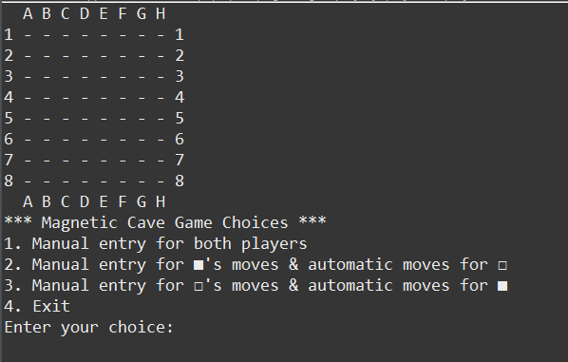

Figure 6:Game start interface

In the first option, the manual mode, each player chooses what he wants to play in, but if he violates the laws, he is prevented, as shown in the Figure 7.

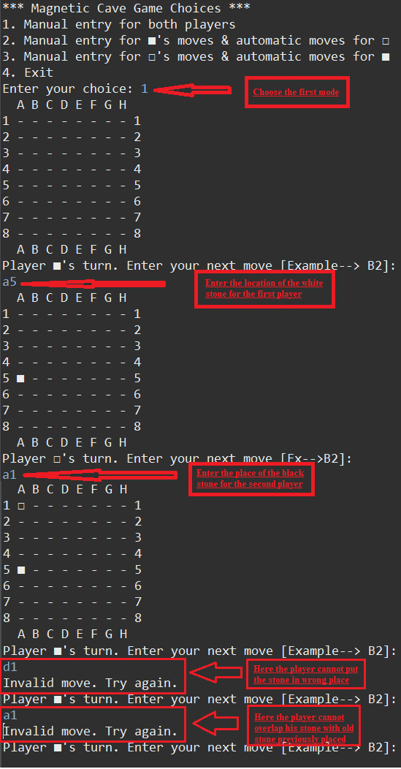

Figure 7:Show play

In the second and third options, there is only a difference between the manual and automatic players. The first player chooses what he wants to play with, and the computer, according to the algorithm, takes a decision and plays, but if the first player violates the laws, he is prevented, as in the previous case, and as shown in the Figure 8, the heuristic value and the time the computer needed until makes a decision.

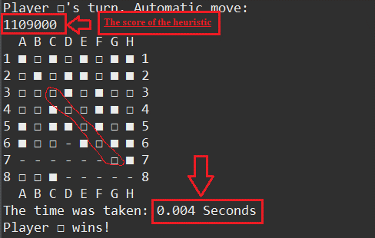

Figure 8:Game with automatic player

As shown in the Figure 8, the computer won by taking a time of 0.004 seconds and built the bridge in a diagonal way.

# **Rivalries with colleagues:**

As shown in the Figure 9 are the results of playing with my colleagues, as playing with some was competitive to the extent that we drew with some and won, but others were easy to win. In the end, the result indicates the strength of our program, since we did not lose once.

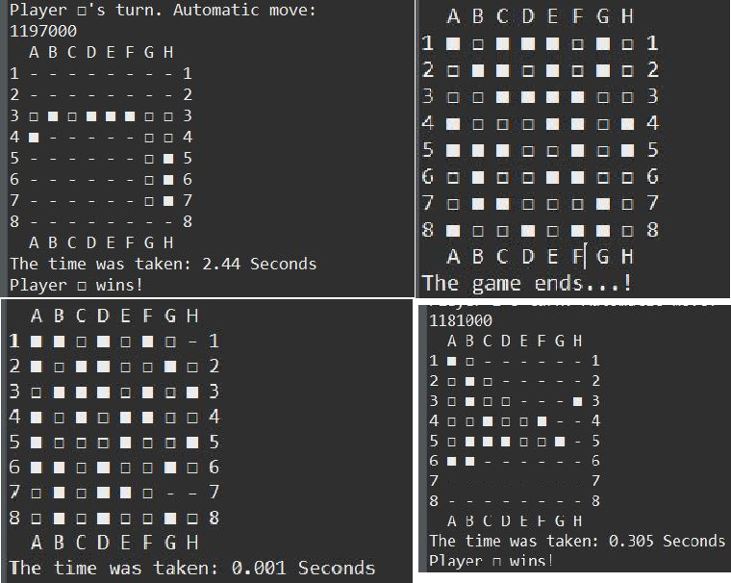

Figure 9:some results of playing with colleagues

**We certify that this submission is the original work of members of the group and meets the Faculty's Expectations of Originality**

Jehad Hamayel 1200348

Katya Kobari 1201478